© 2023 Daniel Arias. All rights reserved.

Mental disorders are a leading cause of morbidity and mortality, affecting over one billion people worldwide. This burden, across all levels of socioeconomic development, is rising, yet the majority of people living with a mental disorder do not have access to adequate mental health services, with many facing stigma and high out-of-pocket payments for their care. Moreover, new and emerging dangers such as climate change and the COVID-19 pandemic pose additional stressors that threaten to exacerbate this burden.

This dissertation aims to contribute to a better understanding of the evolving burden and dynamics of global mental health. The three studies it presents take as their focus different quantitative aspects of how the global burden is measured and evaluated, how it may be changing in response to global challenges, and how novel data sources may help in characterizing these changes, particularly in the absence of robust, high-frequency epidemiological surveillance.

In Chapter 1, we investigated the share of the global burden of disease attributable to mental disorders and its associated economic value. To capture premature mortality due to mental disorders, as well as disability from associated causes, we proposed a composite approach to estimation. Using the most recently available estimates from the Global Burden of Disease study, we found that the burden of mental disorders is likely much higher than previously estimated, encompassing 16% of disability-adjusted life years in 2019. The economic value of this mental health burden was estimated to exceed 4.7 trillion United States dollars using a value of a statistical life year approach, accounting for regional losses that range from 3.9% of gross domestic product in Eastern Sub-Saharan Africa to 7.9% in High-income North America.

In Chapter 2, we focused on Madagascar—a low-income country that is among the most vulnerable to the health consequences of climate change—and examined how health system visits for mental disorders may be shifting in response to climate change exposures such as changes in temperature, soil moisture, and the duration of tropical storms and cyclones. Drawing on meteorologic, geospatial, and health system data reported by 3,413 facilities from 2010 to 2020, we conducted an ecological analysis using negative binomial regression. Our results indicated that warmer temperatures in the cooler central highlands were associated with a decrease in monthly reported visits for mental disorders, while higher soil moisture could lead to an increase in visits, particular in high flood-risk regions and after a three-month lag, indicating potential variation in the impact of climate change on mental health needs and system responses.

In Chapter 3, I investigated how Google search data for mental health symptoms might provide insight into the state of mental health during the COVID-19 pandemic. Using an interrupted time series approach with search data from Australia, Ireland, New Zealand, Singapore, the United Kingdom, and the United States, I found that announcements of COVID-19 vaccine safety and efficacy data in November 2020 were associated with immediate and sustained declines in search density for anxiety and depression. These declines in searches, if taken as a reasonable proxy for population mental health, underscore the importance of timely and transparent public health communication and illustrate the potential application of high-frequency internet search data for population mental health surveillance.

Taken together, these chapters highlight different facets of the global burden of mental disorder and contribute to a growing effort to generate a more comprehensive understanding of the challenges posed by this burden at local, regional, and global levels.

ADHD

attention deficit hyperactivity disorder

C3S

Copernicus Climate Change Service

CCEs

climate change-related exposures

CDC

Centers for Disease Control and Prevention

CHD/CHRD

centre hospitalier de référence de district

CHRR

centre hospitalier de référence régionale

CHU

centre hospitalier universitaire

CITS

controlled interrupted time series

CIs

confidence intervals

CSB

centre santé de base

CoC

clouding of consciousness

DALYs

disability-adjusted life years

DHIS2

District Health Information Software 2

ECMWF

European Centre for Medium-Range Weather Forecasts

ERA5

European ReAnalysis 5

ESA CCI

European Space Agency’s Climate Change Initiative

ESA CCI SM

ESA CCI soil moisture dataset

EUA

Emergency Use Authorization

FDA

Food and Drug Administration

FE

fixed effects

FIPS

Federal Information Processing Standards

FSB

formation sanitaires privées de dase

GAD

generalized anxiety disorder

GBD

Global Burden of Disease

GBO

Global Health Observatory

GDP

gross domestic product

GESIS

Gestion du Système d’Information Sanitaire

HMIS

health management information system

IRB

Institutional Review Board

IRRs

incidence rate ratios

ITS

interrupted time series

LMICs

low- and middle-income countries

MDD

major depressive disorder

MFR La Réunion

Météo-France La Réunion

MIT

Massachusetts Institute of Technology

NB

negative binomial

NCDs

noncommunicable diseases

NOAA

United States National Oceanic and Atmospheric Administration

PAF

population attributable fraction

PPP

purchasing power parity

RHINO

Routine Health Information Network

RSMC

Regional Specialized Meteorological Center

UIs

uncertainty intervals

US

United States

USAID

United States Agency for International Development

USD

United States dollars

USDA

United States Department of Agriculture

VSL

value of a statistical life

WHO

World Health Organization

WMO

World Meteorological Organization

YLDs

years of healthy life lost due to disability

YLLs

years of life lost

km

kilometers

I am grateful to the many individuals who have supported and encouraged me throughout my doctoral studies.

First and foremost, I would like to thank the members of my dissertation committee, Stéphane Verguet, Jessica Cohen, Karestan Koenen, and Margaret McConnell. I thank the committee chair, Stéphane Verguet, for his service, and for his extraordinary mentorship as my academic advisor. Throughout the last four years, he has consistently offered unwavering support and insightful guidance throughout my academic journey, and in the moments where I faltered or doubted myself most, his confidence and cheer always helped see me through.

Jessica Cohen has been a constant source of inspiration throughout my studies, and her teaching and scholarship have set a standard to aspire to. In addition to being a brilliant scholar, she is an incredible mentor and instructor, bringing genuine joy to the rigorous study of challenging questions. I feel extremely grateful to have learned so much from her example and from her enthusiasm for econometrics and public health.

Karestan Koenen has my deepest gratitude for inviting me to join her research collaboration on climate and mental health in Madagascar, an invitation which transformed the arc of my research and led to subject of this thesis. Despite the incredible demands on her schedule as an accomplished scholar and public health leader, she generously shared her expertise with me and her fellow committee members. Her insights and suggestions were instrumental in shaping this research, and her encouragement kept me motivated throughout the entire process.

Margaret McConnell has been an exceptional teacher, mentor, and colleague, and is one of the most dependable people I know. She manages a myriad of commitments with grace, always finding the time to kindle excitement for discovery and to share her thoughts and guidance. So many individuals in our department have been fortunate to have her in their corner, and I am ever grateful to be one of them.

I am also deeply grateful to my coauthors and reviewers, whose thoughtful reflections strengthened every page. I thank Shekhar Saxena for his guiding leadership in global mental health and for welcoming me into the field when I first arrived at Harvard, and I thank Christopher Golden for welcoming me into his lab and providing every opportunity, guidance, and support a student could wish for throughout the development of the second paper of this thesis. I also wish to express my gratitude to Judith Bass, who graciously offered to serve as the External Reader for this dissertation.

The community in the Department of Global Health and Population has been a treasured home away from home, and I am grateful to so many of its members for the opportunity to learn at their side. My deep appreciation goes to David Bloom, David Canning, Margaret Kruk, and Vikram Patel, whose classes and coffee chats all have shaped my interests and the course of my career. I also owe a debt of gratitude to Barbara Heil and Allison Conary for all the mountains they have moved and the uphill struggles they have seen me soundly through.

I also would like to thank the many other individuals at the School of Public Health who have made the last four years so full of warm memories. I am thankful to Claudette Agustin, Matthew Boccuzzi, Jarvis Chen, and Bruce Villineau for all the care and welcome they have shared with me and with each cohort of students in the Population Health Sciences program.

Across the Charles River are many dear colleagues who have dedicated themselves to ensuring that Harvard feels like home to all its students. To Jackie Yun and Janet Daniels at the Graduate School of Arts and Sciences Student Center, and to Sheila Thomas, Katie Saibara, and Karina Gonzalez Herrera of the Office of Equity, Diversity, Inclusion & Belonging, I wish to express my deepest admiration and appreciation.

I am also thankful to the Harvard Center for Population and Development Studies for allowing me to be a part of a vibrant research community, and to Bobby and Johnny Lamont for welcoming me into their home through many trips to Cambridge.

Finally, I would like to thank my friends and family for their love, support, and encouragement. They have been a constant source of strength and motivation, and without them none of this would have been possible.

Mental health is an essential part of human flourishing. As defined by the World Health Organization (WHO), it encompasses “a state of well-being in which every individual realizes [their] own potential, can cope with the normal stresses of life, can work productively and fruitfully, and is able to make a contribution to [their] community.”1

For much of the global population, however, attaining this state of mental health is an enduring challenge, with over one billion people worldwide living with a mental or addictive disorder.2 Mental disorders are a leading cause of disability,2,3 with the Global Burden of Disease (GBD) study estimating that 4.9% of disability-adjusted life years (DALYs) and 14.6% of years of healthy life lost due to disability (YLDs) were attributable to mental disorders in 2019.4 Mental disorders are also closely linked to physical health and can be a significant risk factor for premature mortality.5 Among patients living with the most severe mental illnesses, premature mortality may reduce life expectancy by as much as 10 to 20 years.6

At all levels of sociodemographic development, this burden is rising.7 Yet despite this global scale and despite a growing evidence base for impactful, cost-effective interventions that may help,8 the profound impact of mental disorders has been met by a profound treatment gap.9 A majority of the world’s population lives in countries with fewer than 10 psychiatrists for every 100,000 people (Figure ). Most of those living with a mental disorder do not have access to adequate care,9,10 and many face stigma,11,12 discrimination,13,14 and abuse.15–17

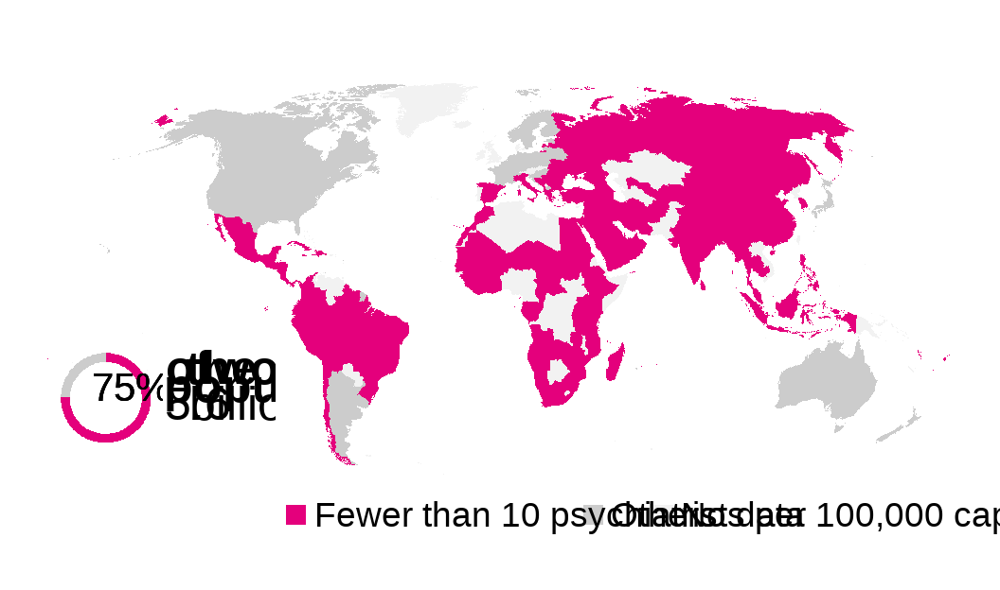

Countries where fewer than 10 psychiatrists per 100,000 capita were working in the health sector between 2013-2017, average. Data from the Global Health Observatory (GHO) of the World Health Organization (WHO).

In addition to the long-standing challenges of these unmet needs, new and emerging dangers such as climate change and COVID-19 reveal additional stressors that threaten to exacerbate this burden. Global climate change—an accelerating existential threat to planetary health that the United Nations considers the “defining crisis of our time”—is already manifesting profound impacts on mental health.18 These impacts are shaped both by the disastrous upheaval caused by worsening extreme weather events and by the incremental change rising temperatures and sea levels have wrought on livelihoods and means of living—altering the availability and access to natural resources, land use, infrastructure, and community.19,20 The essential connections between mental health and human well-being have been further underscored by the devastating impacts of the COVID-19 pandemic, which continues to deal psychological and psychiatric harm to patients, health care workers, and the public overall.21

The extant and evolving challenges of global mental health, in turn, entail jeopardy to health systems and to the three intrinsic goals of improving health, responsiveness, and financial protection.22 According to the WHO’s Mental Health Atlas report from 2020, mental health system governance, capacity, and integration into routine service delivery is fundamentally lacking across nations of all levels of economic development, with only 15% of countries having functional integration of mental health into primary health care.23 This lack of service delivery echoes a lack of basic epidemiological data,24 constraining research and frustrating efforts to respond to mental health needs. Among nations, the Atlas report highlights widening disparities in health system indicators, with worsened gaps in service availability and public health expenditure for mental health between low- and middle-income countries and high-income peers. With respect to health spending, mental health care services in many countries have traditionally relied primarily or exclusively on out-of-pocket payments,25 resulting in a greater risk of catastrophic health expenditure among households with patients living with a mental disorder. These direct costs, when coupled with the indirect costs of diminished earnings due to disability, may exacerbate conditions of poverty,26 which, in turn, may lead to worsening mental health27—feeding a vicious cycle that harms households and nations alike.

A better understanding of the evolving burden and dynamics of global mental health may thus have broad consequences to strengthening health system responses to mental disorders and improving health outcomes for millions of individuals worldwide.

Contributing to such an understanding has motivated this dissertation, which takes as its focus different quantitative aspects of the global burden of mental illness—how we measure and evaluate it, how it may be changing, and how novel data sources may help in characterizing it, particularly in the absence of robust, high-frequency epidemiological surveillance.

The three chapters presented in this dissertation reflect the interdisciplinary nature of global mental health, utilizing a diverse range of quantitative methods and drawing on insights from epidemiology, health economics, and econometrics. Furthermore, these papers align with the broader conceptual framework of population mental health (Figure ), which recognizes the complex interplay of environmental, social, and structural determinants in shaping mental health outcomes. This framework, based on determinants identified by Dykxhoorn et al.,28 illustrates the comprehensive contributions of these determinants to individual and public mental health and guides the approaches in Chapters 1, 2, and 3.

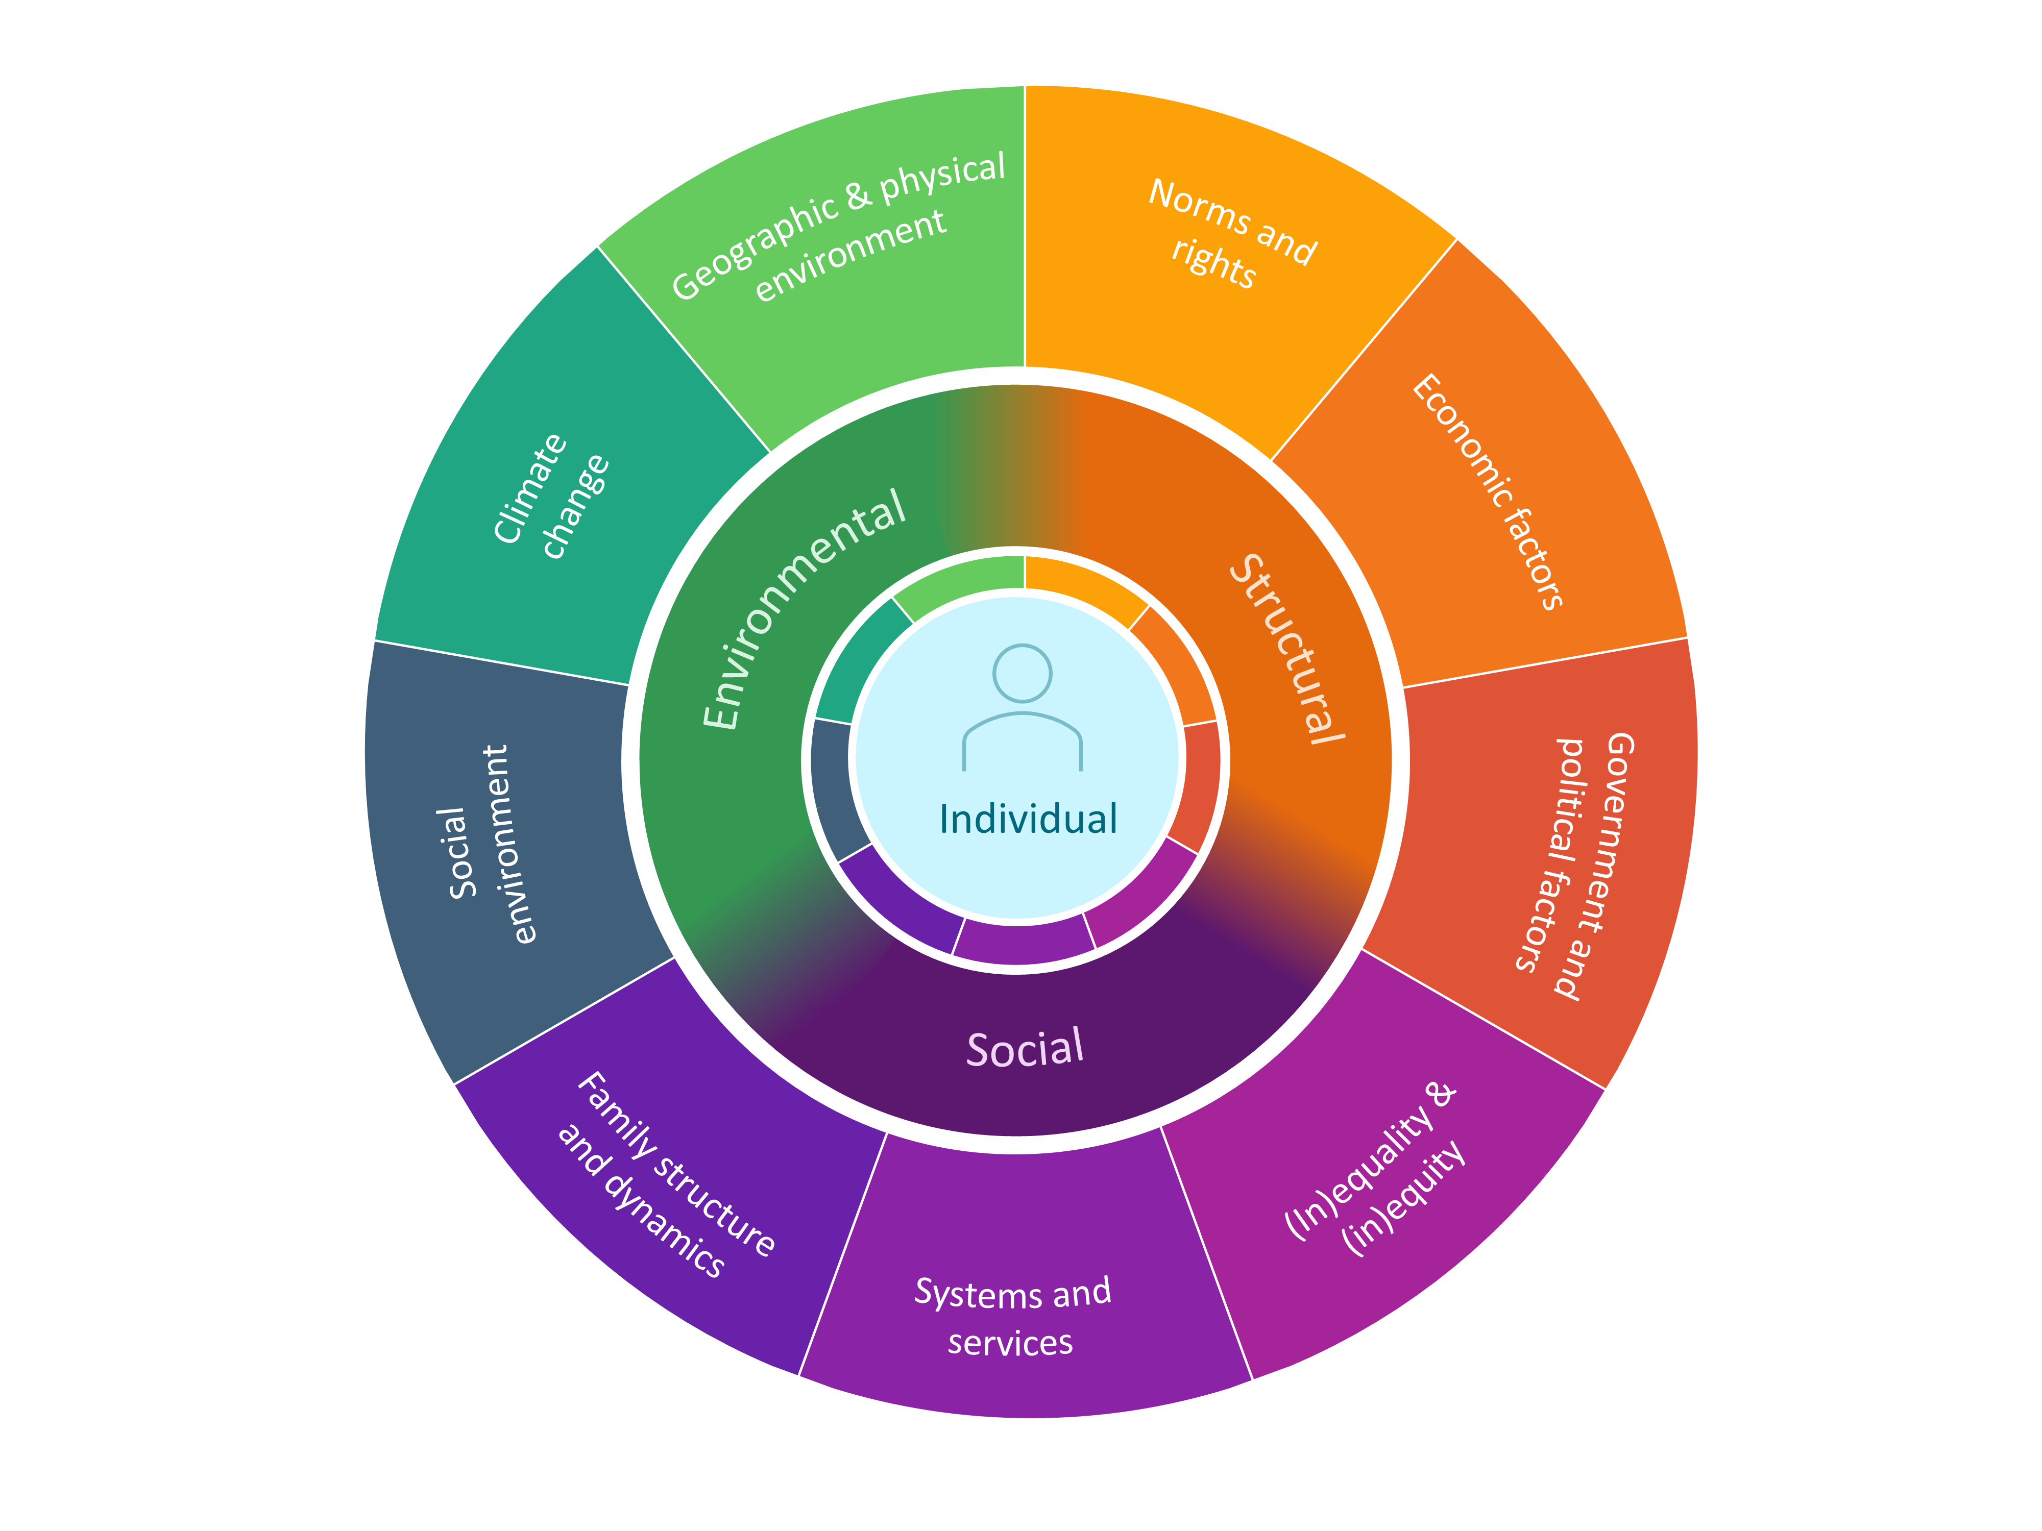

Conceptual framework for population mental health. Original design, based on framework from Dykxhoorn, J., Fischer, L., Bayliss, B. et al. Conceptualising public mental health: development of a conceptual framework for public mental health.BMC Public Health 22, 1407 (2022). <https://doi.org/10.1186/s12889-022-13775-9>. Creative Commons Attribution 4.0 International License

In Chapter 1, we investigated the share of the global burden of disease attributable to mental disorders and its associated economic value. We reviewed recent efforts to estimate both the epidemiologic and economic burden of mental disorders, and we propose a composite approach to estimation to capture a broader share of attributable morbidity and mortality.3–5,29–31 Applying this approach using the most recently available GBD data, we estimated that the global burden of mental disorders is likely much higher than previously estimated, encompassing 16% of disability-adjusted life years in 2019. Using value of a statistical life approaches, we estimated that the economic value of this burden would exceed 4.7 trillion United States dollars (USD).

In Chapter 2, we investigated how health system visits for mental disorders in Madagascar may be shifting in respond to changes in climate. Madagascar has little to no mental health surveillance data and is among the nations most vulnerable to climate change. To address these gaps, we studied the impact of three climate change exposures—temperature, soil moisture, and duration of cyclones and tropical storms—by leveraging meteorologic, geospatial, and health system data reported by 3,413 facilities from 2010 to 2020. We found a statistically significant reduction in monthly mental health related visits associated with each degree Celcius increase in temperature, primarily localized to facilities in the central highlands, where cooler temperatures are more prevalent. We further found that higher soil moisture may be associated with more mental health visits in the future, after a three month lag; this increase was primarily found in the eastern lowlands and the northern dry deciduous forests, consistent with the geographic concentration of flood risk in Madagascar. Our findings point to potential heterogeneity in how changing climate conditions will impact mental health needs and system responses.

In Chapter 3, I investigated how internet search data for health symptoms might provide high-frequency insight into the state of population mental health during the COVID-19 pandemic. Using search data from Australia, Ireland, New Zealand, Singapore, the United Kingdom, and the United States, I explored how announcements of COVID-19 vaccine safety and efficacy data in November 2020 impacted Google search trends for mental health symptoms. I found evidence of statistically significant immediate and sustained declines in searches for anxiety, depression, and major depressive disorder throughout the 40 days following these announcements. The findings underscore the importance of timely and transparent public health communication and illustrate the potential application of high-frequency internet search data for population mental health surveillance.

Overall, these three chapters highlight different facets of the global burden of mental disorders and speak to the interconnectedness of mental health and human well-being, as well as the urgent need for greater research and resources to better illuminate such pathways. Taken together, they contribute to a growing effort to generate a more comprehensive understanding of the challenges posed by this burden—as well as opportunities for improving mental health at local, regional, and global levels.

# 1 Quantifying the global burden of mental disorders and their economic value

## 1.1 Introduction

A growing body of literature suggests that mental disorders are costly, both in the direct medical costs of care, outpatient visits, and hospitalizations, and in indirect costs, such as losses in income and productivity due to disability, which may cause absenteeism and presenteeism.32 These costs further worsen conditions of poverty26—a vulnerability that, in turn, worsens mental health, feeding a vicious cycle of poverty and illness.27 At the national level, mental disorders deplete the supply of labor and capital, resulting in poorer economic output.33 Among households and nations alike, the burden of mental illness thus has considerable economic consequences and poses a challenge to both health and wealth.

Evaluating the economic burden of mental illness is a critical part in making the investment case for global mental health, informing public health decision-making, and guiding priority-setting and the scale-up of much-needed interventions.34 At the global level, however, the most recent estimate of the economic impact of mental disorders was published in 2011, using burden of disease estimates from 2004.29 This landmark paper by Bloom and colleagues estimated that the value of losses due to mental disorders was roughly 1.3 trillion United States dollars (USD) in 2010 (1.6 trillion USD in 2019) when disability-adjusted life years (DALYs) were valued at one times gross domestic product (GDP) per capita.29 The authors further projected that these losses would grow to nearly 2.5 trillion USD 2010 (or approximately 3.0 trillion USD in 2019) by 2030. (See Tables S1.1 and S1.2 in Appendix 1 for estimates from the other two approaches.) These estimates have been widely cited in calls to action concerning global mental health.7,35

While the estimates presented from this paper remain staggering and salient, new studies estimating the morbidity and mortality associated with mental illness have since become available.5,30,36 These studies suggest that previous (and current) estimates of the global burden of mental disorders may be considerably underestimated, which, in turn, has implications for estimating the true economic burden of mental illness.

The most recent estimates of morbidity and mortality due to mental disorders come from the Global Burden of Disease (GBD) 2019 study.4 The GBD study provides disease burden estimates using DALYs, years of healthy life lost due to disability (YLDs), and years of life lost (YLLs), which are then aggregated within a hierarchical grouping scheme that classifies causes of disability and death at different levels of mutually exclusive and completely exhaustive categories. (Mental disorders are a Level 2 condition, nested under noncommunicable diseases (NCDs); see Table S1.3.)

While GBD remains the gold standard for global epidemiologic estimation, the nature of the GBD scheme—in particular, the rationale for grouping certain conditions under mental disorders or not—has been the subject of debate in the literature.30,37,38 In particular, work by Vigo et al. (2016) published in argues for an expanded classification of mental disorders under the GBD classification scheme to account for underestimation of the burden of mental disorders.30 The authors attribute this underestimation to five main causes: 1) the distinction drawn between mental and neurological diseases; 2) the categorization of self-harm and suicide under injuries; 3) the classification of all chronic pain and somatoform disorders under musculoskeletal disorders; 4) the exclusion of personality disorders; and 5) the exclusion of premature mortality due to mental disorders. Using data from the 2013 GBD study, Vigo and colleagues re-allocated the entire burden of dementia, epilepsy, migraine, tension-type headache, and self-harm to mental disorders. In addition, a third of the burden of musculoskeletal disorders without anatomical correlate (i.e., somatoform disorders with prominent pain) was attributed to mental disorders.30 This reallocation attributed 13% of DALYs to mental disorders, a 6 percentage point increase from the GBD estimate of 7%.

In this paper, we attempt to revisit the estimation of the global burden of mental disorders and of its associated economic value. Our aim is to characterize potential underestimation of the burden of mental disorders and to quantify the economic value of this burden under different estimation approaches. Specifically, we expand on Vigo et al.30 by capturing premature mortality due to mental disorders using pooled risk ratios of mortality from a systematic review of mental disorders5 to determine the population attributable fraction (PAF) of premature mortality. Inclusion of premature mortality through the PAF presents a novel composite approach that can more broadly capture attributable morbidity and mortality. Using this approach on GBD 2019 estimates, we then apply monetary values to DALYs to reach estimates of the global economic value of the mental burden of disease using a value of a statistical life (VSL) approach similar to that of Bloom and colleagues,29 which attempts to capture a population’s willingness to pay to reduce morbidity and mortality associated with illness. The VSL approach—in contrast to alternatives such as cost of illness and value of lost output approaches—includes an economic valuation of mortality risk reductions in monetary terms, and thus enables comparison across sectors (beyond the sole health sector) which can motivate decision-making toward ameliorating welfare and societal mental health. Our findings suggest that both the epidemiological and economic burden of mental disorders could be larger than previously estimated, and that underestimation would be larger among regions where premature mortality due to mental disorders is greater.

## 1.2 Methods

To estimate the economic burden of mental disorders, we first estimate the attributable mental burden of DALYs under various estimation approaches using data from the 2019 GBD study (available from the Global Health Data Exchange at <https://ghdx.healthdata.org/gbd-2019>). Second, we apply a monetary value to a DALY to yield an economic assessment associated with these burden estimates.

### 1.2.1 Burden of mental disorders

In our analysis, we replicate the approach of Vigo et al. (2016) using GBD 2019 estimates, applying a similar re-allocation formula to YLLs, YLDs, DALYs, and deaths. Our approach, however, differs in some key respects.

First, we agree with Whiteford and colleagues in viewing the assigning of the entire burden of suicide and self-harm to mental disorders as an overestimate, and consequently do not reallocate all DALYs due to suicide towards the mental health burden.38 While it is empirically clear that mental disorders elevate the risk of death by suicide and that the majority of suicides appear to be due to mental disorders,39 we view assigning the entirety of this burden to mental disorders as overinclusive, which we avoid to favor a conservative estimation strategy.

Second, we attempt to capture premature mortality attributable to mental disorders, recognizing that persons with mental disorders are at elevated risk of all-cause mortality,5 unnatural death,40 and deaths due to natural causes.41 Not capturing this share of mortality is likely to be a prominent cause of underestimating the burden of mental illness, particularly in countries where the dominant share of the DALY burden is mortality (rather than morbidity).

Following Vigo and colleagues, we replicate reallocations in neurological and musculoskeletal conditions, and further include alcohol and mental use disorders, as these were previously classified under mental disorders within the GBD classification.

This provides estimates of YLDs due to mental disorders. We then estimate the PAF of mortality due to mental disorders, using GBD prevalence estimates and relative risk estimates for natural-cause and unnatural-cause mortality generated from a systematic review and meta-analysis by Walker et al.5 A comparison of our allocation approach with those of Vigo et al. and the original GBD hierarchical allocation is shown in Table 1.1.

Our approach to capturing premature mortality relies on a pooled relative risk estimate for mortality by natural and unnatural causes, drawn from 148 studies identified by Walker et al.5 These studies collectively reflect over 338,000 deaths across 29 countries and 6 continents. The majority of deaths (67%) recorded in studies with disaggregated data arose from acute and chronic illnesses, while unnatural causes such as injury and suicide represented 18% of deaths (the rest being unallocated). Overall, the pooled risk of all-cause mortality was 2.2 times higher (95% confidence interval (CI): 2.1-2.3) among people with mental disorders compared to those without. Using this relative risk estimate, Walker and colleagues calculated a PAF to estimate that 8 million deaths were due to mental disorders in 2012.

While Walker and colleagues used a global estimate of the worldwide prevalence of mental disorders in their study to calculate the PAF, we use GBD estimates of prevalence to derive both global- and country-level results. The PAF for a given disorder d and country c is given by:

$$PAF_{\left(d,c\right)}=\frac{p_{\left(d,c\right)} \left(RR_{d}-1\right)}{1+p_{\left(d,c\right)} \left(RR_{d}-1\right)} , \left(1.1\right)$$

where $p_{d,c}$ is the prevalence of a given disorder in a country and $RR_{d}$ is the relative risk of mortality estimated by Walker et al.5

We separately estimate the PAF for natural and unnatural causes of mortality. Using the calculated PAF estimates, we estimate YLLs attributable to mental disorders by multiplying the PAF by the national burden of mortality. For natural causes of death, we conservatively apply the PAF against YLLs attributable to NCDs. For unnatural causes of death, we apply the PAF against YLLs due to self-harm and injuries. These YLLs are then combined with the YLDs calculated previously to provide DALYs.

### 1.2.2 Economic burden of disease

To estimate the economic cost associated with premature mortality and morbidity tied to mental illnesses, we assigned a monetary value to attributable DALYs. VSL approaches assign a monetary value to small reductions in mortality risks.42 Drawing from these approaches, Jamison and colleagues have estimated monetary values of statistical life years,43 which Khadka and colleagues recently adapted to quantify the economic value of changing mortality risk by cause of death in low- and middle-income countries (LMICs).44 While VSL approaches are not meant to assign monetary values to full life years or years lived with illness or disability,42 the Copenhagen Consensus has previously implemented the use of GDP per capita as a proxy for the monetary value of a DALY as a standard estimate.45 Values of one and three times GDP per capita have been suggested as proxies for the value of a DALY.46,47 Estimates of $1,000 and $5,000 per DALY have been used, with the justification that these would be reasonable and convenient lower and upper values, particularly for low-income and lower-middle income countries.48,49

Consistent with previous approaches, we use GDP per capita (USD 2019) for our base-case value of a DALY. GDP inputs are reported in 2019 USD and obtained from the World Bank’s World Development Indicators; for consistency with our epidemiological inputs, we convert to per capita values using GBD population estimates.

### 1.2.3 Sensitivity analyses

The primary focus of this paper concerns structural uncertainty in determining the burden of mental illness, resulting in the evaluation of three different estimation approaches. To address parameter uncertainty within each approach, we apply a three-way sensitivity analysis. First, following a simple intuitive approach, we incorporate the upper and lower uncertainty intervals (UIs) provided by GBD 2019 for YLLs, YLDs, and DALYs to account for parameter uncertainty. Second, we use the upper and lower values of prevalence estimates and of the 95% confidence intervals (CIs) of the pooled relative risk of all-cause mortality from Walker and colleagues in our composite approach.5 Third, our lower bound estimates are set to reallocate one sixth of the burden of musculoskeletal disorders proposed by Vigo and colleagues,30 while our upper bound estimates are set to reallocate one half of this burden.

In addition to our base-case economic valuation, we further report our VSL estimates using three times GDP per capita as the value of a DALY. (Alternative valuations using values of $1,000 and $5,000, as well as purchasing power parity (PPP)-adjusted GDP per capita, are reported in Tables S1.5 and S1.6 of Appendix 1.)

### 1.2.4 Statistical analysis

All analyses were completed using R (version 4.2.1).50

### 1.2.5 Ethics statement

The Institutional Review Board (IRB) of the Harvard T.H. Chan School of Public Health determined that this study was not human subjects research and that additional review was not required (protocol number: IRB20-1946, determined on November 13, 2020).

## 1.3 Results

Under GBD 2019, over 125 million DALYs were attributed to mental disorders, or roughly 5% of the global burden. After including alcohol and drug use, neurological disorders, chronic pain, suicide, and self-harm, the share due to mental disorders rose to 12% of global DALYs (approximately 321 million DALYs). Under the composite approach, an additional 97 million DALYs were attributed to mental disorders, encompassing, in total, over 16% of global DALYs (Figure 2). Under all three methods, the burden of mental disorders (in DALYs) exhibited a country-income gradient, with mental disorders comprising over twice the burden of disease in high-income countries compared to low-income countries.

Rates of DALYs and deaths attributable to mental disorders under the different estimation approaches are presented by GBD region (Figure ). Geographically, the composite approach allocated a large portion of DALYs (to mental disorders) in Eastern Europe, North and Latin America, and sub-Saharan Africa. This is largely driven by the inclusion of premature mortality in the composite approach. Estimates of DALYs by country income group and GBD region are reported in Table 1.2. (Estimates of deaths are reported in Table S1.4-1.6.)

Under the three approaches, we calculated the economic value of mental disorder losses (Table 1.3). Using GDP per capita as a proxy for the value per DALY, economic losses due to mental disorders were estimated at 4.7 trillion USD using our composite approach. This estimate is 1.1 trillion USD larger than that reached using the 2016 reallocation approach and over 3.3 trillion USD larger than that reached from the unadjusted GBD 2019 estimates.. Further adjusting for purchasing power parity, the global value of mental illness losses would exceed 7.2 trillion international dollars in 2019 (Table S1.7).

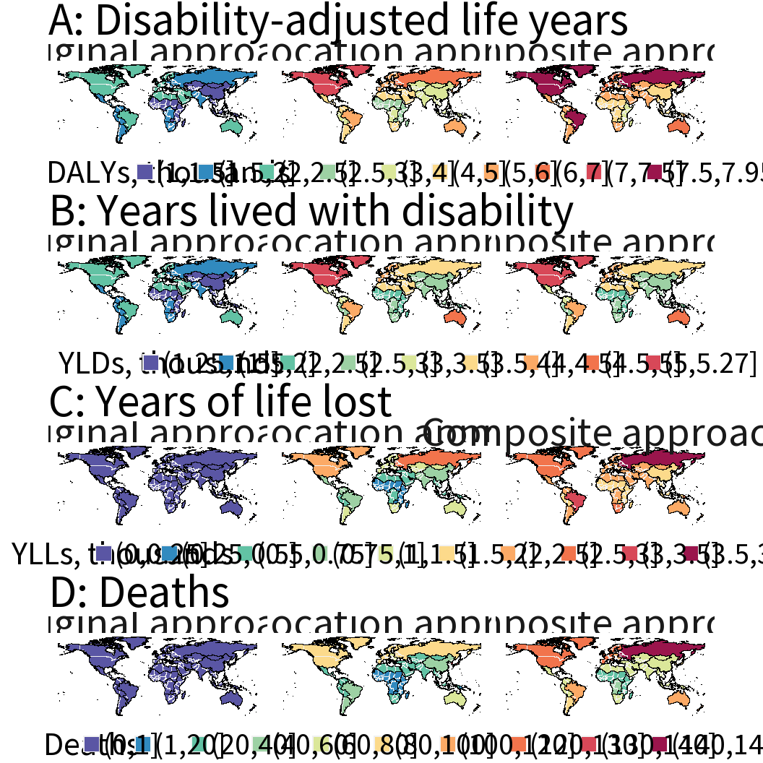

DALYs, YLDs, YLLs, and deaths attributable to mental disorders in 2019, by estimation approach, per 100,000 population. Values are aggregated by GBD region. DALYs: Disability-adjusted life years. YLDs: years lived with disability. YLLs: years of life lost. GBD: Global Burden of Disease.

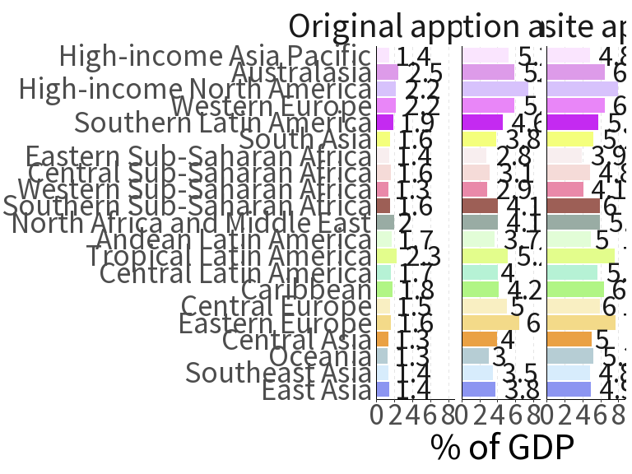

Economic burden of mental disorders, as a percent of GDP. The economic value is determined by using GDP per capita (USD 2019) as the value of a DALY. Values are aggregated by GBD region. GDP: gross domestic product. USD: United States dollars. DALY: disability-adjusted life year. GBD: Global Burden of Disease.

Although economic losses do not represent an actual loss to GDP, a sense of the scale can be gained by expressing the economic consequences with respect to GDP. Figure displays the economic burden of disease due to mental disorders under the three estimation approaches by GBD region, as a percent of regional GDP. (Estimates by absolute values per DALY are provided in Appendix 1, along with mapped data visualizing estimates across all values per DALY.) Across approaches, the greatest change in estimated burden occurs in Eastern Europe, Latin America, North America, and Southern sub-Saharan Africa. Under the relative GDP-per-capita values the economic burden would account for between 3.9% of gross domestic product in Eastern Sub-Saharan Africa and 7.9% in High-income North America under our composite approach.

## 1.4 Discussion

This study explores possible alternative approaches to estimating the global burden of mental illness and the economic losses thereof. In particular, we propose a composite approach to address contention in the classification of mental disorders. This approach suggests that the global DALYs attributable to mental disorders could exceed 418 million per year, or 16% of the total burden.

When applied against an economic value per DALY of one times GDP per capita, this approach further suggests that the per year losses associated with this burden could exceed 4.7 trillion USD in 2019. When adjusting for the uncertainty in estimates of the attributable burden of disease, the losses could range from 3.1 trillion to more than 6.9 trillion USD. Adjusting for purchasing power parity would increase the magnitude of these estimates, with ranges from 4.8 to 10.6 trillion international dollars at the global scale.

Put in context of the existing literature, our epidemiological and economic estimates provide two important contributions. First, our findings echo in magnitude those of Vigo and colleagues,30 which have highlighted that suicide and premature mortality due to mental disorders are potentially large sources of underestimation in the current GBD classification. Second, when including these sources of attributable mortality, the economic findings suggest staggering losses. We estimate that in 2019, the losses would already be over 1.8 trillion USD greater than Bloom and colleagues’ global losses projections for 2030 (2.9 trillion 2019 USD, using the same value per DALY approach).29

Our findings add to a growing literature concerning the classification of mental disorders, in particular related to underscoring the importance of including premature mortality attributable to mental disorders in burden conceptualizations.30,38,51,52 These calls have most recently been emphasized by GBD collaborators who have urged that “the differential mortality gap for individuals with mental disorders needs to be reflected within the GBD framework.”36 Our composite approach to assigning attributable mortality presents one potential attempt for acknowledging this differential mortality gap. Our economic analysis further provides updated monetary estimates of the burden of mental illness; to our knowledge, this is the first such analysis of the global economic burden of mental disorders in over a decade.

Our results should, however, be interpreted with several limitations in mind. First, our estimation approaches themselves all draw upon modeled data (i.e., GBD estimates). While GBD generates descriptions of morbidity and mortality at fine demographic and geographic levels, it is important to emphasize that the sophisticated modeling approaches implemented often draw on (potentially little) available underlying empirical data.53 These inputs can be extremely limited for particular diseases and geographical locations, especially so for mental disorders. By way of example, the GBD 2019 Data Input Sources Tool retrieves 3,084 separate data sources for mental disorders. Of these, only 60 pertain to sub-Saharan Africa (1.9%) and 58 to South Asia (1.8%).54 By comparison, of the 6,064 records pertaining to maternal and neonatal disorders, 631 are for sub-Saharan Africa (10.4%) and 270 for South Asia (4.5%). These severely limited inputs reflect a dearth of global mental health data; as of 2017, the World Mental Health survey initiative had conducted interviews in just 26 countries, only 13 of which were classified as low- or middle-income.24

Relatedly, our composite approach relies on pooled estimates of the relative risk of mortality from a systematic review and meta-analysis that itself is limited by the available data it draws upon.5 The review identified 203 studies for inclusion, of which only two were located in Africa, 16 in Asia, and one in South America. While the authors found that the estimates of mortality risk did not vary by region, the limited representation of studies from the world’s most populous and epidemiologically diverse continents is a considerable shortcoming. It is possible, for instance, that the relative risk of all-cause mortality associated with mental disorders is lower where the burden of mortality is more heavily concentrated among child, maternal, and infectious diseases, and is higher where the burden is dominated by NCDs. Therefore, to reach a conservative estimate of attributable mortality, we separately estimated PAFs for natural and unnatural causes of death and restricted our allocation of YLLs from natural causes to NCDs—meaning no deaths from maternal or infectious diseases were attributed to mental disorders under the composite approach.

Furthermore, our composite approach allocates mortality due to mental disorders by calculating PAFs using the conventional formula, which may be biased in the presence of confounding or effect heterogeneity.55 In particular, the use of adjusted risk ratios (as in the current analysis) may result in anticonservative bias if the crude risk ratios are lower than the adjusted ones. To mitigate the potential for bias, our sensitivity analysis presents results under conservative assumptions for risk ratios and estimates of prevalence and mortality.

Despite these limitations, our findings underscore both that the true burden of mental disorders may only partially be captured by current estimation approaches, and that, consequently, the associated economic losses may be much higher than previously estimated. We note that our findings may themselves be an underestimate, as our composite approach excludes deaths due to neonatal, maternal, and infectious diseases attributable to mental disorders. However, we observe that conventional estimation approaches may fail to capture large shares of premature mortality attributable to mental health causes, both from self-inflicted and unnatural causes of death and mortality from NCDs. Capturing this share of the burden emphasizes that mental health is a critical risk factor for premature mortality, as well as a direct source of morbidity.

The magnitude of economic costs associated with mental disorders raises the need for health economics research, particularly on returns on investment and costing for effective prevention and treatment strategies.56 Further work is also needed to strengthen the measurement of the global burden of mental illness, not only for more fully capturing the morbidity and mortality of mental disorders, but also for incorporating the impacts of new and evolving threats—such as pandemics, conflicts and climate change—to population mental health.

Our study highlights that mental health—far from being an issue solely concentrated in high-income regions alone— is a major global issue, one that imposes a significant toll to health and welfare. The large magnitude of these twin burdens highlights the urgency for global action to support mental health financing and to bolster its prioritization.

## 1.5 Acknowledgements

We thank David Bloom, Goodarz Danaei, and Daniel Vicente Vigo for their feedback on an earlier version of the paper, as well as five anonymous reviewers for their valuable and constructive comments on our manuscript.

### 1.5.1 Author contributions

All authors contributed to study conception, methodology, and interpretation. DA oversaw data acquisition, programming, formal analysis, visualization, and the first draft of the manuscript. All authors contributed to critical revision of the manuscript, with responses to reviewers and subsequent revisions led by DA.

### 1.5.2 Funding statement

This study received no funding.

### 1.5.3 Declaration of interests

We declare no competing interests.

### 1.5.4 Data sharing statement

GBD estimates are available for download from the Global Health Data Exchange and are available freely for non-commercial users under the Open Data Commons Attribution License (<https://ghdx.healthdata.org/gbd-2019>). All codes used for the analysis in this article are available on GitHub (<https://github.com/darias5/gmh_econ>).

# 2 Climate exposures and population mental health in Madagascar: an ecological study of national health information system data

## 2.1 Introduction

As empirical evidence increasingly highlights the wide-scale impact of human activities on climate, there is a growing, parallel body of evidence documenting the impacts our changing climate has on human health.57 Rising temperatures and extreme weather events (including floods, hurricanes, droughts, and fires) have been associated with worsened health outcomes in multiple settings.58,59 In particular, these and other climate change-related exposures (CCEs) have been increasingly linked to worsened mental health61, with systematic reviews suggesting, among other climate condition impacts, positive associations between high ambient temperatures and mental disorders,62 drought conditions and suicide,63 and cyclones and negative mental health outcomes.64

Despite the weight of this evidence, few quantitative studies evaluating the effects of climate on population mental health have, to date, taken place in low- and middle-income countries (LMICs),65 populations that—despite contributing the least to human-driven climate change—are among the most likely to be vulnerable to its impacts.66

Among low-income countries most vulnerable to the health consequences of climate change is Madagascar, a nation that generates one percent *of* one percent of global carbon dioxide emissions. Worsening CCEs in Madagascar (primarily in the form of droughts, floods, and cyclones) are likely to exacerbate endemic, climate-sensitive threats to health, including malnutrition and malaria.67 In particular, persistent drought conditions in recent years have led to extensive food insecurity.68 Though there is debate concerning the extent to which human activity is directly responsible for Madagascar’s current drought,69,70 the extremity of the situation has led some observers to classify conditions in Madagascar as the first climate change famine in history.71

Understanding how both incremental and extreme changes in climate impact population mental health is critical to gauging the full extent to which CCEs impact human health and well-being under a multidisciplinary approach to population health.72 This understanding is particularly important in contexts such as Madagascar, where climate conditions are already demonstrating pronounced pressures on economic, social, and physical well-being.

In investigating the impact of climate exposures on mental health, health system data can serve as a useful tool in settings where epidemiological survey data is sparse. Despite the poor availability of mental health services in many settings, routine health system data can still provide valuable insights into trends and patterns of service use and the need and distribution of care for mental health issues. Although these data may only capture a share of the true burden of disease, reported visits related to mental health complaints can be a valuable starting point for preliminary research into the impact of climate change on population mental health in resource-constrained settings.

In this ecological study, we investigated the association of climate conditions and population mental health in Madagascar between 2010 and 2020 using routine health system data from Madagascar’s Ministry of Public Health. The use of health system data enabled us to indirectly evaluate the extent to which existing public health data may already be showing signals of CCEs, which may aid efforts to prevent and mitigate mental health stressors and better design systemic responses to mental health needs.

As a measure of population mental health, we considered facility-level monthly reported visits related to mental disorders; in terms of exposure, we explored the predictive association of three CCEs with incident mental health visits: mean monthly ambient air temperature, mean monthly soil moisture, and monthly cyclone activity. As exposure to these stressors could involve a delay in onset of mental health symptoms and subsequent care seeking, we further explored whether exposures in prior months were associated with monthly reported visits in subsequent ones. We further considered interactive and additive models to account for complexity in the interaction of climate variables in Madagascar, as well as ecological variation to capture differences in regional climate systems.

## 2.2 Methods

### 2.2.1 Data

To analyze the impact of climate on population mental health in Madagascar, we first obtained health management information system (HMIS) data through a collaboration with the Madagascar Ministère de la Santé Publique. We then obtained gridded temperature and soil moisture data from the European ReAnalysis 5 (ERA5)73 and the European Space Agency’s Climate Change Initiative (ESA CCI),74 respectively. Data on tropical storms and cyclones were obtained from open-source compilations of storms in the South-West Indian Ocean75, which were in turn cross-referenced against storm trajectory data from the United States National Oceanic and Atmospheric Administration (NOAA)76 for accuracy.

#### 2.2.1.1 Outcomes

Madagascar’s health information system provided facility-level data on counts of disease incidence summarized and reported monthly. Prior to 2019, this system was the Gestion du Système d’Information Sanitaire (GESIS); in early 2019, the system transitioned to using District Health Information Software 2 (DHIS2).77

Among facilities reporting any mental health data between 2010 and 2020, data were obtained from 3,204 public and private primary health centers, known as Centres Santé de Base or CSBs, and Formations Sanitaires Privées de Base or FSBs, respectively, 164 district referral hospitals (CHDs), 45 regional referral hospitals (CHRRs) and university hospitals (CHUs), for a total of 3,413 uniquely-identified facilities in our sample.

Exploratory data analysis indicated that the classification and reporting of counts of mental disorders in GESIS varied across types of facilities in their level of detail. Among CHD facilities, incidence of mental disorders was aggregated with neurological disorders (coded as “neuro psychiatric disorders”), while CHRR and CHU facilities reported more detailed counts of specific mental disorders, such as depression, personality disorders, and schizophrenia. Across all facilities, disaggregated data were reported by age group but not by sex. Among CSB facilities, incidences of mental disorders were reported by age group under “mental illnesses and psychic disorders” until June 2015, when reporting was reclassified to “mental disorders”; disaggregated data were reported by both age and sex. A summary of classification by facility type and year is provided in Appendix 2.1, Table S2.1, with English translations of the French disease names provided in Table S2.2. and yearly cumulative reported visit totals by disorder reported by facility level and year in Tables S2.3-5.

To address heterogeneity in reporting, our analysis aggregated any monthly visits concerning mental or neurological disorders reported by a facility into a summary outcome measure, irrespective of age and sex. To address outliers, monthly observations of the outcome were arranged separately for each facility into a unique time series. The nonparametric Friedman’s super smoother regression estimator78 was applied to each time series to identify outlier observations and replace them through linear interpolation.79 By considering outliers on a facility-by-facility basis, the data cleaning approach preserved extreme values that may reflect true variances in incidence (for example, incidences reported by a large, regional reference hospital) while addressing potential errors in data entry. (Additional detail on the data cleaning process is available in Appendix 2.1)

#### 2.2.1.2 Geospatial data

To retrieve spatial climate data for the facilities in our sample, it was first necessary to geocode facilities to obtain their latitude and longitude. Facility data from GESIS included limited information on the location of facilities. While exact facility coordinates were not available, information on the relevant administrative unit served by a facility was included in the data (e.g., regions for CHRRs, districts for CHDs, and communes for CSBs). These data informed a stepwise matching process to locate facilities in our sample.

First, region, district, and commune names in our sample were standardized against reference shapefiles to address variations in translation, abbreviation, transposition, accent marks, spacing, hyphenation, and spelling. (A summary of the standardized names is provided in Appendix 2.2.) Next, facility names, types, and associated administrative units were used to match facilities to a validated spatial inventory of health facilities in Sub-Saharan Africa,80 of which 2,625 coordinates were provided for public facilities in Madagascar. In order to systematically match facilities in our sample to facilities in the spatial inventory, we implemented approximate string matching, which allowed for facility names and administrative units to be matched approximately, rather than exactly, to corresponding patterns in the validated spatial inventory. Applying this matching technique, 1,768 facilities (52%) in our sample were matched to validated coordinates.

Among the remaining facilities, an additional 827 primary facilities were matched to coordinates from a spatial inventory of 3,171 coordinates obtained from the Routine Health Information Network (RHINO),81 which supports an open source database of health facility data in conjunction with the United States Agency for International Development (USAID), the government of Madagascar, and other stakeholders.

To geolocate the remaining facilities, our existing inventories were combined with additional spatial inventories of health facility coordinates gathered from local consultants, the Global Healthsites Mapping Project, and other sources to create a database of 13,358 uniquely identified coordinates for potential matches. Using this database, an additional 448 facilities in our sample were geolocated using manual and approximate string matching.

An additional 255 facilities were matched to the centroid of their relevant administrative unit in cases where the unit was less than or equal to 225 square kilometers (km), as these administrative units are quite small relative to the spatial resolution of gridded climate data (approximately 900 km²). Among the remaining facilities, geolocations were manually identified for 115 facilities using targeted searches, resulting in 3,413 of the 3,413 facilities (100%) in the sample being geolocated.

To gauge the accuracy of the geolocating process, a subset of 1% of geolocated facilities was selected for validation against manually identified coordinates. Comparing the geolocated coordinates to validated coordinates for each facility, the mean distance between coordinates in the validation sample was 1.36 km, with a maximum distance of approximately 9.5 km, indicating high accuracy in the geolocated process relative to the spatial resolution of climate data. Additional detail on the geolocating and validation process is available in Appendix 2.2.

#### 2.2.1.3 Climate data

Facility geolocations were then used to retrieve spatially referenced monthly averages of temperature and soil moisture data from ERA5 and ESA CCI, respectively. To allow for modelling of lagged associations, data were obtained for both ERA5 and ESA CCI soil moisture dataset (ESA CCI SM) from January 2008 to July 2020.

ERA5 is a global atmospheric reanalysis from the European Centre for Medium-Range Weather Forecasts (ECMWF) and is freely available through its Copernicus Climate Change Service (C3S)74. The spatial resolution of ERA5 is approximately 30 km, with quality-assured hourly estimates available from 1959 to the present.74 Using Google Earth Engine, a time series of monthly aggregate values for mean air temperature in degrees Kelvin at a height of 2 meters was obtained for each facility geolocation.82 Temperature data was then converted to degrees Celsius.

We obtained soil moisture data from ESA CCI SM, the world’s first and most comprehensive, multi-decade, satellite-observed dataset of global soil moisture. The spatial resolution of ESA CCI SM is approximately 26 km, with daily estimates available from 1978 to 2021. Using ESA CCI SM active and passive radiometer data, a time series of monthly aggregate values for mean soil moisture—measured as saturation percentage—was constructed from daily observations at each land grid point within Madagascar. We then applied nearest neighbor matching to link these time series to our geolocated facilities.

For a location to have soil moisture data available in ESA CCI SM, it must fall within one of 244,243 land grid points. For some facilities on Madagascar’s coastline, their location placed them outside of ESA CCI’s spatial coverage, resulting in missing values. To address facilities without any soil moisture data, nearest neighbor searching was conducted to identify the nearest land grid point for which ESA CCI SM data would be available; this nearest neighbor’s soil moisture time series data would then be applied to the facility with missing data. Within a time series of ESA CCI data for a given location, however, monthly data could still be missing if adequate satellite observation was not recorded anytime during a given month; for these values, we used linear interpolation to address missing data within a time series.

In addition, we obtained data on tropical storms and cyclones in the South-West Indian Ocean for the 2009-2010 to 2020-2021 seasons, inclusive. Open source data on tropical cyclones in the south-west Indian Ocean was obtained by scraping information from Wikipedia summaries of each cyclone season, which were originally sourced from alerts issued by Météo-France La Réunion (MFR La Réunion), the World Meteorological Organization (WMO)-designated Regional Specialized Meteorological Center (RSMC) for the provision of forecasts and warnings of tropical cyclones in the South-West Indian Ocean. To ensure that the compiled data accurately reflected storms in Madagascar during the study period, we cross-referenced these data against storm trajectory data for the South Indian Basin from NOAA.76

With these data, we generated two indicators to measure exposure to storm activity in a given month: a binary indicator for whether a storm impacted Madagascar in that month and a count indicator for the number of days per month with a storm. To capture lingering post-dissipation effects, we defined impact as the storm’s duration plus an additional 14 days.

### 2.2.2 Statistical analysis

All analyses were completed using R (version 4.2.1).50 Marginal effects were calculated using the ‘margins’ package (version 0.3.26)83 for R.

#### 2.2.2.1 Modeling approach

Exploratory data analysis highlighted that the variance of monthly facility-level counts of incident mental disorders highly exceeded the mean; consequently, our statistical analysis utilized negative binomial (NB) regression, which is recommended in the case of over-dispersed count data.

Our primary analysis involved conducting four models to estimate the association between facility-level counts of incident mental disorders and climate conditions. Model 1 used temperature as the principal predictor of counts of incident mental disorders. Model 2 only used soil moisture as a predictor. Model 3 used both temperature and soil moisture independently as predictors, while Model 4—our preferred model—introduced an interaction term between the two.

Duration of cyclone activity was included in all models using our count indicator of exposure. In all models, we included fixed effects for Madagascar’s twenty-two regions to account for geographic differences in climate patterns and case/visit reporting. We further included month and year fixed effects to account for seasonality and time-varying omitted variables.

In addition, to aid in the interpretation of results, our analysis further reported the average marginal effect of each model predictor. Marginal effects clarify the effect of a per-unit change in a continuous explanatory variable (e.g., temperature) on an outcome where the regression model involves interaction. (In models without interaction or higher-order terms, the slope coefficient from the model will equal the marginal effect.) In addition to estimating the average marginal effects of our temperature, soil moisture, and cyclone variables, we further calculated the marginal effect and predicted values of the outcome for each unit of climate exposure across the three variables of interest.

Though CCEs could acutely impact mental health in our sample, we could anticipate that these impacts might not immediately result in changes to monthly case and visit counts, owing to delays in symptom onset, care seeking, and care delivery. To test for lagged associations—that is, whether in a given month, climate conditions in prior months were associated with counts of mental disorders—versions of Model 4 were conducted using lagged predictors. Measures of association were estimated for each monthly lag increment between 1 month and 18 months, inclusive.

Owing to the large number of observations in our sample, significance was evaluated against an alpha of 0.01, with 99% confidence intervals reported. Coefficients and confidence intervals for our indicators of climate exposure were exponentiated to generated incidence rate ratios (IRRs). Confidence intervals (CIs) were constructed using heteroskedasticity-robust standard errors.

#### 2.2.2.2 Subgroup analysis

Madagascar is home to a diverse range of terrestrial ecoregions, each of which has unique physical, climatic, and ecological characteristics. These variations in the environment include distinct patterns of rainfall, temperature, and cyclone activity, potentially resulting in effect heterogeneity when examining how these exposures impact human health across different ecoregions.

To explore potential heterogeneity of our effect estimates, we evaluated Models 1 through 4 among facilities in each of Madagascar’s four predominant ecoregions: the lowland, humid forests of the east, the subhumid forests of the Central High Plateau, the desert and xeric shrublands of the south, and the northeastern dry deciduous forests. (Ecoregions are presented in Figure .)

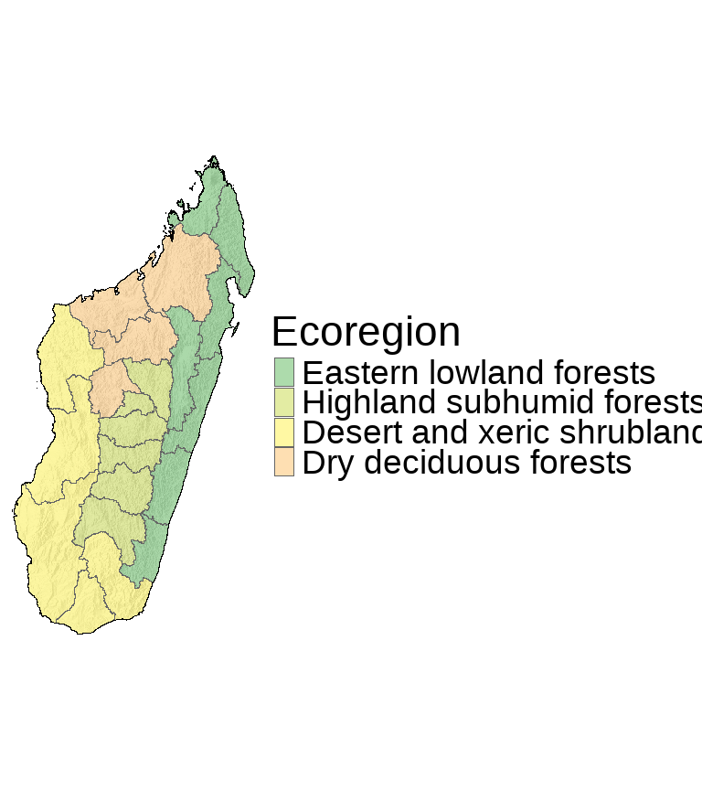

#### 2.2.2.3 Sensitivity analysis

In order to evaluate the robustness of our main results to alternative specifications, data processing, and modeling decisions, we generated 192 plausible model combinations to conduct a multiverse analysis to identify how sensitive effect estimates and confidence intervals were to different methodological choices.

To generate the model combinations, we first detailed seven methodological choices and their potential specifications. These criteria are outlined in Table 2.1.

First, we considered the role of data cleaning of the outcome data and chose to compare our analysis using the cleaned outcome data against the raw unadjusted values. Second, we chose to compare our findings using data from all facilities (the full sample) against a sample without district and regional hospitals (CSB/FSP facilities only). Primary care facilities have smaller catchment areas than hospitals; consequently, it is more likely that climate data for primary care facilities will closely reflect patients’ climate exposure compared to referral hospitals. Third, we considered the decision to model temperature and soil moisture as an additive or interactive relationship (Model 3 vs. Model 4), with both alternatives included in our multiverse analysis. Fourth, we evaluated our decision to account for overdispersion with a NB model by using a Poisson regression framework as an alternative. Fifth, we evaluated alternative specifications of exposure to cyclone activity, using three options: our binary indicator, our count indicator, and no term for cyclone activity included. Sixth, we varied whether time fixed effects (month and year) were included. Seventh, we similarly included and excluded regional fixed effects for comparison.

We then interacted the methodological choices to generate 192 plausible model specifications. Using the effect estimates and confidence intervals for these models, we constructed specification curves for monthly temperature, soil moisture, and—for the 64 models that included the cyclone count indicator— cyclone activity to visually compare the distribution of plausible estimates for different combinations.

#### 2.2.2.4 Ethics statement

The IRB of the Harvard T.H. Chan School of Public Health determined that this study was not human subjects research and that additional review was not required (protocol number: IRB21-1303, determined on October 19, 2021).

## 2.3 Results

Our geolocated sample of facilities—which is displayed in Figure —showed geographic diversity and comprehensive coverage across Madagascar, with most geolocations identified through validated sources.

Figure shows the spatial distribution of temperature and soil moisture across the facilities in our sample during January and June 2015, corresponding to the warmer, wet season and the drier, cool season, respectively. When evaluated over time, annual climate trends in Madagascar showed a relatively stable distribution of average temperatures, while soil moisture had a slight upward shift through 2020 (Figure ). Data of tropical storm and cyclone activity throughout the study period also exhibited seasonal patterns, with most major storms occurring in the hot season, with a peak between February and May (Figure ).

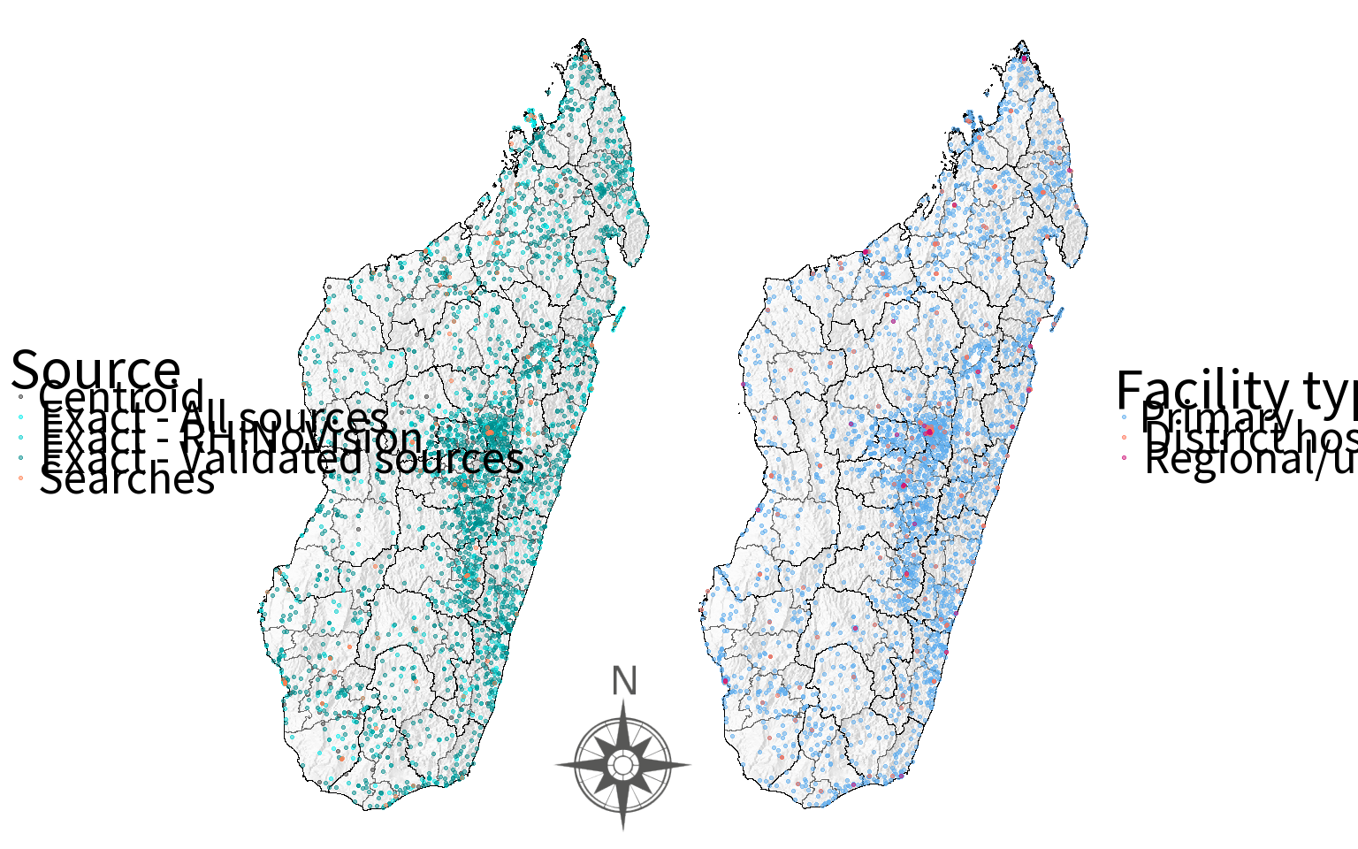

Map of facilities in Madagascar, by coordinate source (left panel) and facility type (right panel).

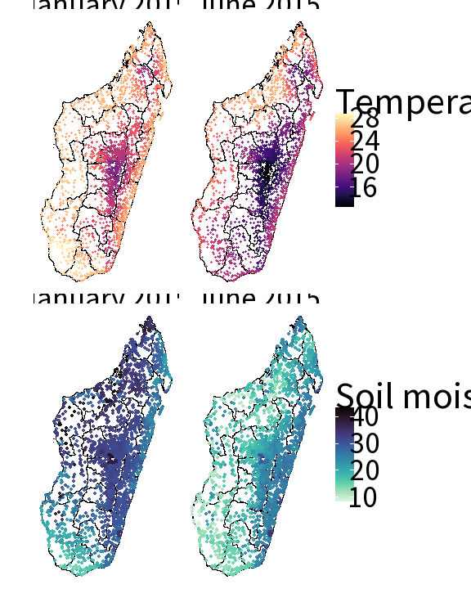

Spatial distribution of climate conditions across clinics and seasons in Madagascar. Mean monthly temperature (top) is measured in degrees Celcius and mean soil moisture is measured in percent saturation (below).

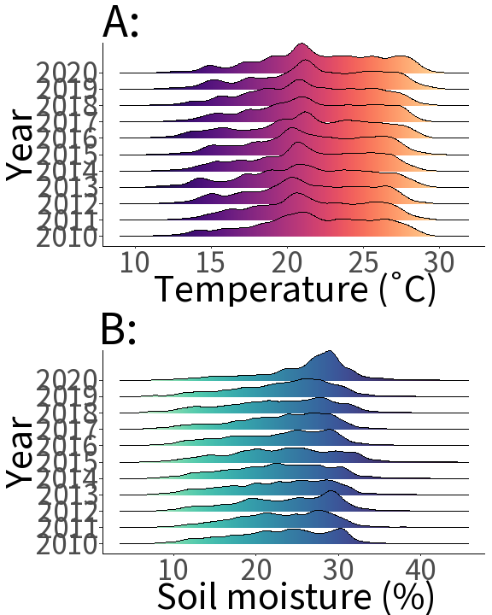

Distribution of A) temperature and B) soil moisture across all month-years and all clinics.

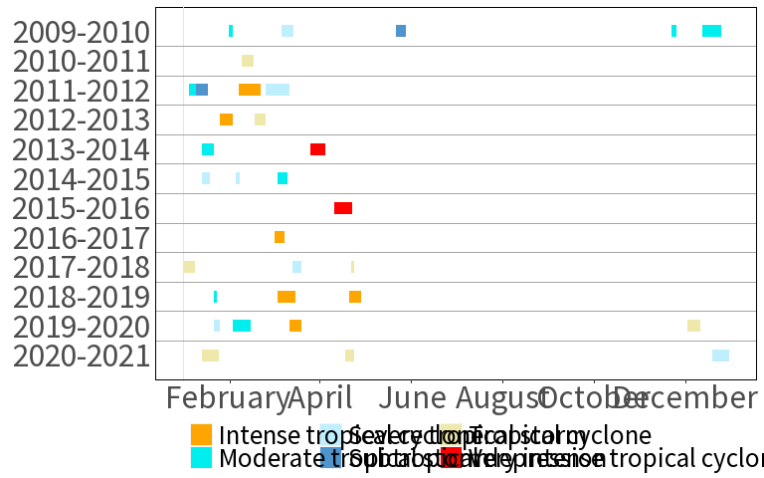

Tropical storms and cyclones in Madagascar by intensity and season, 2009-2010 to 2020-2021, inclusive.

{1.5}

### 2.3.1 Main analysis

The regression models predicting monthly counts of any mental or neurological disorder (Table 2.2) showed significant associations with temperature across all models. A one-degree Celsius increase in temperature was associated with approximately 4.6% fewer visits reported (IRR: 0.954, p < 0.0001, 99% CI: 0.934 – 0.973) by primary clinics and hospitals in Model 1. Inclusion of both climate predictors resulted in little change to the measure of association for temperature. In an additive model with soil moisture included (Model 3), the effect estimate associated with temperature grew to 5.6% fewer visits reported (IRR: 0.944, p < 0.0001, 99% CI: 0.923 – 0.965). Adopting an interactive model (Model 4) attenuated the association (IRR: 0.958, p = 0.038, 99% CI: 0.909 – 1.010), but remained significant at a 95% level of confidence. Across all models with temperature, the average marginal effect associated with temperature (across a sample with all clinics) ranged between 2 and 3 fewer monthly mental health visits reported and was statistically significant at an alpha of 0.01, with the average marginal effect in Model 4 being -2.848 visits (p < 0.001, 99% CI: -3.976 – -1.719).

Effect estimates associated with soil moisture were not statistically significant across all four models. In all models, we observed a modest reduction in visits reported per each additional day duration of cyclone activity, with the incidence ratio ratios of Models 3 (IRR: 0.994, p = 0.047, 99% CI: 0.986 – 1.002) and Models 4 (IRR: 0.994, p = 0.047, 99% CI: 0.986 – 1.002) being significant at a level of 0.05. In all models, however, the average marginal effect was close to 0, with the average marginal effect in Model 4 being only -0.300 visits (p = 0.009, 99% CI: -0.595 – -0.006).

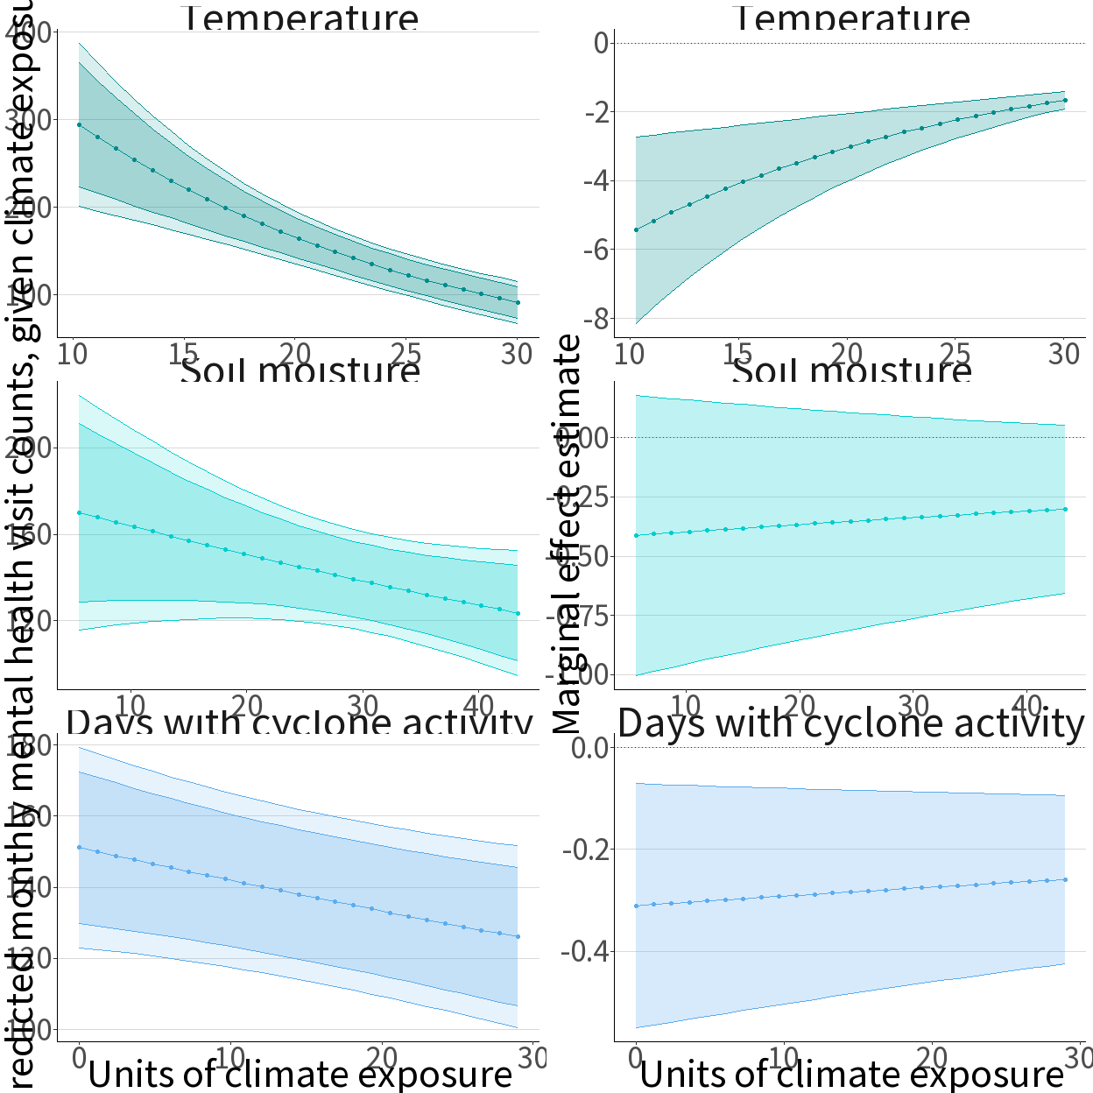

Predicted values of monthly mental health visits and marginal effect estimates by coefficient and their 95% and 99% confidence intervals. The left panels show predicted values of monthly counts of visits related to mental and neurological disorders in Madagascar, given different units of climate exposure. The right panels show marginal effect estimates over different units of climate exposure in the data. The dotted horizontal lines in the right panel depict no marginal effect on visit counts. In all panels, the model used to generate predictions and marginal effects corresponds to Model 4. Units of climate exposure are degrees Celsius for temperature (top), saturation percentage for soil moisture (middle), and days with cyclone activity (bottom).

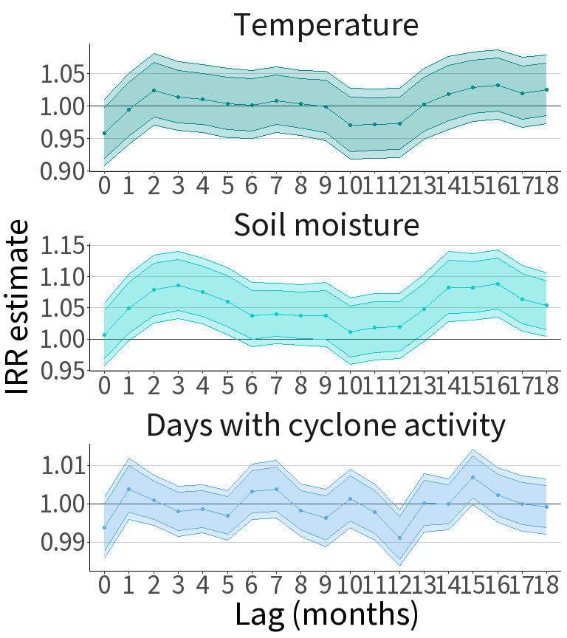 Predicted values of monthly mental health related visits counts under Model 4 echoed the effect estimates from Table 2, with fewer visits reported in warmer months (Figure ). Marginal effect estimates across the distribution of temperatures in our data showed that the greatest level of reduction occurred between 10 and 15 degrees Celsius, with each degree increase associated with 4 to 5 fewer visits related to mental or neurological disorders reported, controlling for other covariates. Months with greater levels of soil moisture and days with cyclone activity also showed fewer reported visits; however, the marginal effects associated with soil moisture were not significant across any unit of exposure, while those associated with days with cyclone activity were close to zero for all lengths of activity.

Examining lagged effects showed potential temporal associations between soil moisture levels in preceding months and visit counts in those following (Figure ), with higher saturation leading to a statistically significant elevation in visits reported 1 to 5 months later. At a lag of 3 months, the elevation in visits was approximately 8.5% (IRR: 1.085, p < 0.0001, 99% CI: 1.046 – 1.127). There appeared to be a significant elevation of similar magnitude 13 to 17 months prior, suggesting potential annularity in lagged association. Effects for temperature were not significant across any lag; cyclone activity similarly showed no significance in lags under a year, but did show modest, statistically significant associations at lags of 12 months (IRR: 0.991, p = 0.002, 99% CI: 0.986 – 0.997) and 15 months (IRR: 1.007, p = 0.011, 99% CI: 1.002 – 1.012). A slight increase in visits was associated with cyclone activity in a prior month, but this increase was not statistically significant (IRR: 1.004, p = 0.206, 99% CI: 0.998 – 1.010).

### 2.3.2 Subgroup analysis

Results from our subgroup analysis showed evidence of potential effect heterogeneity by ecoregion (Table 2.3). For temperature, estimates of association were only statistically significant in the highland subhumid forests, where each one-degree Celsius increase in temperature was associated with 25.2% fewer visits reported (IRR: 0.748, p < 0.0001, 99% CI: 0.632 – 0.885). Temperature was associated with a slight increase in visits in the eastern lowland forests (IRR: 1.016, p = 0.785, 99% CI: 0.875 – 1.180) and the desert and xeric shrublands (IRR: 1.016, p = 0.785, 99% CI: 0.875 – 1.180), but in neither case was the estimate significant at a level of 0.05.

With respect to soil moisture, while our primary analysis found no evidence of a statistically significant association with reported visits in the full sample, we found evidence of heterogeneity in our subgroup analysis. Among facilities in the highland subhumid forests, we found that each percentage point increase in soil moisture was associated with 14.1% fewer reported visits (IRR: 0.859, p = 0.003, 99% CI: 0.754 – 0.979), with an average marginal effect of -7.178 reported visits (p < 0.001, 99% CI: -9.527 – -4.830). Conversely, each percentage point increase in soil moisture in the dry deciduous forests was associated with a 21.6% increase in reported visits (IRR: 1.216, p < 0.0001, 99% CI: 1.077 – 1.373), with an average marginal effect of 3.490 reported visits (p < 0.001, 99% CI: 2.350 – 4.631).

Finally, our estimates of the incidence rate ratio associated with each additional day of cyclone duration in a given month were consistent between each ecoregion and our full sample. Among facilities in the dry deciduous forests, each additional day of cyclone activity was associated with the greatest reduction in reported visits (IRR: 0.986, p = 0.016, 99% CI: 0.971 – 1.001).

### 2.3.3 Multiverse analysis

In our multiverse analysis, 157 of 192 models (82%) returned effect estimates for temperature associating a one-degree increase with fewer reported visits related to mental or neurological disorders, with 115 (60%) of those estimates having p-values below 0.01 (Figure ). Only 6 (3%) models returned statistically significant IRR estimates greater than 1; all six models were negative binomial interactive models that excluded month and year fixed effects and were run on data that restricted to the CSB/FSP sample only.

With respect to soil moisture, only 65 of 192 models (34%) returned effect estimates with p-values below 0.01, with 40 of such models reporting IRRs greater than 1 and 25 models reporting IRRs smaller than 1 (Figure ). The overwhelming majority of models showed no significant association between soil moisture and monthly visit counts, in either direction. Of models showing statistically significant IRRs of a magnitude greater than 1, all excluded both region and time fixed effects.

Among the 64 models that included cyclone activity measured in days per month, 58 models (91%) reported reduced visit counts associated with cyclone duration, compared to 6 models (9%) showing IRRs below 1 (Figure ). None of the 64 models, however, had a p-value below 0.01.

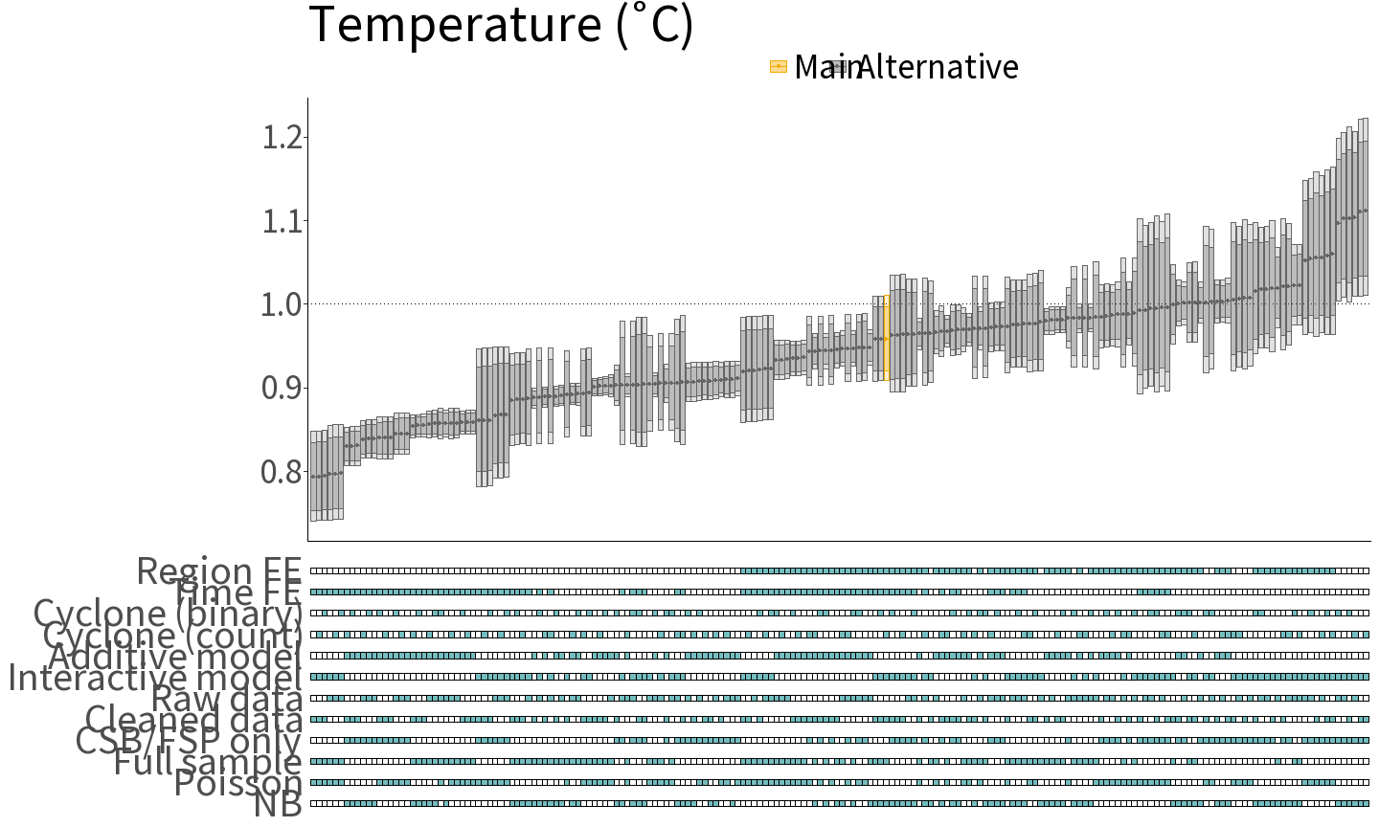

Specification curve depicting the effect estimates and confidence intervals for mean monthly temperature (degrees Celsius) across 192 models. In the top panel, estimated incidence rate ratios (IRRs) across different models are depicted as circles; the darkly and lightly shaded regions above and below these circles correspond to 95% and 99% confidence intervals of these estimates, respectively. The dotted horizontal line depicts a null effect. The IRR estimate and confidence intervals of the preferred model, Model 4, are highlighted in orange. Below each model, a legend of shaded and unshaded boxes indicates which modeling decisions correspond to a given model, with boxes shaded teal showing active features. FE: fixed effects. CSB/FSP: Centres Santé de Base and Formations Sanitaires Privées de Base. NB: negative binomial model.

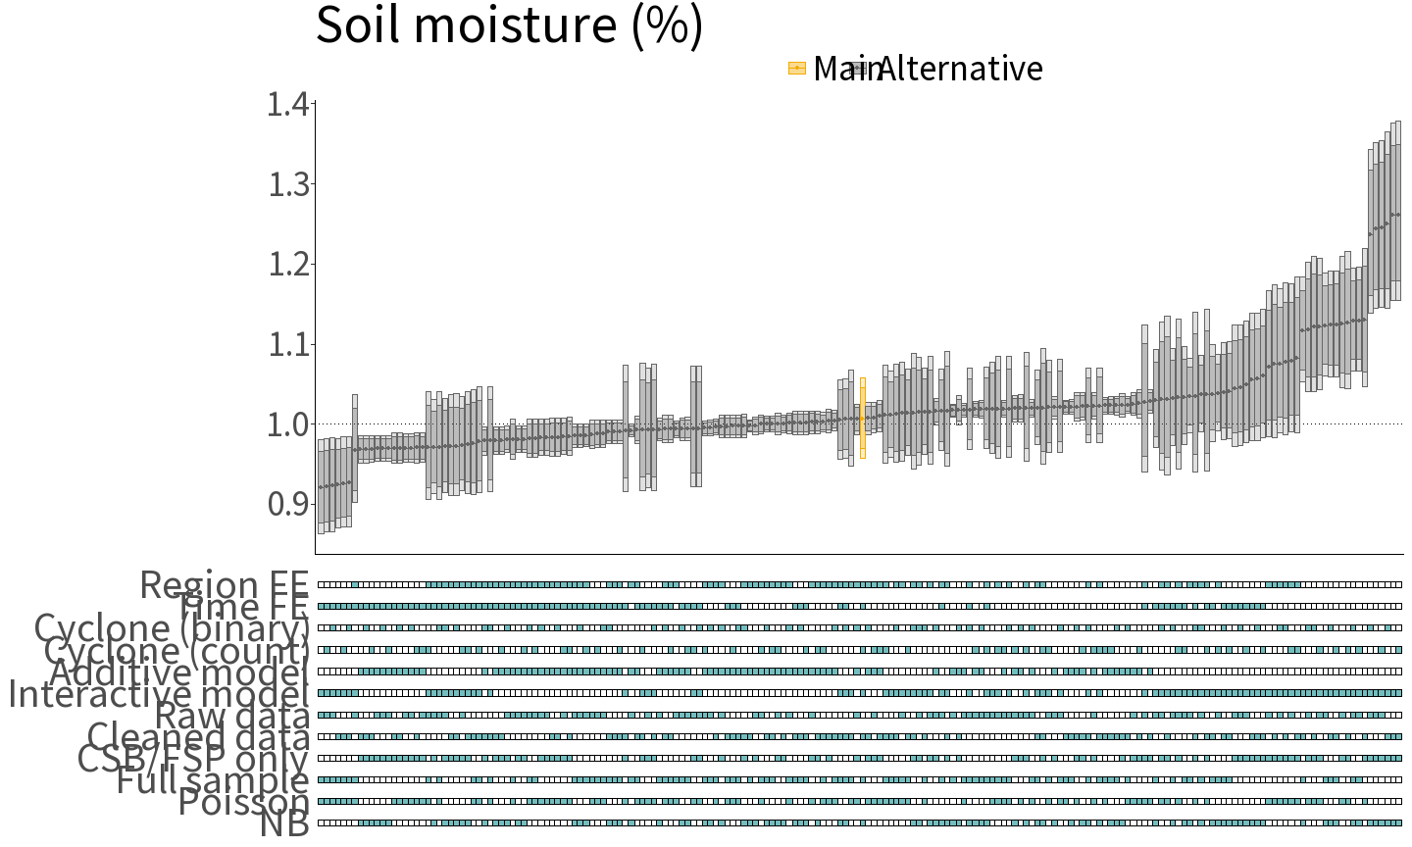

Specification curve depicting the effect estimates and confidence intervals for mean monthly soil moisture (percent saturation) across 192 models. In the top panel, estimated incidence rate ratios (IRRs) across different models are depicted as circles; the darkly and lightly shaded regions above and below these circles correspond to 95% and 99% confidence intervals of these estimates, respectively. The dotted horizontal line depicts a null effect. The IRR estimate and confidence intervals of the preferred model, Model 4, are highlighted in orange. Below each model, a legend of shaded and unshaded boxes indicates which modeling decisions correspond to a given model, with boxes shaded teal showing active features. FE: fixed effects. CSB/FSP: Centres Santé de Base and Formations Sanitaires Privées de Base. NB: negative binomial model.

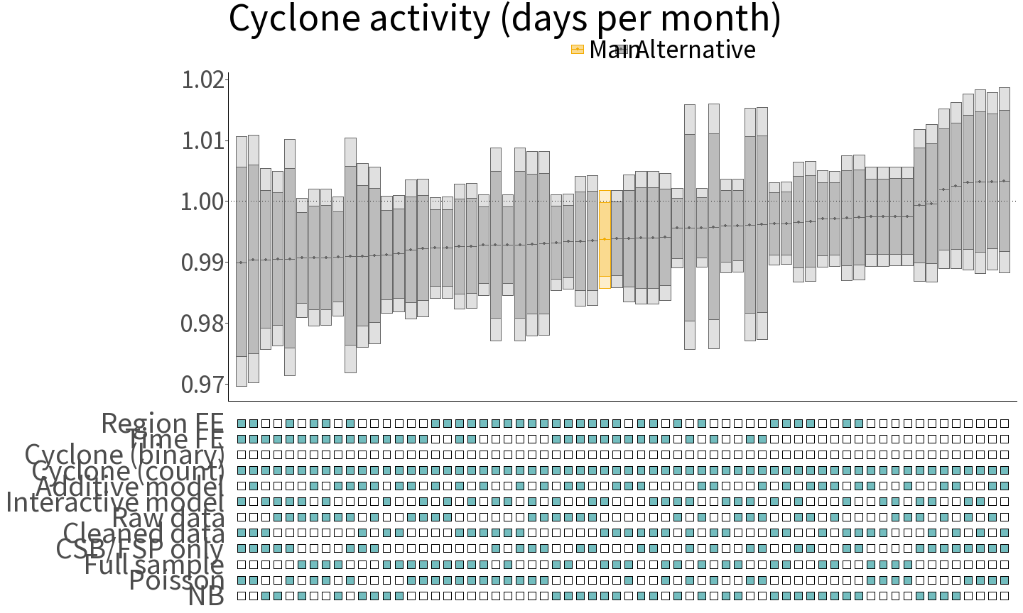

Specification curve depicting the effect estimates and confidence intervals for cyclone activity (measured as days with a tropical storm or cyclone impacting Madagascar in a month) across 64 models. In the top panel, estimated incidence rate ratios (IRRs) across different models are depicted as circles; the darkly and lightly shaded regions above and below these circles correspond to 95% and 99% confidence intervals of these estimates, respectively. The dotted horizontal line depicts a null effect. The IRR estimate and confidence intervals of the preferred model, Model 4, are highlighted in orange. Below each model, a legend of shaded and unshaded boxes indicates which modeling decisions correspond to a given model, with boxes shaded teal showing active features. FE: fixed effects. CSB/FSP: Centres Santé de Base and Formations Sanitaires Privées de Base. NB: negative binomial model.

## 2.4 Discussion

In our study of health facilities in Madagascar, we investigated how temperature, soil moisture, and exposure to cyclone activity impacted monthly counts of patient visits for mental and neurological disorders reported by 3,413 facilities between 2010 and 2020. This study had three major findings. First, we found evidence of a statistically significant reduction in reported mental health visits of approximately 4.5% associated with mean monthly temperature, with warmer temperature being, on average, associated with 2 to 3 fewer visits per month. According to our multiverse analysis, the statistically significant inverse association we observed was robust to numerous specifications, while our subgroup analysis indicated that this association was primarily localized in the highland subhumid forest ecoregion. Second, we found evidence to suggest potential lagged impacts, with higher soil saturation being associated with an 8.5% elevation in reported visit counts in the subsequent quarter. We also found evidence of possible effect heterogeneity, with each percentage point increase in soil moisture leading to an *elevation* of visits in the dry deciduous forest ecoregion and a *decrease* in visits in the highland subhumid forests. Third, while our lagged models and multiverse analysis suggested the possibility of a negative relationship between cyclone activity and mental health visits reported in Madagascar, the marginal effects associated with cyclone duration were negligible, and we did not observe sufficient statistically significant evidence to reject the null assumption of no association at a level of 0.01.

It is important to note in our interpretation of these findings that the true relationship between reported mental health visits and actual cases of mental disorders is not well understood, particularly in Madagascar, where there is no epidemiological data on the prevalence or distribution of mental disorders in the general population. The changes in mental health visits could reflect changes in the actual cases of mental disorders but could also result from the influence of CCEs on help-seeking behavior, diagnostic capacity, or other factors. Additionally, it has been widely recognized that the majority individuals with mental disorders often do not receive any mental health treatment, particularly in low-income settings.9

With these caveats in mind, our results concerning an inverse relationship between temperature and visits related to mental and neurological disorders are nonetheless surprising and run counter to our expectation, given that a robust body of literature has documented that heat and heat waves have a harmful effect on mental health outcomes84 and general aspects such as mood,85 life satisfaction,86 and happiness.87

Research in subtropical regions, however, has found that the association between temperature and mental disorders is likely non-linear, with both extreme cold and extreme heat being associated with harmful effects on mental morbidity.88 Degree increases in temperature, therefore, could show a protective effect in colder months, resulting in an overall inverse association between temperature and reported cases in a sample with few extremely warm months. This is consistent with our marginal effect estimates, which show the greatest reduction in visit counts being associated with degree increases at the coldest temperatures. In addition, this explanation would be consistent with our subgroup analysis, which found that the protective effect of warmer temperatures was observed only among facilities in the central high plateau—where temperatures are generally cooler than those in the surrounding lowlands.

An alternative explanation could be that access to mental health services is limited in warmer months due to factors such as the increased demand for medical services related to heat-related illnesses. A crowding out of provider availability due to physical complaints in warmer months (for example, malaria-related fever) could lead to decreased availability of provider access for mental disorders, especially at primary health facilities with already limited diagnostic capacity. Understanding how climate conditions in Madagascar impact the broader burden of disease, including physical conditions, is the subject of current investigation, and will lend further insight into potential mechanistic explanations for our findings.

With respect to soil moisture, to the best of our knowledge, there have been no studies that directly explore the association between soil saturation and mental health in non-emergency conditions. In terms of extremely low soil moisture, evidence from droughts suggest potential indirect pathways to worsened mental health outcomes,89 but these impacts are not well characterized and may not manifest over a short time horizon.90

Though incidence rate ratios and marginal effect estimates associated with soil moisture were not statistically significant in our main analysis, we observed a significant association of higher soil moisture and visits for mental health complaints in the following quarter, echoing similar findings from United States meteorological data linking higher precipitation with worsened mental health.91 In addition, our subgroup analysis also indicated significant and divergent effects among different ecoregions. In particular, we found that greater soil moisture was associated with more visits reported in the eastern lowlands and the northern dry deciduous forests, which echoes the geographic concentration of flood risk in Madagascar.92 Conversely, the observed (though statistically modest) reduction in visits associated with higher soil moisture in the desert and xeric shrublands overlaps with the concentration of drought risk, where higher soil moisture could indicate reduced drought vulnerability. It is important to note, however, that the time frame of available GESIS data excludes the most severe period of the ongoing drought in Madagascar, limiting our ability to directly study the impact of the current crisis on population mental health in this analysis. Further research could leverage spatial reanalysis data on precipitation to further characterize these associations.

Madagascar’s wet season is marked by frequent tropical storms and cyclones—the intensification of which has been linked to rising temperatures in the Indian Ocean.93 In the majority of our models in the multiverse analysis, we found that months with greater duration of cyclone activity were associated with *fewer* monthly report visits for mental disorders, though none of these models were significant at the threshold of 0.01. In numerous studies, cyclones and similar disasters have been found to worsen mental health;91 however, these storms may also result in numerous conditions that make access to mental health resources more challenging. Disruptions to regular health care services and an intensification of acute health needs94 in the post-disaster period could result in barriers to receiving care for incident mental disorders,95 which would be consistent with a reduction in reported visits despite a rise in mental distress.

Failure to observe effect heterogeneity in our subgroup analysis of the association of cyclone activity with reported monthly visits likely is due, in part, to our specification choice to define exposure to cyclone activity without geographic variation in intensity. While we felt justified in opting for a simplified indicator, given that storms in Madagascar typically impact the whole of the island, a more nuanced (but data-hungry) approach could define exposure with greater geographic precision based on additional climate metrics, including peak wind, rainfall, and distance from the storm’s track.96

A further weakness of our analysis is that inherent to any ecological study relying on aggregated data: the lack of individual-level data substantively constraints our ability to draw causal inferences, account for and exclude potential confounding variables, and ascertain mechanistic explanations for observed associations. While these are important caveats in interpreting our results, we assert that there is considerable value in leveraging existing data from national health management information systems to generate epidemiologic evidence. The opportunity to employ health information system data is particularly important in countries like Madagascar, where, as in many LMICs, HMIS information is routinely generated but systematically underutilized.97

Despite these limitations, our study has important implications for future research on the relationship between climate change exposures and population mental health. By leveraging reported visits from over three thousand health facilities over ten years, utilizing the most comprehensive sources of climate data available, and linking the two via a rigorous, multistep geolocating process, our analysis demonstrates how routine health system data may offer valuable insights, particularly when other epidemiological data are not available. As one of the only studies to investigate mental health and climate in Africa using national HMIS data, our findings also underscore the need for further research to understand the relationships and pathways between changing climate and population mental health, particularly countries most vulnerable to climate change. Finally, our findings and interpretations highlight the importance of local knowledge and collaboration with local ministries in global health research, to make best use of existing data and to foster research to support health system strengthening. We believe that this approach to research is essential for understanding the complex relationships and mechanisms linking climate change exposures to mental health, as well as identifying strategies to mitigate these impacts amid the unfolding global climate crisis.

## 2.5 Acknowledgements

We thank Jessica Cohen, Margaret McConnell, and Stéphane Verguet for their feedback on an earlier version of this paper, as well Marissa Lynn Childs, Angela Jean Rigden, Oladimeji Mudele, and Wenchang Yang for their assistance in initially accessing and processing climate data.

### 2.5.1 Author contributions

All authors contributed to study conception, methodology, and interpretation. DA oversaw data acquisition, programming, formal analysis, visualization, and the first draft of the manuscript.

### 2.5.2 Funding statement

This study was supported by funding from the Motsepe Presidential Research Accelerator Fund for Africa, the Ren Che Foundation, and the Harvard University Climate Change Solutions Fund. The funders had no role in the design and conduct of the study, nor in the collection, management, analysis, and interpretation of the data. The authors alone are responsible for the content and writing of the article.

### 2.5.3 Declaration of interests

We declare no competing interests.

### 2.5.4 Data sharing statement

All codes used for the analysis in this article are available on GitHub (<https://github.com/darias5/madagascar_mh>).

# 3 The impact of COVID-19 vaccine developments on Google COVID-19 search trends for mental health symptoms: a controlled interrupted time series analysis

## 3.1 Introduction

The COVID-19 pandemic has had a profound effect on the mental health and well-being of individuals worldwide. Studies from Australia,98 China,99–108 Denmark,109 Europe,110 Iran,111 Ireland,112 Italy,113,114 Nepal,115 New Zealand,116,117 Spain,118,119 Turkey120, the United Kingdom121, and the United States122,123 have reported high levels of anxiety (6-51%), depression (15-48%), and post-traumatic stress disorder (7-54%) associated with the onset of the pandemic. In the United States (US), approximately four in ten adults reported experiencing symptoms of anxiety or depression in December 2020—a four-fold increase from January-June 2019.124 Globally, it has been estimated that the prevalence of depression and anxiety during the COVID-19 pandemic may be as high as 24% and 21%, respectively125,126, with regions hit hardest by COVID-19 showing the greatest increases in prevalence.127 This striking burden has been described as a mental health crisis128 and as a pandemic in its own right.129

While COVID-19 continues to bring unprecedented challenges to societies around the world, the development and distribution of safe and effective vaccines has fundamentally changed the trajectory of the pandemic. Beyond the physical benefits vaccines provide in reducing the risk of infection and associated morbidity and mortality, a growing body of evidence suggests that vaccination has also contributed to improved mental health.130–133 While there is limited international data on the secondary mental health impact of COVID-19 vaccination, research drawing from the US Census Bureau’s Household Pulse Survey has found that benefits of vaccination may include up to a 30% reduction in symptoms of anxiety and depression among vaccinated adults,130 while research using the University of Southern California Understanding America Survey suggests a reduction in loneliness associated with greater social interactions following vaccination.134

While this literature suggests that receiving a COVID-19 vaccine can improve mental health, the potential mental health benefits of announcements regarding the development of vaccines have received comparatively less attention.135,136 In the context of a deadly pandemic, the announcement of a safe and effective vaccine could be a powerful signal, providing a psychological boost that the worst might soon be mitigated. Studying how population mental health may have been impacted by the release of vaccine efficacy and safety trial data may provide insights into how emotional well-being changed throughout the pandemic in response to these signals, which, in turn, could inform public health communication and contribute to the understanding of how the public responds to information about vaccines—a necessary understanding for increasing vaccine uptake and trust in public health responses.

A key obstacle to studying the impact of public health policies on population mental health, however, is a lack of appropriate high-frequency surveillance data. A potential marker of population mental health is the use of internet search data, which enables real-time, large-scale analysis of evolving mental health issues. A recently published evaluation of Google’s COVID-19 Search Trends Symptoms Dataset137 found a strong correlation between search trends for depression and anxiety with indicators of mental health services utilization (reported in the US Census Household Pulse Survey) and rates of emergency department visits for mental health conditions (from the National Syndromic Surveillance Program of the US Centers for Disease Control and Prevention (CDC)).138 If taken as a reasonable proxy for mental health disorders, search data can provide valuable information on how population mental health reacts to real-time events, enabling policymakers to better respond to mental health needs in a timely manner.

This study analyzes whether news announcements (in November 2020) regarding the imminent availability of safe and effective COVID-19 vaccines impacted population mental health—even before these vaccines were made available to the public. Using Google search density data, I applied interrupted time series approaches to investigate how these announcements might have affected search trends for mental health symptoms in the US and five other countries where data were available: Australia, Ireland, New Zealand, Singapore, and the United Kingdom. Owing to emerging evidence that political ideology may be a predictor of confidence in public health and vaccine hesitancy,139–141 I further explored whether changes in search trends for mental health symptoms varied across US states and counties that predominantly voted Democrat versus Republican in the 2020 presidential election. These findings suggest declines in density for searches related to anxiety and depression in all of the countries examined; in the US, these declines were found to be consistent irrespective of political ideology.

## 3.2 Methods

### 3.2.1 Data sources

#### 3.2.1.1 Vaccine announcements

I took November 16, 2020 as the date of the first credible signal of the imminent availability of safe and effective COVID-19 vaccines. On November 9th, Pzifer announced that early vaccine trial data showed 90% efficacy142 and on the 16th, Moderna announced preliminary results showing 95% efficacy.143 While US Food and Drug Administration (FDA) Emergency Use Authorization (EUA) was not granted until December, the concurrent announcements of vaccine efficacy were widely reported and interpreted by many public health practitioners, policymakers, and the general public as a substantial signal of a new phase of the pandemic, with Moderna’s chief executive officer calling the news “a game changer” in the fight against COVID-19.

#### 3.2.1.2 Symptoms dataset

I accessed aggregated national and subnational data from Google’s COVID-19 Search Trends Symptoms Dataset137 (hereafter referred to as the symptoms dataset) between January 1, 2020 and April 1, 2021. The symptoms dataset provides time series data of search term density, standardized to pairs of health symptoms and regions (e.g., searches for depression in Australia or fever in Cook County, Illinois) and normalized within each pair based on the symptom’s relative popularity. The time series of search density for each symptom-region pair also contains artificial noise, as Google’s differential privacy technique to data aggregation and anonymization adds random noise to protect user privacy (the errors are symmetrically distributed).137

Search density data for over 400 symptoms were reported by Google across national and subnational regions of six predominantly English-speaking countries: Australia, Ireland, New Zealand, Singapore, the United Kingdom, and the United States. In the US, subnational regions include states and counties. Because the aggregated search density data were constructed based on relative search population within each region, I could not compare search density for specific symptoms across different regions; however, comparing search density within regions (or a group of regions) was feasible both over time and across different symptoms.

I utilized three levels of region: 1) national level for the six countries; 2) US state level data across 50 states and the District of Columbia; and 3) US county level data across 2,505 counties (though there are over 3,000 counties in the US, due to data privacy concerns, smaller county results were not included in the symptoms dataset). Following the convention of the symptoms dataset, I will refer to the geographic units (e.g., states, counties, and nations) within the data as “regions.”

#### 3.2.1.3 Voting dataset

I obtained county-level presidential election results for 2020 from the Massachusetts Institute of Technology (MIT) Election Data and Science Lab,144 which I used to calculate aggregate county and state votes (including absentee, early, and election day ballots) for each candidate. The aggregate votes were then used to determine vote share and margins (e.g., the percentage points difference in vote share between the winning candidate and the runner up). Applying a similar approach as other research into COVID-19 and political party inclination,145 I used these margins to sort counties and states into quintiles, such that the 20% most Republican-voting localities appearing in the symptoms dataset were sorted into the first quintile and the 20% most Democratic-voting localities sorted into the fifth quintile.

#### 3.2.1.4 Population data

Population estimates for 2020 by Federal Information Processing Standards (FIPS) code were obtained from theUnited States Department of Agriculture (USDA) Economic Research Service.

### 3.2.2 Statistical analysis

All analyses were conducted using R software (version 4.2.1).50

#### 3.2.2.1 Modeling approach

I used an interrupted time series (ITS) approach to model the Google search density for a given symptom $d$ using the following baseline equation:

$$Y_{d,g,i}=λ_{0}+λ_{1}time_{t}+α_{d}Post_{d,i}+β_{d}time_{t}*post_{d,i}+θ_{r}+T_{t}^{'}χ+ϵ_{it} , \left(3.1\right)$$

where $time_{t}$ is a continuous variable that captures the days before the vaccine announcement ($time_{0}$), $Post_{i}$ is an indicator variable equal to 1 in the period after the announcement (0 otherwise), $θ_{r}$ indicates a series of fixed effects for each region $\left(r\right)$, $T_{t}^{'}χ$ is a matrix of time fixed effects (i.e., month and day of week), and $ϵ_{it}$ is an error term. $α_{d}$ can be interpreted as a level change associated with the announcement date—that is, the immediate difference in search density for a disease $d$ following November 19, 2020; $β_{d}$—the slope change—can be interpreted as the sustained change in search density in the days following November 16th.

I applied this model for all available 420 diseases with county-level data, weighted by population size. As search density may rapidly change in response to new announcements, I trimmed the bandwidth of dates to fit the model to 40 days before and after November 16, 2020.

To control for time-varying confounders which may affect symptom search trends, I applied a controlled interrupted time series (CITS) approach to contrast how searches for mental health symptoms varied above and beyond changes in search density for a comparable physical complaint (i.e., headaches).

After reviewing the list of symptoms for which search density data were available, I identified the following 18 mental health symptoms: anxiety, Asperger syndrome, attention deficit hyperactivity disorder, binge eating, clouding of consciousness, compulsive behavior, depersonalization, depression, dysphoria, generalized anxiety disorder, impulsivity, major depressive disorder, manic disorder, mood disorder, panic attack, psychosis, self harm, and suicidal ideation.

For each of these symptoms, $d$, I ran the following model:

where $mhealth_{di}$ equals 1 if the observation is for a mental health symptom $d$ (0 for headaches). The estimates of interest are given by $δ$, which reflects the additional level shift among symptom searches (compared to searches for headaches) after vaccine announcement, and $γ$, the additional relative change in search density over time (i.e., slope change).

Given the high number of observations in the sample, I evaluated significance against an alpha of 0.01, and I constructed 99% confidence intervals (CIs) using heteroskedasticity-robust standard errors.

##### 3.2.2.1.1 Sensitivity analysis

As with other quasi-experimental methods, it is recommended that the modeling specifications be evaluated using a sensitivity analysis. To do so, I defined a list of seven methodological choices concerning data processing and modeling assumptions and interacted these choices to generate all plausible combinations. These combinations were then conducted to allow for a multiverse analysis to identify how sensitive effect estimates and CIs were to different methodological choices. The criteria used to generate the plausible model combinations are outlined in Table 3.1.

First, I considered the role of data cleaning in the outcome data, which involved outlier smoothing using Friedman’s nonparametric super smoother regression estimator.78 Second, I compared the level of region of aggregated data, using US counties, US states, and, finally, national trends from the six counties in the sample. Third, I evaluated sensitivity to the specification of the bandwidth cut-off around the announcement date, extending it from ±40 days to ±50 and ±60 days. Fourth, I toggled whether to account for day of week fixed effects; fifth, I toggled month fixed effects; and sixth, I toggled regional fixed effects (i.e., fixed effects for states in the US state level data, fixed effects for counties in the US county level data, etc.).

Interacting these choices resulted in 144 plausible models for each symptom. Each model was run for all 18 mental health related symptoms, resulting in 2,736 models being conducted overall.

##### 3.2.2.1.2 Subgroup analysis

Two subgroup analyses were conducted to investigate the generalizability of the findings of the main analysis and to explore potential heterogeneities in measures of association.

The first subgroup analysis applied the CITS approach against all 18 mental health related symptoms against search data from each of the six countries in the sample, using the nationally aggregated data. This analysis aimed to investigate the extent to which effects observed in US states and counties were also seen in other countries.

The second subgroup analysis applied the CITS approach to the 20% most Republican-voting localities (hereafter referred to as red states/counties) and to the 20% most Democratic-voting localities (hereafter referred to as blue states/counties) based on 2020 presidential election vote share. The subgroup analysis comparing CITS effect estimates in blue versus red states aimed to investigate whether the initial response to imminent safe and effective COVID-19 vaccines showed evidence of heterogeneity by predominant political ideology, under the hypothesis that if conservative voters were more likely to be averse to vaccination, any impact on mental health related symptom search density from the announcement of upcoming vaccines would be lesser in red states and counties compared to blue ones.

### 3.2.3 Ethics statement

The IRB of the Harvard T.H. Chan School of Public Health determined that this study was not human subjects research and that additional review was not required (protocol number: IRB23-0095, determined on January 25, 2023).

## 3.3 Results

The estimates for the immediate (level shift) and sustained (slope change) effects associated with the announcement of vaccine safety and efficacy data on search density for all 420 symptoms are presented in Figure .

For most symptoms, search density exhibited negligible differences following the announcement, with small positive level shifts offset by modest negative slope changes. For four mental health symptoms, however, I observed relatively large, negative slope changes for searches for anxiety (-0.078, p < 0.0001, 99% CI: -0.082 – -0.073), depression (-0.059, p < 0.0001, 99% CI: -0.062 – -0.056), major depressive disorder (MDD)(-0.053, p < 0.0001, 99% CI: -0.056 – -0.050), and attention deficit hyperactivity disorder (ADHD)(-0.046, p < 0.0001, 99% CI: -0.048 – -0.043). With respect to level shifts, changes for anxiety (0.035, p = 0.080, 99% CI: -0.016 – 0.086) and depression (0.107, p < 0.0001, 99% CI: 0.071 – 0.143) were close to zero, while those for MDD (0.230, p < 0.0001, 99% CI: 0.197 – 0.264) and ADHD (0.235, p < 0.0001, 99% CI: 0.202 – 0.268) were approximately 0.3 percentage points.

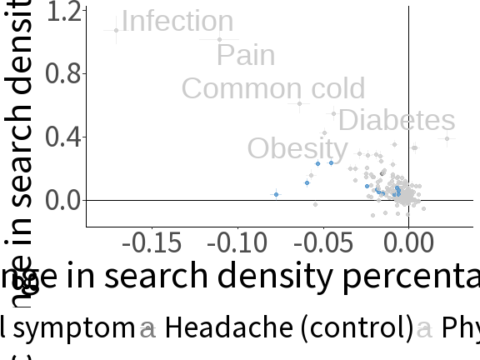

Interrupted time series effect estimates and confidence intervals by symptom. Effect estimates are presented by points; for each symptom, the estimated slope change per day is shown on the x-axis, while the level shift over the post-announcement period is shown on the y-axis. The horizontal and vertical bars next to each point represent the 99% confidence intervals for the estimate slope change and level shift, respectively. Mental health-related symptoms are shown in blue, while physical symptoms are shown in grey. ADHD: Attention deficit hyperactivity disorder. MDD: Major depressive disorder.

While the ITS analysis provided suggestive evidence that search density for mental health symptoms might have changed in the post-announcement period, it also highlighted that searches may have generally changed across other diseases at the same time. The CITS estimates of each mental health symptom (Figure ) using searches for headaches as a comparison broadly echoed the ITS analysis, with most conditions showing level and slope changes close to 0. For three conditions, the CITS analysis showed relatively large slope changes with searches for anxiety (-0.035, p < 0.0001, 99% CI: -0.037 – -0.032), depression (-0.029, p < 0.0001, 99% CI: -0.031 – -0.027), and MDD (-0.012, p < 0.0001, 99% CI: -0.013 – -0.010), all showing sustained declines. All three symptoms had relatively large slope changes in the ITS analysis. In addition, the CITS level shift (i.e., the relative immediate effect) for anxiety was -0.273 percentage points (p < 0.0001, 99% CI: -0.333 – -0.212), a decrease double in magnitude compared to most estimates for other symptoms.

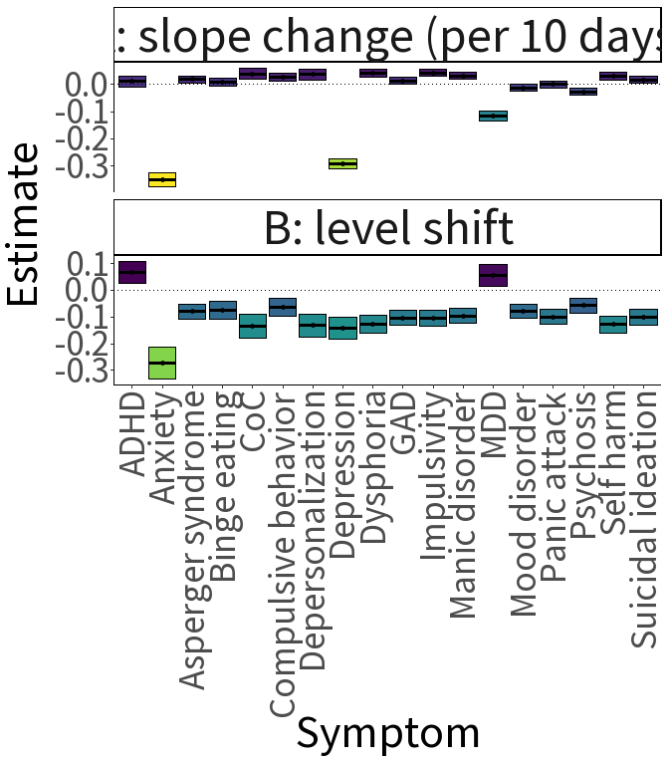

Controlled interrupted time series effect estimates (A: slope change per 10 days and B: level shift) for Google Search density by symptom. Effect estimates are represented as thick, horizontal lines in between colored bands, which represent the 99% confidence intervals for the estimates. Colors reflect the sign and magnitude of effect estimates. Dark blue values above zero indicate an increase in search density, while the yellow and green negative values indicate a decrease. The dotted horizontal line depicts a null effect. ADHD: Attention deficit hyperactivity disorder. CoC: clouding of consciousness. GAD: Generalized anxiety disorder. MDD: Major depressive disorder.

In both the analyses, search trends for anxiety, depression, and MDD showed potential immediate and sustained declines in density following November 16th. Search density for these three symptoms and the comparison search data for headaches is plotted in Figures through at the level of US states, US counties, and international data. I observed relatively strong concordance between the CITS estimates and the observed trends in the data, with strong fit to both mental health symptoms and headaches. I further observed strong within-week patterns in searches, supporting the inclusion of fixed effects to account for this weekly periodicity.

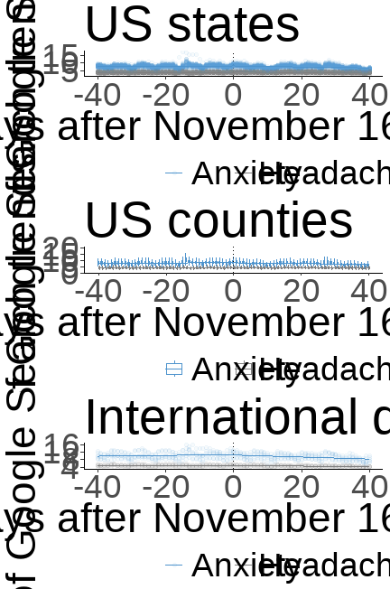

Density of Google Search trends for anxiety, by region and as a function of time. In each row, search density data for two symptoms are displayed: anxiety in blue and headaches in grey. In the first row, data from US states are shown, where each point represents the search density of a specific symptom on a specific date in a specific state. In the second row, data from US counties are shown; because of the large number of counties reporting data, county-level search data are summarized as daily boxplots. In the third row, national data from Australia, Ireland, New Zealand, Singapore, the United Kingdom, and the United States are shown. Each graph shows the density of symptom searches on the y-axis, while time is centered and displayed as days prior to and following November 16, 2020 on the x-axis. The solid lines show predicted lines of best fit under a basic controlled interrupted time series model (i.e., no fixed effects). US: United States.

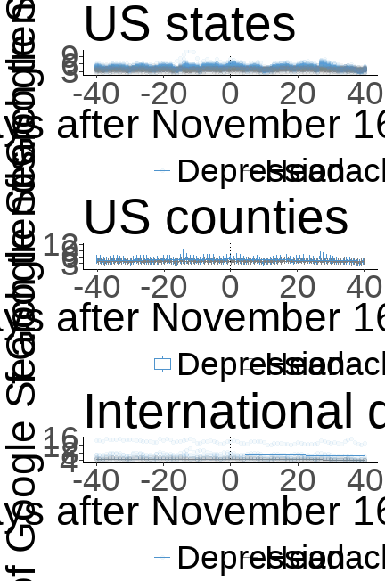

Density of Google Search trends for depression, by region and as a function of time. In each row, search density data for two symptoms are displayed: depression in blue and headaches in grey. In the first row, data from US states are shown, where each point represents the search density of a specific symptom on a specific date in a specific state. In the second row, data from US counties are shown; because of the large number of counties reporting data, county-level search data are summarized as daily boxplots. In the third row, national data from Australia, Ireland, New Zealand, Singapore, the United Kingdom, and the United States are shown. Each graph shows the density of symptom searches on the y-axis, while time is centered and displayed as days prior to and following November 16, 2020 on the x-axis. The solid lines show predicted lines of best fit under a basic controlled interrupted time series model (i.e., no fixed effects). US: United States.

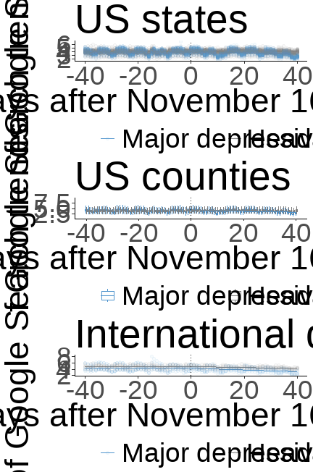

Density of Google Search trends for major depressive disorder (MDD), by region and as a function of time. In each row, search density data for two symptoms are displayed: MDD in blue and headaches in grey. In the first row, data from US states are shown, where each point represents the search density of a specific symptom on a specific date in a specific state. In the second row, data from US counties are shown; because of the large number of counties reporting data, county-level search data are summarized as daily boxplots. In the third row, national data from Australia, Ireland, New Zealand, Singapore, the United Kingdom, and the United States are shown. Each graph shows the density of symptom searches on the y-axis, while time is centered and displayed as days prior to and following November 16, 2020 on the x-axis. The solid lines show predicted lines of best fit under a basic controlled interrupted time series model (i.e., no fixed effects). US: United States.

The multiverse analysis further underscored the robustness of the findings concerning the relatively large negative immediate and sustained effects on searches for anxiety and depression, in particular (Figure ). For anxiety, all 144 models had negative level shifts and slope changes. For depression, all 144 models had negative slope changes, of which only 24 models had any positive level shift. For MDD, I similarly observed a universally negative slope change in all 144 models; however, the majority of models showed a positive level shift (96 models), whereas only 48 showed a downward level shift.

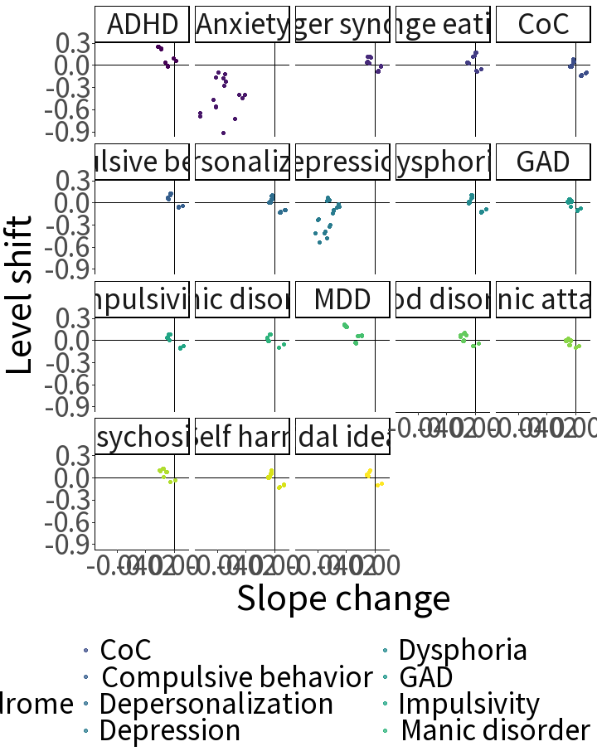

Controlled interrupted time series effect estimates by mental health related symptom for each model specification combination in multiverse analysis. Each point presents the effect estimates of a single model; for each symptom, the estimated slope change per day is shown on the x-axis, while the level shift over the post-announcement period is shown on the y-axis. ADHD: Attention deficit hyperactivity disorder. CoC: clouding of consciousness. GAD: generalized anxiety disorder. MDD: Major depressive disorder.

Slope changes and level shifts for anxiety, depression, and MDD are reported for each combination (144 models) in Figure . Examining the plausible model combinations of the multiverse analysis for these three symptoms underscored the importance of regional level to inference, as the use of county-level data (with a greater number of observations) consistently showed similar effect estimates compared to state level estimates, but with much tighter CIs, even when geographic fixed effects and narrower bandwidths were included. Across all models, the sustained change in search density for anxiety and depression was negative and significant with an alpha of 0.01. In terms of the estimated level shifts, 90 models for anxiety (62%) had a statistically significant negative change, compared to 0 models with a positive one. For depression, of the 64 models with a statistically significant level shift estimate, all 64 models returned a negative level shift coefficient.

Turning to the subgroup analysis, I found modest evidence of effect estimates of similar magnitude comparing across countries (Figure ). Across the most populous countries (Australia, the United Kingdom, and the United States), effect estimates were broadly consistent, with wider CIs than the ITS or CITS main analysis results due to the smaller number of observations. Negative level shifts and slope changes were more pronounced in New Zealand compared to other countries, while the level shift estimated for searches for depression in Ireland was positive; owing to the construction of the Google search density data being relative to regions, this may be due to differences in search volume intensity for depression in Ireland and New Zealand compared to other countries, and not due to a strong effect itself.

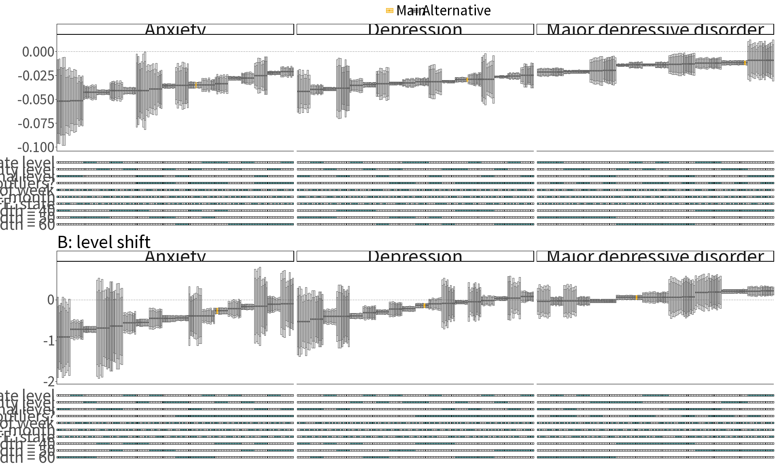

Specification curve depicting the CITS effect estimates and confidence intervals for search density, with panel A depicting the estimated slope change and panel B depicting the estimated level shift. Within each panel, the effect estimates across different models are depicted as circles in the upper graph; the darkly and lightly shaded regions above and below these circles correspond to 95% and 99% confidence intervals of these estimates, respectively. The dotted horizontal line depicts a null effect. The effect estimates and confidence intervals of the main specification are highlighted in orange. Below each model, a legend of shaded and unshaded boxes indicates which modeling decisions correspond to a given model, with boxes shaded teal showing active features. The three vertical columns show effect estimates by symptom. From left to right, these are anxiety, depression, and major depressive disorder. CITS: controlled interrupted time series. FE: fixed effects.

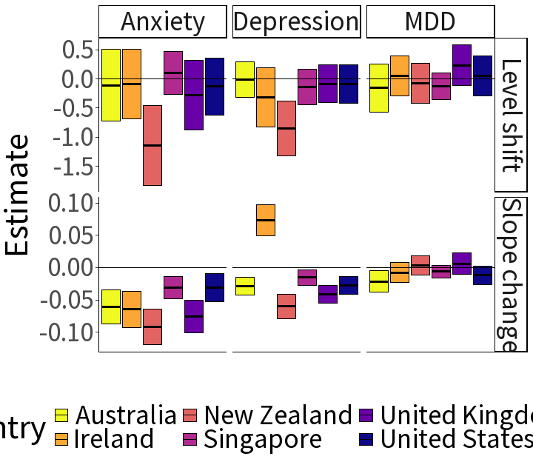

Controlled interrupted time series estimates of changes in search density by mental health related symptom, reported across six countries (Australia, Ireland, New Zealand, Singapore, the United Kingdom, and the United States). The top panel reports estimates of associated level shift and the lower panel estimates of the associated slope change. Estimates are represented as solid black lines, with the shaded regions above and below the lines showing the 95% confidence intervals. The solid black line across all panels reflects a null effect. MDD: Major depressive disorder.

Results from the analysis comparing red and blue states and counties showed broad consistency in both slope changes and level shifts for searches for anxiety, depression, and MDD as found in the main analysis (Figure ). This was particularly observed in the analysis of US state-level data, where confidence intervals for the CITS effect estimates were statistically equivalent across red and blue states. In the county-level analysis, however, I observed larger immediate and sustained declines in searches for depression among red counties than blue ones, with minor overlap in confidence intervals. The observed slope change for searches related to depression among red counties was -0.033 percentage points per day (p < 0.0001, 99% CI: -0.036 – -0.030), compared to -0.025 percentage points per day (p < 0.0001, 99% CI: -0.030 – -0.021) for blue counties. Similarly, a more pronounced level shift was observed in red counties than blue ones, -0.225 percentage points (p < 0.0001, 99% CI: -0.289 – -0.161) versus -0.105 percentage points (p = 0.008, 99% CI: -0.208 – -0.003), respectively.

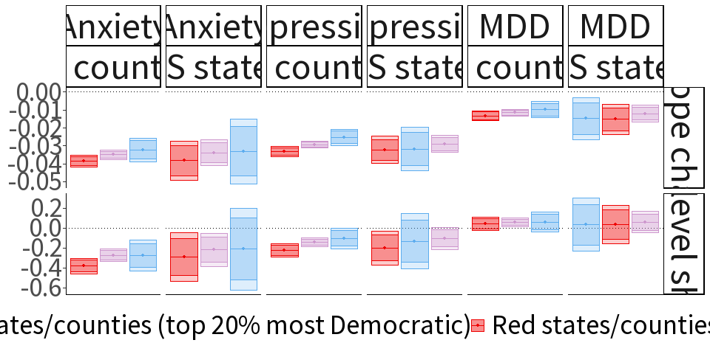

CITS effect estimates and confidence intervals per symptom, region, and predominant political ideology. Panel A depicts the estimated slope change and panel B the estimated level shift. The vertical panels show CITS effect estimates by mental health symptom (from left to right: anxiety, depression, and major depressive disorder); for each symptom, estimates are separately reported using county- and state-level data. For a given symptom and region, three CITS estimates are reported: one estimated from a sample of all counties or states (shown in purple), one conducted solely among the most Democratic counties or states (by 2020 presidential election vote share, shown in blue, and one among the most Republican counties or states (shown in red). Within each panel, the effect estimates across different models are depicted as points on a horizontal bar; the darkly and lightly shaded regions above and below these circles correspond to 95% and 99% confidence intervals of these estimates, respectively. The dotted horizontal line in each panel depicts a null effect. CITS: controlled interrupted time series. US: United States.

## 3.4 Discussion

This study evaluated whether two contemporary announcements of COVID-19 vaccine safety and efficacy data on November 9th and November 16th, 2020 were associated with changes in health-related Google search density related to mental health symptoms. Using search data from US counties, states, and international trends, I applied ITS and CITS modeling approaches to investigate possible associations between these announcements and search density changes. I found evidence of statistically significant immediate and sustained declines in searches for anxiety, depression, and major depressive disorder throughout the 40 days following these announcements. The declines were relatively large compared to changes in other symptoms, both physical and mental, and a multiverse analysis indicated that the findings were robust to alternative specifications.

To interpret these observed changes as reactions to the vaccine safety and efficacy announcements, it is important to evaluate whether they may be responses to other contemporary events. I highlight two potential alternatives that coincided with the period under study: the 2020 US presidential election on November 3rd and the observance of the Thanksgiving holiday in the United States on November 26th. While it is possible that the estimates encompass impacts from these events, data from the subgroup analysis lends support for the interpretation that these alternatives are insufficient to explain the observed declines in search trends for anxiety, depression, and MDD.

With respect to the US presidential election, I would anticipate any post-election decline in mental health related symptoms to be concentrated in the United States, given its domestic importance and the political fervor that surrounded it. Similarly, I would expect that impacts of the Thanksgiving holiday would be unique to the US, as it is not celebrated by the other nations in the sample and there were no other national holidays observed by those nations at the same time (with the exception of Singapore’s observance of Deepavali on November 14th).

In the subgroup analysis comparing Australia, Ireland, New Zealand, Singapore, the United Kingdom, and the United States, I did not observe evidence of US-specific effects, with the analysis showing consistent declines in searches related to anxiety and depression across all countries (though these differed in degree). Furthermore, the estimated declines in search density in Australia and the United Kingdom—which, along with the US, are the most populous nations in the sample—were greater than that of the US for these two symptom searches, providing additional counterevidence to these alternative explanations.

Further countering the explanation that observed declines in search trends for mental health symptoms were due to the US presidential election are the results from the subgroup analysis comparing blue and red states/counties. If voters expressed relief following the election if their candidate was the winner, a greater decline in searches related to anxiety and depression in states and counties would be expected in those that more heavily voted for Joe Biden, the Democratic candidate and subsequent President-elect, than for former President Donald Trump, the Republican candidate. This gradient would also echo the hypothesis that, given findings that political ideology may affect receptiveness to vaccination, the announcement of vaccine safety and efficacy would have had a less pronounced effect among conservative voters compared to liberal ones. Instead, I observed the opposite: among the counties that most heavily voted for the Republican candidate, the estimated declines in search density for anxiety and depression were larger than in those that most heavily voted Democrat. I did, however, observe broad similarities in the confidence intervals of these estimates, such that I did not rule out the possibility that the effects were the same across red and blue counties. However, even this finding would be striking, giving the enduring political controversy over vaccination in the US; while subsequent attitudes towards vaccination may show an ideological split by political affiliation, the findings—if taken as a reasonable reflection of individual attitudes—suggest that whatever relief the vaccine announcements brought was shared across the aisle.

These findings should be interpreted with some limitations in mind. First, the aggregated and anonymized nature of the data imposes a constraint to the interpretations, as it was not possible to identify whether individual political ideologies were correlated with changes in search trends. Instead, I relied on population aggregates that reflect political orientation (i.e., vote share by county and state) as a proxy, focusing on the 20% most Democrat and Republican-voting areas to strengthen the plausibility of this proxy. In addition, the use of Google search density as a proxy for population mental health could not be directly validated in the study, as the search data was anonymized and aggregated. While this is an important limitation, prior work has found a strong correlation between searches for anxiety and depression and US population survey responses for receiving therapy, receiving medication for mental health disorders, and having unmet mental health needs.130 Given the paucity of high-frequency population mental health data, Google search density data offered a unique opportunity to investigate the immediate and sustained impacts of vaccine safety and efficacy announcements with an aggregated measures that may be linked with subjective well-being and care seeking.

Despite these limitations, the findings suggest that the announcement of COVID-19 vaccine safety and efficacy led to a robust and sustained reduction in Google search density for anxiety and depression, relative to search density prior to the announcements and to searches for other symptoms. If symptom search density echoes population health, the results would indicate that these announcements led to an improvement in mental health, an improvement observed across countries and predominant political party inclination. These findings underscore the importance of timely and transparent communication and highlight the potential application of high-frequency internet search data for population mental health surveillance.

## 3.5 Acknowledgements

I thank Jessica Cohen, Karestan Koenen, Margaret McConnell and Stéphane Verguet for their comments on earlier versions of this paper.

### 3.5.1 Funding statement

This study received no funding.

### 3.5.2 Declaration of interests

I declare no competing interests.

### 3.5.3 Data sharing statement

All codes used for the analysis in this article are available on GitHub (<https://github.com/darias5/mh_google_search_trends>).

# Works Cited

1 World Health Organization. Comprehensive mental health action plan 2013. Geneva: World Health Organization. Geneva, Switzerland: WHO, 2013.

2 Rehm J, Shield KD. [Global Burden of Disease and the Impact of Mental and Addictive Disorders](https://doi.org/10.1007/s11920-019-0997-0). *Current Psychiatry Reports* 2019; **21**: 10.

3 Charlson FJ, Baxter AJ, Dua T, Degenhardt L, Whiteford HA, Vos T. [Excess mortality from mental, neurological and substance use disorders in the Global Burden of Disease Study 2010](https://doi.org/10.1017/S2045796014000687). *Epidemiology and Psychiatric Sciences* 2015; **24**: 121–40.

4 Vos T, Lim SS, Abbafati C, *et al.* [Global burden of 369 diseases and injuries in 204 countries and territories, 1990: A systematic analysis for the Global Burden of Disease Study 2019](https://doi.org/10.1016/S0140-6736(20)30925-9). *The Lancet* 2020; **396**: 1204–22.

5 Walker ER, McGee RE, Druss BG. [Mortality in mental disorders and global disease burden implications: A systematic review and meta-analysis](https://doi.org/10.1001/jamapsychiatry.2014.2502). *JAMA Psychiatry* 2015; **72**: 334–41.

6 de Mooij LD, Kikkert M, Theunissen J, *et al.* [Dying Too Soon: Excess Mortality in Severe Mental Illness](https://doi.org/10.3389/fpsyt.2019.00855). *Frontiers in Psychiatry* 2019; **10**: 855.

7 Patel V, Saxena S, Lund C, *et al.* [The Lancet Commission on global mental health and sustainable development](https://doi.org/10.1016/S0140-6736(18)31612-X). *The Lancet* 2018; **392**: 1553–98.

8 Patel V, Chisholm D, Dua T, Laxminarayan R, Medina-Mora ME, editors. [Mental, Neurological, and Substance Use Disorders: Disease Control Priorities, Third Edition (Volume 4)](https://www.ncbi.nlm.nih.gov/pubmed/27227198). Washington (DC): The International Bank for Reconstruction and Development / The World Bank, 2016.

9 Demyttenaere K, Bruffaerts R, Posada-Villa J, *et al.* [Prevalence, severity, and unmet need for treatment of mental disorders in the World Health Organization World Mental Health Surveys](https://doi.org/10.1001/jama.291.21.2581). *JAMA - Journal of the American Medical Association* 2004; **291**: 2581–90.

10 Bass JK, Bornemann TH, Burkey M, *et al.* [A United Nations General Assembly Special Session for mental, neurological, and substance use disorders: The time has come](https://doi.org/10.1371/journal.pmed.1001159). *PLoS medicine* 2012; **9**: e1001159.

11 Alonso J, Buron A, Rojas-Farreras S, *et al.* [Perceived stigma among individuals with common mental disorders](https://doi.org/10.1016/j.jad.2009.02.006). *Journal of Affective Disorders* 2009; **118**: 180–6.

12 Angermeyer MC, Matschinger H. [The stigma of mental illness: Effects of labelling on public attitudes towards people with mental disorder](https://doi.org/10.1034/j.1600-0447.2003.00150.x). *Acta Psychiatrica Scandinavica* 2003; **108**: 304–9.

13 Stuart H. [Mental illness and employment discrimination](https://doi.org/10.1097/01.yco.0000238482.27270.5d). *Current Opinion in Psychiatry* 2006; **19**: 522.

14 Thornicroft G, Rose D, Kassam A. [Discrimination in health care against people with mental illness](https://doi.org/10.1080/09540260701278937). *International Review of Psychiatry* 2007; **19**: 113–22.

15 Human Rights Watch. ‘Like a Death Sentence’ | Abuses against Persons with Mental Disabilities in Ghana. Human Rights Watch. 2012; published online Oct.

16 Mfoafo-M’Carthy M, Huls S. [Human Rights Violations and Mental Illness: Implications for Engagement and Adherence](https://doi.org/10.1177/2158244014526209). *SAGE Open* 2014; **4**: 2158244014526209.

17 Rahman M, Ahmed R, Moitra M, *et al.* Mental Distress and Human Rights Violations During COVID-19: A Rapid Review of the Evidence Informing Rights, Mental Health Needs, and Public Policy Around Vulnerable Populations. *Frontiers in Psychiatry* 2021; **11**.

18 World Health Organization. Mental Health and Climate Change: Policy Brief. 2022; published online June.

19 Atwoli L, Muhia J, Merali Z. [Mental health and climate change in Africa](https://doi.org/10.1192/bji.2022.14). *BJPsych International* 2022; **19**: 86–9.

20 Hayes K, Blashki G, Wiseman J, Burke S, Reifels L. [Climate change and mental health: Risks, impacts and priority actions](https://doi.org/10.1186/s13033-018-0210-6). *International Journal of Mental Health Systems* 2018; **12**: 28.

21 Vindegaard N, Benros ME. [COVID-19 pandemic and mental health consequences: Systematic review of the current evidence](https://doi.org/10.1016/j.bbi.2020.05.048). *Brain, Behavior, and Immunity* 2020; **89**: 531–42.

22 Roberts MJ. Getting health reform right: A guide to improving performance and equity. Oxford; New York: Oxford University Press, 2008.

23 World Health Organization. Mental Health Atlas 2020. Geneva: World Health Organization, 2021.

24 Stein DJ, Lim CCW, Roest AM, *et al.* [The cross-national epidemiology of social anxiety disorder: Data from the World Mental Health Survey Initiative](https://doi.org/10.1186/s12916-017-0889-2). *BMC Medicine* 2017; **15**: 143.

25 Dixon A, McDaid D, Knapp M, Curran C. [Financing mental health services in low- and middle-income countries](https://doi.org/10.1093/heapol/czl004). *Health Policy and Planning* 2006; **21**: 171–82.

26 Patel V, Kleinman A. [Poverty and common mental disorders in developing countries](https://www.ncbi.nlm.nih.gov/pmc/articles/PMC2572527). *Bulletin of the World Health Organization* 2003; **81**: 609–15.

27 Lund C, Breen A, Flisher AJ, *et al.* [Poverty and common mental disorders in low and middle income countries: A systematic review](https://doi.org/10.1016/j.socscimed.2010.04.027). *Social Science & Medicine* 2010; **71**: 517–28.

28 Dykxhoorn J, Fischer L, Bayliss B, *et al.* [Conceptualising public mental health: Development of a conceptual framework for public mental health](https://doi.org/10.1186/s12889-022-13775-9). *BMC Public Health* 2022; **22**: 1407.

29 Bloom DE, Cafiero ET, Jané-Llopis E, *et al.* The Global Economic Burden of Non-communicable Diseases. Geneva, Switzerland: World Economic Forum, 2011.

30 Vigo D, Thornicroft G, Atun R. [Estimating the true global burden of mental illness](https://doi.org/10.1016/S2215-0366(15)00505-2). *The Lancet Psychiatry* 2016; **3**: 171–8.

31 Whiteford HA, Degenhardt L, Rehm J, *et al.* [Global burden of disease attributable to mental and substance use disorders: Findings from the Global Burden of Disease Study 2010](https://doi.org/10.1016/S0140-6736(13)61611-6). *The Lancet* 2013; **382**: 1575–86.

32 Trautmann S, Rehm J, Wittchen H-U. [The economic costs of mental disorders](https://doi.org/10.15252/embr.201642951). *EMBO Reports* 2016; **17**: 1245–9.

33 Canavan ME, Sipsma HL, Adhvaryu A, *et al.* [Psychological distress in Ghana: Associations with employment and lost productivity](https://doi.org/10.1186/1752-4458-7-9). *International Journal of Mental Health Systems* 2013; **7**: 9.

34 Chisholm D, Sweeny K, Sheehan P, *et al.* [Scaling-up treatment of depression and anxiety: A global return on investment analysis](https://doi.org/10.1016/S2215-0366(16)30024-4). *The Lancet Psychiatry* 2016; **3**: 415–24.

35 The Lancet Global Health. [Mental health matters](https://doi.org/10.1016/S2214-109X(20)30432-0). *The Lancet Global Health* 2020; **8**: e1352.

36 GBD 2019 Mental Disorders Collaborators. [Global, regional, and national burden of 12 mental disorders in 204 countries and territories, 1990-2019: A systematic analysis for the Global Burden of Disease Study 2019](https://doi.org/10.1016/S2215-0366(21)00395-3). *The Lancet Psychiatry* 2022; **9**: 137–50.

37 Atun R, Vigo D, Thornicroft G. [Challenges to estimating the true global burden of mental disorders Authors’ reply](https://doi.org/10.1016/S2215-0366(16)30045-1). *The Lancet Psychiatry* 2016; **3**: 403–4.

38 Whiteford HA, Ferrari AJ, Vos T. [Challenges to estimating the true global burden of mental disorders](https://doi.org/10.1016/S2215-0366(16)30026-8). *The Lancet Psychiatry* 2016; **3**: 402–3.

39 Bertolote JM, Fleischmann A. [Suicide and psychiatric diagnosis: A worldwide perspective](https://www.ncbi.nlm.nih.gov/pmc/articles/PMC1489848). *World Psychiatry* 2002; **1**: 181–5.

40 Crump C, Sundquist K, Winkleby MA, Sundquist J. [Mental disorders and risk of accidental death](https://doi.org/10.1192/bjp.bp.112.123992). *The British Journal of Psychiatry* 2013; **203**: 297–302.

41 Colton CW, Manderscheid RW. [Congruencies in increased mortality rates, years of potential life lost, and causes of death among public mental health clients in eight states](https://www.ncbi.nlm.nih.gov/pmc/articles/PMC1563985). *Preventing Chronic Disease* 2006; **3**: A42.

42 Robinson LA, Hammitt JK, O’Keeffe L. Valuing Mortality Risk Reductions in Global Benefit-Cost Analysis. *Journal of Benefit-Cost Analysis* 2019; **10**: 15–50.

43 Jamison DT, Summers LH, Alleyne G, *et al.* [Global health 2035: A world converging within a generation](https://doi.org/10.1016/S0140-6736(13)62105-4). *The Lancet* 2013; **382**: 1898–955.

44 Khadka A, Verguet S. [The economic value of changing mortality risk in low- and middle-income countries: A systematic breakdown by cause of death](https://doi.org/10.1186/s12916-021-02029-x). *BMC Medicine* 2021; **19**: 156.

45 Copenhagen Consensus Center. Methodology.

46 Bertram MY, Lauer JA, De Joncheere K, *et al.* [Costeffectiveness thresholds: Pros and cons](https://doi.org/10.2471/BLT.15.164418). *Bulletin of the World Health Organization* 2016; **94**: 925–30.

47 Commission on Macroeconomics and Health. Macroeconomics and health: Investing in health for economic development; report of the Commission on Macroeconomics and Health. Geneva: World Health Organization, 2001.

48 Jamison DT, Jha P, Laxminarayan R, Ord T. [Infectious Disease, Injury, and Reproductive Health](https://doi.org/10.1017/CBO9781139600484.009). In: Lomborg B, ed. Global Problems, Smart Solutions. Cambridge: Cambridge University Press, 2013: 390–438.

49 Jha P, Hum R, Gauvreau CL, Jordan K. [Benefits and Costs of the Health Targets for the Post-2015 Development Agenda](https://doi.org/10.1017/9781108233767.012). In: Lomborg B, ed. Prioritizing Development, First. Cambridge University Press, 2018: 219–30.

50 R Core Team. R: A language and environment for statistical computing. Vienna, Austria: R Foundation for Statistical Computing, 2022.

51 Vigo D, Jones L, Thornicroft G, Atun R. [Burden of Mental, Neurological, Substance Use Disorders and Self-Harm in North America: A Comparative Epidemiology of Canada, Mexico, and the United States](https://doi.org/10.1177/0706743719890169). *Canadian Journal of Psychiatry Revue Canadienne de Psychiatrie* 2020; **65**: 87–98.

52 Vigo D, Jones L, Atun R, Thornicroft G. [The true global disease burden of mental illness: Still elusive](https://doi.org/10.1016/S2215-0366(22)00002-5). *The Lancet Psychiatry* 2022; **9**: 98–100.

53 Tichenor M, Sridhar D. [Metric partnerships: Global burden of disease estimates within the World Bank, the World Health Organisation and the Institute for Health Metrics and Evaluation](https://doi.org/10.12688/wellcomeopenres.15011.2). *Wellcome Open Research* 2019; **4**: 35.

54 Institute for Health Metrics and Evaluation (IHME). Global Burden of Disease Study 2019 (GBD 2019) Data Input Sources Tool.

55 Darrow LA, Steenland NK. [Confounding and Bias in the Attributable Fraction](https://doi.org/10.1097/EDE.0b013e3181fce49b). *Epidemiology* 2011; **22**: 53–8.

56 Patel V, Chisholm D, Parikh R, *et al.* [Addressing the burden of mental, neurological, and substance use disorders: Key messages from Disease Control Priorities, 3rd edition](https://doi.org/10.1016/S0140-6736(15)00390-6). *The Lancet* 2016; **387**: 1672–85.

57 Watts N, Amann M, Arnell N, *et al.* [The 2020 report of The Lancet Countdown on health and climate change: Responding to converging crises](https://doi.org/10.1016/S0140-6736(20)32290-X). *The Lancet* 2021; **397**: 129–70.

58 Cianconi P, Betrò S, Janiri L. The Impact of Climate Change on Mental Health: A Systematic Descriptive Review. *Frontiers in Psychiatry* 2020; **11**.

59 Rocque RJ, Beaudoin C, Ndjaboue R, *et al.* [Health effects of climate change: An overview of systematic reviews](https://doi.org/10.1136/bmjopen-2020-046333). *BMJ Open* 2021; **11**: e046333.

60 Padhy SK, Sarkar S, Panigrahi M, Paul S. [Mental health effects of climate change](https://doi.org/10.4103/0019-5278.156997). *Indian Journal of Occupational and Environmental Medicine* 2015; **19**: 3–7.

61 Batterham PJ, Brown K, Trias A, Poyser C, Kazan D, Calear AL. [Systematic review of quantitative studies assessing the relationship between environment and mental health in rural areas](https://doi.org/10.1111/ajr.12851). *Australian Journal of Rural Health* 2022; **30**: 306–20.

62 Liu J, Varghese BM, Hansen A, *et al.* [Is there an association between hot weather and poor mental health outcomes? A systematic review and meta-analysis](https://doi.org/10.1016/j.envint.2021.106533). *Environment International* 2021; **153**: 106533.

63 Stanke C, Kerac M, Prudhomme C, Medlock J, Murray V. [Health Effects of Drought: A Systematic Review of the Evidence](https://doi.org/10.1371/currents.dis.7a2cee9e980f91ad7697b570bcc4b004). *PLoS Currents* 2013; **5**: ecurrents.dis.7a2cee9e980f91ad7697b570bcc4b004.

64 Tasdik Hasan M, Adhikary G, Mahmood S, *et al.* [Exploring mental health needs and services among affected population in a cyclone affected area in costal Bangladesh: A qualitative case study](https://doi.org/10.1186/s13033-020-00351-0). *International Journal of Mental Health Systems* 2020; **14**: 12.

65 Sharpe I, Davison CM. [Climate change, climate-related disasters and mental disorder in low- and middle-income countries: A scoping review](https://doi.org/10.1136/bmjopen-2021-051908). *BMJ Open* 2021; **11**: e051908.

66 Baker A, Mitchell I. Projecting Global Emissions for Lower-Income Countries. 2020; published online April.

67 Rakotoarison N, Raholijao N, Razafindramavo LM, *et al.* [Assessment of Risk, Vulnerability and Adaptation to Climate Change by the Health Sector in Madagascar](https://doi.org/10.3390/ijerph15122643). *International Journal of Environmental Research and Public Health* 2018; **15**: 2643.

68 Adam Taylor. Madagascar is headed toward a climate change-linked famine it did not create. *Washington Post* 2021; published online July.

69 Harrington LJ, Wolski P, Pinto I, *et al.* Attribution of severe low rainfall in southern Madagascar, 2019-2. ; : 38.

70 Zhong R. ‘So Many Dimensions’: A Drought Study Underlines the Complexity of Climate. *The New York Times* 2021; published online Dec.

71 World Food Programme. Madagascar: Severe drought could spur world’s first climate change famine. UN News. 2021; published online Oct.

72 Berry HL, Waite TD, Dear KBG, Capon AG, Murray V. [The case for systems thinking about climate change and mental health](https://doi.org/10.1038/s41558-018-0102-4). *Nature Climate Change* 2018; **8**: 282–90.

73 Copernicus Climate Change Service (C3S). Fifth generation of ECMWF atmospheric reanalyses of the global climate. Copernicus Climate Change Service Climate Data Store (CDS). 2017.

74 European Space Agency. European Space Agency Climate Change Initiative Soil Moisture V07.1. ESA. 2022; published online May.

75 Wikipedia. South-West Indian Ocean tropical cyclone. *Wikipedia* 2023; published online Jan.

76 International Best Track Archive for Climate Stewardship (IBTrACS). International Best Track Archive for Climate Stewardship (IBTrACS). National Centers for Environmental Information (NCEI). 2021; published online June.

77 MEASURE Evaluation. Strengthening Health Information Systems in Madagascar. 2019; published online Aug.

78 Friedman JH. A variable span scatterplot smoother. Laboratory for Computational Statistics, Stanford University, 1984.

79 Hyndman RJ, Khandakar Y. [Automatic time series forecasting: The forecast package for R](https://doi.org/10.18637/jss.v027.i03). *Journal of Statistical Software* 2008; **26**: 1–22.

80 Maina J, Ouma PO, Macharia PM, *et al.* [A spatial database of health facilities managed by the public health sector in sub Saharan Africa](https://doi.org/10.1038/s41597-019-0142-2). *Scientific Data* 2019; **6**: 134.

81 RHINoVision Decision Support System. Madagascar Decision Support System.

82 Google Earth Engine. ERA5 Monthly Aggregates - Latest Climate Reanalysis Produced by ECMWF / Copernicus Climate Change Service | Earth Engine Data Catalog. Google Developers. 2022.

83 Leeper TJ, Arnold J, Arel-Bundock V, Long JA. Margins: Marginal Effects for Model Objects. 2021; published online Jan.

84 Thompson R, Hornigold R, Page L, Waite T. [Associations between high ambient temperatures and heat waves with mental health outcomes: A systematic review](https://doi.org/10.1016/j.puhe.2018.06.008). *Public Health* 2018; **161**: 171–91.

85 Connolly M. [Some Like It Mild and Not Too Wet: The Influence of Weather on Subjective Well-Being](https://doi.org/10.1007/s10902-012-9338-2). *Journal of Happiness Studies* 2013; **14**: 457–73.

86 Maddison D, Rehdanz K. [The impact of climate on life satisfaction](https://doi.org/10.1016/j.ecolecon.2011.07.027). *Ecological Economics* 2011; **70**: 2437–45.

87 Rehdanz K, Maddison D. [Climate and happiness](https://doi.org/10.1016/j.ecolecon.2004.06.015). *Ecological Economics* 2005; **52**: 111–25.

88 Zhang S, Yang Y, Xie X, *et al.* [The effect of temperature on cause-specific mental disorders in three subtropical cities: A case-crossover study in China](https://doi.org/10.1016/j.envint.2020.105938). *Environment International* 2020; **143**: 105938.

89 OBrien LV, Berry HL, Coleman C, Hanigan IC. [Drought as a mental health exposure](https://doi.org/10.1016/j.envres.2014.03.014). *Environmental Research* 2014; **131**: 181–7.

90 Vins H, Bell J, Saha S, Hess JJ. [The Mental Health Outcomes of Drought: A Systematic Review and Causal Process Diagram](https://doi.org/10.3390/ijerph121013251). *International Journal of Environmental Research and Public Health* 2015; **12**: 13251–75.

91 Obradovich N, Migliorini R, Paulus MP, Rahwan I. [Empirical evidence of mental health risks posed by climate change](https://doi.org/10.1073/pnas.1801528115). *Proceedings of the National Academy of Sciences* 2018; **115**: 10953–8.

92 Rakotoarison TR, Hajalalaina AR, Raonivelo A, Raherinirina A, Zojaona RT. [Spatial Analysis of Risks and Vulnerabilities to Major Hazards in Madagascar Using the Multi-Criteria Method Based on the Analytical Hierarchy Process (AHP)](https://doi.org/10.4236/gep.2021.95003). *Journal of Geoscience and Environment Protection* 2021; **9**: 15–24.

93 Otto FEL, Zachariah M, Wolski P, *et al.* Climate change increased rainfall associated with tropical cyclones hitting highly vulnerable communities in Madagascar, Mozambique & Malawi. World Weather Attribution, 2022.

94 Wang PS, Gruber MJ, Powers RE, *et al.* [Disruption of Existing Mental Health Treatments and Failure to Initiate New Treatment After Hurricane Katrina](https://doi.org/10.1176/appi.ajp.2007.07030502). *American Journal of Psychiatry* 2008; **165**: 34–41.

95 Shultz JM, Russell J, Espinel Z. [Epidemiology of Tropical Cyclones: The Dynamics of Disaster, Disease, and Development](https://doi.org/10.1093/epirev/mxi011). *Epidemiologic Reviews* 2005; **27**: 21–35.

96 Anderson GB, Schumacher A, Done J. [Exposure Assessment for Tropical Cyclone Epidemiology](https://doi.org/10.1007/s40572-022-00333-z). *Current Environmental Health Reports* 2022; **9**: 104–19.

97 Mbondji PE, Kebede D, Soumbey-Alley EW, Zielinski C, Kouvividila W, Lusamba-Dikassa P-S. [Health information systems in Africa: Descriptive analysis of data sources, information products and health statistics](https://doi.org/10.1177/0141076814531750). *Journal of the Royal Society of Medicine* 2014; **107**: 34–45.

98 Batterham PJ, Calear AL, McCallum SM, *et al.* [Trajectories of depression and anxiety symptoms during the COVID-19 pandemic in a representative Australian adult cohort](https://doi.org/10.5694/mja2.51043). *Medical Journal of Australia* 2021; **214**: 462–8.

99 Ahmed MZ, Ahmed O, Aibao Z, Hanbin S, Siyu L, Ahmad A. [Epidemic of COVID-19 in China and associated Psychological Problems](https://doi.org/10.1016/j.ajp.2020.102092). *Asian Journal of Psychiatry* 2020; **51**: 102092.

100 Gao J, Zheng P, Jia Y, *et al.* Mental health problems and social media exposure during COVID-19 outbreak. *PLoS ONE* 2020; **15**. DOI:[10.1371/journal.pone.0231924](https://doi.org/10.1371/journal.pone.0231924).

101 Hwang T-J, Rabheru K, Peisah C, Reichman W, Ikeda M. [Loneliness and social isolation during the COVID-19 pandemic](https://doi.org/10.1017/S1041610220000988). *International Psychogeriatrics*; : 1–4.

102 Lei L, Huang X, Zhang S, Yang J, Yang L, Xu M. [Comparison of Prevalence and Associated Factors of Anxiety and Depression Among People Affected by versus People Unaffected by Quarantine During the COVID-19 Epidemic in Southwestern China](https://doi.org/10.12659/MSM.924609). *Medical Science Monitor: International Medical Journal of Experimental and Clinical Research* 2020; **26**: e924609-1-e924609-12.

103 Liu N, Zhang F, Wei C, *et al.* [Prevalence and predictors of PTSS during COVID-19 outbreak in China hardest-hit areas: Gender differences matter](https://doi.org/10.1016/j.psychres.2020.112921). *Psychiatry Research* 2020; **287**: 112921.

104 Qiu J, Shen B, Zhao M, Wang Z, Xie B, Xu Y. A nationwide survey of psychological distress among Chinese people in the COVID-19 epidemic: Implications and policy recommendations. *General Psychiatry* 2020; **33**. DOI:[10.1136/gpsych-2020-100213](https://doi.org/10.1136/gpsych-2020-100213).

105 Wang C, Pan R, Wan X, *et al.* Immediate Psychological Responses and Associated Factors during the Initial Stage of the 2019 Coronavirus Disease (COVID-19) Epidemic among the General Population in China. *International Journal of Environmental Research and Public Health* 2020; **17**. DOI:[10.3390/ijerph17051729](https://doi.org/10.3390/ijerph17051729).

106 Wang Y, Di Y, Ye J, Wei W. [Study on the public psychological states and its related factors during the outbreak of coronavirus disease 2019 (COVID-19) in some regions of China](https://doi.org/10.1080/13548506.2020.1746817). *Psychology, Health & Medicine* 2021; **26**: 13–22.

107 Wang H, Xia Q, Xiong Z, *et al.* The psychological distress and coping styles in the early stages of the 2019 coronavirus disease (COVID-19) epidemic in the general mainland Chinese population: A web-based survey. *PLoS ONE* 2020; **15**. DOI:[10.1371/journal.pone.0233410](https://doi.org/10.1371/journal.pone.0233410).

108 Zhang Y, Ma ZF. Impact of the COVID-19 Pandemic on Mental Health and Quality of Life among Local Residents in Liaoning Province, China: A Cross-Sectional Study. *International Journal of Environmental Research and Public Health* 2020; **17**. DOI:[10.3390/ijerph17072381](https://doi.org/10.3390/ijerph17072381).

109 Sønderskov KM, Dinesen PT, Santini ZI, Østergaard SD. [The depressive state of Denmark during the COVID-19 pandemic](https://doi.org/10.1017/neu.2020.15). *Acta Neuropsychiatrica*; : 1–3.

110 Hajek A, Sabat I, Neumann-Böhme S, *et al.* [Prevalence and determinants of probable depression and anxiety during the COVID-19 pandemic in seven countries: Longitudinal evidence from the European COvid Survey (ECOS)](https://doi.org/10.1016/j.jad.2021.12.029). *Journal of Affective Disorders* 2022; **299**: 517–24.

111 Moghanibashi-Mansourieh A. [Assessing the anxiety level of Iranian general population during COVID-19 outbreak](https://doi.org/10.1016/j.ajp.2020.102076). *Asian Journal of Psychiatry* 2020; **51**: 102076.

112 Hyland P, Shevlin M, McBride O, *et al.* [Anxiety and depression in the Republic of Ireland during the COVID-19 pandemic](https://doi.org/10.1111/acps.13219). *Acta Psychiatrica Scandinavica* 2020; **142**: 249–56.

113 Mazza C, Ricci E, Biondi S, *et al.* A Nationwide Survey of Psychological Distress among Italian People during the COVID-19 Pandemic: Immediate Psychological Responses and Associated Factors. *International Journal of Environmental Research and Public Health* 2020; **17**. DOI:[10.3390/ijerph17093165](https://doi.org/10.3390/ijerph17093165).

114 Moccia L, Janiri D, Pepe M, *et al.* [Affective temperament, attachment style, and the psychological impact of the COVID-19 outbreak: An early report on the Italian general population](https://doi.org/10.1016/j.bbi.2020.04.048). *Brain, Behavior, and Immunity* 2020; **87**: 75–9.

115 Samadarshi SCA, Sharma S, Bhatta J. An online survey of factors associated with self-perceived stress during the initial stage of the COVID-19 outbreak in Nepal. *Ethiopian Journal of Health Development* 2020; **34**.

116 Gasteiger N, Vedhara K, Massey A, *et al.* [Depression, anxiety and stress during the COVID-19 pandemic: Results from a New Zealand cohort study on mental well-being](https://doi.org/10.1136/bmjopen-2020-045325). *BMJ Open* 2021; **11**: e045325.

117 Law M, Gasteiger N, Vedhara K, *et al.* [Risk Factors and Changes in Depression and Anxiety over Time in New Zealand during COVID-19: A Longitudinal Cohort Study](https://doi.org/10.3390/psych4040052). *Psych* 2022; **4**: 706–16.

118 González-Sanguino C, Ausín B, Castellanos MÁ, *et al.* [Mental health consequences during the initial stage of the 2020 Coronavirus pandemic (COVID-19) in Spain](https://doi.org/10.1016/j.bbi.2020.05.040). *Brain, Behavior, and Immunity* 2020; **87**: 172–6.

119 Ozamiz-Etxebarria N, Dosil-Santamaria M, Picaza-Gorrochategui M, Idoiaga-Mondragon N. [Stress, anxiety, and depression levels in the initial stage of the COVID-19 outbreak in a population sample in the northern Spain](https://doi.org/10.1590/0102-311X00054020). *Cadernos De Saude Publica* 2020; **36**: e00054020.

120 Özdin S, Bayrak Özdin Ş. [Levels and predictors of anxiety, depression and health anxiety during COVID-19 pandemic in Turkish society: The importance of gender](https://doi.org/10.1177/0020764020927051). *The International Journal of Social Psychiatry* 2020; **66**: 504–11.

121 Dettmann LM, Adams S, Taylor G. [Investigating the prevalence of anxiety and depression during the first COVID-19 lockdown in the United Kingdom: Systematic review and meta-analyses](https://doi.org/10.1111/bjc.12360). *British Journal of Clinical Psychology* 2022; **61**: 757–80.

122 Jia H, Guerin RJ, Barile JP, *et al.* National and State Trends in Anxiety and Depression Severity Scores Among Adults During the COVID-19 Pandemic United States, 2020. *MMWR Morbidity and Mortality Weekly Report* 2021; **70**. DOI:[10.15585/mmwr.mm7040e3](https://doi.org/10.15585/mmwr.mm7040e3).

123 Kujawa A, Green H, Compas BE, Dickey L, Pegg S. [Exposure to COVID-19 pandemic stress: Associations with depression and anxiety in emerging adults in the United States](https://doi.org/10.1002/da.23109). *Depression and Anxiety* 2020; **37**: 1280–8.

124 Panchal N, Kamal R, Cox C, Garfield R. The Implications of COVID-19 for Mental Health and Substance Use. KFF. 2021; published online Feb.

125 Banko-Ferran D, Gihleb R, Giuntella O. [The Impact of COVID-19 on Mental Health](https://doi.org/10.1007/978-3-319-57365-6_362-1). In: Zimmermann KF, ed. Handbook of Labor, Human Resources and Population Economics. Cham: Springer International Publishing, 2020: 1–18.

126 Castaldelli-Maia JM, Marziali ME, Lu Z, Martins SS. [Investigating the effect of national government physical distancing measures on depression and anxiety during the COVID-19 pandemic through meta-analysis and meta-regression](https://doi.org/10.1017/S0033291721000933). *Psychological Medicine* 2021; **51**: 881–93.

127 Santomauro DF, Herrera AMM, Shadid J, *et al.* [Global prevalence and burden of depressive and anxiety disorders in 204 countries and territories in 2020 due to the COVID-19 pandemic](https://doi.org/10.1016/S0140-6736(21)02143-7). *The Lancet* 2021; **398**: 1700–12.

128 Melimopoulos E. How the COVID-19 pandemic is affecting mental health. *Al Jazeera* 2021; published online March.

129 Kwai I, Peltier E. ‘What’s the Point?’ Young People’s Despair Deepens as Covid-19 Crisis Drags On. *The New York Times* 2021; published online Feb.

130 Agrawal V, Cantor JH, Sood N, Whaley CM. The Impact of the COVID-19 Vaccine Distribution on Mental Health Outcomes. 2021; published online Dec. DOI:[10.3386/w29593](https://doi.org/10.3386/w29593).

131 Chourpiliadis C, Lovik A, Kähler AK, *et al.* [Short-term improvement of mental health after a COVID-19 vaccination](https://doi.org/10.1371/journal.pone.0280587). *PLOS ONE* 2023; **18**: e0280587.

132 Nguyen M. [The Psychological Benefits of COVID-19 Vaccination](https://doi.org/10.1155/2021/1718800). *Advances in Public Health* 2021; **2021**: e1718800.

133 Rubinstein M, Haviland A, Breslau J. The effect of COVID-19 vaccinations on self-reported depression and anxiety during February 2021. 2023; published online Feb. DOI:[10.48550/arXiv.2110.06834](https://doi.org/10.48550/arXiv.2110.06834).

134 Lee J. [The effect of vaccination on social isolation during the COVID-19 pandemic](https://doi.org/10.1080/13504851.2022.2087857). *Applied Economics Letters* 2022; **0**: 1–8.

135 Cotfas L-A, Delcea C, Roxin I, Ioanăş C, Gherai DS, Tajariol F. [The Longest Month: Analyzing COVID-19 Vaccination Opinions Dynamics From Tweets in the Month Following the First Vaccine Announcement](https://doi.org/10.1109/ACCESS.2021.3059821). *IEEE Access* 2021; **9**: 33203–23.

136 Kessel R van, Kyriopoulos I, Wong BLH, Mossialos E. [The Effect of the COVID-19 Pandemic on Digital Health: Big Data Interrupted Time-Series Analysis of Google Trends](https://doi.org/10.2196/42401). *Journal of Medical Internet Research* 2023; **25**: e42401.

137 Wahltinez O, et al. COVID-19 Open-Data: Curating a fine-grained, global-scale data repository for SARS-CoV-2. 2020.

138 Vaidyanathan U, Sun Y, Shekel T, *et al.* [An evaluation of Internet searches as a marker of trends in population mental health in the US](https://doi.org/10.1038/s41598-022-12952-5). *Scientific Reports* 2022; **12**: 8946.

139 Debus M, Tosun J. [Political ideology and vaccination willingness: Implications for policy design](https://doi.org/10.1007/s11077-021-09428-0). *Policy Sciences* 2021; **54**: 477–91.

140 Baumgaertner B, Carlisle JE, Justwan F. [The influence of political ideology and trust on willingness to vaccinate](https://doi.org/10.1371/journal.pone.0191728). *PLOS ONE* 2018; **13**: e0191728.

141 Stoler J, Klofstad CA, Enders AM, Uscinski JE. [Sociopolitical and psychological correlates of COVID-19 vaccine hesitancy in the United States during summer 2021](https://doi.org/10.1016/j.socscimed.2022.115112). *Social Science & Medicine* 2022; **306**: 115112.

142 Thomas K, Gelles D, Zimmer C. Pfizer’s Early Data Shows Vaccine Is More Than 90% Effective. *The New York Times* 2020; published online Nov.

143 Grady D. Early Data Show Moderna’s Coronavirus Vaccine Is 94.5% Effective. *The New York Times* 2020; published online Nov.

144 MIT Election Data and Science Lab. County presidential election returns 2000-2020. 2022. DOI:[10.7910/DVN/VOQCHQ](https://doi.org/10.7910/DVN/VOQCHQ).

145 Grossmann M, Reckhow S, Strunk KO, Turner M. [All States Close but Red Districts Reopen: The Politics of In-Person Schooling During the COVID-19 Pandemic](https://doi.org/10.3102/0013189X211048840). *Educational Researcher* 2021; **50**: 637–48.