Multivariate Analysis for Predicting Risk of Microbial Contamination of Food
Lujie Chen, Artur Dubrawski and Daria Sorokina

The Auton Lab, Carnegie Mellon University, Pittsburgh, PA, 15213

Objective
This paper describes the use of multivariate analysis for identifying factors that are predictive of risk of microbial contamination of food at food factories.
Background
Many human cases of foodborne diseases can be attributed to preventable microbial contamination of food during subsequent phases of its production. In our prior research [1], we have shown how simple univariate methods could identify substantial increases in risk of near-future contamination with Salmonella, using records of recent regulatory inspections of individual food factories as predictors.
The approach proposed here extends the analysis towards automatic identification of informative features derived from a wide range of regulatory citations that can result from an inspection. It provides a convenient framework for harnessing predictive power of multivariate data to support public health.
Methods
We derive inputs for the risk prediction models from rates of non-compliance records (NRs) during some predefined time windows in the past. We consider time windows of sizes w = 7, 14, 28, 56, 84 and 168 days. Multiples of 7 are chosen to eliminate day of the week effect. Each input feature value is a ratio of the number of times the NR was issued to the number of times it could have been issued at a specific factory during a specific period of time. Additional features result from aggregating occurrences of citations which belong to the same category, based on the hierarchical taxonomy of their codes. All together, the models have access to 1,499 unique input features. The output feature is binary and it encodes a positive vs. negative outcome of a test for Salmonella conducted at a particular factory over the next week.
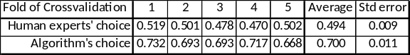
Table 1. Utility of features recommended by experts vs. those chosen automatically by multivariate logistic regression.
The data, aggregated into one record per each factory and each relevant day of data coverage, is used to train and evaluate models built with stepwise logistic regression. For feature selection and model evaluation we use AUC scores (Area Under the ROC Curve). Feature selection uses 5-fold cross-validation internally. The models selected with it are tested on a set-aside validation data in order to prevent overfitting and to identify the appropriate complexity of the final models. The performance on the validation set and the features used by each model are reported.
Results and Conclusions
Firstly, we compare predictive utility of the input features identified by human experts as the most likely indicative of behaviors with a negative impact on public health, against features automatically selected by step-wise logistic regression. Table 1 summarizes the AUC scores obtained for the individual folds of the cross-validation process. The model using the machine-selected set of 13 features vastly outperforms the model using 133 features originally considered useful in predicting risk of Salmonella.
Secondly, we study metrics that can be used for feature selection. The basic method considers average AUC score obtained from 5 cross-validation folds to decide which next feature to add to the model. The conservative method uses the average AUC less two standard errors, to reduce importance of high variance features. Further, we restrict models to only include features with positive (strictly risk-increasing) regression coefficients. Validation set AUC scores observed at subsequent stages of step-wise process for 4 possible combinations of those criteria are presented in Figure 1. They show utility of the conservative metric and a marginal loss of performance when strictly positive regressors are used.
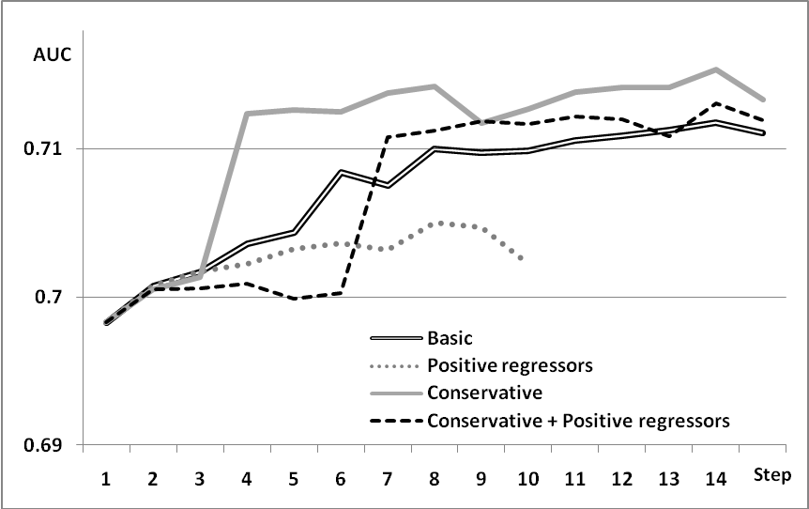
Figure 1. Performance of feature selection using various metrics.
References
[1] Dubrawski A. The Role of Data Aggregation in Public Health and Food Safety Surveillance. In: Biosurveillance: A Health Protection Priority, Eds.: T. Kass-Hout and X. Zhang. Taylor & Francis, 2010 (in press).
Acknowledgements
This work was supported in part by the U.S. Department of Agriculture (award 1040770), Centers of Disease Control and Prevention (R01-PH000028), and National Science Foundation (IIS-0911032). The authors thank Lynda Kelley of USDA, and Mark Huckabee and Adrienne Dunham of SAIC for invaluable feedback.

