
MINISTRY OF EDUCATION, CULTURE AND RESEARCH
OF THE REPUBLIC OF MOLDOVA
Technical University of Moldova
Faculty of Computers, Informatics and Microelectronics
Department of Software Engineering and Automation

Report
Laboratory Work No.10
Operational Systems
Topic: Add your own system call: trace

Done by:
Daria Tureac, st. group FAF-243

Checked by:
Reitman P., university assistant
FCIM, UTM

Chișinău – 2026

Goal
Implement the trace system call in xv6-riscv to dynamically track and print selected system calls made by a process using a binary bitmask.
Part 1: The number and the user side
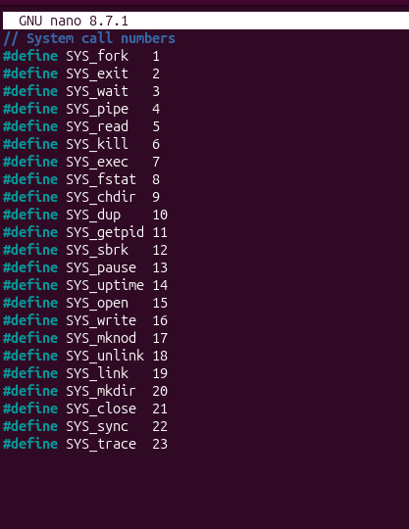
Figure 1.1 – adding SYS_trace
In kernel/syscall.h I added a new line #define SYS_trace 23. This gives the new system call its unique number, following the last existing one (SYS_sync = 22).
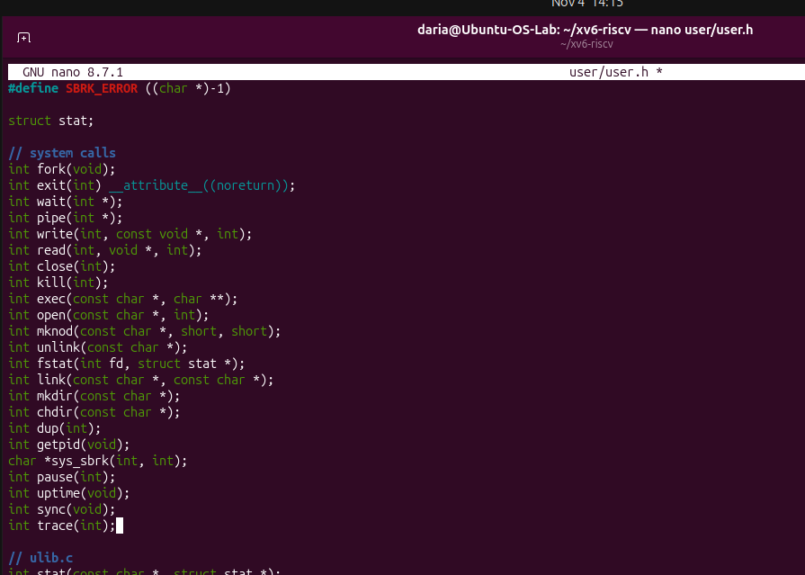
Figure 1.2 – adding trace
In user/user.h I declared the user-space prototype int trace(int); in the system calls section. It lets user programs call trace() with an integer mask.

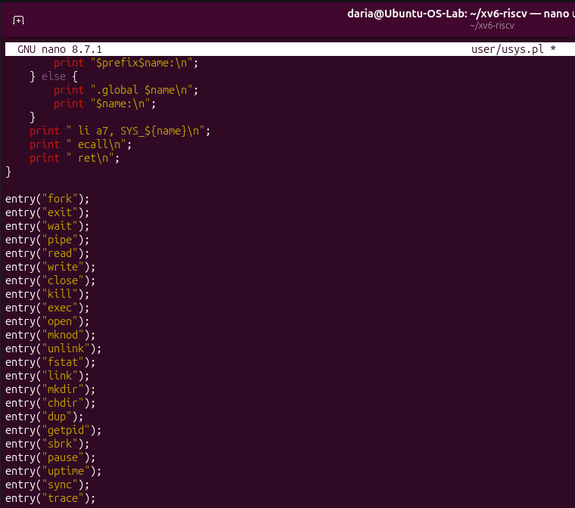
Figure 1.3 – adding entry trace
In user/usys.pl I added entry("trace"); at the end of the list. This script generates the assembly stub that loads the syscall number into register a7, executes ecall and returns.
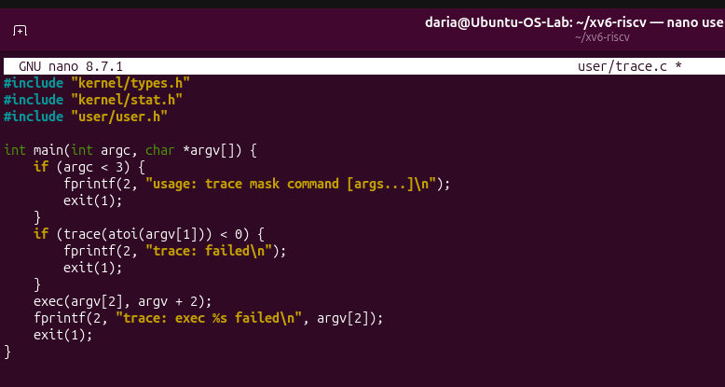
Figure 1.4 – trace.c code
This is the user/trace.c utility. It checks that at least two arguments are given (mask and command), calls trace(atoi(argv[1])) to set the mask, and then runs the command with exec. If trace or exec fails, it prints an error message and exits with code 1.
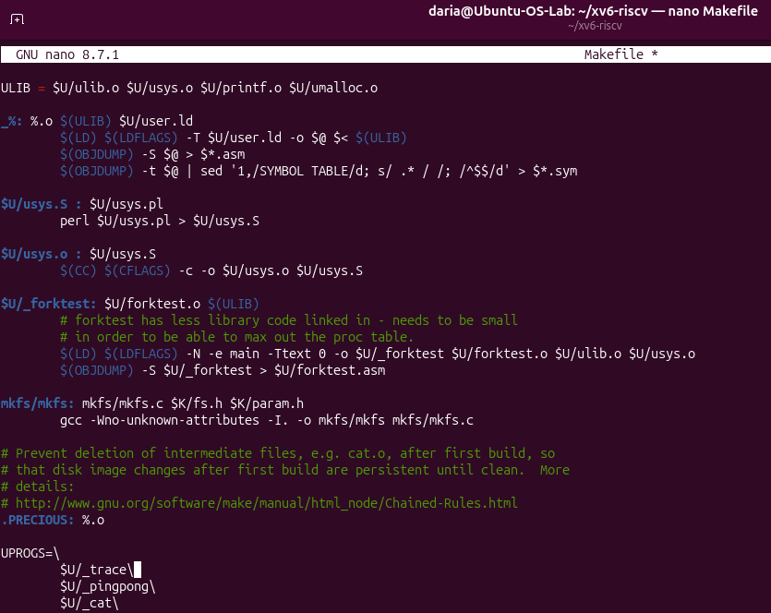
Figure 1.5 – adding trace to Makefile
In the UPROGS list of the Makefile I added $U/_trace\. Now the trace program is compiled and included in the xv6 file system image.
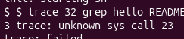
Figure 1.6 – Check 1
I ran trace 32 grep hello README after only the user-side changes. The output unknown sys call 23 and trace: failed is expected: the kernel does not have a handler for syscall 23 yet. This confirms the user side works and only the kernel part is missing.

Part 2: The kernel side

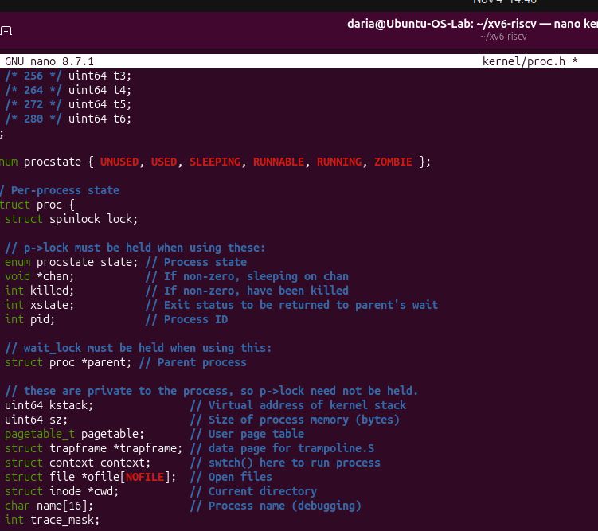
Figure 2.1 – adding trace_mask
In kernel/proc.h I added the field int trace_mask; to struct proc. Each process now stores its own mask of system calls to trace.
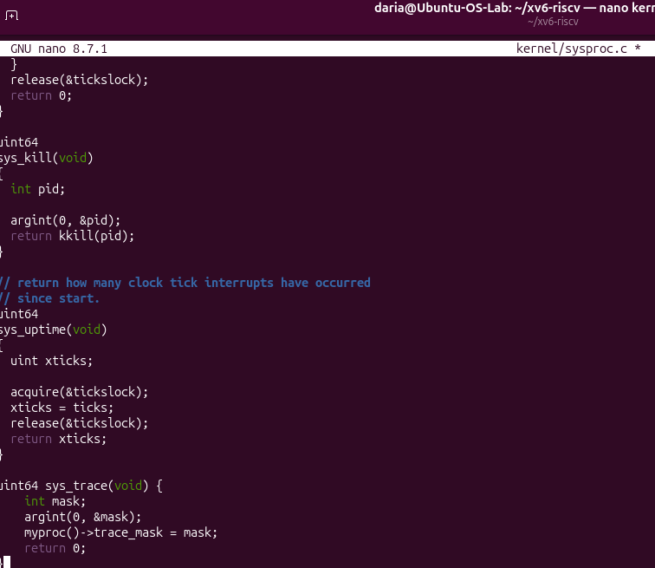
Figure 2.2 – adding handler
In kernel/sysproc.c I implemented sys_trace(). It reads the mask argument with argint(0, &mask), saves it in myproc()->trace_mask and returns 0.

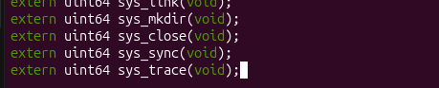
Figure 2.3 – function exists
In kernel/syscall.c I added extern uint64 sys_trace(void);. This tells the compiler that the handler is defined in another file.
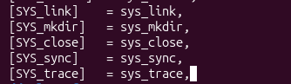
Figure 2.4 – give function a place
I added the entry [SYS_trace] = sys_trace, to the syscalls[] dispatch table. Now syscall number 23 is routed to sys_trace.
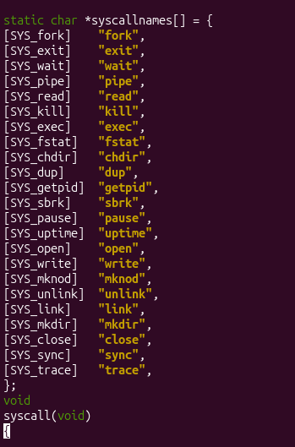
Figure 2.5 – adding table of names
I created the syscallnames[] array, which maps each syscall number to its name as a string (including "trace"). It is used to print readable names in the trace output.
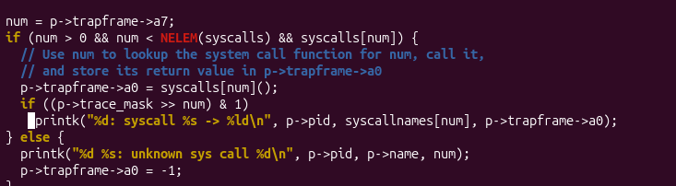
Figure 2.6 – adding new if condition
In the syscall() function, after the handler runs, I check (p->trace_mask >> num) & 1. If the bit for this syscall is set, the kernel prints pid: syscall name -> return value.

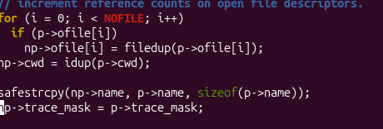
Figure 2.7 – children inherit mask
In fork() in kernel/proc.c I added np->trace_mask = p->trace_mask;. The child process copies the parent’s mask, so tracing continues in all descendants.

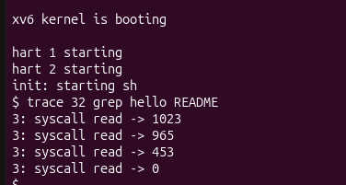
Figure 2.8 – Check 2
After rebuilding, trace 32 grep hello README works. Only read calls are printed (with return values 1023, 965, 453 and 0), because mask 32 = 2^5 enables only syscall 5 (read).

Part 3: Play with the mask

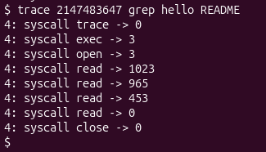
Figure 3.1 – all the calls
With mask 2147483647 (all bits set), every system call of grep is traced: trace, exec, open, several read calls and close. This shows the full sequence of syscalls used by the program.

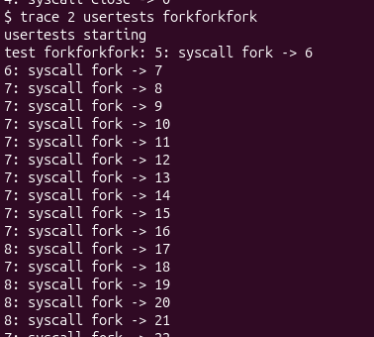
Figure 3.2 – fork trace start
I ran trace 2 usertests forkforkfork (mask 2 = fork). The beginning of the output shows fork calls from several different PIDs (5, 6, 7, 8…), which proves that the mask is inherited by child processes.

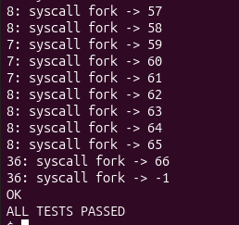
Figure 3.3 – fork trace end
The end of the same output. The last fork returns -1 because the process table is full, which is expected for this stress test. After that the test prints OK and ALL TESTS PASSED.
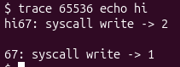
Figure 3.4 – only write
I ran trace 65536 echo hi (65536 = 2^16 = write). Only write calls are shown. echo calls write twice, once for the text hi and once for the newline, so the trace line appears between them.

Observe:
- In trace 32 grep hello README why do you see only read, and not open or close?
Mask 32 ($2^{5}$) enables only the read system call (ID 5), leaving other system calls untraced.

- In forkforkfork, three different pids print lines. Which line of code from Part 2 makes that possible?
The line np->trace_mask = p->trace_mask; in kernel/proc.c enables child processes to inherit the trace mask upon creation.

- In trace 65536 echo hi the trace line is printed between "hi" and the new line. Why? (How many times does echo call write?)
echo calls write twice (once for the text and once for the newline), causing the trace output to appear between them.

- Which mask traces both open 15. and close (21), and nothing else?
The mask is $2^{15}+2^{21}=2129920$.

Conclusion
Successfully added the trace system call and user utility, modified the kernel process control block and system call dispatch table, and verified core functionality through mask-based tracing tests.

