
MINISTRY OF EDUCATION, CULTURE AND RESEARCH
OF THE REPUBLIC OF MOLDOVA
Technical University of Moldova
Faculty of Computers, Informatics and Microelectronics
Department of Software Engineering and Automation

Report
Laboratory Work No.12
Operational Systems
Topic: Producer, Consumer and the other tools

Done by:
Daria Tureac, st. group FAF-243

Checked by:
Reitman P., university assistant
FCIM, UTM

Chișinău – 2026

Goal

To implement and master advanced synchronization primitives, including producer-consumer buffers, condition variables, readers-writers solutions, and deadlock handling.

Part 1: Producer and Consumer

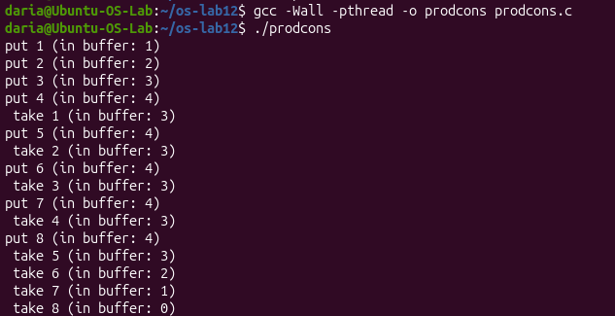
Figure 1.1 – prodcons

The producer puts items into a bounded buffer and the consumer takes them out. “In buffer” never goes above 4, because the empty semaphore blocks the producer when the buffer is full. At the end the consumer takes all remaining items and the buffer returns to 0.

Observe
- The producer is fast, yet "in buffer" never goes above 4. Which call stops it?

The sem_wait(&empty) call stops the producer when the buffer reaches capacity.

- Who waits at the start: the consumer or the producer? Which call makes it wait?

The consumer waits at the start due to the sem_wait(&full) call, since the buffer begins empty.

- In producer(), swap the first two lines: lock the mutex BEFORE sem_wait(&empty). Run it. What happens when the buffer is full, and why? (Ctrl-C to stop it, then put the lines back.)

Swapping the lines causes a deadlock when the buffer fills up because the producer holds the mutex while blocking on sem_wait(&empty), preventing the consumer from ever freeing a slot.

Part 2: The condition variable

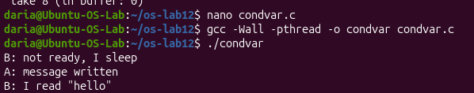
Figure 2.1 – condvar
In condvar.c thread B checks the ready flag, sees it is not ready and sleeps on the condition variable. Thread A writes the message and signals, then B wakes up and reads “hello”. The output shows the correct order of events.

Observe
- In order.c (Lab 11) the semaphore itself remembered that the message was ready. Here, which variable remembers it?

The integer variable ready remembers that the message is ready.
- Replace "while (!ready)" with "if (!ready)", compile, run. Does it still work here?

Yes, it typically still works in simple runs, but it loses the safety check required for concurrency.

- Then why do we write while? Give one reason why a thread can wake up and still find ready == 0.

We use while because a thread can experience a spurious wakeup or another thread might alter the condition before it re-acquires the lock.

Part 3: Readers and Writers

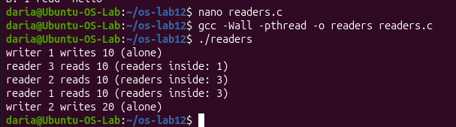
Figure 3.1 – readers

Three readers are inside the room at the same time (“readers inside: 3”), while writers 1 and 2 always write alone. This shows the readers-writers solution: many readers can share the data, but a writer needs exclusive access.

Observe
- Three readers are inside at the same time, but a writer is always alone. Which two lines of reader() make that possible?

The lines sem_wait(&room); (when readers == 1) and the rlock protection make this possible by locking out writers as soon as the first reader enters.

- Why does the counter readers need its own lock (rlock)? What could go wrong without it?

The counter readers needs rlock to prevent race conditions during concurrent updates; without it, simultaneous increments or decrements could corrupt the reader count.

- Imagine readers that keep arriving without a pause. What happens to writer 2? (This problem has a name: starvation.)

Writer 2 will experience starvation, meaning it gets delayed indefinitely because continuous incoming readers keep the room semaphore locked.

Part 4: Build a deadlock, then remove it

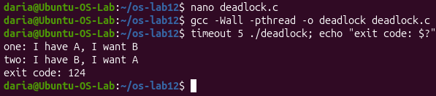
Figure 4.1 – deadlock before change

The program was run with timeout 5 and stopped by the timeout (exit code 124). Thread “one” holds mutex A and wants B, while thread “two” holds B and wants A. Neither can continue, so the program hangs in a circular wait, which is a deadlock.

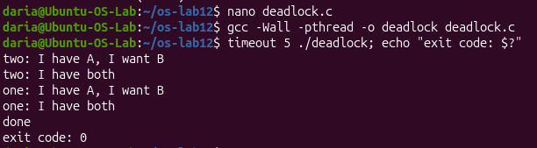
Figure 4.2 – deadlock after change

After both threads were changed to take the locks in the same order (A first, then B), the program finishes normally. Both threads get both locks, “done” is printed, and the exit code is 0. This shows that a fixed lock order removes the circular wait.

Observe
- In the stuck run, which thread holds which mutex, and which one is each thread waiting for? Draw the circle.

Thread one holds mutex A and waits for B, while thread two holds mutex B and waits for A, creating a circular wait.

- Remove both sleep(1) lines from the ORIGINAL version and run it ten times. Does it still always hang? Why is that worse, not better?

Removing the sleep lines makes the hang intermittent rather than guaranteed, which is worse because it hides a non-deterministic race condition.

- In one sentence: why can taking the locks in the same order never deadlock?

Taking locks in the same order prevents circular wait, making a deadlock impossible.

Conclusion

Successfully verified all multi-threaded programs and gained practical experience in coordinating concurrent processes safely and avoiding deadlocks.

