
MINISTRY OF EDUCATION, CULTURE AND RESEARCH
OF THE REPUBLIC OF MOLDOVA
Technical University of Moldova
Faculty of Computers, Informatics and Microelectronics
Department of Software Engineering and Automation

Report
Laboratory Work No.9
Operational Systems
Topic: Watching system calls with strace

Done by:
Daria Tureac, st. group FAF-243

Checked by:
Reitman P., university assistant
FCIM, UTM

Chișinău – 2026

Goal
To analyze the interface between user-space applications and the Linux kernel by inspecting system calls with strace and implementing low-level file I/O operations using open, read, write, and close.

Part 1: See the calls of a real command

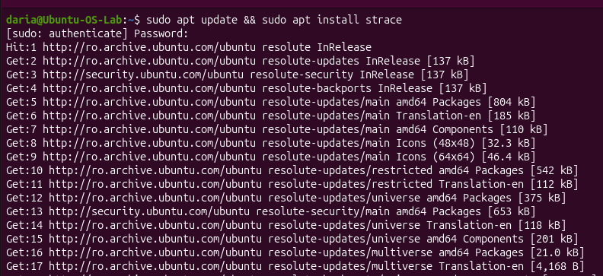
Figure 1.1 – strace install

The screenshot shows the installation of strace. The command sudo apt update && sudo apt install strace first refreshes the package lists from the Ubuntu repositories (after the sudo password is entered) and then installs strace, the utility used throughout this lab to observe system calls.

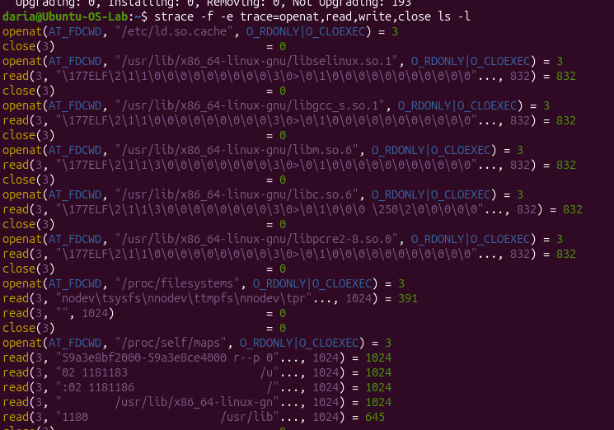
Figure 1.2 - System Call Tracing of the ls -l Command using strace

The screenshot shows the trace of ls -l restricted to four system calls (openat, read, write, close) with the -e trace option, while -f also follows child processes. In the visible part, the dynamic loader opens /etc/ld.so.cache and the shared libraries (libselinux, libgcc_s, libm, libc, libpcre2). Each openat returns descriptor 3, read fetches the 832-byte ELF header, and close returns 0, so descriptor 3 is reused for the next file. The program then reads /proc/filesystems and /proc/self/maps. The final write calls that print the listing to descriptor 1 (stdout) come later in the full trace.

Observe:
Which system call does ls use to print to the screen? To which descriptor does it write?
To print to the screen, ls uses the write system call. It writes to standard file descriptor 1, which corresponds to stdout.

Part 2: A program that calls the kernel directly

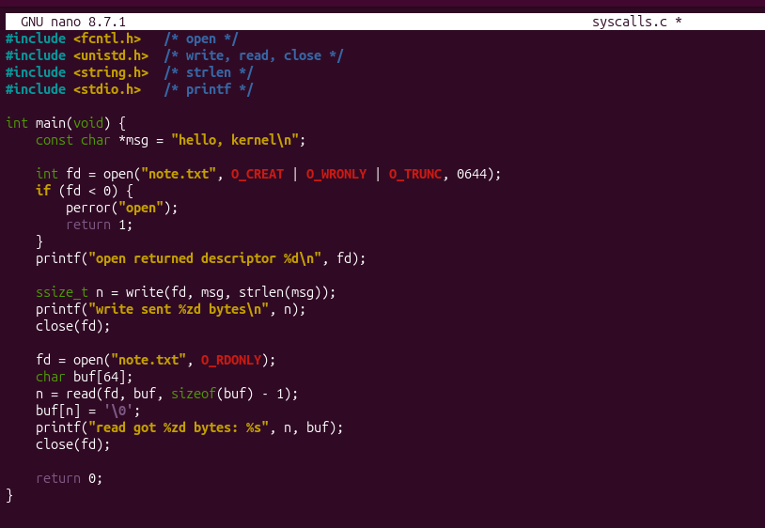
Figure 2.1 – syscalls.c code

The screenshot shows the source code of syscalls.c in the nano editor. The program creates note.txt with open() using O_CREAT | O_WRONLY | O_TRUNC and mode 0644, and prints the returned descriptor. It then writes the string “hello, kernel\n” with write() and closes the file. After that, it reopens note.txt with O_RDONLY, reads up to sizeof(buf) - 1 bytes with read(), terminates the buffer with '\0', prints the result and closes the file again.

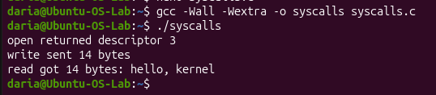
Figure 2.2 - execution and standard output of the syscalls program

The screenshot shows the program being compiled with gcc -Wall -Wextra (no warnings or errors) and then executed. The output confirms that open() returned descriptor 3, that write() sent 14 bytes (the length of “hello, kernel\n”), and that read() got the same 14 bytes back from note.txt.

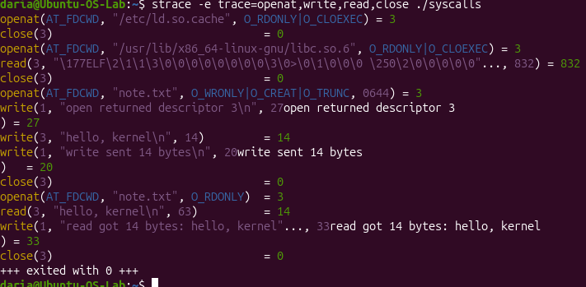
Figure 2.3 - system call tracing of the syscalls executable using strace

The screenshot shows the trace of ./syscalls filtered to openat, read, write and close. After the loader opens ld.so.cache and libc.so.6, the program’s own calls begin. openat("note.txt", O_WRONLY|O_CREAT|O_TRUNC, 0644) returns 3. The two write(1, ...) calls of 27 and 20 bytes are the printf messages sent to stdout, and write(3, "hello, kernel\n", 14) = 14 stores the text in the file. After close(3), the second openat with O_RDONLY returns 3 again, because it is the lowest free descriptor. Then read(3, ..., 63) = 14 returns the saved text, a final write(1, ...) prints it, and the program exits with status 0.

Observe:
The descriptor returned by the first openat is 3, not 0, 1 or 2. Why are those three already taken?

Descriptors 0, 1, and 2 are already reserved by the operating system for standard standard streams: standard input (stdin), standard output (stdout), and standard error (stderr), respectively. Therefore, the lowest available file descriptor for a newly opened file is 3.

Conclusion
In this laboratory, I examined how operating system services are requested through system calls. By tracing command execution and building a C program using direct kernel calls, I verified how file descriptors are managed and observed the transition between user mode and kernel mode.

