
MINISTRY OF EDUCATION, CULTURE AND RESEARCH
OF THE REPUBLIC OF MOLDOVA
Technical University of Moldova
Faculty of Computers, Informatics and Microelectronics
Department of Software Engineering and Automation

Report
Laboratory Work No.11
Operational Systems
Topic: The race and the semaphore

Done by:
Daria Tureac, st. group FAF-243

Checked by:
Reitman P., university assistant
FCIM, UTM

Chișinău – 2026

Goal

Understand race conditions in multi-threaded execution, observe thread non-determinism, and implement synchronization mechanisms (mutexes and semaphores) to ensure mutual exclusion, signaling, and resource counting.

Part 1: See the race

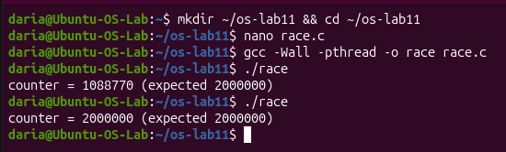
Figure 1.1 - Race condition output showing incorrect and varying counter values

Observe
- counter++ looks like one step. Write the three steps the CPU really does.

The CPU reads the current value of counter into a register, increments that value by 1, and writes the updated value back to memory.

- Describe, with those steps, how two threads can lose one addition.

If Thread A and Thread B both read the same initial value from memory, they will independently increment it and overwrite each other's updates, resulting in two increments being counted as one.

- Why is the result different at every run?

The result varies because the operating system's thread scheduler interleaves thread execution non-deterministically, changing the exact timing of race conditions on every run.

Part 2: Fix it: mutex, then semaphore

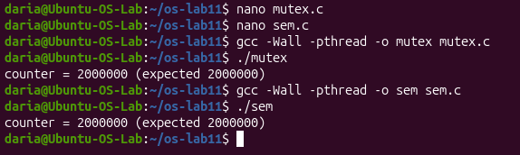
Figure 2.1 - Protected counter output showing the expected 2000000 value using mutex and semaphore

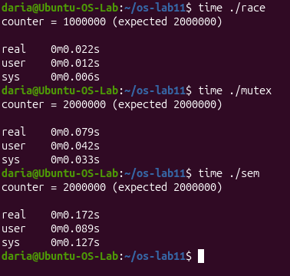
Figure 2.2 – Time for race, mutex and semaphore

Observe
- Run mutex and sem three times each. Is the answer always 2 000 000?

Yes, the answer is always 2,000,000 because mutual exclusion prevents race conditions.

- What would happen in sem.c with sem_init(&s, 0, 2)? Try it and explain.

It allows two threads into the critical section simultaneously, leading to a race condition and an incorrect counter value.

- Why is the locked version slower?

It is slower due to the performance overhead of synchronization primitives and lock contention.

Part 3: A semaphore as a signal

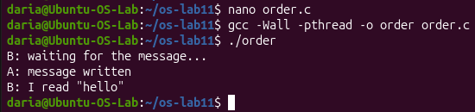
Figure 3.1 - Thread synchronization order using a zero-initialized semaphore signal

Observe
- Change the start value to 1 (sem_init(&ready, 0, 1)), compile, run. What does B read now, and why?

B reads an empty string (or uninitialized data) because the semaphore starts at 1, allowing B to proceed immediately before A has time to write "hello".

- Put it back to 0. In one sentence: what does a semaphore that starts at 0 mean?

A semaphore that starts at 0 acts as a blocking synchronization signal, meaning the waiting thread must pause until another thread posts to unlock it.

Part 4: A semaphore as a counter: the parking lot

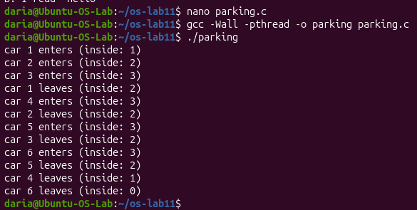
Figure 4.1 - Parking simulation output managed by a semaphore counting free places

Observe
- What is the largest value of "inside" you see? Which line of code guarantees it?

The largest value of "inside" is 3, which is guaranteed by #define PLACES 3 and the initial capacity set in the semaphore.

- Set PLACES to 1. What does the semaphore become?

Setting PLACES to 1 turns the counting semaphore into a binary semaphore, making it function just like a mutex.

Conclusion

Successfully demonstrated how unsynchronized concurrent access leads to data races, resolved the race conditions using mutexes and semaphores, and effectively utilized semaphores for thread signaling and managing shared resource limits.

