
MINISTRY OF EDUCATION, CULTURE AND RESEARCH
OF THE REPUBLIC OF MOLDOVA
Technical University of Moldova
Faculty of Computers, Informatics and Microelectronics
Department of Software Engineering and Automation

Report
Laboratory Work No.13
Operational Systems
Topic: Semaphores in your own kernel

Done by:
Daria Tureac, st. group FAF-243

Checked by:
Reitman P., university assistant
FCIM, UTM

Chișinău – 2026

Goal

To implement counting semaphores inside the xv6 kernel as new system calls (sem_init, sem_down, sem_up) utilizing spinlocks and the kernel's sleep/wakeup mechanism.

Part 1: The numbers and the user side

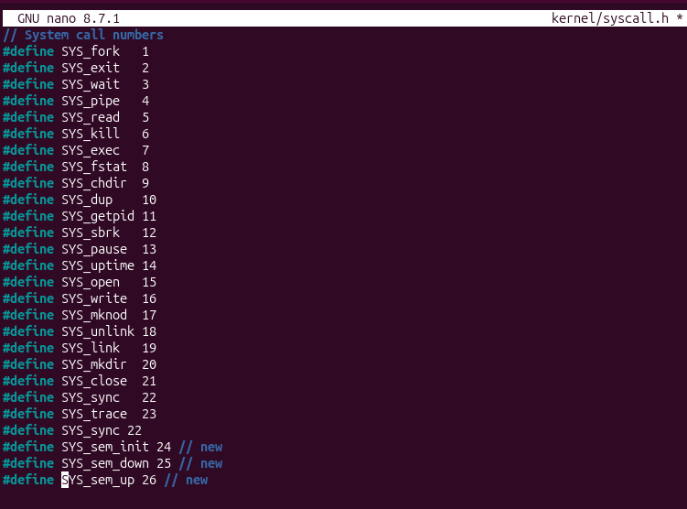
Figure 1.1 - kernel/syscall.h: the numbers

Three new system call numbers were added at the end of the list: SYS_sem_init (24), SYS_sem_down (25) and SYS_sem_up (26). The kernel uses these numbers to identify the new system calls.

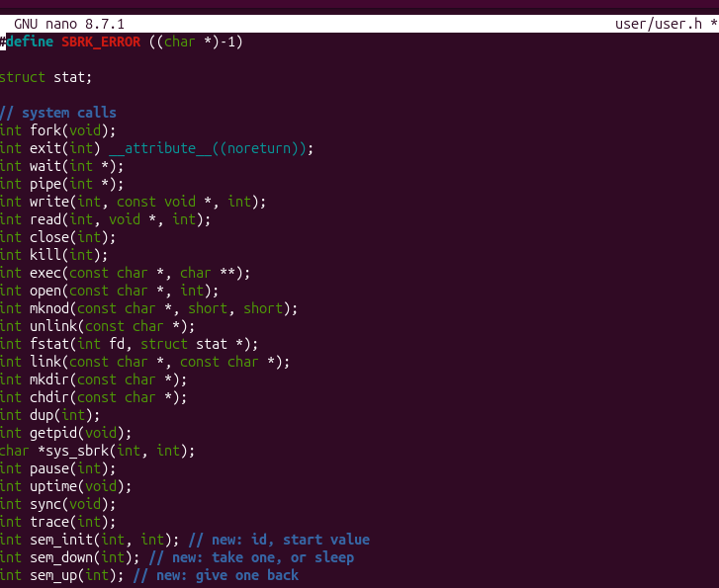
Figure 1.2 - user/user.h: the declarations
The prototypes of sem_init(int, int), sem_down(int) and sem_up(int) were added to user.h. This lets user programs call the new system calls like normal functions.

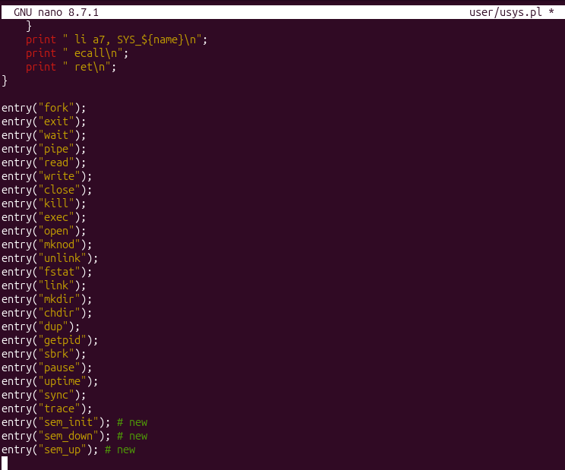
Figure 1.3 - user/usys.pl: the stubs

Three new entry() lines were added for sem_init, sem_down and sem_up. The script uses them to generate the assembly stubs that load the syscall number and execute ecall to enter the kernel.

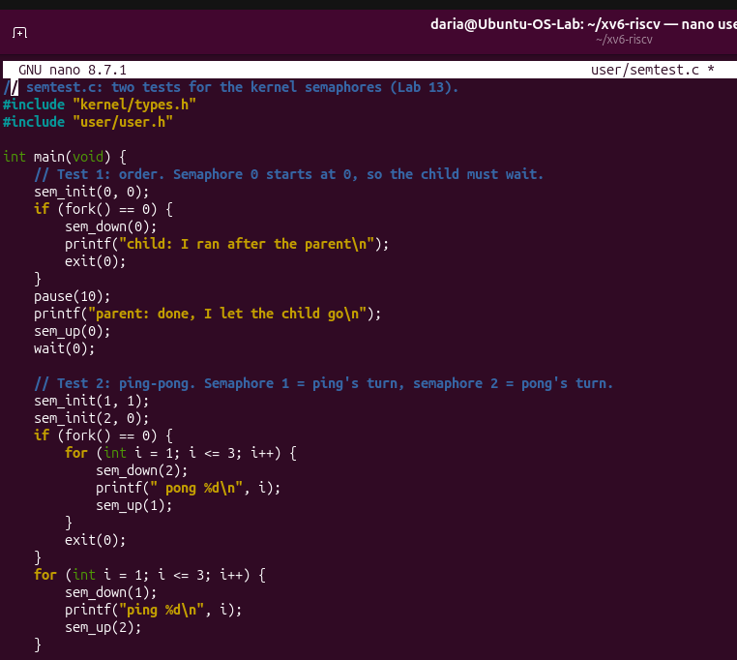
Figure 1.4 - user/semtest.c: the test

The test program has two parts. Test 1 checks ordering: semaphore 0 starts at 0, so the child must wait until the parent calls sem_up. Test 2 is a ping-pong between two processes using semaphores 1 and 2, which forces the output to alternate strictly.

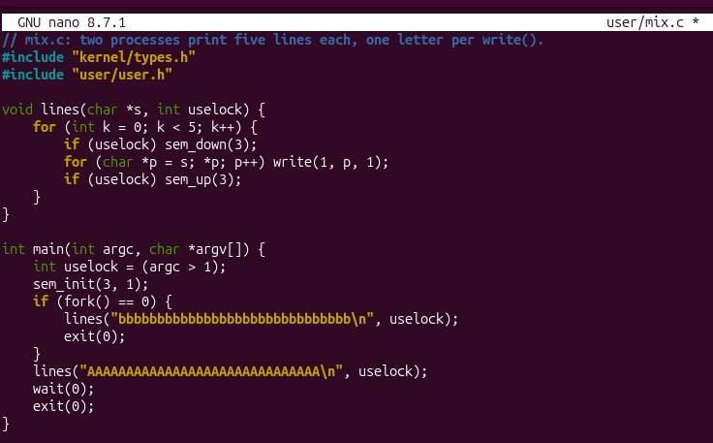
Figure 1.5 - user/mix.c: two processes on one screen

Two processes print five lines each, one letter per write() call. If a lock argument is given, every line is wrapped in sem_down(3) and sem_up(3), which makes the whole line a critical section.

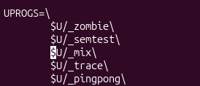
Figure 1.6 – UPROGS adding

_semtest and _mix were added to the UPROGS list in the Makefile, so the new user programs are built and included in the xv6 file system.

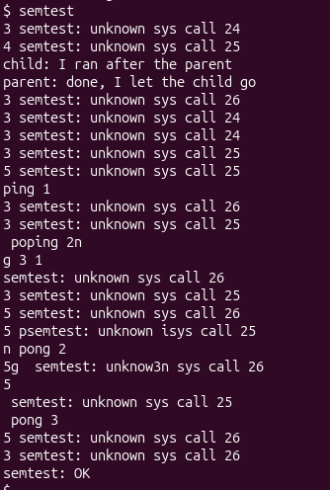
Figure 1.7 – check 1

semtest was run before the kernel part was written. The output is full of “unknown sys call 24/25/26” messages, which is expected: the user side already calls the new system calls, but the kernel does not know them yet.

Part 2: The kernel side

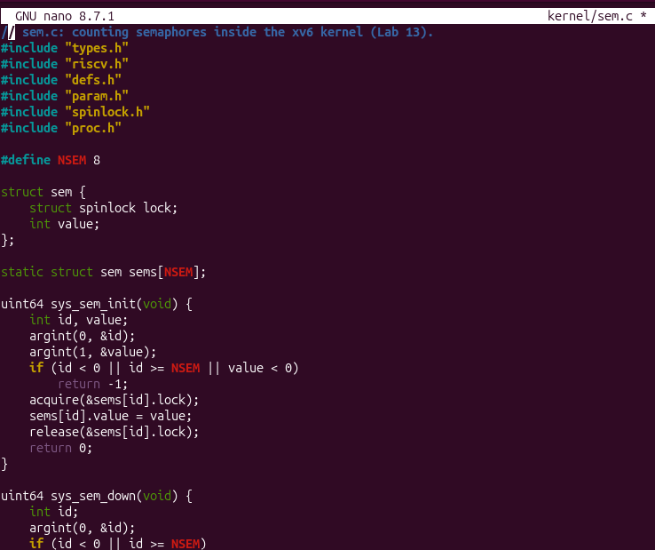
Figure 2.1 - kernel/sem.c: the semaphores

The new kernel file defines a table of NSEM = 8 semaphores, each with a spinlock and a value. sys_sem_init checks the arguments (id and value) and sets the starting value under the lock. The same file also contains sys_sem_down (sleeps while the value is 0) and sys_sem_up (increases the value and wakes up sleepers).

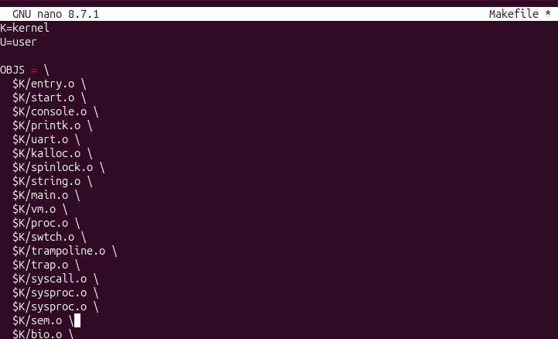
Figure 2.2 - Makefile: compile sem.c into the kernel

$K/sem.o was added to the OBJS list, so sem.c is compiled and linked into the kernel.

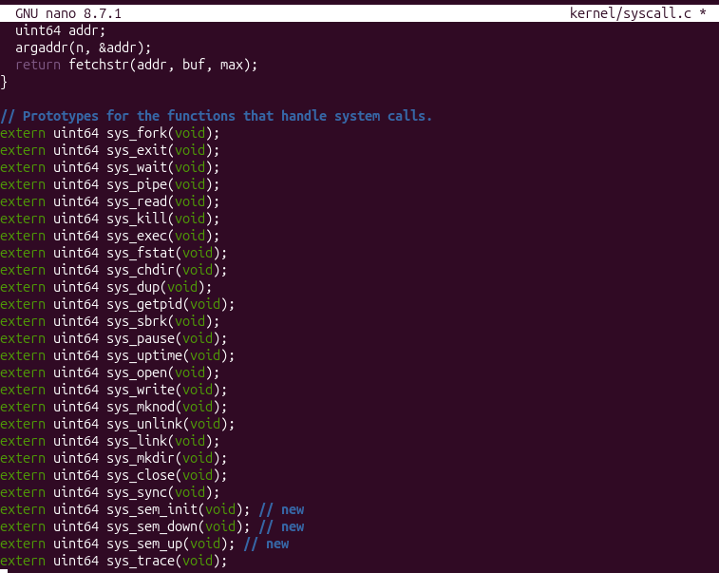
Figure 2.3 - kernel/syscall.c: the table 1

The extern prototypes of sys_sem_init, sys_sem_down and sys_sem_up were added, so that syscall.c knows these functions exist in sem.c.

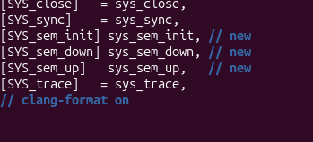
Figure 2.4 - kernel/syscall.c: the table 2

The new entries [SYS_sem_init], [SYS_sem_down] and [SYS_sem_up] were added to the syscall table. This connects each syscall number to its kernel handler function.

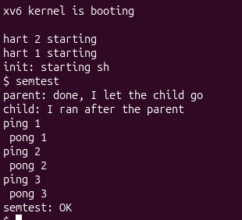
Figure 2.5 – check 2

After rebuilding, semtest runs without errors. The parent prints before the child (“parent: done” → “child: I ran after the parent”), ping and pong alternate three times, and the program ends with semtest: OK. This confirms that the kernel semaphores work.

Part 3: A semaphore as a lock: mix

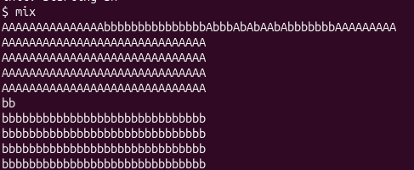
Figure 3.1 – mix without lock

Without the lock, the letters of the two processes are mixed inside the first line (for example AAAA...bbbb...AbbbAbAbAAb...). This happens because one line needs many write() calls, and the scheduler can switch between the processes after any of them.

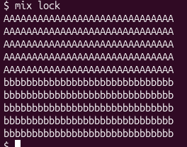
Figure 3.2 – mix with lock

With mix lock, every line is printed whole: first five lines of A, then five lines of b. The semaphore makes each line a critical section, so the other process cannot print in the middle of it.

Observe
- Without the lock, why do the letters mix? (How many system calls does one line cost?)

Without the lock, the operating system can switch between processes at any time during execution. Printing a single line requires multiple write() system calls (one per character), causing the character outputs from concurrent processes to interleave.

- With the lock every line is whole. Which two lines of mix.c make one line a critical section?

The lines sem_down(3); before the write loop and sem_up(3); after it define the critical section.

- In sem_down the test is "while (s->value == 0)", not "if". Why can a process wake up and still find 0?

A process might wake up due to a broadcast or spurious wakeup, or another competing process might acquire the resource before the newly awakened process gets scheduled.

- sem_down calls release(&s->lock) BEFORE sleep(). What would go wrong if it slept holding the spinlock?

Sleeping while holding a spinlock would cause a kernel deadlock, because no other CPU could acquire that spinlock to call sem_up and change the state needed to wake up the sleeping process.

Conclusion

Successfully verified kernel-level process synchronization and mutual exclusion using semtest and mix utilities, completing Lab 13.

