
MINISTRY OF EDUCATION, CULTURE AND RESEARCH
OF THE REPUBLIC OF MOLDOVA
Technical University of Moldova
Faculty of Computers, Informatics and Microelectronics
Department of Software Engineering and Automation

Daria Tureac FAF-243

Report
Laboratory Work No.4
Operational Systems

Checked by:
Reitman P., university assistant
FCIM, UTM

Chișinău – 2026

Before you start

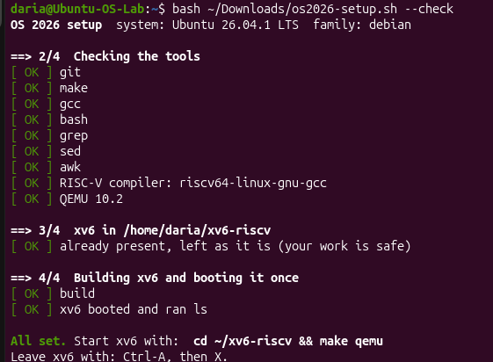
Figure 1 – Before you start

Part 1
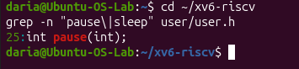
Figure 1.1 - The grep result in user.h
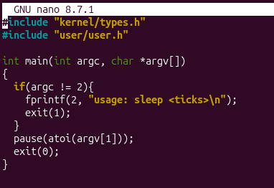
Figure 1.2 - The updated sleep.c
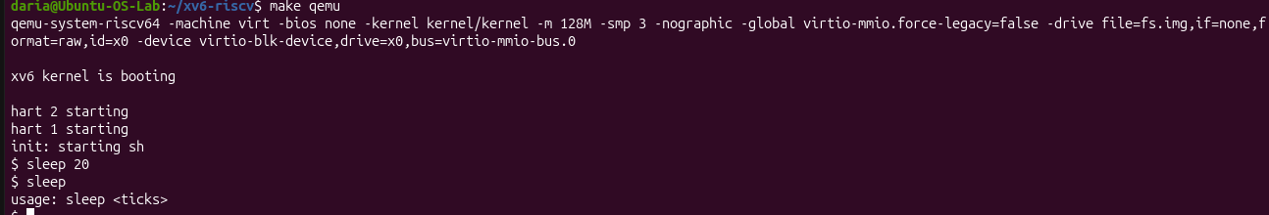
Figure 1.3 - sleep running in xv6, with and without an argument

Part 2
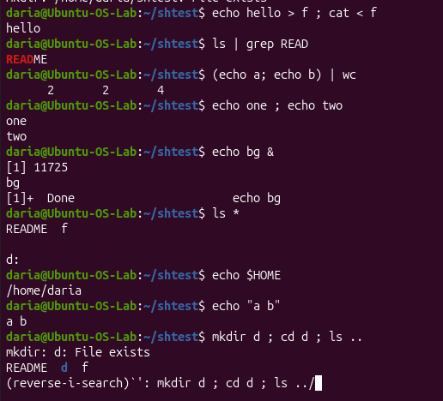
Figure 2.1 - The commands run in bash
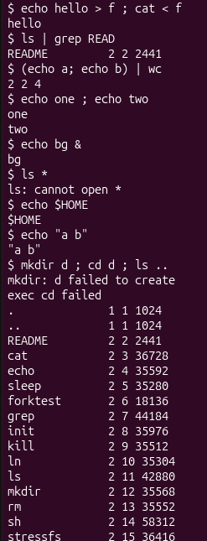
Figure 2.2 - The same commands run in xv6

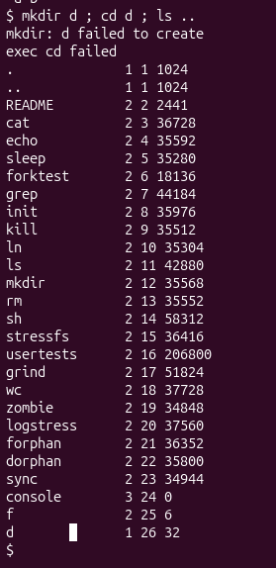
Figure 2.3 - ls failing after cd d, and the working alternative.

Command | Tests | bash | xv6
echo hello > f ; cat < f | redirection | hello | hello
ls | grep READ | pipe | README | README 2 2 2241
(echo a; echo b) | wc | grouping, list | 2 2 4 | 2 2 4
echo one ; echo two | sequence | one  two | one  two
echo bg & | background | [1] 11725  bg  [1]+ Done echo.bg | bg
ls * | globbing | README f  d: | ls: cannot open *
echo $HOME | variables | /home/daria | $HOME
echo "a b" | quotes | a b | "a b"
mkdir d ; cd d ; ls .. | PATH | mkdir: d: File exists  README d f | mkdir d: failed to create  exec cd failed
arrow up, Tab, Ctrl+R | history, completion | (reverse-i-search)’ : mkdir d ; cd d ; ls ../ | Nothing changed

Observe:
- List the features both shells have, and the ones only bash has.
Features in both vs. only in bash: Both shells support basic I/O redirection (<, >), pipes (|), command sequencing (;), and background execution (&); only bash supports globbing (*), environment variables ($HOME), string quoting ("a b"), subshell grouping (), command history, and Tab completion.
- In xv6, ls stops working after cd d. Why? Find a way to run ls from inside d anyway.(Hint: where do the xv6 programs live?)
Why ls fails after cd d and alternative: xv6 lacks a PATH environment variable and searches for executables exclusively in the current working directory, where d/ls does not exist. It can be executed using its absolute or relative path: /ls .. or ../ls ...
3. Which missing feature would you miss most in daily work, and which would be easiest to add?
Most missed vs. easiest to add: Tab completion and command history would be missed most for daily terminal productivity, while a basic PATH lookup mechanism (e.g., falling back to check the root / directory when a command is not found in the current folder) would be the easiest feature to implement in user/sh.c.

Part 3
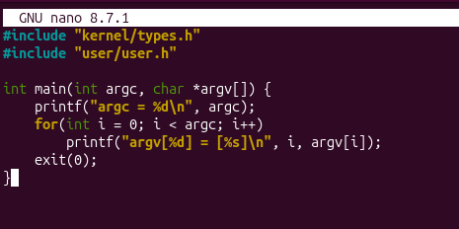
Figure 3.1 - args.c

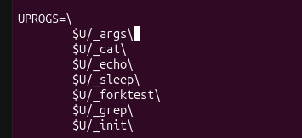
Figure 3.2 - UPROGS line
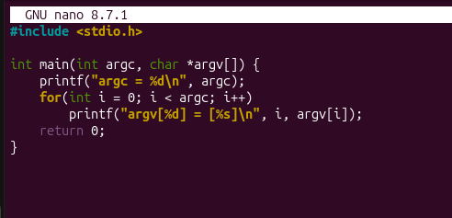
Figure 3.3 - args_linux.c
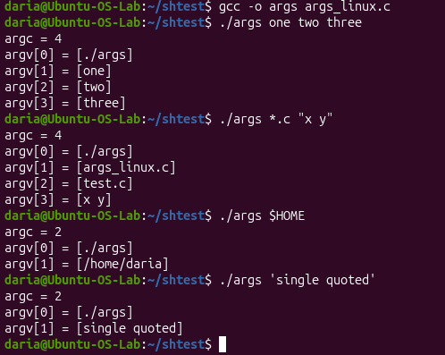
Figure 3.4 - args_linux output in bash

Observe:

- Paste both outputs for args *.c "x y". How many arguments did each program receive?
Linux (bash):
- Output:
argc = 4
argv[0] = [./args]
argv[1] = [args_linux.c]
argv[2] = [test.c]
argv[3] = [x y]
- Argument count: The program received 4 arguments (including argv[0]).
xv6:
- Output:
argc = 3
argv[0] = [args]
argv[1] = [*.c]
argv[2] = ["x y"]
- Argument count: The program received 3 arguments (including argv[0]).

- So who turns *.c into file names and removes the quotes: the program, the kernel, orthe shell?
The shell performs expansion (*.c) and quotes stripping ("x y"), not the kernel and not the user program itself. bash processes and transforms the command-line arguments before executing the binary, whereas the basic xv6 shell lacks wildcard expansion and quote parsing, passing the literal strings directly to the program.
3. What happened to the extra spaces in one two three?
The extra spaces were ignored and treated solely as argument delimiters. The shell parses the input line, strips away all consecutive whitespace separators, and passes only the individual tokens (one, two, and three) into the argv array.

Part 4
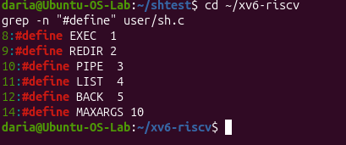
Figure 4.1 - The command kinds defined in sh.c
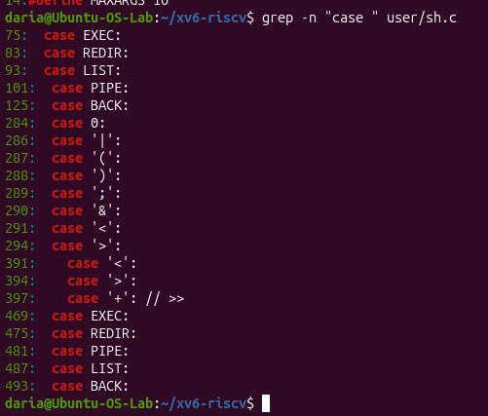
Figure 4.2 - Where each kind is run
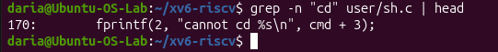
Figure 4.3 - The code that handles cd
Observe:
  - Name the five kinds of command the xv6 shell knows and the character that produces each.
Simple command / Executable: regular commands (no special character, represented by ' ' / EXEC).
Redirection: produced by < (input) or > (output) (represented by '<' or '>' / REDIR).
Pipe: produced by | (represented by '|' / PIPE).
List / Sequence: produced by ; (represented by ';' / LIST).
Background execution: produced by & (represented by '&' / BACK)

  - Where is cd handled, and why is it not run as a separate program?
Where it is handled: cd is implemented as a built-in command directly inside the main loop of user/sh.c (in main(), checked via buf[0] == 'c' && buf[1] == 'd').
Why it cannot be a separate program: When a shell executes an external program, it calls fork() to create a child process. If cd were a separate executable, it would change the current working directory of the child process only, leaving the shell's own working directory unchanged when the process terminates.

3. Search sh.c for any code that handles * or $. What does that explain about Part 2?
Search result: Searching for * or $ in user/sh.c yields no code for handling wildcard expansion or environment variables.
Explanation for Part 2: This explains why commands like ls * and echo $HOME did not work as expected in xv6 during Part 2. The xv6 shell treats * and $ as literal text characters and passes them unchanged to argv, unlike bash which performs globbing and variable expansion prior to command execution.

Conclusion
In this lab, we explored the inner workings of the xv6 shell by comparing its minimalistic architecture with the feature-rich Linux bash environment. Through hands-on experimentation, we observed how key shell responsibilities—such as I/O redirection, piping, argument parsing, wildcard expansion, and built-in command handling (cd)—are executed at the system level. Ultimately, analyzing user/sh.c demonstrated how a compact codebase provides fundamental command-line functionality while highlighting the distinct boundary between shell-level parsing and kernel-level execution.

