
MINISTRY OF EDUCATION, CULTURE AND RESEARCH
OF THE REPUBLIC OF MOLDOVA
Technical University of Moldova
Faculty of Computers, Informatics and Microelectronics
Department of Software Engineering and Automation

Report
Laboratory Work No.7
Operational Systems
Topic: Three Small Programs: Processes, Redirection, a Pipe

Done by:
Daria Tureac, st. group FAF-243

Checked by:
Reitman P., university assistant
FCIM, UTM

Chișinău – 2026
Goal

The goal is to investigate process creation, standard output behavior, and pipeline mechanisms by compiling, executing, and modifying pre-written C programs.

Part 1: fork + exec + wait

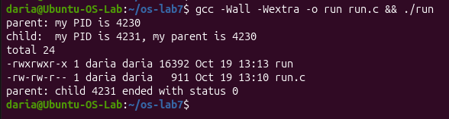
Figure 1.1 – ls

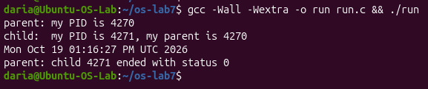
Figure 1.2 – date

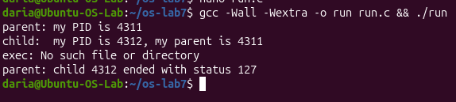
Figure 1.3 – nosuchprog

Observe
- The line perror("exec") is in the child, right after execlp. Why is it printed only with nosuchprog?
It is printed only with nosuchprog because a successful execlp call replaces the current process image entirely, meaning any code after it runs only if the execution fails.
- Which number does the child print as "my parent", and whose PID is it?
The child prints the PID of the original parent process (4230 in Figure 1.1), which is the PID of the process that called fork.
- What status does the parent see with ls, and what status with nosuchprog?
The parent sees status 0 with ls (success) and status 127 with nosuchprog (indicating a command-not-found error).

Part 2 : A zombie, on purpose

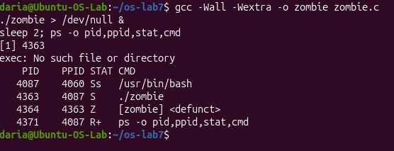
Figure 2.1 – initial

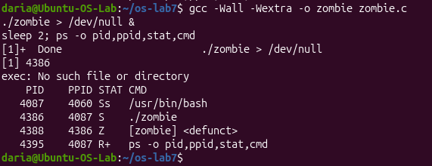
Figure 2.2 – after 20 sec

Observe
- Which letter does ls have in the STAT column, and what does it mean?
In the STAT column, it has the letter Z, which means a zombie process (defunct).
2. After 20 seconds, is the [ls] <defunct> line still there? Which line of zombie.c made it disappear?
After 20 seconds, the line is no longer there because the waitpid(pid, &status, 0); line in zombie.c reaped the zombie process.

Part 3: Redirection: ls -l > out.txt
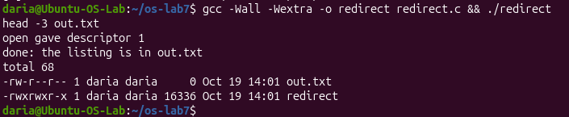
Figure 3.1 – redirect
Observe
- Which number did open give, and why exactly that one?
open gave descriptor 1 because it is the lowest available file descriptor after close(1) freed it.
- ls was not changed at all. Why does its listing not appear on the screen?
ls writes to standard output (descriptor 1), which was redirected to out.txt
- To redirect the errors instead (like 2> err.txt), which descriptor would you close before open?
I would close descriptor 2 (standard error).

Part 4: A pipe: ls/etc | wc -l

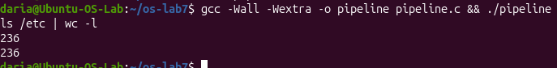
Figure 4.1 – pipeline
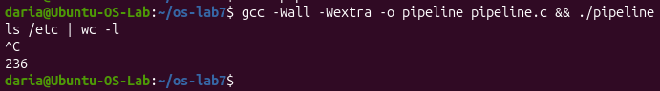
Figure 4.2 – pipeline hang

Observe
- Did ./pipeline and ls /etc | wc -l give the same number?
Yes, both ./pipeline and ls /etc | wc -l gave the exact same number (236).

- After the change, which of the two children never ends, ls or wc?
After the change, the wc child never ends.

- Why, in one sentence: what is wc waiting for?
wc is waiting for an EOF (End-of-File) signal that never arrives because the parent process still has the write end of the pipe (p[1]) open

Conclusion

In this laboratory work, we successfully explored core Linux process management concepts by implementing programs that utilize fork, exec, and wait system calls. We analyzed process lifecycle states through zombie processes, managed file descriptors for standard output redirection, and constructed inter-process communication pipelines using pipes.

