
MINISTRY OF EDUCATION, CULTURE AND RESEARCH
OF THE REPUBLIC OF MOLDOVA
Technical University of Moldova
Faculty of Computers, Informatics and Microelectronics
Department of Software Engineering and Automation

Report
Laboratory Work No.3
Operational Systems
Topic:The Command Line: Shell, Pipes and Text Filters

Done by:
Daria Tureac, st. group FAF-243

Checked by:
Reitman P., university assistant
FCIM, UTM

Chișinău – 2026

Goal

The goal is to build proficiency in Bash navigation and command-line evaluation, master input/output redirection, and analyze data efficiently using single-line command pipelines.

Before you start:
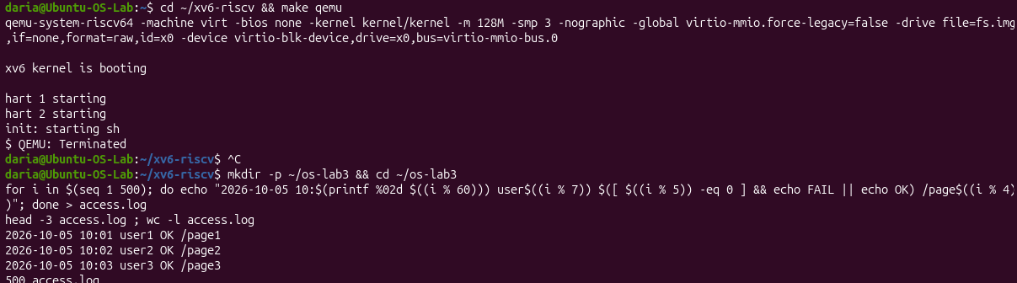
Figure 1 – Before you start
The screenshot shows xv6 booting in QEMU and then terminating with Ctrl+C. Below it, the os-lab3 directory is created and a 500-line access.log is generated with a loop. head -3 and wc -l confirm that the file has the expected format and size.

Part 1

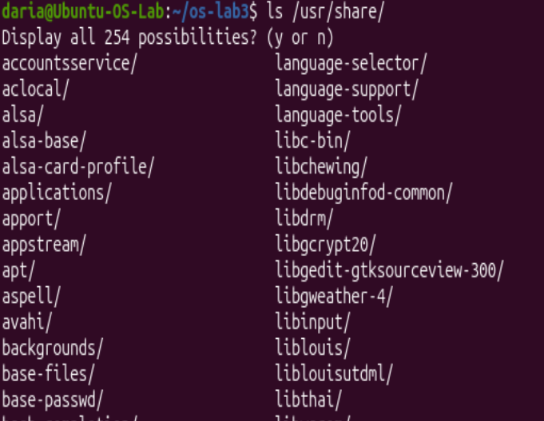
Figure 1.1 – Tab Completion
Typing ls /usr/share/ and pressing Tab twice makes the shell ask “Display all 254 possibilities?”. This shows that Tab completion lists every entry in the directory when there is no unique match.

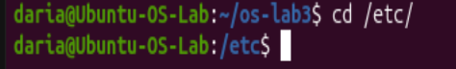
Figure 1.2 – etc completion
Typing cd /etc/ and completing it with Tab shows the shell finishing the path automatically. The prompt then changes to /etc, so the current directory has changed.

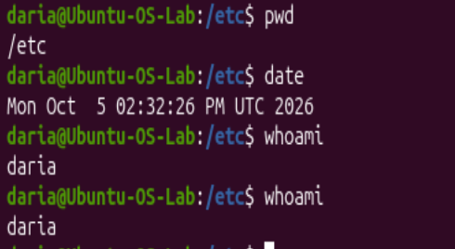
Figure 1.3 – Ctrl+R result
The terminal shows pwd, date and whoami run in sequence. The second whoami was recalled from history with Ctrl+R (reverse search), so the command did not need to be typed again.

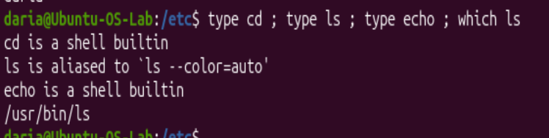
Figure 1.4 – Output of type and which
type reports that cd and echo are shell builtins, while ls is an alias for ls --color=auto. which ls shows the real executable at /usr/bin/ls. So ls is an external program and cd and echo are built into the shell.
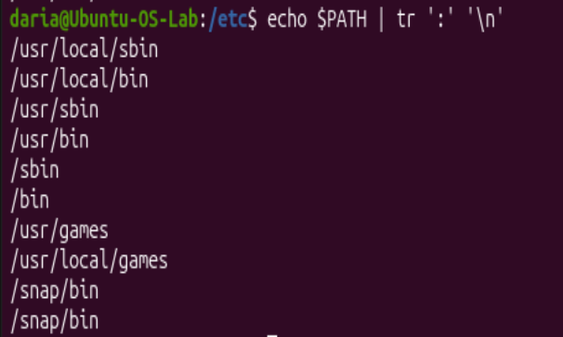
Figure 1.5 – The directories in PATH
echo $PATH | tr ':' '\n' prints each PATH entry on its own line, from /usr/local/sbin to /snap/bin. This shows the directories the shell searches for executables, in order, and that there are 10 of them.
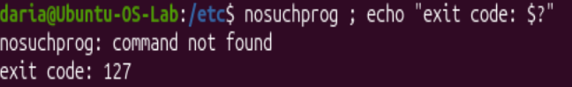
Figure 1.6 - Exit code of a missing command
Running the non-existent nosuchprog gives “command not found”. echo $? then prints exit code 127, which is the standard code for a missing command.


Figure 1.7 – sort by time
In the man ls page, the -t option sorts files by modification time, newest first. The word “Sort” is highlighted by the search.

Observe
- Which of cd, ls, echo are built-ins, and why MUST cd be one?
Both cd and echo are shell built-ins, whereas ls is an external utility. cd MUST be a built-in command because it changes the working directory of the shell process itself; an external program would only change the directory for its own child process without affecting the parent shell.
- How many directories are in your PATH, and in which one is ls?
In my PATH are 10 directories, /usr/bin/ls – is ls.
- What exit code does a command that is not found return?
A non-existent command returns exit code 127.
- Which option of ls sorts by modification time?
In man ls, the option to sort files by modification time is -t.

Part 2
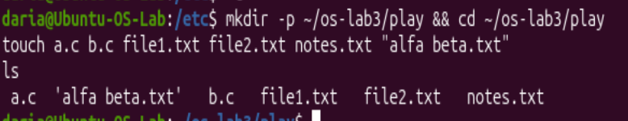
Figure 2.1 - Files created in the play directory
The play directory is created and filled with a.c, b.c, file1.txt, file2.txt, notes.txt and a file with a space in its name, alfa beta.txt. ls shows the file with the space wrapped in quotes.
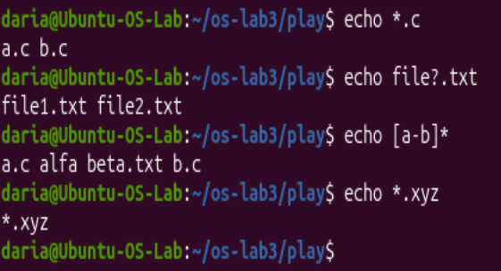
Figure 2.2 - Globbing results
*.c, file?.txt and [a-b]* are expanded by the shell into matching file names. *.xyz matches nothing, so it is printed unchanged.
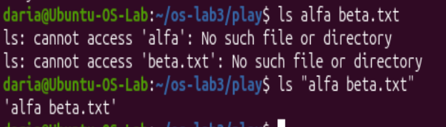
Figure 2.3 - The ls error on a name with a space, and the fix
Unquoted ls alfa beta.txt fails, because the shell splits it into two separate arguments. Quoting it as "alfa beta.txt" keeps it as one argument, and ls finds the file.
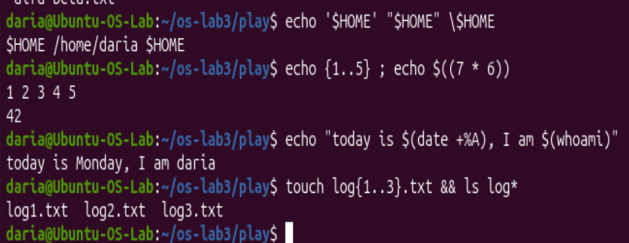
Figure 2.4 - Single quotes, double quotes and backslash
Single quotes and the backslash print $HOME literally, while double quotes expand it to /home/daria. The rest of the screenshot shows brace expansion ({1..5}), arithmetic ($((7 * 6)) = 42), command substitution inside double quotes, and log{1..3}.txt creating three files at once.

Observe:
1. Command | My prediction | Real output | Explanation (if different)
echo *.c | No such file or directory | *.c | Expected Bash to throw an error, but unmatched wildcards are passed literally as strings.
echo file?.txt | file1.txt | file?.txt | Expected ? to match a dummy file, but since no file exists, Bash prints the pattern literally.
echo [a-b]* | [a-b]* | access.log | Predicted a literal string, but [a-b]* matched access.log starting with 'a'.
echo *.xyz | (empty line) | *.xyz | Assumed unmatched globs evaluate to nothing, but Bash returns the unexpanded string.
ls alfa beta.txt | ls: cannot access 'alfa beta.txt' | ls: cannot access 'alfa': No such file...  ls: cannot access 'beta.txt': No such file... | Expected space to be part of the filename, but unquoted spaces split arguments into two separate targets.
ls "alfa beta.txt" | ls: cannot access 'alfa beta.txt': No such file or directory | ls: cannot access 'alfa beta.txt': No such file or directory | Prediction matched because double quotes preserve the space inside a single argument.
echo '$HOME' "$HOME" \$HOME | /home/daria /home/daria /home/daria | $HOME /home/daria $HOME | Expected $HOME to expand everywhere, but single quotes and \ suppress variable evaluation.
echo {1..5} ; echo $((7 * 6)) | {1..5}  7 * 6 | 1 2 3 4 5  42 | Did not expect Bash brace expansion {1..5} or automatic arithmetic calculation $((...)).
echo "today is $(date +%A), I am $(whoami)" | today is $(date +%A), I am $(whoami) | today is Monday, I am daria | Expected literal text inside quotes, but $(...) command substitution executes inside double quotes.
touch log{1..3}.txt && ls log* | log1.txt log2.txt log3.txt | log1.txt log2.txt log3.txt | Prediction matched because brace expansion creates 3 files and log* globs all of them.

- echo knows nothing about files, yet echo *.c printed file names. Who produced them?
The shell performed glob expansion on *.c and passed the resulting filenames as arguments to echo before the command was executed.
- Why did ls alfa beta.txt fail? Give two different ways to fix it.
ls alfa beta.txt failed because the shell split the string into two separate arguments: alfa and beta.txt. To fix it, quote the filename as "alfa beta.txt" or escape the space as alfa\ beta.txt.

- What is the difference between single and double quotes?
Single quotes (' ') preserve the literal value of all characters and prevent all expansions. Double quotes (" ") allow variable expansion ($HOME), command substitution ($(...)), and arithmetic expansion ($((...))).

Part 3
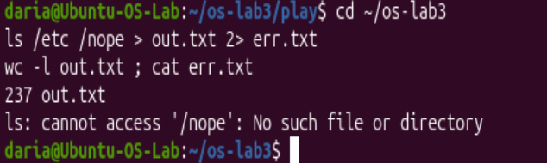
Figure 3.1 - stdout and stderr in separate files.
ls /etc /nope > out.txt 2> err.txt sends the listing to out.txt (237 lines) and the error message to err.txt. This shows that stdout and stderr are independent streams.
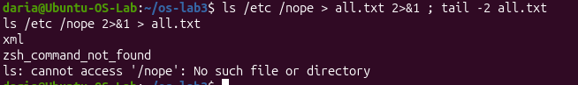
Figure 3.2 – Comparing the order of redirections
With > all.txt 2>&1, both streams end up in the file. With 2>&1 > all.txt, the error cannot access '/nope' still appears on the terminal, because stderr was duplicated to the terminal before stdout was redirected.
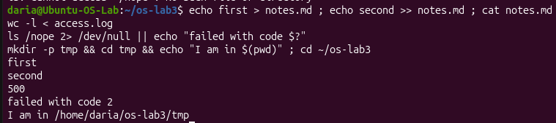
Figure 3.3 - The ; && || operators
The screenshot shows > and >> writing to notes.md, and wc -l < access.log printing only the number 500. After ls /nope 2> /dev/null, the || branch runs and prints “failed with code 2”. Finally mkdir -p tmp && cd tmp && echo ... shows && chaining commands that succeed.
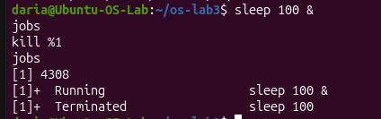
Figure 3.4 - Running a background job and stopping it
sleep 100 & starts a background job, and jobs lists it as Running with job number 1 and PID 4308. After kill %1, jobs shows the job as Terminated.

Observe:
1. Which file got the error message, and which got the listing?
err.txt got the error message, and out.txt got the listing.
- What is the difference between > all.txt 2>&1 and 2>&1 > all.txt? Try both andexplain why the result differs.
> all.txt 2>&1 first redirects stdout to the file and then duplicates stderr to stdout (both go into all.txt), whereas 2>&1 > all.txt redirects stderr to the current stdout (the terminal) before redirecting stdout to the file, leaving error messages on the screen.
- Why does wc -l < access.log print only a number, while wc -l access.log alsoprints the file name?
wc -l < access.log reads data via standard input (stdin) without knowing the filename, so it outputs only the number; wc -l access.log receives the filename as an argument, so it prints both the number and the name.
- Explain each operator in one sentence: ; && ||.
; executes commands sequentially regardless of the result; && executes the next command only if the previous one succeeds; || executes the next command only if the previous one fails.

Part 4
Figure 4.1 – Number of failed requests
grep "FAIL" access.log | wc -l returns 100, the total number of failed requests in the log.

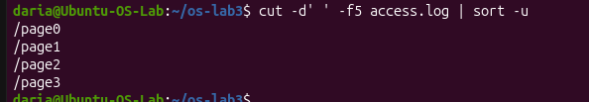
Figure 4.2 – Unique pages requested
cut -d' ' -f5 access.log | sort -u extracts the page field and removes duplicates. The log contains four unique pages, /page0 to /page3.

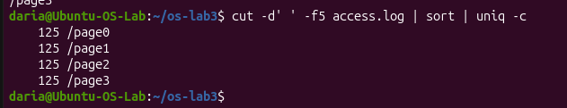
Figure 4.3 – Request count per page
sort | uniq -c counts the requests per page. Each of the four pages received exactly 125 requests.

Figure 4.4 – User with most failed requests
The pipeline filters FAIL lines, extracts the user field, counts the entries and sorts them in descending order. head -1 then shows user5 with 15 failures.

Figure 4.5 – Requests and failures for user3
grep -c gives 72 total requests for user3, and a second grep piped into grep -c FAIL gives 15 failed ones. Both numbers are printed in one echo line using command substitution.

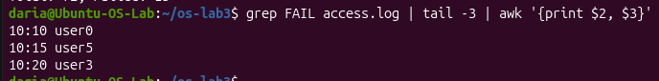
Figure 4.6 – Last 3 failed requests time and user
tail -3 takes the last three failed requests and awk prints only the time and user columns. The three entries are 10:10 user0, 10:15 user5 and 10:20 user3.

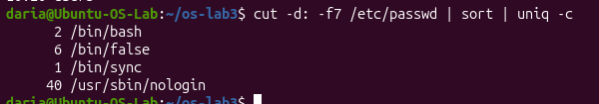
Figure 4.7 – Login shells in /etc/passwd
The shell field (field 7) of /etc/passwd is counted. There are 2 users with /bin/bash, 6 with /bin/false, 1 with /bin/sync and 40 with /usr/sbin/nologin.

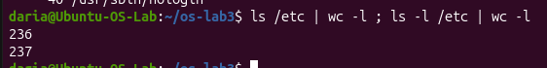
Figure 4.8 – Difference between ls and ls -l line counts
ls /etc | wc -l gives 236 and ls -l /etc | wc -l gives 237. The extra line is the “total” summary line that ls -l prints at the top.

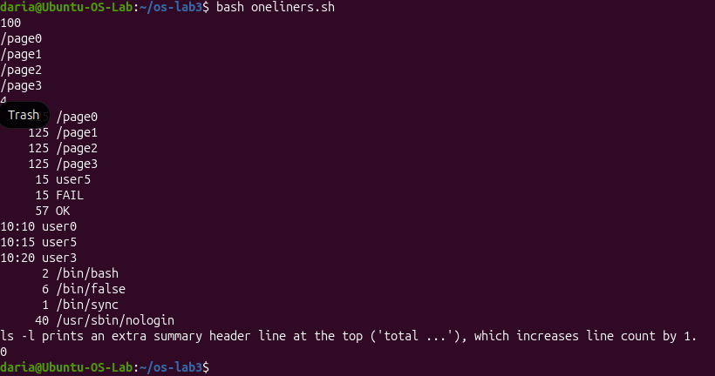
Figure 4.9 – Full run of oneliners.sh
The script runs all previous one-liners in one go and prints each result in order. This confirms that the whole analysis is reproducible with a single command.

Part 5
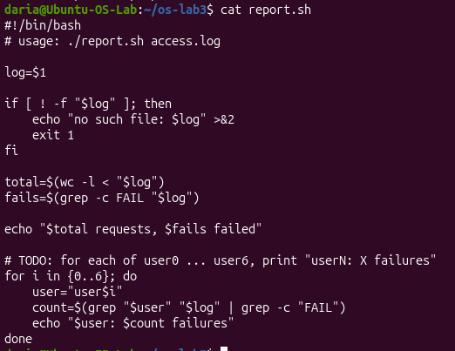
Figure 5.1 – Contents of report.sh
The script starts with the #!/bin/bash shebang and checks that the log file exists. If it does not, it prints an error to stderr and exits with code 1. Otherwise it counts the total and failed requests, then loops over user0–user6 to count failures per user.

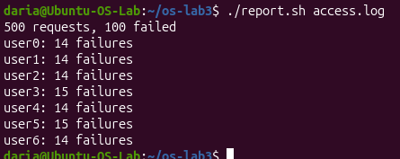
Figure 5.2 – Running the scripton access.log
The report shows 500 requests and 100 failed. Each of the seven users has 14 or 15 failures, which adds up to 100.

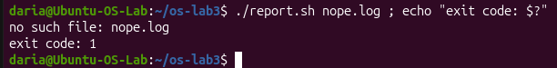
Figure 5.3 – Error handling for a missing file
Running ./report.sh nope.log prints “no such file: nope.log”. echo $? then prints exit code 1, so the script reports the failure correctly to its caller.

Observe:

- What does the first line #!/bin/bash do, and what happens if you run ./report.shbefore chmod +x?
The shebang (#!/bin/bash) specifies /bin/bash as the interpreter to execute the script. Running ./report.sh before chmod +x results in a "Permission denied" error because the file lacks execute permissions.
- Why must you type ./report.sh and not just report.sh?
The ./ prefix explicitly specifies the path to the script in the current directory. Without it, the shell searches only the directories listed in the $PATH environment variable, which excludes the current working directory by default for security reasons.
3. Why does the script write the error with >&2 and end with exit 1?
>&2 redirects the error message to standard error (stderr), separating error output from standard output (stdout). exit 1 terminates the script with a non-zero exit code, signaling to the system or calling process that an error occurred.

Conclusion
In this laboratory work, I gained practical experience in log analysis using core Linux command-line utilities such as grep, cut, awk, sort, and uniq. By developing executable Bash scripts (oneliners.sh and report.sh), I mastered text processing, loop constructs, error redirection, and task scheduling with cron. Overall, these tasks strengthened my understanding of shell scripting best practices and automated system administration workflows.

