
MINISTRY OF EDUCATION, CULTURE AND RESEARCH
OF THE REPUBLIC OF MOLDOVA
Technical University of Moldova
Faculty of Computers, Informatics and Microelectronics
Department of Software Engineering and Automation

Daria Tureac FAF-243

Report
Laboratory Work No.3
Operational Systems

Checked by:
Reitman P., university assistant
FCIM, UTM

Chișinău – 2026

Before you start:
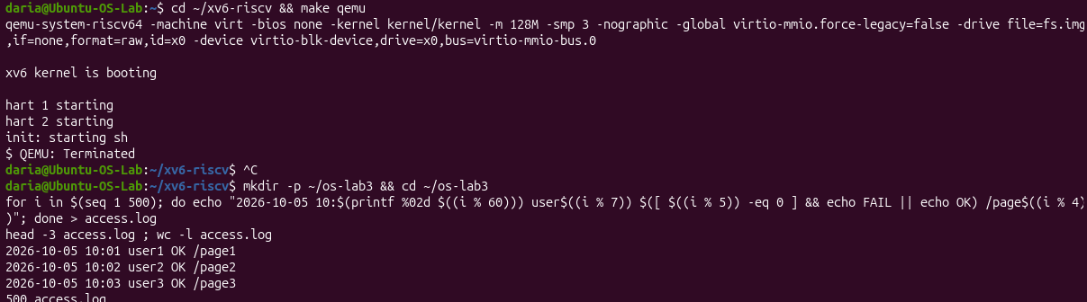
Figure 1 – Before you start

Part 1

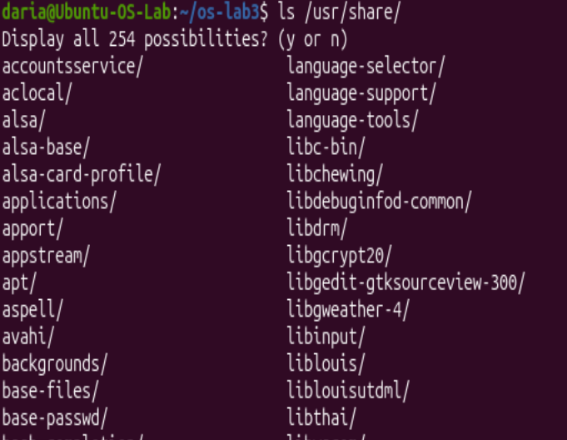
Figure 1.1 – Tab Completion

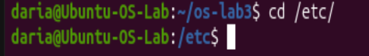
Figure 1.2 – etc completion

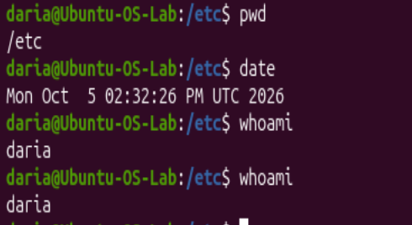
Figure 1.3 – Ctrl+R result

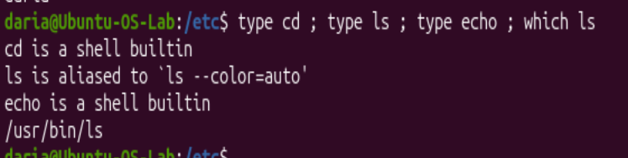
Figure 1.4 – Output of type and which
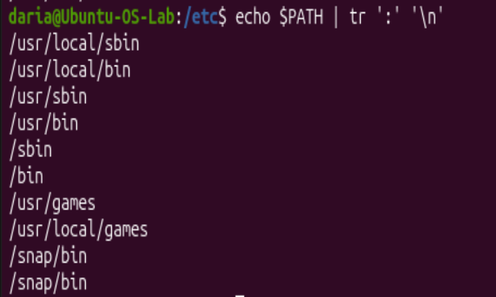
Figure 1.5 – The directories in PATH
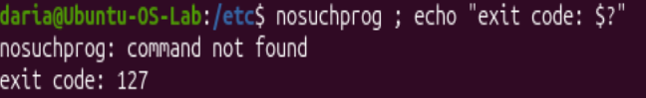
Figure 1.6 - Exit code of a missing command


Figure 1.7 – sort by time

Observe
- Which of cd, ls, echo are built-ins, and why MUST cd be one?
Both cd and echo are shell built-ins, whereas ls is an external utility. cd MUST be a built-in command because it changes the working directory of the shell process itself; an external program would only change the directory for its own child process without affecting the parent shell.
- How many directories are in your PATH, and in which one is ls?
In my PATH are 10 directories, /usr/bin/ls – is ls.
- What exit code does a command that is not found return?
A non-existent command returns exit code 127.
- Which option of ls sorts by modification time?
In man ls, the option to sort files by modification time is -t.

Part 2
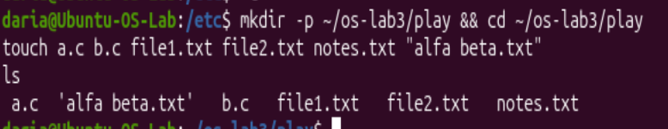
Figure 2.1 - Files created in the play directory
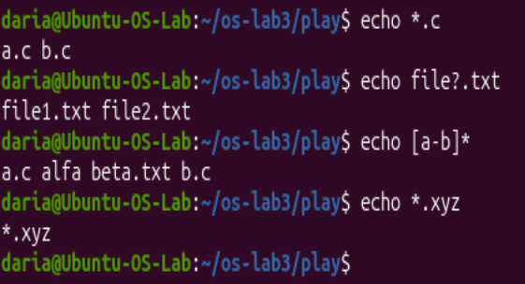
Figure 2.2 - Globbing results
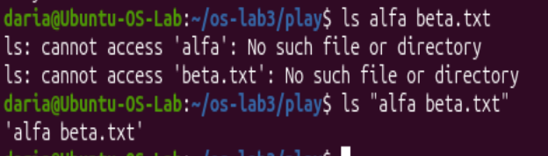
Figure 2.3 - The ls error on a name with a space, and the fix
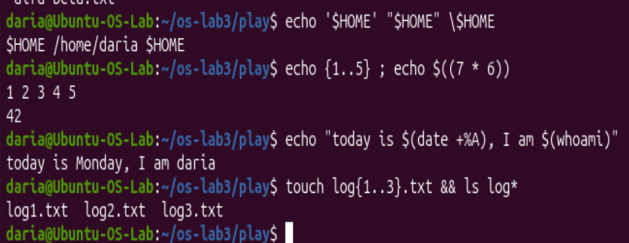
Figure 2.4 - Single quotes, double quotes and backslash

Observe:
1. Command | My prediction | Real output | Explanation (if different)
echo *.c | No such file or directory | *.c | Expected Bash to throw an error, but unmatched wildcards are passed literally as strings.
echo file?.txt | file1.txt | file?.txt | Expected ? to match a dummy file, but since no file exists, Bash prints the pattern literally.
echo [a-b]* | [a-b]* | access.log | Predicted a literal string, but [a-b]* matched access.log starting with 'a'.
echo *.xyz | (empty line) | *.xyz | Assumed unmatched globs evaluate to nothing, but Bash returns the unexpanded string.
ls alfa beta.txt | ls: cannot access 'alfa beta.txt' | ls: cannot access 'alfa': No such file...  ls: cannot access 'beta.txt': No such file... | Expected space to be part of the filename, but unquoted spaces split arguments into two separate targets.
ls "alfa beta.txt" | ls: cannot access 'alfa beta.txt': No such file or directory | ls: cannot access 'alfa beta.txt': No such file or directory | Prediction matched because double quotes preserve the space inside a single argument.
echo '$HOME' "$HOME" \$HOME | /home/daria /home/daria /home/daria | $HOME /home/daria $HOME | Expected $HOME to expand everywhere, but single quotes and \ suppress variable evaluation.
echo {1..5} ; echo $((7 * 6)) | {1..5}  7 * 6 | 1 2 3 4 5  42 | Did not expect Bash brace expansion {1..5} or automatic arithmetic calculation $((...)).
echo "today is $(date +%A), I am $(whoami)" | today is $(date +%A), I am $(whoami) | today is Monday, I am daria | Expected literal text inside quotes, but $(...) command substitution executes inside double quotes.
touch log{1..3}.txt && ls log* | log1.txt log2.txt log3.txt | log1.txt log2.txt log3.txt | Prediction matched because brace expansion creates 3 files and log* globs all of them.

- echo knows nothing about files, yet echo *.c printed file names. Who produced them?
The shell performed glob expansion on *.c and passed the resulting filenames as arguments to echo before the command was executed.
- Why did ls alfa beta.txt fail? Give two different ways to fix it.
ls alfa beta.txt failed because the shell split the string into two separate arguments: alfa and beta.txt. To fix it, quote the filename as "alfa beta.txt" or escape the space as alfa\ beta.txt.

- What is the difference between single and double quotes?
Single quotes (' ') preserve the literal value of all characters and prevent all expansions. Double quotes (" ") allow variable expansion ($HOME), command substitution ($(...)), and arithmetic expansion ($((...))).

Part 3
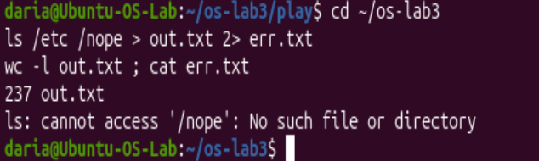
Figure 3.1 - stdout and stderr in separate files.

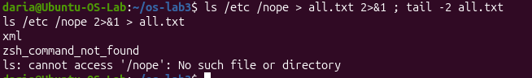
Figure 3.2 – Comparing the order of redirections
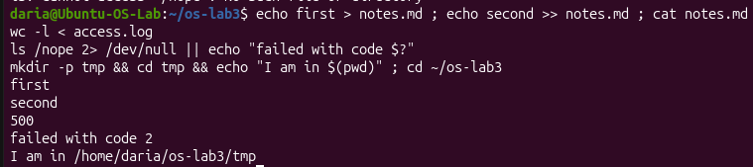
Figure 3.3 - The ; && || operators
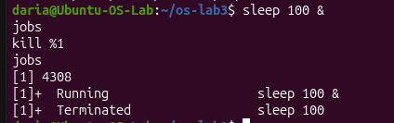
Figure 3.4 - Running a background job and stopping it
1. Which file got the error message, and which got the listing?
err.txt got the error message, and out.txt got the listing.
- What is the difference between > all.txt 2>&1 and 2>&1 > all.txt? Try both andexplain why the result differs.
> all.txt 2>&1 first redirects stdout to the file and then duplicates stderr to stdout (both go into all.txt), whereas 2>&1 > all.txt redirects stderr to the current stdout (the terminal) before redirecting stdout to the file, leaving error messages on the screen.
- Why does wc -l < access.log print only a number, while wc -l access.log alsoprints the file name?
wc -l < access.log reads data via standard input (stdin) without knowing the filename, so it outputs only the number; wc -l access.log receives the filename as an argument, so it prints both the number and the name.
- Explain each operator in one sentence: ; && ||.
; executes commands sequentially regardless of the result; && executes the next command only if the previous one succeeds; || executes the next command only if the previous one fails.

Part 4
Figure 4.1 – Number of failed requests
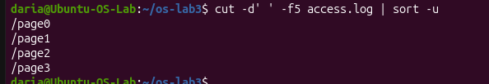
Figure 4.2 – Unique pages requested
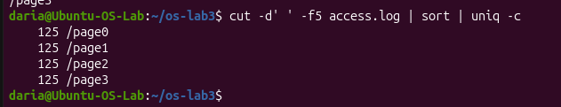
Figure 4.3 – Request count per page
Figure 4.4 – User with most failed requests
Figure 4.5 – Requests and failures for user3
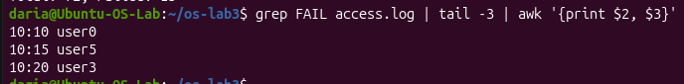
Figure 4.6 – Last 3 failed requests time and user
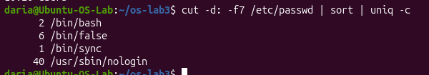
Figure 4.7 – Login shells in /etc/passwd
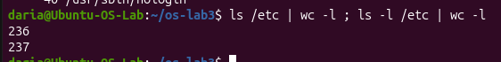
Figure 4.8 – Difference between ls and ls -l line counts
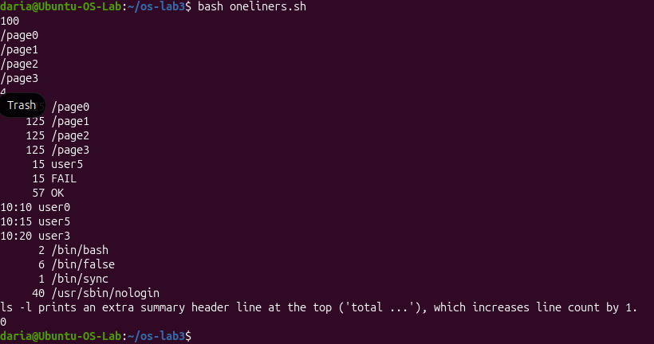
Figure 4.9 – Full run of oneliners.sh

Part 5
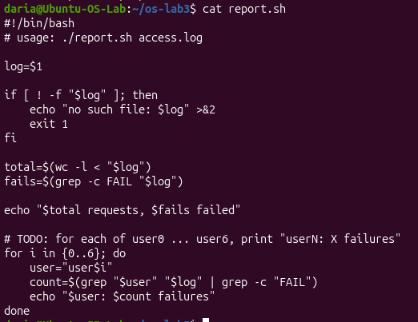
Figure 5.1 – Contents of report.sh
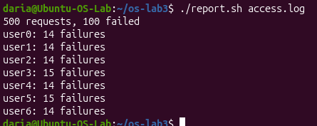
Figure 5.2 – Running the scripton access.log
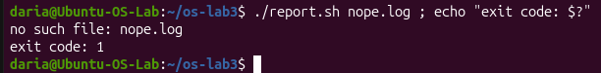
Figure 5.3 – Error handling for a missing file
Observe:

- What does the first line #!/bin/bash do, and what happens if you run ./report.shbefore chmod +x?
The shebang (#!/bin/bash) specifies /bin/bash as the interpreter to execute the script. Running ./report.sh before chmod +x results in a "Permission denied" error because the file lacks execute permissions.
- Why must you type ./report.sh and not just report.sh?
The ./ prefix explicitly specifies the path to the script in the current directory. Without it, the shell searches only the directories listed in the $PATH environment variable, which excludes the current working directory by default for security reasons.
3. Why does the script write the error with >&2 and end with exit 1?
>&2 redirects the error message to standard error (stderr), separating error output from standard output (stdout). exit 1 terminates the script with a non-zero exit code, signaling to the system or calling process that an error occurred.

Conclusion
In this laboratory work, I gained practical experience in log analysis using core Linux command-line utilities such as grep, cut, awk, sort, and uniq. By developing executable Bash scripts (oneliners.sh and report.sh), I mastered text processing, loop constructs, error redirection, and task scheduling with cron. Overall, these tasks strengthened my understanding of shell scripting best practices and automated system administration workflows.

