
MINISTRY OF EDUCATION, CULTURE AND RESEARCH
OF THE REPUBLIC OF MOLDOVA
Technical University of Moldova
Faculty of Computers, Informatics and Microelectronics
Department of Software Engineering and Automation

Report
Laboratory Work No.6
Operational Systems
Topic: Inside the xv6 file system

Done by:
Daria Tureac, st. group FAF-243

Checked by:
Reitman P., university assistant
FCIM, UTM

Chișinău – 2026

Goal
Goal is to explore the architecture and concepts of the xv6 filesystem, write a custom stat program, measure kernel filesystem limits defined in kernel/fs.h, and implement a recursive find utility to traverse the directory tree.
Before you start
bash os2026-setup.sh --check # toolchain, QEMU and ~/xv6-riscv are ready
Use your ~/xv6-riscv tree. Every new program: user/NAME.c plus a line $U/_NAME\ in UPROGS (TAB at the start, nothing after the backslash). Exit QEMU with Ctrl-A then X.
Tip: the file system image is rebuilt by make. To start from a clean disk: make clean ; make qemu

Part 1. Read what xv6 shows you
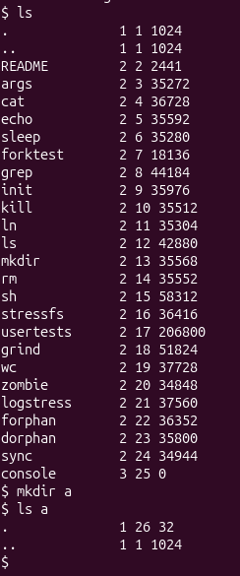
Figure 1.1 – xv6 ls

The listing shows the type, inode number and size for each entry: type 1 is a directory, type 2 is a file and type 3 is a device (console). The root directory has inode 1, and . and .. are identical there because root has no parent. The new empty directory a has size 32, which equals two 16-byte entries (. and ..).
Observe
- What do types 1, 2 and 3 mean (kernel/stat.h)?

According to kernel/stat.h: 1 represents T_DIR (directory), 2 represents T_FILE (regular file), and 3 represents T_DEVICE (device file).

- Which inode number does the root directory have, and why are . and .. the same there?

The root directory has inode number 1. In the root directory, . (current directory) and .. (parent directory) refer to the exact same inode because the root directory has no parent above it.
- An empty directory a has size 32. A directory entry has a fixed size. How big is one entry, and which two entries does a contain?
Each directory entry (struct dirent) is 16 bytes long (2 bytes for the inode number + 14 bytes for the filename DIRSIZ). An empty directory contains 2 entries: . and .. ($2×16=32$ bytes).

Part 2. Write mystat
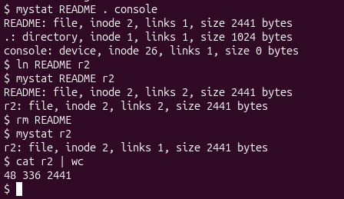
Figure 2.1 – mystat output
mystat prints the type, inode, link count and size of each file. After ln README r2, both names show inode 2 and 2 links. After rm README, r2 still has inode 2 and the same size, but only 1 link. The data is intact, as cat r2 | wc confirms.

Observe
- Paste the outputs after ln and after rm. What changed and what did not?

After ln README r2:
- README: file, inode 2, links 2, size 2441 bytes
- r2: file, inode 2, links 2, size 2441 bytes
After rm README:
- r2: file, inode 2, links 1, size 2441 bytes
Explanation: The inode number and file size remained identical because both names pointed to the same data on disk. Only the link count changed (increased to 2 with ln, decreased to 1 with rm).

- Find the line in kernel/sysfile.c (sys_unlink) that decrements the link count. When are the data blocks freed?

In kernel/sysfile.c, the link count is decremented by ip->nlink--;.

Data blocks and the inode are freed only when the link count drops to zero (ip->nlink == 0) and there are no open file references remaining (ip->ref == 0).
- xv6 has no symbolic links and no permissions. Look at struct dinode in kernel/fs.h: which fields does an xv6 inode have?

An xv6 struct dinode contains: type (file type), major and minor (device numbers), nlink (number of directory links), size (file size in bytes), and addrs[NDIRECT+1] (array of block addresses).

Part 3. Measure the limits
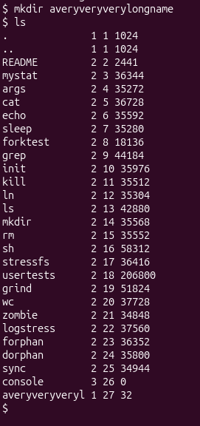
Figure 3.1 – Limits

The directory name averyveryverylongname is truncated to averyveryveryl (14 characters) in the ls output. This is because of the DIRSIZ limit of 14 characters per name in a directory entry.
Observe
  - What does ls show for averyveryverylongname, and which constant explains it?

ls truncates the directory name to averyveryveryl (14 characters). This is defined by DIRSIZ (#define DIRSIZ 14 in kernel/fs.h).
  - Compute the largest file xv6 can hold: 12 direct blocks plus one indirect block that holds block numbers of 4 bytes each, blocks of BSIZE bytes. Show the calculation.

BSIZE = 1024 bytes.
Direct blocks: 12 blocks $×$ 1024 bytes = 12,288 bytes.
Indirect block capacity: $1024/4=256$ block addresses.
Indirect data size: 256 blocks $×$ 1024 bytes = 262,144 bytes.
Max file size: $12+256=268$ blocks = 274,432 bytes (~268 KB).

  - From the nmeta line: how many blocks does the whole disk have, and how many are for the log, the inodes, and the data?

Total disk size: 2000 blocks (FSSIZE in kernel/param.h).
Meta blocks (nmeta output): 46 blocks (Boot block: 1, Superblock: 1, Log: 30, Inodes: 13, Bitmap: 1).
Data blocks: $2000-46=1954\text{ blocks}$.

Part 4. Write find

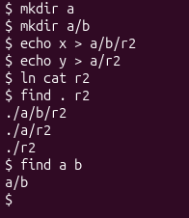
Figure 4.1 – Find test

Two files named r2 and a hard link (ln cat r2) are created in different directories. find . r2 finds all three: ./a/b/r2, ./a/r2 and ./r2. find a b lists the directory tree starting from a and b. This shows that find traverses subdirectories recursively and matches file names.

Conclusion
In this laboratory work, I gained practical experience with the xv6-riscv operating system, focusing on file system structure, system calls, and utility implementation. By writing mystat and find, I deepened my understanding of inode metrics, link count management, directory traversal mechanics, and system-level resource constraints such as indirect blocks and maximum path lengths.

