
MINISTRY OF EDUCATION, CULTURE AND RESEARCH
OF THE REPUBLIC OF MOLDOVA
Technical University of Moldova
Faculty of Computers, Informatics and Microelectronics
Department of Software Engineering and Automation

Daria Tureac FAF-243

Report
Laboratory Work No.6
Operational Systems

Checked by:
Reitman P., university assistant
FCIM, UTM

Chișinău – 2026

Before you start
bash os2026-setup.sh --check # toolchain, QEMU and ~/xv6-riscv are ready
Use your ~/xv6-riscv tree. Every new program: user/NAME.c plus a line $U/_NAME\ in UPROGS (TAB at the start, nothing after the backslash). Exit QEMU with Ctrl-A then X.
Tip: the file system image is rebuilt by make. To start from a clean disk: make clean ; make qemu

Part 1. Read what xv6 shows you
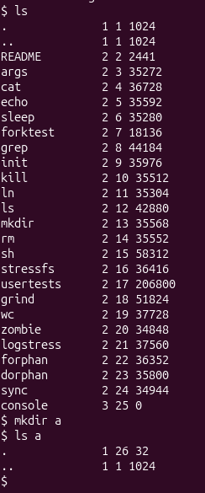
Figure 1.1 – xv6 ls
Observe
- What do types 1, 2 and 3 mean (kernel/stat.h)?

According to kernel/stat.h: 1 represents T_DIR (directory), 2 represents T_FILE (regular file), and 3 represents T_DEVICE (device file).

- Which inode number does the root directory have, and why are . and .. the same there?

The root directory has inode number 1. In the root directory, . (current directory) and .. (parent directory) refer to the exact same inode because the root directory has no parent above it.
- An empty directory a has size 32. A directory entry has a fixed size. How big is one entry, and which two entries does a contain?
Each directory entry (struct dirent) is 16 bytes long (2 bytes for the inode number + 14 bytes for the filename DIRSIZ). An empty directory contains 2 entries: . and .. ($2×16=32$ bytes).

Part 2. Write mystat
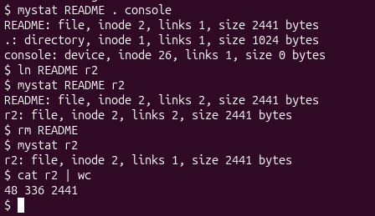
Figure 2.1 – mystat output

Observe
- Paste the outputs after ln and after rm. What changed and what did not?

After ln README r2:
- README: file, inode 2, links 2, size 2441 bytes
- r2: file, inode 2, links 2, size 2441 bytes
After rm README:
- r2: file, inode 2, links 1, size 2441 bytes
Explanation: The inode number and file size remained identical because both names pointed to the same data on disk. Only the link count changed (increased to 2 with ln, decreased to 1 with rm).

- Find the line in kernel/sysfile.c (sys_unlink) that decrements the link count. When are the data blocks freed?

In kernel/sysfile.c, the link count is decremented by ip->nlink--;.

Data blocks and the inode are freed only when the link count drops to zero (ip->nlink == 0) and there are no open file references remaining (ip->ref == 0).
- xv6 has no symbolic links and no permissions. Look at struct dinode in kernel/fs.h: which fields does an xv6 inode have?

An xv6 struct dinode contains: type (file type), major and minor (device numbers), nlink (number of directory links), size (file size in bytes), and addrs[NDIRECT+1] (array of block addresses).

Part 3. Measure the limits
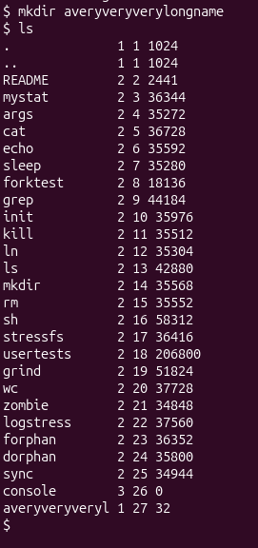
Figure 3.1 - Limits
Observe
  - What does ls show for averyveryverylongname, and which constant explains it?

ls truncates the directory name to averyveryveryl (14 characters). This is defined by DIRSIZ (#define DIRSIZ 14 in kernel/fs.h).
  - Compute the largest file xv6 can hold: 12 direct blocks plus one indirect block that holds block numbers of 4 bytes each, blocks of BSIZE bytes. Show the calculation.

BSIZE = 1024 bytes.
Direct blocks: 12 blocks $×$ 1024 bytes = 12,288 bytes.
Indirect block capacity: $1024/4=256$ block addresses.
Indirect data size: 256 blocks $×$ 1024 bytes = 262,144 bytes.
Max file size: $12+256=268$ blocks = 274,432 bytes (~268 KB).

  - From the nmeta line: how many blocks does the whole disk have, and how many are for the log, the inodes, and the data?

Total disk size: 2000 blocks (FSSIZE in kernel/param.h).
Meta blocks (nmeta output): 46 blocks (Boot block: 1, Superblock: 1, Log: 30, Inodes: 13, Bitmap: 1).
Data blocks: $2000-46=1954\text{ blocks}$.

Part 4. Write find

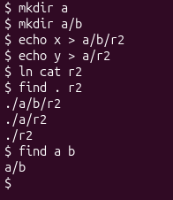
Figure 4.1 – Find test

Conclusion
In this laboratory work, I gained practical experience with the xv6-riscv operating system, focusing on file system structure, system calls, and utility implementation. By writing mystat and find, I deepened my understanding of inode metrics, link count management, directory traversal mechanics, and system-level resource constraints such as indirect blocks and maximum path lengths.

