
MINISTRY OF EDUCATION, CULTURE AND RESEARCH
OF THE REPUBLIC OF MOLDOVA
Technical University of Moldova
Faculty of Computers, Informatics and Microelectronics
Department of Software Engineering and Automation

Report
Laboratory Work No.8
Operational Systems
Topic: The Same Calls, Inside Your Own OS

Done by:
Daria Tureac, st. group FAF-243

Checked by:
Reitman P., university assistant
FCIM, UTM

Chișinău – 2026
Goal

The goal is to execute process management system calls (fork, exec, and wait) within the xv6 operating system and implement inter-process communication using pipes through the pingpong program.

Part 1: run, inside xv6

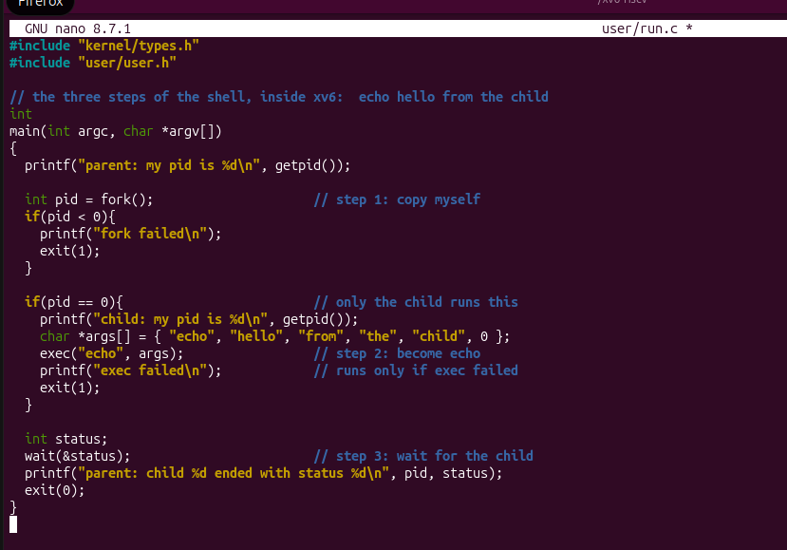
Figure 1.1 – run.c

This is the xv6 version of run.c in the nano editor. It follows the same three steps as the Linux version: fork() to copy the process, exec("echo", args) in the child to become echo, and wait(&status) in the parent. The exec failed message and exit(1) run only if exec fails.

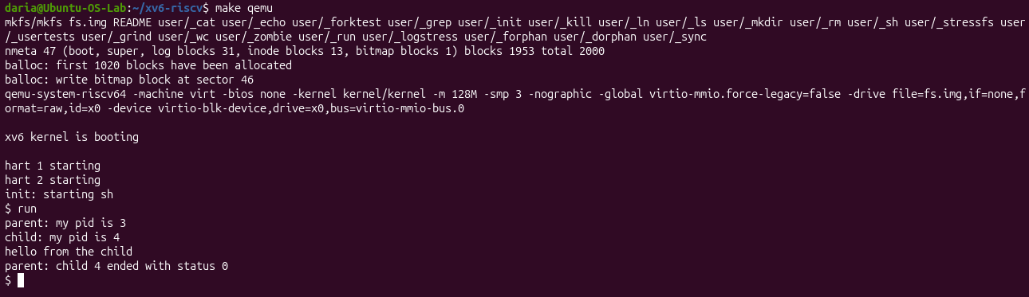
Figure 1.2 – run

xv6 is built and booted with make qemu, and run is started from the xv6 shell. The parent has PID 3 and the child PID 4. The line “hello from the child” is printed by echo, not by run. The parent finishes with status 0.
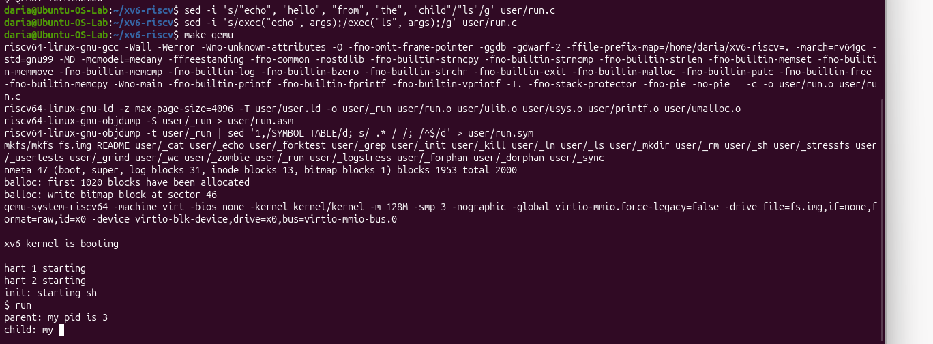
Figure 1.3 – run ls

With sed I replaced echo and its arguments with ls, then rebuilt and relaunched xv6. The output ends at “child: my” because the screenshot was taken while the output was still being printed. After that point the ls listing would appear, since the child’s code has been replaced by ls.

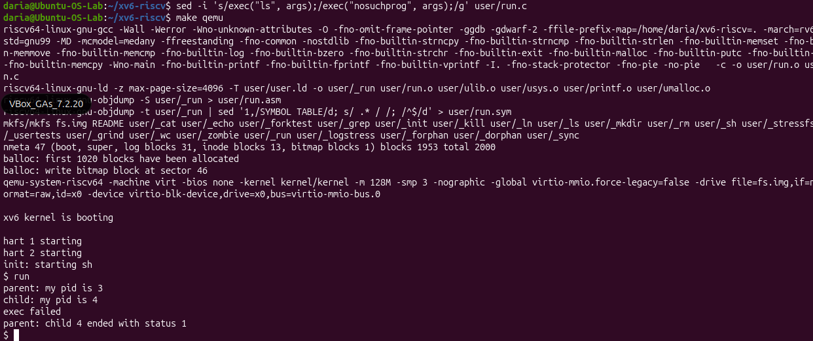
Figure 1.4 – nosuchprog

Another sed command changed the program name to nosuchprog, which does not exist in xv6. exec fails, the child prints “exec failed”, and exit(1) ends it. The parent therefore sees status 1, because xv6 returns the exact value passed to exit().

Observe
- Write the three calls that run.c uses in xv6 and the three calls run.c used on Linux in Lab 7. What is the same?
Both xv6 and Linux use fork(), exec(), and wait(), keeping the exact same system call names and sequential process management logic.
- Who prints "hello from the child": the code of run, or echo?
The string "hello from the child" is printed by the echo program because exec() successfully replaces the child's memory image.
- Why is the status 1 here and 127 on Linux? (Look at the exit line after exec in both programs.)
The status is 1 in xv6 because the code explicitly calls exit(1) upon failure, while Linux shells conventionally return 127.

Part 2: pingpong
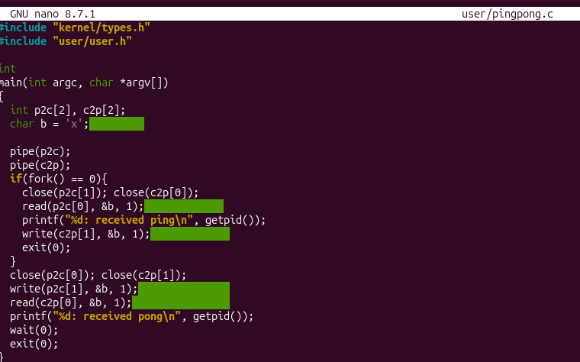
Figure 2.1 – pingpong.c
The source code uses two pipes: p2c (parent to child) and c2p (child to parent). After fork(), each side closes the pipe ends it does not use. The child reads the byte, prints “received ping” and writes the byte back. The parent writes first, then blocks on read until the child replies, and prints “received pong”.
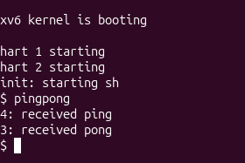
Figure 2.2 – qemu pingpong
The pingpong program runs in xv6. The child (PID 4) prints “received ping” first, then the parent (PID 3) prints “received pong”. This confirms the byte went parent → child → parent through the two pipes in the correct order.

Observe
- Why do you need TWO pipes, and not one for both directions?
Two pipes are required because pipes are unidirectional; using a single pipe for both directions would cause race conditions, message interleaving, or the parent and child reading their own transmitted data.
- Nothing in your code says "wait until the child has replied". Which call makes the parent wait?
The read() system call makes the parent block and wait until the child writes data into the pipe and replies.

Conclusion
In this laboratory work, I successfully implemented process control using fork(), exec(), and wait() alongside inter-process communication via unidirectional pipes in the xv6 operating system. Through building run.c and pingpong.c, I gained hands-on experience with process lifecycle management, kernel system calls, and bidirectional synchronization using file descriptors.

