
MINISTRY OF EDUCATION, CULTURE AND RESEARCH
OF THE REPUBLIC OF MOLDOVA
Technical University of Moldova
Faculty of Computers, Informatics and Microelectronics
Department of Software Engineering and Automation

Daria Tureac FAF-243

Report
Laboratory Work No.1,2
Operational Systems

Checked by:
Reitman P., university assistant
FCIM, UTM

Chișinău – 2026

Laboratory work 1

Before you start
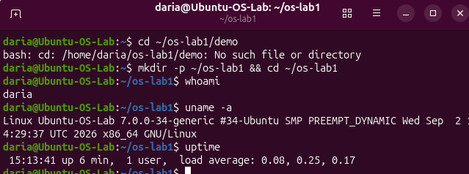
Figure 1.1 Before you start
The first cd fails because ~/os-lab1/demo does not exist yet. mkdir -p ~/os-lab1 && cd ~/os-lab1 creates the working directory (-p creates parent directories and gives no error if the directory exists) and enters it. whoami prints the current user (daria). uname -a prints the kernel name, version and architecture (Linux, x86_64). uptime shows how long the system has been running (6 min), the number of logged-in users, and the load average over the last 1, 5 and 15 minutes.

Part 1. Files and directories
- Navigate and inspect:
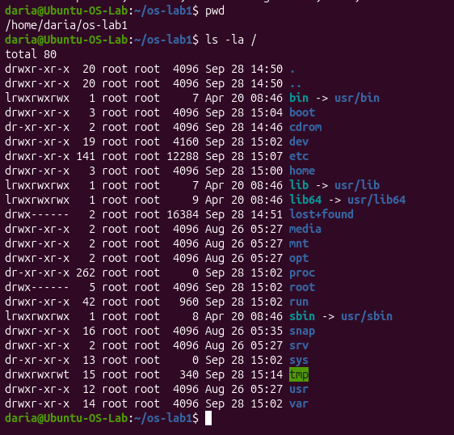
Figure 1.2 Where am I and the root

pwd prints the current working directory (/home/daria/os-lab1). ls -la / lists everything in the root directory in long format, including hidden entries. bin, lib, lib64 and sbin are symbolic links to /usr/.... Directories such as /proc, /sys and /dev are virtual and are generated by the kernel. /root and /lost+found are accessible only to root (drwx------).

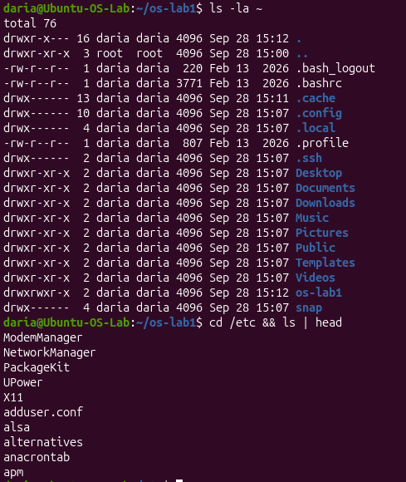
Figure 1.3 Home directory

ls -la ~ lists the home directory with hidden files (names starting with a dot, such as .bashrc and .profile), permissions, owner and size. cd /etc && ls | head moves to the system configuration directory and shows its first 10 entries. && runs the second command only if the first one succeeded.

- Create, copy, rename, remove, and watch the tree change:
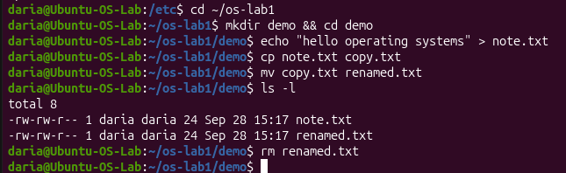
Figure 1.4 Create, copy, rename, remove, and watch the tree change

mkdir demo && cd demo creates a directory and enters it. echo "..." > note.txt writes text into a new file. cp copies the file, mv renames it (copy.txt → renamed.txt), and ls -l shows both files with equal size (24 bytes). rm renamed.txt deletes the renamed copy, so only note.txt remains.

- Look at ownership and permissions. The OS decides who may touch what:
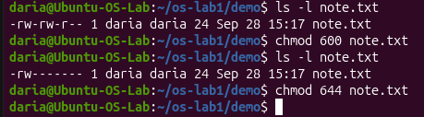
Figure 1.5 Look at ownership and permissions

ls -l shows the owner and group (daria daria) and the permission string. chmod 600 gives read and write to the owner only, and the listing changes from -rw-rw-r-- to -rw-------. chmod 644 restores the usual default: the owner can read and write, everyone else can only read.

Observe
- Who owns the files you just created, and which group?
The created files are owned by your user account and its primary group (typically daria:daria).
- What do the ten characters at the start of `ls -l` mean for note.txt after chmod 600?
The ten characters -rw------- represent a regular file (-) where the owner has read and write permissions (rw-), while access is completely denied for the group and others (---).
- Name two directories directly under / and say, in one line each, what they hold.
/bin contains essential system command binaries, and /etc stores system-wide configuration files.

Part 2. Processes

- List the processes the OS is currently juggling:
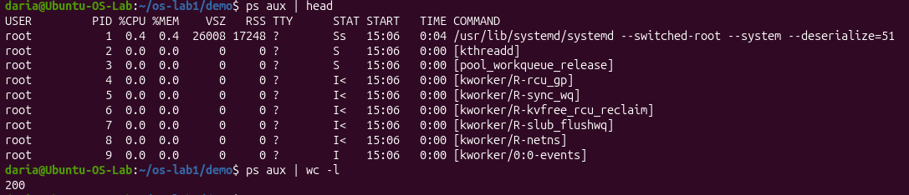
Figure 1.6 How many processes

ps aux | head shows the first lines of the process table: user, PID, CPU/memory usage, state and command. PID 1 is systemd, and the names in square brackets (kthreadd, kworker/...) are kernel threads. ps aux | wc -l counts the output lines (200, including the header line).
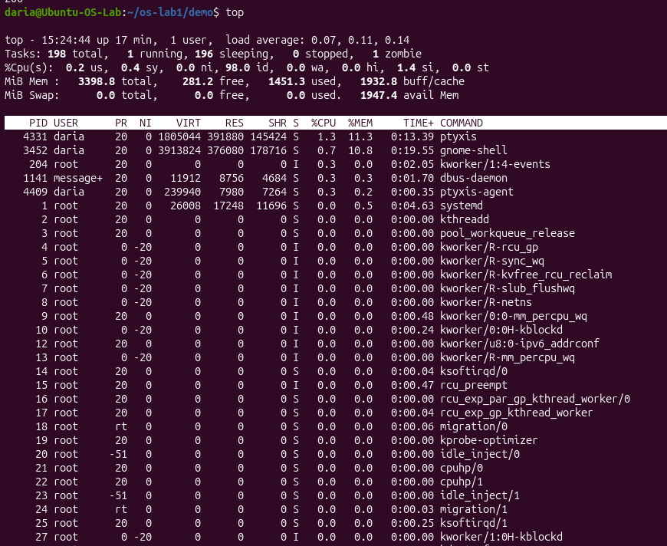
Figure 1.7 Live view

top is an interactive real-time view of the system. The header shows 198 tasks in total (1 running, 196 sleeping, 1 zombie), the CPU is 98% idle, and the memory and swap usage. The table below lists processes sorted by CPU usage. The system is almost idle, and swap is 0.

- Start a background process, find it, then stop it:
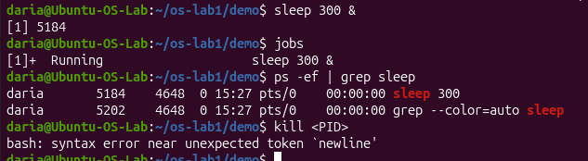
Figure 1.8 Start a background process, find it, then stop it

sleep 300 & starts a process in the background, and the shell prints its job number and PID (5184). jobs lists the shell's background jobs. ps -ef | grep sleep finds the process by name (the second line is the grep command itself). The last kill <PID> command failed because <PID> was typed literally and the shell treats < as input redirection. The real PID has to be substituted, as in the next figure.

- Peek at what the kernel exposes about a process through the /proc pseudo-filesystem:
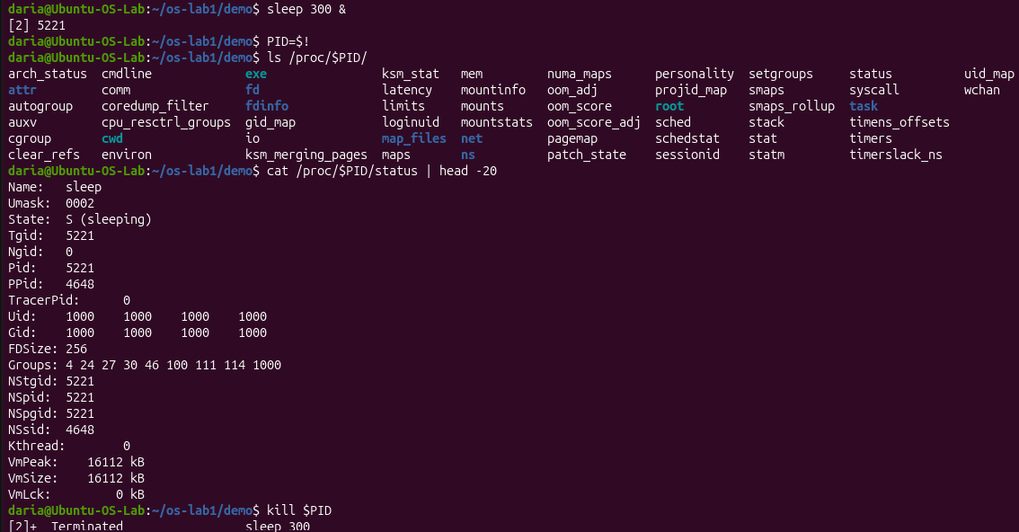
Figure 1.9 Peek a kernel

PID=$! saves the PID of the last background process in a variable. ls /proc/$PID/ shows the files the kernel exposes for this process (status, cmdline, fd, maps, etc.). /proc is a pseudo-filesystem that exists only in memory. cat /proc/$PID/status | head -20 shows the process name, state (S (sleeping)), PID, parent PID, UID/GID and memory usage. kill $PID terminates the process, and the shell reports Terminated.

Observe
- What is the PID of process number 1, and what is it (look it up)?
PID 1 is 1, which is systemd (or init), the initial root process launched by the kernel to boot the system and manage all background services.
- Roughly how many processes were running on your idle VM?
An idle Ubuntu virtual machine runs 198 processes (top command)
- ) From /proc/<pid>/status, what does the "State:" line say for your sleeping process?
The State: line displays S (sleeping) or S (interruptible sleep).

Part 3. Memory

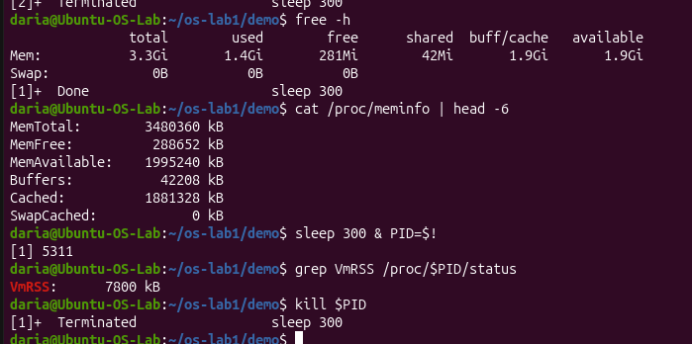
Figure 1.10 Memory view

free -h shows total, used, free and available RAM in human-readable units (3.3 GiB total, 0 B swap). cat /proc/meminfo | head -6 shows the same data in kB straight from the kernel. grep VmRSS /proc/$PID/status shows how much physical memory the sleep process actually uses (7800 kB). The process is then killed with kill $PID.

Observe:
- How much total RAM does the VM have, and how much is free?
The VM has 3.3 GiB of total RAM, with around 281 Mib free.
- What is swap, and how much is configured?
Swap is space on the disk used as virtual memory when RAM is full; 0 B of swap is configured on this VM.
- How much resident memory (VmRSS) does a bare `sleep` process use, and does that surprise you?
The sleep process uses 7800 kB of resident memory (VmRSS), which is expectedly low since it only loads basic system libraries.

Part 4. Devices and storage

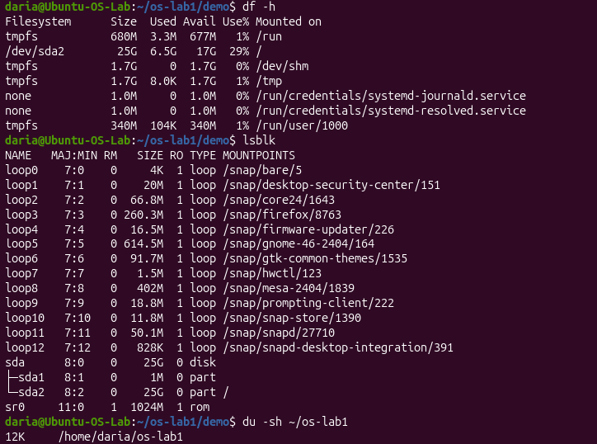
Figure 1.11 File systems

df -h shows the disk space of mounted file systems; the root / is on /dev/sda2 (25 GB, 29% used), and tmpfs entries live in RAM. lsblk shows block devices: the disk sda with partitions sda1 and sda2, the CD-ROM sr0, and many loop devices, which are mounted snap packages. du -sh ~/os-lab1 shows the total size of the lab directory (12 KB).

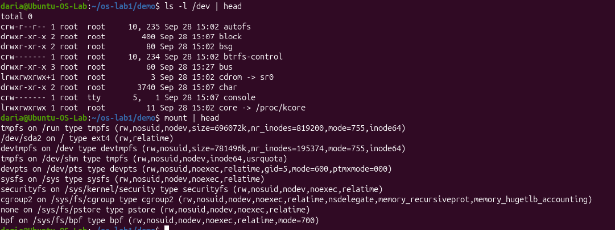
Figure 1.12 Devices presented as files

ls -l /dev | head shows device files. The first character of the permissions marks the type: c is a character device, d a directory, l a symbolic link (cdrom -> sr0, core -> /proc/kcore). mount | head lists mounted file systems with their types and options, for example /dev/sda2 on / type ext4.

Observe:

- Which device is your root filesystem "/" mounted on?
The root filesystem / is mounted on /dev/sda2.
- Give one entry from /dev and say what real thing it stands for.
/dev/cdrom (symbolic link to sr0) represents the virtual or physical CD/DVD-ROM drive.
- In one sentence: what does "everything is a file" mean, based on what you saw?
"Everything is a file" means Unix exposes hardware devices, system resources, and kernel interfaces as file paths so programs can interact with them using standard system calls like read() and write().

Laboratory work 2
Before you start

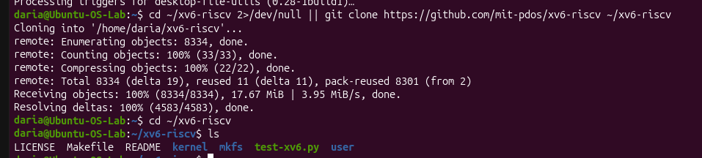
Figure 2.1 Before you start

cd ~/xv6-riscv 2>/dev/null || git clone ... enters the directory if it exists (errors are discarded to /dev/null) and otherwise clones the xv6 repository from GitHub. After cloning, ls shows the project: kernel/ (kernel source), user/ (user programs), mkfs/ (tool that builds the disk image), Makefile, README and LICENSE.

Part 1. Build it and boot it (~15 min)
- Compile the kernel and the user programs, then launch xv6 in the emulator:
After a few seconds you should see the kernel come up and drop you into a shell:

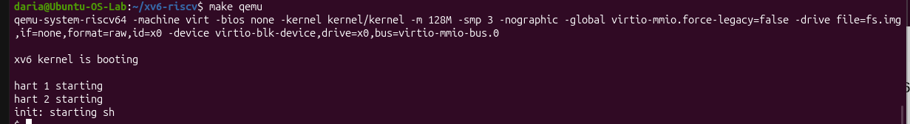
Figure 2.2 Compile the kernel and the user programs

make qemu compiles xv6 and starts it in the QEMU emulator. The long qemu-system-riscv64 line shows the emulated machine: RISC-V, 128 MB RAM, 3 CPUs and a virtual disk fs.img. The kernel prints xv6 kernel is booting, starts harts (CPU cores) 1 and 2, and init starts the shell (init: starting sh). The $ prompt is the xv6 shell.

Part 2. Use xv6 as the Unix it is
At the xv6 $ prompt, run its built-in programs. Notice how familiar they feel: this is the ancestor of the Linux you used in Lab 1.

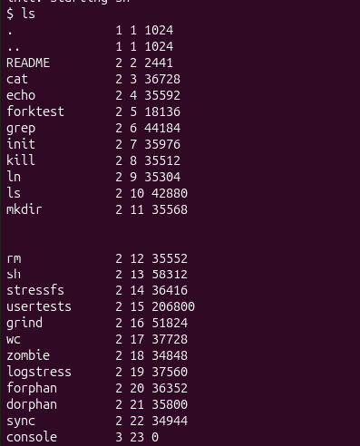
Figure 2.3 List all files

ls in xv6 lists the root directory. The columns are: name, file type (1 = directory, 2 = file, 3 = device), inode number and size in bytes. It contains the user programs (cat, echo, grep, ls, sh, wc, etc.), the README file and the console device.

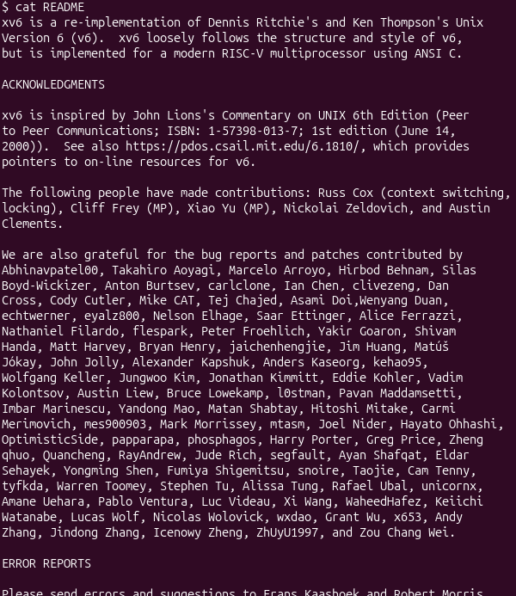
Figure 2.4 cat README

cat README prints the contents of the README file. The text describes xv6 as a re-implementation of Unix Version 6 for RISC-V, followed by acknowledgments and build instructions. It confirms that cat works by reading the file and writing it to the screen.

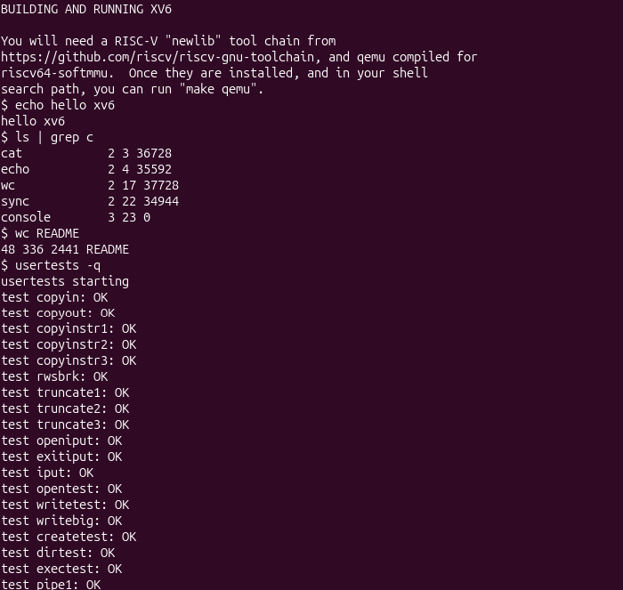
Figure 2.5 Executing basic commands, pipe redirection, and kernel tests in xv6

echo hello xv6 prints its arguments. ls | grep c pipes the output of ls into grep, which keeps only the lines containing "c" (cat, echo, wc, sync, console). wc README counts lines, words and bytes (48 / 336 / 2441). usertests -q runs the built-in test suite; each OK means the corresponding kernel feature (file I/O, pipes, exec, etc.) works correctly.

Observe:
- List three programs xv6 ships with.
Programs: cat, echo, and grep.
- You just used a pipe ( | ) inside xv6. Which two OS features must exist for a pipe to work?
Required OS Features: Multitasking (to spawn and execute concurrent processes) and Inter-Process Communication (a shared kernel buffer to redirect standard output of one process into standard input of another).
- In one sentence: how does the xv6 shell compare to the Linux shell from Lab 1?
Shell Comparison: The xv6 shell is a minimal educational implementation restricted to basic I/O redirection and piping, whereas the Linux shell (Bash) is a feature-rich environment with command history, tab completion, environment variables, and full scripting capabilities.

Part 3. Read the source

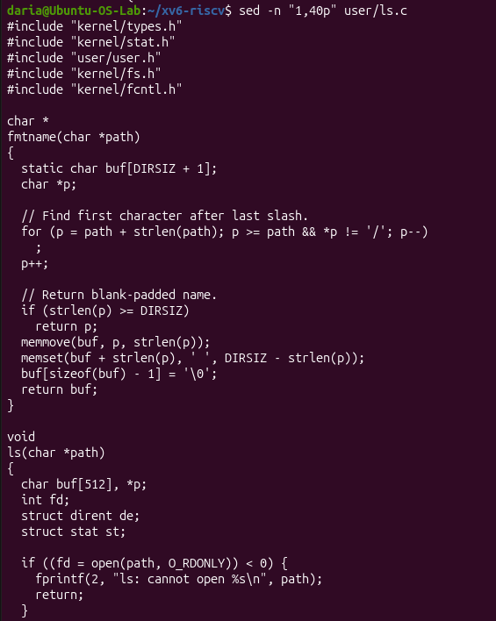
Figure 2.6 Inspecting source code structure of ls.c

sed -n "1,40p" user/ls.c prints lines 1–40 of the source. It includes the headers, the fmtname() function, which extracts the file name from a path and pads it with spaces, and the start of ls(), which opens the path with the open() system call and reports an error if it fails.
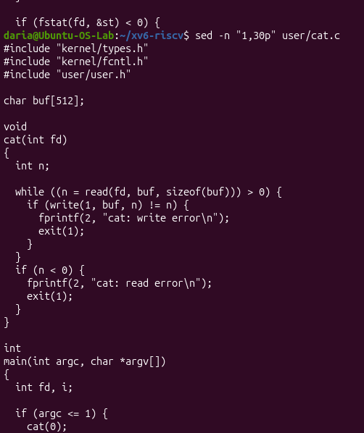
Figure 2.7 Inspecting source code structure of cat.c

sed -n "1,30p" user/cat.c shows the source of cat. The cat(fd) function repeatedly calls read() into a 512-byte buffer and write()s it to file descriptor 1 (stdout) until the file ends. main calls cat(0), which reads standard input, when no arguments are given.

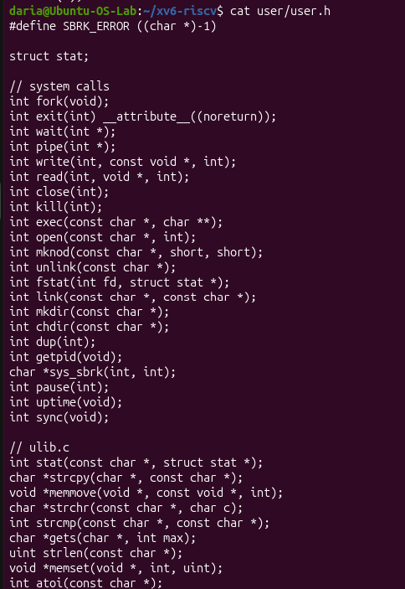
Figure 2.8 The list of system calls available to programs

cat user/user.h prints the header declaring the system calls available to user programs: fork, exit, wait, pipe, read, write, open, close, kill, exec, getpid, and others. Below them are the library functions from ulib.c, printf.c and umalloc.c (strlen, memmove, printf, malloc, free), which run in user space.

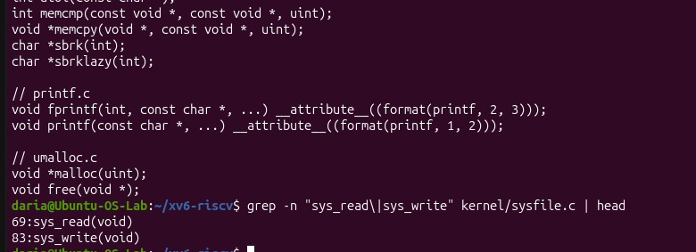
Figure 2.9 Locating sys_read and sys_write system call implementations in kernel/sysfile.c

The top part is the end of user.h (the C library declarations). grep -n "sys_read\|sys_write" kernel/sysfile.c searches the file for the two names and prints matching lines with line numbers: sys_read is at line 69 and sys_write at line 83. These are the kernel-side implementations of the read() and write() system calls.

Observe:
- Which system calls does user/cat.c use, and what does each one ask the kernel to do?
System calls used in user/cat.c:
open(): Requests the kernel to open a file and return a file descriptor.
read(): Requests the kernel to read data from an open file descriptor into a buffer.
write(): Requests the kernel to write data from a buffer to standard output (file descriptor 1).
close(): Requests the kernel to close the file descriptor.
exit(): Requests the kernel to terminate the current process.
- In which kernel file, and on which line, is sys_read implemented?
sys_read implementation location: It is implemented in kernel/sysfile.c
- In one sentence: what is the difference between the code in kernel/ and the code in user/?
Difference between kernel/ and user/: Code in kernel/ executes in privileged supervisor mode with direct access to hardware resources, whereas code in user/ runs in unprivileged user mode and must use system calls to request kernel actions.

Part 4. Write your first xv6 program

- Create user/sleep.c:

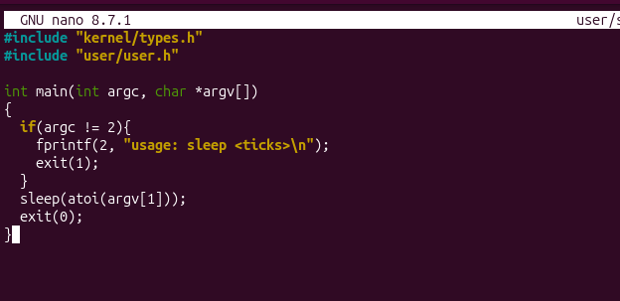
Figure 2.10 Create user/sleep.c

The sleep program is written in the nano editor. It checks that exactly one argument is given, otherwise prints a usage message to stderr (file descriptor 2) and exits with code 1. Then it converts the argument to an integer with atoi() and calls the sleep() system call, which pauses the process for that number of ticks, and exits normally.
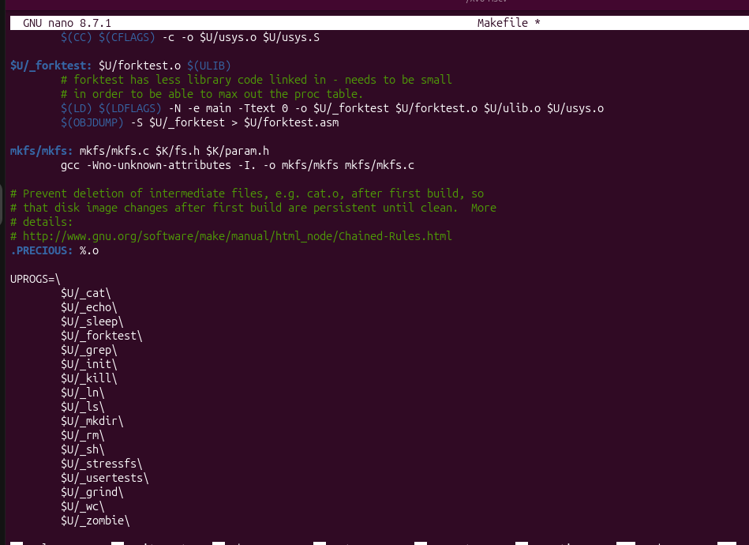
Figure 2.11 Add the line for sleep

The Makefile is opened in nano. UPROGS is the list of user programs that are compiled and put into the disk image. Adding $U/_sleep\ to this list makes make build user/sleep.c and include it in xv6 (* in the title means the file is modified and unsaved).

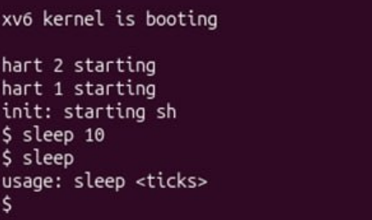
Figure 2.12 Test the program
The screenshot shows sleep 10 followed by sleep without arguments, which should demonstrate the new program.

Conclusion
Through these laboratories, we gained practical experience with fundamental operating system principles by analyzing Linux process management, memory allocation, and virtual filesystems alongside kernel-level code inspection in xv6. Investigating system calls, inter-process communication via pipes, and user-space utilities highlighted how kernels abstract hardware and manage system resources. Overall, these exercises successfully demonstrated the operational boundary between unprivileged user applications and privileged kernel operations.

