
MINISTRY OF EDUCATION, CULTURE AND RESEARCH
OF THE REPUBLIC OF MOLDOVA
Technical University of Moldova
Faculty of Computers, Informatics and Microelectronics
Department of Software Engineering and Automation

Daria Tureac FAF-243

Report
Laboratory Work No.8
Operational Systems

Checked by:
Reitman P., university assistant
FCIM, UTM

Chișinău – 2026

PART 1 | run, inside xv6
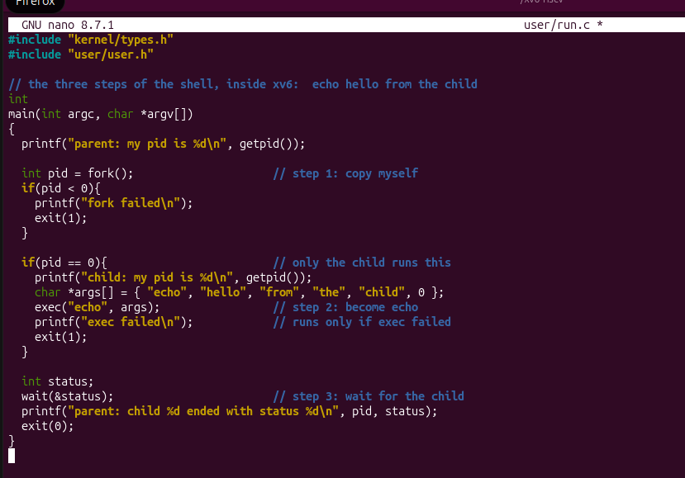
Figure 1.1 – run.c

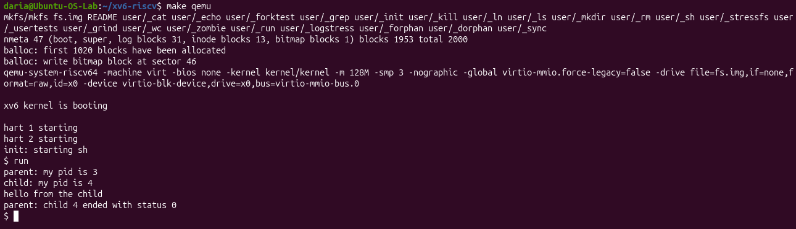
Figure 1.2 – run

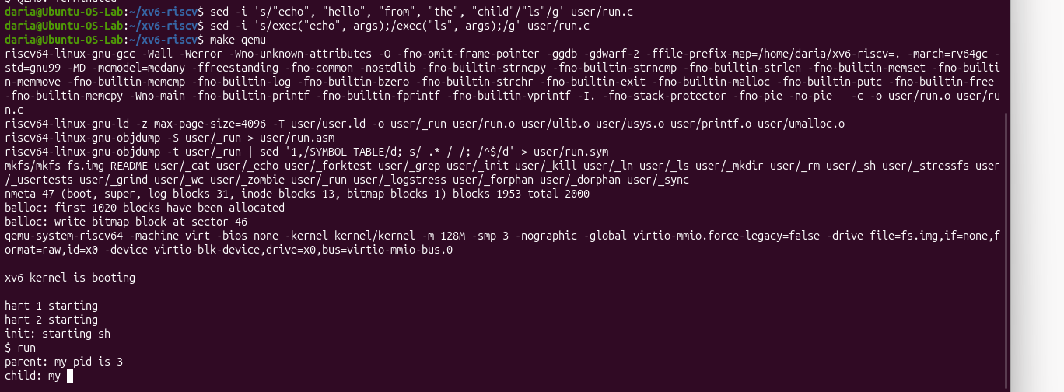
Figure 1.3 – run ls

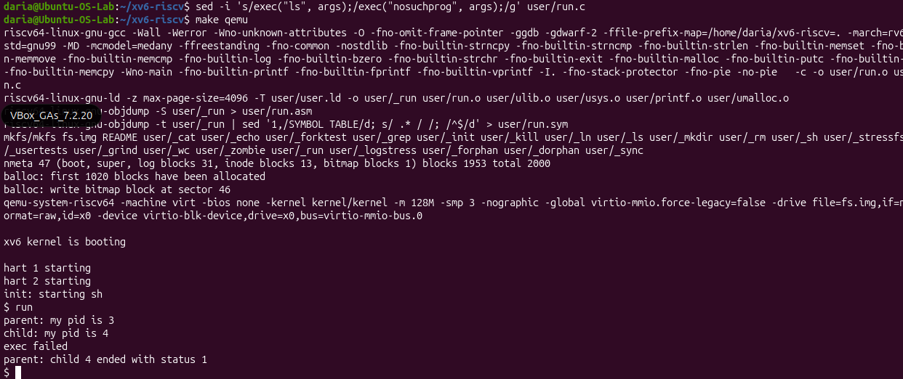
Figure 1.4 – nosuchprog

Observe
- Write the three calls that run.c uses in xv6 and the three calls run.c used on Linux in Lab 7. What is the same?
Both xv6 and Linux use fork(), exec(), and wait(), keeping the exact same system call names and sequential process management logic.
- Who prints "hello from the child": the code of run, or echo?
The string "hello from the child" is printed by the echo program because exec() successfully replaces the child's memory image.
- Why is the status 1 here and 127 on Linux? (Look at the exit line after exec in both programs.)
The status is 1 in xv6 because the code explicitly calls exit(1) upon failure, while Linux shells conventionally return 127.

PART 2 | pingpong

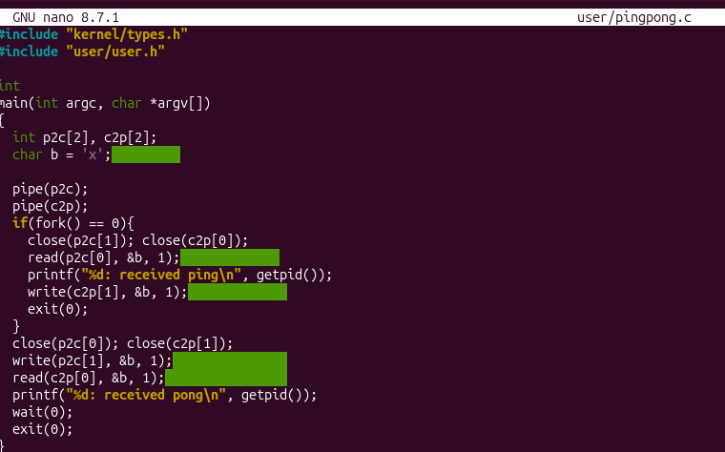
Figure 2.1 – pingpong.c
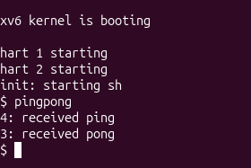
Figure 2.2 – qemu pingpong

Observe
- Why do you need TWO pipes, and not one for both directions?
Two pipes are required because pipes are unidirectional; using a single pipe for both directions would cause race conditions, message interleaving, or the parent and child reading their own transmitted data.
- Nothing in your code says "wait until the child has replied". Which call makes the parent wait?
The read() system call makes the parent block and wait until the child writes data into the pipe and replies.

Conclusion
In this laboratory work, I successfully implemented process control using fork(), exec(), and wait() alongside inter-process communication via unidirectional pipes in the xv6 operating system. Through building run.c and pingpong.c, I gained hands-on experience with process lifecycle management, kernel system calls, and bidirectional synchronization using file descriptors.

