
MINISTRY OF EDUCATION, CULTURE AND RESEARCH
OF THE REPUBLIC OF MOLDOVA
Technical University of Moldova
Faculty of Computers, Informatics and Microelectronics
Department of Software Engineering and Automation

Daria Tureac FAF-243

Report
Laboratory Work No.5
Operational Systems

Checked by:
Reitman P., university assistant
FCIM, UTM

Chișinău – 2026

Before you start
Work as your normal user, NOT as root (root ignores most permission checks and the experiments would lie).
whoami # must not print root
mkdir -p ~/os-lab5 && cd ~/os-lab5

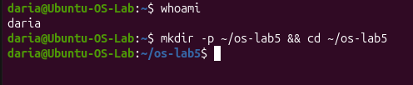
Figure 1 – Before you start

Part 1. The tree and the file types (~15 min)

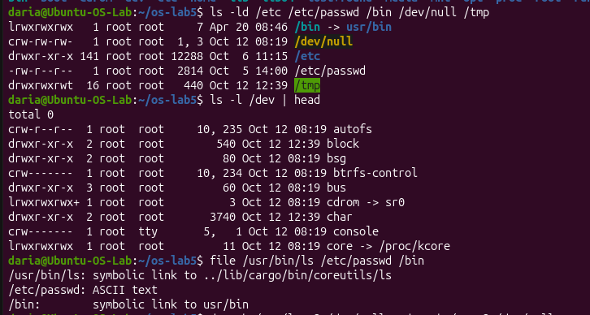
Figure 1.1 – File types

Figure 1.2 – Disk usage

Observe:
- For each path in the second line, write its type from the first letter of ls -l.

/bin is a symbolic link (l), /dev/null is a character device (c), /etc is a directory (d), /etc/passwd is a regular file (-), and /tmp is a directory (d).

- What is /bin on your system: a directory or a link, and to where?

On this system, /bin is a symbolic link that points to usr/bin

- Find one character device and one block device in /dev.

An example of a character device is console, and a block device can be found inside the block directory or referenced via sr0.

- Which is bigger on your laptop, /var/log or /usr, and by roughly how much?

/usr is much larger than /var/log (5.1G compared to 595M), exceeding it by roughly 4.5 GB.

Part 2. Inodes and links

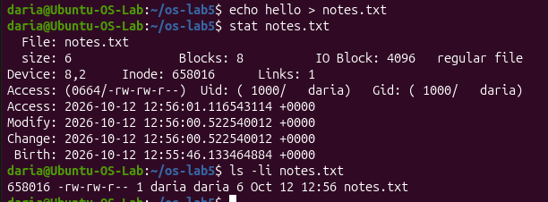
Figure 2.1 – Inode stat

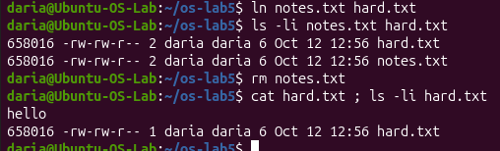
Figure 2.2 – Hard link

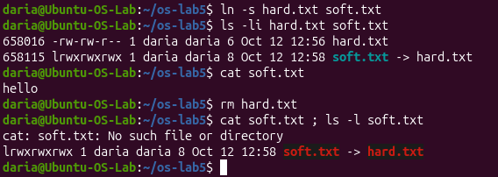
Figure 2.3 – Soft link

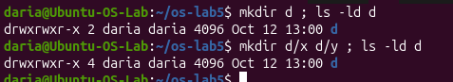
Figure 2.4 – dir links

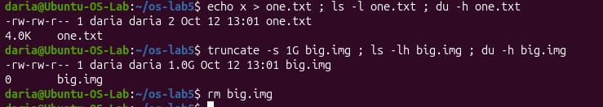
Figure 2.5 – Sparse file

Observe:
- Which number in stat is the inode, and which tells how many names the file has?

The Inode: field shows the inode number (658016), and the Links: field shows how many names (links) the file has (1).

- After rm notes.txt, why could you still read hard.txt? What does rm really remove?

You could still read hard.txt because both names pointed to the exact same inode (658016) with a link count of 2. The rm command only removes the directory entry (the specific file name) and decrements the link count, but the underlying data remains intact as long as at least one link exists.

- Why did cat soft.txt fail at the end, although soft.txt still exists? How big is soft.txt and why exactly that size?

It failed because a symbolic link points to a file name (hard.txt), and when that target file was deleted, the link became broken ("dangling"). The size of soft.txt is 8 bytes because it stores the text path string pointing to the target (hard.txt, which is 8 characters long).

- A new directory has 2 links, and 4 after you create two subdirectories. Explain where each link comes from. (5) Why does a 2-byte file use 4.0K, and a 1 GB file use 0?

A new directory initially has 2 links: one from its own name in the parent directory, and one from the internal . (dot) entry pointing to itself. When you create two subdirectories inside it, each subdirectory contains a .. (dot-dot) entry that points back to the parent directory, increasing its link count by 2 (totaling 4).

Part 3. Permissions

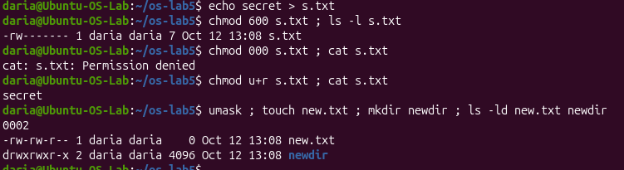
Figure 3.1 – File permissions

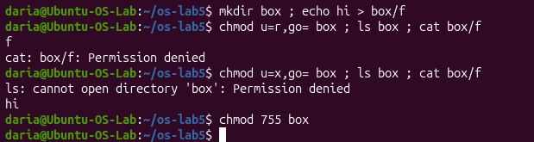
Figure 3.2 – Directory permissions

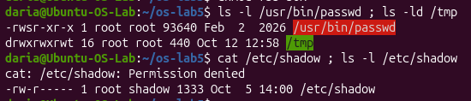
Figure 3.3 – Special bits

Observe:
- Write 600, 644, 755 and 700 as rwx strings, and give one real use for each.

600 (rw-------): Grants read and write access exclusively to the owner; commonly used for sensitive private files like SSH keys or configuration files containing passwords.
644 (rw-r--r--): Allows the owner to read and write, while everyone else can only read; standard for regular editable documents or source code files.
755 (rwxr-xr-x): Gives the owner full read, write, and execute permissions, while others can read and execute; ideal for executable programs, binaries, or scripts.
700 (rwx------): Provides full access solely to the owner with no permissions for group or others; used for private directories or scripts (like .ssh).

- With chmod 000 you own the file but cannot read it. Why does ownership not help?

File ownership grants administrative control to modify permissions, but the operating system kernel enforces access control checks strictly against the explicit permission bits (rwx). Since all bits are revoked (000), the kernel blocks the read request with a permission denied error regardless of ownership.

- What is your umask, and how does it explain the permissions of new.txt and newdir?

The current umask value is 0002. Umask acts as a mask subtracted from maximum permissions (typically 666 for files and 777 for directories), resulting in 664 (rw-rw-r--) for new.txt and 775 (drwxrwxr-x) for newdir, which matches the created outputs.

- Explain the box experiment: what does r allow on a directory, and what does x allow?

The read (r) permission on a directory allows you to list the file names inside it (e.g., ls shows f), but does not permit reading their contents or navigating through it. The execute (x) permission allows you to traverse or enter the directory, which is required to access or read the files inside it even if the file itself has read permissions.

- What do the s in /usr/bin/passwd and the t in /tmp mean, and why does passwd need the s?

The s (SetUID) bit means the program executes with the privileges of its file owner (root) rather than the invoking user. The passwd utility needs this so ordinary users can update their encrypted passwords inside the protected /etc/shadow file, which they cannot directly write to. The t (sticky) bit on /tmp ensures that users can only delete their own files within a shared directory.

Part 4. Disks and the kernel as files (~15 min)

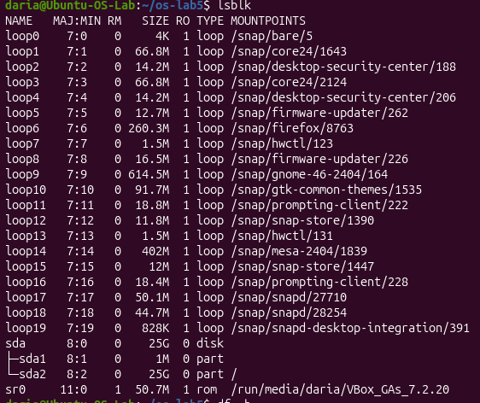
Figure 4.1 – lslblk command

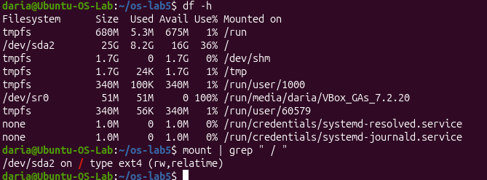
Figure 4.2 – Disks mount

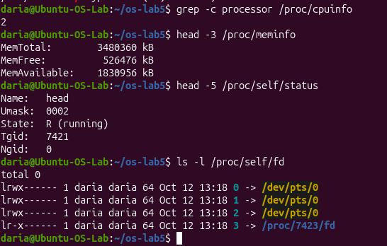
Figure 4.3 – Proc kernel

Observe:

- Draw your disk: disk name, partitions, which one is mounted at / and with what file system type.

Disk Structure: The disk is named sda with partition sda2 (25G) mounted at / using the ext4 file system type.

- How full is your root file system?

Root File System Usage: The root file system is 36% full, with 8.2 GB used out of 25 GB.

- How many CPU cores and how much RAM does your laptop have, according to /proc?

CPU and RAM: According to /proc, the system has 2 CPU cores and approximately 3.3 GB of total RAM (3480360 kB).

- /proc/self/status showed the name of a program. Which one, and why that one?

Program Name in /proc/self/status: It showed head because the head command was the active process reading its own status file.

Conclusion

In this laboratory work, I gained hands-on experience exploring the Linux file system hierarchy, understanding the mechanics of inodes, hard links, and symbolic links, and analyzing permission structures including umask and special bits like SetUID (s) and Sticky (t). Furthermore, by inspecting /proc and storage utilities, I learned how Linux abstracts system hardware, storage partitions, and active kernel process states as accessible files on the system.

