**HOW TO USE**

To use the joystick is really simple, drop the “Outer Joystick” prefab in your Canvas and you are almost done. To adjust the area where the joystick can be dragged, just modify the size of the component "J" inside the prefab. Make sure that the center of “J” is in the center of the inner joystick.

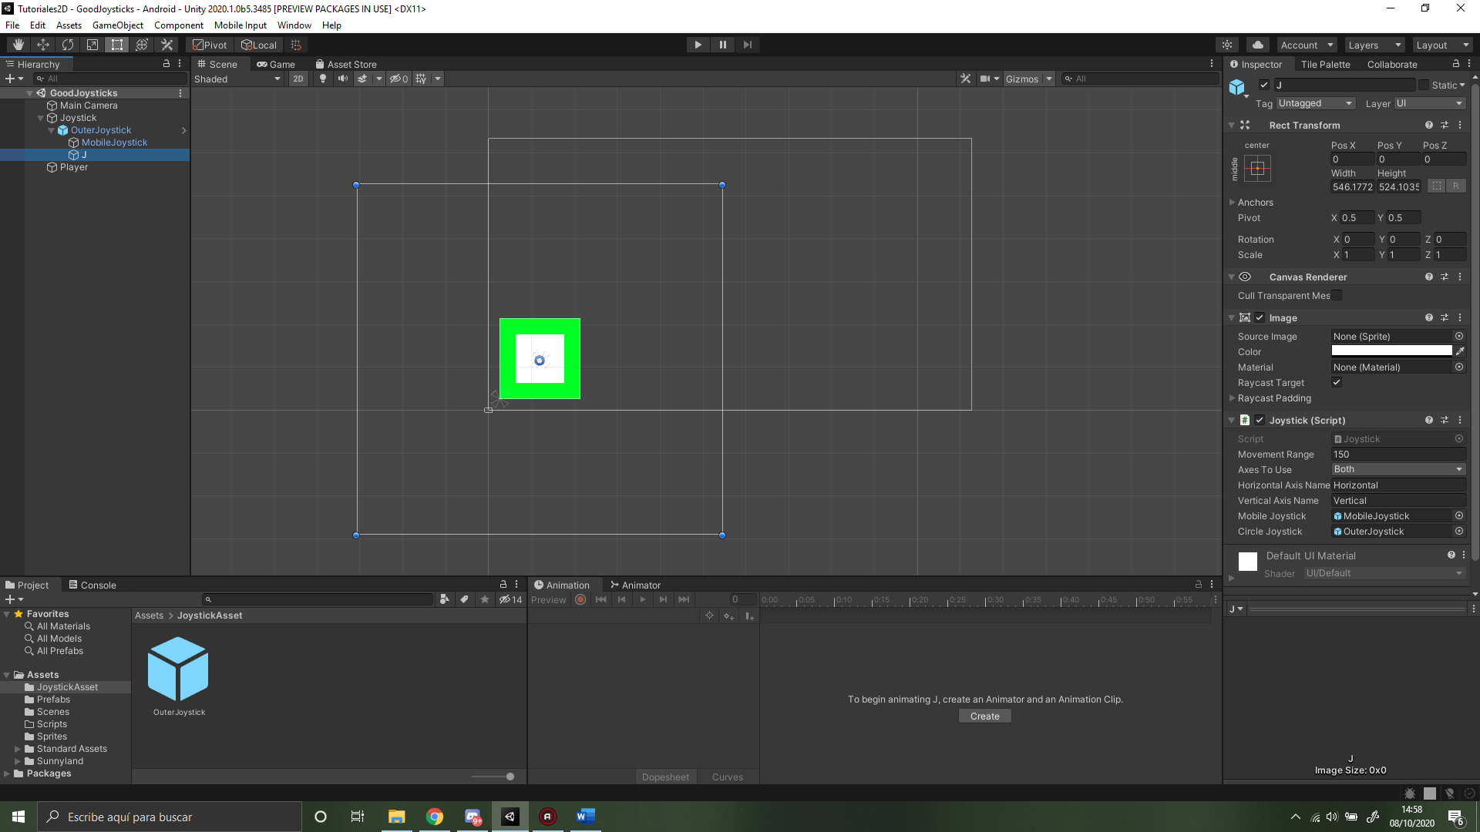

The outer rectangle is the canvas, and the inner rectangle is “J”. The area where the joystick can be dragged is the area that both rectangles share.

To make your player move or whatever that you want, inside your own script, you have to use the static values of MyJoystick scrpit:

“MyJoystick.JHV” for horizontal movement

“MyJoystick.JVV” for Vertical movement.

The “MovementJoystickPlayer” is a good example of this.

To use a second Joystick, do the same but with the “OuterJoystickRight”, and the variables this time are:

“MyJoystick2.JHV2” for horizontal movement

“MyJoystick2.JVV2” for Vertical movement.

The scene has a second joystick implemented.

**CHANGE JOYSTICK APPEARANCE**

To change the appearance of the inner joystick, just change the Sprite form the “Mobile Joystick”, and to change the outer, just change the Sprite form the “Outer Joystick”. You can change the Outer and the mobile Joystick sizes as you like, those are merely sthetic.

**PROPERTIES**

**Distance:** The distance is the maximun range that the joystick can go. If you move the joystick, it will “hit” an invisible wall sometime, if you increase the distance, that wall will be further from the center of the joystick. To understand this correctly, just try it out will 100 and 300 values.

**Min:** Minimun range for the joystick to move, it’s better for most games to just move the joystick to the center and make the joystick stop. This value goes from 0 to 1, if you select 0.5 for example, the joystick will have to travel half of the **Distance** to start moving.

**Mobile/Circle Joystick:** Just the components of the joystick, they are merely visual

**RECOMMENDATIONS**

-Leave the min value at 0.1 or lower (better 0.1).

-Leave the “J” size like that (already tested).