

Functional Safety Concept Lane Assistance

**Document Version: [Version]**

**Template Version 1.0, Released on 2017-06-21**

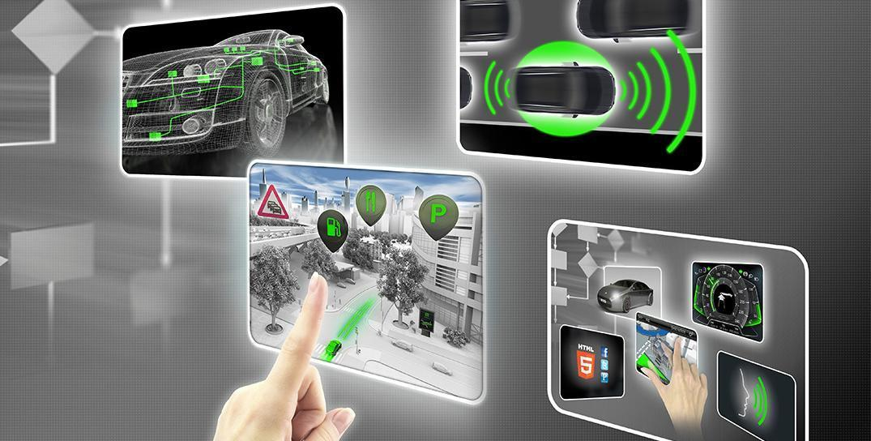

# Document history

|  |  |  |  |
| --- | --- | --- | --- |
| Date | Version | Editor | Description |
| 11/15/2017 | 1.0 | Darien Martinez | First attempt |
|  |  |  |  |
|  |  |  |  |
|  |  |  |  |
|  |  |  |  |

# 

# Table of Contents

Document history

Table of Contents

Purpose of the Functional Safety Concept

Inputs to the Functional Safety Analysis

Safety goals from the Hazard Analysis and Risk Assessment

Preliminary Architecture

Description of architecture elements

Functional Safety Concept

Functional Safety Analysis

Functional Safety Requirements

Refinement of the System Architecture

Allocation of Functional Safety Requirements to Architecture Elements

Warning and Degradation Concept

# 

# Purpose of the Functional Safety Concept

On the Functional Safety Concept documents the system high level requirements are identified. These requirements are allocated to different parts of the item architecture. Technical safety requirements will be derived from these safety concepts. Instruction on how to validate and verify the requirements are presented as well.

# Inputs to the Functional Safety Concept

## Safety goals from the Hazard Analysis and Risk Assessment

|  |  |
| --- | --- |
| **ID** | **Safety Goal** |
| Safety_Goal_01 | The oscillating steering torque from the Lane Departure Warning function shall be limited. |
| Safety_Goal_02 | The Lane Keeping Assistance function shall be time limited, and additional steering torque shall end after a given time interval so the driver cannot misuse the system for autonomous driving. |
| Safety_Goal_03 | The Lane Departure Warning function shall be deactivated when the camera sensor stop working. |
| Safety_Goal_04 | The Lane Keeping Assistance function shall be deactivated when the camera sensor stop working. |

## Preliminary Architecture

The following figure shows the Lane Assistance item architecture:

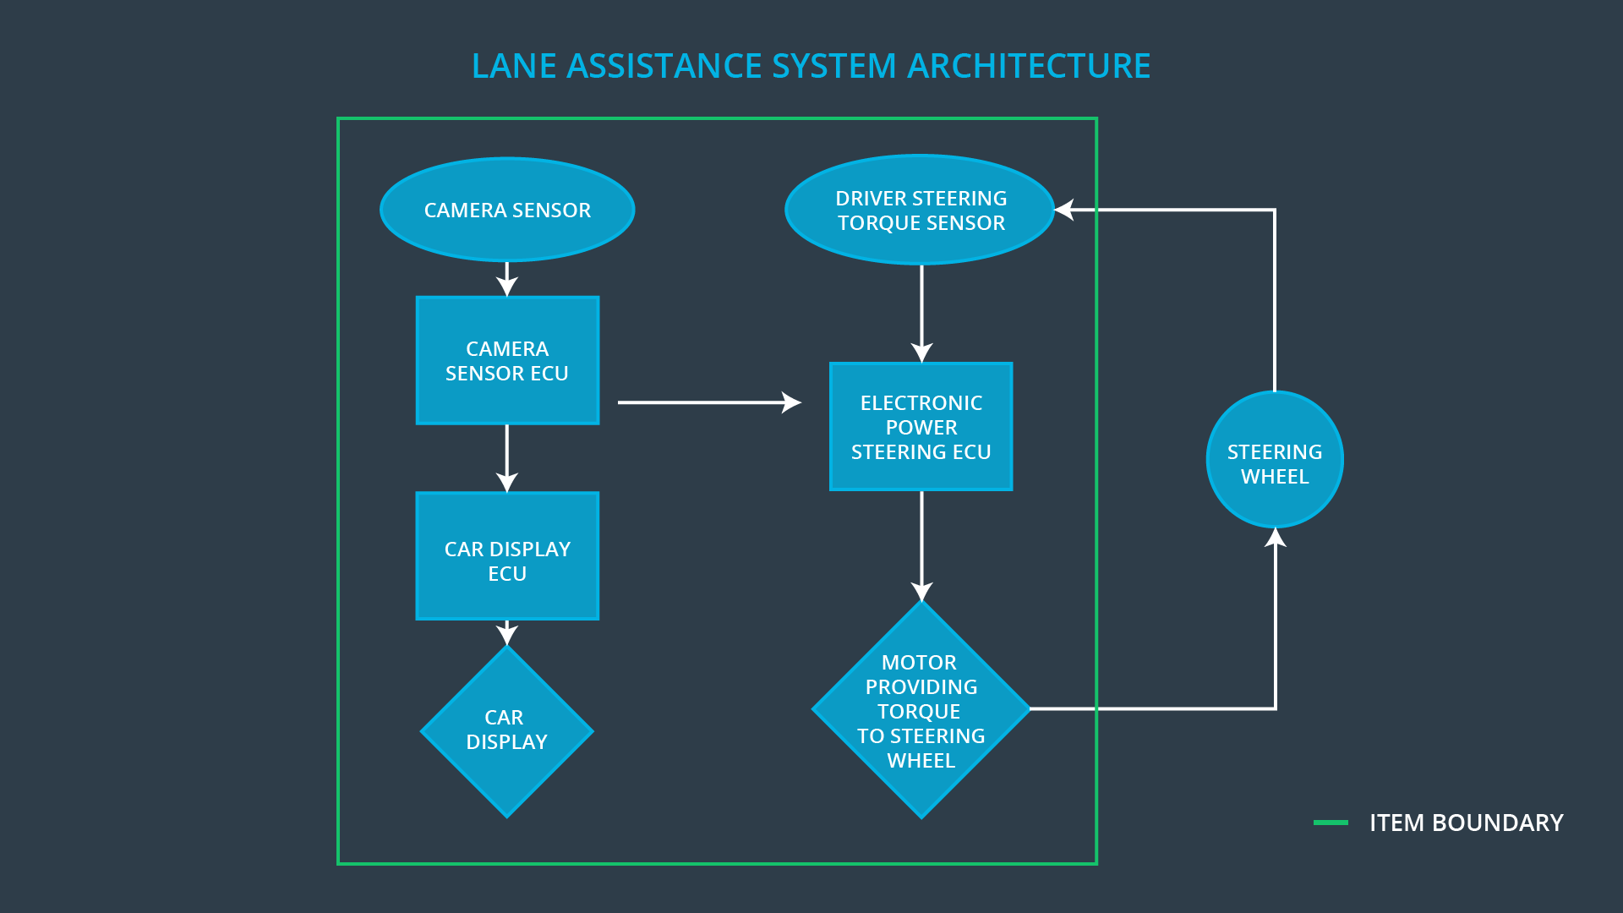

### Description of architecture elements

|  |  |
| --- | --- |
| **Element** | **Description** |
| Camera Sensor | Capture road images and provide them to the Camera Sensor ECU. |
| Camera Sensor ECU | Analyze provided images to calculate the car position on the road respect to the road lanes. |
| Car Display | Provide feedback to the driver displaying warnings and the Lane Departure Assistance status. |
| Car Display ECU | Drive the Car Display component to show the Lane Keeping Assistance warning and Lane Departure Assistance status. |
| Driver Steering Torque Sensor | Measure the torque applied to the steering wheel by the driver. |
| Electronic Power Steering ECU | Use the information received from the Driver Steering Torque Sensor and the torque requested by the Lane Keeping Assistance and Lane Warning and request the necessary torque to be applied by the Motor actuator. |
| Motor | Applies the torque indicated by the Electronic Power Steering ECU to the steering wheel. |

# Functional Safety Concept

The functional safety concept consists of:

* Functional safety analysis
* Functional safety requirements
* Functional safety architecture
* Warning and degradation concept

## Functional Safety Analysis

|  |  |  |  |
| --- | --- | --- | --- |
| **Malfunction ID** | **Main Function of the Item Related to Safety Goal Violations** | **Guidewords (NO, WRONG, EARLY, LATE, MORE, LESS)** | **Resulting Malfunction** |
| Malfunction_01 | Lane Departure Warning (LDW) function shall apply an oscillating steering torque to provide the driver a haptic feedback | MORE | The Lane Departure Warning function applies an oscillating torque with very high torque amplitude (above limit) |
| Malfunction_02 | Lane Departure Warning (LDW) function shall apply an oscillating steering torque to provide the driver a haptic feedback | MORE | The Lane Departure Warning function applies an oscillating torque with very high torque frequency (above limit) |
| Malfunction_03 | Lane Keeping Assistance (LKA) function shall apply the steering torque when active in order to stay in ego lane | NO | The Lane Keeping Assistance function is not limited in time duration which lead to misuse as an autonomous driving function. |
| Malfunction_04 | The Lane Departure Warning function shall be deactivated when the camera sensor stop working. | WRONG | The Lane Departure Warning start acting randomly when the camera sensor is not working. |
| Malfunction_05 | The Lane Keeping Assistance function shall be deactivated when the camera sensor stop working. | WRONG | The Lane Keeping Assistance start acting randomly when the camera sensor is not working. |

## Functional Safety Requirements

Lane Departure Warning (LDW) Requirements:

|  |  |  |  |  |
| --- | --- | --- | --- | --- |
| **ID** | **Functional Safety Requirement** | **ASIL** | **Fault Tolerant Time Interval** | **Safe State** |
| Functional  Safety  Requirement  01-01 | The Lane Departure Warning item shall ensure that the lane departure oscillating torque amplitude is below Max_Torque_Amplitude. | C | 50 ms | Vibration torque amplitude below Max_Torque_Amplitude. |
| Functional  Safety  Requirement  01-02 | The Lane Departure Warning item shall ensure that the lane departure oscillating torque frequency is below Max_Torque_Frequency. | C | 50 ms | Vibration frequency is below Max_Torque_Frequency. |
| Functional Safety Requirement  01-03 | The Lane Departure Warning function shall be deactivated when the camera sensor stop working. | C | 10 ms | Function is deactivated. |

Lane Departure Warning (LDW) Verification and Validation Acceptance Criteria:

|  |  |  |
| --- | --- | --- |
| **ID** | **Validation Acceptance**  **Criteria and Method** | **Verification Acceptance**  **Criteria and Method** |
| Functional  Safety  Requirement  01-01 | Validate Max_Torque_Amplitude chosen is high enough to be detected by a driver while low enough not to cause loss of steering | Verify the system does turn off if the Lane Departure Warning exceeded Max_Torque_Amplitude. |
| Functional  Safety  Requirement  01-02 | Validate Max_Torque_Frequency chosen is adequate to be detected by the driver and not cause the loss of steering. | Verify the system does turn off if the Lane Departure Warning exceeded Max_Torque_Frequency. |
| Functional Safety Requirement 01-03 | Validate Lane Departure Warning is off when the camera sensor is not working. | Verify the Lane Departure Warning is never on when the camera sensor is not working. |

Lane Keeping Assistance (LKA) Requirements:

|  |  |  |  |  |
| --- | --- | --- | --- | --- |
| **ID** | **Functional Safety Requirement** | **ASIL** | **Fault Tolerant Time Interval** | **Safe State** |
| Functional  Safety  Requirement  02-01 | The electronic power steering ECU shall ensure that the Lane Keeping Assistance torque is applied only Max_Duration. | B | 500 ms | Lane Keeping Assistance torque is zero. |
| Functional Safety Requirement 02-02 | The Lane Keeping assistance shall be deactivated when the electronic power steering ECU detects the camera sensor is not working. | C | 10 ms | Function is deactivated. |

Lane Keeping Assistance (LKA) Verification and Validation Acceptance Criteria:

|  |  |  |
| --- | --- | --- |
| **ID** | **Validation Acceptance**  **Criteria and Method** | **Verification Acceptance**  **Criteria and Method** |
| Functional  Safety  Requirement  02-01 | Validate the Max_Duration chosen not allow the driver to use the car as self-driving car. | Verify the system does deactivate if the Lane Keeping Assistance torque application exceeded Max_Duration. |
| Functional Safety Requirement 02-02 | Validate the Lane Keeping assistance shall be deactivated when the camera sensor stop working. | Verify the system does deactivate the Lane Keeping Assistance if the camera sensor is not working. |

## Refinement of the System Architecture

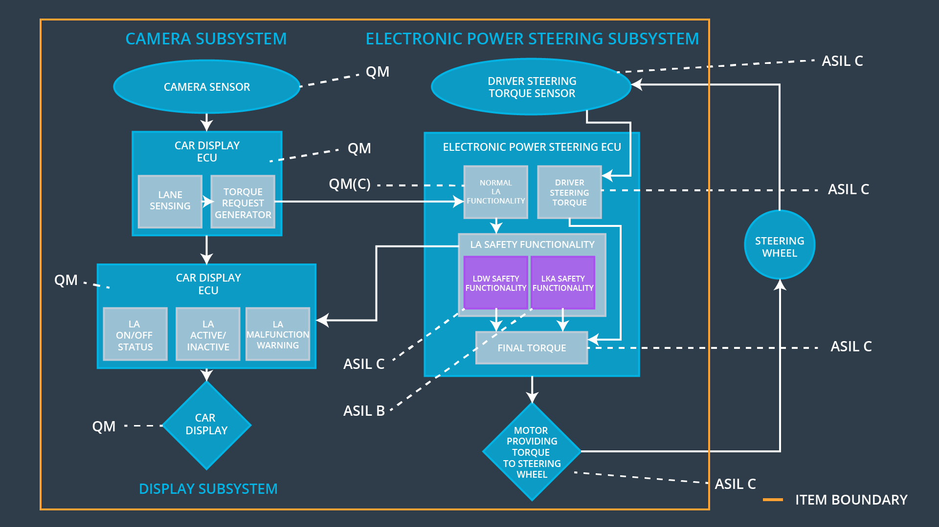

## Allocation of Functional Safety Requirements to Architecture Elements

|  |  |  |  |  |
| --- | --- | --- | --- | --- |
| **ID** | **Functional Safety Requirement** | **Electronic Power Steering ECU** | **Camera ECU** | **Car Display ECU** |
| Functional  Safety  Requirement  01-01 | The Lane Departure Warning item shall ensure that the lane departure oscillating torque amplitude is below Max_Torque_Amplitude. | **X** |  |  |
| Functional  Safety  Requirement  01-02 | The Lane Departure Warning item shall ensure that the lane departure oscillating torque frequency is below Max_Torque_Frequency. | **X** |  |  |
| Functional Safety Requirement 01-03 | The Lane Departure Warning function shall be deactivated when the camera sensor stop working. | **X** |  |  |
| Functional  Safety  Requirement  02-01 | The electronic power steering ECU shall ensure that the Lane Keeping Assistance torque is applied only Max_Duration. | **X** |  |  |
| Functional Safety Requirement 02-02 | The Lane Keeping assistance shall be deactivated when the electronic power steering ECU detects the camera sensor is not working. | **X** |  |  |

## Warning and Degradation Concept

|  |  |  |  |  |
| --- | --- | --- | --- | --- |
| **ID** | **Degradation Mode** | **Trigger for Degradation Mode** | **Safe State invoked?** | **Driver Warning** |
| WDC-01 | Turn off Lane Departure Warning functionality | Malfunction_01,  Malfunction_02,  Malfunction_04 | Yes | Lane Departure Warning Malfunction Warning on Car Display |
| WDC-02 | Turn off Lane Keeping Assistance functionality | Malfunction_03,  Malfunction_05 | Yes | Lane Keeping Assistance Malfunction Warning on Car Display |