

Software Safety Requirements and Architecture

Lane Assistance

**Document Version: [Version]**

**Template Version 1.0, Released on 2017-06-21**

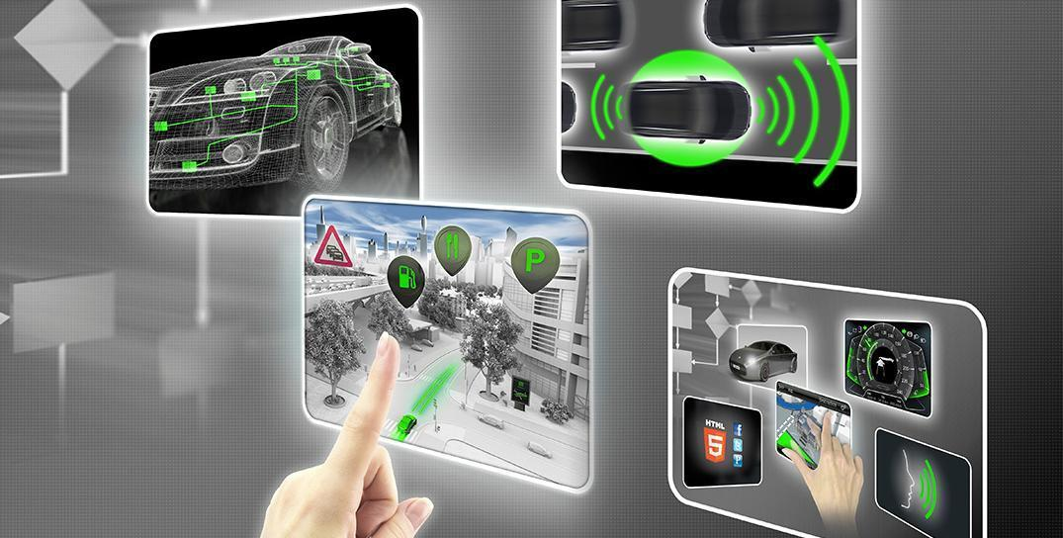

# Document history

|  |  |  |  |
| --- | --- | --- | --- |
| Date | Version | Editor | Description |
| 11/23/2017 | 1.0 | Darien Martinez | First attempt |
|  |  |  |  |
|  |  |  |  |
|  |  |  |  |
|  |  |  |  |

# 

# Table of Contents

Document history

Table of Contents

Purpose

Inputs to the Software Requirements and Architecture Document

Technical safety requirements

Refined Architecture Diagram from the Technical Safety Concept

Software Requirements

Refined Architecture Diagram

# Purpose

This document identify the new requirements for the software components at a component level to identify potential problems on software design and architecture that could lead to a violation of safety goals. These requirements are more detail oriented than the technical safety concept requirements.

# Inputs to the Software Requirements and Architecture Document

## Technical safety requirements

Technical Safety Requirements related to Functional Safety Requirement 01-01 are:

|  |  |  |  |  |  |
| --- | --- | --- | --- | --- | --- |
| **ID** | **Technical Safety Requirement** | **ASIL** | **Fault Tolerant Time Interval** | **Architecture Allocation** | **Safe State** |
| Technical  Safety  Requirement  01-01-01 | The Lane Departure Warning safety component shall ensure that the amplitude of the ‘LDW_Torque_Request’ sent to the ‘Final electronic power steering Torque’ component is below ‘Max_Torque_Amplitude’ | C | 50 ms | LDW Safety | Lane Departure |
| Technical  Safety  Requirement  01-01-02 | When the Lane Departure Warning is deactivated, the ‘LDW Safety’ software module shall send a signal to the Car Display ECU to turn on a warning signal. | C | 50 ms | LDW Safety | Lane Departure Warning torque to zero. |
| Technical  Safety  Requirement  01-01-03 | When a failure is detected by the Lane Departure Warning functionality, it shall deactivate the Lane Departure Warning feature and set ‘LDW_Torque_Request’ to zero. | C | 50 ms | LDW Safety | Lane Departure Warning torque to zero. |
| Technical  Safety  Requirement  01-01-04 | The validity and integrity of the data transmission for ‘LDW_Torque_Request’ signal shall be ensured. | C | 50 ms | LDW Safety | Lane Departure Warning torque to zero. |
| Technical  Safety  Requirement  01-01-05 | Memory test shall be conducted at start up of the EPS ECU to check for any memory problems | A | Ignition cycle | Data Transmission Integrity Check | Lane Departure Warning torque to zero. |

## Refined Architecture Diagram from the Technical Safety Concept

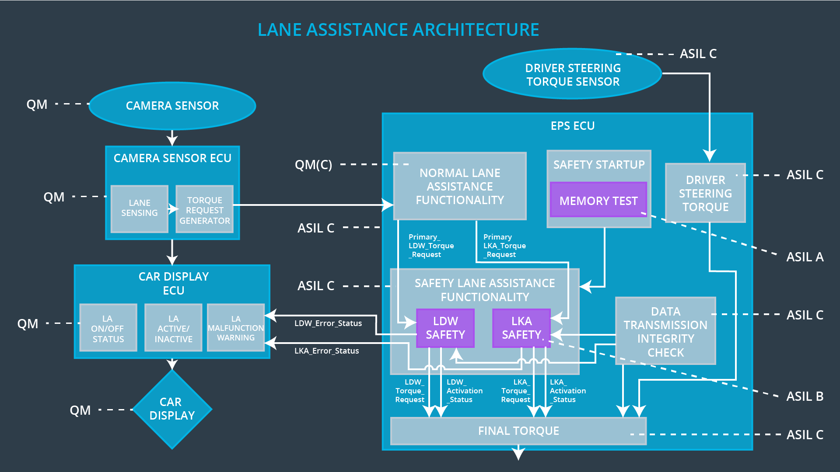

# Software Requirements

**Lane Departure Warning (LDW) Amplitude Malfunction Software Requirements:**

|  |  |  |  |  |  |
| --- | --- | --- | --- | --- | --- |
| **ID** | **Technical Safety Requirement** | **ASIL** | **Fault Tolerant Time Interval** | **Allocation to Architecture** | **Safe State** |
| Technical  Safety  Requirement  01-01-01 | The Lane Departure Warning safety component shall ensure that the amplitude of the ‘LDW_Torque_Request’ sent to the ‘Final electronic power steering Torque’ component is below ‘Max_Torque_Amplitude.’ | C | 50 ms | LDW Safety | Lane Departure Warning torque to zero. |

|  |  |  |  |  |
| --- | --- | --- | --- | --- |
| ID | Software Safety Requirement | ASIL | Allocation Software Elements | Safe State |
| Software  Safety  Requirement  01-01-01-01 | The input signal ‘Primary_LDW_Torq_Req’ shall be read and pre-processed to determine the torque request coming from the ‘Basic/Main LAFunctionality’ SW Component. Signal ‘processed_LDW_Torq_Req’ shall be generated at the end of the processing. | C | LDW_SAGETY_INPUT_PROCESSING | N/A |
| Software Safety Requirement 01-01-01-02 | In case the ‘processed_LDW_Torq_Req’ signal has a value greater than ‘Max_Torque_Amplitude_LDW’ (maximum allowed safe torque), the torque signal ‘limited_LDW_Torq_Req’ shall be set to zero, else ‘limited_LDW_Torq_Req’ shall take the value of ‘processed_LDW_Torq_Req’ | C | TORQUE_LIMITER | ‘limited_LDW_Torq_Req’ = 0 (Nm=Newton-meter) |
| Software Safety Requirement 01-01-01-03 | The ‘limited_LDW_Torq_Req’ shall be transformed into a signal ‘LDW_Torq_Req’ which is suitable to be transmitted outside the LDW Safety component (‘LDW Safety’) to the ‘Final EPS Torque’ component. | C | LDW_SAFETY_OUTPUT_GENERATOR | LDW_Torq_Req = 0 (Nm) |

|  |  |  |  |  |  |
| --- | --- | --- | --- | --- | --- |
| **ID** | **Technical Safety Requirement** | **ASIL** | **Fault Tolerant Time Interval** | **Allocation to Architecture** | **Safe State** |
| Technical  Safety  Requirement  01-01-02 | When the Lane Departure Warning is deactivated, the ‘LDW Safety’ software module shall send a signal to the Car Display ECU to turn on a warning signal. | C | 50 ms | LDW Safety | Lane Departure Warning torque to zero. |

|  |  |  |  |  |
| --- | --- | --- | --- | --- |
| **ID** | **Software Safety Requirement** | **ASIL** | **Allocation Software Elements** | **Safe State** |
| Software Safety Requirement 01-01-02-01 | Any data to be transmitted outside the LDQ Safety component (‘LDW Safety’) including ‘LDW_Torque_Req’ and ‘activation_status’ shall be protected by an End-2-End protection mechanism. | C | E2C Calc | LDW_Torq_Req = 0 (Nm) |
| Software Safety Requirement 01-01-02-02 | The E2E protection protocol shall contain and attach the control data (alive counter (SQC) and CRC) to the data to be transmitted. | C | E2E Calc | LDW_Torq_Req = 0 (Nm) |

|  |  |  |  |  |  |
| --- | --- | --- | --- | --- | --- |
| **ID** | **Technical Safety Requirement** | **ASIL** | **Fault Tolerant Time Interval** | **Allocation to Architecture** | **Safe State** |
| Technical  Safety  Requirement  01-01-03 | When a failure is detected by the Lane Departure Warning functionality, it shall deactivate the Lane Departure Warning feature and set ‘LDW_Torque_Request’ to zero. | C | 50 ms | LDW Safety | Lane Departure Warning torque to zero. |

|  |  |  |  |  |
| --- | --- | --- | --- | --- |
| **ID** | **Software Safety Requirement** | **ASIL** | **Allocation Software Elements** | **Safe State** |
| Software Safety Requirement 01-01-03-01 | Each Software element shall output a a signal to indicate any error which is detected by the element. Error signal = error_status_input (LDW_SAFETY_INPUT_PROCESSING), error_status_torque_limiter(TORQUE_LIMITER), error_status_output_gen(LDW_SAFETY_OUTPUT_GENERATOR) | C | All | N/A |
| Software Safety Requirement 01-01-03-02 | A software element shall evaluate the error status of all other software elements and in case any one of them indicates an error, it shall deactivate the Lane Departure Warning feature (‘activation_status’=0) | C | LDW_SAFETY_ACTIVATION | Lane Departure Warning function deactivated (‘activation_status’ =0). |
| Software Safety Requirement 01-01-03-03 | In case of a no error from the software elements, the status of the Lane Departure Warning feature shall be set to activated (‘activation_status’=1). | C | LDW_SAFETY_ACTIVATION | N/A |
| Software Safety Requirement 01-01-03-04 | In case an error is detected by any of the software elements, it shall set the value to its corresponding torque to zero so that ‘LDW_Torq_Req’ is set to zero | C | All | LDW_Torq_Req = 0 |
| Software Safety Requirement 01-01-03-05 | Once the Lane Departure Warning functionality has been deactivated, it shall stay deactivating until the time the ignition is switched from off to on again. | C | LDW_SAFETY_ACTIVATION | Lane Departure Warning function deactivated (‘activation_status’ =0). |

|  |  |  |  |  |  |
| --- | --- | --- | --- | --- | --- |
| **ID** | **Technical Safety Requirement** | **ASIL** | **Fault Tolerant Time Interval** | **Allocation to Architecture** | **Safe State** |
| Technical  Safety  Requirement  01-01-04 | The validity and integrity of the data transmission for ‘LDW_Torque_Request’ signal shall be ensured. | C | 50 ms | LDW Safety | Lane Departure Warning torque to zero. |

|  |  |  |  |  |
| --- | --- | --- | --- | --- |
| **ID** | **Software Safety Requirement** | **ASIL** | **Allocation Software Elements** | **Safe State** |
| Software Safety Requirement 01-01-04-01 | When the Lane Departure Warning function is deactivated (‘activation_status’ set to zero), the activation_status shall be sent to the Car Display ECU. | C | LDW_SAFETY_ACTIVATION, Car Display ECU | N/A |

|  |  |  |  |  |  |
| --- | --- | --- | --- | --- | --- |
| **ID** | **Technical Safety Requirement** | **ASIL** | **Fault Tolerant Time Interval** | **Allocation to Architecture** | **Safe State** |
| Technical  Safety  Requirement  01-01-05 | Memory test shall be conducted at start up of the EPS ECU to check for any memory problems | A | Ignition cycle | Data Transmission Integrity Check | Lane Departure Warning torque to zero. |

|  |  |  |  |  |
| --- | --- | --- | --- | --- |
| **ID** | **Software Safety Requirement** | **ASIL** | **Allocation Software Elements** | **Safe State** |
| Software Safety Requirement 01-01-05-01 | A CRC verification check over the software code in the Flash memory shall be done every time the ignition is switched from off to on to check for any content corruption. | A | MEMORYTEST | Activation_status = 0 |
| Software Safety Requirement 01-01-05-02 | Standard RAM test to check the data bus, address bus and device integrity shall be done every time the ignition is switched from off to on (e. G. walking 1s test, RAM pattern test, Refer to RAM and processor vendor recommendations) | A | MEMORYTEST | Activation_status = 0 |
| Software Safety Requirement 01-01-05-03 | The test result of the RAM or Flash memory shall be indicated to the LDW_Safety component via the ‘test_status’ signal. | A | MEMORYTEST | Activation_status = 0 |
| Software Safety Requirement 01-01-05-04 | In case any fault is indicated via the ‘test_status’ signal the INPUT_LDW_PROCESSING shall set an error on the error_status_input(=1) so that the Lane Departure Warning functionality is deactivated and the LDW_Torque_Req is set to zero. | A | LDW_SFETY_INPUT_PROCESSING | Activation_status = 0 |

# 

# Refined Architecture Diagram

