FINAL EXAM PROJECT
LIBRARY MANAGEMENT SYSTEM
Project Proposal, UX/UI Design and Development Plan
Team Members: | Dariga Eralyeva , Amina Moldakhanova
Course: | Java Spring Boot
Project: | Library Management System (LMS)

1. Project Overview
The Library Management System (LMS) is a web-based application designed to simplify and automate the daily operations of a library. It provides a digital catalog where users can search for books, check availability, reserve titles, and track their borrowed books. Librarians and administrators can manage books, users, reservations, borrowing records, and returns through an administrative interface.
The system is planned as a Java Spring Boot application with a PostgreSQL database. The interface will be designed in Figma and implemented as a responsive web application.
2. Problem Statement
Many libraries still rely on manual paperwork or disconnected spreadsheets to manage their collections and lending processes. These methods can make it difficult to find books quickly, monitor availability, track due dates, and maintain accurate borrowing records. Manual processes may also lead to duplicated records, delays, and avoidable human errors.
The proposed LMS addresses these issues by centralizing library information and providing a clear, easy-to-use digital workflow for both library visitors and staff.
3. Project Objectives
- Digitize the library catalog and centralize book information.
- Allow users to search and filter books online.
- Enable users to reserve available books and view their borrowing information.
- Help librarians manage book records, users, loans, and returns.
- Track book availability and borrowing history accurately.
- Reduce manual work, processing time, and data-entry errors.
4. Target Users and Roles
User role | Needs | Main capabilities
Students | Find books and manage personal loans | Browse catalog, search, reserve books, view due dates and history
Teachers | Access learning and research materials | Browse catalog, reserve books, view personal borrowing records
Librarians | Manage daily library operations | Register loans and returns, check availability, update book records
Administrators | Control the system and its data | Manage books, categories, users, and borrowing records
5. Functional Requirements
ID | Requirement | Description
FR-01 | User registration and login | The system shall allow users to create an account and sign in securely.
FR-02 | Book catalog | The system shall display a catalog of books with title, author, category, and availability.
FR-03 | Search and filtering | Users shall be able to search by title or author and filter by category or availability.
FR-04 | Book details | Users shall be able to open a book page and view its description and availability.
FR-05 | Book reservation | Authenticated users shall be able to reserve an available book.
FR-06 | Personal dashboard | Users shall be able to view current loans, reservations, due dates, and borrowing history.
FR-07 | Book management | Authorized staff shall be able to add, edit, and remove book records.
FR-08 | User management | Administrators shall be able to view and manage user accounts.
FR-09 | Loan and return management | Librarians shall be able to register book issue and return operations.
FR-10 | Availability tracking | The system shall update book availability when a book is borrowed, returned, or reserved.
6. Expected Results
At the end of development, the project is expected to deliver a working web-based Library Management System prototype. Users will be able to authenticate, browse and search the catalog, view book details, make reservations, and review their personal borrowing information. Staff users will have tools to manage books, users, loans, and returns. The result should reduce routine manual work and make library information more accessible and consistent.
7. UX/UI Design in Figma
Screens of figma (7- pages)
Login & registratrion
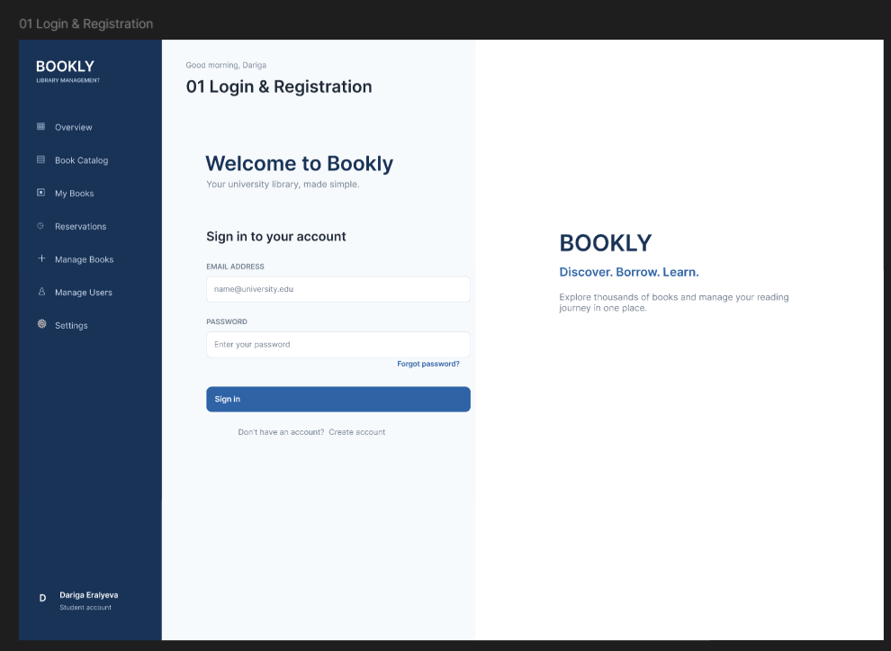

Dasboard
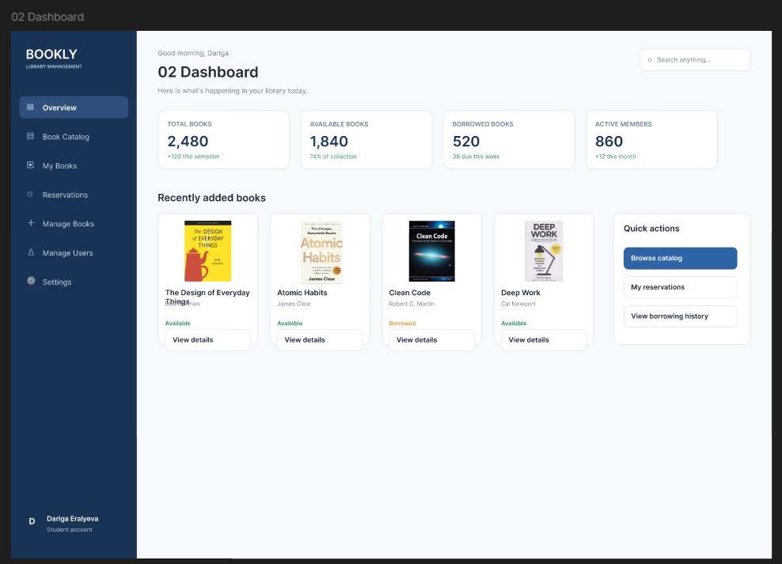

Book catalog
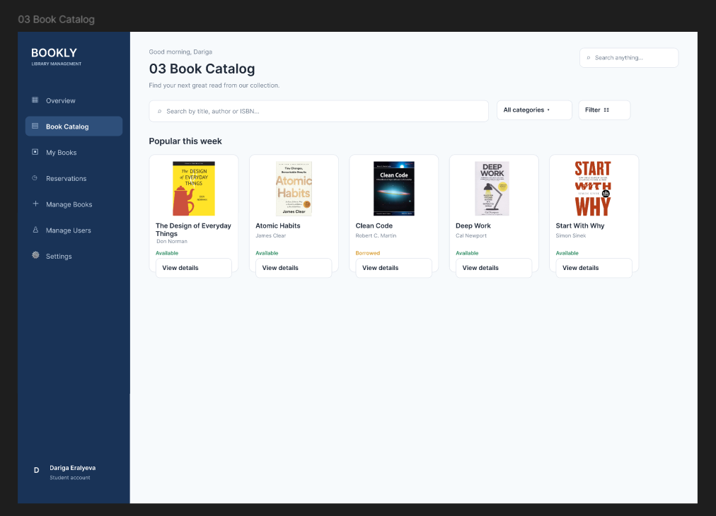

Book Details
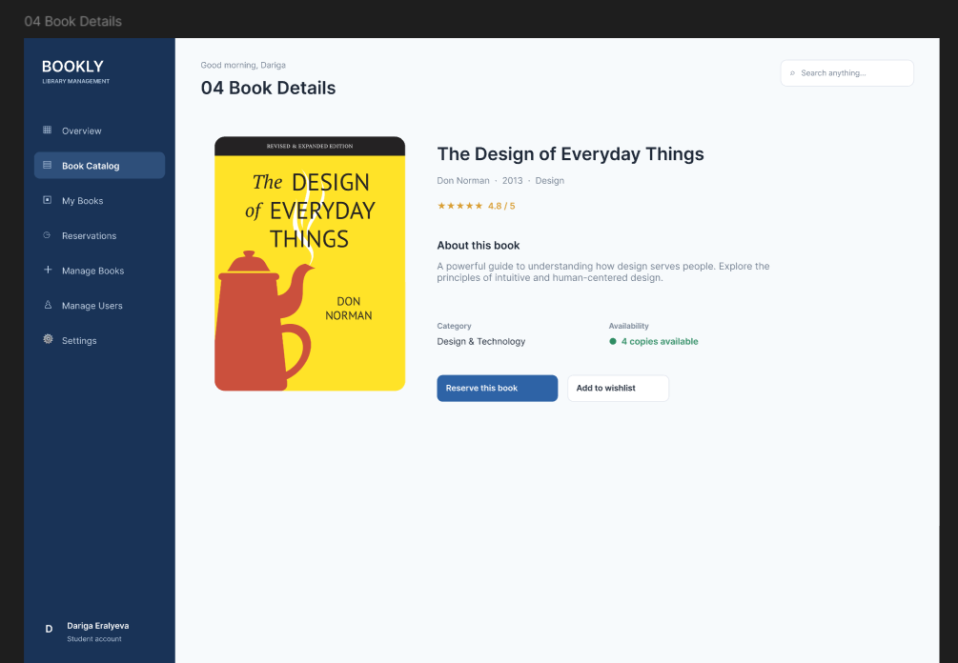

My Books
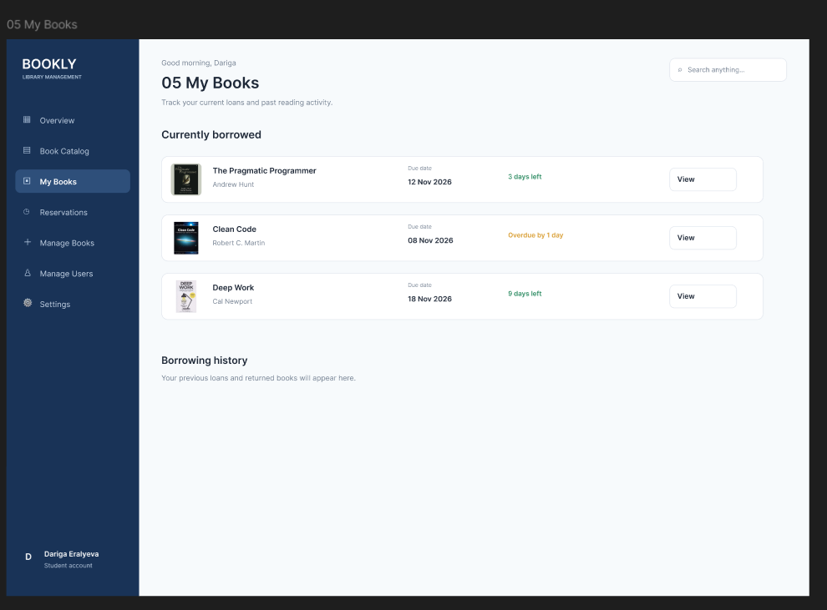

Manage Books(Admin)
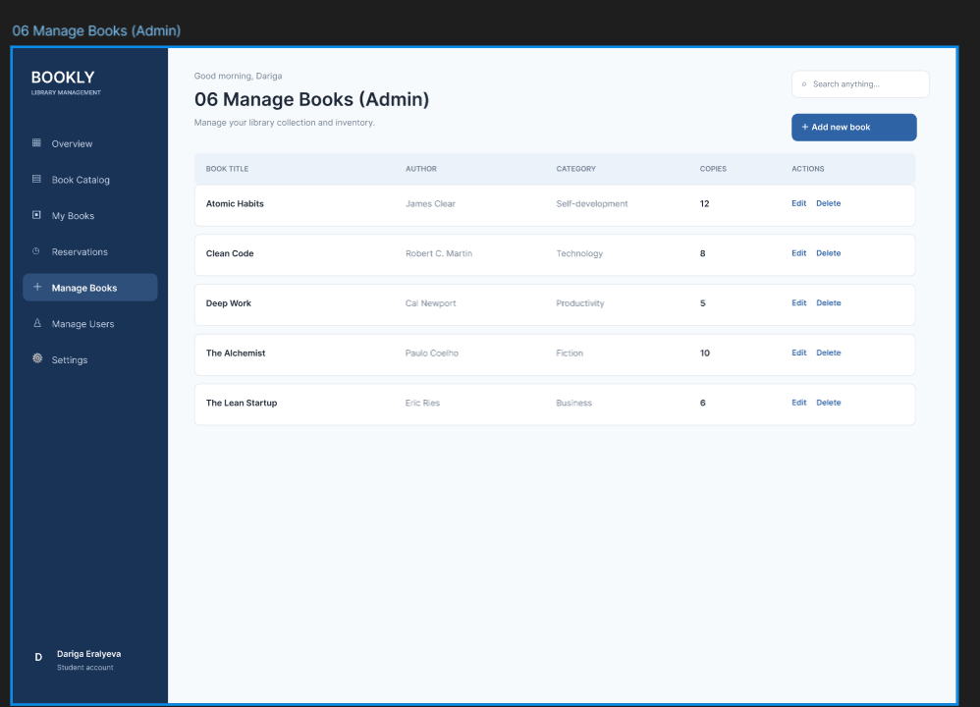

Manage Users (Admin)
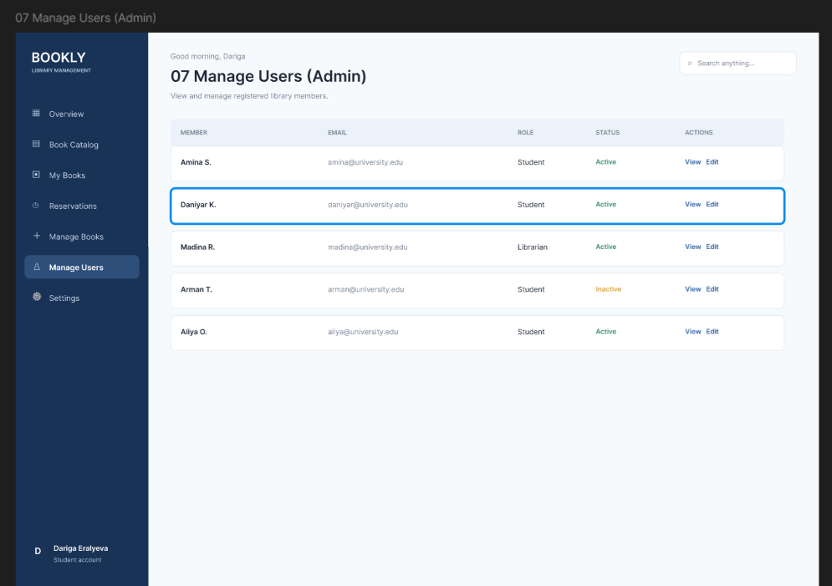

The interface is designed as a clean desktop web application. The visual style uses a dark navy primary color, light blue backgrounds, white content surfaces, and clear typography. The goal is to make the main library tasks easy to understand and complete.
Design system details:
- Primary color: Navy Blue — #1E3A5F
- Secondary background: Light Blue — #EAF2F8
- Surface color: White — #FFFFFF
- Typography: Inter (or a similar sans-serif font)
- Style: Minimal, readable, consistent, and suitable for a library service.
7.1 Designed Screens
- 01. Login & Registration — Allows users to sign in or create an account.
- 02. Dashboard — Provides an overview and quick access to the catalog and personal reservations.
- 03. Book Catalog — Displays book cards and provides search and filtering controls.
- 04. Book Details — Shows detailed information about a selected book and a reservation action.
- 05. My Books — Shows the user's current loans, reservations, due dates, and history.
- 06. Manage Books (Admin) — Allows authorized staff to add, edit, and remove books.
- 07. Manage Users (Admin) — Allows administrators to view and manage user accounts.
7.2 Main User Flow
- Open the website.
- Sign in or create an account.
- Open the user dashboard.
- Select the Book Catalog.
- Search or filter the catalog.
- Open a book's details page.
- Check whether the book is available.
- If available, select “Reserve this book”.
- View the reservation in “My Books”.
Figma design link: https://www.figma.com/design/jK27iO2kKbAyNeVPHUU5X6/Untitled
8. Technology Stack and Dependencies
Technology / dependency | Purpose
Programming language | Java 17 or Java 21
Backend framework | Spring Boot
Web layer | Spring Web / Spring MVC
Data access | Spring Data JPA and Hibernate
Database | PostgreSQL
Security | Spring Security
Validation | Spring Boot Starter Validation
Frontend Framework & Styling | HTML5, CSS3, JavaScript, Bootstrap 5, Thymeleaf templates
Build tool | Maven
Utilities | Lombok (optional)
Testing | Spring Boot Starter Test, JUnit
Design | Figma
Version control | Git and GitHub
9. Database Design (Initial Plan)
The database will store information about users, books, authors, categories, reservations, and borrowings. The final schema may be refined during implementation.
Entity | Stored information
Users | User accounts, credentials, contact details, and role.
Books | Book title, ISBN, description, publication year, category, and availability.
Authors | Author names and related information.
Categories | Book categories or genres.
Reservations | User reservations, reservation date, and status.
Borrowings | Issue date, due date, return date, and loan status.
Planned relationships:
- One category can contain many books (one-to-many).
- One author can write many books, and a book may have multiple authors (many-to-many).
- One user can create multiple reservations (one-to-many).
- One user can have multiple borrowing records (one-to-many).
- Each reservation and borrowing record refers to a specific book.

10. System Architecture
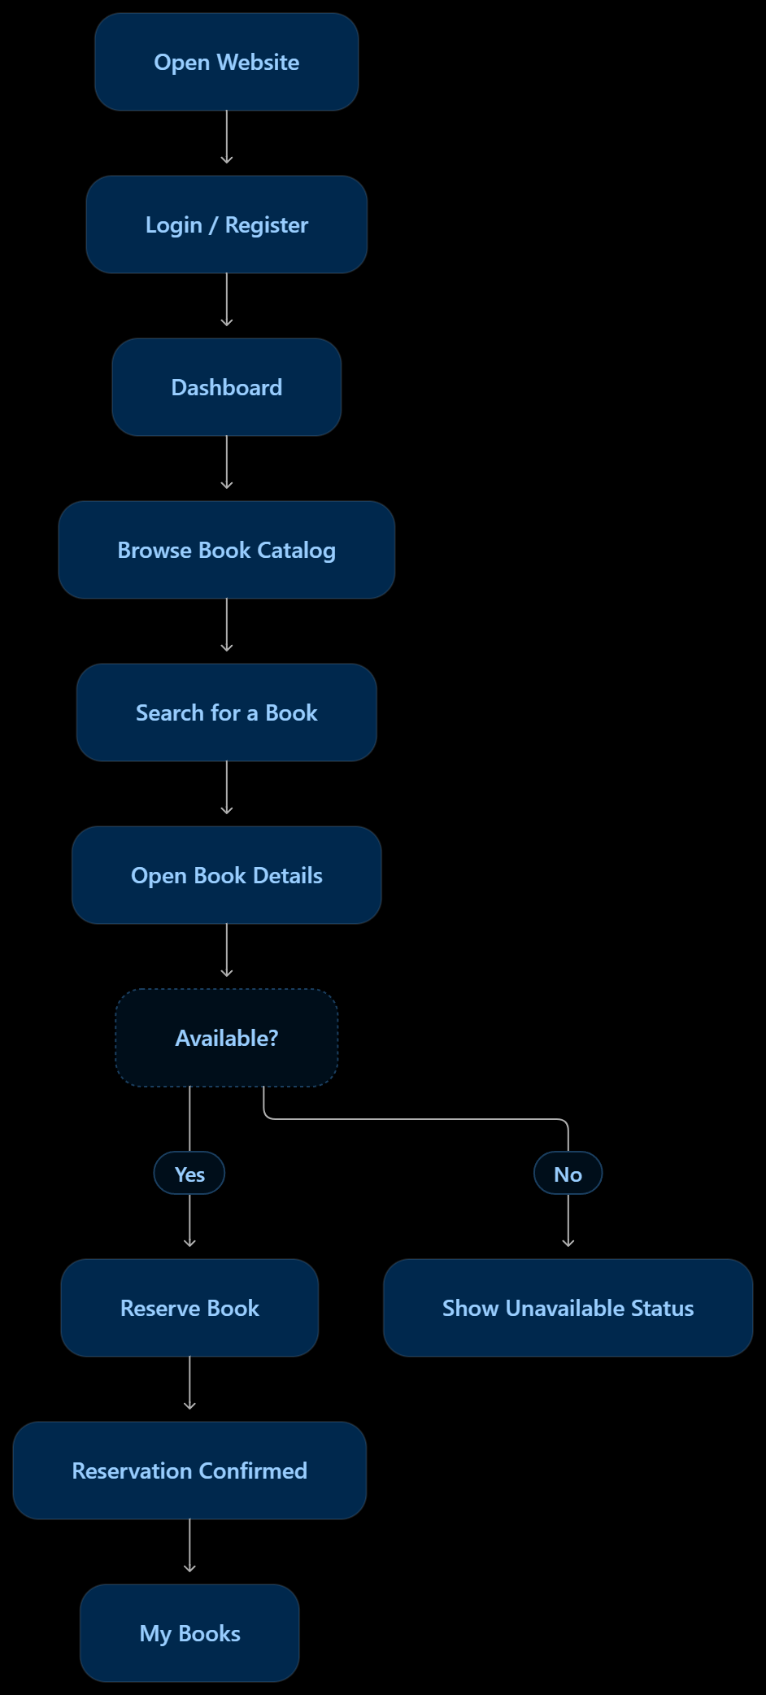

The application will follow a layered architecture. Each layer has a separate responsibility, which improves maintainability, testing, and separation of concerns.
Layer | Responsibility
Frontend Layer | User interface built with HTML5, CSS3, JavaScript, Bootstrap, and Thymeleaf engine. Handles UI rendering, client-side dynamic interactions, dynamic form validation, and responsive page layouts.
Controller | Receives HTTP requests, validates request data, and returns views or responses.
Service | Contains business logic, such as reservation rules and borrowing workflows.
Repository | Uses Spring Data JPA to read and write data in the database.
Database | PostgreSQL stores users, books, reservations, and borrowing records.
Frontend (HTML/CSS/JS/Thymeleaf) → Controller → Service → Repository → PostgreSQL Database
10.1 Example: Book Reservation Flow
- The user clicks the reservation button on the book details page.
- The Controller receives the reservation request.
- The Service checks the user's permissions and verifies book availability.
- The Repository retrieves the book and saves the reservation record.
- The database stores the reservation and the system updates the relevant availability status.
- The application displays a confirmation to the user.
11. Team Responsibilities
This project is structured as a collaborative team project between Dariga Eralyeva and Amina Moldakhanova.
Team Member | Primary Roles | Key Responsibilities
Dariga Eralyeva | Team Lead, Backend & Database Developer | • Project architecture definition & scope management  • PostgreSQL schema design, JPA entities, and database relationships  • Backend business logic development (Spring Boot Services, Security, Controllers)  • Integration testing and API design
Amina Moldakhanova | Frontend Developer & UX/UI Designer | • Designing responsive UI wireframes and interactive prototypes in Figma  • Developing client-side HTML5 structure and custom CSS3 / Bootstrap styling  • Building dynamic UI elements and client-side form validations using JavaScript  • Integrating Thymeleaf templates with backend data models for user and admin views
12. Development Roadmap
Phase | Activities | Assigned Lead
Phase 1 — Planning | Confirm project scope, target roles, requirements, and initial database entities. | Dariga E. & Amina M.
Phase 2 — UX/UI Design | Finalize Figma wireframes, UI components, responsive layout system, and interactive user flow. | Amina Moldakhanova
Phase 3 — Database Setup | Configure PostgreSQL database, create JPA entities, define foreign keys and constraints. | Dariga Eralyeva
Phase 4 — Backend Development | Build Spring Security configuration, catalog services, reservation logic, and admin APIs. | Dariga Eralyeva
Phase 5 — Frontend Development | Create HTML structure, CSS layout, JavaScript interactions, and bind data to Thymeleaf pages. | Amina Moldakhanova
Phase 6 — Integration | Connect frontend components with backend endpoints and verify end-to-end functionality. | Dariga E. & Amina M.
Phase 7 — Testing & QA | Test UI responsiveness, access control rules, user workflows, and perform bug fixes. | Dariga E. & Amina M.
Phase 8 — Final Preparation | Write technical documentation, complete README, finalize Git repository, and prepare presentation. | Dariga E. & Amina M.
13. Project Deliverables
Deliverable | Description / status
Project Proposal | This document detailing project scope, team breakdown, stack, database design, architecture, and roadmap.
Figma Design System & UI | 7 desktop/mobile web interface screens and an interactive prototype created by Amina Moldakhanova.
Frontend Implementation | Responsive web pages (HTML5, CSS3, JavaScript, Bootstrap) integrated with Thymeleaf templates.
Backend & Database | Java Spring Boot layered application connected to a PostgreSQL relational database.
GitHub Repository | Source code repository containing backend and frontend modules: https://github.com/darigaahmetovna/library-management-system
14. Conclusion
The Library Management System is intended to provide a practical digital solution for common library operations. By combining an intuitive, responsive user interface developed by Amina Moldakhanova, a robust Java Spring Boot backend, and a PostgreSQL database designed by Dariga Eralyeva, the project demonstrates structured team collaboration and layered web application architecture.
Project Links:
- Figma: https://www.figma.com/design/jK27iO2kKbAyNeVPHUU5X6/Untitled
- GitHub: https://github.com/darigaahmetovna/library-management-system

