**Supreme Court Coverage & Analytics Application, Version 2.0**

User Manual

Written by Darin Ellis

November 29, 2018

**Contents**

**1 INTRODUCTION …………………………………………...2**

**1.1** History……………..........................................................................2

**1.2** Description ……………..................................................................2

**1.3** Platform Requirements..................................................................2

**1.4** Developer Contact Information ......................................................2

**2 SUPPORTED BROWSERS ………………………………3**

**2.1** Google Chrome…..........................................................................3

**2.2** Others………………….. .................................................................3  
  
**3 WEBPAGES …..………………………………………...….4**

**3.1** Search ……………………...............................................................4

**3.2** Article View …………………...........................................................5

**4 DOWNLOADING ARTICLES …..……………………...….6**

# Introduction

The Supreme Court Coverage/Analysis Tool (SCOTUSApp) is a web application that collects and stores U.S. Supreme Court-related news articles and allows users to to view and download them.

**History**

SCOTUSapp was originally developed by computer science students at the University of Kentucky at the request of Dr. Wedeking and Dr. Zilis of the UK Political Science department in the fall of 2017. The tool has since been worked on by several students, but is now maintained by Evan Cole and Darin Ellis, UK alumni and former members of the original development team.

## Description

SCOTUSapp will automatically collect Supreme Court-related articles from the internet throughout the day. These articles are stored in a database and can be viewed using a web page. Filters can be applied to view a subset of the articles, which can then be downloaded directly to your computer.

## Platform Requirements

SCOTUSApp is a web application and, as such, can be accessed on any platform by using a web browser.

## Developer Contact Information

Questions and bug reports should be sent to the project email: ukscotusapp@gmail.com

# Supported Web Browsers

## Google Chrome

We can guarantee full functionality of the webpages when they are viewed on the Google Chrome web browser.

**Others**

The Safari web browser, while not as thoroughly tested, should also be suitable. Other web browsers should work as well, but we cannot guarantee that they will.

# Webpages

## Search

In figure below you can see an example of the Search (or main) page. By default it displays all articles. You can search the stored articles by entering your search terms in the search bar. The search terms will be found in both the keywords and title of a given article. You can also search for articles within a specific range of dates by selecting the bounds in the boxes below the search bar. You can also download the articles by clicking the Download buttons - see Downloading Articles for more information. Click the article title to view the contents of that article. You can use the Restart button on the top right to clear all of your search terms and filters.

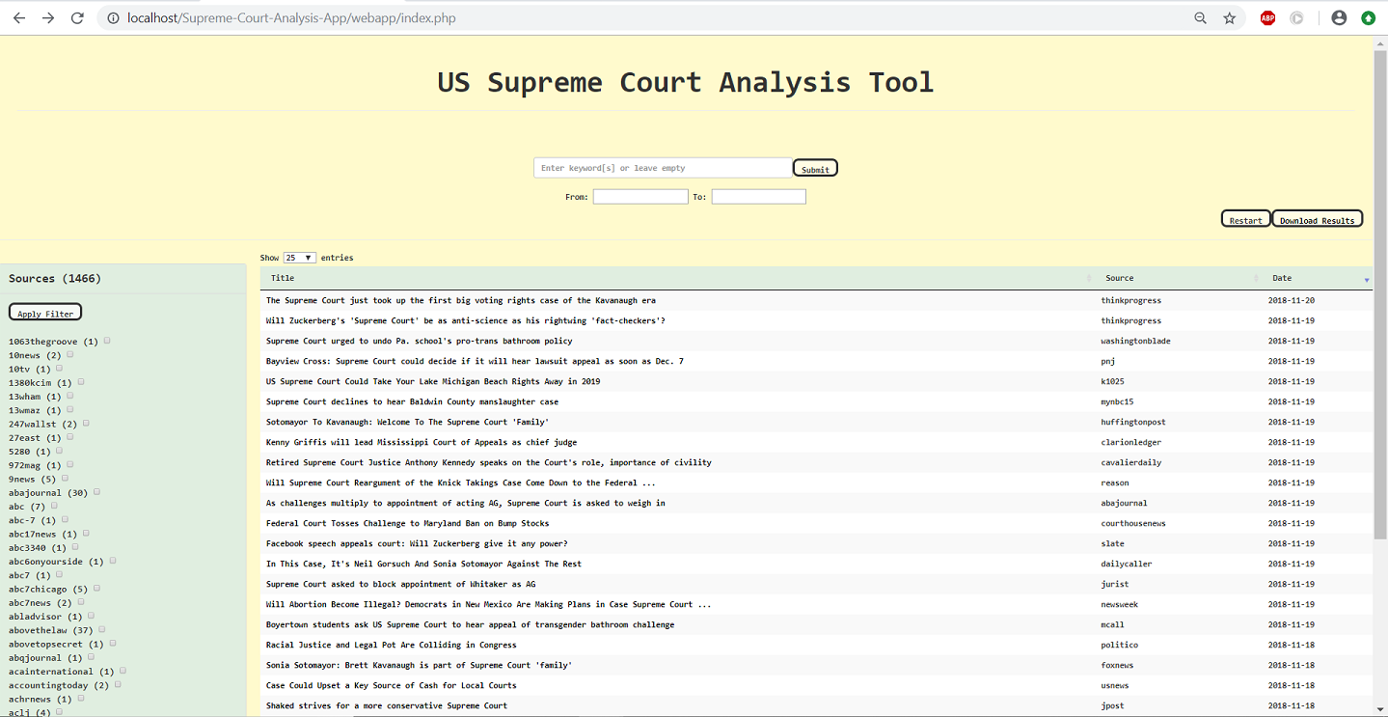

## Article View

You can get to the article view page (shown in the figure below) from the Search page by clicking on the title of the article you want to view. You can navigate back to the search page by using the Restart button on the right or by using your browser’s back button. The top left box shows the author, source, publication date, and the original URL of the article. It also displays the “sentiment and “magnitude” of the text. These values, provided through the use Google’s Natural Language API, indicate the tone and force of the article, respectively. The bottom left box lists the keywords of the article text. The top right box will display the article’s body of text. The bottom right box shows the top image of the article, as well as entities matched to the image.

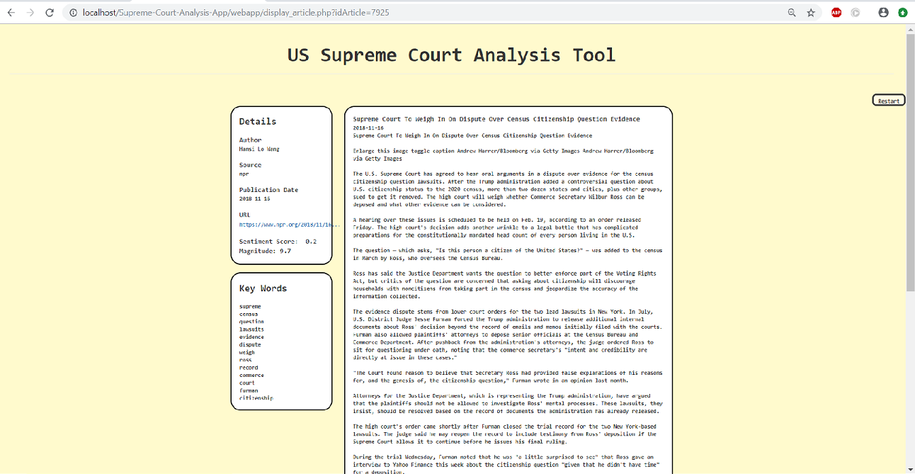

# Downloading Articles

To download the articles currently displayed on the Search page, click the Download button on the Search page. This will download a .zip file containing a .csv file and many .txt files. The .csv file lists all the articles with their important information, while the body of text is stored in a .txt file keyed to that article through the “article ID” element in the .csv file.