sudo systemctl status mysql

80 sudo service mysql status

81 sudo service mysql start

82 sudo service mysql status

83 sudo mysql -u root -p

84 mc

85 cd Питомник

86 mkdir src

87 touch src/animal.py

88 touch src/registry.py

89 touch src/counteiner.py

90 touch src/main.py

91 mc

92 python src/main.py

93 python --version

94 python3 --version

95 python3 src/main.py

96 mc

97 cd../

98 cd ../

99 mv Питомник nursery

100 mc

101 mv nursery final_work

102 mc

103 history

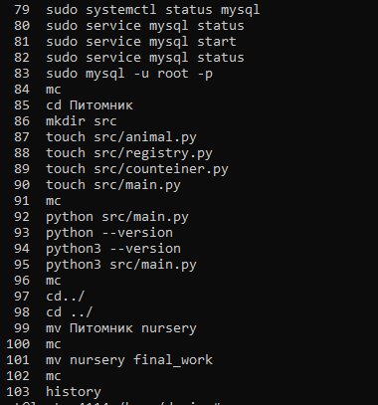

https://docs.google.com/document/d/1cUilcuFTxDs5fR7KUw1IAIppEP7MVbVs2mMIelEBp8Q/edit?usp=sharing