 | G1
Базовый  -Xms512m  -Xmx512m  -Xlog:gc=debug:file=./logs/gc-%p-%t.log:tags,uptime,time,level:filecount=5,filesize=10m  -XX:+HeapDumpOnOutOfMemoryError  -XX:HeapDumpPath=./logs/dump  -XX:+UseG1GC | Скрины 1.1  time 388
-Xms512m  -Xmx512m  -Xlog:gc=debug:file=./logs/gc-%p-%t.log:tags,uptime,time,level:filecount=5,filesize=10m  -XX:+HeapDumpOnOutOfMemoryError  -XX:HeapDumpPath=./logs/dump  -XX:+UseG1GC  -XX:MaxGCPauseMillis=100000 | Скрины 1.2  time 404
-Xms512m  -Xmx512m  -Xlog:gc=debug:file=./logs/gc-%p-%t.log:tags,uptime,time,level:filecount=5,filesize=10m  -XX:+HeapDumpOnOutOfMemoryError  -XX:HeapDumpPath=./logs/dump  -XX:+UseG1GC  -XX:MaxGCPauseMillis=10 | Скрины 1.3
-Xms2048m  -Xmx2048m  -Xlog:gc=debug:file=./logs/gc-%p-%t.log:tags,uptime,time,level:filecount=5,filesize=10m  -XX:+HeapDumpOnOutOfMemoryError  -XX:HeapDumpPath=./logs/dump  -XX:+UseG1GC | Скрины 1.4
-Xms5120m  -Xmx5120m  -Xlog:gc=debug:file=./logs/gc-%p-%t.log:tags,uptime,time,level:filecount=5,filesize=10m  -XX:+HeapDumpOnOutOfMemoryError  -XX:HeapDumpPath=./logs/dump  -XX:+UseG1GC | Скрины 1.5
1.1

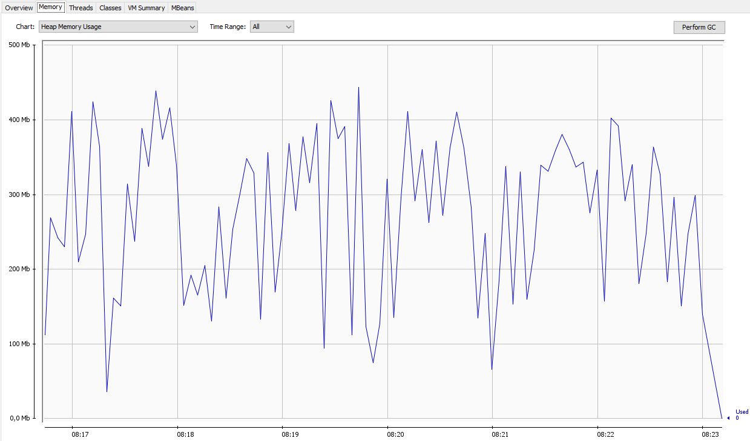
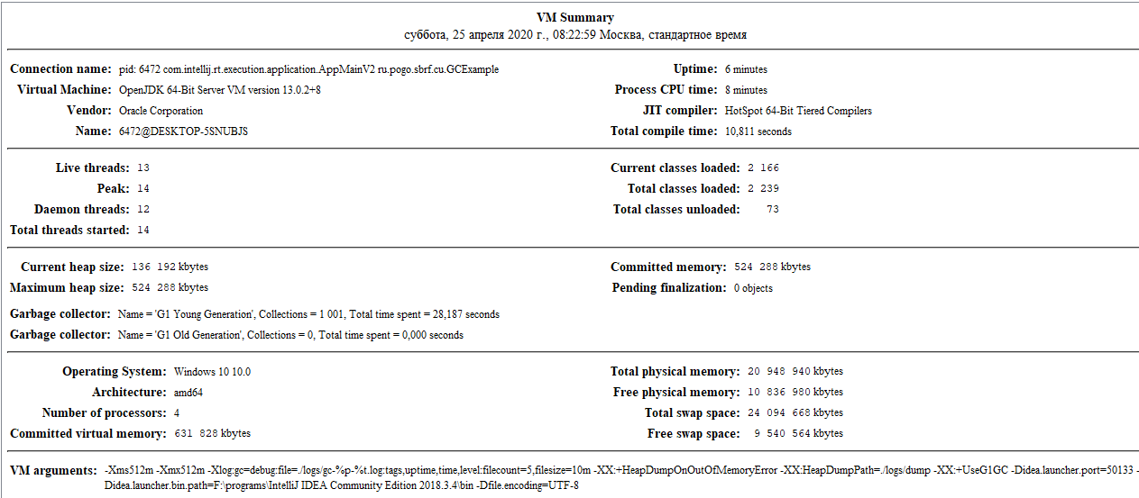
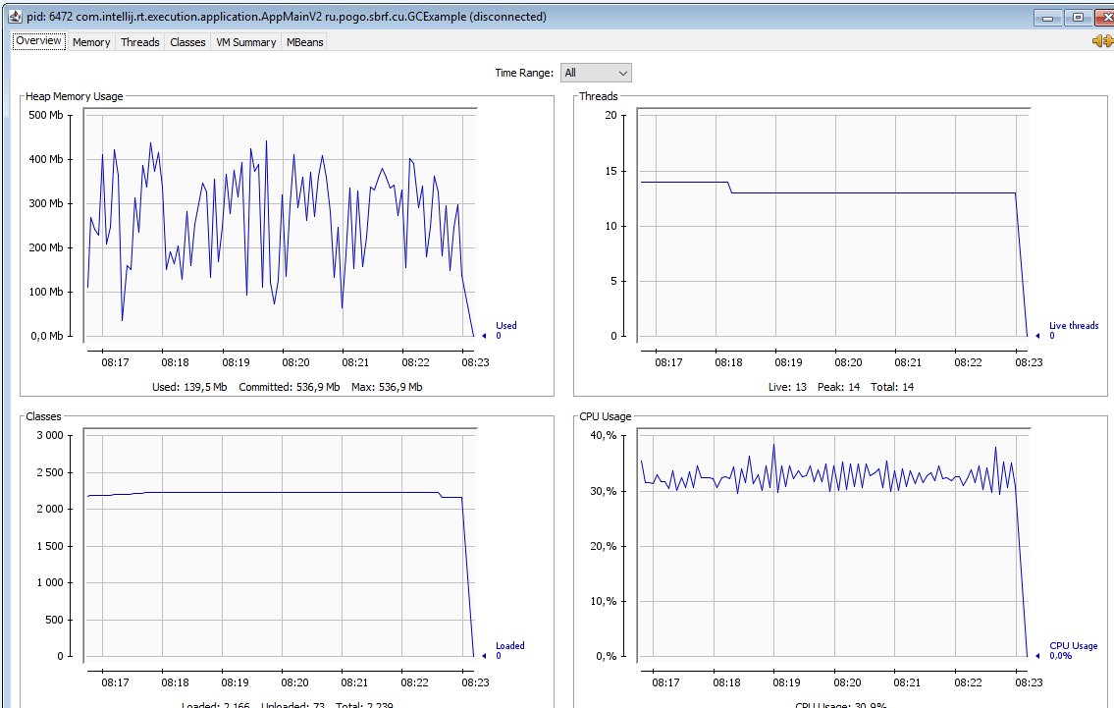
Starting pid: 6472@DESKTOP-5SNUBJS
GC name:G1 Young Generation
GC name:G1 Old Generation
new size:2000000

time:386
1.2
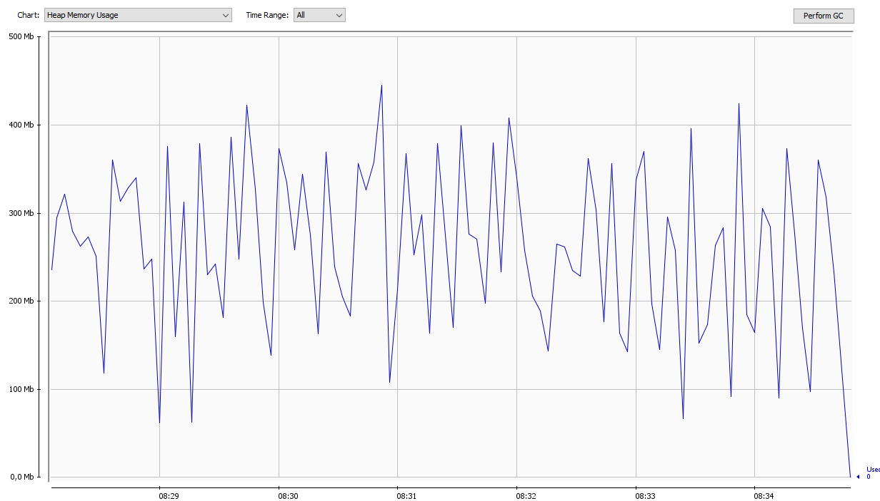
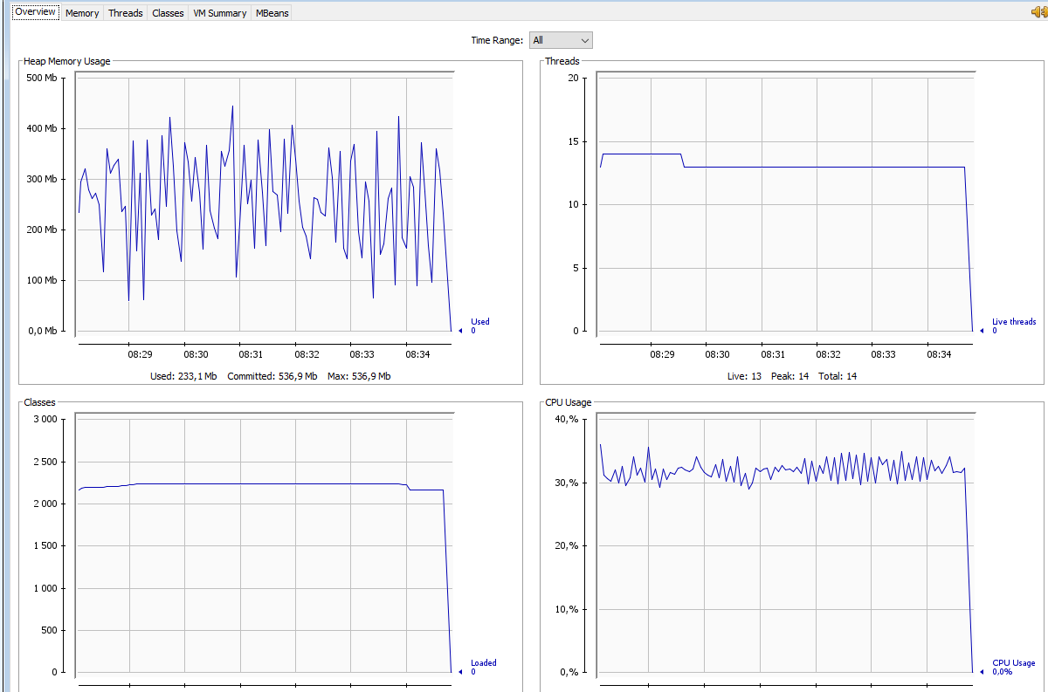
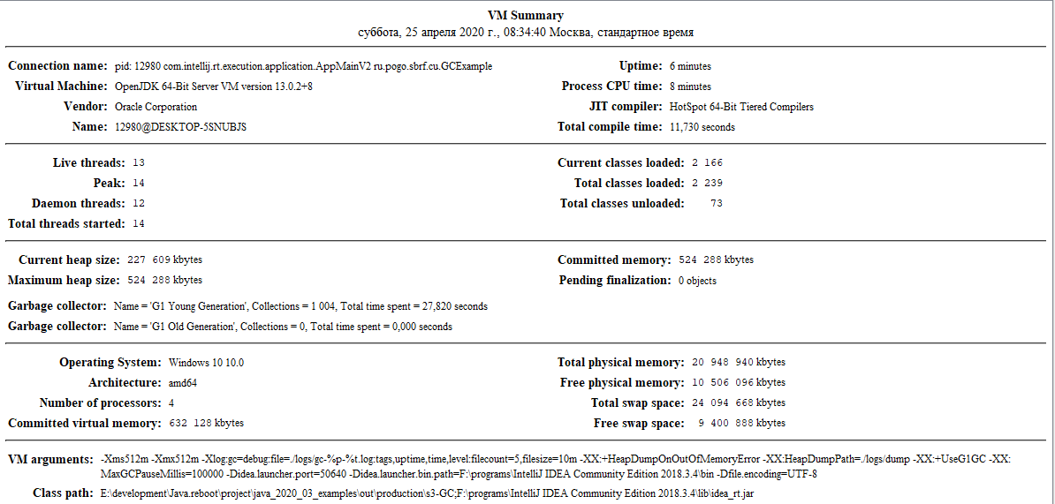
1.3
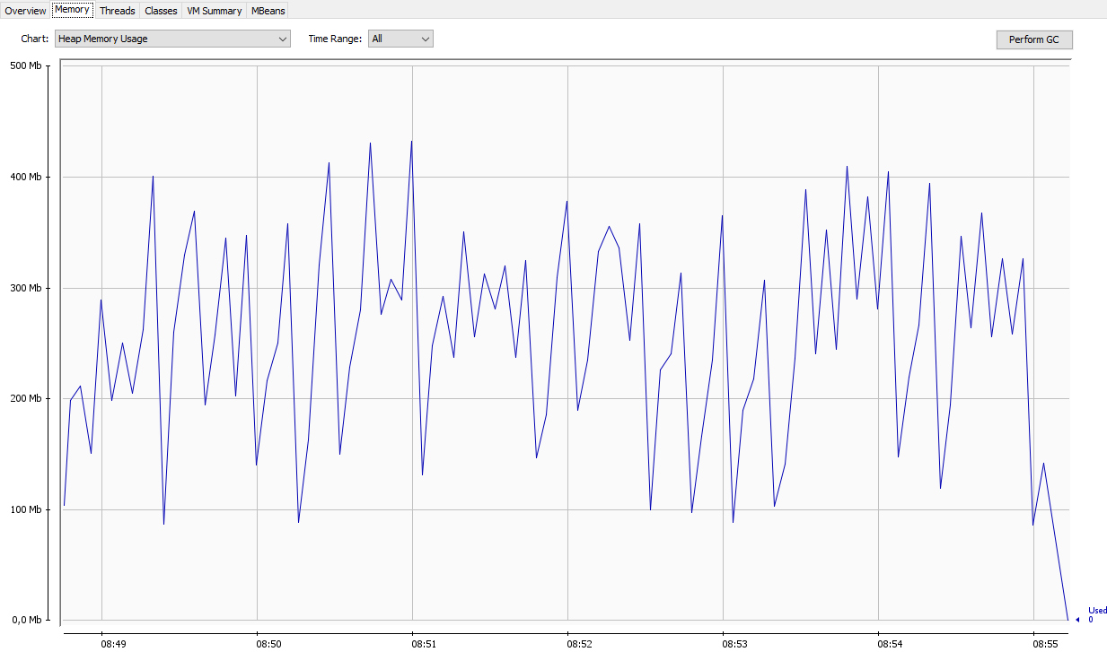
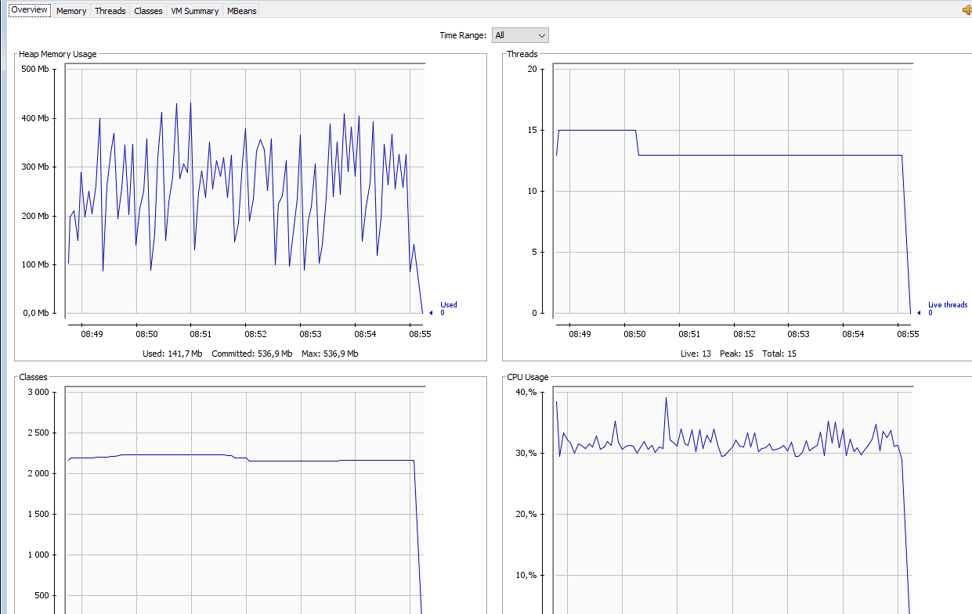
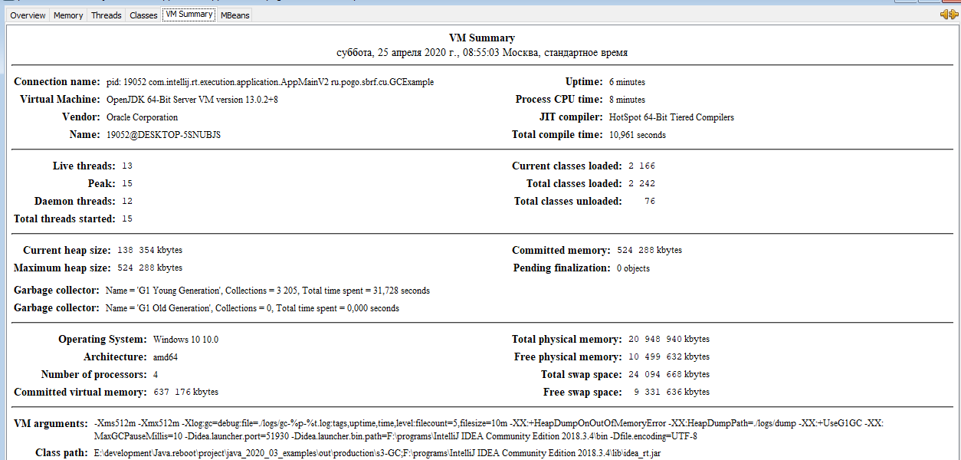
1.4
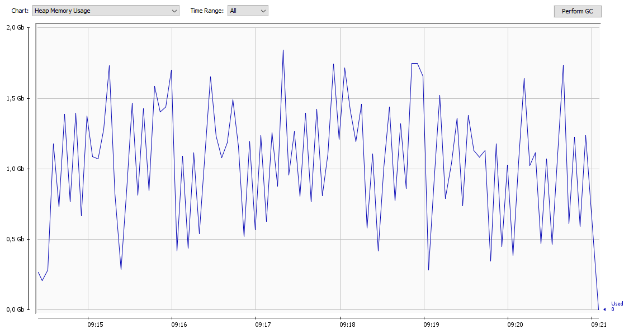
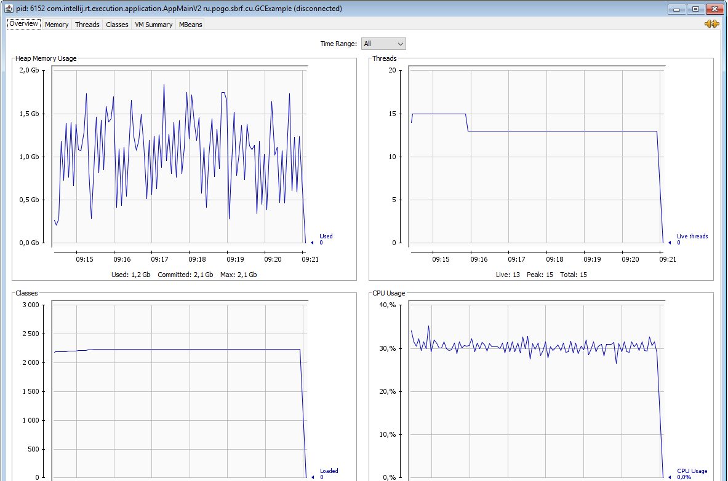
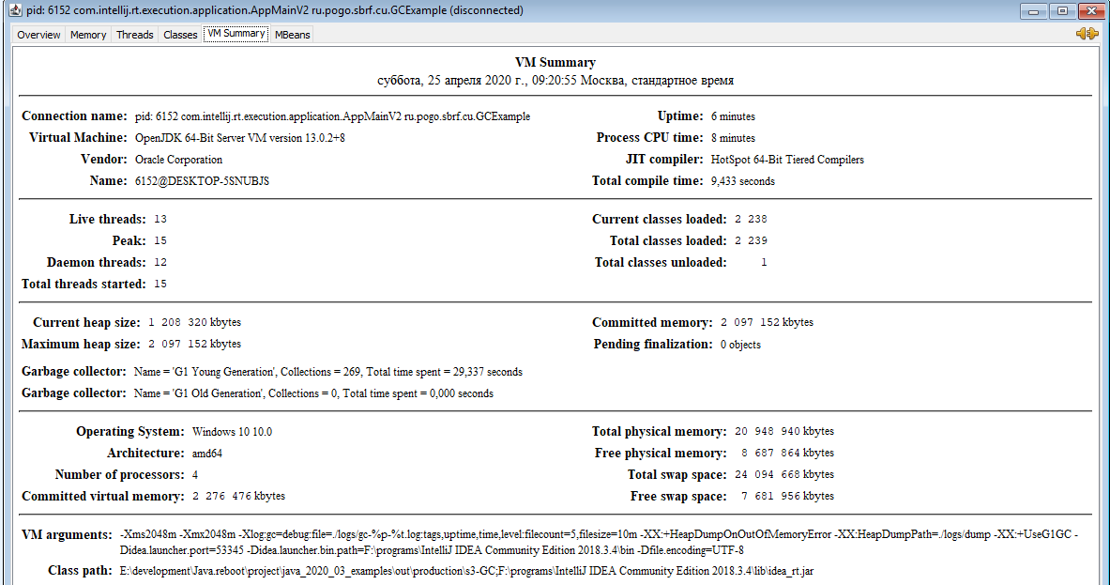
1.5
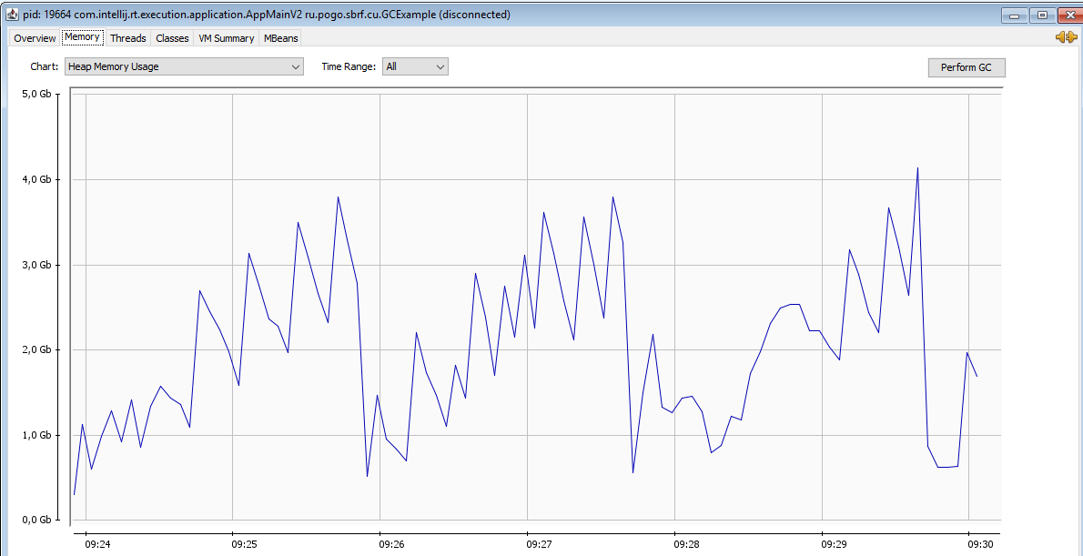
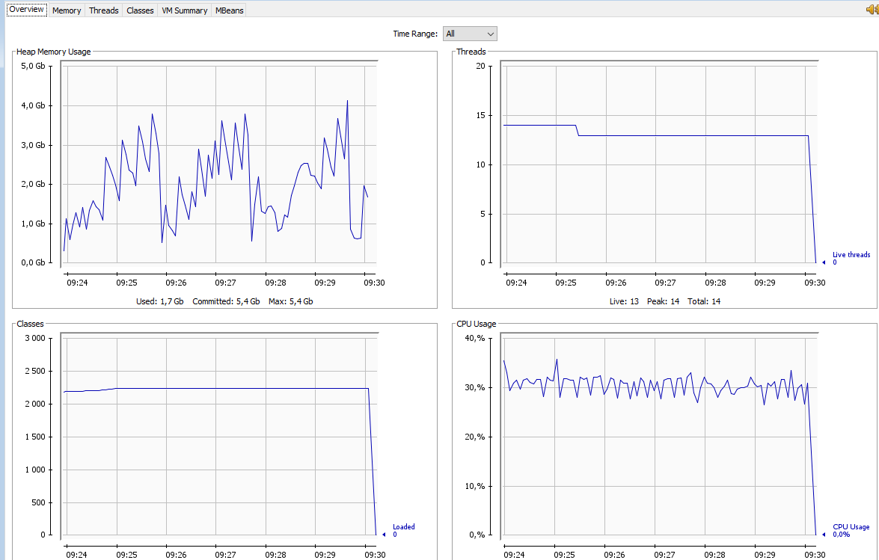
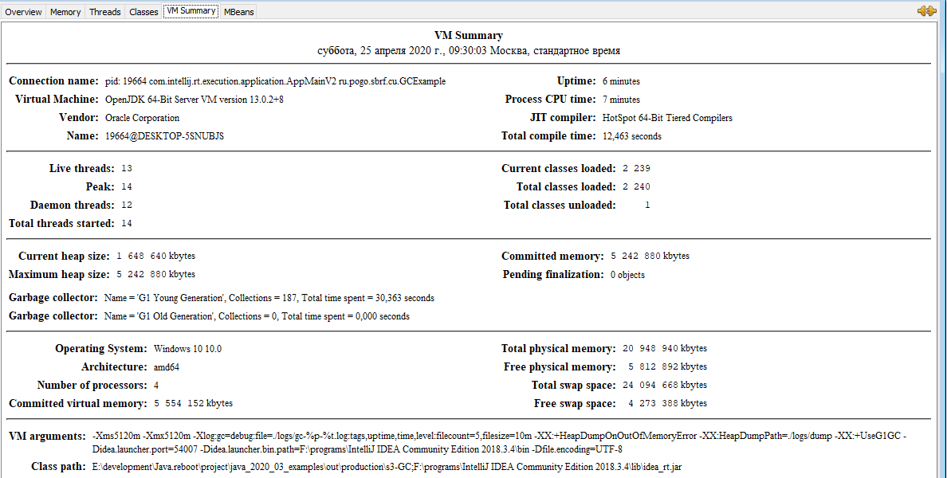

2.1
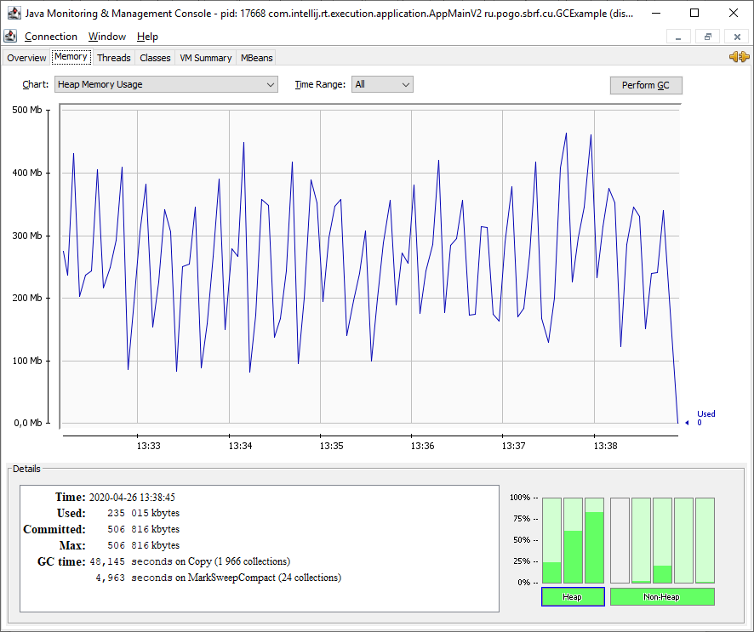
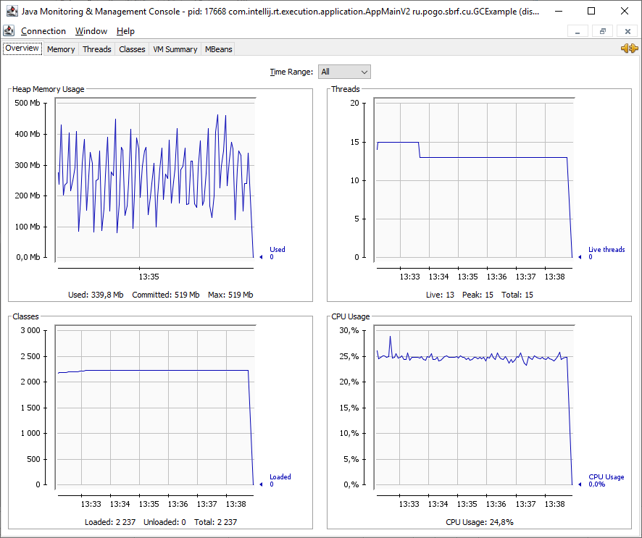

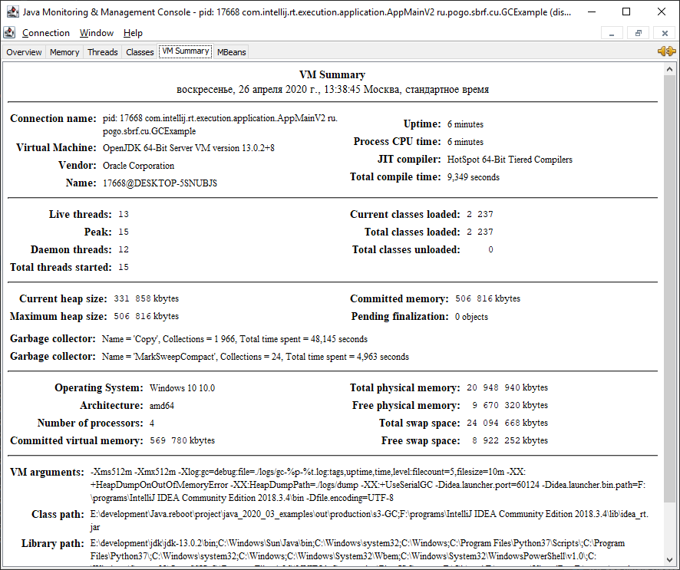

2.2
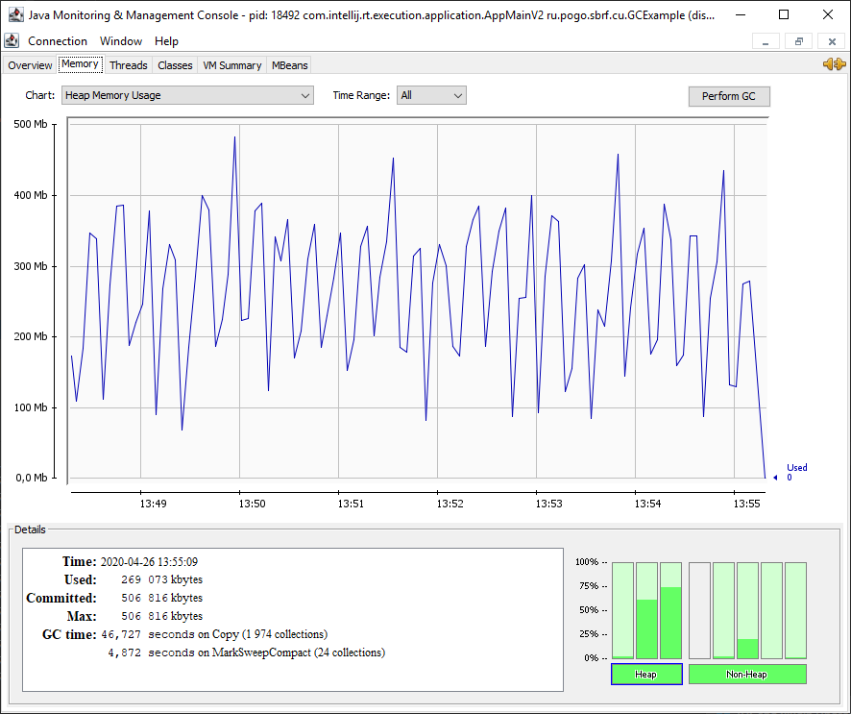
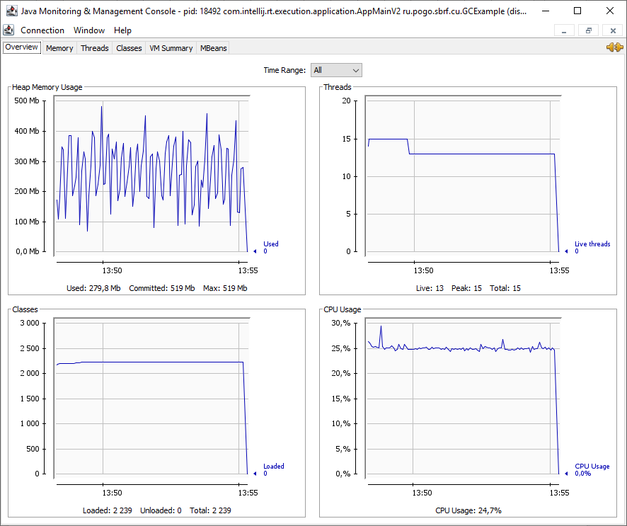

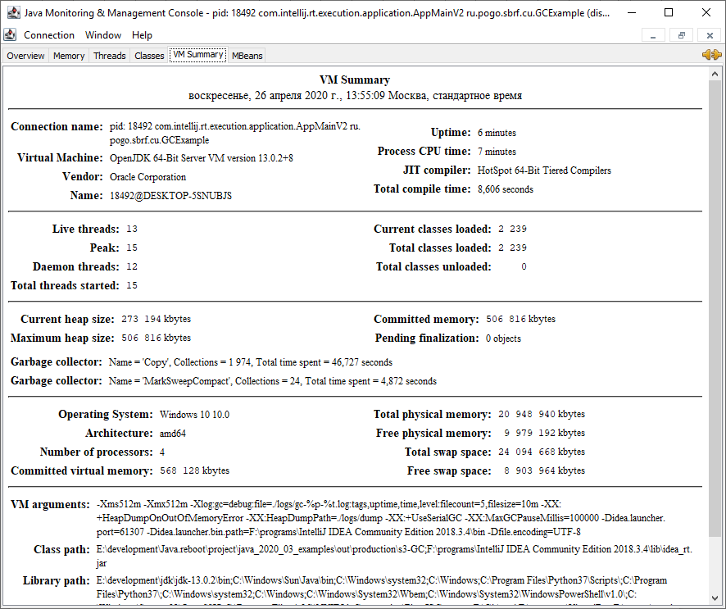

2.3
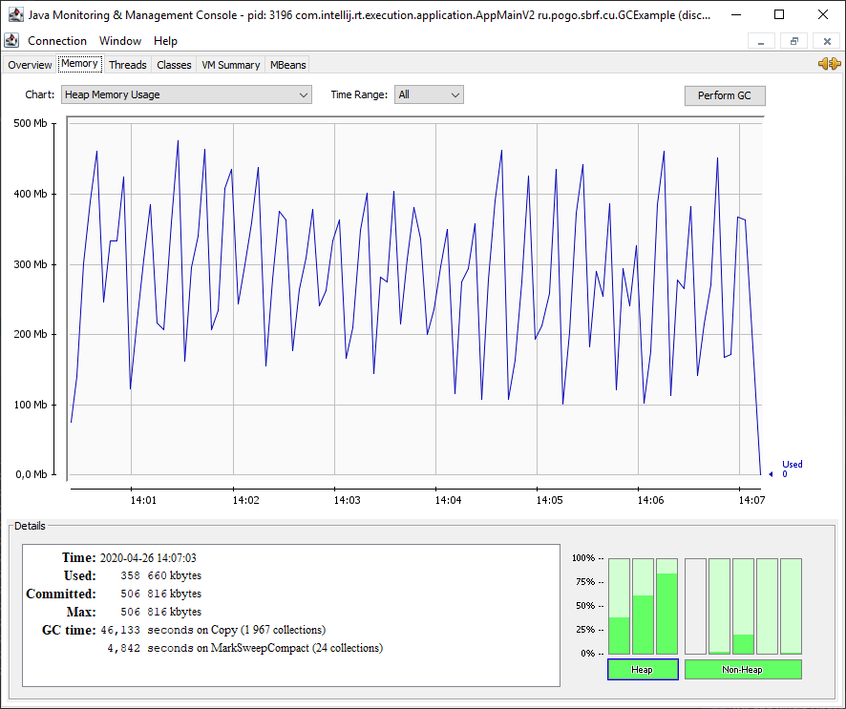
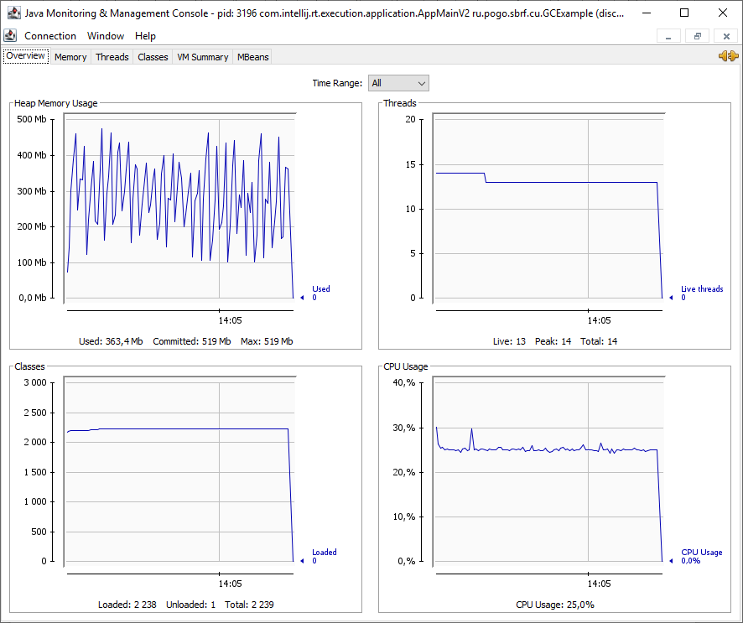
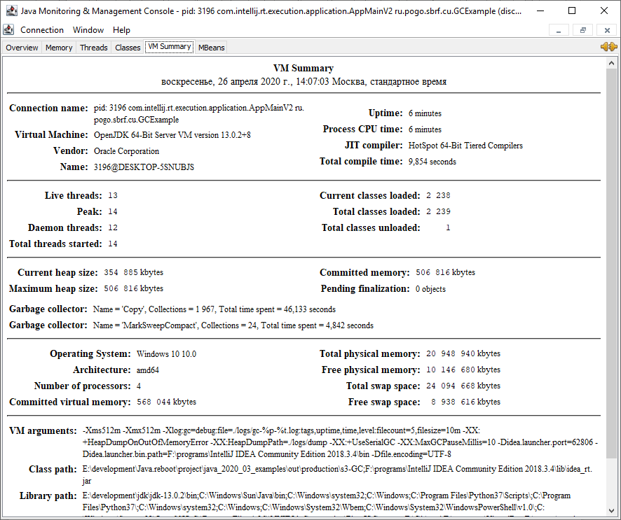

2.4
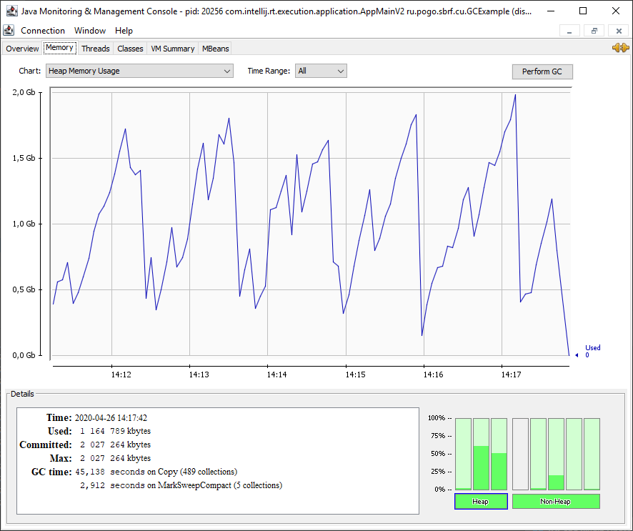
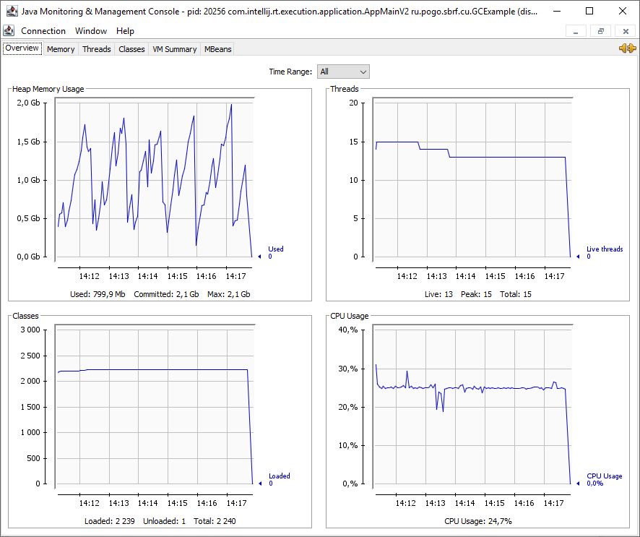
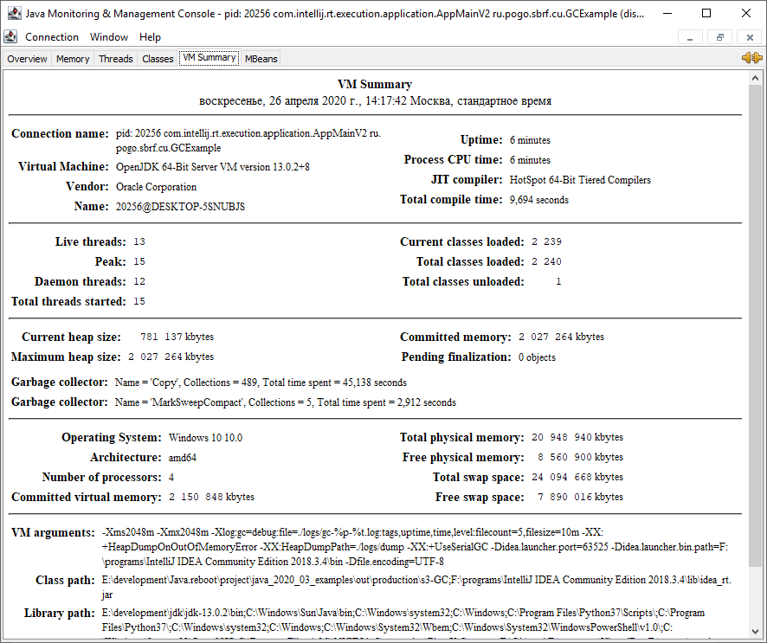

2.5
