**Project Report: Portfolio Management Platform**

The Portfolio Management Platform is a full-stack web application that offers real-time news and cryptocurrency updates, as well as secure portfolio management features. For increased security and functionality, it integrates role-based access control (RBAC) and strong user authentication, including two-factor authentication (2FA).

**2. Objectives**

* Provide a platform for managing portfolios with CRUD functionality.
* Secure user authentication with JWT and 2FA.
* Implement role-based access control to restrict sensitive operations.
* Offer live data updates using APIs like NewsAPI and CoinGecko.

**3. System Features**

**Authentication System**

* **User Registration**:
  + Users can create accounts by providing a username (or email) and password.
  + Passwords are securely hashed using Bcrypt before storage.

**Login**:

* Users authenticate via /auth/login using their credentials.
* If 2FA is enabled, they must provide a valid 6-digit code from an authenticator app.

**Two-Factor Authentication (2FA)**:

* Users can enable 2FA via /auth/2fa/setup.
* A QR code is generated, which users scan with apps like Google Authenticator.
* Tokens are verified using Speakeasy.

**Role-Based Access Control (**

* **Roles**:
  + Admin: Full access to all routes and operations.
  + Editor: Limited access to portfolio CRUD routes.
* Middleware (checkRole) ensures users only access resources allowed by their roles

**Portfolio Management**

* **CRUD Operations**:
  + Create, Read, Update, and Delete portfolio items.
  + Admins and editors have varying permissions for operations.
* **Dynamic Data**:
  + Each portfolio item includes fields like title, description, images, and timestamps.

**Tech Stack**

* **Backend**:
  + **Node.js**: Handles server-side logic and routing.
  + **Express.js**: Simplifies route and middleware management.
  + **Mongoose**: Manages database operations with MongoDB.
  + Изображение выглядит как текст, снимок экрана, Шрифт, программное обеспечение

    Автоматически созданное описание
  + Изображение выглядит как текст, снимок экрана, программное обеспечение, веб-страница

    Автоматически созданное описание
* **Frontend**:
  + **EJS**: Dynamic templates for rendering HTML.
  + **CSS**: Provides styling for user interfaces.
* **Security**:
  + **JWT**: Manages user sessions with token-based authentication.
  + **Bcrypt**: Secures passwords with hashing.
  + **Speakeasy**: Implements 2FA.
* **APIs**:
  + **NewsAPI**: Provides live news updates.
  + **CoinGecko**: Fetches cryptocurrency prices.

1. **Step 1**: Register at /auth/register.
2. **Step 2**: Log in at /auth/login.
3. **Step 3**: Enable 2FA (optional) by navigating to /auth/2fa/setup.
4. **Step 4**: Manage portfolios via /portfolio.

6. Folder Structure

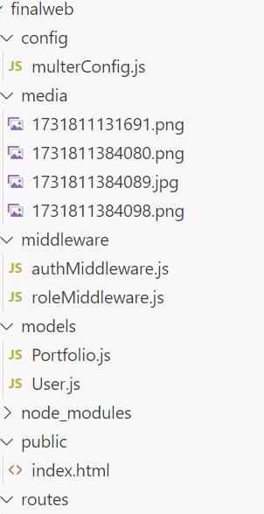

**Portfolio Management**

The Portfolio Management section of the platform allows users to create, view, update, and delete portfolio items. Each portfolio item consists of the following fields:

**Fields for a Portfolio Item:**

1. **Title**: A short, descriptive name for the portfolio item.
2. **Description**: A detailed explanation of the item.
3. **Images**: Up to **three images** can be uploaded and attached to each item. These images will be displayed in a **carousel format** on the frontend.

**Features of Portfolio Management**

* **Create Portfolio Items**:
  + Users can input the title and description.
  + Upload up to three images.
  + On submission, the portfolio item is saved in the database and displayed in the carousel.
* **View Portfolio Items**:
  + All portfolio items are listed with their titles, descriptions, and associated image carousels.
* **Edit Portfolio Items**:
  + Users can update the title, description, and replace the images if needed.
* **Delete Portfolio Items**:
  + Removes the item along with its associated images from the database.

We also use the multer library in Node.js to handle file uploads, specifically for managing media files like images. It allows users to upload files (e.g., portfolio images), which are then stored on the server with unique filenames. This functionality is particularly useful for attaching images to portfolio items.

**Features Enabled by the Code**

1. **File Upload for Portfolio Items**:
   * Users can upload up to three images when creating or editing a portfolio item.
   * The images are saved on the server in the media/ directory.
2. **Automatic File Naming**:
   * Uploaded files are renamed using the current timestamp combined with their original extension.
   * This ensures uniqueness and prevents filename collisions.
3. **Organized File Storage**:
   * All uploaded files are stored in a dedicated media/ directory on the server.
   * The storage location is centralized and easily accessible.
4. **MIME Type Preservation**:
   * The original file extension is preserved (e.g., .jpg, .png, .gif), ensuring compatibility when displaying or processing the files.

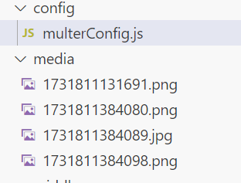

Nodemailer

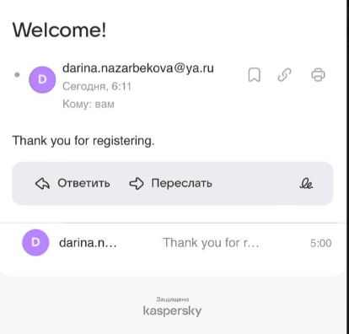

In conclusion

With its sophisticated security features and real-time data integration, the Portfolio Management Platform is a scalable and reliable application for managing portfolios. Its primary features, such as file upload management, role-based access control (RBAC), and user authentication with two-factor authentication (2FA), offer a safe and convenient experience. By offering real-time data updates, the integration of external APIs such as NewsAPI and CoinGecko further improves the platform's usefulness and makes it more dynamic and interesting for users. The platform is prepared for deployment and can be readily expanded to accommodate future needs thanks to its modular design, clear codebase, and clearly defined features.