4.0 Executive Summary: Governing the AI Operational Lifecycle and Merger Risks Through Cyber KRIs
As Artificial Intelligence (AI) integration accelerates—particularly through corporate mergers and acquisitions—the Board faces a critical duty to oversee the unique operational and lifecycle risks these technologies introduce.

This section of this report provides a strategic blueprint that translates technical operational data into measurable business risk, enabling effective oversight across three core pillars:

- Core Cyber KRI Harmonisation: Auditing and bringing the target company’s operational hosting environment, access controls, and infrastructure patching up to enterprise standards before AI integration to protect deployment integrity.
- AI-Specific Risk Management: Establishing distinct, specialized Key Risk Indicators (KRIs) to monitor the unique ways AI systems can be exploited, manipulated, or fail.
- Strategic Oversight: Mapping technical failures directly to financial, legal, and operational consequences to protect shareholder value and corporate reputation.

4.1. The Foundation: Enterprise Cyber Risk Harmonisation
This serves as the structural blueprint, connecting the target company's technical vulnerabilities directly to our business consequences. It demonstrates to executive leadership exactly how specific, measurable technical failures (KRIs) can escalate into major corporate disasters.
It deals directly with foundational computer security, employee behaviour, and general infrastructure hygiene. This focus allows us to isolate, assess, and remediate the acquired operational environment before it compromises our mature ecosystem
1. Insider Threat & Data Loss
- Potential Business Impacts: Loss of valuable data, regulatory action, loss of customer confidence.
- Consolidated Enterprise KRIs:
  - KRI-01: % of IT assets running Unsupported Operating System
  - KRI-02: % of overdue Critical Vulnerabilities
  - KRI-03: % of User Accounts with local Privileged Access
  - KRI-04: % of corporate and privileged accounts operating without Multi-Factor Authentication (MFA) enforced (New Identity Protection)
  - KRI-06: % of Leavers not notified to Tech on time
  - KRI-07: % of Removable Media Exceptions
  - KRI-09: % of click rate over last Phishing simulation for users
  - KRI-10: % of click rate over last Phishing simulation for Senior Leaders
  - KRI-12: % of core data assets lacking proper access controls and classification tagging
  - KRI-13: % of source-code and software repositories operating without active access logging and monitoring
2. Ransomware & Infrastructure Disruption
- Potential Business Impacts: Loss of business operations and processing capabilities, product safety issues, regulatory breach.
- Consolidated Enterprise KRIs:
  - KRI-01: % of IT assets running Unsupported Operating System
  - KRI-02: % of overdue Critical Vulnerabilities
  - KRI-03: % of User Accounts with local Privileged Access
  - KRI-04: % of corporate and privileged accounts operating without Multi-Factor Authentication (MFA) enforced (New Identity Protection)
  - KRI-05: % of Critical and High Risk Third Parties with control deficiencies
  - KRI-06: % of Leavers not notified to Tech on time
  - KRI-07: % of Removable Media Exceptions
  - KRI-09: % of click rate over last Phishing simulation for users
  - KRI-10: % of click rate over last Phishing simulation for Senior Leaders
  - KRI-12: % of core enterprise infrastructure assets missing from or failing to send active security logs to the SIEM / SOC (New Threat Visibility)
  - KRI-14: % of core infrastructure assets completely omitted from or not covered by vulnerability scanning tools

3. Perimeter & Third-Party Supply Chain Risk
- Potential Business Impacts: Disruption of supply to enterprise operations, hostile compromise of internal corporate assets.
- Consolidated Enterprise KRIs:
  - KRI-03: % of User Accounts with local Privileged Access
  - KRI-05: % of Critical and High Risk Third Parties with control deficiencies
  - KRI-06: % of Leavers not notified to Tech on time
  - KRI-08: % of Tier 1 externally facing web applications with overdue Critical or High Vulnerabilities
  - KRI-09: % of click rate over last Phishing simulation for users
  - KRI-10: % of click rate over last Phishing simulation for Senior Leaders
  - KRI-11: % of enterprise Application Programming Interfaces (APIs) operating without mandatory authentication or authorization gates
4. Business Resilience & Operational Continuity
- Potential Business Impacts: Loss of manufacturing/operational capabilities, product or employee safety breach, delayed incident remediation.
- Consolidated Enterprise KRIs:
  - KRI-01: % of IT assets running Unsupported Operating System
  - KRI-02: % of overdue Critical Vulnerabilities
  - KRI-05: % of Critical and High Risk Third Parties with control deficiencies
  - KRI-07: % of Removable Media Exceptions
  - KRI-08: % of Tier 1 externally facing web applications with overdue Critical or High Vulnerabilities
  - KRI-15: % of recorded cyber incidents that breached internal response SLA resolution timelines.

4.2 The Branch: Artificial Intelligence, Algorithmic and Agentic Risk
Once the underlying hosting environment has been secured through the enterprise cybersecurity controls described in the preceding section, a second governance challenge emerges. Traditional cybersecurity controls are designed to protect infrastructure, networks, and access pathways. However, AI machine learning models, autonomous agents, and data training pipeline introduce additional i.e. can exhibit rogue behaviour, leak data, or suffer manipulation even when even when the underlying technology estate is secure.
AI risk is managed as a distinct threat vector within the Enterprise Risk Framework (Table 2). The Enterprise AI Governance Framework provides the permanent monitoring mechanism through which these risks are measured, controlled, and reported throughout the AI lifecycle.
Firstly, the Due Diligence Findings (R-01 to R-12) provide immediate visibility into the most significant operational, regulatory, security, and governance exposures identified within Luma Pay. These findings require immediate management attention and must remain under active Board oversight throughout the short-term integration period (Appendix Table 1).
The Enterprise AI Governance Framework provides the permanent automated mechanism through which those risks are monitored, measured, and controlled over the longer term.

M&A DUE DILIGENCE FINDINGS (R-01 TO R-12)
The Appendix Table below outlines the six core liabilities identified during the M&A due diligence window. To support Board oversight, each risk is decomposed into operational dimensions (Volume, Velocity, Coverage) and paired with an early deterioration indicator designed to highlight conditions requiring management attention and escalation.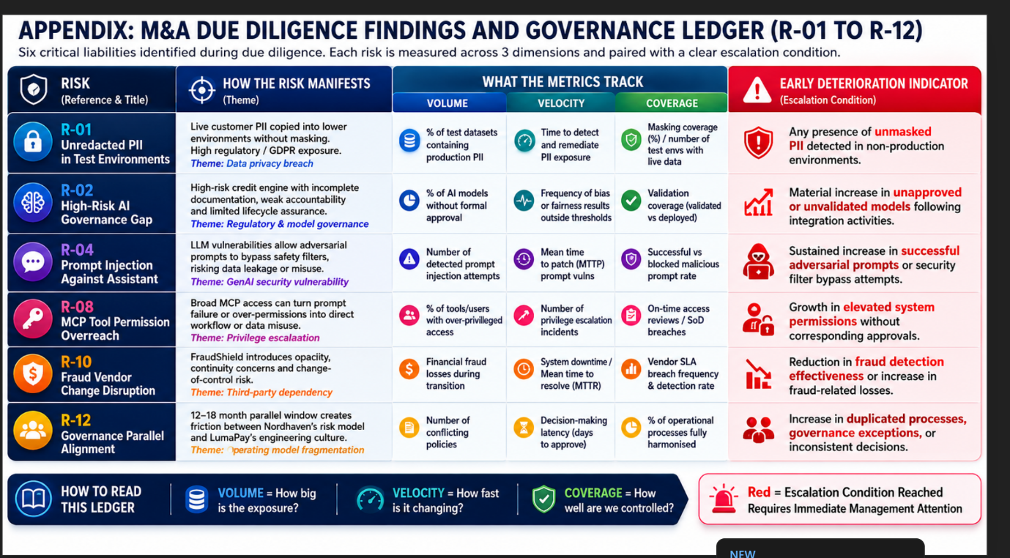

The transaction risks outlined above identify the specific exposures requiring remediation during the integration period. As corrective actions are completed and acquired systems are integrated into the enterprise operating model, responsibility for ongoing oversight transitions from the due diligence remediation programme to the Enterprise AI Governance Framework and associated AI KRI dashboard. This ensures that risks identified during acquisition remain subject to continuous monitoring, governance, and Board visibility throughout the AI lifecycle.

System-Level AI KRIs:

The 14 Baseline Metrics (KRI-AI-01 to KRI-AI-14) are designed to track core AI infrastructure hygiene across the entire enterprise.

Threat Vector | Potential Business Impacts | System-Level AI KRIs
AI Integrity & Model Manipulation | - Inaccurate automated decisions  - Brand and reputational damage  - Financial loss from skewed outputs  - Model poisoning | KRI-AI-01: % of training data sources utilized without formal copyright, compliance, and lineage validation.  KRI-AI-02: % of enterprise AI models operating without automated drift, hallucination, or adversarial prompt monitoring.  KRI-AI-03: % of production AI models missing active automated defence against Indirect Prompt Injection attacks.
AI Data Privacy & Leakage | • Intellectual property leakage: Sensitive corporate code, trade secrets, or legal text being absorbed into public AI models.  • Regulatory Non-Compliance: Major financial fines triggered by breaches of the EU AI Act, GDPR, or localized data privacy laws.  • Loss of Customer Trust: Reputational fallout from leaks of customer information or proprietary customer data. | KRI-AI-04 (Shadow AI Monitoring): % of shadow (unapproved) AI tools accessed by employees on the corporate network.  KRI-AI-05 (Data Masking Compliance): % of production AI models operating without an approved data privacy mask (e.g., risk of leaking PII).  KRI-AI-06 (Prompt Interception): % of outbound Generative AI prompts flagged by internal guardrails for containing unencrypted Sensitive or PII data strings.  KRI-AI-07 (Model Weight Access): % of operational API endpoints exposing proprietary model weights or system architectures without mandatory multi-factor authentication (MFA).
Agentic Autonomy & Governance | • Unauthorized autonomous financial or operational transactions  • Cascading API failures  • Un-auditable rogue agent behaviour | KRI-AI-06: % of autonomous AI agents operating without mandatory financial or operational execution limits (guardrails).  KRI-AI-07: % of Agentic AI workflows lacking a mandatory "Human-in-the-Loop" (HITL) sign-off for high-impact actions.  KRI-AI-08: % of deployed AI agents lacking complete, tamper-proof execution lineage and audit logs.  KRI-AI-09: % of AI agents granted over-privileged access rights beyond their strict operational scope.  KRI-AI-10: % of AI agent orchestration loops lacking automated detection for infinite cascading logic loops.
Third-Party AI Supply Chain Risk | • Hidden vendor vulnerabilities  • Regulatory fines  • Unmanaged exposure to black-box models | KRI-AI-11: % of third-party AI software vendors lacking verified "Bill of Materials" (AI BOM) or bias audits.  KRI-AI-12: % of unvetted open-source AI software/model libraries integrated into production environments.

Operational Mechanics: The Monthly 40-KRI Control Library
While this report leverages a streamlined 14-metric baseline blueprint for executive governance, our engineering teams maintain a comprehensive Monthly Operational Dashboard comprising 40 specialised technical indicators (AI-01 through AI-40), which supports ongoing operational monitoring and monthly governance reporting). For itemization of all available system-level controls, see Appendix A: Master AI Operational Control Library (AI-01 through AI-40).
Following leading industry integration standards, we do not enforce all 40 controls simultaneously across the newly acquired environment. Doing so would create unnecessary operational drag before the full enterprise architecture is mapped.
Instead, this monthly Excel framework functions as an on-demand control library. During the initial 100 days of parallel operations, we selectively activate roughly 10–12 specific technical indicators from this 40-line database that directly monitor and track our immediate transactional liabilities (R-01 through R-12). The remaining latent indicators within the spreadsheet will be systematically phased into our monthly reporting cycle over our 12–18-month roadmap as unvetted systems are progressively discovered and onboarded.
KRI Thresholds, Risk Appetite and Escalation
All AI Key Risk Indicators (KRIs) operate within defined tolerance thresholds aligned to the organisation's approved risk appetite. Performance against these thresholds is reported through the Enterprise AI KRI dashboard and monthly governance reporting process, providing management and the Board with ongoing visibility of emerging AI risks.
Each indicator is assessed using a traffic-light methodology: Good (Within Tolerance), Watch (Near Tolerance), and Bad (Out of Tolerance). Trend analysis highlights areas of improving or deteriorating risk exposure, enabling timely management intervention where required.
Where indicators exceed approved tolerance levels, predefined escalation procedures support proportionate response, ranging from operational remediation through to executive and Board-level oversight for significant or persistent deviations.
This approach provides a clear, auditable, and risk-based mechanism for monitoring AI systems throughout their lifecycle while maintaining alignment with organisational risk appetite, governance obligations, and regulatory expectations. To ensure accountability, ownership of each KRI is assigned to the operational teams best positioned to monitor, investigate, and remediate the underlying risk conditions.
The following ownership model establishes clear accountability for control effectiveness, threshold breach remediation, and ongoing governance oversight throughout the AI lifecycle.

KRI Operational Team Ownership Mapping

Operational Team Owner | Assigned KRI Focus Areas | Critical M&A Remediation Mandate
Identity & Access Management (IAM) | KRI-03, KRI-04, KRI-06, KRI-AI-07 | Revoking local privileged access, enforcing MFA on all accounts, and auditing leaver SLAs for integrated target staff.
Network & Perimeter Security | KRI-08, KRI-11, KRI-AI-04 | Blocking shadow AI tools across corporate networks and locking down unauthenticated API gateways.
Vulnerability & Asset Management | KRI-01, KRI-02, KRI-14 | Scanning newly acquired infrastructure and remediating overdue critical vulnerabilities on target hosting environments.
Data Engineering & Privacy Team | KRI-12, KRI-AI-01, KRI-AI-05 | Enforcing dynamic data masking policies to purge live customer PII from lower, non-production testing environments.
SecOps / Threat Intelligence (SOC) | KRI-13, KRI-15, KRI-AI-03 | Ensuring core infrastructure logs are actively feeding the SIEM and deploying filters to block adversarial prompt injections.
AI Governance & Compliance | KRI-AI-02, KRI-AI-08 through 12 | Monitoring live model drift, verifying AI Software Bills of Materials (BOMs), and tracking human-in-the-loop limits.

4.4 Merger Risk & Implementation Roadmap
To safeguard our enterprise ecosystem, our strategy spans from initial transaction evaluation through a phased, progressive rollout across four defined stages:
Transaction Evaluation (Completed Phase)
- Pre-Merger Due Diligence: Conducted an initial risk assessment of the target company's historical hygiene, flagging unvetted AI practices and infrastructure vulnerabilities.
- Risk Discounting: Utilised identified technical failures and compliance gaps to accurately inform valuation and transaction risk parameters.
Foundation & Alignment (Months 1–3)
- Adopt the Base Framework: Deploy our mature enterprise risk blueprint to audit, baseline, and remediate the acquired company's general infrastructure hygiene.
- Establish the AI Risk Boundary: Clearly define and catalogue what qualifies as an "AI Asset" within the acquired inventory to establish a strict security perimeter.
- Inventory Data Sources: Identify exactly where the data for the combined enterprise KRIs lives (e.g., HR systems for leaver data, vulnerability scanners for unpatched systems).
- Define Owners: Assign clear corporate accountability across both legacy and newly integrated teams for every specific metric.
Automation & Centralisation (Months 4–6)
- Plug in AI Metrics: Layer new AI-specific operational KRIs (such as data lineage and model drift) directly onto the incoming machine learning pipelines.
- Build Dashboards: Eliminate manual spreadsheets by connecting all data sources directly into a centralized corporate Risk Dashboard.
- Establish Governance: Formalize the reporting cadence to separate daily operational tracking from monthly executive and Board reporting.
Stage 4: Strategic Integration (Months 7+)
- Correlate with Budget: Use persistent KRI spikes or remediation failures within the acquired environment to justify and direct targeted security capital expenditure.
- Continuous Optimization: Regularly update KRI thresholds to match evolving AI threat vectors, agentic behaviours and compliance regulations

5.0 The AI Systems Operational Lifecycle
To ensure our KRI Metrics remain actionable, we measure system health continuously across the five primary phases of the AI lifecycle.
[ 1. Design] ──> [ 2. Data Collection] ──> [ 3. Development] ──> [ 4. Deployment] ──> [ 5. Production Monitoring]
Phase 1: Design & Procurement
Operational focus centres on architecture verification, third-party vetting, and access scope limits before any code is deployed.
- Key Lifecycle Controls: We audit third-party AI software vendors for verified Bills of Materials (KRI-AI-13) and establish financial/operational execution limit guardrails (KRI-AI-08) at the architectural blueprint stage. This prevents systemic vendor opacity issues (R-10) from infecting the platform before integration begins.
Phase 2: Data Collection & Lineage
Operational focus centres on data ingestion hygiene, purity testing, and privacy stripping.
- Key Lifecycle Controls: This phase enforces dynamic data masking across testing and staging environments (KRI-AI-05), while tracking copyright and lineage validity (KRI-AI-01). This ensures that live production PII copied down by acquired teams (R-01) is flagged and purged automatically prior to model ingestion.
Phase 3: System Development & Testing
Operational focus centres on repository integrity, supply chain vetting, and model pre-validation.
- Key Lifecycle Controls: We track the usage of unvetted open-source AI libraries (KRI-AI-14) and monitor active access logging across all software repositories (KRI-03/KRI-13). This eliminates unapproved shadow models (R-02) before they can advance to production environments.
Phase 4: Active Deployment
Operational focus centres on access enforcement, interaction filtering, and perimeter gating.
- Key Lifecycle Controls: During deployment, we enforce mandatory Multi-Factor Authentication on operational API endpoints (KRI-AI-07) and verify least-privilege baselines across model context protocols (KRI-AI-11). This blocks tool permission overreach (R-08) and isolates newly connected environments.
Phase 5: Production Monitoring (Sustained Engineering)
Operational focus centres on live performance stability, network validation, and continuous alignment.
- Key Lifecycle Controls: We run automated monitoring for live model drift and adversarial prompt attempts (KRI-AI-02/KRI-AI-03), monitor corporate networks for employee shadow AI sprawl (KRI-AI-04), and actively detect infinite cascading logic loops in autonomous agent workflows (KRI-AI-12). This prevents system degradation and stops unmaintained or orphaned models from becoming corporate blind spots.

5.1 AI Lifecycle Monitoring Framework
In accordance with the AI Lifecycle monitoring Stage, the frequency of risk evaluations is dynamically stratified into a four-tiered cadence engine dictated by system complexity, application domains, and baseline risk severities:
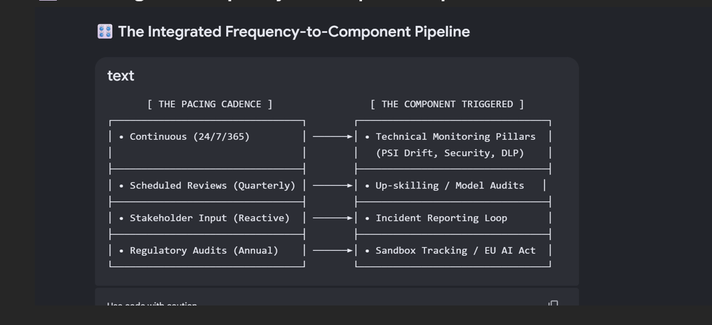
- Continuous Operational Monitoring: Automated sensors operate continuously at the system edge to intercept real-time changes in data distribution, environmental states, and conversational system behaviours. See Section Continuous Operational Monitoring (ISO 31000).
- Structured Scheduled Reviews: Separate from automated telemetry, the architecture mandates periodic, scheduled evaluations executed quarterly by internal engineers or external data auditors. These reviews conduct deep-dive validation testing on "Locked Models," inspect code repository lineages, and cross-examine long-term prediction accuracy baselines to catch silent systemic decay.
- Reactive Stakeholder Input Triggers: Event-driven audits are routed through user feedback channels. Upon the filing of an end-user Incident Report detailing algorithmic bias or unexpected behaviours, the console instantly freezes the associated prompt log sequence. This initiates an immediate, out-of-band technical review to investigate the boundary failure, bypassing standard scheduled timelines.
- Formalized Regulatory Audits: To maintain absolute compliance with statutory frameworks such as the EU AI Act, the environment enforces an annual compliance gate. This tier synthesizes historical telemetry records, multi-hop sandbox explosion logs, and human-in-the-loop validation histories to generate unalterable transparency reports and process reviews, providing verifiable assurance to external regulatory authorities.

5.2 Continuous Operational Monitoring (ISO 31000)
To ensure systemic stability, risk mitigation, and corporate alignment with ISO 31000 standards, this enterprise architecture implements an automated, real-time tracking governance layer. This AI Observability Framework bridges the gap between static asset protection (At-Rest Security) and live operational defence (Active Run-Time Security) across all five phases of the AI Lifecycle.

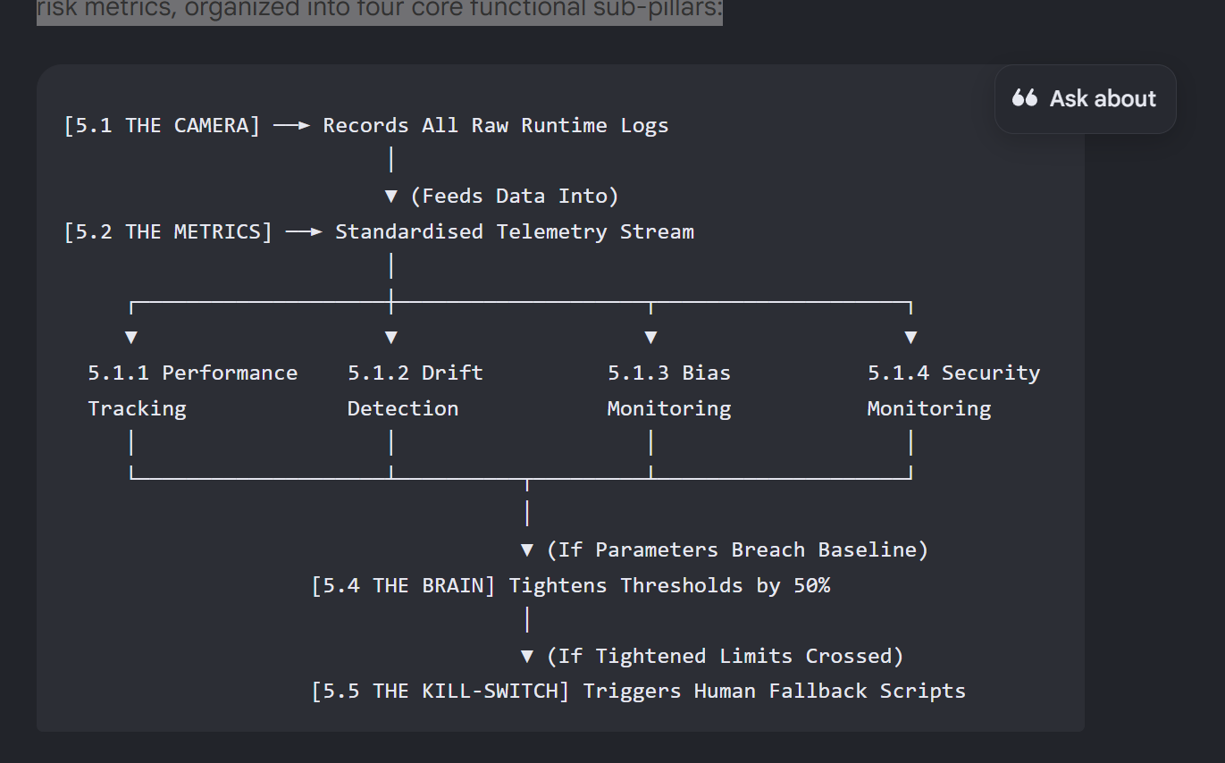

Technical Implementation of High-Fidelity Lifecycle Observability
Technical monitoring is executed via a unified data console fed directly by our Standardised Telemetry Stream. This stream converts raw technical data into executive risk metrics, organized into four non-negotiable, core functional sub-pillars:

📊 5.1.1 Performance Tracking (Operational Health)
- What it monitors: Infrastructure health, token response latency during context retrieval, and lifecycle energy consumption metrics.
- The Architectural Source: Powered by Section 5.2 (The Metrics) tracking Token Velocity Costs and Time-to-First-Token (TTFT) to protect compute budgets.
📉 5.1.2 Drift Detection (Algorithmic Stability)
- What it monitors: Mathematical model decay, statistical Accuracy Degradation, and real-time prediction decay over runtime.
- The Architectural Source: Uses Section 5.2 (The Metrics) to calculate the Population Stability Index (PSI).
⚖️ 5.1.3 Bias Monitoring (Output Fairness)
- What it monitors: Automated auditing of output fairness and demographic parity to eliminate data skew and systemic algorithmic discrimination.
- The Architectural Source: Powered by Section 5.1 (The Camera) feeding raw model outputs into automated pattern-matching filters to verify distributional parity.
🛡️ 5.1.4 Security Monitoring (Threat Containment)
- What it monitors: Perimeter threats, multi-hop recursive sandbox loops for suspicious files, and blockages of legacy Active Directory NTLMv1 or LM protocol fallbacks.
- The Architectural Source: Driven by Section 5.3 (The Vault) to isolate and protect our Digital Crown Jewels (PII, Model Weights, Prompts, Embeddings, and Source Code).
5.2 Operational Execution of High-Fidelity AI Observability Architecture
- To eliminate systemic visibility gaps and minimize threat dwell time during active operations, the lifecycle environment operationalizes a continuous AI Observability Framework in compliance with Stage 5 parameters. Shifting from passive monitoring to deep architectural traceability, the console enforces four core logging attributes across all active multi-agent execution paths to power the sub-pillars above:
- End-to-End Checkpoint Coverage (The Baseline): Telemetry sensors capture data states at every micro-layer of the runtime pipeline. The system registers immutable logs tracking user prompts, generated model responses, autonomous tool/API invocations, grounding retrieval sources, and filesystem write destinations.
- Fidelity and Cryptographic Compliance Gating (The Protection): To balance diagnostic utility with strict data privacy mandates, log data undergoes real-time tokenization and masking at the boundary layer. Sensitive textual components (such as customer PII or proprietary code blocks) are stripped and replaced with anonymous hashes before permanent database storage occurs, ensuring compliance with global data protection laws.
- Real-Time Timeliness Pipelines (The Speed): All serialized checkpoint streams utilize cloud-native webhooks to bypass processing queues, routing data directly into the centralized SIEM console. This real-time ingestion ensures that alerts fire dynamically the millisecond a threshold is crossed.
- Deterministic Attribution Chains (The Audit Trail): Every operational system event is stamped with a multi-variable identity signature. The observability console binds every processing action to an authenticated human or non-human entity token, documenting the exact model version, policy rule-set tier, and environmental classification (Sandbox vs. Production) to maintain an unalterable audit trail for downstream corporate governance tracking.

🏛️ 5.3 The 5-Step Building-Block Runtime Sequence
To make this technical stream actionable, the data captured by our four monitoring sub-pillars flows sequentially through a 5-step risk-mitigation pipeline.
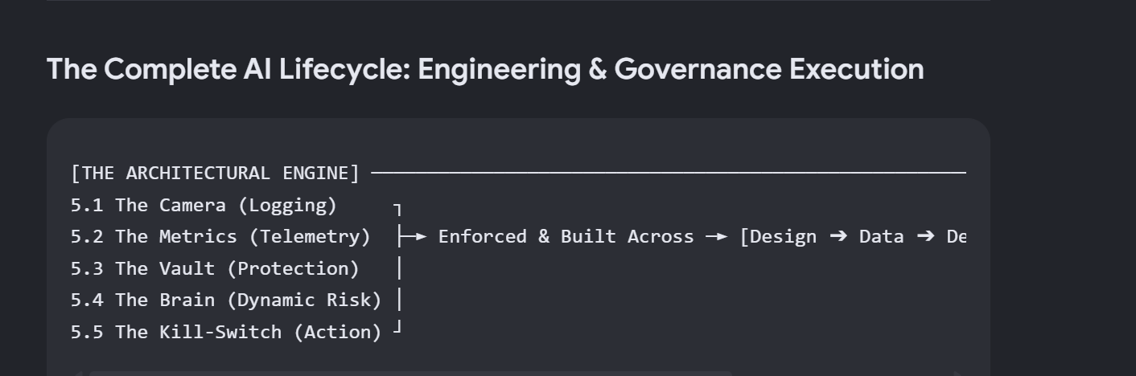
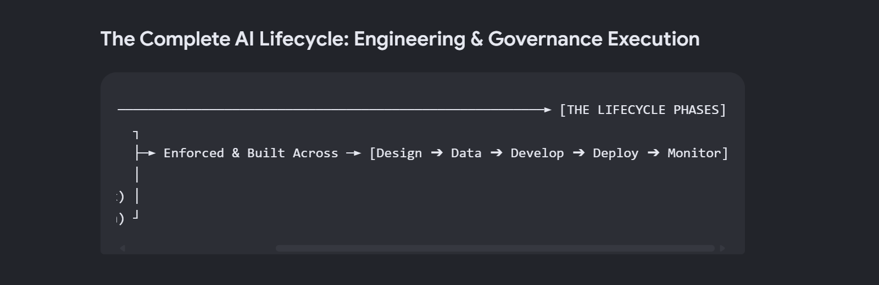
📸 Step 1 | High-Fidelity Observability (The Camera)
- Execution: Establishes the end-to-end logging checkpoints.
- Outcome: Ensures every prompt, response, and identity token is programmatically logged without blind spots to eliminate systemic threat presence.
- Cryptographic Log Hardening: To protect backend telemetry from exploitation, the centralized cloud SIEM platform enforces field-level encryption paired with automated string redaction at the network ingestion layer. Access to raw diagnostic text is policed via strict Role-Based Access Control (RBAC). The unmasking of any tokenized string is structurally barred from manual override; every single unmask event automatically triggers a permanent, high-priority audit log entry.
📈 Step 2 | Performance, Accuracy & MLOps Telemetry (The Metrics)
- Execution: Serves as the quantitative operational metric layer.
- Outcome: Tracks the mathematical health of the model (Accuracy Degradation, Drift, and Token Costs) and feeds this clean data stream directly into the rules engine.
🔒 Step 3 | Section 5.3: Digital Crown Jewels & Data Protection (The Vault)
- Execution: Defines and shields high-stakes M&A assets using Cryptographic Compliance Gating.
- Data Movement Tracking: Technical sensors continuously monitor the physical movement of these labelled assets across four lifecycle states: when data is read at rest, transformed during contextualization, generated within model outputs, or transmitted across external software boundaries. Any unauthorized data movement triggers runtime Data Loss Prevention (DLP) overrides.
- Outcome: Enforces encryption at rest and context-aware masking in transit for PII, Model Weights, Prompts, Embeddings, and Source Code.
🧠 Step 4 | Section 5.4: Dynamic Risk Contextualization (The Brain)
- Execution: Deploys a live, dynamic rules engine.
- Outcome: Evaluates who is interacting with the Vault. If a Crown Jewel asset is accessed or a performance drop occurs in any of the four monitoring sub-pillars, the system automatically tightens all monitoring thresholds.
🛑 Step 5 | Section 5.5: Automated Threshold Execution (The Kill-Switch)
- Execution: Initiates real-time active system defence.
- Outcome: when a threshold is crossed, the system executes an automated Application Command, revokes the agent's active session tokens, and launches isolated human-in-the-loop fallback scripts.

5.4 The Complete Ai Lifecycle: Engineering, Governance and Runtime Execution

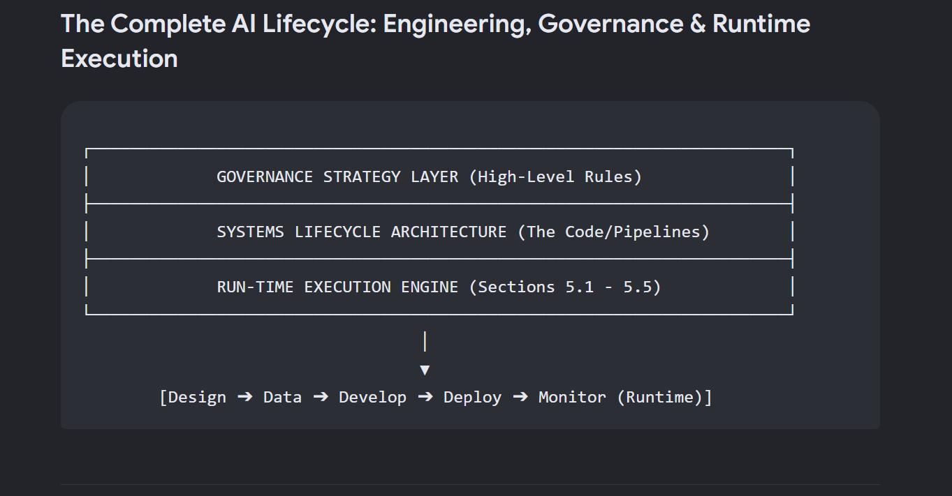
Phase 1: Design Phase (Boundaries & Permissions)
📋 Governance Strategy Layer
- M&A Rule: Define strict operational boundaries before writing code. Agents analysing target data rooms are restricted from external internet APIs to prevent Material Non-Public Information (MNPI) leaks. Human-approval steps must be hardcoded.
⚙️ Systems Lifecycle Architecture
- Operational Execution: Build a Zero-Trust Network Topology for Model Context Protocol (MCP) servers. Configure unique IAM roles for each of the 4 M&A agents to ensure strict data containment.
- System Controls: Hardcode token limits, timeout thresholds, and strict API rate limits to prevent cascading system failures if an external data-room endpoint lags. Write deterministic state-machine code (e.g., AWS Step Functions) that forces the system to stall for a physical human signature before moving a deal from Sourcing to Due Diligence.
⚡ Run-Time Execution Engine
- 5.1 The Camera (Logging): Log all architectural configuration changes, schema definitions, and initial IAM role assignments.
- 5.2 The Metrics (Telemetry): Define baseline target benchmarks for expected token latency and operational cost budgets.
- 5.3 The Vault (Data Protection): Map and enforce the logical network boundaries isolating the core M&A model instances from public networks.
- 5.4 The Brain (Dynamic Risk): Rule: If an unauthorized IAM configuration change or out-of-bounds tool access is attempted, flag it as a critical design breach.
- 5.5 The Kill-Switch (Automated Execution): Instantly lock the system design schema and block the agent from initializing if it violates its hardcoded boundary constraints.

Phase 2: Data Phase (Provenance & Masking Engineering)
📋 Governance Strategy Layer
- M&A Rule: Guarantee case-document ingestion quality, trace source provenance, and protect sensitive information. This pipeline runs an OCR confidence check on data room PDFs, appends immutable cryptographic tags to tracking logs for data lineage, and deploys an automated ETL script that programmatically replaces live acquisition target names with anonymized placeholders in your staging environment.
⚙️ Systems Lifecycle Architecture
- Operational Execution: Build an automated Data Ingestion and Scrubbing ETL Pipeline. Run optical character recognition (OCR) confidence checks on data-room PDFs.
- System Controls: Implement immutable data lineage tracking. The system must append cryptographic tags to tracking logs to record the exact source document, hash, and version used to generate any agent input.
⚡ Run-Time Execution Engine
- 5.1 The Camera (Logging): Record the real-time ingestion pipeline activity, capturing the cryptographic lineage tags of every document processed.
- 5.2 The Metrics (Telemetry): Monitor real-time data quality indicators, such as PDF OCR confidence scores and token distribution balances.
- 5.3 The Vault (Data Protection): Run the automated ETL scripts to dynamically mask MNPI/PII and replace sensitive acquisition target names with anonymized placeholders in real time.
- 5.4 The Brain (Dynamic Risk): Rule: If PDF OCR confidence drops below a set threshold, flag potential data corruption and automatically tighten ingestion validation checks by 50%.
- 5.5 The Kill-Switch (Automated Execution): Automatically halt the ingestion pipeline and isolate the data batch if unmasked MNPI or raw PII leaks into a lower staging environment.

Phase 3: Develop Phase (Version Control & Deprecation)
📋 Governance Strategy Layer
- M&A Rule: Enforce strict version control, change-management approval procedures, and schema definitions for all prompts, tools, and orchestration logic. Prompt updates for a "Due Diligence Agent" must go through code review to ensure the agent never overlooks critical change-of-control clauses.
⚙️ Systems Lifecycle Architecture
- Operational Execution: Implement a Semantic Versioning Git Workflow specifically for your prompts (e.g., due-diligence-agent-v1.4.2). Prompts must be treated exactly like application code.
- Orphaned Model Mitigation: Assign a hard technical expiration date (e.g., a 180-day review cycle) to every deployed prompt template and foundation model checkpoint. Write automated "Orphaned Infrastructure" depreciation scripts that scan your system and flag unmaintained tools.
⚡ Run-Time Execution Engine
- 5.1 The Camera (Logging): Log every prompt version deployment change, developer commit hash, and MCP schema modification.
- 5.2 The Metrics (Telemetry): Track the precise operational age of active prompts and models, calculating days elapsed since the last formal review.
- 5.3 The Vault (Data Protection): Restrict and encrypt access to the code repositories containing internal system prompts, system tools, and custom model embeddings.
- 5.4 The Brain (Dynamic Risk): Rule: If an active agent passes day 150 of its 180-day review cycle without maintenance, tighten its operational anomaly-detection thresholds by 50% to catch potential drift.
- 5.5 The Kill-Switch (Automated Execution): Programmatically lock the repository main branch and restrict deployment capabilities if developers attempt to merge unreviewed prompt or orchestration logic.

Phase 4: Deploy Phase (Evaluation & Resilience)
📋 Governance Strategy Layer
- M&A Rule: Block production deployments until the system produces verifiable evaluation results and architectural approval evidence. Run updates against standardized test data rooms with known risks. Require a 100% catch rate of critical liabilities before production promotion.
⚙️ Systems Lifecycle Architecture
- Operational Execution: Construct a CI/CD Automated Evaluation Suite. When a developer updates an agent, the pipeline automatically spins up a sandboxed test environment.
- Resilience Engineering: Implement circuit breakers. Run the agent against a benchmark of mock M&A files containing hidden liabilities. If the update fails the evaluation suite or throws errors during a blue-green deployment, traffic must automatically roll back to the last stable architecture.
⚡ Run-Time Execution Engine
- 5.1 The Camera (Logging): Capture comprehensive evaluation suite logs, saving every evaluation prompt and model response generated during pre-production testing.
- 5.2 The Metrics (Telemetry): Calculate rolling evaluation performance, tracking precision, recall, and accuracy metrics against the cached validation dataset.
- 5.3 The Vault (Data Protection): Protect live production environment API keys, model weights, and access tokens inside secure secret managers during deployment.
- 5.4 The Brain (Dynamic Risk): Rule: If the agent's evaluation catch rate drops below the baseline during testing, tighten CI/CD gate validation parameters by 50%.
- 5.5 The Kill-Switch (Automated Execution): Automatically abort the CI/CD pipeline, trigger the circuit breaker, and completely block production deployment if the agent drops below a 100% liability catch rate.

Phase 5: Ongoing Monitor Phase (Live Run-Time Operations)
📋 Governance Strategy Layer
- M&A Rule: Continuously inspect live system traces, tracking model drift, unexpected tool usage patterns, and user bypass attempts. If a live analyst agent makes an unusual volume of database calls, freeze access to prevent data exfiltration.
⚙️ Systems Lifecycle Architecture
- Operational Execution: Deploy deep telemetry monitoring infrastructure using engineering tools like LangSmith, Datadog, and AWS CloudTrail to monitor raw execution traces.
- System Controls: Write automated pattern-matching filters to instantly flag "infinite loops" (e.g., an agent calling an MCP document tool 50 times in a row) and configure system alerts that trigger if human dealmakers correct the agent's financial summaries more than 15% of the time.
⚡ Run-Time Execution Engine
- 5.1 The Camera (Logging): Log every single live user prompt, agent response, and identity token across all MCP servers without blind spots.
- 5.2 The Metrics (Telemetry): Track the mathematical health of the model. Monitor F1-Score/Precision Degradation against baseline data. Calculate the Population Stability Index (PSI) over a rolling 24-hour window to monitor Covariate and Label Shift. Track Token Velocity Costs and Time-to-First-Token (TTFT).
- 5.3 The Vault (Data Protection): Guard live M&A production data rooms, proprietary Model Weights, active Prompts, and live vector Embeddings.
- 5.4 The Brain (Dynamic Risk): Rule: If a Crown Jewel asset in the Vault is accessed, or if telemetry metrics reveal an active accuracy drop tighten telemetry monitoring thresholds
- 5.5 The Kill-Switch (Automated Execution): The moment a tightened threshold is crossed, the system executes an automated Application Command to revoke active IAM session tokens, isolate the agent container, and run isolated human-in-the-loop fallback scripts.

5.5 M&A Lifecycle Governance: Orphaned Model Discovery
A critical operational manifestation of tracking risks without established metrics (occurs during a Merger and Acquisition (M&A) phase, specifically regarding the inheritance of Orphaned Models—unmanaged artificial intelligence applications whose original engineering owners have exited the organisation. Because these inherited systems lack documentation or baseline metrics, they bypass standard compliance filters, operating as high-consequence blind spots.
To mitigate this vulnerability and intercept potential data breaches before they materialise, the technical team operationalizes an active exploratory discovery framework:
- Telemetry Footprint Harvesting: Technical monitors utilize network-layer Token Egress Velocities and Cloud Access Security Broker (CASB) payload inspections to flag hidden, recurring outbound data traffic targeting unvetted cloud infrastructure or third-party web domains.
- Identity Attribution Tracing: Upon detecting an ownerless AI pipeline, the observability engine intercepts the active connection strings, tracing the cryptographic signature back to the authenticated human user or department currently leveraging the tool for daily operations.
- Technical Remediation and Support Gating: Rather than executing an immediate hard shutdown that disrupts business continuity, the technical team is dispatched to actively remediate the asset. Engineers wrap the application in the corporate security mesh—mandating modern authentication protocols (blocking Active Directory NTLMv1 or LM exploits), configuring Microsoft Purview Data Labels to enforce active runtime DLP, and establishing baseline F1-Score and PSI drift index tracking.
- Governance Register Synchronization: Finally, the system forces structural accountability by assigning a living, permanent corporate Risk Owner to the asset, transforming an unmeasured, unmaintained shadow system into a fully governed enterprise deployment aligned with corporate risk appetites.

5.6 Non-Technical Monitoring
To ensure compliance with ISO 31000 Clause 6.6 and ISO/IEC 42005, the continuous telemetry console is structurally paired with four Non-Technical Monitoring Tools. These organizational practices are designed to capture emerging risks, negative externalities, and model misuse vectors that bypass automated system sensors, even when an artificial intelligence system appears to be functioning as designed.
Ingestion Triage & Competency Gates (Incident Reporting & Up-Skilling): The lifecycle framework establishes an integrated Incident Reporting Feedback Loop. End-users are provided a unified interface to instantly flag outputs demonstrating subtle inaccuracies, algorithmic bias, or unexpected behaviours. Symmetrically, the environment enforces a mandatory Re-Skilling and Up-Skilling Competency Gate. Operators are legally and technically barred from accessing active multi-agent production shells until they pass certified training modules focusing on prompt risk interpretation and automated alert response procedures.
Production Controls & Pre-Deployment Isolation (HITL & Regulatory Sandboxes): Symmetrical human-centric overrides police active execution loops. The system mandates Human-in-the-Loop (HITL) Oversight gates across high-consequence application boundaries. If a system anomaly or an adversarial exploit triggers a critical threshold warning—or if a contractually "Locked Model" experiences statistical drift—autonomous command dispatch is suspended, forcing a human validation check before system state changes can occur. Finally, all multi-agent architectures and third-party web applications are subjected to isolation within a supervised Regulatory Sandbox environment prior to production sign-off. This step ensures that controlled, multi-stage stress experiments can successfully validate system trustworthiness, fairness, and perimeter resilience before full deployment authorization is granted.

