**Amazon S3 Configurations**

1. Create a BUCKET

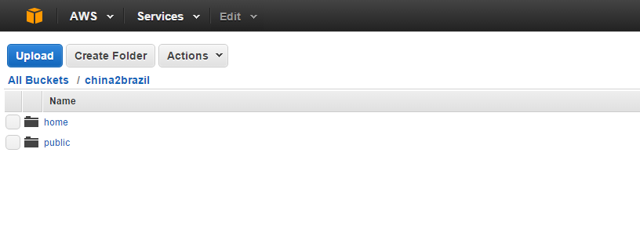

Example:

BucketName = china2brazil

Folders:

- china2brazil

- china2brazil\public (All public files)

- china2brazil\home (Personal user files)

1. Define Permissions

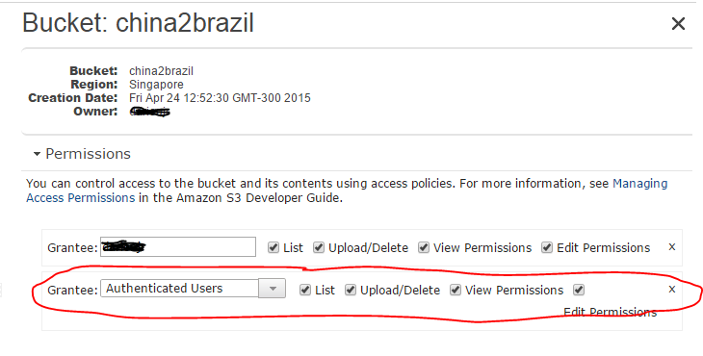

**Amazon IAM Configuration**

1. **Create a group**

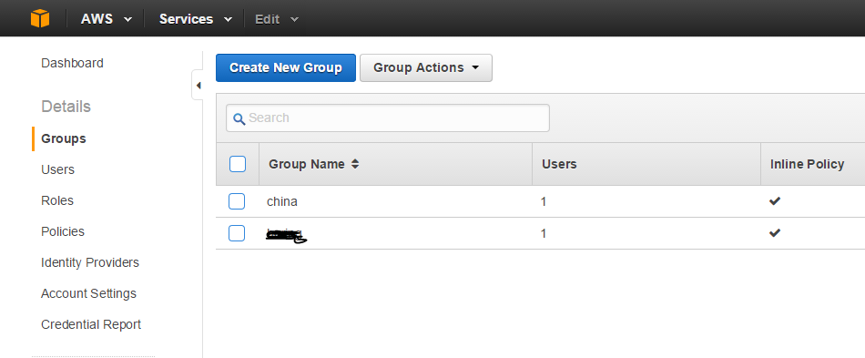

1. **Create a policies**

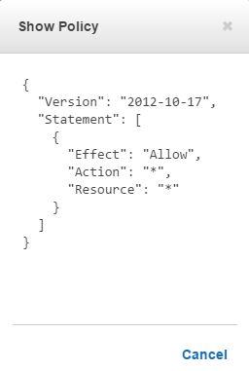

**Attach the policies in a group**

