README.txt

In MATLAB > Go to Home tab in the menu bar > Click on Add-Ons > Click Get Add-Ons > In the search bar type in "Image Processing Toolbox" > Add the toolbox if not already installed.
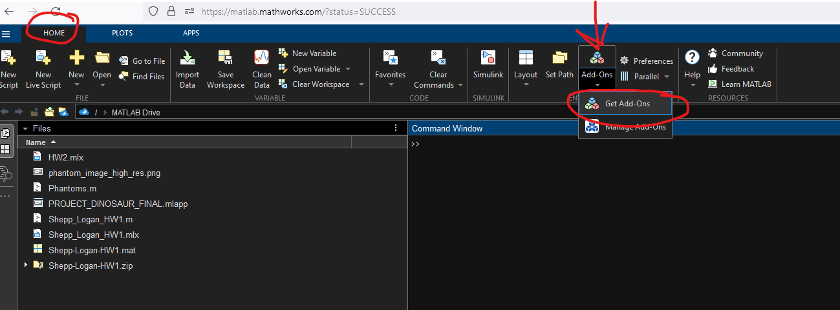
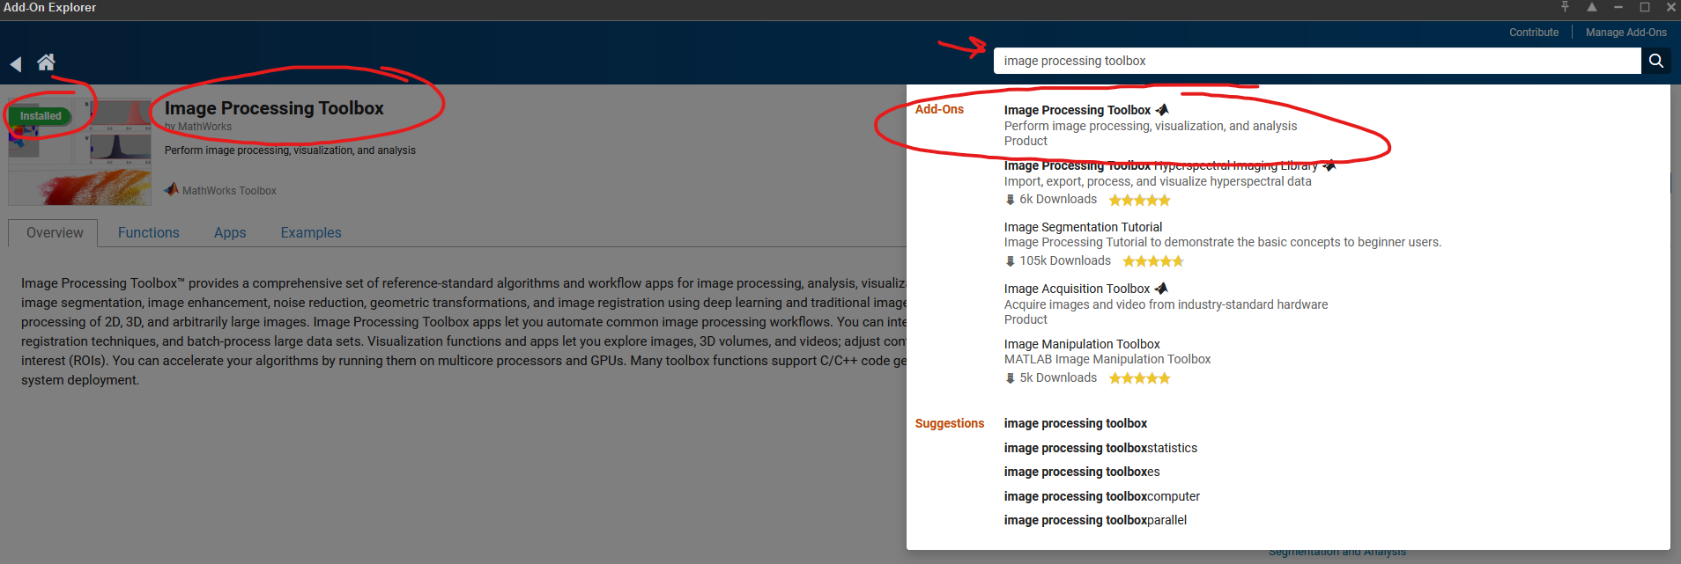
In MATLAB > Drag and drop the .mlapp file in the zip folder into "Files" column
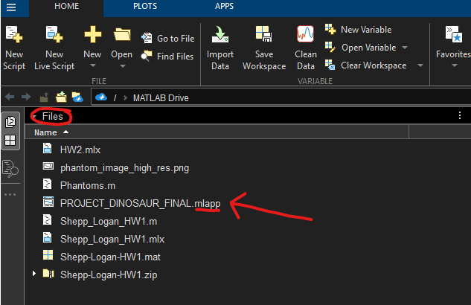
In MATLAB > Click on “APPS” tab in the menu bar > Click on “Design App”
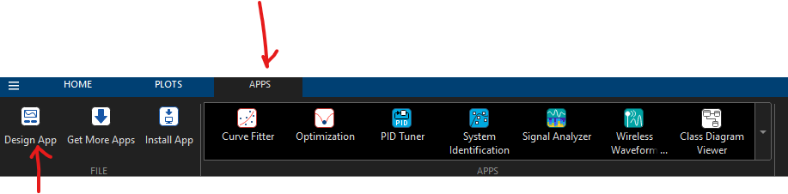

In MATLAB App Designer > Click on “Open” > Click on the mlapp file that you drag and dropped from earlier (this will load the application’s GUI)
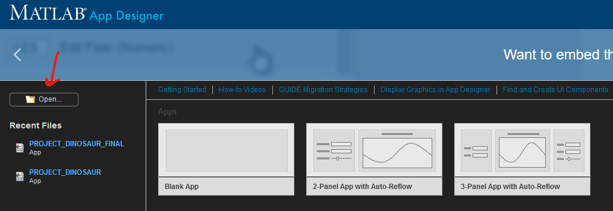
In MATLAB App Designer > Click on the “Designer” tab > Click “Run”
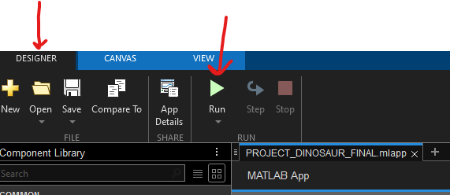

If you want to toggle between the source code and the GUI. In MATLAB App Designer > to the right of the screen should be Design View (to see the GUI) and Code View (to see the source code).
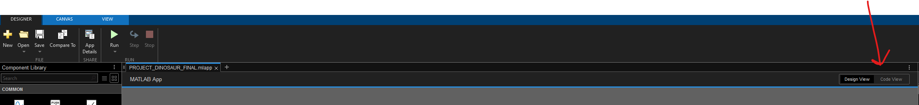
The application GUI should be running. You are free to play around with the fields and widgets/buttons! Have fun!
For more information/context on each widget/button/field read the below:
FOR THE PHANTOM CONTROLS:
Dimension Width and Height: This will elongate or shorten the shapes WITHIN the phantom skull (big outer circle). This applies to both Phantom 1 and Phantom 2. However, in phantom 1 it will edit the width and height of ALL circles within the phantom. Because phantom 2 only has 1 shape/object inside of the phantom you would only edit Offset X1 and Y1 if you want to change the positioning.
Matrix X and Y Pixels: This will resize the matrix/graph/plot frame (outer square/rectangle that holds the phantom in spot.
Offset fields: These fields will offset the shapes WITHIN the phantom so that it corresponds to the X and Y positions within the axes.
You MUST press the Update phantom button every time to make a change to one of the input fields so that it shows that change on the axes.
Generate phantom button: will just set up default phantoms if the user doesn’t want to use custom phantoms.
Save button: will save the phantom with no axes labels.
Dropdown button: will give 3 options, the first 2 options are custom made phantoms that correspond to the images in the pdf whereas phantom 3 is using the default Shepp-Logan phantom from the MATLAB library.

FOR PHANTOM RECONSTRUCTION/ANALYSIS CONTROLS:
Here are some recommendations for inputs (we highly recommend using the Shepp-Logan as it is much more distinct/well known and optimized):
For Parallel reconstruction method:
Initial setup: Rotation Step Size = 1 Degrees = 360
Can change the Rotation Step Size to the following values for best results: 10 and 60 for contrasting differences.
Can change the Degrees to the following values for the best results: 40, 90, 260, 360 for contrasting differences.
Remember to click the Analyze and/or Reconstruct button to view changes made!
For Radial reconstruction method:
Initial setup: Source Distance = 0.25 Detectors = 850 (this will change depending on which phantom you are using [custom or Shepp-Logan]; explained ahead)
Click on Reconstruct and wait (this can take up to a minute to finish on custom phantoms), if you press too many buttons it may crash requiring a restart of the application.
Can change Source Distance to 0.1 or 1 for contrasting differences.
For the custom-made phantoms (Phantom 1 and Phantom 2) you MUST use a detector value of approximately ~3700 and up. (Due to errors in sensor geometry in the code) Shepp-Logan can have a minimum of 800 D-value
Remember to click the Analyze and/or Reconstruct button to view changes made!
Parallel_Reconstruction.m and Radial Reconstruction.m are standalone short codes that show the functions used as a base; With fixed variables for a behind the scenes.
PROJECT_DINOSAUR_FINAL.mlapp is the main application, if you have the MATLAB Application, you can run it directly, the readme shows how to run in the web browser desktop version.

