Providing flexibility to mobile devices: an approach to meet the diverse requirements of the elderly

Vinícius Pereira Gonçalves
Institute of Mathematics and Computer Science, University of São Paulo (USP), São Carlos, Brazil
16-33739638
vpg@icmc.usp.br

Vânia Paula de Almeida Neris
Department of Computing, Federal University of São Carlos (UFSCar), São Carlos, Brazil
16-33518233
vania@dc.ufscar.br

Jó Ueyama
Institute of Mathematics and Computer Science, University of São Paulo (USP), São Carlos, Brazil
16-33739638
joueyama@icmc.usp.br

Sibelius Seraphini
Institute of Mathematics and Computer Science, University of São Paulo (USP), São Carlos, Brazil
16-33739638
sibelius@grad.icmc.usp.br

Teresa Cristina Martins Dias
Department of Statistic, Federal University of São Carlos (UFSCar), São Carlos, Brazil
16-33518233
dtmd@ufscar.br

Abstract
The elderly population grows in Brazil and it is necessary to develop appropriate technologies to them. With the low prices of smartphones, many families would like their elderly to use this technology in order to have contact with them when they are not at home. However, the current design of mobile devices applications favor young audience, instead of also considering the elderly different needs. Elderly population has its differences, such as educational levels, experience with technology, cognitive skills and physical dexterity. This paper presents the designs of interfaces that are flexible to meet the diverse requirements of elderly when interacting with smartphones. A framework for the design of flexible user interfaces was applied in a study case. Considering the results of this study with elderly users, interaction requirements were formalized considering syntactic, semantic and pragmatic aspects. Finally, a set of rules defining the design of the system flexible behavior was specified.
Keywords
Tailorable interfaces, flexibility, mobile device, elderly, design.
1 Introduction
Technological innovations are not just comfort gadgets, but play an increasingly essential role in people’s routines. The elderly, in particular, who represent a significant portion of society can benefit from the use of technological innovations [34]. Population aging is a widespread reality and must be taken into account when designing “future” technologies and services.
According to the Brazilian Institute of Geography and Statistics [18], this new demographic reality will have to be followed by new public policies, which should be based on information from the 2010 Census. Needs are to be met, not only by building houses adapted for the elderly and public transport easily accessible, but also cause these users to be included in the digital age, where people use technology to their advantage.
In the 2000 Census, the number of seniors was 14.5 million, representing 8% of the population. Ten years later, Brazil has 18 million people over 60 years, which now represents 12% of the total population [18]. The age exerts a strong influence on the use of information and communication technologies (ICTs), indicating a significant reduction in use after 45 years [23]. Thus, researches in the area show a negative association between age and interaction skills [15].
According to [29], many elderly people in industrialized countries are active. Although they are usually retired, lead a dynamic life and often have great interest in modern technologies, such as mobile devices. This same study shows that 18% of elderly people use smartphones, and that there was a 6% increase in the acquisition by the elderly, these devices between 2010 and 2011.
In the Brazilian context of access to technology and knowledge, the research needs in dealing with diverse needs and abilities are emergency, as reports of the Grand Challenges in Computing Research in Brazil. The fourth challenge titled "Participative and universal access to knowledge of Brazilian citizens" [2]. The way user interfaces are designed not currently favor the interaction of the general population, considering they do not consider the different needs of users, especially those who are not digitally literate.
Therefore, even among older adults there are differences with regard to experience with technologies, cognitive skills, schooling and physical dexterity. This paper argues for the design of interfaces that are flexible to meet the diverse requirements of the elderly in interaction with smartphones. The myth of the average user [7] disappeared, and Design for All [36] is a reality that must be considered in design projects.
Given the above, one way to deal with the diverse needs and is tailored systems offer the flexibility to adapt user interfaces to different organizational contexts, according to the preferences and needs of elderly users [13] [14] [16].
According to [28], while feedbacks facilitate understanding of tasks during interaction with mobile devices, older users face more complex problems that are related to how to perform basic activities. Often, only feedbacks are not sufficient to allow the user complete the task aged satisfactorily [10] [11] [28].
When the interface is more complex, if the user does not understand the concept of mobile services such as SMS messages (Short Message Service), the problem worsens. Similarly, the complex hierarchy of menus from a mobile device increases the difficulty to navigate through the device's functions, it places a high demand on remembering the sequence of actions [10] [13].
However, the design solutions for mobile devices whose target audience elderly should not offer solutions that discriminate or cause embarrassment. Instead, solutions must be flexible, respecting diversity in the user group, adjusting to each profile, and minimizing the fears arising from the use of inexperience or lack of knowledge [12] [13] [14] [34].
In this context, this paper reports the results of an exploratory experiment with elderly users, with the goal to support the formalization of a flexible design of mobile interfaces to meet the requirements of elderly audience interaction. The study considers the application of a framework for the design of flexible interfaces and observing users interacting with older mobile devices.
The result of this study, we formalize requirements of interaction with smartphones in 6 different aspects from those related to device physics question, until the impact of this interaction with the real world and the behavior of a system of adjustable mobile device to meet the requirements of interaction of the elderly.
The rest of the paper is organized as follows. In Section 2 presents the related work; Section 3 presents the design of flexible interfaces through PLuRaL, a framework for the design of flexible interfaces that are capable of adapting to different situations of use; Section 4 describes an exploratory experiment of the interaction of elderly people with no flexible interfaces, including planning, implementation and main results of the experiment; Section 5 presents the design process that elicited and formalized aspects of flexibility in the interaction of elderly people with smartphone, Section 6 describes the implementation stage of flexible interfaces based on FlexInterface, Section 7 presents the applying a nonparametric test with purpose of the verify if there is an improvement on interaction of users with interfaces FlexInterface and Section 8 presents the conclusion.
2 Elderly interacting with smartphones
Although studies related to mobile technology are already being explored for some years [11], the design solutions offered to elderly users still do not meet the demand requirements of public interaction [12] [34]. Studies in the literature show that elderly users face problems of accessibility and usability when interacting with mobile devices.
In this scenario, getting to know the main problems identified in the literature, a survey of related work was done and the problems encountered are summarized in Table 1. In the first column is the identification of the problem, in the second column the type of problem encountered and the third column is the reference work where problems were found.
Table 1 - Problems of interaction of elderly people with smartphones.
Id | Problem | Source
P1 | Small icons | Tang e Kao [37], Goebel [9]
P2 | Issues inadequate | Tang e Kao [37]
P3 | Menu hierarchy | Tang e Kao [37], Hellman [15]
P4 | Keys with multiple functions | Tang e Kao [37]
P5 | Automated assistants | Tang e Kao [37]
P6 | Following actions/navigation | Tang e Kao [37], Hellman [15], Nielsen [28]
P7 | Scroll bar | Hellman [15]
P8 | Session time | Hellman [15]
P9 | Feedback | Hellman [15], Goebel [9]
P10 | Help | Hellman [15]
P11 | Font size | Nielsen [28], Goebel [9]
P12 | Interface elements moving | Nielsen [28]
P13 | Color contrast | Nielsen [28]
P14 | Search | Nielsen [28]
P15 | Error Messages | Nielsen [28]
P16 | Keyboard size | Goebel [9]

Several problems are related with the interaction between elderly people and smartphones. However, much of the work found in the literature points out the problems of the elderly average user and therefore often does not address the diversity there is within that audience.
Besides the differences arising from the use of different contexts [26], it is important to consider the dynamic nature and evolution of ICTs. Whereas users evolve, it is necessary to develop methods and techniques that assist in design, implementation and evaluation of interfaces geared to the preferences and needs of the target audience [14]. Systems without flexibility can cause user frustration.
Research on flexibility has highlighted some technical issues, for example, the infrastructure required to generate tunable applications [3] [21]. Other research has prioritized specific mechanisms that promote adaptation, for example, icons and menus [22] [32]. Some papers bring guidelines for designing interfaces for older people [15] [13], others have investigated the phenomenon with respect tailorability [25], for example, the reasons why users customize [31] [33].
Similarly, some research uses the design of flexible applications on smartphone for the elderly people [12] [30], but it do not use the implementation and evaluation of adaptive models. Other researchers develop smartphones for seniors and apply generic usability testing on these devices [37]. Some other papers have discussed the design of flexible solutions without including the topic of evaluation [8] [39]. Thus, there are interface evaluation methods, for example, the Heuristic Evaluation [27] [10] and Cognitive Pathway [19], that do not analyze the adjustable behavior of the interface.
With regard to the design and evaluation of tailorable interfaces solutions, literature brings little on methods and techniques to aid the design of flexible interfaces to older users. Given the above, it is necessary to develop appropriate approaches and practices that support this structure and contemplate the diverse requirements of the elderly population.
Considering the problems presented in the literature, it is interesting to approach the elderly in order to understand their requirements and peculiarities of interaction. The next section describes a framework that aims to support the design of flexible interfaces, allowing an interface set for each user profile.
3 Design of flexible interfaces
One of the great challenges of researchers in Human Computer Interaction (HCI) is how to provide interfaces that serve the largest possible number of users regardless of their abilities sensory, physical, cognitive and emotional [12] [13] [14] [25] [26] [34]. One way that presents itself is to develop flexible interfaces. Thus, a resource is to develop systems that allow changes in their behavior during the interaction, offering each user the ability to have the interface adjusted according to your preferences, needs and intentions of use [14] [25] [26].
During the process of interface design, it is necessary to consider all stakeholders of the system, in this case, the elderly users interaction with the software. In this paper, we implement user adjustable interfaces using a framework called PLuRaL [1]. This framework is grounded in the areas of HCI and Organizational Semiotics [37] [20] and has a comprehensive view of the requirements of interaction, considering that includes those that are controversial or minority and coming not only from users but also different devices and interaction environments. Aspects semantic, pragmatic and social impacts of the interaction are also considered. Also, the behavior of the system under measurement is modeled using the concept of Standards [26].
The PLuRaL is organized into three pillars [1]. The first aims to clarify the differences among potential users, devices and environments in which the system can be used. Thus, this step is intended to clarify the problem and identify possible solutions.
The second pillar is the formalization of functional requirements, which is constructed from a consistent view on the field and that includes rules governing the behavior of users. Finally, the third pillar brings an approach that defines the design of flexible interfaces through the formalization of standards tailored to the behavior of the system.
Considering an approach that emphasizes the Universal Design [4], it is interesting to design systems that enable access to knowledge and information, without physical and social segregation [34]. That make sense for the largest possible number of users according to their different sensory abilities, physical, cognitive and emotional. Therefore, it is necessary to approach the elderly users and understand their peculiarities and requirements of interaction in order to generate interfaces tailored to meet the preferences and needs of this target audience.
Unlike conventional applications [10], the development of a bespoke system, requires designers to consider the different interfaces in their potential uses, including the evolution of users and experience with technology [12] [13].
With the goal of meet the diverse requirements of elderly audience interaction with flexible interface and aligned with the principles of Universal Design, this paper adopted the PLuRaL as a benchmark in driving the design process. However, considering that the literature emphasizes the interaction problems faced by elderly users and brings little about the diversity of this population requirements of users [34], it was decided to observe a group of elderly interacting with smartphone and considering the results this exploratory experiment, guided and enrich the design process recommended by the framework [12].
4 Observation of elderly in interaction with smartphones
With the goal of know more about the interaction of users with older mobile devices, an exploratory experiment was performed with a group of 10 elderly between 60 and 84 years old, among no schooling and higher education and different experiences with the use of technologies.
This section describes the planning, execution and formalizes the results from the exploratory experiment. These results provided the basis for the design process of flexible smartphone interfaces to meet the requirements of elderly audience interaction.
4.1 Planning exploratory experiment
For planning exploratory experiment that observed the elderly in interaction with smartphones, sets up the goals, hypothesis, methodology, equipment and devices to be used to verify the hypothesis.
Hypothesis: based on the problems found in the literature, it is believed that the diversity of problematic situations encountered, should confirm the presence of specific situations to define the design.
Objective of the experiment: observe and analyze user interaction with older applications smartphones and identify usability issues and accessibility during the interaction with the device.
Applied methodology: in order to analyze the user interaction with older applications of smartphones, a group of seniors users was invited to participate in a practice of device utilization, as illustrated in Figure 1. The goal of the activity was that these users record a contact in the smartphone book and call the number after. According to the results from the experiment, it was possible to formalize the interaction requirements on PLuRaL framework [1]. This interaction treated aspects such as the device physical design, the impact of this interaction with the real world and the adaptable behavior of a mobile device, in order to treat the interaction requirements with elderly people.
Support material: to develop the exploratory experiment it was prepared Statement of Consent Free and Clear, Profile Questionnaire Definition and Form of Participant Observation. The Instrument of Consent participants clarifies the purpose of the study, the voluntary participation and scientific character of the same. The Profile Questionnaire Survey had issues of social and cultural defining the profile of these elderly users. Finally, Form of Participant Observation is designed to assist in observing user during the interaction with the smartphone. Besides making use of the observation form, participants were also being filmed, so all the details of the study were analyzed.
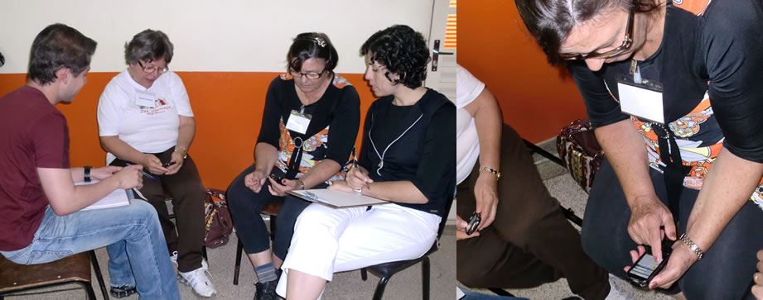
(a) (b)
Figure 1. (a) Where the experiment took place and (b) elderly interacting with the smartphone.

Devices used: the elderly were organized into pairs and each individual pair received a smartphone Samsung Galaxy 5 with Android operating system release 2.2. The mobile device were charged with battery and credits to make calls.
4.2 Execution
The exploratory experiment with elderly and smartphones happened in a Reference Center for Social Assistance (CRAS) in São Carlos-SP (Figure 1a). These users are part of a group that performs physical activities for seniors, such as dance and theater. In parallel to these activities, 10 people were invited to participate in some tasks for interaction with the mobile device described follows.
Initially, we raised the profiles of those users. Furthermore, it was found that users who did not have any education either never used the mobile device or just used to answer calls. users with education level or graduate or complete high school they are able to make calls, send messages, take pictures and play on smartphone. It is worth highlighting that there was a user who had Alzheimer's disease, which according to the group's instructor, was in an advanced stage.
The participants worked in pairs and each individual had a smartphone (Figure 1b). During test: The pair sat side by side during the interaction with the mobile device. Moreover, it was shown a role for these users with the name and phone number of a person, so save the contact in the smartphone and then bind to the number reported.
While those users performed the task in the mobile device, researchers who conducted the exploratory experiment met an observation form with questions like: Did you need help to finish the task? Is the screen size appropriated for these items? Is the sequence of actions to save the contact: Contacts > New Contact > Save to phone > Enter > appropriate? As can be seen in Table 2

Table 2 - Data from the observation form.
pair | Did you need help to start the task? | Screen size is appropriate? | Size of the buttons is appropriate? | Key size is appropriate? | Color combination is appropriate? | Sequence of actions to save: Contacts> New contact> Save to phone> Insert Data> Save. Is appropriate? | Comments
P1 | yes | no | no | no | yes (“green helped me”) | no | -
P1 | yes | no | no | no | yes (“I able to see, ok”) | partly | There are many levels/ very sensitive screen/ sections change very fast
P2 | yes | no | no (“very small”) | no | no | no | Much difficulty to interact
P2 | yes | no (“space to register contact is very small”) | yes | no (“keys too small for fingers”) | no (“the gray color is too light”) | yes | It trouble understanding where each number
P3 | yes | no | no (“very small”) | yes | yes | partly | -
P3 | yes | no | no | no | yes | no | Very difficult to accomplish the task
P4 | yes | yes | no (“my long fingernail hurt to click”) | no (“many erros”) | no (“I prefer more colorful”) | yes | -
P4 | yes | no (“I have difficulty to interact”) | no | no (“very small”) | no (“I prefer more colorful”) | yes | -
P5 | yes | yes | yes | no (nºs > ok/ letters> small) | no (“save button must be colored”) | partly | -
P5 | no | yes | no (“must remain a standard for the delete button”) | no (“keys too small for fingers”) | yes | yes | User had to interact easily/ user found the registration form contact simple and easy to fill

The elderly were informed that, if necessary, they could help or ask for help to his friend during the task. The number was from a home phone, where the researcher recorded a thanks message on the answering machine.
For the formation of the double was analyzed of the profiles, considering age and education. Therefore, as can be seen in Table 3, individuals with similar age and educational levels were grouped. Upon completion of the tasks the authors did a discussion with the duo, on issues relating to interaction and the difficulties encountered during interaction with the smartphone.

Table 3 - Profile of users.
Pair | Gender | Age | Origin | Education level | Home phone usage | Smartphone usage
P1 | F | 81 | BA | less than 4 year | daily | no
P1 | F | 84 | SP | less than 4 year | rarely | no
P2 | F | 76 | SP | less than 4 year | daily | no
P2 | F | 74 | SP | less than 4 year | daily | yes
P3 | F | 65 | SP | less than 4 year | daily | no
P3 | M | 69 | BA | less than 4 year | rarely | no
P4 | F | 66 | SP | less than 4 year | daily | no
P4 | F | 60 | MG | less than 4 year | daily | yes
P5 | F | 62 | SP | more than 12 years | daily | yes
P5 | F | 60 | SP | more than 12 years | never | yes

4.3 Results of observation
During the tests it was observed that several users had difficulties in interacting with the smartphone. One participant noted that the D1: "The screen is very sensitive to touch, so it causes many errors and path to perform the requested task is too long." The touch sensitivity that the user refers, relates to conduct involuntary touches on the mobile screen and then do the same unwanted actions.
Except for the user 60 who had higher education level, all other users needed help to perform the task of saving a contact. Moreover, none of them interacted with the friend of the pair.
Regarding the size of the screen, one of the members of D4 said: "It was not appropriate and that it hindered the interaction." Another user of D2 explained that: "The space for the registration of contact is very small, so there is a general notion of the registration screen." As the mobile touch screen was used, women who had long fingernail, as seen in Figure 2 (a), had difficulty to complete tasks successfully.
The D5 also pointed out that: "One should maintain a standard for the position of buttons, because it ends up confusing people." With respect to the size of the keys all participants felt that it was not suitable, because the errors were constant. The D4 explained that "When attempting to touch a letter or number ends up striking the nearest because the keys are too small", as can be seen in Figure 2 (b). Furthermore, the D2 and D5 stated that: "the keys are too small for fingers, so we have to repeat an action several times".

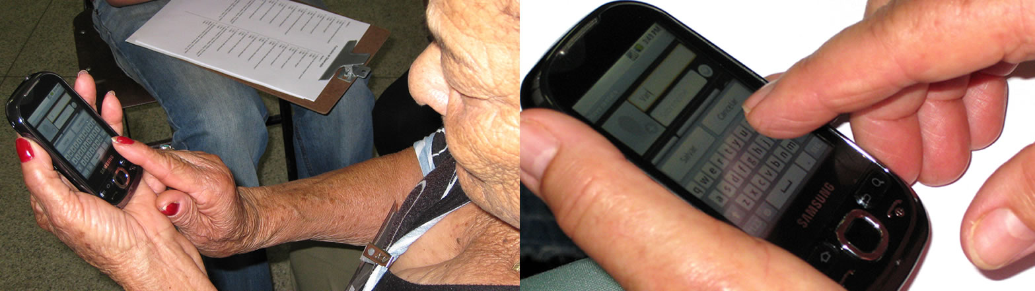
(a) (b)
Figure 2. Older users trying to interact with smartphone.

Another problem observed in the interaction of elderly people with smartphone has to do with colors. Most couples said they do not like monochromatic interfaces. In this sense the pair D2 noted that: "These predominantly black and white colors are difficult to read and not give due prominence to the most important things, such as text - Enter the Name." The pair D4 said: "The interface should be more colorful, such as the save button could be yellow and not gray."
Regarding to the sequence of actions, it was possible to observe that de D2 had a lot of difficulty to follow a logical sequence to complete the task. One of these tasks explained that: "There are many levels to complete the task." Unlike D2 pair that does not have any education, the integral of the pair D5 that had accomplished the task level requested in accordance with the sequence of actions and default device succeeded.
5 Design of flexible interaction with older smartphones
After those experiments it was possible to see the different interaction needs for this group of individuals. With the goal of develop solutions that follow the premises of Universal Design [4], the 3 pillars of the PLuRaL were applied.
The initial step of the first pillar framework relates to define the interested parties in the system according to the layers that help to clarify the scope of the solution as shown in Figure 3. Furthermore, some of the actors mentioned will interact with the system, providing support to the start of the next step of the design process [25].
This paper shows a research approach of systems development that adapt to different necessities. Some of these necessities are the different users needs, multiple devices and the changes of the environmental [26]. Therefore, the developers should not consider just the average necessities, but should consider the diversity of needs.
The graph presented in Figure 3 consists of characters that fall into layers called the stakeholders in the system solution. The layers listed and consider the community where viewers have, for example, ANATEL, ABNT and SBC, they also consider the market, partners and competitors, as is the case with mobile devices vendors and software developers for mobile devices and the sphere nearest the solution is the contribution and the actors that are responsible to the research team, programmers and designers.

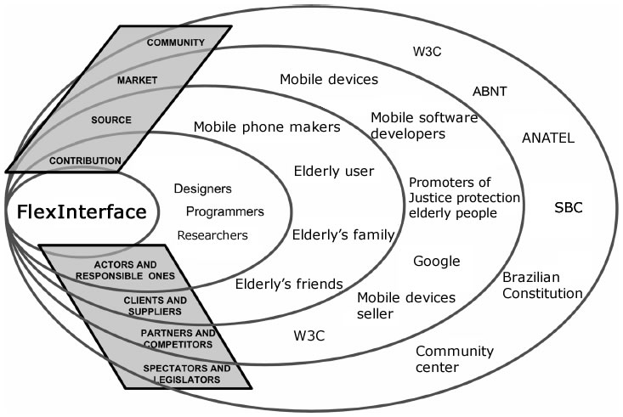
Figure 3. Stakeholder’s chart.

[1] [26] have developed a technique based on Collaborative Analysis of Requirements and Design (CARD) [24]. To approach this research, we defined three different types of cards (for users, equipment and environment), as recommended by [26]. Figure 4 illustrates an example of cardboard for a group of users. These cards describe features related to intentions to use (pragmatic impact), the domain terms (semantic differences) and the social impact.
Therefore, the use of these cards allows for the definition of differences in respect of the intentions of use and knowledge about the system domain [25]. The examples shown in Figure 4 consist of characteristics of elderly users of smartphones, considering the features of the device. The aspects listed consider deficits of vision as a physical characteristic as possible the ease of use as a purpose of use and user satisfaction using the mobile device.
Additionally, it can see that the card describes a general specification, since the characteristics simplest to the most essential. In the area "emotional issues", for example, it can highlight impatience for those impatient users to use the smartphone, but also the lack of curiosity or interest in handling this device, or be something new, or because they fear for break it.
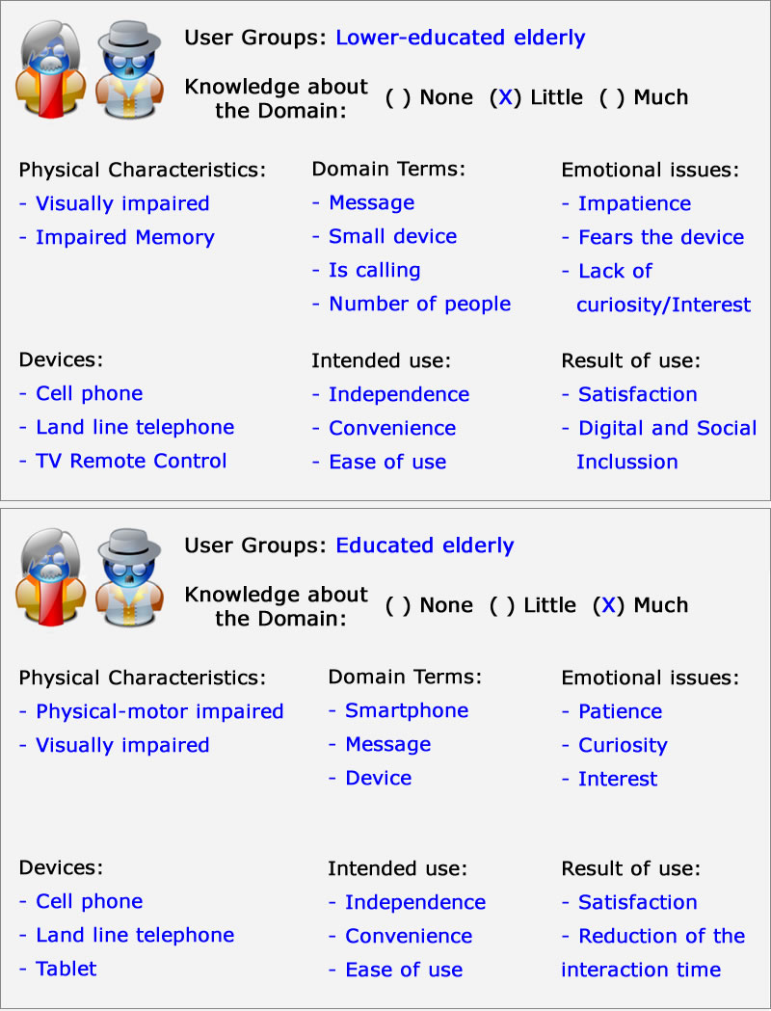
Figure 4. Cards for the characterization of user groups.

The card for the device considers the features related to input and output information, for example, keyboard and screen; physical, as is the case of screen size, processing power, memory and quantity.
The card for the environment is characterized by issues of availability of network connection communication, signal brightness and wireless carrier. The cards can be filled by one person, or by some designers, or even in a participatory practice [1]. Furthermore, additional fields may be included in card according to the need of the project, and finally the cards can be grouped to form a "context table".
Nevertheless, the last step of the first pillar details the context of use and its specialties, through interaction requirements with the interface [25]. These requirements are formalized with the help of the Ladder Semiotics [35]. Thus, considering the experiment with the elderly and the information filled in the cards for users, equipment and environment could be established requirements and distribute the layers of interaction Ladder Semiotics.

The ladder allows information Semiotics (signs) are viewed from different perspectives [20] [35], starting from the physical world, and going to empirical, syntactic, semantic, pragmatic, and finally the social layer. The three layers at the bottom of the stairs comprise the IT platform, the base of a system where most people centers his attention on the system design.
- Physical World: issues on this layer are related to the hardware that supports the system, including the paths over which information is transmitted and also the capacity of the route. That is, this layer relates to all aspects of a material system. As an example of a problem belonging to this layer it has a very mobile screen touch for certain situations, for example, to use your finger to scroll the phone book and look up a contact, it can end up selecting one unwanted contact.
- Empirical: the empirical relates to the coding, so that the statistical behavior of the messages can be combined to more effectively the statistical characteristics of the media (signal for error rates). The main question of this layer is related to the encoding that allows efficient use of hardware resources. In this study, these are the issues of memory and network traffic smartphone, for example.
- Syntactic: the formal structure of signs is related to the syntactic layer. For example, it take an alternate path in the smartphone to send an SMS or the size of the interaction elements..
The three layers on top of the ladder forms the functions of human information, which are related to the characteristics of human organization / social.
- Semantic: that domain establishes signals with actions that can be taken from them, or meanings that are suggested by the elements of a system. Here, the social vision of the problem is already required as meaning that a community of users can do from the elements related to their culture and other details of its origins. For example, a green button to save a contact in the mobile device suggests the user permission to perform the action.
- Pragmatic: this layer is associated with intention - the intention is that the developer had to create the system, the user's intent in relation to it, or the intentional communication of messages. Understanding the context of users is essential in this area, since it allows to predict how they intend to use the system. For the elderly, issues of independence and ease of use should be prioritized. From the observations made​​, it is clear that the functionality of connecting to a given number (as a favorite) and save a contact should be simplified.
- Social World: the top layer of Semiotic Ladder consists of standards that drive an organization and its environment. This includes not only the law or cultural norms and ethics, but also the impact the system has on society. In this study, the requirements are related to user elderly satisfaction and issues of digital inclusion and social.

Figure 5 illustrates a ladder partially filled in the context of the interaction of users with older applications for mobile devices. Requirements adapted to the smartphone's screen size (the physical layer), offering alternatives to increase the text for better visualization (empirical), allowing a more accessible navigation structure (syntax), offering a simple call to contacts and significant (semantics), reducing anxiety and increasing curiosity about the device (pragmatic) and provide social integration (social world) were mentioned [12].
From techniques and approaches seen so far it is possible to have a consistent view of the field, originating from the social context raised. In this sense, the second pillar of PLuRaL leads designers to define the features of the application that will behave and adjustable through the description of use cases and ontologies for domain may be systematized approached [25].
However, for this study the design of interfaces was set to tailor functionalities already implemented on mobile devices. Therefore the related functionality to save/edit contacts in the smartphone and make calls were set to present tailored feature on their interfaces.
Therefore, considering that the features are already defined, the third pillar of the PLuRaL is applied to determine the behavior adjustable, including the sequence of actions and the alternate flows.
With the goal of gathering design proposals that meet the requirements presented in Semiotic Ladder of the first pillar, the last step of the framework by defining a set of characteristics of users, devices and environments, the system behavior. Therefore, a system that has specific functionality and a particular representation, may have a single functionality being represented by different user interfaces.

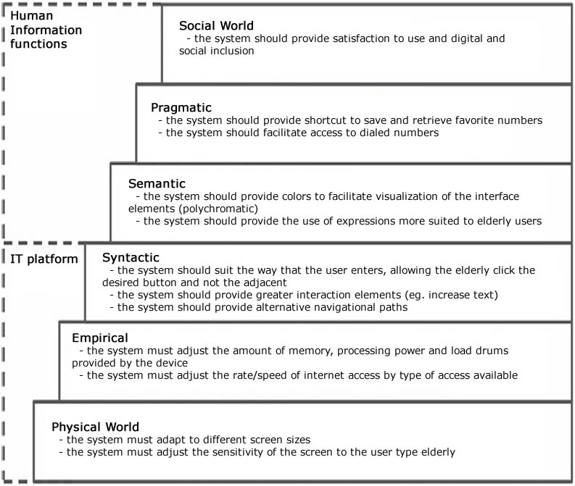
Figure 5. Semiotics ladder with the requirements for the interface Adjustable.

The last step in the PLuRaL include the outline of user interfaces, through a participatory practice. According [26], simple designs are insufficient to represent the diverse elements of a system to measure, hence a more formal approach needs to be adopted.
Accordingly, Figure 6 (a) represents the mock up of a flexible interface targeted for elderly with low schooling, where you can observe the exclusion of the scroll bar and a larger keyboard. Even at this stage it possible to set a mock up considered educated elderly users, as shown in Figure 6 (b), where there was a need to establish consistency standardization of interface elements with other similar systems.
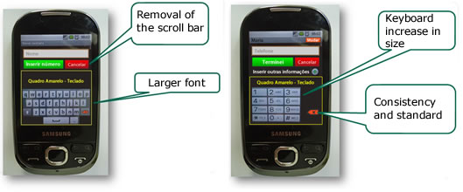
(a) (b)
Figure 6. (a) Mock up for lower-educated elderly; (b) Mock up for educated elderly.

Nevertheless, being established behavior adjustable, it can consistently characterize the actions and alternative ways to interact with smartphones. Therefore, this pillar a wide variety of settings can be modeled as described in Table 4, where designers can mention situations as simple as every time a user dialing a number and typing mistakes applicants this keyboard must be reconfigured to a most appropriate size for this user.

Table 4 - Examples of standards that represent the behavior of a flexible smartphone to meet the diverse requirements of elderly users.
Context |  |  | Condition |  | Tailorable behavior
Device | Environment | Users | Functionality | Representation |  | Element and mode
smartphone | any | elderly with education level less than 4 year | search contact | contact List / index |  | remove scrollbar
smartphone | any | elderly with memory deficit | save | form |  | polychromatic
smartphone | any | elderly with education level more than 4 year | buttons | save / cancel |  | more significant
smartphone | any | Elderly inexperienced in the use of smartphones | save | form |  | fewer fields to fill
smartphone | any | Elderly with physical motor deficit | dial | key |  | greater distance between the keys
smartphone | any | elderly experienced in the use of smartphones | buttons | save / cancel |  | monochrome
smartphone | any | elderly deficit of vision | dial | keyboard |  | increase keyboard

6 Implementation issues
Using the set of rules that were defined in Section 5, for the design of flexible interfaces for elderly users, we developed a functional prototype which provides the interfaces that can adapt to the older public during run-time. The FlexInterface is a framework that assists in implementing flexible interfaces and was developed by means of Adaptive Middleware OpenCom [14] [38]. With the aid of this resource, it is possible to have mobile phone interfaces that adapt to different older-user profiles.
6.1 The FlexInterface Approach
This research adopts a generic approach to build adaptive applications in mobile devices. Thus, [6] [17] [38] it shows that run-time reconfiguration is a key feature to handle the heterogeneous hardware that is inherent in mobile devices.
Thus, by defining the design of flexible interfaces so that they meet the many interaction requirements of the elderly with mobile phones [12] [13] [14] [34], it was possible to develop a software layer called FlexInterface based on the OpenCom component model [14] [38].
FlexInterface is generic and has a flexible and extensible architecture that is not dependent on language. It is based on a microkernel, where the functions are incremented upon request [17] [38]. In this context, there is FlexComp, which is a generic and reflective component of FlexInterface that has two receptacles called FlowScreen and ProfileChecker, as shown in Figure 7.
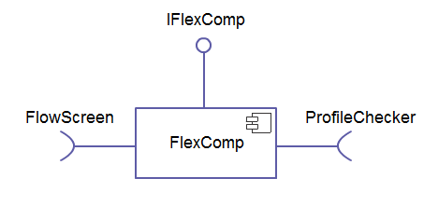
Figure 7. ElderlyFlex Component and its receptacles.

The FlowScreen component is responsible for storing the sequence of actions/screens that a given older user profile possesses, so that it can carry out a task in the device. Thus, with the FlowScreen it is possible, for example, to determine a sequence of specific screens, for older adults with a low level of education, to record a contact in the cell phone’s agenda (Example: flow of actions / screens: Record Name > Record Phone > Save Contact).
Additionally, the ProfileChecker component receives the user’s interaction data and on the basis of this information, is able to set the most appropriate type of profile, and then determine whether it is necessary to reconfigure the FlexInterface components.
6.2 FlexInterface for Older Users
FlexInterface is a framework supported by the development of adaptive interface designs that allows the application to adapt to the needs of the user during his interaction with it.
With regard to the many requirements which emerged in the case study with the elderly and which led to a set of rules being defined for behavior-based adjustable interfaces [12], two different profiles of elderly people were selected: seniors with up to fourth grade schooling (low education) and those with education beyond the fourth grade (high education).
Given the range of requirements, we used FlexInterface to provide adaptability to the interfaces. This meant that, as well as a change of actions/screen flow and of the interface elements, changes in the structure and size of the keyboard were also necessary. In view of this, the ElderlyFlex has been created, which is an extension of the FlexComp of the FlexInterface. This extension includes a new receptacle that is able to load the keyboard component and is suitable for the profile determined by the ProfileChecker, as shown in Figure 8.
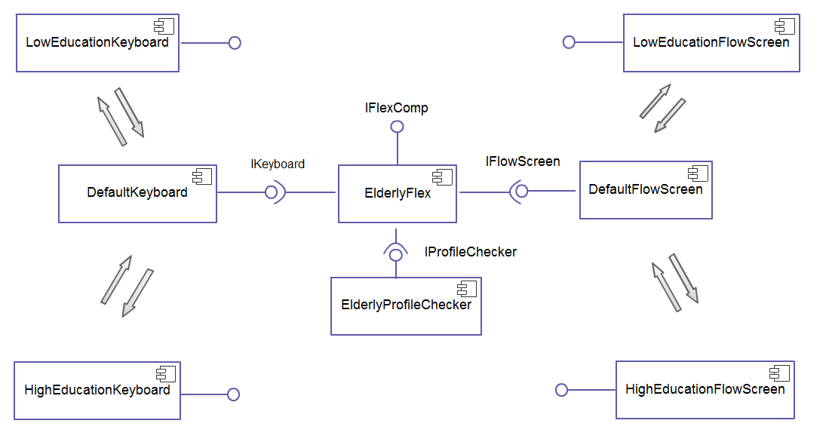
Figure 8. Our FlexInterface Components along with implemented Plugable Extensions.

Thus, the keyboard is represented by three components to meet the requirements of elderly users: a) the default, b) for the elderly with low education and c) for the elderly with high education (DefaultKeyboard, LowEducationKeyboard and HighEducationKeyboard, respectively). Depending on how the user interacts with the application, the ProfilerChecker sets the most suitable profile at runtime and enables the ElderlyFlex to connect to the keyboard component that is most suited to the profile, as shown in Figure 9.
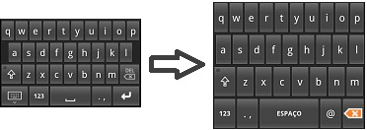
(a) (b)
Figure 9. (a) Default Keyboard; (b) Adapted keyboard.

To determine which keyboard is best suited for each user profile Elderly collected the data from user input. For each keystroke, the following was collected:
- Given character
- Elapsed time (ms) from previous tap
- Error (when the user deletes a character)
With regard to the FlexInterface architecture, the components were developed that require the screen flow called FlowScreen. For this particular scenario, it was possible to explore the reconfiguration of the actions/screen flow. In this case, the ProfileChecker defines the interaction profile and analyzes the use of a new layout with a different action flow that can be used for the interface at the appropriate time.
Thus, owing to the change in the user´s standard interaction, in the scenario in which the default screens/actions flow component (DefaultFlow) is loaded the ProfilerChecker can,for example, set the low education as the most appropriate default for this older user. As a result, the default flow component will be disconnected and destroyed, freeing up the memory; following this, the screens/actions flow component for lower education (LowEducationFlow) will be created and connected to ElderlyFlex, making the application suitable for the new interaction default.
It should be noted that when the screens/actions flow reconfiguration is added, the screens of each flow establish the interface layout formatting, the position of the keys, the colors and the voice access, by strictly adhering to the rules defined by [12] and using the PLuRaL framework [1].

7 Applying a nonparametric test on the experiments
This section presented the applying a nonparametric test with purpose of the verify if there is an improvement on interaction of users with interfaces FlexInterface, using as a parameter the practice described in Section 4 of elderly interacting with smartphone non-flexible interfaces. The nonparametric test analized the interaction of elderly people with flexible interfaces and non-flexible in smartphones, the users used the same devices, and them performed the same task, described in Section 4.
For users in the sample, 68% participated in the group that interacted with the flexible interface. Considering both groups, the average age is approximately 69 years (standard deviation of about 8 years). The level of education of the elderly in both groups ranging from no education (19%) post-graduation (10%), with the majority (45%) is from 1st to 4th grade.
The task described in Section 5 was held for approximately 90% of users.
A variable degree of satisfaction in the statistical analysis, was classified in levels (Very low: 0 a 19; Low: 20 a 39; Good: 40 a 59; Very good: 60 a 79 e Excellent: 80 a 100). Figure 10 shows the levels of user satisfaction when performing the task with the interface fexível (Figure 10a) and non-flexible (Figure 10b). Regardless of whether or not completing the task flexible degree of user satisfaction varies from 67% to 100% if the task is non-flexible degree of user satisfaction varies from 33% to 67%.
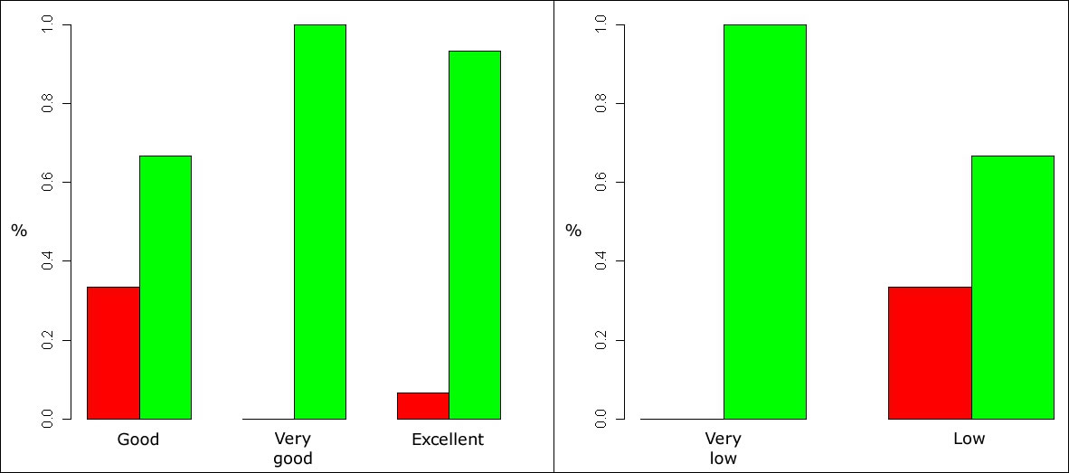
(a) (b)
Figure 10. Satisfaction second task completion (green = yes, red = no). (a) With flexible interaction, (b) without flexible interaction.

To compare the execution times of task between flexible and non-flexible proposal was performed using the Mann-Whitney test. This is a nonparametric test often used when the assumption for applying a parametric test, as for example, normal observations, it is not checked and when the sample size is small. This test compares two sets of data [5]. The methodology is described below.
The idea of the test is to combine the two groups, assigning jobs and adding them to groups. If the sum of the ranks of a group differ much from each other, the groups come from different populations.
The data consists of two groups characterized by two random samples. Let (X₁, X₂, ..., X_{n}) a random sample of size n withdrawal of the population and is the first (Y₁, Y₂, ...., Y_{m}) of a random sample taken from the population size m 2. Assign the jobs (n + m) observations (groups combined). Denote R(X_{i}) associated with the post observation X_{i}, i = 1, ..., n by R(Y_{i}) associated with the observation post Y_{j}, j = 1, ..., m. Denote N = n + m.
The assumptions for application of the test is that the observations of the two groups are random and independent of each other, the measurement scale is at least ordinal.
The hypotheses can be written as follows:
H₀: E(X) ≥ E(Y)
H₁: E(X) < E(X)
In other words, the null hypothesis (H₀) of the test is that, on average, the results from group 1 are taken from the population at least equal to the results of the group removed from the second population and the alternative hypothesis (H₁) is, on average, group results taken from one population are lower than the results of the group removed from the second population.
The Mann-Whitney variable is applied in the runtime task, flexible and non-flexible. In this case, the hypothesis H₀ is equal, on average, between the behavior of two times of proposed and H₁ is the assumption that the behavior of the proposed time is less flexible than the flexible proposal on average. The hypothesis H₀ is rejected (p-value = 0.001). That is, the runtime task proposed for flexible on average is less than the time of the proposed non-flexible. The graph of Figure 11a shows the behavior of this variable in each situation. Note that 50% of users performed the task in the task flexible up to 5 minutes and non-flexible task was performed within 10 minutes. Similarly, the Mann-Whitney test is applied to the variable degree of satisfaction of tasks, flexible and non-flexible. In this case, the hypothesis H₀ is equal, on average, between the degrees of satisfaction for both proposed and H₁ is the hypothesis that the degree of satisfaction of the proposal is less flexible than the flexible proposal on average. The hypothesis H₀ is rejected (p-value < 0.001). That is, the satisfaction to execute the task is higher when it is flexible. The graph of Figure 11b shows the behavior of this variable for both tasks. Note that 50% of users of the proposal presented a flexible satisfaction between 83% and 100% for the proposal and there is non-flexible satisfaction between 14% and 29%.
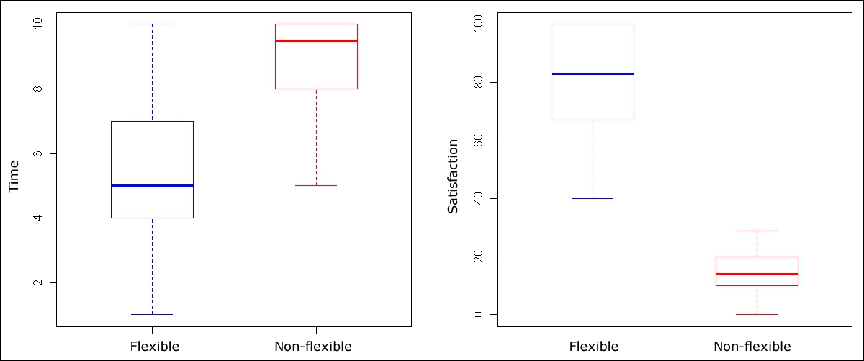
(a) (b)
Figure11. Boxplot. (a) Of the task execution times, (b) the degrees of satisfaction, in each situation.

8 Conclusion
The decrease of motor, perceptual or cognitive performance are not the only obstacles to the use of mobile technologies, faced by elderly users. The way the interface shows for this audience has not met the requirements of different interaction.
The complexity of the usage scenario, which includes people who are not familiar with the technology and even differences within specific groups (for example, even among the elderly population. There are differences regarding education, experience with ICT, and cognitive skills physical prowess) suggests the need for approaches bidding requirements for the design of flexible interfaces that traditional methods of Software Engineering and Human-Computer Interaction is not fully supported.
Therefore, it is important to improve the process of developing user interfaces, allowing interaction and flexibility in adding quality to the design of tailored solutions. Soon, introduce appropriate approaches that address the greatest number of people, to contribute to the "Universal Access and Participatory Citizen Brazilian to Knowledge" [2], the fourth Challenge in Computer Science Research in Brazil.
This work was done using an exploratory experiment of elderly users and it was adopted a framework to support the design process of flexible interfaces. The observation of the elderly endorsed the characterization of the public concerned that guided and enriched the formalization of non-functional requirements at different levels: physical, empirical, syntactic, semantic, pragmatic and social [35]. The requirements here formalized and standards may support the subsequent design of user interfaces for mobile flexible to meet the public elderly.
Facing the definition of standards for the design of flexible user interfaces elderly, it was developed the FlexInterface - a framework that supports the development of flexible interface design, adaptive middleware based on OpenCom, allowing the application fits user needs during their interaction with the device.
Given the above, below we highlight the potential benefits in adopting a generic approach to flexible interface in the field of smartphones.
Adaptability and extensibility. The use of flexible interfaces that enables the interface is modified according to the individual needs of each user. The generic approach of FlexInterface allows new user profiles to be added to an application without the need to change other components.
Transfer of skills. The use of different technologies to build applications for each device does not allow the transfer of skills through different tools. Set of skills and areas of expertise are rarely transferable to deal with different technologies. A generic approach promotes the transfer of skills, since developers use only one tool for the development of applications based on a variety of technologies.
Code reuse / modularity. A generic approach promotes code reuse, so developers can reuse components. For example, in the component FlexInterface Checker Profile for Seniors (ElderlyProfileChecker) can be reused in other interfaces to be used by the elderly.
Universal Design. This approach meets the different needs of interaction and include them in the proposed design. The framework considers a FlexInterface Universal Design approach, being designed so that access to knowledge and information is done without physical and social segregation and that make sense for the largest possible number of users according to their different abilities sensory, physical, cognitive and emotional.
Applicable Business Solutions. The modified proposal on the agenda of Android, the new user registration. These modifications allowed the native application to adapt in time interaction to better meet the needs of elderly users. Therefore, commercial applications could adopt the FlexInterface to add value to your applications, allowing users to be able to perform the tasks required.
Thus, this research brings up the argument that it is necessary to have computing solutions that embrace the diversity of human beings and therefore able to reach the largest possible number of users regardless of their physical, cognitive and emotional. It is hoped that the ideas presented here support the design of custom interfaces, recognizing and respecting the diversity that lies within each group of users.
Acknowledgements
The authors thank the colleagues LaSDPC-USP-lifes UFSCar, lynx and UFSCar CRAS, for their pertinent observations. The authors thank especially the elderly who participated in the experiments. Finally, the research funding agencies CNPq (474803/2009-0) and FAPESP (2008/05346-4).
References
- ALMEIDA, V. P.; BARANAUSKAS, M. C. C. A Framework for Designing Flexible Systems. In: IEEE International Conference on Systems Man and Cybernetics (SMC) - Human-Machine Systems Track, 2011, Anchorage. Proc. SMC 2011, p. 2600-2607, 2011.
- BARANAUSKAS, M. C. C.; DE SOUZA, C. S. Desafio nº 4: Acesso Participativo e Universal do Cidadão Brasileiro ao Conhecimento. In: Computação Brasil, ano VII, n27, 2006.
- BONACIN, R.; BARANAUSKAS, M. C. C. An Organizational Semiotics Approach Towards Tailorable Interfaces. In: The 11th International Conference on Human-Computer Interaction, 2005, Las Vegas, USA: Lawrence Erlbaum Ass., Inc. (LEA), 2005.
- CONNELL, B. R.; JONES, M.; MACE, R.; et al. The Principles of Universal Design, Version 2.0. Raleigh. The Center for Universal Design, North Carolina State University. 1997. http://www.design.ncsu.edu/cud/about_ud/udprinciples.htm. Last visit Feb, 2011.
- CONOVER, W. U. Practical Nonparametric Statistics. 3a. ed. Wiley, 1999.
- COULSON G.; BLAIR, G.; GRACE, P.; TAIANI, F.; JOOLIA, A.; LEE, K.; UEYAMA, J.; SIVAHARAN, T. A Generic Component Model for Building Systems Software. ACM Transaction on Computer Systems, 2008.
- FISCHER, G. User Modeling in Human-Computer Interaction In. User Modeling and User-Adapted Interaction (UMUAI), 2001.
- GERMONPREZ, M.; HOVORKA, D.; COLLOPY, F. A Theory of Tailorable Technology Design, Journal of the Association for Information Systems, 2007.
- GOEBEL, M. Ergonomic Design of Computerized Devices for Elderly Persons - The Challenge of Matching Antagonistic Requirements. Universal Access in HCI (HCII 2007), 2007.
- GONÇALVES, V. P.; LEITE, B. C. S.; CARVALHO; J. R.; et al. Inspeção de Usabilidade: Um Processo Informatizado para Melhor Satisfazer os Objetivos do Usuário. In: Escola Regional de Informática (ERIN 2010), 2010, Manaus. ISSN: 2178375-6-9-772178-375006. Anais do ERIN 2010, v. 1. p. 157-166, 2010.
- GONÇALVES, V. P.; NERIS, V. P. A.; MORANDINI, M.; et al. Uma Revisão Sistemática sobre Métodos de Avaliação de Usabilidade Aplicados em Software de Telefones Celulares. In: Simpósio Brasileiro de Fatores Humanos em Sistemas Computacionais e Congresso Latino-americano de Interação Humano-Computador (IHC+CLIHC 2011), 2011, Porto de Galinhas. ISBN: 978‐85‐7669‐257‐7. Anais do IHC+CLIHC 2011, v. 1. p. 197-201, 2011.
- GONÇALVES, V. P.; NERIS, V. P. A.; UEYAMA, J. Interação de Idosos com Celulares: Flexibilidade para Atender a Diversidade. In: Simpósio Brasileiro de Fatores Humanos em Sistemas Computacionais e Congresso Latino-americano de Interação Humano-Computador (IHC+CLIHC 2011), 2011, Porto de Galinhas. ISBN: 978-85-7669-257-7. Anais do IHC+CLIHC 2011, v. 1. p. 343-352, 2011.
- GONÇALVES, V. P.; NERIS, V. P. A.; UEYAMA, J.; et al. An Analytic Approach to Evaluate Flexible Mobile Phone User Interfaces for the Elderly. In 14th International Conference on Enterprise Information Systems (ICEIS 2012), 2012, Wrolaw. ISBN: 978-989-8565-12-9. In Proc. ICEIS 2012, v. 3, p. 91-96, 2012.
- GONÇALVES, V. P.; SERAPHINI, S.; NERIS, V. P. A.; et al. FlexInterface: a Framework to Provide Flexible Mobile Phone User Interfaces. In 15th International Conference on Enterprise Information Systems (ICEIS 2013), 2013, Angers. In Proc. ICEIS 2013, 2013. No prelo.
- HELLMAN, R. Universal Design and Mobile Devices. Proceedings of the 4th international conference on Universal access in human computer interaction: coping with diversity. Beijing, 2007.
- HENDERSON, A.; KYNG, M. There’s no place like home: Continuing Design in Use. In: J.Greenbaum and M. Kyng (eds) Design at work: Cooperative Design of Computer Systems. Hillsdale, NJ, Lawrence Erlbaum, 1991.
- HUGHES, D.; UEYAMA, J.; MENDIONDO, E.; et al. A middleware platform to support river monitoring using wireless sensor networks. Journal of the Brazilian Computer Society, v. 17, p. 85-102, Rio de Janeiro, RJ, Brasil, 2011.
- IBGE - Instituto Brasileiro de Geografia e Estatística (Gov.). Censo demográfico de 2010. 2010. http://www.ibge.gov.br/home/estatistica/populacao/censo2010/default.shtm. Last visit March, 2011.
- LEWIS, C.; WHARTON, C. Cognitive walkthroughs. In M. Helander, T.K. Landauer, P. Prabhu (Eds.) Handbook of human-computer interaction, 2nd ed. Elsevier Science, 1997.
- LIU, K. Semiotics in information systems engineering, Cambridge University Press, 2000.
- MACÍAS, J. A.; PATERNÒ, F. Customization of Web applications through an intelligent environment exploiting logical interface descriptions. In Interacting with Computers 20, 2008.
- MACLEAN, A.; CARTER, K.; LÖVSTRAND, L.; et al. User-tailorable systems: Pressing the issue with buttons. In: Proceedings of the Conference on Computer Human Interaction (CHI ‘90), 1–5 April, Seattle (Washington). ACM Press, New York, 1990.
- MT - Minister of Industry (Gov.). Learning a Living - First Results of the Adult Literacy and Life Skills Survey. Canada and Organisation for Economic Cooperation and Development (OECD), Paris, 2005. http://www.nald.ca/fulltext/learnliv/learnliv.pdf. Last visit Feb, 2011.
- MULLER, M. Layered participatory analysis: new developments in the CARD technique. Proceedings of the SIGCHI conference on Human factors in computing systems, March, Seattle, Washington- USA, p.90-97, 2001.
- NERIS, V. P. A.; BARANAUSKAS, M. C. C. Making interactive systems more flexible: an approach based on users’ participation and norms. In Simpósio de Fatores Humanos em Sistemas Computacionais (IHC 2010): Belo Horizonte, 2010.
- NERIS, V.P.A.; BARANAUSKAS, M.C.C. Designing tailorable software systems with the users participation, 09/2012, Journal of the Brazilian Computer Society, v. 18, p. 213-227, Rio de Janeiro, RJ, Brasil, 2012.
- NIELSEN, J. Usability Engineering. Cambridge: Academic Press, 1993.
- NIELSEN. J. Usability for Senior Citizens. Alertbox. 2002. http://www.useit.com/alertbox /seniors.html. Last visit Feb, 2011.
- NIELSEN. J. Generation App: 62% of Mobile Users 25-34 own Smartphones. 2011. http://blog.nielsen.com/nielsenwire/online_mobile/generation-app-62-of-mobile-users-25-34-own-smartphones. Last visit Feb, 2012.
- OLWAL, A.; LACHANAS, D.; ZACHAROULI, E. OldGen: Mobile Phone Personalization for Older Adults. In: CHI 2011, Vancouver. Proceedings of the CHI 2011, 2011.
- OVIATT, S.; DARRELL, T.; FLICKNER M. Multimodal Interfaces that Flex, Adapt and Persist. Communications of the ACM. January, 2004.
- PARK, J.; HAN, S.; PARK, Y.; et al. Adaptable versus adaptive menus on the desktop: Performance and user satisfaction. In International Journal of Industrial Ergonomics, 2007.
- RIVERA, D. The Effect of Content Customization on Learnability and Perceived Workload. CHI '05 extended abstracts on Human factors in computing systems. Portland, USA, 2005.
- RODRIGUES, K. R. H; GONÇALVES, V. P.; NERIS, V. P. A. Tecnologias de Informação e Comunicação Inclusivas e o Envelhecer. In: Ana Cristina Viana Campos; Efigênia Ferreira e Ferreira. (Org.). Envelhecimento. ed. Érica - Iátria (SP), 2013. No prelo.
- STAMPER, R. K.; ALTHAUS, K; BACKHOUSE, J. MEASUR: Method for Eliciting, Analizing and Specifying User Requirements. Em: Computerized assistance during the information systems life cycle, T.W. Olle, A.A. Verrijn-Stuart and L. Bhabuts (eds). North-Holland: Elsevier Science Publishers, 1988.
- STAMPER, R.; LIU, K.; SUN, L.; et al. Semiotic Methods for Enterprise Design and IT Applications, Proceedings of the 7th International Workshop on Organisational Semiotics, INSTICC Press, 2004.
- TANG, H. H.; KAO, S. A. Understanding the Real Need of the Elderly People When Using Mobile Phone, HCII 2005. Las Vegas, 2005.
- UEYAMA, J.; PINTO, V. P. V.; MADEIRA, E. R. M.; et al. Exploiting a Generic Approach for Constructing Mobile Device Applications. In: The Fourth International Conference on Communication System software and middleware, 2009, Dublin. Proceedings of The Fourth International Conference on Communication System software and middlewaRE, ACM, 2009.
- WULF, V.; PIPEK, V.; WON, M. Component-based tailorability: Enabling highly flexible software applications. In: International Journal of Human-Computer Studies, 2008.

