Visualization of Simulation Results

# Simulation Setup

There are 8 different scenarios that are simulated. They differ in:

* the sample size per treatment arm (N=80 vs. N=100),
* the decision rule (liberal vs. conservative, see next paragraph for a discussion) and
* the recruitment speed (20 vs. 30 patients per month).

All other settings are identical for all simulations. Particularly,

* all trials use concurrent controls only,
* the assumptions for TRD and PRD are the same,
* the assumptions for the three domains are the same, except for a higher probability of new oral treatments being available to be added to the platform,
* there cannot be more than 4 oral compounds and 3 nasal compounds and 3 IV compounds in the platform in parallel,
* allocation to control within each domain is held constant at 35%,
* the platform does not add any more compounds at time points later than 60 months since platform start,
* after this time point, the platform ends once all compounds have made a decision.

# Decisions

Terminology: In the following, “conservative” refers to a setting with more strict decision rules, i.e., one-sided p-values of p<0.05 compared to control to claim success of a compound and p<0.4 to allow continuation to second stage, and “liberal” refers to a setting with less strict decision rules, i.e., one-sided p-values of p<0.1 compared to control to claim success of a compound and p<0.5 to allow continuation to second stage.

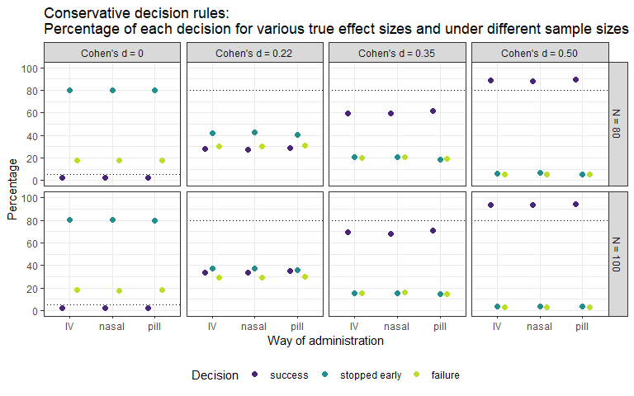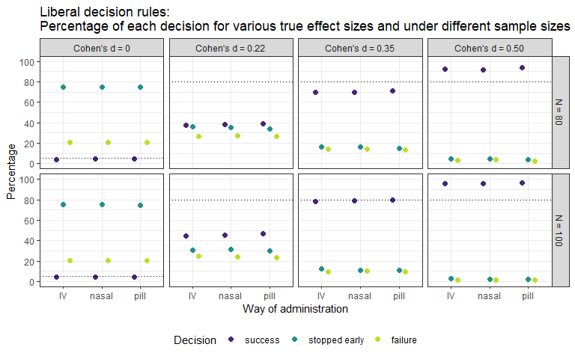

For the other statistical endpoints, the decision threshold is not overly influential. Its only impact is that slightly more trials are stopped early due to futility when the decision threshold is more conservative. Therefore, for the remaining analysis, the simulations with liberal decision criterion are considered. Results are mostly very similar to the simulation with conservative decision criterion.

# Sample sizes

## Total number of patients per domain

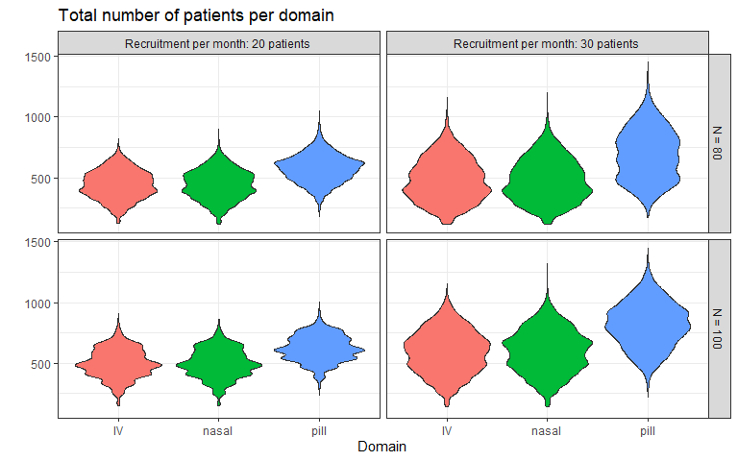

## Total number of patients per population

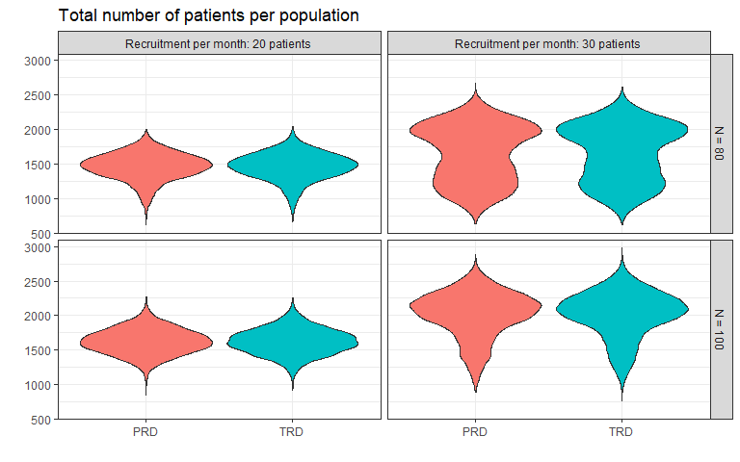

## Total number of patients in platform

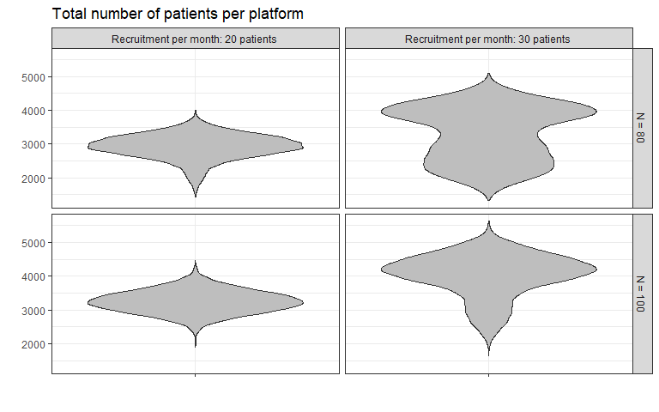

## Sample size of control arms per population

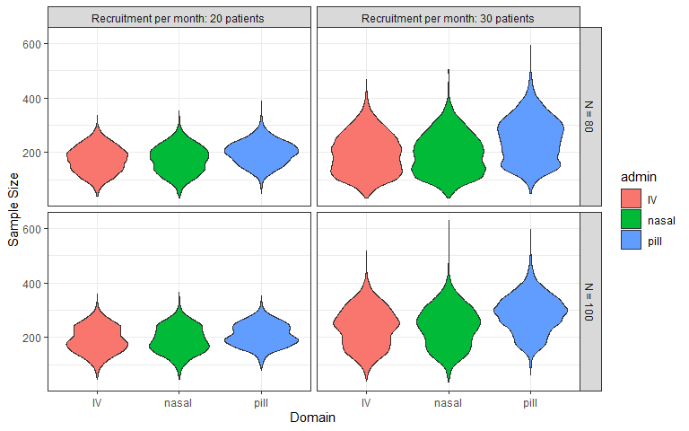

# Number of arms

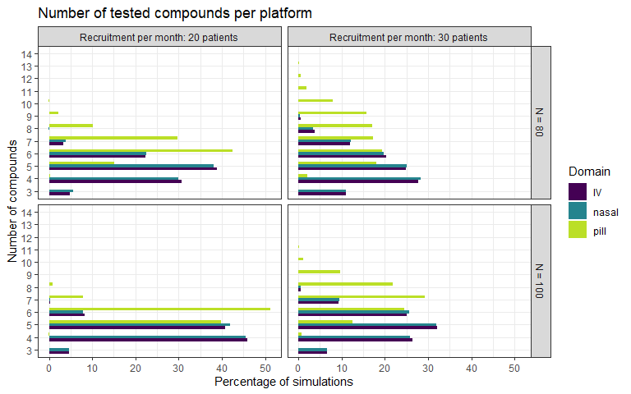

# Estimation of Cohen’s d

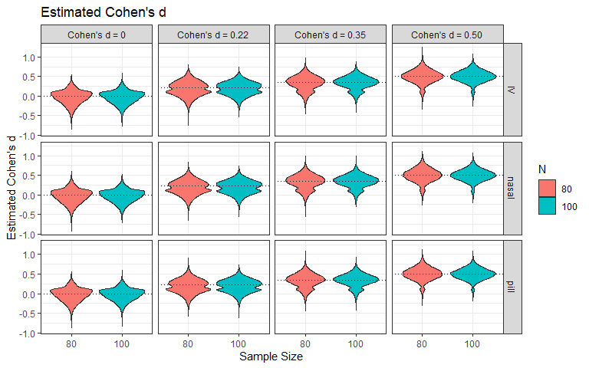 The estimation of the effect size is subject to variance, which is slightly reduced by the increase of the sample size from 80 to 100.

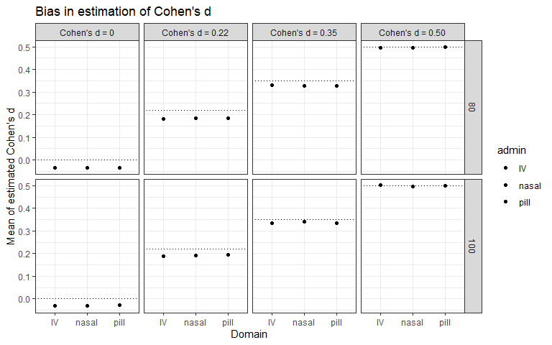

Bias is a systematic over- or underestimation of an estimator. The true value as specified in the simulations is indicated by the dotted lines. The average estimation is indicated by the dot. Naturally, when there is early stopping for futility, bias is introduced. The bias is smaller for large effect sizes, because the trials rarely stops.

# Duration

## Average duration per arm

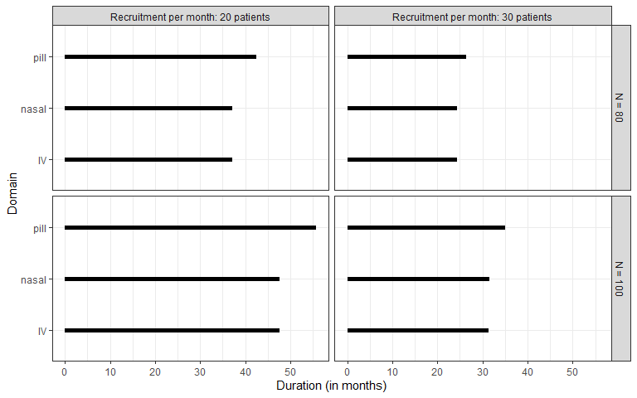

## Average duration per arm with interval

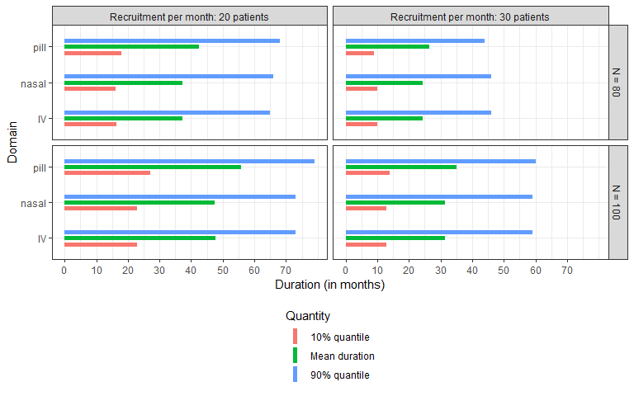

## Duration per arm for selected simulations

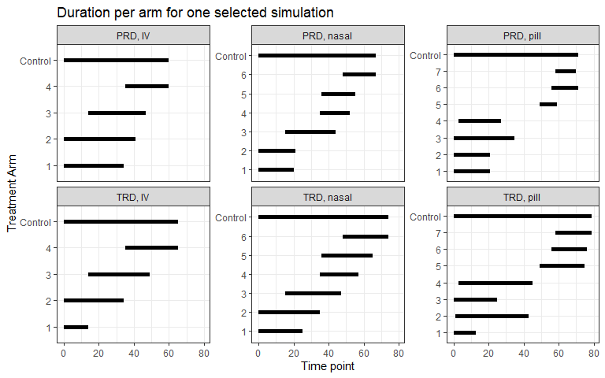

This is just one randomly chosen example. One could look at multiple such illustrations to get an impression of how the platform can potentially proceed.