Toward an Executable ESG Aspect-Based Sentiment Analysis Framework for Indonesian Sustainability Reports
Daris Dzakwan Hoesien

Introduction

Motivation
Environmental, Social, and Governance disclosure has undergone a fundamental paradigm shift, transitioning from a niche voluntary practice to a critical institutional requirement for investors, regulators, and researchers evaluating corporate sustainability performance (Leuz 2021). This evolution reflects a broader commitment to stakeholders beyond traditional shareholders, as firms face mounting pressure to demonstrate tangible "good" alongside financial outcomes (Leuz 2021). However, the current landscape of sustainability reporting remains characterized by extreme structural and content heterogeneity. Reports vary significantly in format and depth due to the absence of global regulatory standardization, often conflating concrete performance metrics with vague, forward-looking narratives (Luu 2018; Leuz 2021).
In the Indonesian context, these challenges are acutely pronounced. Indonesia is currently classified as having an early-stage reporting framework characterized by lower ESG scores compared to developed markets (Saini 2021). Listed companies often produce bilingual reports with varying degrees of transparency, yet empirical evidence indicates that the readability of these disclosures remains consistently low (du 2020). Linguistic analysis suggests that such reports are often difficult for users to decipher, frequently exhibiting a pattern of "isomorphism" where companies adopt standardized language constructs that obscure specific sustainability issues (du 2020). This lack of clarity facilitates a gap between disclosed intentions and actual corporate conduct, as communication methods remain insufficient to bridge the divide between reporting quality and environmental risk (Koestoer 2023; Kamarudin 2020).
Traditional document-level analysis—which assigns a singular score or sentiment to an entire report—is increasingly inadequate for capturing this complexity. ESG disclosures are inherently multifaceted; a single page may contain a specific environmental commitment, a social program update, and a generic governance compliance statement (Mengaldo 2025a). This internal variance allows for "greenwashing," where companies deploy "soft language" or boilerplate narratives to mask a lack of measurable sustainability outcomes (Hussainey 2021). To address these limitations, this research argues that ESG disclosures must be treated as a record-level Aspect-Based Sentiment Analysis problem. By decomposing reports into discrete statements classified by aspect, pillar, sentiment, and provenance, we can transform raw PDF corpora into aligned, inspectable, and evaluable computational artifacts.

Problem Statement
The central research problem is the absence of a reproducible and validated pipeline capable of transforming heterogeneous sustainability-report PDFs into structured, record-level evidence. Current manual review processes are unscalable, while standard automated tools often fail to capture the semantic nuance and domain-specific logic required for rigorous ESG analysis (Yu 2023). This study addresses six critical technical challenges:
- Extraction Provenance: Maintaining a verifiable link between extracted text and original document coordinates is essential to move beyond "black-box" reasoning and provide transaction-level evidence required for auditing (Nohr 2026).
- Prompt Configuration: Designing reliable Large Language Model prompts is critical to address output volatility; task-specific Chain-of-Thought prompting has been shown to significantly reduce hallucinations in long-context disclosures (Song 2026a; Artificial Intelligence 2026 AND Peizhen Bai AND Mali Jin AND Xingyi Song AND Siqi Sun AND Ben Wu AND Hanpei Zhang 2026).
- Granular Labeling: Record-level labeling is necessary to address the "cherry-picking" and "cheap talk" prevalent in voluntary disclosures, as document-level scoring often masks internal variance (Webersinke 2022; Hussainey 2021).
- Construct Validity: Identifying the divergence between general sentiment and domain-specific climate labels (e.g., ClimateBERT) is necessary to determine if disclosures reflect substantive risk or merely semantic masking (Webersinke 2022, 2024).
- Quality Auditing: Automated pipelines are susceptible to OCR failure, schema drift, and missing data, particularly in complex, semi-structured tables (Song 2026a; Schierholz 2025).
- Evidence Visualization: Converting extraction outputs into interactive dashboards and semantic graphs is required to facilitate stakeholder engagement and align with emerging regulatory requirements like IFRS S1 and S2 (Zaki 2026).

Research Questions
The study systematically addresses the gap between raw disclosure and actionable intelligence through the following research framework:
- RQ1. ESG ABSA Schema: How can ESG disclosures be effectively represented using a record-level schema that integrates aspect, ESG pillar, sentiment, and tone within the Indonesian reporting context?
- RQ2. Tone vs. Climate-Specific Models: How do LLM-generated tone labels compare with specialized outputs from models like ClimateBERT, and what does this reveal about the validity and reliability of automated ESG assessments?
- RQ3. Pipeline Diagnostics: What specific failure modes, such as OCR-related data loss or ontology gaps, characterize the automated extraction of ESG records from heterogeneous PDF sources?
- RQ4. Stability and Reproducibility: To what extent do ESG extraction outputs remain stable and consistent across varying prompts, LLM models, and service providers?

Objectives and Contributions
The study systematically addresses the gap between raw disclosure and actionable intelligence through the following research framework:

Research Objectives
- O1: To Build a Reproducible OCR-to-ESG Extraction Pipeline: Develop a modular system that converts raw PDF reports into usable text while preserving page-level provenance for rigorous auditability.
- O2: To Design a Record-Level ESG ABSA Schema: Establish a technical framework for classifying extracted statements based on granular ESG pillars and sentiment dimensions tailored to bilingual Indonesian disclosures.
- O3: To Evaluate Model Divergence: Conduct a comparative analysis between general LLM tone labels and specialized ClimateBERT labels to assess construct validity and the necessity of domain-specific modeling.
- O4: To Create a Diagnostic Framework: Implement automated audits for parsing failures, schema drift, and missing labels to ensure the integrity of the extraction pipeline.
- O5: To Develop a Semantic Evidence Layer: Map extracted aspects to a formal ESG ontology and provide interactive dashboards for real-time data exploration and evidence verification (Zaki 2026).

Expected Contributions
- Technical Framework: An executable, modular pipeline for automated ESG record extraction, addressing the current scholarly gap in engaging with quantified sustainability metrics (Zaki 2026).
- Annotation Schema: A bilingual, record-level ESG schema specifically refined for the Indonesian regulatory and linguistic context (du 2020).
- Evidence Layer: A linked data structure connecting raw report artifacts to LLM metadata, human-in-the-loop annotations, and validation tables.
- Methodological Insights: A comprehensive stability analysis of LLM prompts and a critical assessment of why general sentiment and climate-specific commitment labels are non-interchangeable in high-stakes sustainability research.

Thesis Structure
- Chapter 1: Introduction—Outlines the motivation, problem statement, and technical objectives of the study within the context of global and Indonesian ESG reporting.
- Chapter 2: Literature Review—Examines the evolution of NLP in sustainability, the challenge of greenwashing, and the state-of-the-art in LLM-based extraction and ESG measurement discrepancies (Yu 2023).
- Chapter 3: Methodology—Details the OCR-to-ABSA pipeline architecture, including prompt engineering strategies and the validation framework utilizing ClimateBERT and human annotation.
- Chapter 4: Implementation and Evaluation—Presents technical implementation details, performance metrics, and ablation studies regarding model stability across different LLM providers.
- Chapter 5: Results and Discussion—Evaluates the proposed ESG ABSA schema, analyzes specific failure modes, and discusses the implications of model divergence for future ESG research and policy.
- Chapter 6: Conclusion—Summarizes the findings, acknowledges limitations, and suggests future directions for automated, granular sustainability analysis.

Author’s contributions and the role of Artificial Intelligence
The author independently formulated the research questions, designed and implemented the framework, and evaluation in the form of live dashboard. The implementation, including dataset preprocessing, software development, and evaluation, was executed by the author under the guidance of the thesis supervisor.
The writing, including the articulation of arguments and interpretation of findings, reflects the author’s original contributions. Artificial intelligence (AI) tools were employed to enhance the presentation and documentation of this thesis while preserving the integrity of original research contributions. Specifically, Codex (developed by OpenAI) assisted in refining the clarity and readability of written content across multiple drafts, as well as provided support for debugging code snippets, resolving LaTeX formatting issues, and structuring tabular data. All AI-generated suggestions underwent rigorous evaluation and extensive revision by the author to ensure alignment with academic standards and research objectives. The fundamental research contributions, including the conceptual framework development, experimental design, data analysis, and scholarly conclusions, represent entirely original work by the author, with AI tools serving exclusively as auxiliary resources for writing enhancement and documentation support.

Related Works

ESG and Sustainability Reporting Context
The Indonesian sustainability reporting landscape is characterized by a multi-phase transition from voluntary practices to institutionalized mandates. Firmansyah & Wibowo (Wibowo 2025) delineate this evolution across three distinct phases: the initiation phase marked by the issuance of POJK 51/2017, a transition period encompassing the Roadmap Keuangan Berkelanjutan Tahap II (2021–2025), and a current phase of harmonization with global standards, specifically the adoption of IFRS S1 and S2 through the Pernyataan Standar Pengungkapan Keberlanjutan 1 and 2 (Wibowo 2025). This shift reflects a broader paradigmatic move from philanthropic-oriented CSR to strategic ESG integration, a trend confirmed by bibliometric analyses of Indonesian CSR scholarship (B. D. B. A. R. F. A. M. B. Firmansyah 2026). Early research by Harymawan et al. (Kamarudin 2020) established the foundational understanding of this landscape (2013–2017), revealing generally low disclosure levels and an absence of universal guidance prior to the formal rollout of OJK regulations. While POJK 51/2017 provided the initial regulatory push for standardized disclosure (Purnomo 2022; Respati 2023), scholars have critiqued the mandate for lacking specific qualitative benchmarks for accuracy, balance, and reliability, which has perpetuated a "transparency gap" in local reporting (Simamora 2024).
Empirical assessments of sustainability reporting quality in Indonesia highlight persistent challenges in both readability and substance. Adhariani & Toit (du 2020) identified a "low level of readability" across reports, observing a pattern of isomorphism where firms adopt homogenous linguistic structures that obscure critical information. Further, sector-specific studies suggest that companies prioritize certification disclosures—such as ISO or PROPER—over substantive operational impacts like pollution (Sriningsih 2026). For instance, among manufacturing and mining firms, the average environmental disclosure score stands at 54.94%, reflecting a cautious approach to transparency (Sriningsih 2026). Compliance heterogeneity remains another significant issue; Situngdong Kombong & Kurniawati (Kurniawati 2025) found that while high-impact sectors like agriculture and aquaculture show awareness, approximately 40% of companies remain in the "medium" implementation category for POJK 51 standards (Kurniawati 2025).
The technical complexity of this landscape is further complicated by the bilingual nature of disclosures, with nearly 100% of public companies preparing reports in both Indonesian and English to meet regulatory provisions (Muhammad 2023). This necessitates cross-lingual Natural Language Processing approaches to manage information extraction. Moreover, as professional practices shift toward IFRS-aligned standards, practitioners face a distinct "competency gap" and infrastructure limitations (A. Firmansyah 2025). Recent computational approaches, such as the application of DistilBERT to classify ESG segments and detect greenwashing, have begun to address these bottlenecks by identifying that while 39.1% of FMCG company reports show fair disclosure, 18.5% exhibit strong greenwashing tendencies (Alamsyah 2025). The field has increasingly pivoted toward systematic literature reviews to map these trends in diversity, firm value, and sustainability reporting (Hidayati 2023), alongside longitudinal observations that indicate a trend toward annual reporting at the expense of integrated report formats (Nehodenko 2025).
|p2.5cm|p2cm|p3cm|p1.8cm|X|X| Authors & Method/ Approach & Datasets & Modalities involved & Key contributions & Limitations
Putri et al. (Alamsyah 2025) & Transformer-based NLP & 23 FMCG companies (2021–2024) & Text & Identified 18.5% strong greenwashing; calculated Perceived-Real Gap Score (Alamsyah 2025). & Confounding factors included varying report lengths and boilerplate language (Alamsyah 2025).
Wiputra (Wiputra 2026) & Automated scoring & 99 IDX-listed firms (2023 reports) & Text & Established similarity indices between AI-generated and human-expert scores for 33 GRI indicators (Wiputra 2026). & Assumes human expert is absolute ground truth; scope limited to 33 indicators (Wiputra 2026).
Sri Wahyuningrum et al. (Sriningsih 2026) & Panel regression analysis & 286 firm-year observations (2019–2022) & Text & Average environmental disclosure score of 54.94%; favor certification over operational impacts (Sriningsih 2026). & Focus restricted to mining and manufacturing sectors (Sriningsih 2026).
Adhariani & Toit (du 2020) & Linguistic techniques & Top IDX public companies & Text & Quantified low readability and "isomorphism" in reporting language (du 2020). & Relies on historical linguistic metrics rather than modern neural models (du 2020).
Firmansyah (A. Firmansyah 2025) & Qualitative policy analysis & Regulatory and academic literature & Text & Mapped "competency gap" and institutional infrastructure needs for IFRS-aligned reporting (A. Firmansyah 2025). & Qualitative findings require empirical validation via automated audit systems (A. Firmansyah 2025).
Kurniawati & Michelle (Michelle 2025) & Content analysis & 2022 sustainability reports (110 IDX firms) & Text & Found reports are business-oriented with minimal environmental/social disclosure (Michelle 2025). & Limited to 2022 data; does not detail specific environmental activities (Michelle 2025).
Nugrahani et al. (Muhammad 2023) & Panel data content analysis & 305 Indonesian public companies (2017–2020) & Text & 64% compliance with POJK 51; governance and firm size influence reporting quality (Muhammad 2023). & Could not prove government pressure improves quality; limited sample period (Muhammad 2023).
Harymawan et al. (Kamarudin 2020) & Longitudinal content analysis & 224 firm-year observations (2013–2017) & Text & Positive correlation between quantity and quality of sustainability disclosure (Kamarudin 2020). & Relatively small sample; limited content analysis in KLD measurement (Kamarudin 2020).
Situngdong Kombong & Kurniawati (Kurniawati 2025) & Content analysis & 2022 reports of 48 agriculture/ aquaculture firms & Text & 40% of companies in medium compliance category for POJK 51 (Kurniawati 2025). & Restricted to specific high-impact sectors; small sample size (Kurniawati 2025).
Bezverkhyi et al. (Nehodenko 2025) & Qualitative analysis & Corporate reports of major Asian countries (2019–2023) & Text & Identified shift toward annual reporting and away from integrated formats in Indonesia (Nehodenko 2025). & Excludes certain SE Asian countries; relies on secondary sources (Nehodenko 2025).

Automated ESG Information Extraction and Classification
The research landscape for automated Environmental, Social, and Governance information extraction has evolved from rudimentary keyword-matching and dictionary-based approaches to sophisticated agentic Large Language Model pipelines. Anaraki et al. (Basili 2025) provide a foundational taxonomy of these developments, noting that the unstructured and heterogeneous nature of corporate sustainability reports poses significant challenges for automated classification. The shift toward LLM-driven frameworks has enabled more granular, schema-aware analysis, effectively moving beyond surface-level sentiment to extract structured data compatible with regulatory reporting standards such as GRI and SASB (Basili 2025).
Central to this progress is the use of the Retrieval-Augmented Generation paradigm to ground extraction processes. Bronzini et al. (Staiano 2024, 2024) demonstrated that LLMs, when integrated with RAG and In-Context Learning, can derive structured JSON, tabular data, and ESG-oriented triples from unstructured narratives with high precision. Building upon this, Zou et al. (Zhou 2023) developed the ESGReveal system, an agentic approach that utilizes an LLM agent to achieve 76.9% accuracy in data extraction across 166 companies. This agentic paradigm facilitates complex information retrieval and disclosure analysis (achieving 83.7% accuracy) that surpasses the capabilities of traditional Open Information Extraction methods (Zhou 2023; Staiano 2024).
Recent advancements have focused on structural robustness and domain compliance to bridge the gap between extraction and standard-aligned reporting. EulerESG, developed by Ding et al. (Wenjie 2025), addresses the limitations of brittle, rule-based extraction by utilizing a dual-channel retrieval system to populate standard-aligned metric tables with up to 0.95 average accuracy. To manage the "black-box" risks of LLMs in risk-averse financial domains, Weichel et al. (Schäfer 2025) proposed a two-step hybrid methodology combining rule-based table extraction with regularized LLMs. This approach optimizes for robustness in parsing complex financial and emissions tables while minimizing false values (Schäfer 2025).
Furthermore, the integration of framework-aware verification modules is essential for ensuring that extracted data is auditable. Gupta et al. (Verma 2025b) introduced LLM-based modules designed to assess the compliance of sustainability disclosures against established frameworks, identifying significant gaps in sector-specific reporting quality. In the context of emerging markets, Fan et al. (Zheng 2025) presented the FinATG framework, which utilizes domain-adaptive span representations and constrained decoding to achieve an entity F1 score of 88.5 for extracting carbon and green investment data. Finally, to counteract greenwashing risks, Ong et al. (K. O. A. R. M. A. D. V. A. E. C. A. G. Mengaldo 2025b, 2025b) introduced Aspect-Action Analysis with Cross-Category Generalization (A3CG). This semantic logic explicitly links broad environmental claims ("Aspects") to verifiable corporate investments ("Actions"), ensuring that the generated data reflects objective performance rather than strategic ambiguity (K. O. A. R. M. A. D. V. A. E. C. A. G. Mengaldo 2025b, 2025b).
The table below summarizes the technical specifications, contributions, and identified limitations of the core state-of-the-art methods in the domain of automated ESG extraction and classification.
|p1.8cm|X|X|p1.8cm|X|X| Authors & Method/Approach & Datasets & Modalities Involved & Key Contributions & Limitations
Bronzini et al. (Staiano 2024) & LLM + RAG + Graph analysis & Corporate sustainability reports & Text & Derivation of structured insights (JSON/tabular) and graph-based ESG representations. & OIE methods traditionally fail to capture domain-specific activities without pre-defined templates (Staiano 2024).
Zou et al. (Zhou 2023) & LLM Agent + RAG & 166 HKEX-listed firms & Text & Achieved 76.9% accuracy in data extraction and 83.7% in disclosure analysis. & Inability to process pictorial information; relies on textual input (Zhou 2023).
Ding et al. (Wenjie 2025) & Dual-channel retrieval + LLM analysis & 4 global companies; 12 SASB sub-industries & Text & High-fidelity population of standard-aligned metric tables (0.95 avg accuracy). & Requires explicit awareness of ESG frameworks to function correctly (Wenjie 2025).
Gupta et al. (Verma 2025b) & LLM-based modules for extraction & verification & Organizational sustainability reports & Text & Assessment of compliance with reporting frameworks; identifies disclosure gaps. & Disclosure quality shows significant inconsistency across industrial sectors (Verma 2025b).
Ong et al. (K. O. A. R. M. A. D. V. A. E. C. A. G. Mengaldo 2025b) & Aspect-Action Analysis (A3CG) & Corporate sustainability disclosures & Text & Links semantic Aspects to verifiable Actions to mitigate greenwashing risks. & Limited empirical deployment benchmarks; may be prone to selective favorability (K. O. A. R. M. A. D. V. A. E. C. A. G. Mengaldo 2025b).
Anaraki et al. (Basili 2025) & Systematic literature review / Taxonomy & Sustainability reporting corpus & Text & Established an evidence-based taxonomy of LLM applications in ESG. & Highlights unresolved challenges in standardizing ESG metrics (Basili 2025).
Weichel et al. (Schäfer 2025) & Hybrid rule-based + regularized LLM & Annual and sustainability reports & Text & Robustness optimization for parsing complex tables; minimizes false values. & LLMs’ "black-box" nature is suboptimal; sensitive to visually dense page layouts (Schäfer 2025).
Fan et al. (Zheng 2025) & Domain-adaptive autoregressive & Sustainability-focused financial corpora & Text & Entity F1 88.5; REL F1 80.2; specialized extraction of environmental metrics. & Architecture primarily tailored to English corpora in emerging market contexts (Zheng 2025).

ESG Sentiment and Aspect-Based Analysis
The field of Aspect-Based Sentiment Analysis for Environmental, Social, and Governance domains has evolved from traditional sentence-level classification to sophisticated hierarchical, neurosymbolic, and cross-lingual architectures. Early limitations in sentiment analysis arose because standard models often failed to address the nuance of multiple targets within a single sentence (Mukkolakal 2022). To resolve this, researchers introduced the Sustainability Term-Based Sentiment Analysis method, which leverages attention-based neural networks to focus on specific sustainability terms, achieving an accuracy of 91.30% and a 90% F1-score on a dataset of over 125,000 annotated data points (Mukkolakal 2022).

Hierarchical and Neurosymbolic Architectures
Current methodologies prioritize the hierarchical structure of ESG data to improve prediction granularity. Lengkeek et al. (Knaap AND Flavius Frăsincar 2023) developed a two-step structure that utilizes parent-aspect predictions to refine child-aspect polarity, resulting in a 7.6% increase in F1-scores on financial datasets (Knaap AND Flavius Frăsincar 2023). Moving beyond purely neural approaches, neurosymbolic AI has emerged as a robust solution for mining key aspects of socially responsible investing by combining neural pattern recognition with symbolic reasoning (Heever AND Ranjan Satapathy AND Erik Cambria AND Rick Siow Mong Goh 2024). For instance, Ong et al. (K. O. A. R. M. A. F. X. A. R. S. A. J. S. A. E. C. A. G. Mengaldo 2025) introduced ESGSenticNet, a neurosymbolic knowledge base constructed from 1,679 sustainability reports that integrates symbolic parsing rules with LLM-based labeling to enforce alignment with hierarchical ESG taxonomies (K. O. A. R. M. A. F. X. A. R. S. A. J. S. A. E. C. A. G. Mengaldo 2025).
To bridge the gap between regulatory standards and computational extraction, several studies utilize formal ontologies to guide models. Usmanova & Usbeck (Usbeck 2024) demonstrated that LLMs guided by domain-specific ontologies can effectively model ESRS topical standards and minimize hallucinations during report analysis (Usbeck 2024). Similarly, Iwata et al. (Hisano 2025) employed a semi-automatic ontology construction method to map news-reported ESG controversies to normative frameworks like the SDGs, ensuring high-quality, interpretable knowledge graphs (Hisano 2025). This alignment with compliance standards is further reflected in Naskar et al. (Dey 2024), who utilized a multi-tasking sequence labeling architecture based on Global Reporting Initiative standards to detect organizational violations (Dey 2024).

Regional and Cross-Lingual Trends
In regional contexts, research has focused on adapting these models to localized data. In Indonesia, Prathama et al. (Septiandri 2025) integrated BERT-based aspect classification with generative LLMs and Bi-LSTM to predict stock prices, achieving a 31.11% reduction in RMSE (Septiandri 2025). Meanwhile, Octovianto et al. (Budi 2025) established a benchmark for Indonesian environmental sentiment analysis on social media, identifying the IndoBERT-large-p2 model as achieving a 72.44% F1-score (Budi 2025).
For global applications, cross-lingual collaboration has become critical to overcoming the scarcity of high-resource language data. Zhang et al. (Zhang 2025) proposed a framework that integrates semantic contrastive learning with language-adaptive modulation, achieving 75.8% accuracy in trilingual financial sentiment recognition (Zhang 2025). Expanding on this, He et al. (Computational Linguistics 2025 AND Chenyuan He AND Yuxiang Jia AND Hongde Liu AND Senbin Zhu 2025) introduced a Cross-Lingual Collaboration method that aligns semantic and syntactic structures across languages to enhance zero-shot entity-level sentiment analysis (Computational Linguistics 2025 AND Chenyuan He AND Yuxiang Jia AND Hongde Liu AND Senbin Zhu 2025). Finally, Ibn Ahad et al. (Association for Computational Linguistics 2025 AND Ahad 2025) addressed multilingual decision-making by implementing a bidirectional reasoning supervision approach, which incorporates both positive and negative rationales to improve classification performance across low, medium, and high-resource languages (Association for Computational Linguistics 2025 AND Ahad 2025).

State-of-the-Art: ESG Sentiment and ABSA
|p1.8cm|p3cm|p3cm|p1.8cm|X|X| Authors & Method / Approach & Datasets & Modalities Involved & Key Contributions & Limitations
Sandwidi & Mukkolakal (Mukkolakal 2022) & STBSA & 125,000+ annotated data points & Text & 91.30% accuracy; focused attention on sustainability terms. & Highly dependent on domain-specific annotated datasets.
Lengkeek et al. (Knaap AND Flavius Frăsincar 2023) & Two-step hierarchical structure & Financial Question & Answering & Text & Increased F1-score by 7.6% via parent-child aspect prediction. & Two-step model adds structural and computational complexity.
Naskar et al. (Dey 2024) & Multi-tasking sequence labeling & Annotated articles (2015–2022) & Text & Detects GRI-based sustainability violations and incidents. & Performance tied to the rigor and coverage of GRI standard definitions.
Ong et al. (K. O. A. R. M. A. F. X. A. R. S. A. J. S. A. E. C. A. G. Mengaldo 2025) & Neurosymbolic Knowledge Base & 1,679 SGX sustainability reports & Text & Hierarchical ESG taxonomy alignment via symbolic reasoning + GPT-4o. & Reliant on LLM capabilities and manual development of parsing rules.
van der Heever et al. (Heever AND Ranjan Satapathy AND Erik Cambria AND Rick Siow Mong Goh 2024) & Hybrid SenticNet + Deep Learning & Diverse (reports/social/news) & Text & Enhanced interpretability and real-time monitoring of ESG trends. & Requires careful synchronization between symbolic and neural layers.
Usmanova & Usbeck (Usbeck 2024) & LLM-Ontology integration & Corporate sustainability reports & Text & ESRS-aligned knowledge graphs; reduced model hallucination. & Dependent on the coverage and update frequency of the target ontology.
Iwata et al. (Hisano 2025) & Semi-automatic ontology/RDF & News content/Normative frameworks & Text & Links reported incidents to specific SDGs/UN Global Compact. & Abstract frameworks may complicate standardized taxonomy mapping.
Prathama et al. (Septiandri 2025) & ESG-IDX (BERT + LLM + Bi-LSTM) & Indonesian news / IDX data & Text, Time-series & 31.11% reduction in RMSE for stock price prediction. & Findings and models are specific to the Indonesian market context.
Octovianto et al. (Budi 2025) & IndoBERT-large-p2 & Instagram & Text & First open dataset for Indonesian environmental sentiment; 72.44% F1-score. & Limited by informal linguistic structure of social media discourse.
Zhang et al. (Zhang 2025) & Contrastive Semantics + XLM-R & Trilingual (Eng/Chi/Fra) & Text & 75.8% accuracy; robust cross-lingual semantic alignment. & High computational cost for language-adaptive modulation.
He et al. (Computational Linguistics 2025 AND Chenyuan He AND Yuxiang Jia AND Hongde Liu AND Senbin Zhu 2025) & Cross-lingual collaboration & 7 languages & Text & Improved zero-shot entity-level sentiment via semantic alignment. & Effectiveness varies by linguistic distance; redundancy removal complexity.

Greenwashing Detection and ESG Verification
The research landscape for mitigating greenwashing and verifying Environmental, Social, and Governance disclosures has rapidly evolved from simple text classification to sophisticated, agentic architectures. Current literature focuses on three primary pillars: the development of domain-specific benchmarks, the application of hallucination mitigation strategies, and the design of robust, evidence-based verification frameworks.

Benchmark Development and Data-Driven Evaluation
To address the scarcity of high-quality data for training and evaluating models in sustainability domains, several researchers have introduced specialized benchmarks. Zhao et al. (Yilei Zhao AND Wentao Zhang AND Lei Xiao AND Yandan Zheng AND Mengpu Liu AND Lim 2026) developed a three-level hierarchical benchmark derived from 310 corporate sustainability reports, designed to test capabilities ranging from simple factual extraction to complex, multi-step auditing. Similarly, Bai et al. (Artificial Intelligence 2026 AND Peizhen Bai AND Mali Jin AND Xingyi Song AND Siqi Sun AND Ben Wu AND Hanpei Zhang 2026) introduced ESG-Bench, which utilizes human-annotated question-answer pairs grounded in real-world contexts to evaluate Large Language Model reasoning and factuality in compliance-critical environments. On a more granular level, Birti et al. (Osborne 2025) addressed the need for specific activity detection by constructing the ESG-Activities dataset, which comprises 1,325 labeled text segments mapped to the EU ESG taxonomy. These benchmarks demonstrate that fine-tuning on domain-specific data significantly improves classification accuracy compared to general-purpose prompting (Osborne 2025).

Hallucination Mitigation and Uncertainty Estimation
Addressing the propensity of LLMs to hallucinate in compliance-critical environments is a focal point of recent research. Wu et al. (Y. W. A. P. H. A. D. Wang 2025) demonstrated the efficacy of a Chain-of-Verification method, which successfully reduced hallucination rates from 16% down to 10% in sustainability report scoring. Broader techniques for addressing these reliability gaps include logit-based uncertainty detection and Pareto optimal self-supervision, which allow systems to estimate the risk of erroneous outputs (Shi 2025). In high-stakes financial advising, Jasem (Jasem 2026) proposes a framework utilizing semantic entropy-based uncertainty gating to trigger validation efforts dynamically and prevent unsupported claims. Similarly, Sood (Sood 2026) advocates for human–AI co-governance models within enterprise metaverse environments, where explainability, stress-testing, and escalation protocols serve to detect and constrain hallucinations in real-time.
|p1.8cm|X|X|p1.8cm|X|X| Authors & Method/Approach & Datasets & Modalities involved & Key Contributions & Limitations
Zhao et al. (Yilei Zhao AND Wentao Zhang AND Lei Xiao AND Yandan Zheng AND Mengpu Liu AND Lim 2026) & Multi-agent system & 310 corporate sustainability reports & Text, Charts & 84.15% accuracy on complex tasks; expert-level toolset. & High complexity of multi-step auditing workflows.
Wu et al. (Y. W. A. P. H. A. D. Wang 2025) & Chain-of-Verification & Sustainability reports (e.g., football) & Text & Reduced hallucination rate (16% → 10%); accuracy to 58%. & Models cannot fully replace humans; overconfidence issues.
Aguirre Calderón (Calderón 2025) & RAG with post-gen verification layer & Sustainability and research reports & Text & 80% reduction in analyst labor; citation traceability. & Dependence on initial parsing and chunking quality.
Moghe et al. (Talekar 2025) & AuditGPT & Audit reports, sales, regulatory texts & Text & Evidence-backed, structured verdicts (Compliant/Non-Compliant). & Reliance on effective semantic retrieval for accuracy.
Birti et al. (Osborne 2025) & Fine-tuning LLMs & ESG-Activities (1,325 segments) & Text & Enhanced accuracy for EU ESG taxonomy classification. & General LLM limits in domain-specific contexts.
Kaoukis et al. (Kaoukis 2025) & KG-Augmented RAG & Corporate ESG reports & Text & Verified, justification-centric verdicts; responsible abstention. & Reliance on highly structured domain knowledge bases.
Sood (Sood 2026) & Adaptive human–AI co-governance & Institutional advisory contexts & Text & Real-time explainability and stress-testing protocols. & Requires cultural transformation and advisor upskilling.
Nohr (Nohr 2026) & Deterministic rule-layer & Tokenized real-world assets & Text / Ledger Data & Cryptographically verifiable evidence; lifecycle provenance. & Lack of flexibility compared to probabilistic LLM models.
Bai et al. (Artificial Intelligence 2026 AND Peizhen Bai AND Mali Jin AND Xingyi Song AND Siqi Sun AND Ben Wu AND Hanpei Zhang 2026) & CoT prompting & ESG-Bench (human-annotated QA) & Text & Baseline for mitigating hallucinations in long-context reports. & Complexity of reasoning over compliance-critical data.
Jasem (Jasem 2026) & Multi-layer self-verification & uncertainty gating & Communications applications & Text & Dynamic control of verification effort and error detection. & RAG fails to completely prevent all citation hallucinations.
Zhang et al. (Shi 2025) & Survey of detection techniques & Survey literature & Text & Categorization of logit-based and Pareto self-supervision methods. & Difficulty identifying imperceptible or hidden false info.

LLM with Zero-shot, Few-shot and Chain-of-thought in Aspect-based Sentiment Analysis
The landscape of Aspect-based Sentiment Analysis has undergone a significant paradigm shift, moving from supervised fine-tuning of Pre-trained Language Models to generative paradigms leveraging Large Language Models (Xue 2025; Z. M. A. M. P. A. Y. H. A. L. Y. A. W. Wang 2024). While early methods relied on sequence tagging and auxiliary subtasks to identify aspect terms and sentiment polarity, contemporary research focuses on the adaptability and in-context learning capabilities of LLMs to overcome data scarcity and cross-domain generalization challenges (N. C. H. A. J. F. A. C. Wolff 2024; J. F. A. U. K. A. N. C. H. A. C. Wolff 2026).

In-Context Learning and Domain-Specific Adaptation
Zero-shot and few-shot in-context learning have emerged as efficient alternatives to the resource-intensive process of fine-tuning. Guo et al. (Y. G. A. Z. X. A. Y. Yang 2023) established a foundational evaluation framework for financial NLP, demonstrating that decoder-only models can perform aspect-based financial sentiment analysis using manual zero-shot and few-shot prompts. In subsequent evaluations, Guo et al. (Y. G. A. Z. X. A. Y. Yang 2023) utilized nine financial datasets to show that example selection—whether random or based on similarity—significantly impacts ChatGPT’s performance.
To maximize the utility of these models, researchers have focused on self-adaptive instruction optimization and data augmentation. Jin et al. (W. J. A. J. W. A. Y. G. A. B. S. A. N. W. A. B. Z. A. G. Yang 2025) proposed the BYD-OBS-ABSA framework, which employs a random search bootstrap algorithm to iteratively refine instructions and mitigate LLM hallucinations. In low-resource settings, Hellwig et al. (N. C. H. A. J. F. A. C. Wolff 2024) investigated the use of few-shot prompting to generate synthetic training samples, significantly enhancing F1 scores for Aspect Category Detection.
The application of LLMs in specialized regional domains further highlights these capabilities. Prathama et al. (Septiandri 2025) utilized a hybrid approach where BERT handles aspect classification and generative LLMs manage sentiment for Indonesian news, resulting in a 31.11% decrease in RMSE for stock price prediction. Similarly, Hirunsri and Nadee (Nadee 2024) applied Transformers to Thai ESG annual reports, finding that domain-specific models achieve higher accuracy than general-purpose ones. Multilingual challenges are also addressed through bidirectional reasoning supervision by Ibn Ahad et al. (Association for Computational Linguistics 2025 AND Ahad 2025), which integrates positive and negative rationales across English, Hindi, Bengali, and Telugu, while He et al. (Computational Linguistics 2025 AND Chenyuan He AND Yuxiang Jia AND Hongde Liu AND Senbin Zhu 2025) introduced Cross-Lingual Collaboration to align semantic structures for zero-shot entity-level sentiment analysis.

Chain-of-Thought and Reasoning Frameworks
The limitation of standard prompt-based learning in handling complex, multi-opinion sentences has led to the development of reasoning-centric frameworks. Ventirozos et al. (Shardlow 2025) introduced a technique using Unified Meaning Representation to structure reasoning, while Wu et al. (Xue 2025) highlighted that self-improvement and self-debate mechanisms significantly enhance transparency and accuracy in multi-step tasks. Wu et al. (Xue 2025) also found that while LLMs show promise in multilingual ABSA, they often require sophisticated reasoning paths to match task-specific models.
To address the nuances of implicit sentiment analysis, where sentiment indicators are not explicit, researchers have introduced progressive and syntactic strategies. Liu et al. (C. L. A. G. C. A. Y. L. A. M. Wang 2026) proposed the Progressive Chain-of-thought framework, incorporating Tree-of-Thought and chain self-consistency to infer intensity and opinion reasons, achieving 86.12% accuracy on the restaurant dataset (C. L. A. G. C. A. Y. L. A. M. Wang 2026). Similarly, Radi et al. (Kaur 2025) introduced the Iterative Syntactic-Guided Chain of Thought framework, which leverages dependency parsing to navigate multi-opinion contexts, achieving F1 scores of 80.43 and 84.47 on the Sem-Eval 2015 and 2016 datasets (Kaur 2025). Advancing these multi-dimensional paths, He et al. (Li 2025) developed the Multi-Chain Thought Prompt Learning framework, simulating human multi-path reasoning to deeply explore sentiment cues across diverse perspectives (Li 2025; Shardlow 2025).
|p1.8cm|p3cm|p3cm|p1.8cm|X|X| Authors & Method/Approach & Datasets & Modalities involved & Key Contributions & Limitations
Liu et al. (C. L. A. G. C. A. Y. L. A. M. Wang 2026) & P-CoR & Restaurant, Laptop & Text & 86.12% Acc/79.22% F1 on Rest; superior ISA performance. & Requires deep contextual understanding; high complexity.
Radi et al. (Kaur 2025) & IS-COT & Sem-Eval 2015/2016 & Text & 80.43 and 84.47 F1 scores; handles implicit targets. & Specific to multi-opinion sentences; requires syntactic parsing.
Guo et al. (Y. G. A. Z. X. A. Y. Yang 2023) & Zero-shot/Few-shot In-context & 9 Financial datasets & Text & Benchmark for financial LLM evaluation; strategies for example selection. & Dependence on prompt construction; potential for hallucinations.
Wu et al. (Xue 2025) & CoT (Self-Improve/Debate) & 9 datasets & Text & Enhanced transparency; empirical baseline for multilingual ABSA. & Performance depends on prompts; often falls short of task-specific models.
Jin et al. (W. J. A. J. W. A. Y. G. A. B. S. A. N. W. A. B. Z. A. G. Yang 2025) & BYD-OBS-ABSA & 6 public datasets & Text & Self-adaptive instruction optimization to mitigate hallucinations. & High reliance on prompting strategy quality.
He et al. (Li 2025) & MT-CPL & General ABSA & Text & Multi-dimensional text comprehension; voting mechanisms. & Intermediate steps may not always improve outcomes.
Ventirozos et al. (Shardlow 2025) & UMR-based CoT & 4 diverse datasets & Text & Structured reasoning using UMR for zero-shot ACSA. & Performance is model-dependent; variable across scales.
Hellwig et al. (N. C. H. A. J. F. A. C. Wolff 2024) & Synthetic data via few-shot & Low-resource settings & Text & 81.33 F1 via few-shot synthetic augmentation. & Efficiency gap compared to optimized fine-tuning.
Ibn Ahad et al. (Association for Computational Linguistics 2025 AND Ahad 2025) & Bidirectional Reasoning Supervision & English, Hindi, Bengali, Telugu & Text & Consistent performance across resource levels; structured rationales. & Requires fine-tuning; relies on quality of rationales.
He et al. (Computational Linguistics 2025 AND Chenyuan He AND Yuxiang Jia AND Hongde Liu AND Senbin Zhu 2025) & Cross-Lingual Collaboration & 2 English, 1 Chinese & Text & Improved zero-shot sentiment accuracy; semantic alignment. & Amplification of benefits dependent on linguistic similarity.
Prathama et al. (Septiandri 2025) & Hybrid BERT + LLM & Indonesian News/IDX Data & Text & 31.11% RMSE reduction in stock price prediction. & Hybrid complexity; reliant on news/stock integration.
Octovianto et al. (Budi 2025) & IndoBERT variant & Indonesian Instagram & Text & 72.44% F1-score; first open benchmark for Indonesian env. sentiment. & Limited to specific social media context.
Hirunsri & Nadee (Nadee 2024) & Domain-specific Transformers & Thai Annual Reports & Text & Higher prediction accuracy than general-purpose models. & High manual effort for data preparation and labeling.

Knowledge-Guided, Ontology-Based
The integration of structured domain knowledge with generative AI models has emerged as the definitive solution for overcoming the limitations of pure Large Language Models in Environmental, Social, and Governance analysis. While pure LLM approaches excel at pattern recognition, they are frequently constrained by "hallucinations"—the generation of factually incorrect or ungrounded outputs—as well as challenges related to "immateriality" (the extraction of topics lacking business value) and "semantic alignment" (the mismatch between corporate narratives and standardized reporting frameworks) (Cole 2024; K. O. A. R. M. A. F. X. A. R. S. A. J. S. A. E. C. A. G. Mengaldo 2025). To address these, recent research has transitioned from simple keyword-based NLP to sophisticated, structure-aware architectures that handle the fragmentation of non-financial reporting (Wicaksono 2025; AND Wei Liu AND Chunyan Miao 2026). Recent literature classifies this progression into two stages: Data-to-KG (knowledge generation) and KG-to-App (application integration), distilled into paradigms such as ontology-first lifting, rule-supervised extraction, and agentic validation pipelines (AND Wei Liu AND Chunyan Miao 2026).

Semantic Alignment and Ontology-Driven Reporting
Ontology-based methods provide the structural backbone required to align unstructured disclosures with evolving international standards such as the ESRS and GRI. Usmanova and Usbeck (Usbeck 2024) demonstrated that by guiding LLMs with formal ontologies modeled after ESRS topical standards, organizations can identify reporting gaps and automate knowledge graph construction with higher reliability than unguided models. Similarly, Iwata et al. (Hisano 2025) utilized semi-automatic ontology construction to map news-reported controversies to normative principles like the UN Global Compact, transforming abstract regulatory language into structured, reusable RDF templates. This semantic grounding ensures that ESG data is not only machine-readable but also contextually mapped to normative frameworks (Hisano 2025). Further research includes specialized architectures such as the RSO (Perzylo 2024) and ESGMKG (Bandara 2024), which facilitate interoperability between disparate reporting standards and ensure cross-framework consistency (Wicaksono 2025).
|p1.8cm|p3cm|p3cm|p1.8cm|X|X| Authors & Method/Approach & Datasets & Modalities Involved & Key Contributions & Limitations
Ong et al. (K. O. A. R. M. A. F. X. A. R. S. A. J. S. A. E. C. A. G. Mengaldo 2025) & Neurosymbolic (Parsing + GPT-4o labeling) & 1,679 SGX sustainability reports & Text & Addresses ’immateriality’ and ’irrelevance’; improves ESG topic alignment and materiality over dictionary methods. & English-only; requires periodic updates to remain current with evolving frameworks (K. O. A. R. M. A. F. X. A. R. S. A. J. S. A. E. C. A. G. Mengaldo 2025).
Usmanova & Usbeck (Usbeck 2024) & Formal ontology-guided LLM & Corporate sustainability reports & Text & Automates reasoning over disclosure gaps; minimizes hallucinations via domain-specific guidance. & Highly optimized for ESRS; requires extension for other global frameworks (Usbeck 2024).
Iwata et al. (Hisano 2025) & Semi-automatic ontology & News articles; Negative news datasets & Text & Maps news controversies to normative principles (e.g., UNGC); enables principled, type-level reasoning. & Selection behavior varies by LLM (Hisano 2025); semi-automatic nature requires manual intervention in design.
Kaoukis et al. (Kaoukis 2025) & KG-augmented RAG & Corporate ESG reports; 620-claim benchmark (Tsaparas 2025) & Text & Justification-centric greenwashing detection; provides evidence-backed verdicts while abstaining when unverified. & Cannot classify claims where evidence is missing or unreachable (Kaoukis 2025).
Zhao et al. (Yilei Zhao AND Wentao Zhang AND Lei Xiao AND Yandan Zheng AND Mengpu Liu AND Lim 2026) & Hierarchical Multi-Agent System & 310 corporate sustainability reports & Text, Charts & 84.15% accuracy on analysis tasks; integrates multi-step auditing workflows and verifiable references. & Performance contingent on efficacy of agentic toolchains in non-atomic scenarios (Yilei Zhao AND Wentao Zhang AND Lei Xiao AND Yandan Zheng AND Mengpu Liu AND Lim 2026).
Nohr (Nohr 2026) & Deterministic Rule-Layer (Crystal Validator™) & Tokenized RWAs; transactional data & Text / Quantitative & Generates machine-verifiable compliance evidence; enforces lifecycle provenance for institutional auditing. & Limited to deterministic compliance; not designed for semantic sentiment analysis of unstructured text.
van der Heever et al. (Heever AND Ranjan Satapathy AND Erik Cambria AND Rick Siow Mong Goh 2024) & Neurosymbolic (SenticNet + Deep Learning) & Corporate reports; social media; news & Text & Enhances interpretability of ESG aspects; supports real-time monitoring through hybrid reasoning. & Complexity in integrating diverse data sources into a unified reasoning framework.
Yu et al. (Bandara 2024) & Ontology-driven architecture & Corporate financial/ESG reports & Text & Creates a unified semantic layer for ESG metric integration across diverse reporting requirements. & Requires significant design science methodology to align specific frameworks.
Zhou et al. (Perzylo 2024) & RSO Ontology mapping & GRI and ESRS standards & Text & Achieves semantic interoperability between standards; reduces redundant reporting efforts for SMEs. & Current focus on environmental indicators; requires expansion for Social/Governance pillars.

ESG Datasets, Benchmarks, and Evaluation Practices
The recent proliferation of Large Language Models in the domain of Environmental, Social, and Governance analysis has necessitated a transition from general-purpose document processing to specialized, verifiable frameworks. Current literature is defined by two primary streams: the development of gold-standard benchmarks for domain-specific information extraction, the implementation of robust hallucination mitigation and verification strategies

ESG Benchmark Design and Data Gaps
Early research addressed the fragmented nature of ESG data by creating high-quality, ground-truth benchmarks to define the standards that modern frameworks must emulate. Beck et al. (Schierholz 2025) addressed foundational data gaps by developing a gold-standard dataset for the extraction of Scope 1, 2, and 3 GHG emissions from 139 sustainability reports. In the realm of Question Answering, Sun et al. (Song 2026b) and Bai et al. (Artificial Intelligence 2026 AND Peizhen Bai AND Mali Jin AND Xingyi Song AND Siqi Sun AND Ben Wu AND Hanpei Zhang 2026) introduced ESG-Bench, which employs human-annotated QA pairs to evaluate long-context reasoning and mitigate hallucinations in compliance-critical settings. Similarly, George & Saji (undefined 2025) proposed ESGBench, an evaluation framework that requires models to generate supporting evidence chains for answers to improve traceability and factual consistency (undefined 2025).
Linguistic and thematic specialization further characterizes this stream. Lee et al. (Kim 2024) provided the ESG-Kor dataset, consisting of 118,946 manually labeled sentences for Korean financial documents, while Birti et al. (Osborne 2025) established ESG-Activities, a benchmark of 1,325 labeled segments aligned with the EU ESG taxonomy. For "outside-in" verification—the process of validating corporate claims against public evidence—Pavlova et al. (M. P. A. B. C. A. M.-Z. Wang 2024) and Billert & Conrad (Conrad 2024) developed news-based corpora to verify report claims against real-world sustainability events. Addressing the specific challenge of greenwashing, Ong et al. (K. O. A. R. M. A. D. V. A. E. C. A. G. Mengaldo 2025a) introduced the A3CG framework, which emphasizes aspect-action analysis and cross-category generalization to ensure insights are grounded in verifiable actions rather than vague or misleading rhetoric.

Hallucination Mitigation and Verification Frameworks
As ESG evaluation enters high-stakes financial environments, research has shifted toward ensuring auditability and mitigating model errors. Wu et al. (Y. W. A. P. H. A. D. Wang 2025) demonstrated that a Chain-of-Verification self-correction method could reduce initial hallucination rates from 16% down to 10% while increasing overall accuracy to 58%. Other frameworks prioritize structural verification; for instance, Nohr (Nohr 2026) contrasted probabilistic LLM ratings with deterministic rule-layer systems (such as the Crystal Validator), arguing that the latter are necessary to generate transaction-level, cryptographically verifiable evidence for tokenized real-world assets.
Advanced verification techniques include Kaoukis et al.’s (Kaoukis 2025) EmeraldMind, which utilizes a domain-specific knowledge graph to deliver justification-centric verdicts and evidence-backed classifications. Liu et al. (Han 2024) proposed Veri-Green, which integrates blockchain-based incentive mechanisms with machine learning and Vickrey Clarke Groves auctions to ensure that third-party assurance is truthful and computationally efficient. For real-time advisory, Sood (Sood 2026) proposed a human-AI co-governance framework involving explainability and escalation protocols to interpret and constrain hallucinations.
|p1.8cm|X|X|p1.8cm|X|X| Authors & Method/Approach & Datasets & Modalities Involved & Key Contributions & Limitations
Beck et al. (Schierholz 2025) & Extraction Pipeline & 139 Sustainability Reports & Text/ Numerical & Gold-standard for Scope 1, 2, and 3 GHG extraction & Focused specifically on GHG emissions data
Sun et al. (Song 2026b); Bai et al. (Artificial Intelligence 2026 AND Peizhen Bai AND Mali Jin AND Xingyi Song AND Siqi Sun AND Ben Wu AND Hanpei Zhang 2026) & Long-context CoT prompting & ESG-Bench (human-annotated QA) & Text & Hallucination mitigation in compliance settings & Requires human-annotated QA ground truth
George & Saji (undefined 2025) & Explainable QA framework & ESGBench & Text & Integration of evidence chains for traceability & Challenges in domain alignment and consistency
Lee et al. (Kim 2024) & Rule-based extraction & 118,946 sentences & Text & Large-scale Korean dataset for objective extraction & Limited to specific linguistic/regulatory rules
Birti et al. (Osborne 2025) & Fine-tuned LLMs & 1,325 labeled segments & Text & Activity benchmark aligned with EU ESG taxonomy & Dependence on fine-tuning data quality
Pavlova et al. (M. P. A. B. C. A. M.-Z. Wang 2024) & Outside-in verification & News articles & Text & Correlation of claims with public media evidence & Temporal correlation and relevance challenges
Billert & Conrad (Conrad 2024) & Event-based extraction & News articles & Text & Verification of claims against real-world news events & Limited by news media scope and bias
Zhao et al. (Yilei Zhao AND Wentao Zhang AND Lei Xiao AND Yandan Zheng AND Mengpu Liu AND Lim 2026) & Multi-agent & 310 corporate reports & Text, Charts & 84.15% accuracy on multi-step analysis tasks & High computational overhead of agent workflows
Wu et al. (Y. W. A. P. H. A. D. Wang 2025) & Chain-of-Verification & Football sustainability reports & Text & Reduced hallucination rate from 16% to 10% & Max accuracy ~58%; not yet at human-expert level
Aguirre Calderón (Calderón 2025) & RAG-based profiling & Internal/External ESG Docs & Text & 80% reduction in analyst labor; citation traceability & Performance strictly linked to retrieval quality
Moghe et al. (Talekar 2025) & RAG / Structured verdict generation & Audit/Sales reports & Text & Evidence-backed assessments (Compliant/Non-Compliant) & Sensitive to retrieval relevance and vector quality
Hoang et al. (Lo 2026) & Agentic Lifecycle framework & Multi-report corpora & Text/Logic & Transformation of static reports into dynamic governance & Complex multi-agent architectural requirements
Yim et al. (Yiu 2025) & RAG-powered assessment & 2020-2024 Climate reports & Text & "Open box" transparency in TCFD disclosures & Opaque to granular assessment factor variations
|p1.8cm|X|X|p1.8cm|X|X| Authors & Method/Approach & Datasets & Modalities Involved & Key Contributions & Limitations
Nohr (Nohr 2026) & Deterministic rule-layer & Tokenized RWAs & Structured Data & Cryptographically verifiable compliance evidence & Lacks probabilistic, LLM-based creative assessment
Liu et al. (Han 2024) & Blockchain-based VCG auction & ESG Reports & Text/ Structured & Truthful, incentivized third-party verifier selection & Highly complex implementation and governance
Mashkin & Chersoni (Chersoni 2023) & Cross-lingual Transformers & Financial/ESG Docs & Multilingual Text & Strong performance in multilingual issue identification & Limited to English and French financial contexts
Jasem (Jasem 2026) & Entropy-based uncertainty gating & Communications data & Text & Prevents unsupported claims via verification gating & Increased verification latency for real-time tasks
Kaoukis et al. (Kaoukis 2025) & Knowledge Graph + RAG & Greenwashing claims dataset & Text/ Graph & Justification-centric, evidence-backed verdicts & Requires construction of domain-specific graphs
Sood (Sood 2026) & Human–AI co-governance & Metaverse advisory data & Text/ Multimodal & Real-time hallucination constraint for risk advisory & Requires human expert oversight and upskilling
Ong et al. (K. O. A. R. M. A. D. V. A. E. C. A. G. Mengaldo 2025a) & A3CG & Sustainability reports & Text & Robustness against greenwashing via action-linking & Specific to aspect-action analysis paradigm

Data Gaps and Benchmark Design
Methodological robustness is fundamentally constrained by the quality of available data. Benchmark design is currently shifting from general classification to specialized extraction tasks that treat ESG as a verification problem. By identifying informational voids and inconsistent reporting standards, this research aims to standardize ground-truth evaluation for ESG models (T. S. A. C. C. S. A. G. G. A. J. N. A. T. Y. A. M. Leippold 2024; T. S. A. J. B. A. C. H. A. M. K. A. M. Leippold 2023).

Architectural and Structural Gaps
Standard probabilistic LLMs often fail in risk-averse financial domains because they cannot generate the transaction-level, verifiable evidence required for auditing (Nohr 2026). Furthermore, sustainability reports use "visually dense layouts" (infographics, charts, and tables) for "impression management" (Duan 2026). Standard text-only systems frequently overlook these, leading to "inference-based hallucinations," even though current Vision Language Models struggle with heterogeneous layouts despite achieving F1 scores of approximately 0.82 in metric extraction (Cao 2025; Schümann 2026; Verma 2025a).Identifying Technical Data Gaps in Sustainability
Despite the increasing volume of corporate disclosures, significant technical hurdles prevent automated systems from achieving high accuracy.
- Extraction and Parsing Failures: A primary technical gap involves the failure of automated pipelines to ingest complex, semi-structured PDF layouts (Staiano 2024). Research by Beck et al. (Schierholz 2025) (co-authored by Schierholz) highlights that data gaps in sustainability reporting—particularly regarding greenhouse gas emissions—are often caused by the technical difficulty of extracting data from multi-column tables and non-standardized units within unstructured narratives.
- The Scope 3 Reporting Gap: While Scope 1 and 2 emissions are increasingly reported with consistency, Scope 3 reporting remains sparse and technically inconsistent across industries (Schierholz 2025). Current carbon accounting practices are often unsystematic and lack comparability due to reporting inconsistency and boundary incompleteness; in some sectors, corporate reports have been found to omit half of the total emissions along the value chain (Stoll 2021).
- "Sentimental Masks" and Omissions: Data gaps are not always accidental; they can be strategic. Literature identifies "cherry-picking" (reporting only non-material or positive metrics) and "cheap talk" as practices that create artificial gaps in a firm’s environmental risk profile (Webersinke 2024, 2022). This strategic ambiguity, often used to mask a lack of substantive action, requires benchmarks that can identify not just what is present, but what has been omitted (Webersinke 2022; K. O. A. R. M. A. D. V. A. E. C. A. G. Mengaldo 2025b).
The Role of Benchmark Datasets in ESG NLP
A technical benchmark provides a standardized "ground truth" to evaluate model performance. The field is currently shifting from general classification datasets to specialized extraction benchmarks:
- Target-Specific Benchmarking: Newer benchmarks, such as ClimateBERT-NetZero, are designed specifically to evaluate a model’s ability to distinguish between vague corporate pledges and verifiable, science-based reduction targets (T. S. A. J. B. A. C. H. A. M. K. A. M. Leippold 2023). This tool utilizes an expert-annotated dataset of 3.5K text samples to detect corporate, national, and regional net-zero commitments (T. S. A. J. B. A. C. H. A. M. K. A. M. Leippold 2023).
- Nature and Biodiversity: As focus expands beyond carbon, specialized datasets are emerging for nature-related disclosures, addressing the "small data" challenge where high-quality labeled examples of biodiversity impact are scarce. Grounded in the Taskforce on Nature-related Financial Disclosures guidelines, these datasets—such as those developed by Schimanski et al. (T. S. A. C. C. S. A. G. G. A. J. N. A. T. Y. A. M. Leippold 2024)—provide 2,200 expert-annotated samples across dimensions like water, forests, and biodiversity to assess corporate nature communication at scale (T. S. A. C. C. S. A. G. G. A. J. N. A. T. Y. A. M. Leippold 2024).

Establishing Deterministic Auditing
To overcome the volatility of "black-box" models, this research incorporates deterministic rule-layer verification (Nohr 2026). This architecture requires models to "abstain responsibly" and provide justification-centric verdicts rather than probabilistic guesses. By combining integrated retrieval and generation techniques (Cao 2025; Verma 2025a) with structured ontologies (Kaoukis 2025), the framework transforms noisy PDF corpora into inspectable computational artifacts. Initiatives like ESG-Bench further support this by providing human-annotated datasets that label outputs as either factually supported or hallucinated (Song 2026a; Artificial Intelligence 2026 AND Peizhen Bai AND Mali Jin AND Xingyi Song AND Siqi Sun AND Ben Wu AND Hanpei Zhang 2026).

Methodology

Research Design and Methodological Overview
High-level methodological flow
This study adopts an executable mixed-method research design for automated ESG disclosure analysis over Indonesian sustainability and annual reports. The methodology is computational because the core workflow converts report PDFs into machine-readable evidence, extracts structured ESG records, classifies aspect-sentiment-tone signals, aligns outputs to an ontology, and evaluates stability across models and prompts. At the same time, it remains interpretive because the workflow preserves page-level provenance, supports manual review through Streamlit audit pages, and treats annotation, disagreement analysis, and failure inspection as part of the research method rather than only a post-processing step.
The central methodological strategy is a staged pipeline implemented in this repository. The pipeline begins with PDF ingestion and OCR, continues with page-aware LLM extraction, adds validation and representation layers through ClimateBERT-style comparison and ABSA-style processing, then produces thesis-ready evidence artifacts such as CSV summaries, JSONL benchmark files, visualizations, and audit tables. In this design, the main inputs are sustainability and annual report PDFs together with associated page markdown, OCR metadata, prompts, and ontology resources. The main outputs are structured ESG records in results/esg_records.json, stage-specific benchmark outputs such as results/t1_results.jsonl and results/t2_results.jsonl, ontology coverage tables, stability summaries, and dashboard exports under results/thesis_workflow_dashboard/ and results/revision_analysis/.
The design intentionally combines more than one methodological logic. First, it uses heuristic and weakly supervised components, including lexicon rules and ontology mappings, because a fully labeled Indonesian ESG corpus is not yet available. Second, it uses multiple LLMs and prompt templates as a comparative extraction strategy, since output quality depends not only on model family but also on prompt format and schema constraints. Third, it uses ClimateBERT-style labeling as an external semantic comparison layer rather than as a direct replacement for disclosure-tone analysis. This separation is important because climate-topic detection and disclosure maturity are related but not identical constructs.
This methodological direction is suitable for the research problem because ESG reports are long, bilingual or code-switched, structurally inconsistent, and often mix narrative claims with metrics, tables, governance boilerplate, and forward-looking commitments. A simple single-model classifier would hide those differences and make source auditing difficult. The proposed workflow instead prioritizes traceability, modularity, and cross-checking. Each page, run, record, and downstream artifact can be traced back to document folders in data/thesis_dataset/, page markdown files, and logged run metadata. This directly supports the thesis objective of building a tone-aware, ontology-aligned ESG analysis framework for Indonesian reports.
Traditional or simpler alternatives were considered implicitly in the implementation. A pure keyword system would be more deterministic but too brittle for bilingual reporting language. A single LLM prompt would be easier to run but would hide prompt sensitivity and schema drift. A ClimateBERT-only approach would provide climate-topic labels but would not distinguish commitment, action, and outcome tones. The implemented methodology therefore uses comparative prompts, multiple model families, rule-based baselines, classical machine learning, and a lightweight hybrid model as complementary components rather than mutually exclusive replacements.
At the level of research questions, the methodology addresses four linked goals: transforming PDFs into structured ESG evidence, defining aspect-pillar-sentiment-tone schema, comparing tone with ClimateBERT-style labels, and diagnosing instability or failure modes across prompts and models. Reproducibility and provenance are treated as thesis-wide support conditions for those four goals rather than as standalone research questions. Chapter 3 therefore focuses not on a single classifier in isolation, but on a complete methodological system that turns raw disclosures into auditable research evidence.

System Architecture
The repository documentation defines the workflow as an end-to-end research-data pipeline. Its operational architecture can be summarized as follows.
Executable system architecture of the repository
The OCR layer creates page-level markdown and OCR JSON under data/thesis_dataset/<document>/. The extraction layer uses prompts stored in prompt/ and writes structured outputs and raw responses into results/esg_records.json and results/background_llm_jobs/. The ground-truth and benchmark layer writes resumable JSONL outputs to results/t1_results.jsonl and results/t2_results.jsonl. The analysis layer then produces ontology coverage, failure modes, prompt stability, model stability, and greenwashing-oriented summaries in results/revision_analysis/ and results/thesis_workflow_dashboard/.
This architecture is also reflected in the Streamlit surface. pages/Bulk_OCR.py manages ingestion, pages/llm_processing.py runs the combined T1-T2-T3 pipeline, pages/ground_truth.py manages resumable benchmark generation, pages/1_4_ClimateBERT_Record_Batch.py prepares one-to-one ClimateBERT comparison inputs, pages/1_6_Ontology_Path_Viewer.py inspects ontology assignments, and pages/1_0_Revision_Analytics.py consolidates diagnostics and stability evidence. The methodology chapter therefore describes a system that is both conceptual and executable.

Design Principles
Five design principles guide the methodology.
First, provenance is preserved at page and record level. Extracted outputs are always linked back to OCR-expanded documents and page markdown, and dedicated verifier pages exist to map structured statements back to their source pages.
Second, the system favors modular comparison over single-model dependence. Prompt families, model families, rule-based logic, classical ML, and hybrid transformer-based components are all retained so disagreement can be inspected rather than hidden.
Third, the pipeline is designed for bilingual robustness. Indonesian and English text may coexist within the same report or even the same segment, so the method uses multilingual preprocessing, bilingual prompts, and ontology resources that reduce cross-language drift.
Fourth, the method prioritizes interpretability together with automation. Lexical triggers, ontology paths, record-level reasoning fields, and audit tables are kept because the thesis is not only measuring output counts but also evaluating whether the outputs are credible and explainable.
Fifth, the workflow is reproducibility-oriented. Background jobs store status files and event logs, prompts are versioned as standalone markdown files, and dashboard outputs are exported into persistent result folders. This principle matters because the thesis relies on repeated reruns, prompt comparisons, and artifact regeneration rather than a single static experiment.
These principles lead directly to later technical decisions: page batching instead of isolated page inference, JSONL resumability for benchmark runs, ontology alignment after extraction, and separate treatment of topic labels, tone labels, and sentiment polarity.

Data Sources
Section-level diagram for the data-source stack used by the workflow.
The primary data source is a corpus of sustainability and annual report PDFs stored in data/thesis_pdf/. According to the repository-wide inspection documented in code_documentation.md, this directory contained 193 PDF files at the time of inspection. These files form the raw document-level source for the thesis workflow. They are complemented by a machine-expanded corpus in data/thesis_dataset/, which contained 189 OCR-processed document folders at inspection time. Each processed folder typically includes ocr_result.json, a pages/ directory with page-level markdown such as page_0001.md, and an images/ directory with extracted image crops.
This dataset is appropriate for the research problem because the thesis studies how sustainability disclosures can be transformed into structured ESG evidence rather than how short isolated sentences can be classified in a clean benchmark setting. The corpus captures the real reporting environment: long reports, mixed Indonesian and English text, varied layout structure, numeric tables, narrative commitments, governance descriptions, and different sectoral vocabularies. That diversity is necessary for evaluating whether an ESG ABSA pipeline remains useful under realistic disclosure conditions.
The dataset also supports the research questions directly. For RQ1, it provides raw PDFs and OCR-expanded page units. For RQ2 and RQ3, it provides disclosure text that can be converted into aspect, pillar, sentiment, tone, and ClimateBERT-style comparison labels. For RQ4, it provides enough variability to observe schema drift, missing labels, ontology gaps, and model/prompt instability.
The repository includes additional structured support data. data/idx_data.csv and data/stock_info/ provide company and sector context. data/ESG Score.xlsx functions as an external benchmark or lookup source rather than as a native pipeline artifact. The main ontology and analysis-side derived resources are stored under results/revision_analysis/, including ontology.json, ontology coverage tables, prompt stability summaries, failure-mode tables, and pilot annotation files. These resources are not raw data in the same sense as the PDFs, but they are methodological inputs because later stages depend on them for mapping, validation, and evaluation.

Technical Characteristics and Sampling
The raw source data is document-based, but the effective unit of downstream computation changes by stage. OCR produces document folders and page markdown. LLM extraction operates on page batches or page-level contextual chunks. Ground-truth and benchmark stages operate on text units derived from extracted records. Ontology mapping operates on extracted aspects and record-level texts. This multi-level structure is necessary because no single unit is sufficient for all tasks.
The current workflow evidence snapshot reports 23 completed OCR documents covering about 5,512 pages, 332 extracted tone records, 2,074 T2 rows, 70 pilot labels, and 1,220 result artifacts. These numbers should be interpreted as the active experimental evidence layer used by the thesis dashboard, not as the total raw corpus size. In other words, the repository contains a larger raw and OCR-expanded inventory, while the dashboard snapshot represents the currently processed and thesis-integrated subset.
Selection is therefore partly corpus-driven and partly workflow-driven. Reports are collected because they are relevant to Indonesian ESG disclosure analysis, but the final processed subset is also shaped by practical constraints such as OCR completion, page-batch processing, background job success, and the availability of downstream annotation and validation capacity. This is consistent with the repository design, which stores both large-scale source inventory and smaller thesis-ready evidence layers.

Inclusion, Exclusion, and Evidence-Layer Boundaries
The study uses different inclusion and exclusion logic at different stages, and these boundaries need to be stated explicitly because later evaluation claims depend on them. At document level, the broad inclusion target is Indonesian sustainability or annual reporting material available as machine-processable PDF files in the thesis corpus. Documents are excluded from the active experimental subset when OCR expansion is incomplete, page structure is too unstable for downstream use, or later extraction and audit stages have not yet produced reusable artifacts.
At page and text-unit level, inclusion is based on usability for provenance-preserving extraction rather than on an assumption that every page contains ESG evidence. Pages may still enter OCR storage even if they later prove non-informative. In contrast, extracted-record evaluation excludes malformed outputs, explicit missing-tone failures for some downstream denominators, and records that cannot be aligned reliably enough for the specific comparison being reported. This means that the thesis uses several evidence layers rather than a single monolithic dataset: the raw PDF inventory, the OCR-expanded inventory, the active thesis-facing subset, and the smaller reviewed or comparison-ready subset used in specific tables.
The purpose of these boundaries is methodological transparency rather than aggressive filtering. The thesis does not claim that the current active subset is a statistically representative sample of all sustainability reports. Instead, it claims that this subset is sufficient to evaluate whether the implemented workflow can operate on long, noisy, bilingual reports and reveal its main strengths and weaknesses.

Ethics, Bias, and Data Limitations
The corpus is based on corporate reports rather than private personal data, so the main ethical concerns are not individual privacy but rather licensing boundaries, faithful source tracing, and fair interpretation of corporate disclosures. The methodology mitigates evidential misuse by retaining provenance links from structured outputs back to report pages. This reduces the risk that generated records are discussed without access to their source context.
Several biases remain. First, the corpus is biased toward firms that produce machine-accessible reports and toward sectors with stronger reporting practices. Second, environmental and governance language appears more strongly represented than social disclosures in the current evidence snapshot, which may affect downstream tone and aspect distributions. Third, bilingual and code-switched language can produce uneven extraction quality because the same disclosure function may be expressed differently across Indonesian and English segments. Fourth, prompt-dependent extraction can introduce representation bias if one template systematically omits certain fields.
Data quality limitations are explicitly acknowledged in the repository. OCR noise, inconsistent formatting, page duplication, table fragmentation, and missing or unstable JSON fields can all affect downstream outputs. The thesis dashboard also notes a current need for stronger OCR baselines and formal manual validation. These limitations do not invalidate the workflow, but they do affect generalizability and motivate the use of diagnostics, review queues, and pilot annotation rather than overclaiming final benchmark performance.

Data Collection and Preprocessing Pipeline
Mermaid-derived preprocessing sequence from PDF ingestion to auditable ESG-ready text units.
The preprocessing pipeline converts raw PDFs into analyzable page units and then into extraction-ready text batches. This stage is methodologically important because every later classifier or ontology mapper depends on the quality and structure of these intermediate artifacts.

OCR Expansion and First-Stage Extraction
The first transformation is document OCR and structural extraction. The repository documents this stage through pages/Bulk_OCR.py, pages/1_2_OCR_Quality_Workbench.py, and the OCR-expanded folders in data/thesis_dataset/. Each processed report yields an ocr_result.json file containing page arrays and fields such as markdown text, images, tables, hyperlinks, dimensions, and confidence-related metadata. In parallel, the system writes page-level markdown files under pages/, which are the most commonly reused unit in downstream page audits and page-batch inference.
The unit of analysis at this point is the page. This choice is appropriate because later provenance checks require the workflow to map structured ESG statements back to specific page files, and page-level markdown provides a stable and auditable representation of the original report. At the same time, the system does not restrict itself to single-page inference; page-level files can be grouped into page batches when additional context is needed.

Standardization, Storage, and Tooling
The preprocessing outputs are standardized around a reproducible directory structure. Raw source PDFs remain in data/thesis_pdf/. OCR-expanded artifacts are stored in data/thesis_dataset/<document>/ocr_result.json, data/thesis_dataset/<document>/pages/, and data/thesis_dataset/<document>/images/. This structure allows downstream workers to resolve a document folder, inspect its pages, and trace extraction failures to specific files.
The methodological logic is also standardized in code. pages/llm_processing.py defines repository constants for the prompt directory, OCR output directory, results directory, and background-job directory. Background jobs are launched through code/llm_background_worker.py, while run state is preserved through status.json, control.json, and JSONL-like event logs under results/background_llm_jobs/. This storage logic is not incidental implementation detail; it is part of the reproducibility design because it ensures that extraction can be resumed, audited, and compared across runs.

Conversion into Structured ESG Records
After OCR, the next conversion is from page text into structured ESG records. In pages/llm_processing.py, the T3 extraction stage sends contextualized text to LLM backends and appends results to results/esg_records.json. Each run object can store metadata such as timestamp, model, target pages, prompt, success status, parsed records, raw output, and error information. When successful, record-level fields may include text, aspect, labels, esg, tone, sentiment, sentiment_score, and reasoning.
This conversion stage is central to the methodology because it creates the canonical evidence layer used by the rest of the system. Instead of treating extracted text as an unstructured blob, the workflow transforms it into schema-bearing records that can later be benchmarked, filtered, aligned to ontology paths, or compared against ClimateBERT outputs.

Alignment and Synchronization
The workflow combines several data layers that must be aligned after extraction. First, extracted records must remain linked to their source document and source pages. Second, T1 and T2 benchmark outputs must be aligned back to the record texts or labels they were derived from. Third, ontology mapping must connect extracted aspects to canonical ontology paths. Fourth, external comparison labels such as ClimateBERT-style outputs must preserve stable record identifiers for later agreement analysis.
This alignment logic is visible in multiple parts of the repository. pages/2_2_LLM_Statement_Page_Verifier.py maps extracted statements back to OCR page markdown. pages/1_4_ClimateBERT_Record_Batch.py explicitly preserves record_id for one-to-one ClimateBERT comparison runs. code/data_alignment.py implements matching utilities for aligning reference labels, ABSA outputs, and benchmark outputs by text or related identifiers. The alignment unit therefore varies by task, but the underlying principle is stable: every derived label should remain recoverable to a concrete upstream artifact.

Preprocessing Quality Checks
The repository includes both manual and automated quality checks. Automated checks appear in OCR processing summaries, page processing audits, parse-success tables, and missing-field diagnostics. Manual checks are supported through Streamlit inspection pages such as the OCR quality workbench, page-level processing audit, statement-to-page verifier, and ground-truth review visualizers.
The dashboard report indicates that OCR ingestion is operationally complete for the active subset, but it also notes the need for stronger semantic baselines such as page-count parity checks and small manually reviewed OCR samples. This is methodologically important: preprocessing quality is treated as a measured risk rather than an invisible assumption. The final preprocessed dataset is therefore not just the collection of OCR files, but the subset that passes through enough audit steps to be usable for extraction and benchmarking.

Feature Extraction and Representation Learning
Section-level diagram summarizing how explicit, sparse, contextual, and ontology-aware features are combined.
Feature extraction in this study is multi-layered. Some features are explicit and interpretable, such as lexical triggers, aspect keywords, and ontology paths. Others are learned or semi-learned, such as TF-IDF vectors, transformer embeddings, and hybrid fused representations. The repository does not rely on one single feature philosophy; instead, it combines surface features and contextual features because ESG report language contains both formulaic disclosure patterns and semantically nuanced claims.

Overall Feature Strategy
The extracted feature groups can be divided into four categories. The first group contains lexical and rule-based indicators used for aspect, polarity, and tone heuristics. The second group contains classical sparse text representations built from word and character n-gram TF-IDF. The third group contains contextual multilingual sentence embeddings and section-aware representations. The fourth group contains metadata-like supporting features such as ontology paths, source section labels, page linkage, and comparison labels from ClimateBERT-style inference.
These feature groups are connected directly to the research objective. Lexical features improve interpretability and provide a transparent baseline. Sparse features support classical machine learning comparisons. Contextual embeddings capture semantic variation across Indonesian, English, and mixed disclosures. Ontology and metadata features connect extracted outputs to ESG-specific interpretive structure and later evaluation tasks.

Rule-Based Lexical Features
The rule-based component is implemented in code/rule_based.py with supporting lexicons in code/lexicons.py. The method matches disclosure text against predefined aspect lexicons and tone/polarity trigger lists. collect_aspects() assigns one or more aspect labels by matching regular-expression patterns. polarity_basic() uses positive and negative word lists to assign a simple polarity label. tone_basic() uses ordered lexical cues to assign disclosure tone, prioritizing Outcome over Action over Commitment, and returning Unknown when no strong cue is found.
This feature group is highly interpretable because every decision can be tied to a lexical trigger. The helper explain_rule_based_sentence() returns matched aspect, sentiment, and tone triggers for a sentence, which is useful for explainability outputs in later chapters. The limitation is that rule-based matching can be brittle, especially under bilingual phrasing, code-switching, implicit claims, or complex sentence structure.

Classical Sparse Text Features
The classical ML component is implemented in code/classical_ml.py. It builds a Featureizer that combines word n-gram TF-IDF with character n-gram TF-IDF. Word n-grams capture lexical and short-phrase disclosure patterns, while character n-grams add robustness to spelling variation, morphology, and OCR noise. After vectorization, the method trains one-vs-rest logistic regression for multi-label aspects and logistic regression or dummy fallbacks for sentiment and tone.
Formally, if a sentence $x$ is transformed into a sparse vector $v\left(x\right)$, the linear classifier computes scores of the form
$$z_{k}=w_{k}^{⊤}v\left(x\right)+b_{k}$$
for class $k$, where $w_{k}$ is the learned coefficient vector and $b_{k}$ is the intercept.
The predicted class is derived from the highest or thresholded score depending on the task. This representation is appropriate because it provides a strong, reproducible baseline and makes coefficient-based explanations possible. The code also includes local explanation logic that multiplies active feature values by model coefficients to show which terms contributed most strongly to a prediction.

Contextual and Hybrid Representations
The contextual representation layer is implemented in code/hybrid_model.py. This module uses a small multilingual transformer encoder, defaulting to distilbert-base-multilingual-cased when available, and falling back to deterministic embeddings if the transformer cannot be loaded. Sentence embeddings are pooled from transformer outputs, then passed into a HierarchicalEncoder that incorporates section-type embeddings and cross-section attention. This allows the method to capture not only the local sentence meaning but also document-structure context.
The hybrid model then fuses four information sources: sentence vectors, contextual section vectors, ontology vectors, and a document vector. In the MTLHybrid class, the fused representation is formed by concatenation followed by a nonlinear projection:
$$h_{i}=f\left(\left[s_{i};c_{i};o_{i};d\right]\right)$$
where $s_{i}$ is the sentence vector, $c_{i}$ is the contextual section vector, $o_{i}$ is the ontology vector, $d$ is the document-level vector, and $f\left(⋅\right)$ is the learned fusion network. Separate output heads then predict sentiment and tone. This representation is appropriate because ESG disclosure meaning is often shaped by both local phrasing and broader section context, for example when a metric appears inside a target-setting section or a governance compliance section.

Ontology-Based Feature Enhancement
Ontology alignment is used as a feature enhancement and interpretive layer rather than only as a final visualization step. In the rule-based pipeline, canonical ontology paths are attached using CANON_PATHS. In the hybrid pipeline, ontology nodes are embedded and projected into the fused representation. The workflow documentation also describes ontology resources as including pillar, aspect, sub-aspect, synonym, and regulatory-anchor information.
This enhancement improves the representation in two ways. First, it regularizes semantically similar disclosures under common ESG concepts. Second, it makes outputs regulator-readable and more interpretable by mapping extracted aspects to structured paths rather than leaving them as free-text labels only. The main limitation is ontology scope: if an Indonesian-specific disclosure topic is absent from the current ontology resources, the mapping may still be incomplete or overly generic.

Proposed Framework
Conceptual split between record generation and validation-comparison within the proposed framework.
The proposed framework is not a single standalone classifier but a composite methodological system centered on a structured ESG evidence store. The extracted features described above are used in two main ways: first, to generate structured records from report text; second, to evaluate and refine those records through comparison, benchmarking, and ontology-aware analysis.

Framework 1: LLM-Centered ESG Record Generation
The first framework is the page-aware LLM extraction workflow implemented primarily in pages/llm_processing.py and code/llm_background_worker.py. Its purpose is to convert OCR-expanded report text into structured ESG records with fields such as text span, aspect, pillar, tone, sentiment, and reasoning. The framework accepts document or page-batch inputs, combines them with prompt templates, sends requests to configured model backends, and writes normalized outputs into results/esg_records.json.
The implemented prompt inventory shows multiple prompt families, including zero-shot, few-shot, chain-of-thought, and tone-specific variants in both Indonesian and English, plus data-oriented prompt files such as data.md and data_v1.md. This comparative prompt design allows the framework to test whether output quality depends on schema framing, language, or reasoning style.
At a high level, the framework processes a batch $B=\{p_{1},…,p_{n}\}$ of page texts under prompt template $q$ and model $m$ to produce a structured output set $R$:
$$R=F\left(B,q,m\right)$$
where $F$ denotes the end-to-end extraction function. In practice, $R$ is accepted only if it can be parsed into the expected record schema. Otherwise, the run is preserved with error metadata for later audit rather than silently discarded.

Framework 2: Benchmarking, Comparison, and Evidence Scoring
The second framework is the validation and comparison layer built around T1 and T2 outputs, ClimateBERT-style comparison, and ontology-aligned diagnostics. pages/ground_truth.py loads extracted texts from results/esg_records.json, derives benchmark text units, and writes resumable outputs to results/t1_results.jsonl and results/t2_results.jsonl. T1 focuses on ClimateBERT or local classification-style outputs, while T2 captures rule-based or hybrid ABSA-oriented labels and related processing.
The design uses JSONL because each processed item can be appended independently and resume logic can skip already complete records. load_processed_t1() and load_processed_t2() use stable keys such as label-model pairs or labels alone to avoid rerunning completed items. This matters methodologically because benchmark generation may be interrupted by model availability, long-running jobs, or partial failures, and the study needs a reproducible way to continue from the last valid state.
Evidence from multiple sources is then combined downstream. The workflow compares tone labels against ClimateBERT-style labels, maps extracted aspects to ontology paths, measures missing-tone and schema-drift rates, and preserves disagreement cases for manual review. The scoring logic is therefore not a single scalar objective but a collection of evidence-quality indicators: parse success, field completion, label agreement, ontology coverage, and failure-mode distribution.

Inference and Output Mapping
Inference in the overall system means more than generating a label. It includes mapping model outputs back into actionable thesis artifacts. For T3 extraction, raw outputs are parsed into structured records. For T1 and T2 benchmarking, JSONL outputs are mapped back to labels and record texts. For ontology analysis, extracted aspects are mapped to canonical paths. For provenance checks, statements are mapped back to page markdown. For dashboard reporting, all of these outputs are aggregated into CSV summaries, graphs, and narrative evidence tables.
This mapping step is essential because the thesis aims to produce usable disclosure evidence rather than isolated classification scores. A predicted tone label has limited value if it cannot be tied back to a record, source page, ontology path, and comparison context. The implemented framework therefore treats output mapping as part of the methodological core.

Ground Truth, Weak Labels, and Evaluation Reference
Layered evaluation-reference construction used when a full expert gold corpus is not yet available.
True expert-labeled reference data does not yet exist for the full corpus. This is one of the central methodological constraints of the study, and the repository is designed around that constraint rather than ignoring it. The workflow therefore uses a layered reference strategy: weak labels from extraction outputs, benchmark outputs in JSONL form, pilot human annotation files, and comparison labels from ClimateBERT-style runs.

Why a Special Reference Construction Process Is Needed
Existing outputs are not sufficient to act as final gold labels. The extracted record layer is generated by prompts and models that can drift in schema, omit fields, or disagree across templates. ClimateBERT-style labels are useful as an external comparison signal but do not fully capture disclosure tone. Human annotation is available only in pilot form. As a result, the study requires a special reference-construction process that balances automation with manual oversight.
The dashboard snapshot confirms this limitation. It reports 70 pilot labels and explicitly notes the need for stronger human-coded baselines, disagreement examples, and broader evaluation coverage. The methodology therefore treats reference construction as iterative: weak labels support early experimentation, pilot labels support focused validation, and future expansion can move toward a stronger stratified gold set.

Reference Generation Procedure
Reference generation begins with extracted records in results/esg_records.json. pages/ground_truth.py converts top-level text fields, nested record texts, and parseable raw outputs into benchmark text units. These units are then processed by T1 and T2 pipelines, with outputs appended line-by-line into results/t1_results.jsonl and results/t2_results.jsonl. The use of JSONL makes the process resumable and auditable.
For T1, the system can call a ClimateBERT client when available or use local model alternatives discovered from the model cache. For T2, rule-based and hybrid logic provide tone, sentiment, and ontology-related outputs. In addition, pages/1_4_ClimateBERT_Record_Batch.py prepares one-to-one record batches for external ClimateBERT validation, explicitly preserving record_id so imported outputs can be aligned back to the original records.
Human review enters through the pilot annotation files and review-oriented Streamlit pages. results/revision_analysis/pilot_ground_truth_seed.csv provides an annotation scaffold, while pilot_ground_truth_annotations.csv stores reviewed labels. These artifacts do not yet form a complete gold corpus, but they are sufficient to support targeted inspection, early agreement analysis, and the identification of difficult cases.

Validation, Constraints, and Current Limitations
Generated references are validated through a combination of structural and semantic checks. Structurally, a record is considered complete only if expected labels are present and no explicit error state is stored. Semantically, agreement pages and review queues inspect whether tone, sentiment, and ClimateBERT-style labels are coherent or contradictory. Provenance pages further constrain the outputs by checking whether extracted statements can be found in the OCR source text.
The current reference layer nevertheless has important limitations. Weak labels remain model-dependent. Prompt sensitivity affects which records are extracted in the first place. OCR quality is operationally tracked but not yet fully benchmarked with formal CER or WER across the active subset. Ontology coverage, while strong in the current dashboard snapshot, still depends on the scope of the existing ontology resources. For these reasons, the study does not claim a finalized gold-standard benchmark. Instead, it claims an auditable and extensible reference-construction process suitable for iterative thesis research.

Threats to Validity and Reproducibility Boundaries
Internal validity is limited by the evolving nature of the research workspace. Prompt refinement, model comparison, ontology expansion, and review-oriented diagnostics were developed iteratively in the same repository. This improves engineering transparency, but it also means the thesis should not be read as a fully frozen benchmark in which development and evaluation were perfectly isolated from the beginning.
Construct validity is limited by the fact that disclosure tone, sentiment polarity, climate-topic labels, and greenwashing-oriented ratios are related but non-identical constructs. The thesis mitigates this by keeping those layers separate analytically, but it cannot eliminate the underlying conceptual overlap entirely. ClimateBERT-style commitment outputs are therefore treated as an external semantic comparison signal rather than as definitive reference truth for tone.
External validity is limited by domain concentration. The active evidence layer is drawn from Indonesian sustainability and annual reports, often with bilingual or mixed-language phrasing and sector-specific reporting conventions. The findings therefore support claims about this setting more strongly than claims about other regulatory, linguistic, or sectoral environments.
Reproducibility is strong at the level of stored artifacts, prompts, logs, and resumable outputs, but weaker at the level of exact semantic reruns for third-party LLMs. Model availability, provider-side updates, and stochastic generation behavior can alter future outputs even when the repository preserves prompt files and artifact paths. For that reason, the thesis claims reproducible workflow structure and reproducible evidence storage more confidently than perfectly identical future outputs.

Summary
Summary diagram of the chapter’s end-to-end methodological contribution.
This chapter has described an executable methodology for Indonesian ESG disclosure analysis. The workflow begins with PDF reports, expands them into OCR-based page artifacts, transforms those artifacts into structured ESG records through comparative LLM prompting, enriches the records through rule-based, classical ML, and hybrid contextual representations, aligns them to ontology paths and ClimateBERT-style comparison labels, and preserves the full process in reproducible result stores and dashboard artifacts.
Methodologically, the contribution of this design is not only that it automates extraction, but that it does so in a way that remains auditable, modular, bilingual-aware, and compatible with partial reference data. The next chapter can therefore focus on implementation and results using a clearly defined data flow, model structure, and evaluation reference layer grounded in the code and artifacts of the repository.

Experiments

Experimental Scope and Protocol

Experimental Objective and Tested Methods
The purpose of the Chapter 4 experiments is to evaluate whether the implemented ESG pipeline can transform sustainability-report PDFs into structured, auditable ESG disclosure records, classify those records into ESG pillar, aspect, sentiment, and disclosure tone, compare tone outputs against ClimateBERT-style labels, and expose failure modes that matter for thesis validity. In practice, the experiments do not test one isolated model. They test a full repository workflow composed of OCR ingestion, LLM-based structured extraction, benchmark labeling, ontology alignment, and diagnostic dashboards.
The main method under evaluation is the repository’s staged ESG analysis framework. The first stage is OCR and page extraction, which converts PDF files into page-level markdown and OCR JSON. The second stage is T3 LLM extraction, which generates structured ESG records stored in results/esg_records.json. The third stage is the T1 comparison layer, where extracted record texts are compared against ClimateBERT-style classification outputs or their local proxy equivalents. The fourth stage is the T2 ABSA-style layer, which includes rule-based logic, classical machine learning, and a lightweight hybrid contextual model. The final layer aggregates outputs into ontology coverage tables, failure-mode summaries, agreement scores, and dashboard artifacts.
Several comparison approaches are already implemented in the codebase. code/rule_based.py provides a lexicon-driven baseline with explicit aspect, polarity, and tone triggers. code/classical_ml.py provides a classical TF-IDF plus logistic-regression baseline. code/hybrid_model.py provides a contextual multilingual hybrid representation that fuses sentence embeddings, section context, ontology vectors, and a document-level vector. In parallel, the LLM extraction layer compares prompt and model variants rather than relying on a single fixed prompt. This is important because the thesis problem is not only classification performance but also schema stability, field completion, and practical utility of extracted records.
The implemented prompt inventory includes seven primary prompt templates used in the thesis-facing stability analysis: data.md, tone_chain_of_thought_english.md, tone_chain_of_thought_indonesian.md, tone_few_shot_english.md, tone_few_shot_indonesian.md, tone_zero_shot_english.md, and tone_zero_shot_indonesian.md. These operationalize three prompting strategies: zero-shot, few-shot, and chain-of-thought, in both English and Indonesian. At the backend level, the code supports OpenRouter-hosted models, LM Studio or other OpenAI-compatible local endpoints, and Ollama-style local inference. The active results summarized in the thesis dashboard show that the most important model comparison for the current evidence layer is between arcee-ai/trinity-large-preview:free and openai/gpt-oss-120b:free, while additional live reprocess runs include arcee-ai/trinity-large-thinking:free, minimax/minimax-m2.5:free, and openai/gpt-oss-20b:free.
This design follows directly from Chapter 3. The methodology argued that a mixed and modular evaluation strategy is more appropriate than a single-model setup because ESG reports are bilingual, structurally inconsistent, and prone to OCR and schema noise. The Chapter 4 implementation therefore tests both final output quality and engineering reliability.

Configuration, Infrastructure, and Reproducibility
The implementation is centered on a Python and Streamlit research workspace. The main system surface is a multi-page Streamlit application under pages/, supported by reusable logic in code/. Source data is stored under data/, derived artifacts under results/, prompt templates under prompt/, and documentation under documentation/. This structure is part of the experiment design because each stage writes stable intermediate artifacts that can be audited or reused later.
For OCR-expanded data, each processed document in data/thesis_dataset/ contains ocr_result.json, page markdown files, and extracted images. For extraction outputs, pages/llm_processing.py writes structured run objects to results/esg_records.json and background job state to results/background_llm_jobs/. For benchmark runs, pages/ground_truth.py writes resumable JSONL outputs to results/t1_results.jsonl and results/t2_results.jsonl. For thesis reporting, summary tables and figures are exported to results/revision_analysis/ and results/thesis_workflow_dashboard/.
The main feature-extraction and model settings are as follows. The rule-based model uses curated lexical triggers for aspect, polarity, and tone. The classical model uses word and character TF-IDF vectors with logistic regression and one-vs-rest classification for multi-label aspects. The hybrid model uses distilbert-base-multilingual-cased when available, with a lightweight hierarchical encoder and a fused prediction head. In code/hybrid_model.py, the encoder weights are frozen by default for fast CPU-friendly operation, and the architecture uses a small multi-head attention block for section interaction. This is appropriate for the current thesis environment because the repository is designed to be executable on local research hardware and interactive dashboards, not only on high-end training servers.
The experiment results also reflect the available compute environment. The active pipeline supports cloud LLM calls through OpenRouter and local model execution through LM Studio-compatible backends and downloaded Hugging Face-style models. ClimateBERT comparison in the current saved outputs mostly uses local downloaded models such as distilroberta-base-climate-commitment and related classification checkpoints, while the repository notes that a full one-to-one remote ClimateBERT benchmark is still future work. This constraint affects how results are interpreted: current ClimateBERT tables are meaningful as proxy validation, but not yet as a final external benchmark.
Reproducibility is one of the strongest implementation features of the codebase. The thesis dashboard report lists 1,220 result artifacts, 184 LLM background jobs, and persistent saved graph attachments. The repository explicitly states that visualizations can be regenerated by rerunning scripts such as code/visualize_tone_climatebert.py, while Streamlit pages such as 6_1_Chapter_4_Implementation_Results.py and 6_6_Chapter_4_Results_Visualizer.py provide live views over the same stored artifacts. The experiments are therefore reproducible in an engineering sense even where some semantic baselines remain incomplete.

Evaluation Boundaries and Comparison Conditions
Not all Chapter 4 results use the same denominator or the same evidence layer, so each comparison must be interpreted against its own subset. OCR completion refers to the tracked processed-document layer. Tone distributions and agreement tables refer to the active extracted-record layer after additional validity filtering. Pilot annotation observations refer to a smaller review-oriented subset. For that reason, the chapter avoids treating every reported number as if it came from one unified benchmark corpus.
Comparison fairness is strongest when the same extracted text unit is preserved across later stages. This is the case for the main tone-versus-ClimateBERT comparison workflow, where record-level text and record identifiers are preserved for downstream comparison. By contrast, prompt and model comparisons should be interpreted as controlled configuration comparisons only when the same data slice and the same acceptance rules are held constant. Where those conditions are not perfectly fixed, the thesis treats the results as diagnostic evidence rather than as definitive head-to-head benchmark rankings.

Evaluation Metrics

Primary Metrics
The thesis uses several primary evaluation metrics because no single metric captures the full quality of this pipeline.
For RQ1, the main metric is OCR processing completion, measured as the number of documents successfully processed and the number of pages covered by the OCR-expanded corpus. In the current dashboard snapshot, 23 out of 23 OCR-tracked documents are marked done, covering approximately 5,512 pages. This metric is suitable because the first requirement of the system is operational: the pipeline must convert PDFs into usable intermediate artifacts before any downstream ESG analysis can occur.
For T3 extraction quality, the primary metrics are JSON parse success rate, average records per run, field completion rate, missing-tone rate, and schema-drift rate. JSON parse success rate measures whether a model and prompt combination produces structurally valid outputs. Average records per run measures extraction yield. Field completion rate measures how often the expected schema is actually filled. Missing-tone rate measures how often tone is omitted, which is critical because tone is the main thesis contribution. Schema-drift rate captures malformed or repurposed fields, such as tone values appearing in sentiment slots.
For classification and comparison tasks, percent agreement and Cohen’s kappa are used. Agreement captures raw overlap between the repository’s tone labels and ClimateBERT-style commitment labels, while Cohen’s kappa adjusts for chance agreement. In the saved summary, the comparison tone_commitment_vs_climate_commitment_label covers 332 records and yields 83.7% agreement with Cohen’s kappa of 0.645. Higher values indicate stronger alignment, but kappa is preferred over raw agreement alone because the commitment class is relatively frequent.
For representation and ontology quality, ontology coverage is used. This metric tracks whether extracted aspects can be mapped to ontology paths. In the current RQ4 summary, 52 aspects are tracked and all 52 are mapped to ontology paths. This does not prove perfect semantic correctness, but it measures whether the ontology layer is operational and comprehensive enough for downstream interpretation.
For company-level interpretive risk, the greenwashing index is used as a task-specific ratio between commitment and outcome records at document level. Higher values indicate a stronger imbalance toward promises relative to reported outcomes. The metric is useful because it translates the tone taxonomy into an interpretable governance and disclosure-risk signal, but it remains heuristic and is not yet externally validated.

Secondary and Complementary Metrics
Basic metrics alone are insufficient because this pipeline is not a single-label classification benchmark. Additional metrics are needed to evaluate reliability, interpretability, and usefulness.
First, prompt stability metrics are used to assess how sensitive the extraction layer is to prompt formulation. These include prompt-level parse success, average records, missing-tone rate, schema-drift rate, and field completion. Second, model stability metrics assess whether apparent quality gains are robust across model families. Third, failure-mode counts are used to identify specific structural or linguistic conditions under which the system breaks down, including bilingual or code-switched text, modal or hedged language, passive constructions, regulatory Indonesian terms, table-heavy layouts, and explicit missing-tone cases.
Fourth, denominator audits are used to interpret results correctly. The file results/revision_analysis/chapter4_tone_denominator_audit.csv distinguishes corpus extraction coverage from tone-table denominators. For example, 5,444 units are used for total extracted-record coverage, but 4,853 units are used for tone distribution and agreement because 591 cases are excluded from those denominators and treated as missing-tone quality issues. This is methodologically important because agreement should not be inflated or distorted by invalid or absent tone outputs.
Fifth, lexical trigger counts serve as a lightweight explainability metric. They show how often action, commitment, outcome, hedge, passive, regulatory, and table-layout triggers co-occur with predicted tones. These metrics do not replace semantic evaluation, but they help explain why certain prompts or models tend to overpredict commitment or underdetect outcome language.
Taken together, these metrics provide a more complete evaluation frame. OCR metrics measure operational readiness. Parse and completion metrics measure extraction usability. Agreement metrics measure construct overlap. Ontology coverage measures semantic mapping readiness. Stability metrics measure robustness. Failure modes measure weakness concentration. Greenwashing ratios and lexical triggers provide task-specific interpretation beyond generic accuracy.

Experimental Results

RQ1: ESG ABSA Schema
RQ1 asks how ESG disclosures can be represented effectively through a record-level schema that integrates aspect, ESG pillar, sentiment, and tone. The Chapter 4 results show that the proposed schema is operational and expressive enough to support that goal in the current thesis-facing subset.
The first result relevant to RQ1 is that the ingestion and extraction pipeline is operational at meaningful corpus scale. The OCR processing summary lists 23 processed documents, all marked as done, covering approximately 5,512 pages. The largest processed reports include Bank Neo Commerce Annual and Sustainable Report Tahun 2024.pdf with 694 pages, vktr_ar_sr_2024.pdf with 548 pages, and alfamart_sustainability_2025.pdf with 510 pages. This demonstrates that the schema is not being tested only on short pilot inputs, but on long, structurally varied corporate reports.
The second result is that the extraction layer produces a usable structured evidence set. The thesis dashboard report records 332 tone-bearing ESG records and 2,074 T2 rows. Among the 332 extracted records, the most common tone is commitment with 115 records, and the most common ESG pillar is environmental with 179 records. Governance contributes 121 records, while the social pillar appears only 4 times in the summary used by the thesis planning notes. This indicates that the schema is already expressive enough to separate tone from polarity and from ESG pillar, but it also reveals imbalance in the active sample.
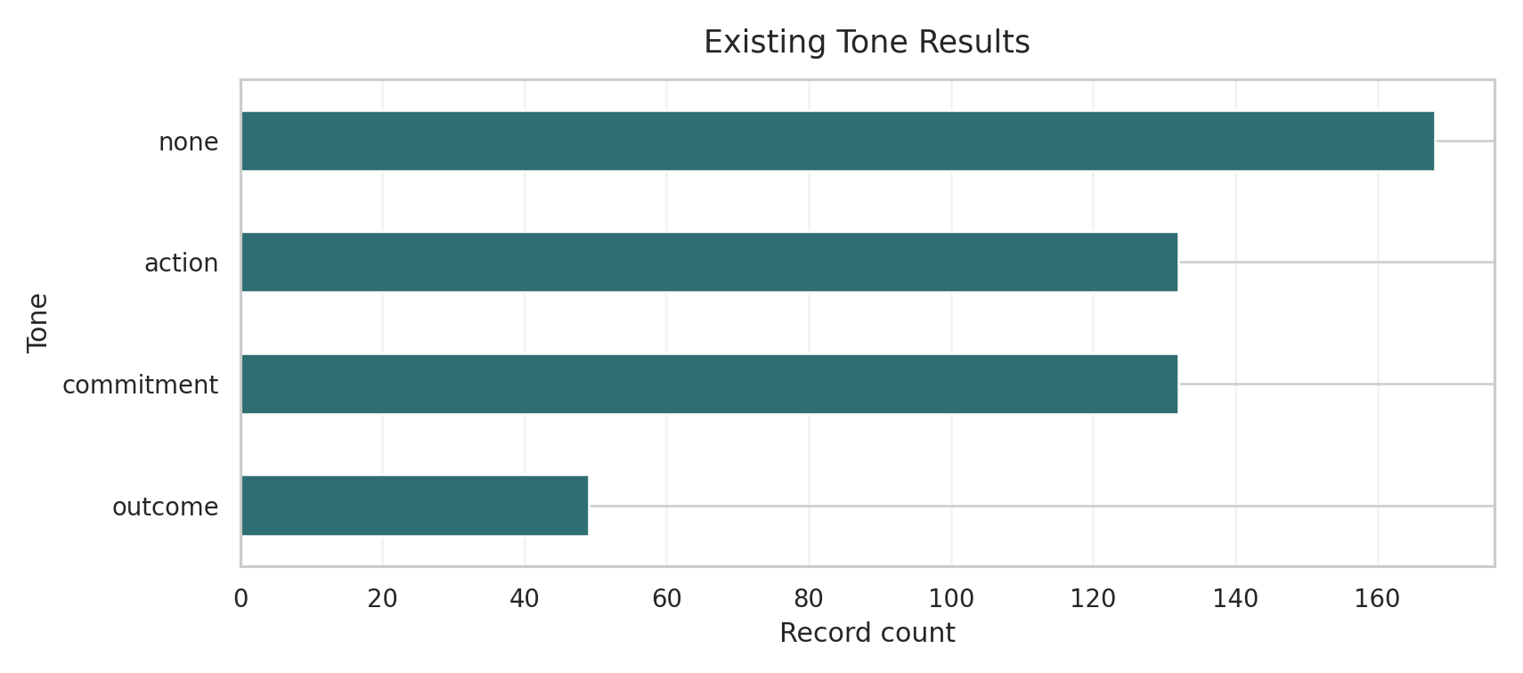
Tone distribution across the active extracted-record layer. This figure supports RQ2 by showing that commitment is the dominant disclosure tone in the current thesis-facing subset.
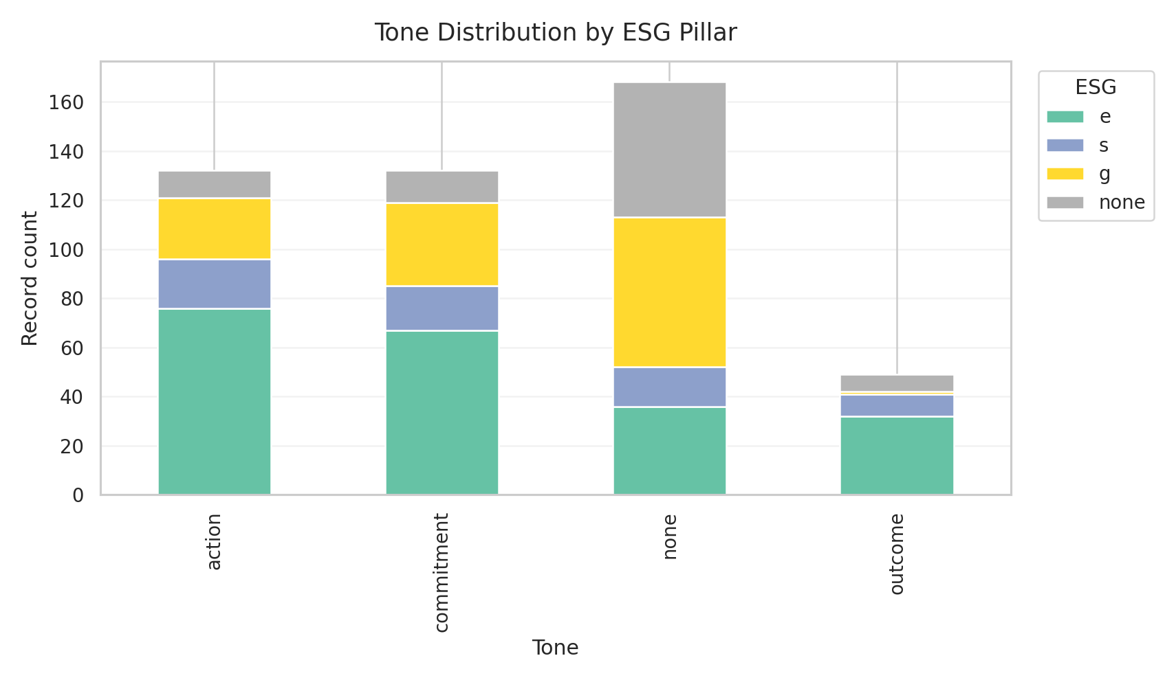
ESG pillar distribution by tone. This figure shows that environmental and governance disclosures dominate the active evidence layer and helps explain why social-pillar findings remain comparatively weak.
Prompt-level extraction behavior is shown in Table 9.
Prompt-level extraction performance across the thesis-facing subset.
Prompt | Runs | Parse Success | Avg. Records | Missing Tone | Schema Drift | Field Completion
tone_chain_of_thought_english.md
tone_chain_of_thought_indonesian.md
tone_few_shot_english.md
tone_few_shot_indonesian.md
tone_zero_shot_english.md
tone_zero_shot_indonesian.md
These results show that parse success alone is not an adequate quality metric. Every prompt listed above reaches 100% parse success, yet their practical usefulness differs sharply. tone_chain_of_thought_english.md yields the highest average record count. In other words, a prompt can be syntactically valid and still be unsuitable for the core thesis task.
The denominator audit clarifies the scale of the tone-quality problem. Of 5,444 extracted units in the relevant coverage view, 591 are excluded from tone distribution and agreement because they represent missing-tone cases. This is a meaningful failure rate, not a negligible noise band. It supports the claim that tone extraction is the most fragile part of the schema and justifies treating missing-tone behavior as an explicit Chapter 4 result rather than a minor implementation bug.
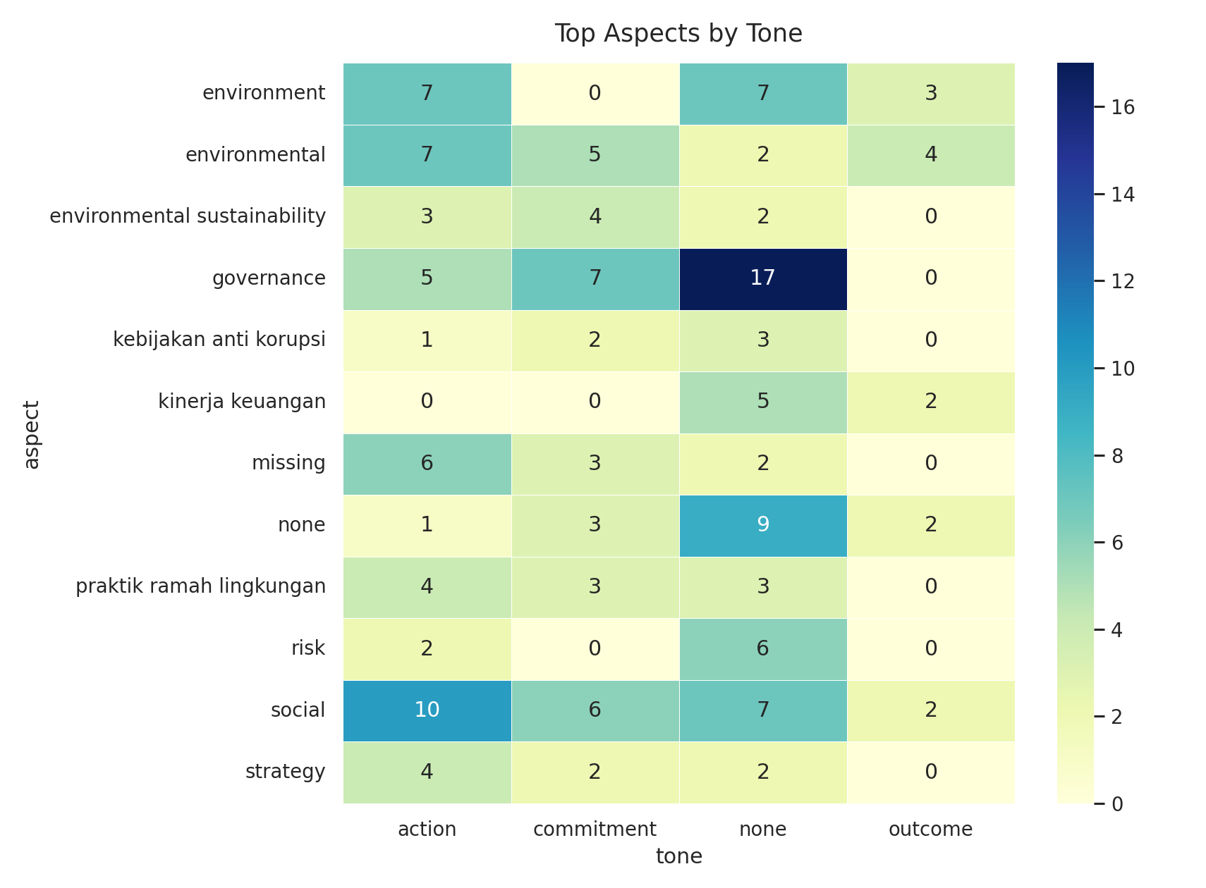
Aspect-by-tone heatmap for the active extracted-record layer. This figure supports RQ2 by showing which aspects are concentrated in commitment, action, or outcome language rather than only reporting overall counts.
The ontology layer strengthens the schema interpretation further. The current ontology table shows 52 aspects tracked and 52 mapped to ontology paths. This does not prove perfect semantic correctness, but it shows that the record-level schema is not only syntactically structured; it is also semantically linkable to a broader ESG concept layer. In practical terms, the schema supports page-linked extraction, multi-field labeling, and ontology-aligned interpretation in a single evidence structure.
Overall, RQ1 is answered positively within the current thesis scope. ESG disclosures can be represented through a record-level schema that integrates aspect, ESG pillar, sentiment, and tone, and that schema remains usable at realistic report scale. The main qualification is that class balance is uneven and tone completion remains more fragile than aspect or ontology coverage.

RQ2: Tone vs. Climate-Specific Models
RQ2 asks how LLM-generated tone labels compare with specialized outputs from models like ClimateBERT, and what that comparison reveals about the validity of automated ESG assessment. The most important quantitative result for this question is the alignment between disclosure tone and ClimateBERT-style commitment labels. Table 10 summarizes the main agreement result.
|X|p1.3cm|p1.5cm|p1.3cm|p1.8cm|p1.8cm|X| Compared labels & Records & Percent agreement & Cohen’s kappa & Tone commitment rate & Climate-commitment label rate & Interpretation boundary
tone_ commitment vs climate_commitment _label & 332 & 83.7% & 0.645 & 34.6% & 36.4% & Strong overlap, but not label equivalence
This is a strong but not perfect alignment. The result suggests that the repository’s tone taxonomy captures a signal that overlaps substantially with climate-commitment detection, but the two constructs are not identical. This is theoretically useful because it supports the claim that tone adds a maturity or disclosure-function layer beyond climate-topic recognition.
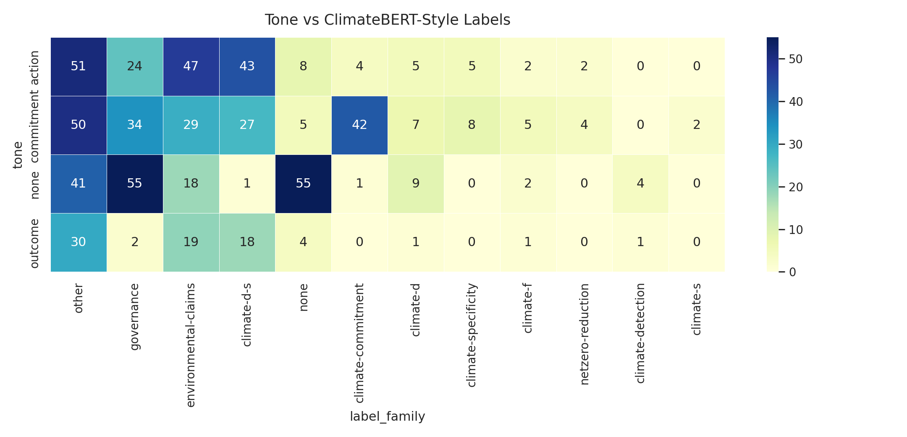
Cross-distribution of LLM tone labels and ClimateBERT-style labels. This figure supports RQ3 by showing where commitment aligns strongly and where action or outcome labels diverge from climate-topic categorization.
The saved tone-by-ClimateBERT crosstab provides a more detailed view:
Although the label space is broader than a single climate-commitment binary, the table shows that commitment records cluster differently from action and outcome records. In the thesis planning notes, commitment is most strongly associated with climate-commitment, climate-d, and environmental-claims, while action and outcome disperse more across governance and other label families. This pattern supports the idea that commitment language dominates environmental claim-making even when a record does not yet describe measurable outcome.
The comparison therefore supports a qualified validity claim. Tone labels and ClimateBERT-style labels are strongly related at commitment level, which suggests that the tone taxonomy is not arbitrary. At the same time, the two systems answer different analytical questions. ClimateBERT-style outputs focus on climate-topic or climate-commitment relevance, whereas the tone schema asks whether a disclosure is a promise, an action, or an achieved outcome. The result is therefore best interpreted as partial construct alignment rather than label equivalence.
Overall, RQ2 is answered positively but with a clear boundary. LLM-generated tone labels overlap meaningfully with specialized climate-oriented outputs, especially for commitment language, but they should not be treated as interchangeable with climate-topic classification. The comparison supports the validity of the tone taxonomy as an additional analytical layer rather than as a replacement for specialized climate models.

RQ3: Pipeline Diagnostics
RQ3 asks what specific failure modes characterize the automated extraction of ESG records, including OCR-related data loss, schema problems, and ontology gaps. This is the research question where the Chapter 4 evidence is most explicitly diagnostic rather than comparative.
The failure-mode count table is shown below.
|X|p1.8cm|p1.8cm|X|X| Failure mode & Count & Share of reviewed failures & Likely cause & Representative example type
missing_tone & 61 & 61.0% & Output omitted the central tone field despite otherwise parseable extraction & Record with populated text/aspect fields but empty tone
schema_drift & 20 & 20.0% & Model produced values in the wrong field or changed schema semantics & Tone-like content placed in sentiment or free-text slots
hedged_or_modal_language & 10 & 10.0% & Commitment/action boundary blurred by future-oriented or hedged phrasing & “will”, “target”, “intend”, “berkomitmen” mixed with current actions
regulatory_or _indonesian_domain_terms & 3 & 3.0% & Domain-specific Indonesian ESG terminology not handled consistently & Governance/regulatory phrasing with weak tone cues
table_or_numeric_layout & 3 & 3.0% & Table-heavy or numeric formatting disrupted semantic extraction & KPI/table rows detached from narrative context
passive_voice & 3 & 3.0% & Passive construction weakened action/outcome detection & Statement describes achievement without explicit actor
bilingual_or_code_switched & 1 & 1.0% & Language switching complicated cue interpretation & Mixed Indonesian-English ESG statement
schema_drift with action prediction & 1 & 1.0% & Structural mismatch in otherwise action-like output & Action record with malformed output fields
hedged_or_modal_language with action prediction & 1 & 1.0% & Action phrasing mixed with promise language & Agreement/plan statement straddling action and commitment
passive_voice with action prediction & 1 & 1.0% & Passive form weakened event interpretation & Passive wording treated as action rather than outcome
The dominant weakness is clear: 61 missing-tone cases. Beyond that, schema drift and hedged language are the next most important failure patterns. This means that the pipeline is more vulnerable to discursive ambiguity and formatting irregularity than to simple parser breakdown. The problem is therefore partly linguistic, not only technical.
Two additional graphs support the failure-analysis argument directly by separating absolute frequency from composition.
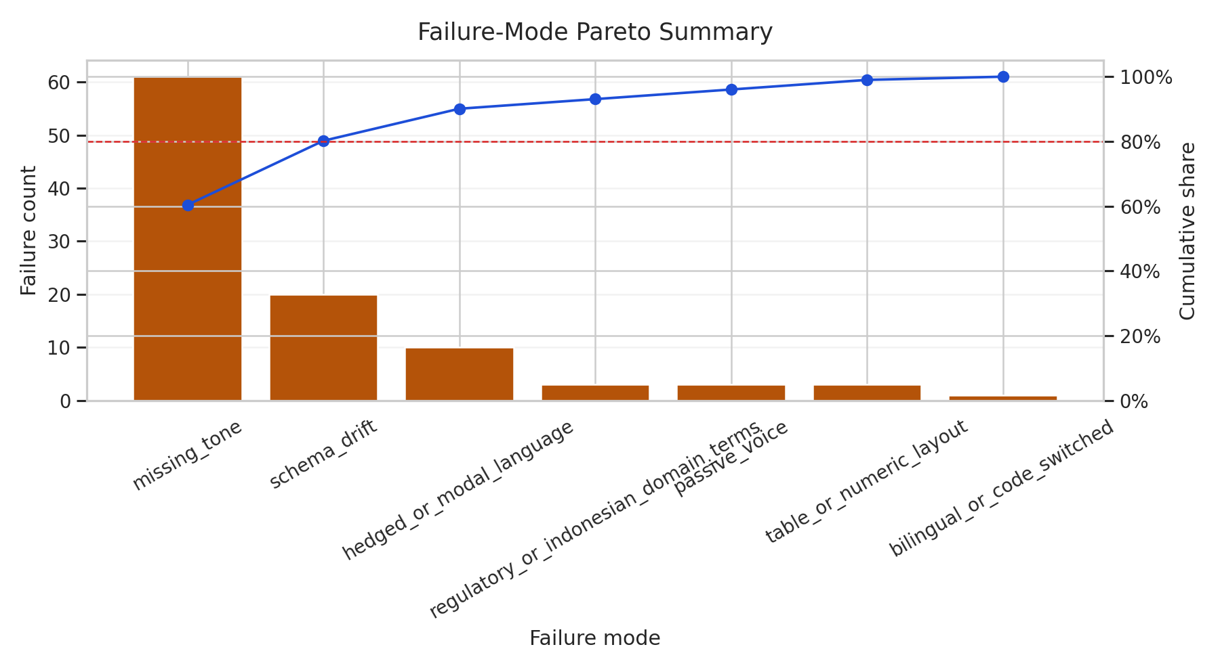
Failure-mode Pareto chart. This figure shows which small number of failure categories account for most observed extraction weakness in the current thesis-facing subset.
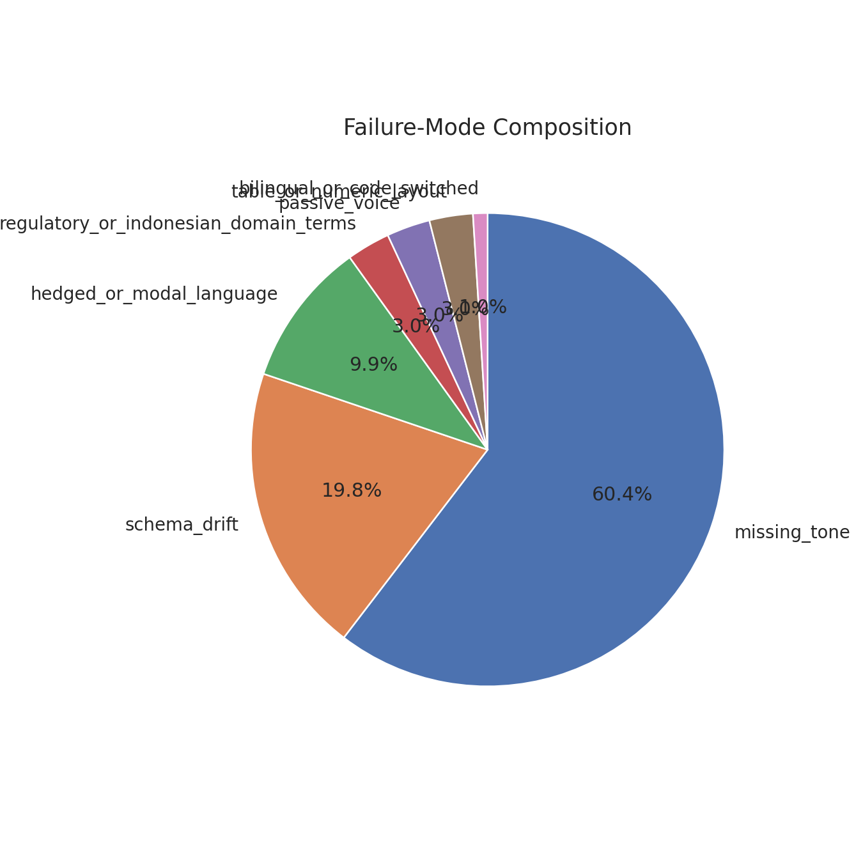
Failure-mode composition. This figure shows the relative share of missing tone, schema drift, language ambiguity, layout-related issues, and other recorded failure categories.
Ontology coverage provides a positive counterweight. The current ontology table shows 52 aspects tracked and 52 mapped to ontology paths. The highest-frequency mapped aspects are climate-detection with 79 records, governance with 66, missing with 60, and none with 23. Below these, domain-specific concepts such as roadmap karbon, pelatihan antikorupsi, komitmen net zero, and implementasi eco-mechanized mining are mapped to structured paths anchored to GRI-, governance-, or climate-oriented categories. This indicates that the ontology layer is currently stronger in coverage than the tone layer is in stability.
The denominator audit reinforces the diagnostic reading of these results. Of 5,444 extracted units in the relevant coverage view, 591 are excluded from tone distribution and agreement because they represent missing-tone cases. This is not a trivial cleanup issue. It shows that the extraction pipeline can remain operational while still failing on the central tone field often enough to distort downstream interpretation if those cases are ignored.
These findings reveal an important contradiction. The system is semantically organized enough to map diverse ESG aspects to ontology paths, yet it is still fragile when asked to consistently distinguish commitment, action, and outcome in noisy or governance-heavy contexts. That contradiction becomes one of the central interpretive findings of the chapter.
Overall, RQ3 is answered directly by the diagnostic evidence. The most important failure modes are missing tone, schema drift, hedged or modal language, and layout- or terminology-related ambiguity. OCR processing is operational at document level, but the central downstream weakness remains tone stability rather than ontology coverage.

RQ4: Stability and Reproducibility
RQ4 asks to what extent ESG extraction outputs remain stable across varying prompts, LLM models, and service providers. This question is answered through prompt-level stability summaries, model-level summaries, stored workflow artifacts, and the reproducibility structure of the repository.
The repository performs strongly on reproducibility as an engineering system. The saved thesis dashboard report indexes 1,220 result artifacts and 184 LLM background jobs. Five static figures are already exported for thesis reuse: tone_distribution.png, esg_by_tone.png, aspect_by_tone_heatmap.png, climatebert_label_by_tone.png, and climatebert_remote_top_scores.png. In addition, the Chapter 4 Streamlit pages render live views over the same result tables, allowing the written thesis chapter and the interactive dashboard to remain aligned.
This reproducibility evidence matters because it shows that the research output is not dependent on one temporary notebook state. The file structure preserves both intermediate and summarized evidence. The pipeline can therefore be re-run, inspected, and extended without rebuilding the thesis reporting layer from scratch. At the same time, this should not be confused with a claim that all third-party LLM outputs are exactly repeatable across time. The thesis claims reproducible workflow structure and artifact persistence more strongly than deterministic output identity.
The strongest stability results appear in the model- and prompt-level summaries. Table 4.3 shows the current model comparison.
|X|p1.8cm|p1.8cm|p1.8cm|p1.8cm|p1.8cm|X| Model & Runs & Parse success rate & Avg. records & Missing-tone rate & Schema-drift rate & Short interpretation
arcee-ai/ trinity-large-preview:free & 90 & 100.0% & 3.02 & 0.05% & 0.11% & Best stable thesis-facing baseline: high schema obedience and near-zero tone omission
openai/ gpt-oss-120b:free & 20 & 100.0% & 3.00 & 100.0% & 42.5% & Formally parseable but practically unusable for tone analysis
arcee-ai/ trinity-large-thinking:free & 89 & 89.9% & 12.52 & 0.0% & 0.0% & Very high extraction yield, but lower formal stability than the preview model
minimax/ minimax-m2.5:free & 776 & 56.6% & 4.94 & 0.05% & 0.26% & High-volume live usage with weak parse reliability
openai/ gpt-oss-20b:free & 145 & 95.9% & 1.13 & 0.0% & 0.0% & Structurally stable but low extraction yield
qwen3.5:0.8b & 2 & 0.0% & 0.00 & 0.0% & 0.0% & No usable extraction in the current slice
The most important comparison for the thesis-facing stable subset is between arcee-ai/trinity-large-preview:free and openai/gpt-oss-120b:free. Both achieved perfect parse success in the summarized slice, but gpt-oss-120b exhibited a 100% missing-tone rate and a 42.5% schema-drift rate in the corresponding prompt-model grouping. This is a strong warning against treating model size or brand reputation as a proxy for task suitability. In this workflow, schema obedience and tone completion matter more than raw generative capability.
Figure 4.7 complements Table 4.4 because it makes the trade-off between formal stability and usable extraction output easier to read.
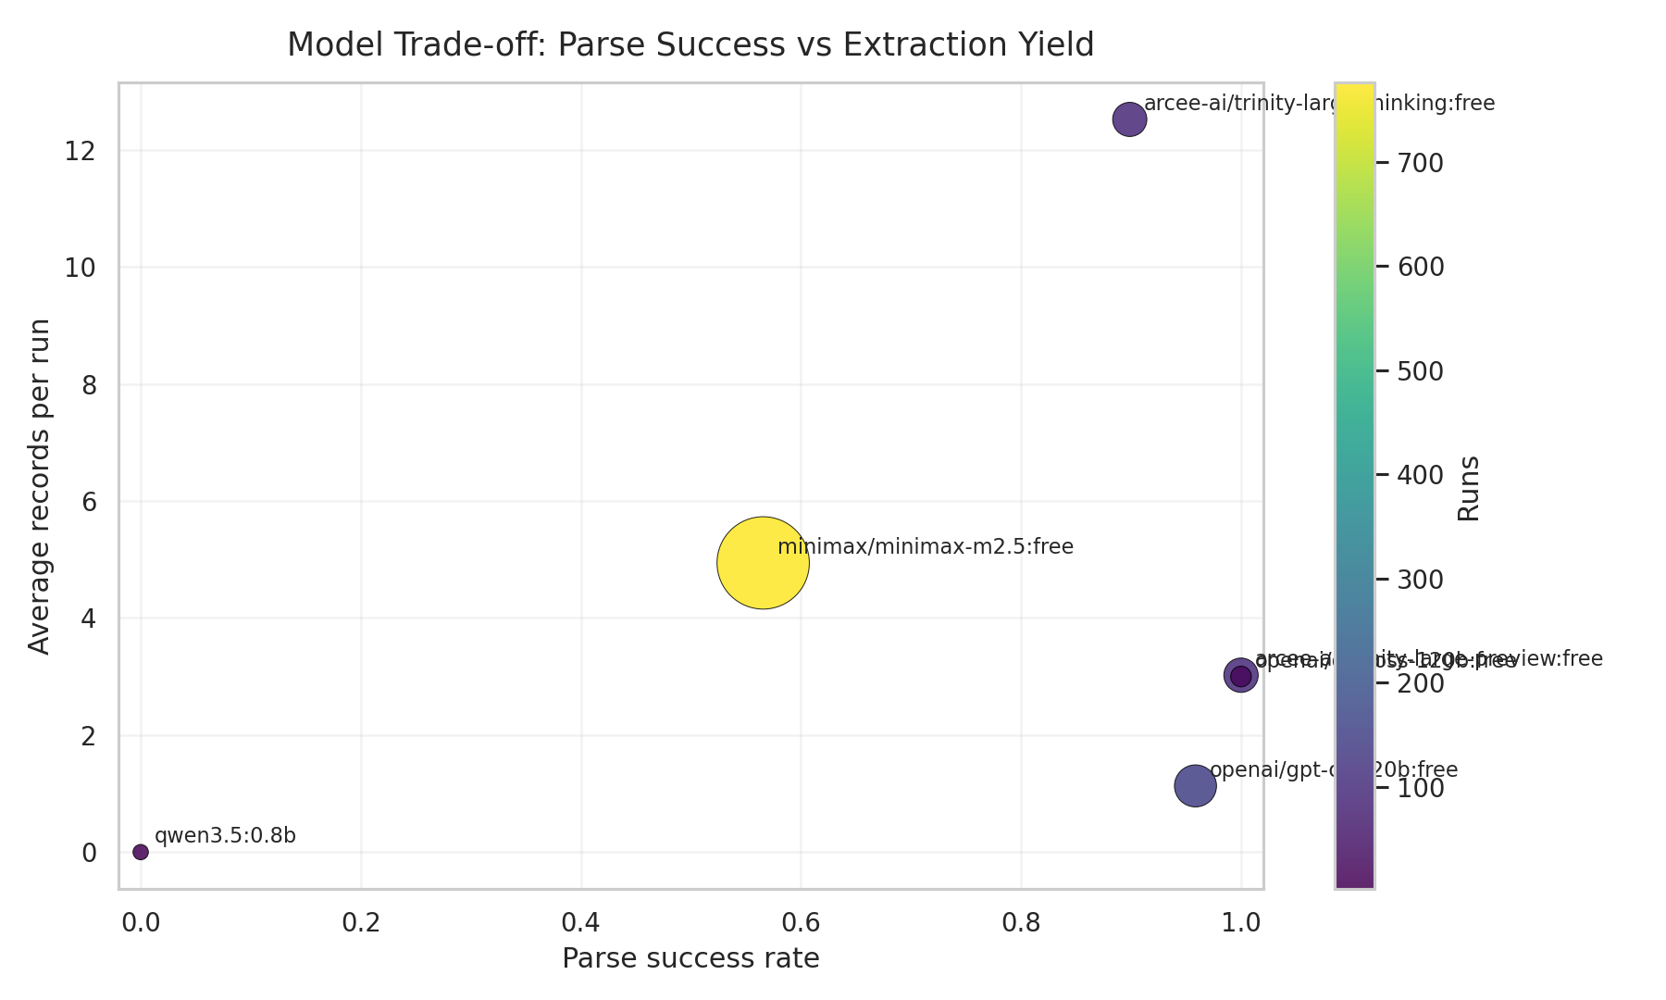
Model trade-off scatter plot with parse success on the x-axis and average extracted records on the y-axis. This figure helps separate models that are formally stable from those that are practically useful.
Prompt-level stability shows a similar pattern. Chain-of-thought prompts, especially in English, produce the highest average records per run, while data.md produces formally parseable but functionally unusable tone outputs. Few-shot prompts appear inconsistent: the English few-shot prompt yields no average extracted records in the current summary, while the Indonesian few-shot prompt yields very low completion. This suggests that examples alone do not guarantee better extraction. In this repository, explicit tone framing and schema-constrained instruction style appear more important.
Figure 4.8 should be read together with the prompt-level results table because prompt-family trends are central to the argument that prompt design matters more than nominal prompting style labels.
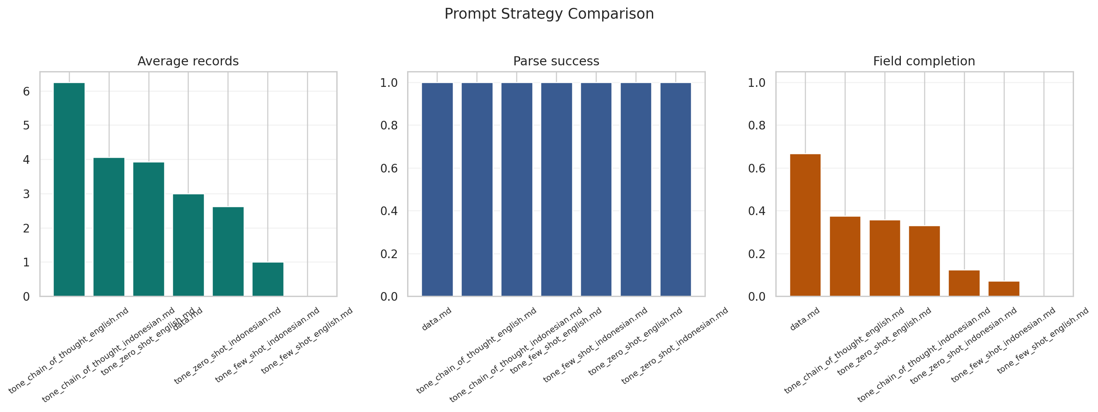
Prompt-strategy comparison across average records, parse success, and field completion. The figure shows that chain-of-thought and tone-specific framing matter more than generic prompt validity alone.
These results reveal a practical trade-off. Some settings maximize extraction volume, while others maximize structural cleanliness. The best-performing configuration for this thesis is therefore not the one with the highest nominal complexity, but the one that balances parse success, tone completion, and manageable drift. This is exactly the type of engineering validity condition the chapter needs to report.
Overall, RQ4 is answered with an important qualification. The workflow is reproducible and stable in an engineering sense because prompts, outputs, logs, and derived artifacts are stored persistently, and because the same evaluation views can be regenerated. However, semantic output stability is not uniform across prompts, models, or providers. Stability depends strongly on prompt design and schema-following behavior, so the thesis can claim reproducible workflow structure more confidently than universally stable model behavior.

Explainability Outputs
The explainability layer helps show why the pipeline behaves as it does. At implementation level, code/rule_based.py uses explicit lexical triggers for commitment, action, and outcome, while code/classical_ml.py provides TF-IDF coefficient tables and local explanations. The lexicon file contains signals such as berkomitmen, commitment, will, menargetkan, target, aim to, and dedicated to for commitment-oriented language, and telah, achieved, has been, and successfully for outcome-oriented language.
The lexical trigger count summary confirms that these categories shape predictions in practice. Commitment triggers co-occurred 53 times with commitment predictions, compared with 30 action and 36 missing cases. Outcome triggers co-occurred 18 times with outcome predictions, but also 19 times with missing predictions and 17 times with commitment predictions. This helps explain why boundary cases remain difficult: many disclosure segments contain future-oriented and achieved language at the same time, especially in mixed narrative-reporting sections.
Two additional figures fit especially well in this subsection because they extend the explainability argument without requiring a new evaluation protocol.
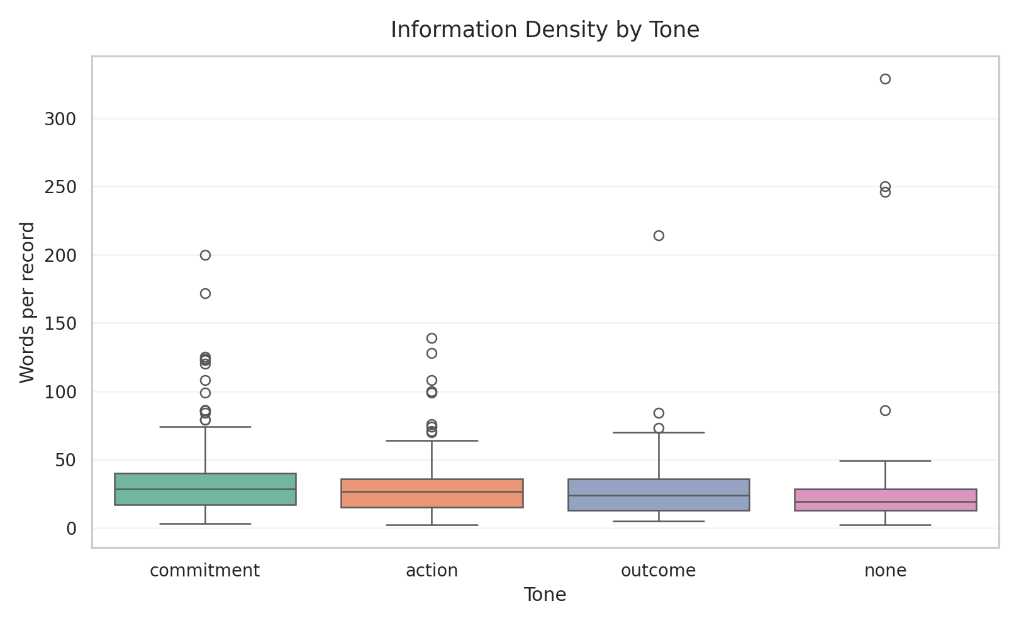
Information-density by tone. This figure shows whether commitment, action, outcome, and none records differ systematically in word count and therefore in extraction complexity.
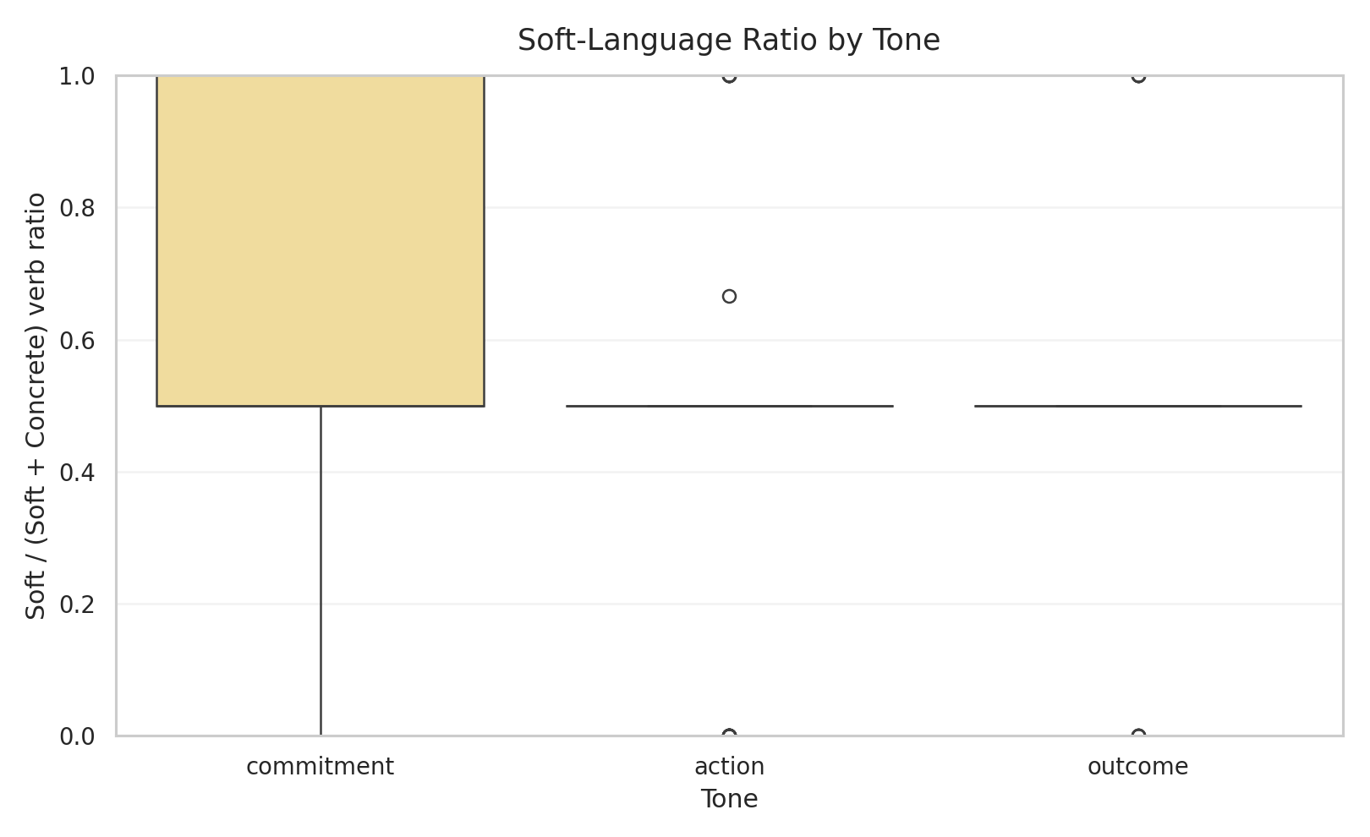
Soft-language ratio by tone. This figure shows whether commitment records contain a higher proportion of soft or future-oriented verbs than action and outcome records, thereby giving a linguistic explanation for some tone-boundary failures.
Ontology-path evidence is also interpretable. Environmental and climate-oriented examples include roadmap karbon, komitmen net zero, kerja sama energi bersih, and teknologi ramah lingkungan. Governance examples include pelatihan antikorupsi, kebijakan konflik kepentingan, and sertifikasi smap. These mappings show that the system can convert raw disclosure terms into structured thematic paths that are suitable for later chapter interpretation.
Representative records help illustrate the difference between commitment, action, and outcome:
- Commitment example: “As a pioneer among industrial estate developers in Indonesia, BeFa is at the forefront of creating a green and eco-friendly industrial zone...” This record is labeled commitment, carries environmental claims, and receives a strong local climate-commitment prediction.
- Outcome example: “Keberhasilan pembangunan fasilitas perakitan kendaraan listrik di Magelang menjadi tonggak penting...” This record is labeled outcome with positive sentiment because it describes a realized infrastructure milestone
- Action example: “Pada tanggal 10 Oktober 2023, Perusahaan dan MB menandatangani perjanjian kerja sama...” This record is labeled action because it describes a concrete agreement, but not yet a completed performance outcome
These examples show that the tone taxonomy is meaningful in practice. The main challenge is not whether the categories are interpretable, but whether the extraction layer can assign them consistently across different prompts, models, and disclosure styles.

Validation of Reference Data and Pilot Reference Layer
The current evaluation target is not a full expert-labeled benchmark. It is a layered reference system built from extracted records, ClimateBERT-style comparison labels, weak lexical suggestions, and pilot human annotation files. This reference layer therefore has to be evaluated in its own right.
The strongest available comparison source is the ClimateBERT proxy agreement table over 332 records. It provides broad coverage and acceptable agreement, but it remains a proxy because the repository itself notes that a full one-to-one external ClimateBERT benchmark is still incomplete. The pilot human annotation layer is represented by files such as pilot_ground_truth_seed.csv and pilot_ground_truth_annotations.csv. The dashboard report currently records 70 pilot labels, which is useful for review and disagreement analysis but not enough to serve as a definitive gold standard.
Qualitatively, the reference layer is partially trustworthy but still noisy. Many pilot rows are marked needs_review, which is appropriate and should be reported transparently. Several examples show disagreement between predicted tone and suggested tone. For instance, some governance or agreement-signing records are predicted as action but receive commitment-oriented heuristic suggestions because the text includes modal or forward-looking language. This is not merely annotation error; it reflects the conceptual difficulty of distinguishing action from commitment in governance-heavy sustainability language.
The repository also preserves invalid or weak reference cases rather than silently filtering them. Missing-tone and schema-drift rows remain visible in the review files. This is methodologically sound because it prevents the evaluation set from becoming artificially clean. At the same time, it means that the current reference layer should be described as a pilot reference framework rather than a finalized benchmark corpus.
Overall, the selected reference system is reliable enough for exploratory evaluation, disagreement analysis, and chapter-level empirical claims about patterns and failure modes. It is not yet reliable enough for definitive benchmark claims about absolute model superiority.

Comparative Component Analysis
The repository does not yet contain a full controlled ablation study in the strict machine-learning sense, where one component at a time is removed under a fixed benchmark and identical evaluation set. However, the existing results do support a comparative component analysis across prompts, models, and representational choices. This section therefore addresses the checklist requirement cautiously and explicitly.
The first comparative finding concerns the prompt layer. If prompt framing is treated as a removable component, then tone-specific chain-of-thought prompting is the most important component for usable T3 extraction. Replacing it with the generic data.md prompt preserves JSON parse success but causes catastrophic tone failure. This indicates that explicit tone instruction is more important than generic extraction framing for the thesis task.
The second finding concerns model choice. If model family is treated as a removable or swappable component, then not all large language models are equivalent. arcee-ai/trinity-large-preview:free produces stable parse and tone behavior in the thesis-facing subset, whereas openai/gpt-oss-120b:free shows unacceptable tone omission and schema drift in the summarized grouping. This means the pipeline depends more strongly on schema-following behavior than on raw model scale.
The third finding concerns representation type. The repository’s architecture suggests three feature regimes: handcrafted lexical features, sparse learned features, and contextual fused features. The rule-based model offers maximum interpretability and is useful for explainability and error diagnosis, but it is brittle under ambiguity. The classical TF-IDF model offers reproducible statistical baselines and coefficient-level explanations, but it is limited by sparse surface-form dependence. The hybrid contextual model is designed to capture sentence meaning, section context, and ontology information together, making it the most conceptually complete architecture. The current Chapter 4 evidence, however, is stronger for prompt/model stability than for full benchmark comparison among these three ABSA components, because the saved thesis dashboard focuses on pipeline evidence rather than controlled classifier benchmarking.
The fourth finding concerns ontology integration. The ontology layer appears robust in coverage, which implies that aspect-to-path mapping is not currently the most fragile component. If any component is most responsible for pipeline weakness, it is the tone-label production step rather than the ontology layer.
These component comparisons lead to a clear synthesis. The most important component of the implemented system is the prompt-and-schema design of the extraction layer, followed by the choice of model backend that can reliably honor that schema. Contextual and ontology-aware representations remain important for interpretability and future benchmarking, but the present evidence shows that extraction stability is the prerequisite for all later gains.
Figure 4.11 should be added as a final integrative visual if the Sankey export is generated from the visualizer, because it would summarize how the most frequent aspects distribute across commitment, action, and outcome in one compact view.

Chapter Synthesis
The main findings of Chapter 4 are fivefold.
First, the pipeline successfully operationalizes PDF-to-structured ESG extraction over a nontrivial document set: 23 processed reports and roughly 5,512 OCR-covered pages. Second, the extraction layer produces a meaningful evidence store with 332 tone-bearing records and 2,074 T2 rows, confirming that the proposed schema is practically usable. Third, tone commitment aligns strongly with ClimateBERT-style commitment labels, with 83.7% agreement and Cohen’s kappa of 0.645, which supports the construct relevance of the tone taxonomy without collapsing it into climate-topic classification. Fourth, the major weakness of the system is not parser failure but tone instability, especially missing-tone cases and schema drift under certain prompt settings. Fifth, the most important determinant of usable output is the interaction between prompt design and model compliance, not simply model scale.
The best overall thesis-facing configuration in the current saved evidence is the one represented by arcee-ai/trinity-large-preview:free with tone-focused prompts, because it combines high parse success with low missing-tone and low schema-drift rates. The most important system component is the tone-aware extraction prompt design. The main trade-off is between broad extraction flexibility and schema reliability: settings that appear generically capable do not necessarily produce thesis-usable structured outputs.
These findings connect directly back to Chapter 3. The methodology emphasized modularity, provenance, bilingual robustness, and interpretability. Chapter 4 shows that these design choices were justified. The system works best when it preserves traceable intermediate artifacts, separates tone from sentiment, and treats disagreement as information rather than noise. These results also prepare the next chapter: the discussion can now interpret commitment dominance, governance-related tone failures, model disagreement, and ontology coverage as substantive findings rather than mere implementation artifacts.

Discussion

Key Findings and Synthesis

Main Findings and Their Meaning
The central argument of this thesis is that ESG disclosure analysis for Indonesian sustainability reports becomes more informative when it is treated not only as a topic-detection problem, but as a tone-aware, provenance-preserving, ontology-aligned evidence extraction problem. The Chapter 4 results support this argument. The implemented workflow successfully transformed 23 sustainability-report PDFs into an auditable OCR-expanded corpus covering approximately 5,512 pages, generated 332 tone-bearing ESG records and 2,074 T2 rows, mapped 52 aspects to ontology paths, and achieved 83.7% agreement with ClimateBERT-style commitment labels at Cohen’s kappa of 0.645.
The most important empirical finding is that disclosure tone is both measurable and meaningful. The extracted evidence set is dominated by commitment tone, with 115 of 332 records assigned to commitment, while environmental disclosure is the most frequent ESG pillar with 179 records. This means that the active corporate disclosure sample in the repository is not primarily organized around verified outcomes. It is organized around forward-looking commitments and strategic positioning. That pattern matters because it directly supports the thesis motivation: sentiment polarity alone would miss the difference between a positive achieved result and a positive promise.
The strongest overall implementation configuration in the thesis-facing subset is the combination of tone-aware prompts and stable schema-following models, especially arcee-ai/trinity-large-preview:free with tone-specific prompt templates. This configuration does not simply produce more text. It produces structurally usable records with very low missing-tone and schema-drift rates relative to weaker alternatives. By contrast, openai/gpt-oss-120b:free achieved perfect parse success in the summarized slice but produced a 100% missing-tone rate and a 42.5% schema-drift rate in the corresponding grouping. The meaning of this result is clear: for this task, schema compliance and tone completion are more important than nominal model scale or general fluency.
The most important technical insight from Chapter 4 is therefore not that a specific model “won,” but that the decisive factor is the interaction between prompt design and model behavior. The thesis methodology assumed that prompt sensitivity and structured-output fragility would be major determinants of quality. The Chapter 4 results confirm that assumption. They also show that ontology coverage is comparatively robust, while tone assignment remains the most fragile part of the system. This partly confirms and partly sharpens Chapter 3. Chapter 3 anticipated modular weakness; Chapter 4 demonstrates that the main bottleneck is concentrated in tone stability rather than in OCR completion or ontology mapping alone.

Tone distribution in the active thesis-facing subset. This figure is used to interpret commitment dominance as a substantive disclosure pattern rather than as a descriptive count reported in Chapter 4.

Deeper Patterns and Research Question Mapping
The deeper pattern behind the results is that different components of the system rely on different kinds of information. The OCR layer depends on document completeness and page-level traceability. The extraction layer depends on prompt framing, model obedience, and output schema stability. The comparison layer depends on construct overlap between tone and climate-topic signals. The ontology layer depends on semantic coverage of ESG vocabulary. These components do not fail for the same reason, and that is why the modular design matters.
The most influential component in the full pipeline is the tone-aware extraction prompt design. This can be seen directly in the prompt stability table: data.md is parseable but functionally poor for tone, whereas chain-of-thought tone prompts yield far better record counts and lower omission. This means that the pipeline’s best results are not produced by generic extraction capacity, but by explicit instruction that forces the model to separate commitment, action, and outcome.
Different methods also rely on different information types. The rule-based model relies on surface lexical cues such as berkomitmen, will, target, achieved, and successfully. The classical TF-IDF model relies on sparse word and character statistics. The hybrid model is designed to rely on contextual and ontology-aware information. The LLM extraction layer, however, relies on broader contextual reasoning and instruction following. This explains why some governance-heavy or agreement-signing texts become difficult: they contain both action markers and commitment framing, so simple lexical cues and broad generative interpretation can disagree.
The following matrix summarizes how the main research questions map to evidence.
All four research questions are therefore answered in the current thesis scope, although not all answers are equally mature. RQ1 and RQ4 are strongest at operational and diagnostic level because the repository preserves provenance, artifacts, and visible failure cases rather than hiding them. RQ2 and RQ3 are also supported, but they still depend on pilot-level validation and proxy comparison rather than full gold-standard benchmarking.
Table 5.1. Research-question evidence summary.
Research question | Main Chapter 4 evidence | Figure or Table | Current confidence level | Remaining limitation
RQ1. ESG ABSA Schema | 23 processed OCR documents, about 5,512 pages, 332 tone-bearing records, 2,074 T2 rows, and 52 mapped ontology aspects | Figure 9, Figure 10, Figure 11 | Moderate to high | Evidence is operationally strong, but class balance remains uneven and social coverage is weak
RQ2. Tone vs. Climate-Specific Models | 83.7% agreement and Cohen’s kappa of 0.645 between tone commitment and climate-commitment proxy labels across 332 records | Table 10 and Figure 12 | Moderate | ClimateBERT comparison is still proxy-based rather than a complete one-to-one external benchmark
RQ3. Pipeline Diagnostics | 61 missing-tone failures, 20 schema-drift cases, and a concentrated failure distribution dominated by a small set of recurring weaknesses | Table 11, Figure 4.5, Figure 4.6 | High for diagnostic claims | Failure analysis is strong, but some categories still need more manually curated case examples
RQ4. Stability and Reproducibility | 1,220 stored result artifacts, 184 background jobs, prompt-level summaries, and clear model-level trade-offs between parse stability and usable extraction | Table 9, Table 12, Figure 4.7, Figure 4.8 | Moderate to high | Workflow reproducibility is strong, but semantic outputs remain sensitive to prompt/model/provider changes

Research Question Resolution

Resolution of RQ1 and RQ2
RQ1 asks whether sustainability-report PDFs can be transformed into structured ESG evidence through the implemented pipeline. The answer is yes. The OCR and preprocessing workflow processed 23 tracked documents and approximately 5,512 pages, and the downstream extraction pipeline produced a stable evidence store with 332 tone-bearing records and 2,074 T2 outputs. In practical terms, this means the thesis has demonstrated the feasibility of moving from raw report files to page-linked, machine-readable ESG evidence at nontrivial corpus scale.
RQ2 asks whether the system can represent ESG disclosure beyond coarse topic detection by separating pillar, aspect, sentiment, and disclosure tone. The answer is also yes, but with an important qualification. The active result set shows meaningful distributions across tone and ESG pillar, with commitment as the dominant tone and environmental disclosure as the dominant pillar. This confirms that the schema can capture multiple dimensions of disclosure behavior. However, the pilot annotation evidence and the missing-tone cases show that this representation is not yet equally reliable across all text types. The contribution of RQ2 is therefore not only that the schema exists, but that the thesis demonstrates where it is robust and where it needs stronger human calibration.

Resolution of RQ3 and RQ4
RQ3 asks how the tone-aware pipeline compares with ClimateBERT-style climate classification. The answer is that the two are strongly related but not interchangeable. The agreement table shows 83.7% percent agreement and Cohen’s kappa of 0.645 between tone commitment and climate-commitment labels across 332 records. This is a strong descriptive result because it validates the relevance of the tone taxonomy while also preserving its distinctiveness. In practical terms, ClimateBERT-style labels can tell us that a disclosure is climate-related, but tone labels can additionally tell us whether the disclosure reports a promise, an action, or a realized outcome.

Relationship between LLM tone labels and ClimateBERT-style labels. Reused here because the discussion interprets this cross-distribution as evidence of partial construct overlap rather than full label equivalence.
RQ4 asks what weaknesses remain in the current evaluation and extraction strategy. The answer is that the major weaknesses are concentrated in tone omission, schema drift, and ambiguity-rich text. The strongest evidence is the 61 missing-tone cases, the 19 schema-drift cases in missing predictions, the hedged-or-modal-language failures, and the sensitivity of results to prompt and model choice. The proposed evaluation strategy is sufficient to reveal these weaknesses because it combines OCR completion, parse success, stability summaries, disagreement tables, ontology coverage, and review-oriented pilot files. However, it is not yet sufficient to claim final benchmark superiority because the gold-standard annotation layer remains limited. Taken together, the four RQs show that the thesis objective has been achieved at the level of an executable, interpretable, and diagnostically rich ESG disclosure-analysis framework.

Limitations
The first major limitation is the reference-data limitation. The thesis does not yet rely on a complete expert-labeled benchmark. Instead, it uses a layered reference system built from extracted records, ClimateBERT-style comparison labels, heuristic suggestions, and pilot human annotation files. This is sufficient for exploratory evaluation and disagreement analysis, but it limits the strength of claims about absolute model performance.
The second limitation is domain and sample concentration. The results are grounded in Indonesian sustainability and annual reports, with bilingual or mixed-language disclosure patterns. This is a strength for domain specificity, but it limits immediate generalization to other regulatory settings, other document genres, or monolingual corpora. The social pillar is also underrepresented in the current thesis-facing subset, which means tone and aspect findings are shaped more strongly by environmental and governance disclosure.
The third limitation is model and prompt sensitivity. The prompt stability table shows that formally valid prompts can still produce unusable tone outputs. The model stability table shows that some models with perfect parse success can still fail semantically by omitting tone or drifting schema. This means that the system is not yet robust to arbitrary backend substitution. Its performance depends on careful pairing between prompt design and model behavior.
The fourth limitation is the existence of technical failure cases that affect interpretation. The failure-mode table includes 61 missing-tone outputs, 19 schema-drift cases, hedged-language failures, table-layout problems, and issues with regulatory Indonesian terms. These failures do not invalidate the pipeline, but they do mean that the Chapter 4 findings should be interpreted as evidence of a strong but still imperfect research system.
The fifth limitation is that the greenwashing index remains heuristic. Company-level ratios such as 73.0 for BEST-SR_2024 or 4.778 for vktr_ar_sr_2024 are analytically interesting, but they are not yet validated against external ESG ratings, enforcement cases, or human expert judgment. For that reason, the index should currently be interpreted as a screening or discussion aid, not as a final adjudication tool.
Two figures fit well in this limitations section because they help the reader see where the evidence is uneven rather than only being told so.
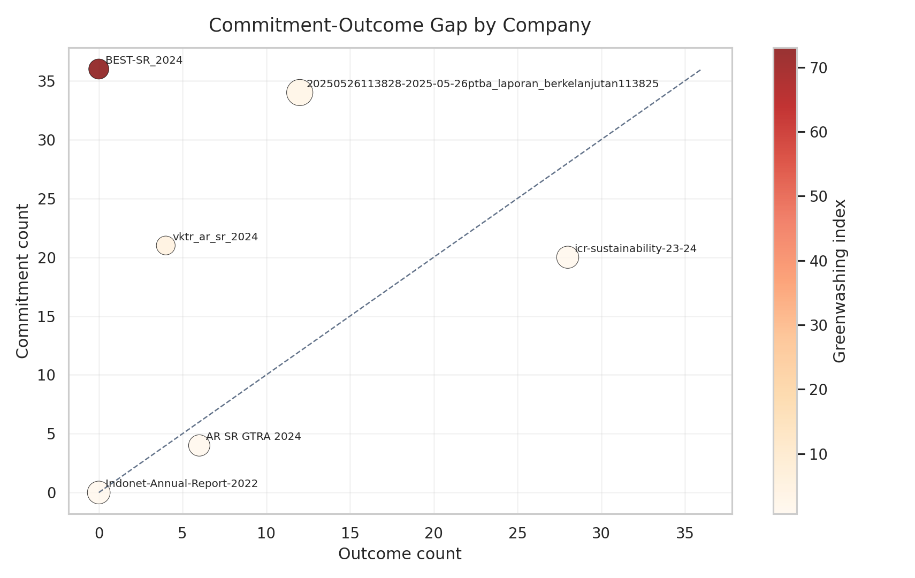
Commitment-outcome gap by company. This figure visualizes the relationship between commitment count, outcome count, and the company-level screening ratio, while the surrounding text keeps clear that the score remains heuristic.
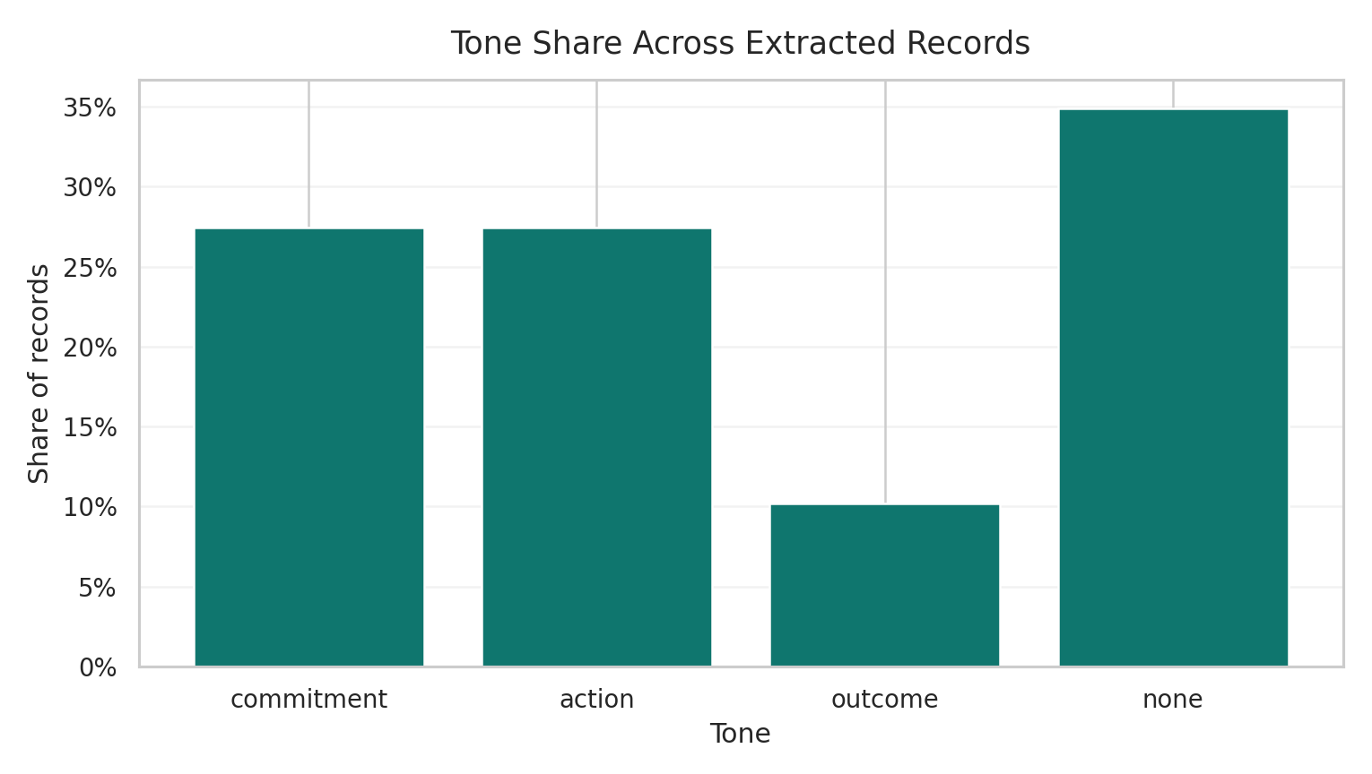
Tone-share ratio chart for the active extracted-record layer. This figure supports the discussion claim that commitment-heavy evidence remains much more common than outcome-heavy evidence in the current subset.

Future Work

Immediate Technical Extensions
The most immediate improvement is to expand and formalize the human annotation layer. The current pilot annotation files should be extended into a stratified expert-reviewed benchmark with inter-annotator agreement, especially for commitment versus action boundary cases, governance-heavy disclosures, and records currently marked needs_review. This directly addresses the weakest part of the evaluation design.
The second immediate improvement is to strengthen tone-specific prompt engineering and schema enforcement. The results already show that tone-specific chain-of-thought prompts outperform generic extraction prompts. The next step is to convert this finding into a more systematic prompt protocol, including stricter output validation, field-level confidence checks, and targeted rerun logic for missing-tone outputs.
The third immediate improvement is OCR quality evaluation. The repository currently proves that OCR completion is operational, but it does not yet report character error rate, table extraction accuracy, or page-level semantic quality baselines. Adding those checks would help separate upstream OCR noise from downstream tone-classification difficulty.
The fourth immediate improvement is one-to-one ClimateBERT benchmarking over the full extracted record set. The repository already supports record-batch generation for this purpose. Completing that pipeline would turn the current proxy comparison into a stronger external reference layer.
The fifth immediate improvement is better filtering of non-ESG and accounting-policy text. The pilot annotation files show examples where financial or accounting statements are correctly treated as none, but more explicit front-end filtering could reduce wasted extraction capacity and improve downstream quality.

Long-Term Research Roadmap
In the longer term, this research can grow into a broader program on computational sustainability disclosure analysis for low-resource and bilingual settings. One direction is model training: the hybrid contextual architecture could be extended through supervised fine-tuning on a larger Indonesian ESG tone corpus, allowing the system to learn tone distinctions more directly rather than depending so heavily on prompt-driven extraction.
A second direction is robustness and domain transfer. The framework should be tested on longer, noisier, and more sectorally diverse reports, and then extended to other regulatory environments beyond the current Indonesian focus. This would reveal whether the tone taxonomy and ontology structure remain useful under different reporting cultures.
A third direction is deployment-oriented research. Because the repository already stores page-level provenance and rich artifacts, it could be adapted into an analyst-facing review system for regulators, ESG research teams, investors, or auditors. In that setting, the most important research question would shift from “can the model classify?” to “how should humans and models collaborate when evidence quality is uncertain?”
A fourth direction is graph and knowledge-integration research. The ontology and semantic-export components already point toward graph-based querying and GraphRAG-style workflows. Future work could examine how structured ESG evidence, ontology paths, and source-page provenance can support traceable retrieval rather than only static reporting.
Taken together, these future directions form a coherent roadmap: first stabilize annotation and benchmarking, then improve model robustness and OCR quality, then extend across domains and deployment contexts, and finally integrate the workflow into broader evidence-centric research infrastructure.

Broader Impact

Practical and Societal Benefits
The most direct beneficiaries of this research are ESG analysts, sustainability-report authors, regulators, investors, and research teams working on corporate accountability. For ESG analysts, the system reduces the cost of moving from hundreds of PDF pages to a smaller set of structured, reviewable disclosure records. For sustainability-report authors, the tone framework provides feedback about whether a report is dominated by commitments, operational actions, or realized outcomes. For regulators and oversight bodies, the provenance-preserving design offers a way to inspect disclosure claims without losing the link to the source page. For investors, the greenwashing-oriented ratios and tone distributions can serve as a supplementary signal when reading large volumes of narrative disclosure.
The broader practical value of the thesis is that it improves on existing ESG automation in three ways. First, it preserves auditable page-level lineage. Second, it distinguishes disclosure maturity rather than treating all positive ESG language as equivalent. Third, it reveals failure modes and uncertainty instead of hiding them behind a single summary score. These are meaningful improvements for real-world use because ESG decision-making often depends as much on traceability and interpretability as on aggregate classification accuracy.
At societal level, the work supports stronger information transparency in sustainability communication. If deployed responsibly, a system like this can help identify when corporations communicate mostly aspiration, when they report concrete action, and when they document measurable outcomes. That distinction is valuable for accountability, sustainability governance, and public understanding of corporate climate and ESG claims.

Ethical Risks, Bias, and Responsible Use
The main ethical risk is over-automation. If users treat the extracted tone labels or greenwashing ratios as definitive truth rather than as decision-support signals, the system could mischaracterize organizations or obscure nuance in legally or strategically sensitive disclosures. This risk is especially important because the current evaluation layer is still partly weakly supervised.
Bias and fairness concerns also remain. The current active evidence layer overrepresents environmental and governance language and underrepresents the social pillar. The model and prompt outputs are also sensitive to bilingual phrasing, governance boilerplate, and table-heavy layouts. Without careful review, the system may systematically underperform on certain sectors, disclosure styles, or language patterns.
Privacy concerns are relatively limited because the corpus is based on public corporate reports, but responsible deployment still requires care around data handling, caching, provenance logs, and model outputs. Misuse is more likely to arise through misinterpretation than through private-data exposure. For example, a high greenwashing index should not be treated as proof of misconduct without human review and external corroboration.
The appropriate safeguards are therefore clear: maintain source-page traceability, preserve uncertainty and failure flags, require human review for sensitive cases, expand annotation before high-stakes deployment, and avoid using the system as a sole basis for regulatory or investment judgment. In sustainability terms, the work is aligned with broader responsible-governance goals because it encourages more transparent, evidence-based reading of ESG claims. The balanced conclusion is that this is useful technology for ESG evidence organization and interpretation, but its value depends on disciplined, review-oriented, and context-aware use.

Conclusion
This thesis set out to design an executable framework for analysing Indonesian sustainability reports as structured ESG evidence rather than as unstructured narrative text. The core objective was not only to classify disclosures, but to build a reproducible workflow that transforms heterogeneous PDF reports into auditable records with page-level provenance, aspect labels, ESG pillar assignments, sentiment, and disclosure tone. This objective was achieved through a modular pipeline that combined OCR, page-aware extraction, LLM-based structuring, ontology alignment, comparison against ClimateBERT-style labels, and dashboard-based diagnostics.
The results show that the proposed approach is technically feasible and analytically useful. The active thesis subset covered 23 processed reports and about 5,512 pages, producing 332 tone-bearing ESG records and 2,074 downstream rows. The record-level schema was operational, all 52 tracked aspects were mapped to ontology paths, and the comparison with ClimateBERT-style commitment labels showed strong but not perfect alignment, with 83.7
A key methodological choice in this thesis was to treat the system as an executable research workspace rather than as a single-model benchmark. This choice was justified by the results. The main strengths of the framework are traceability, modularity, and diagnostic transparency. The main weaknesses are also clear: tone extraction remains sensitive to prompt design and model behavior, and missing-tone cases and schema drift show that fully reliable automation has not yet been reached. These limitations do not reduce the value of the work; instead, they show where future validation and benchmark development are needed.
The significance of the thesis is practical as well as academic. For researchers, it provides a reproducible basis for ESG disclosure analytics in a bilingual and low-resource setting. For analysts, regulators, and reporting teams, it offers a way to move from long PDF reports to structured, reviewable evidence without losing the connection to the source pages. More broadly, the work shows that useful ESG text analytics requires not only better models, but also better document engineering, provenance preservation, and evaluation design. In that sense, the thesis contributes an engineering-oriented foundation for more transparent and auditable sustainability-report analysis.
Alamsyah, Anisa Kusuma Putri AND Sri Widiyanesti AND Andry. 2025. “The Illusion of Sustainability: Unmasking Greenwashing in FMCG Reports with Transformer-Based NLP,” December. https://doi.org/10.1109/bts-i2c67944.2025.11399348.
AND Wei Liu AND Chunyan Miao, Chaoyue He AND Xin Zhou AND Di Wang AND Xinjia Yu AND Lei Xiao AND Langyue Li AND Hong Xu (71477). 2026. “KG4ESG: The ESG Knowledge Graph Atlas.” https://doi.org/10.20944/preprints202602.1970.v2.
Artificial Intelligence 2026 AND Peizhen Bai AND Mali Jin AND Xingyi Song AND Siqi Sun AND Ben Wu AND Hanpei Zhang, Association for. 2026. “ESG-Bench: Benchmarking Long-Context ESG Reports for Hallucination Mitigation.” https://doi.org/10.48448/gh3k-mw12.
Association for Computational Linguistics 2025 AND Ahad, M M Lutfe AND Kabir, Jawad Ibn AND Elahi. 2025. “Bidirectional Reasoning Supervision for Multilingual Financial Decision Making.” https://doi.org/10.48448/d8aj-h971.
Bandara, Mingqin Yu AND Fethi Rabhi AND Madhushi. 2024. “Ontology-Driven Architecture for Managing Environmental, Social, and Governance Metrics.” Electronics 13 (April): 1719–19. https://doi.org/10.3390/electronics13091719.
Basili, Seyed Alireza Mousavian Anaraki AND Danilo Croce AND Roberto. 2025. “Large Language Models for Sustainability Reporting: A Systematic Review and Research Agenda.” Sustainable Futures 10 (November): 101494–94. https://doi.org/10.1016/j.sftr.2025.101494.
Budi, Christofer Octovianto AND Muhammad Okky Ibrohim AND Indra. 2025. “Indonesian Sentiment Analysis in Natural Environment Topics,” February. https://doi.org/10.11591/ijeecs.v38.i2.pp1353-1366.
Calderón, Juan Aguirre. 2025. “ESG Company Proiling, a Retrieval-Augmented Generation (RAG): Approach for Data-Driven Corporate Analysis.” https://hdl.handle.net/10609/154180.
Cao, G Saipooja M N AND Santhosh Rs AND Perumalraja Rengaraju AND Chung-Horng Lung AND Yang. 2025. “Enhanced ESG Report Analysis Using Modified Multimodal RAG,” November. https://doi.org/10.1109/fllm67465.2025.11390981.
Chersoni, Ivan Mashkin AND Emmanuele. 2023. “HKESG at the ML-ESG Task:exploring Transformer Representations for Multilingual ESG Issue Identification,” August. https://hdl.handle.net/2031/ce2fdb4e-bf74-4f70-9aa0-7fc555c9ad94.
Cole, Arash Hajikhani AND Carolyn. 2024. “A Critical Review of Large Language Models: Sensitivity, Bias, and the Path Toward Specialized AI.” Quantitative Science Studies 5 (January): 736–56. https://doi.org/10.1162/qss\_a\_00310.
Computational Linguistics 2025 AND Chenyuan He AND Yuxiang Jia AND Hongde Liu AND Senbin Zhu, Association for. 2025. “EFSA-CLC: Enhancing Zero-Shot Entity-Level Financial Sentiment Analysis with Cross-Lingual Collaboration.” https://doi.org/10.48448/3236-v461.
Conrad, Fabian Billert AND Stefan. 2024. “Nano-ESG: Extracting Corporate Sustainability Information from News Articles.” arXiv (Cornell University), December. https://doi.org/10.48550/arxiv.2412.15093.
Dey, Abir Naskar AND Tushar Goel AND Vipul Chauhan AND Ishan Verma AND Tirthankar Dasgupta AND Lipika. 2024. “Knowledge-Driven Neural Models for Extraction and Analysis of Sustainability Events from the Web,” January. https://doi.org/10.1017/eds.2024.32.
du, Desi Adhariani Toit AND Elda. 2020. “Readability of Sustainability Reports: Evidence from Indonesia.” Journal of Accounting in Emerging Economies 10 (September): 621–36. https://doi.org/10.1108/jaee-10-2019-0194.
Duan, Bingjie Li AND Binglong Xia AND Cheng Zh AND Yitong Xu AND Zhao. 2026. “A Multi-Level Visual Representation Dataset for Large-Scale Non-Financial Information Disclosure.” Scientific Data, February. https://doi.org/10.1038/s41597-026-06848-6.
Firmansyah, Amrie. 2025. “Peran Akuntan Dalam Era PSPK 1 Dan PSPK 2: Perspektif Akuntansi Keberlanjutan,” December. https://doi.org/10.54957/akuntansiku.v4i3.1858.
Firmansyah, Boubacar Demba Barry AND Rizki Febriani AND Muhamad Bagas. 2026. “Corporate Social Responsibility and Business Ethics in Indonesia: A Scopus-Based Bibliometric Analysis (2005–2025),” February. https://doi.org/10.1186/s43093-026-00751-7.
Han, Liyuan Liu AND Zhiguo Ma AND Yiyun Zhou AND Melissa Fan AND Meng. 2024. “Trust in ESG Reporting: The Intelligent Veri-Green Solution for Incentivized Verification,” January. https://doi.org/10.1016/j.bcra.2024.100189.
Heever AND Ranjan Satapathy AND Erik Cambria AND Rick Siow Mong Goh, Wihan van der. 2024. “Neurosymbolic AI for Mining Key Aspects of Socially Responsible Investing,” December. https://doi.org/10.1109/icdmw65004.2024.00070.
Hidayati, Irma. 2023. “SUSTAINABILITY REPORTING IN INDONESIA: A SYSTEMATIC LITERATURE REVIEW,” September. https://doi.org/10.36277/geoekonomi.v14i2.319.
Hisano, Tsuyoshi Iwata AND Guillaume Comte AND María Eugenia Flores AND Ryoma Kondo AND Ryohei. 2025. “Aligning ESG Controversy Data with International Guidelines Through Semi-Automatic Ontology Construction.” https://doi.org/10.48550/arxiv.2509.10922.
Hussainey, Habiba Al‐Shaer AND Khaldoon Albitar AND Khaled. 2021. “Creating Sustainability Reports That Matter: An Investigation of Factors Behind the Narratives.” Journal of Applied Accounting Research 23 (November): 738–63. https://doi.org/10.1108/jaar-05-2021-0136.
Jasem, Al Noor Ali Aziz. 2026. “A Framework for Self-Reflective Error Detection and Correction in Large Language Models for Communications Applications,” March. https://doi.org/10.26643/ijr/22.
Kamarudin, Iman Harymawan AND Fajar Kristanto Gautama Putra AND Tanaya Devi Kemala Agni AND Khairul Anuar. 2020. “SUSTAINABILITY REPORT PRACTICES IN INDONESIA: CONTEXT, POLICY, AND READABILITY.” International Journal of Energy Economics and Policy 10 (March): 438–43. https://doi.org/10.32479/ijeep.8979.
Kaoukis, Ioannis Aris AND Psaroudaki, Georgios AND Koufopoulos. 2025. “EmeraldMind: A Knowledge Graph-Augmented Framework for Greenwashing Detection.” https://doi.org/10.48550/arxiv.2512.11506.
Kaur, Mohammad Radi AND Nazlia Omar AND Wandeep. 2025. “Syntactic-Guided Chain of Thought for Iterative Implicit and Explicit Target Detection in Aspect-Based Sentiment Analysis.” IEEE Access 13 (January): 84738–51. https://doi.org/10.1109/access.2025.3568695.
Kim, Jaeyoung Lee AND Geonyeong Son AND Misuk. 2024. “ESG-Kor: A Korean Dataset for ESG-Related Information Extraction and Practical Use Cases,” January. https://doi.org/10.18653/v1/2024.findings-emnlp.387.
Knaap AND Flavius Frăsincar, Matteo Lengkeek AND F. van der. 2023. “Leveraging Hierarchical Language Models for Aspect-Based Sentiment Analysis on Financial Data,” June. https://doi.org/10.1016/j.ipm.2023.103435.
Koestoer, Marsdenia AND Raldi Hendrotoro Seputro. 2023. “A Sustainability Reporting Issue: A Comparative Review Between Indonesia and Nordic Country.” International Journal of Professional Business Review. Tutor Treinamento e Desenvolvimento. https://doi.org/10.26668/businessreview/2023.v8i12.4014.
Kurniawati, Christine Bawaeda Sitandung Kombong AND Kurniawati. 2025. “Implementation of POJK 51 and CSR Disclosure in the Sustainability Reports of Agricultural and Aquaculture Sector Companies in 2022,” December. https://doi.org/10.59141/jrssem.v5i5.1228.
Leippold, Tobias Schimanski AND Chiara Colesanti Senni AND Glen Gostlow AND Jingwei Ni AND Tingyu Yu AND Markus. 2024. “Exploring Nature: Datasets and Models for Analyzing Nature-Related Disclosures.” SSRN Electronic Journal, January. https://doi.org/10.2139/ssrn.4665715.
Leippold, Tobias Schimanski AND Julia Bingler AND Camilla Hyslop AND Mathias Kraus AND Markus. 2023. “ClimateBERT-NetZero: Detecting and Assessing Net Zero and Reduction Targets.” SSRN Electronic Journal, January. https://doi.org/10.2139/ssrn.4599483.
Leuz, Hans Bonde Christensen AND Luzi Hail AND Christian. 2021. “Mandatory CSR and Sustainability Reporting: Economic Analysis and Literature Review.” Review of Accounting Studies 26 (July): 1176–1248. https://doi.org/10.1007/s11142-021-09609-5.
Li, Yating He AND Zhenzhen He AND Tiquan Gu AND Bowen Gu AND Yaling Wan AND Min. 2025. “Multi-Chain of Thought Prompt Learning for Aspect-Based Sentiment Analysis.” Applied Sciences 15 (November): 12225–25. https://doi.org/10.3390/app152212225.
Lo, Thong Hoang AND Mykhailo Klymenko AND Xiwei Xu AND Shidong Pan AND Yi Ding AND Xushuo Tang AND Zhengyi Yang AND Jieke Shi AND David. 2026. “ESG Reporting Lifecycle Management with Large Language Models and AI Agents.” https://doi.org/10.48550/arxiv.2603.10646.
Luu, Ellen Pei‐yi Yu AND Qian Guo AND Bac Van. 2018. “Environmental, Social and Governance Transparency and Firm Value.” Business Strategy and the Environment 27 (March): 987–1004. https://doi.org/10.1002/bse.2047.
Mengaldo, Keane Ong AND Rui Mao AND Deeksha Varshney AND Erik Cambria AND Gianmarco. 2025a. “Towards Robust ESG Analysis Against Greenwashing Risks: Aspect-Action Analysis with Cross-Category Generalization,” January, 14854–79. https://doi.org/10.18653/v1/2025.acl-long.723.
———. 2025b. “Towards Robust ESG Analysis Against Greenwashing Risks: Aspect-Action Analysis with Cross-Category Generalization.” ArXiv.org. https://doi.org/10.48550/arxiv.2502.15821.
Mengaldo, Keane Ong AND Rui Mao AND Frank Xing AND Ranjan Satapathy AND Johan Sulaeman AND Erik Cambria AND Gianmarco. 2025. “ESGSenticNet: A Neurosymbolic Knowledge Base for Corporate Sustainability Analysis.” arXiv (Cornell University), January. https://doi.org/10.48550/arxiv.2501.15720.
Michelle, Anggreni Dian Kurniawati AND Paullyne. 2025. “Enhancing Sustainable Transparency: A Content Analysis of Sustainability Reporting in Financial Vs. Non-Financial Sectors,” March. https://doi.org/10.24002/kinerja.v29i1.10338.
Muhammad, Tri Siwi Nugrahani AND Hadri Kusuma AND Johan Arifin AND Rifqi. 2023. “Determinants of Sustainability Report Quality in Indonesian Public Companies: An Isomorphism Theory Approach,” December. https://doi.org/10.18280/ijsdp.181222.
Mukkolakal, Blaise Sandwidi AND Suneer Pallitharammal. 2022. “Transformers-Based Approach for a Sustainability Term-Based Sentiment Analysis (STBSA),” January. https://doi.org/10.18653/v1/2022.nlp4pi-1.19.
Nadee, Tharnsaithong Hirunsri AND Winai. 2024. “Sentiment Analysis of ESG Disclosures on Annual Report in Thailand,” November. https://doi.org/10.1109/incit63192.2024.10810488.
Nehodenko, Kostiantyn Bezverkhyi AND Iryna Parasii-Verhunenko AND Олександр Юрченко AND Olena Hryhorevska AND Yevhen Nesenіuk AND Viktoria. 2025. “DETERMINANTS OF SUSTAINABILITY REPORTING AUDIT: AN EMPIRICAL ANALYSIS OF PRACTICES IN ASIA,” October. https://doi.org/10.55643/fcaptp.5.64.2025.4885.
Nohr, Steven Paul. 2026. “LLM-Based ESG Rating Architectures Vs. Deterministic Rule-Layer Verification Systems for Tokenized RWAs,” January. https://doi.org/10.6084/m9.figshare.31203868.v1.
Osborne, Mattia Birti AND Andrea Maurino AND Francesco. 2025. “Optimizing Large Language Models for ESG Activity Detection in Financial Texts,” November. https://doi.org/10.1145/3768292.3770371.
Perzylo, Yuchen Zhou AND Yuan Guang Cao AND Alexander. 2024. “Towards Digital Sustainability Reporting: An Ontology for Mapping of Indicators in GRI and ESRS.” In Studies on the Semantic Web. https://doi.org/10.3233/ssw240016.
Purnomo, Alfonsa Roselina. 2022. “Disclosures on Environmental Sustainability Issues Based on Regulation and GRI.” In. https://doi.org/10.32535/jicp.v5i3.1737.
Respati, Kuat Waluyo Jati AND Linda Agustina AND Deviani Deviani AND I Gusti Ketut Agung Ulupui AND Dwi Kismayanti. 2023. “The Effect of Environmental Performance on Sustainability Reporting: A Case of Indonesia,” March. https://doi.org/10.21511/ee.14(1).2023.04.
Saini, Monica Singhania AND Neha. 2021. “Quantification of ESG Regulations: A Cross-Country Benchmarking Analysis.” Vision The Journal of Business Perspective 26 (November): 163–71. https://doi.org/10.1177/09722629211054173.
Schäfer, Hendrik Weichel AND Martín Simón AND Jörg. 2025. “Robust Table Information Extraction from Sustainability Reports: A Time-Aware Hybrid Two-Step Approach,” January. https://doi.org/10.18653/v1/2025.climatenlp-1.16.
Schierholz, Jacob Beck AND A. F. Steinberg AND Andreas Dimmelmeier AND Laia Domènech AND Emily Kormanyos AND Maurice Fehr AND Malte. 2025. “Addressing Data Gaps in Sustainability Reporting: A Benchmark Dataset for Greenhouse Gas Emission Extraction.” Scientific Data 12 (August): 1497–97. https://doi.org/10.1038/s41597-025-05664-8.
Schümann, Lars Wilhelmi AND Christian Bruns AND Matthias. 2026. “Enhancing the Extraction of GHG Emission-Reduction Targets from Sustainability Reports Using Vision Language Models.” Machine Learning and Knowledge Extraction 8 (February): 37–37. https://doi.org/10.3390/make8020037.
Septiandri, Ubaidillah Ariq Prathama AND Ayu Purwarianti AND Ali Akbar. 2025. “ESG-IDX: A Framework to Utilize ESG-Related News Sentiment for Indonesia Stock Price Prediction,” September. https://doi.org/10.1109/icaicta67604.2025.11335140.
Shardlow, Filippos Ventirozos AND P. G. Appleby AND Matthew. 2025. “Exploring Zero-Shot ACSA with Unified Meaning Representation in Chain-of-Thought Prompting.” arXiv (Cornell University). Cornell University. https://doi.org/10.48550/arxiv.2512.19651.
Shi, Yue Zhang AND Yafu Li AND Leyang Cui AND Cai Deng AND Lemao Liu AND Tingchen Fu AND Xinting Huang AND Enbo Zhao AND Yanwen Zhang AND Yulong Chen AND Longyue Wang AND Ahn Tuan Luu AND Wei Bi AND Freda Shi AND S. 2025. “��Siren’s Song in the AI Ocean: A Survey on Hallucination in Large Language Models,” January. https://doi.org/10.1162/coli.a.16.
Simamora, Atika Atika AND Alex Johanes. 2024. “The Effect of Corporate Culture on Sustainability Report Quality,” January. https://doi.org/10.24912/ja.v28i1.1761.
Song, Siqi Sun AND Ben Wu AND Mali Jin AND Peizhen Bai AND Hanpei Zhang AND Xingyi. 2026a. “ESG-Bench: Benchmarking Long-Context ESG Reports for Hallucination Mitigation.” https://doi.org/10.48550/arxiv.2603.13154.
———. 2026b. “ESG-Bench: Benchmarking Long-Context ESG Reports for Hallucination Mitigation.” In Proceedings of the AAAI Conference on Artificial Intelligence, 40:39322–30. Association for the Advancement of Artificial Intelligence. https://doi.org/10.1609/aaai.v40i46.41281.
Sood, Rohit. 2026. “Mitigating AI Hallucinations in ESG-Driven Credit Risk Advisory-Human–AI Co-Governance in the Enterprise Metaverse.” In. https://doi.org/10.4018/979-8-3373-7534-2.ch011.
Sriningsih, Indah Fajarini Sri Wahyuningrum AND Hadrian Geri Djajadikerta AND Terri Trireksani AND Mochamad Arief Budihardjo AND Sriningsih. 2026. “Environmental Disclosure in Indonesia: A Study of Manufacturing and Mining Companies,” January. https://doi.org/10.1108/ajar-11-2023-0367.
Staiano, Marco Bronzini AND Carlo Nicolini AND Bruno Lepri AND Andrea Passerini AND Jacopo. 2024. “Glitter or Gold? Deriving Structured Insights from Sustainability Reports via Large Language Models.” EPJ Data Science 13 (June). https://doi.org/10.1140/epjds/s13688-024-00481-2.
Stoll, Lena Klaaßen AND Christian. 2021. “Harmonizing Corporate Carbon Footprints.” Nature Communications 12 (October). https://doi.org/10.1038/s41467-021-26349-x.
Talekar, Abhijeet B. Moghe AND Rutuj Langde AND Mufaddal Bohra AND Ayush Chaware AND Anirudh Bhagwat AND Ashish. 2025. “AuditGPT: Automated Financial Auditing and Regulatory Compliance Checks Using LLMs,” December. https://doi.org/10.1109/icaiqsa67794.2025.11440503.
Tsaparas, Georgios Kaoukis AND Ioannis-Aris Koufopoulos AND Eleni Psaroudaki AND Danae Pla Karidi AND Evaggelia Pitoura AND George Papastefanatos AND Panayiotis. 2025. “EmeraldData.” Open MIND.
undefined, S. S. George Saji AND Nithish. 2025. “ESGBench: A Benchmark for Explainable ESG Question Answering in Corporate Sustainability Reports,” January. https://doi.org/10.48550/arxiv.2511.16438.
Usbeck, Aida Usmanova AND Ricardo. 2024. “Structuring Sustainability Reports for Environmental Standards with LLMs Guided by Ontology,” January. https://doi.org/10.18653/v1/2024.climatenlp-1.13.
Verma, Tanay Gupta AND Tushar Goel AND Ishan. 2025a. “Exploring Multimodal Language Models for Sustainability Disclosure Extraction: A Comparative Study,” January. https://doi.org/10.18653/v1/2025.insights-1.13.
———. 2025b. “Leveraging Large Language Models for SustainabilityDisclosures Extraction and Verification,” December. https://aisel.aisnet.org/acis2025/86.
Wang, Chang Liu AND Gao Chen AND Yong Li AND Mengdi. 2026. “Exploring Implicit Sentiment Analysis Through Progressive Prompting Strategies.” IEEE Transactions on Computational Social Systems, January, 1–13. https://doi.org/10.1109/tcss.2026.3658513.
Wang, Mariya Pavlova AND Bernard Casey AND M.-Z. 2024. “ESG-FTSE: A Corpus of News Articles with ESG Relevance Labels and Use Cases.” arXiv (Cornell University), May. https://doi.org/10.48550/arxiv.2405.20218.
Wang, Yue Wu AND Peng Hu AND Derek. 2025. “The AI Annotator: Large Language Models’ Potential in Scoring Sustainability Reports,” October. https://doi.org/10.3390/systems13100899.
Wang, Zhiyuan Ma AND Meiqi Pan AND Yunfeng Hou AND Ling Yang AND Wei. 2024. “Toward Knowledge Integration with Large Language Model for End-to-End Aspect-Based Sentiment Analysis in Social Multimedia.” IEEE Transactions on Computational Social Systems 12 (November): 3844–57. https://doi.org/10.1109/tcss.2024.3484460.
Webersinke, Julia Bingler AND Mathias Kraus AND Markus Leippold AND Nicolas. 2022. “Cheap Talk and Cherry-Picking: What ClimateBert Has to Say on Corporate Climate Risk Disclosures.” Finance Research Letters 47 (March): 102776–76. https://doi.org/10.1016/j.frl.2022.102776.
———. 2024. “How Cheap Talk in Climate Disclosures Relates to Climate Initiatives, Corporate Emissions, and Reputation Risk,” April. https://doi.org/10.1016/j.jbankfin.2024.107191.
Wenjie, Yi Ding AND Xushuo Tang AND Zhengyi Yang AND Wenqian Zhang AND Simin Wu AND Yuxin Huang AND L. Lan AND Weiyuan Li AND Yin Chen AND Mingchen Ju AND Wenke Yang AND Thong Hoang AND Mykhailo Klymenko AND Xingxing Zu AND Zhang. 2025. “EulerESG: Automating ESG Disclosure Analysis with LLMs.” https://doi.org/10.48550/arxiv.2511.21712.
Wibowo, Amrie Firmansyah AND Puji. 2025. “Pergeseran Paradigma Pelaporan Keberlanjutan Di Indonesia Menuju Pengungkapan Keberlanjutan Berbasis Keuangan,” December. https://doi.org/10.54957/akuntansiku.v4i4.1983.
Wicaksono, Annas Vijaya AND Faris Dzaudan Qadri AND Linda Salma Angreani AND Hendro. 2025. “From Fragmentation to Interoperability: How Semantic Models Transform Environmental, Social, Governance (ESG) Reporting, Knowledge, and Sustainability Governance.” Journal of Innovation & Knowledge 13 (December): 100924–24. https://doi.org/10.1016/j.jik.2025.100924.
Wiputra, Richard. 2026. “Sustainable Procurement Disclosure Index (SPDI) Assessment Dataset: Human and AI-Generated Scores for Indonesian Listed Firms.” https://doi.org/10.17632/t68s3y9yy4.1.
Wolff, Jakob Fehle AND Udo Kruschwitz AND Nils Constantin Hellwig AND Christian. 2026. “Leveraging Fine-Tuning of Large Language Models for Aspect-Based Sentiment Analysis in Resource-Scarce Environments.” Knowledge-Based Systems 336 (January): 115277–77. https://doi.org/10.1016/j.knosys.2026.115277.
Wolff, Nils Constantin Hellwig AND Jakob Fehle AND Christian. 2024. “Exploring Large Language Models for the Generation of Synthetic Training Samples for Aspect-Based Sentiment Analysis in Low Resource Settings.” Expert Systems with Applications 261 (October): 125514–14. https://doi.org/10.1016/j.eswa.2024.125514.
Xue, Chengyan Wu AND Bolei Ma AND Zheyu Zhang AND Ningyuan Deng AND Yanqing He AND Yun. 2025. “Evaluating Zero-Shot Multilingual Aspect-Based Sentiment Analysis with Large Language Models.” International Journal of Machine Learning and Cybernetics 16 (June): 8079–8101. https://doi.org/10.1007/s13042-025-02711-z.
Yang, Weiqiang Jin AND Junli Wang AND Yang Gao AND Bing Shi AND Ningwei Wang AND Biao Zhao AND Guang. 2025. “Self‐adaptive LLM Instructions Optimization for Aspect‐based Sentiment Analysis by Incorporating Emotion‐oriented In‐contexts.” Computational Intelligence 41 (October). https://doi.org/10.1111/coin.70129.
Yang, Yue Guo AND Zian Xu AND Yi. 2023. “Is ChatGPT a Financial Expert? Evaluating Language Models on Financial Natural Language Processing,” January. https://doi.org/10.18653/v1/2023.findings-emnlp.58.
Yilei Zhao AND Wentao Zhang AND Lei Xiao AND Yandan Zheng AND Mengpu Liu AND Lim, Wei Yang Bryan. 2026. “Advancing ESG Intelligence: An Expert-Level Agent and Comprehensive Benchmark for Sustainable Finance.” https://doi.org/10.48550/arxiv.2601.08676.
Yiu, Tik Yu Yim AND Woei Tan AND Yuxuan Zhang AND Tak‐Wah Lam AND Siu Ming. 2025. “Demystifying TCFD Disclosures: An AI-Powered Framework for Enhanced Transparency and Trust,” November. https://doi.org/10.1145/3768292.3770400.
Yu, P. Raghavendra Rau AND Ting. 2023. “A Survey on ESG: Investors, Institutions and Firms,” January. https://doi.org/10.1108/cfri-12-2022-0260.
Zaki, Ahmad. 2026. “Reframing Accounting Disclosure in Indonesia Towards IFRS S1 and S2 Adoption,” March. https://doi.org/10.20885/jca.vol8.iss1.art7.
Zhang, Liman Zhang AND Q. Lin AND Fanyu Meng AND Siyu Liang AND Jingxuan Lu AND Сhen Liu AND Kehan Chen AND Yan. 2025. “Leveraging Contrastive Semantics and Language Adaptation for Robust Financial Text Classification Across Languages,” August. https://doi.org/10.3390/computers14080338.
Zheng, J. H. Fan AND Daojuan Wang AND Yuhua. 2025. “Smart Money, Greener Future: AI-Enhanced English Financial Text Processing for ESG Investment Decisions,” July. https://doi.org/10.3390/su17156971.
Zhou, Yi Zou AND Mengying Shi AND Zhongjie Chen AND Zhu Deng AND ZongXiong Lei AND Zihan Zeng AND Shiming Yang AND HongXiang Tong AND Lei Xiao AND Wenwen. 2023. “ESGReveal: An LLM-Based Approach for Extracting Structured Data from ESG Reports.” https://doi.org/10.48550/arxiv.2312.17264.

