St. Francis Institute of Technology

Mount Poinsur, S.V.P. Road, Borivali (W), Mumbai-103

**Class: TE IT A & B Academic Year: 2023-24**

**Experiment – 2**

**Designing of a Registration Form using HTML5**

**________________________________________________________________**

**1. Aim:** To design a registration form using HTML5

**2. Objective:** After performing the experiment, the students will be able to understand and implement the basic concepts of HTML5 including –

* Use of various Attributes and Formatting tags
* Blocks
* Frames
* Forms
* Multimedia

**3. Lab objective mapped:** Students will be able to *identify* and *apply* the appropriate HTML tags to develop a webpage. (PO3, PO5, PSO3, PSO4)

**4. Prerequisite:** HTML5

**5. Requirements:** The following are the requirements **–**

* PC/Laptop
* Visual Studio Code
* Browser

**6. Pre-Experiment Theory:**

*HTML Block Elements*

Every HTML element has a default display value, depending on what type of element it is.

Block-level element always starts on a new line. It always takes up the full width available (stretches out to the left and right as far as it can). A block level element has a top and a bottom margin.

The <div> element is a block-level element. It is often used as a container for other HTML elements.

<div style="background-color:black;color:white;padding:20px;">

  <h2>London</h2>

  <p>St. Francis Institute of Technology (SFIT) was established in 1999 with a view to create an Engineering Degree Institute to fulfill the long felt public need of an Institute of Excellence in Borivali..</p>

</div>

Other block-level elements in HTMLare:

*<address> <article> <aside> <blockquote> <canvas><dd> <div> <dl> <dt> <fieldset> <figcaption> <figure> <footer> <form> <h1>- <h6> <header> <hr> <li> <main><nav><noscript> <ol> <p> <pre> <section> <table> <tfoot> <ul> <video>*

*Forms*

An HTML form is used to collect user input. The user input is most often sent to a server for processing.

The HTML *<form>* element is used to create an HTML form for user input:

*<form>*

*.*

*form elements*

*.*

*</form>*

* The *<form>* element is a container for different types of input elements, such as: text fields, checkboxes, radio buttons, submit buttons, etc.
* The HTML *<input>* element is the most used form element.
* An *<input>* element can be displayed in many ways, depending on the type attribute.
* Here are some examples:

*<input type="text">* Displays a single-line text input field

*<input type="radio">* Displays a radio button (for selecting one of many choices)

*<input type="checkbox">* Displays a checkbox (for selecting zero or more of many choices)

*<input type="submit">* Displays a submit button (for submitting the form)

*<input type="button">* Displays a clickable button

* The *<input type="text">* defines a single-line input field for text input.

*<form>*

*<label for="fname">First name:</label><br>*

*<input type="text" id="fname" name="fname"><br>*

*<label for="lname">Last name:</label><br>*

*<input type="text" id="lname" name="lname">*

*</form>*

* The *<label>* tag defines a label for many form elements. It is useful for screen-reader users. The for attribute of the <label> tag should be equal to the id attribute of the *<input>* element to bind them together.
* The *<input type="radio">* defines a radio button. Radio buttons let a user select ONE of a limited number of choices.

*<p>Choose your favorite Web language:</p>*

*<form>*

*<input type="radio" id="html" name="fav_language" value="HTML">*

*<label for="html">HTML</label><br>*

*<input type="radio" id="css" name="fav_language" value="CSS">*

*<label for="css">CSS</label><br>*

*<input type="radio" id="javascript" name="fav_language" value="JavaScript">*

*<label for="javascript">JavaScript</label>*

*</form>*

* The *<input type="checkbox">* defines a checkbox. Checkboxes let a user select ZERO or MORE options of a limited number of choices.

*<form>*

*<input type="checkbox" id="vehicle1" name="vehicle1" value="Bike">*

*<label for="vehicle1"> I have a bike</label><br>*

*<input type="checkbox" id="vehicle2" name="vehicle2" value="Car">*

*<label for="vehicle2"> I have a car</label><br>*

*<input type="checkbox" id="vehicle3" name="vehicle3" value="Boat">*

*<label for="vehicle3"> I have a boat</label>*

*</form>*

*Frames*

* An HTML iframe is used to display a web page within a web page. The HTML *<iframe>* tag specifies an inline frame.
* An inline frame is used to embed another document within the current HTML document.

*<iframe src="url" title="description"></iframe>*

* It is a good practice to always include a title attribute for the *<iframe>.* This is used by screen readers to read out what the content of the iframe is.
* Use the height and width attributes to specify the size of the iframe.
* The height and width are specified in pixels by default:

*<iframe src="demo_iframe.htm" height="200" width="300" title="Iframe Example"></iframe>*

**7. Laboratory Exercise**

**A. Procedure-**

Write HTML code on Visual Studio Code

Select File, New to write to a new file

Save the file as .html

To view the output, right-click on the file and select *Open With* option. Then choose any web browser that is available.

Check output

**B. Program Code**

Write and execute an HTML code to design a registration form as per the given details.

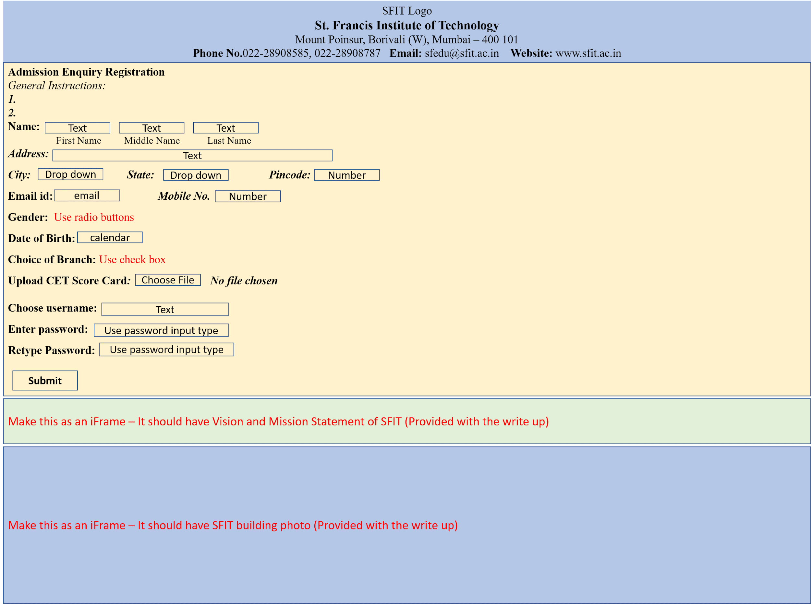

The following features of HTML are to be used -

* Block elements
* Forms
* iFrames

**8. Post Experimental Exercise-**

1. what is the difference between datalist tag and select tag?

2. **Complete the following code.**

a. In the form below, add two checkboxes, both with the name "fruits".

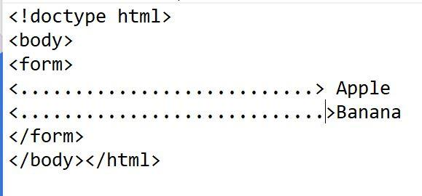

**b.** Complete the following code to display webpage within a webpage.

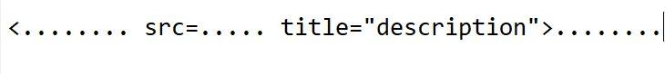

**9. Results/Observations/Program output:**

Present the program code and output

**CODE:**

| **<!DOCTYPE html>**  **<html>**  **<head>**  **<title>Admission Enquiry</title>**  **</head>**  **<body style="background-color: #f2f2f2; font-family: Arial, sans-serif; margin: 0; padding: 0;">**  **<div style="background-color: #3498db; text-align: center; padding: 20px;">**  **<img src="C:\Users\Sherw\Downloads\logo.png" height="200px" width="200px" ></img>**  **<h2>St. Francis Institute of Technology</h2>**  **<p>Mount Poinsur, Borivali(W), Mumbai - 400 101</p>**  **<p><strong>Phone No:</strong> 022-28908585, 022-28908787 <strong>Email:</strong> <a href="mailto:sfedu@sfit.ac.in">sfedu@sfit.ac.in</a> <strong>Website:</strong> <a href="http://www.sfit.ac.in">www.sfit.ac.in</a></p>**  **</div>**  **<div style="background-color: #ffffff; padding: 20px; margin: 20px auto; max-width: 800px; border-radius: 5px; box-shadow: 0px 0px 5px rgba(0, 0, 0, 0.2);">**  **<h3>Admission Enquiry Registration</h3>**  **<i>General Instructions:</i>**  **<ol>**  **<li>Enter proper details</li>**  **<li>Enter correct marksheets</li>**  **</ol>**  **<label><strong>Name:</strong></label>**  **<input type="text" id="fname" name="fname">**  **<input type="text" id="mname" name="mname">**  **<input type="text" id="lname" name="lname">**  **<br><br>**  **<label><i><strong>Address:</strong></i></label><br>**  **<textarea rows="3" cols="70" name="comment" placeholder="Enter text here..."></textarea>**  **<br><br>**  **<label><strong>City:</strong></label>**  **<select>**  **<option value=""></option>**  **<option value="Mumbai">Mumbai</option>**  **<option value="Pune">Pune</option>**  **<option value="Bangalore">Bangalore</option>**  **<option value="Chennai">Chennai</option>**  **</select>**  **<label><strong>State:</strong></label>**  **<select>**  **<option value=""></option>**  **<option value="Maharashtra">Maharashtra</option>**  **<option value="Gujarat">Gujarat</option>**  **<option value="Andhra Pradesh">Andhra Pradesh</option>**  **<option value="Bihar">Bihar</option>**  **</select>**  **<label><strong>Pincode:</strong></label>**  **<input type="text" id="pincode" name="pincode">**  **<br><br>**  **<label><strong>Phone No:</strong></label>**  **<input type="text" id="phoneno" name="phoneno">**  **<label><strong>Email:</strong></label>**  **<input type="text" id="email" name="email">**  **<br><br>**  **<label><strong>Gender:</strong></label>**  **<input type="radio" id="male" name="gender" value="male">Male**  **<input type="radio" id="female" name="gender" value="female">Female**  **<br><br>**  **<label><strong>Date of Birth:</strong></label>**  **<input type="date" id="birthday" name="birthday">**  **<br><br>**  **<label><strong>Choice of Branch:</strong></label>**  **<select>**  **<option value=""></option>**  **<option value="it">Information Technology</option>**  **<option value="cs">Computer Science</option>**  **<option value="electrical">Electrical Engineering</option>**  **<option value="mechanical">Mechanical Engineering</option>**  **<option value="humanities">Basic Science of Humanities</option>**  **</select>**  **<br><br>**  **<label><strong>Upload CET Score Card:</strong></label>**  **<input type="file" id="myfile" name="myfile">**  **<br><br>**  **<label><strong>Choose Username:</strong></label>**  **<input type="text" id="username" name="username">**  **<br><br>**  **<label><strong>Enter Password:</strong></label>**  **<input type="password" id="pass" name="pass">**  **<br><br>**  **<label><strong>Retype Password:</strong></label>**  **<input type="password" id="repass" name="repass">**  **<br><br>**  **<input type="submit" value="Submit">**  **<iframe src="F:\VSCODE\exp21.1.html" width="800" height="200"></iframe>**  **<iframe src="F:\VSCODE\exp22.1.html" width="800" height="200"></iframe>**  **</div>**  **<div style="background-color: #333333; color: #ffffff; text-align: center; padding: 10px; position: absolute; bottom: 1; width: 100%;">**  **&copy; 2023 St. Francis Institute of Technology. All rights reserved.**  **</div>**  **</body>**  **</html>** |
| --- |

**VISION AND MISSION:**

| **<html>**  **<head>**  **<title></title>**  **<style>**  **.myDiv {**    **background-color: lightblue;**  **}**  **</style>**  **</head>**  **<body>**  **<div class="myDiv">**  **<h4>Vision</h4>**  **<p>**  **To be a chrysalis where bright youngsters are transformed into technological**  **entrepreneurs and innovative leaders of tomorrow’s world, consistent with the**  **Franciscan vision of integrity, peace and love.</p>**    **<h4>Mission</h4>**  **<p>To churn highly competent engineering graduates with a commitment to result**  **oriented work, a perennial zest for learning, a quest for excellence, an open**  **mind and the universal values of honesty, dignity and mutual care.</p>**  **</div>**  **</body>**  **</html>** |
| --- |

**BUILDING:**

| **<html>**  **<head>**  **<title></title>**  **<style>**  **.myDiv {**    **background-color: lightblue;**  **}**  **</style>**  **</head>**  **<body>**  **<div="myDiv">**  **<img src="C:\Users\Sherw\Downloads\building.jpg" height="150px" width="800px"></img>**  **</div>**  **</body>**  **</html>** |
| --- |

**OUTPUT:**

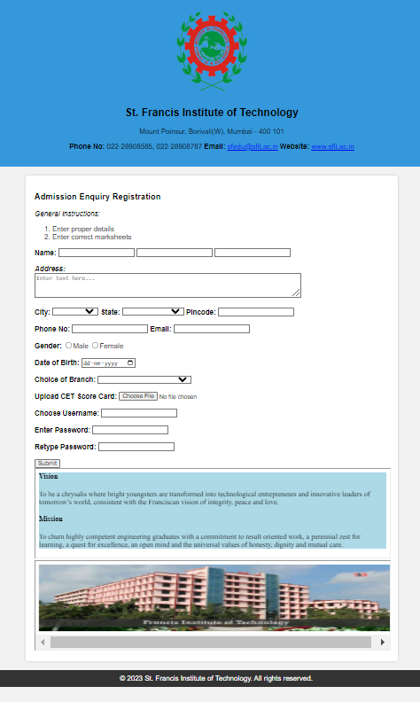

**10. Conclusion:**

Write what was performed in the experiment

Write which all features of HTML you used to perform the experiment

**11. References:**

* HTML 5 Black Book (Covers CSS3, JavaScript, XML, XHTML, AJAX, PHP, jQuery) 2Ed., DT Editorial Services
* <https://www.w3schools.com/html/default.asp>
* <https://spoken-tutorial.org/watch/HTML/Forms+in+HTML/English/>
* <https://spoken-tutorial.org/watch/HTML/More+on+Forms/English/>
* <https://www.tutorialspoint.com/html/index.htm>
* [https://www.youtube.com/watch?v=qz0aGYrrlhU](https://www.tutorialspoint.com/)