St. Francis Institute of Technology

Mount Poinsur, S.V.P. Road, Borivali (W), Mumbai-103

**Class: TE IT A & B Academic Year: 2023-2024**

**Experiment – 5**

**Menu driven program using control structures in JavaScript**

**________________________________________________________________**

**Aim:** To write a menu driven program in JavaScript to demonstrate the use of control structures

**Objective:** After performing the experiment, the students will be able to understand and implement the basic concepts of JavaScript including use of

* Variables
* Operators
* Conditions
* Loops

**Lab objective mapped:** Students will be able to use JavaScript to develop interactive web pages (PO3, PO5, PSO3, PSO4)

**Prerequisite:** HTML andJavaScript

**Requirements:** The following are the requirements **–**

* PC/Laptop
* Visual Studio Code
* Browser

**Pre-Experiment Theory:**

The JavaScript if-else statement is used *to execute the code whether condition is true or false*. There are three forms of if statement in JavaScript.

1. If Statement
2. If else statement
3. if else if statement

**JavaScript If statement**

It evaluates the content only if expression is true. The signature of JavaScript if statement is given below.

1. if(expression){
2. //content to be evaluated
3. }

### JavaScript If...else Statement

It evaluates the content whether condition is true of false. The syntax of JavaScript if-else statement is given below.

1. if(expression){
2. //content to be evaluated if condition is true
3. }
4. else{
5. //content to be evaluated if condition is false
6. }

# **JavaScript Switch**

The JavaScript switch statement is used *to execute one code from multiple expressions*. It is just like else if statement that we have learned in previous page. But it is convenient than *if..else..if* because it can be used with numbers, characters etc.

switch(expression){

case value1:

code to be executed;

break;

case value2:

code to be executed;

break; }

# **JavaScript Loops**

The JavaScript loops are used *to iterate the piece of code* using for, while, do while or for-in loops. It makes the code compact. It is mostly used in array.

There are four types of loops in JavaScript.

1. for loop
2. while loop
3. do-while loop
4. for-in loop

## **JavaScript For loop**

The JavaScript for loop *iterates the elements for the fixed number of times*. It should be used if number of iteration is known. The syntax of for loop is given below.

1. for (initialization; condition; increment)
2. {
3. code to be executed
4. }

### The for…in loop

The for…in loop is similar to for loop, which iterates through the properties of an object, i.e., when you require to visit the properties or keys of the object, then you can use for…in loop. It is a better choice when you are working with objects or dictionaries where the order of index is not essential.

Syntax

1. for (variable_name in object_name) //Here in is the keyword
2. {
3. // statement or block to execute
4. }

### The for…of loop

Unlike the object literals, this loop is used to iterate the iterables (arrays, string, etc.).

Syntax

1. for(variable_name of object_name) // Here of is a keyword
2. {
3. //statement or block to execute
4. }

**Laboratory Exercise:**

**A. Procedure**

Open Visual Studio Code

Select File, New to write to a new file

Save the file as .html

Write the code

To view the output, right-click on the file and select Open With option. Then choose any

web browser that is available.

Check output

**B. Program Code**

Write a Menu driven program in JavaScript to carry out the following in order to demonstrate the use of control structures -

* To find greatest among three numbers.
* To display even numbers less than 20.
* To calculate area of a triangle.
* To find if the entered year is a leap year or not
* To display a table of number n.
* To find the entered number is a perfect number or not.

**Post Experimental Exercise-**

Google Form Quiz Link -

**Results/Observations/Program output:**

Present the program code and output

**Conclusion:**

Write what was performed in the experiment

Write which all features of HTML and JavaScript you used to perform the experiment

**References:**

* HTML 5 Black Book (Covers CSS3, JavaScript, XML, XHTML, AJAX, PHP, jQuery) 2Ed., DT Editorial Services
* <https://www.w3schools.com/js/default.asp>
* <https://www.tutorialspoint.com/javascript/index.htm>
* <https://www.youtube.com/watch?v=W6NZfCO5SIk>
* <https://www.youtube.com/watch?v=PkZNo7MFNFg>

| CODE:  // Taking user input  const choice = parseInt(prompt(  "Enter your choice:\n" +  "1. Find greatest among three numbers\n" +  "2. Display even numbers less than 20\n" +  "3. Calculate area of a triangle\n" +  "4. Check leap year\n" +  "5. Display table of a number\n" +  "6. Check perfect number"  ));  switch (choice) {  case 1:  // Find greatest among three numbers  const num1 = parseFloat(prompt("Enter the first number:"));  const num2 = parseFloat(prompt("Enter the second number:"));  const num3 = parseFloat(prompt("Enter the third number:"));  let max = num1;  if (num2 > max) {  max = num2;  }  if (num3 > max) {  max = num3;  }  console.log(The greatest number is: ${max});  break;  case 2:  // Display even numbers less than 20  console.log("Even numbers less than 20:");  for (let i = 2; i < 20; i += 2) {  console.log(i);  }  break;  case 3:  // Calculate area of a triangle  const base = parseFloat(prompt("Enter the base of the triangle:"));  const height = parseFloat(prompt("Enter the height of the triangle:"));  const area = 0.5 * base * height;  console.log(The area of the triangle is: ${area});  break;  case 4:  // Check leap year  const year = parseInt(prompt("Enter a year:"));  if ((year % 4 === 0 && year % 100 !== 0) || year % 400 === 0) {  console.log(${year} is a leap year.);  } else {  console.log(${year} is not a leap year.);  }  break;  case 5:  // Display table of a number  const n = parseInt(prompt("Enter a number:"));  console.log(Table of ${n}:);  for (let i = 1; i <= 10; i++) {  console.log(${n} x ${i} = ${n * i});  }  break;  case 6:  // Check perfect number  const num = parseInt(prompt("Enter a number:"));  let sum = 0;  for (let i = 1; i <= num / 2; i++) {  if (num % i === 0) {  sum += i;  }  }  if (sum === num) {  console.log(${num} is a perfect number.);  } else {  console.log(${num} is not a perfect number.);  }  break;  default:  console.log("Invalid choice.");  } |
| --- |

**OUTPUT:**

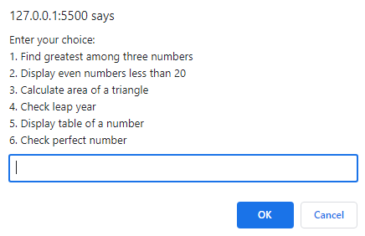

* To find greatest among three numbers.



* To display even numbers less than 20.

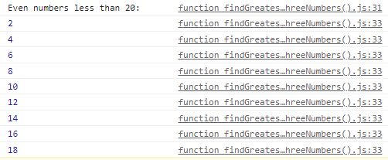

* To calculate area of a triangle.



* To find if the entered year is a leap year or not



* To display a table of number n.

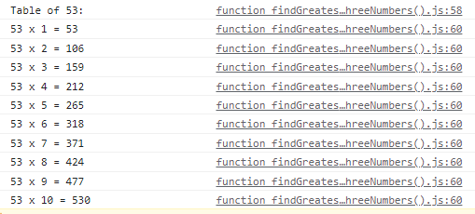

* To find the entered number is a perfect number or not.

