GUEST_ROLE

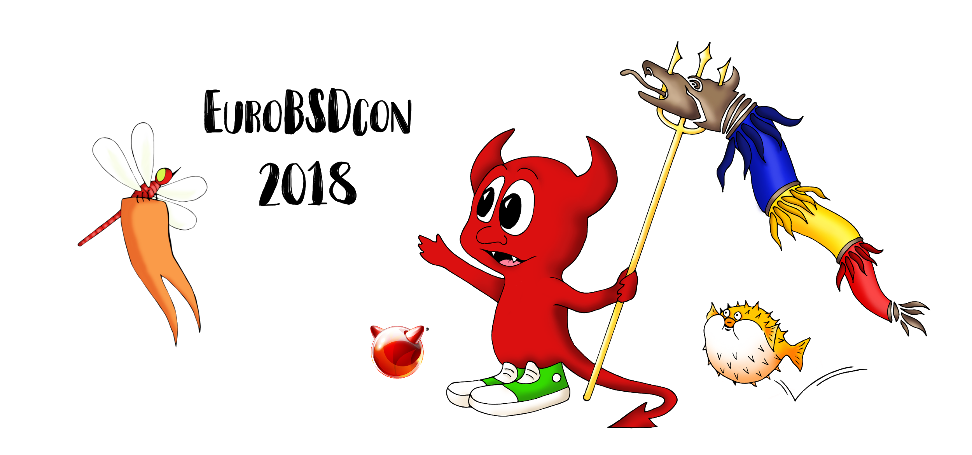

GUEST_NAME

GUEST_MAIL

|  |
| --- |
| **GUEST_EVENTS** |
| *GUEST_TUTORIALS* |