Raspberry Location Tracking

Darius Birescu, Dan Blaga June, 2018

1. **Repository**

The project codebase, history, diagrams can be found at the following git repository:

<https://github.com/dariusbirescu/RaspberryLocationTracking>

1. **User requirements**
2. The system should compute the remaining distance to the destination
3. The system should be able to track a persons’ location
4. The system should periodically save the data of the previous and current user locations
5. The system should operate in any vehicle
6. The system should notify the user if the current location has not changed in a period of 10 minutes
7. The system should be able to accept input parameters regarding the next location to be visited
8. **System overview**

The system overview is depicted below:

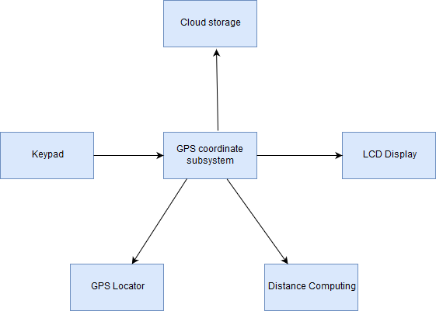

GPS coordinate subsystem: contains the GPS-related modules (getting the coordinates, computing the remaining travel distance)

Keypad, LCD Display: the user will use the keypad to introduce the coordinates of the new location, and will see the remaining distance on the LCD display

Cloud storage: The location data will be stored using a cloud storage service