Darius Tatum
CS-340 Client/Server Development
Professor Reed Perkins
October 2, 2026
Project One: AnimalShelter CRUD Module
About the Project
This is a Python class named AnimalShelter. I wrote it for Grazioso Salvare, a rescue-dog training company. They get outcome records from shelters around Austin and need a way to add, look up, change, and remove those records. Other scripts import this class instead of talking to MongoDB themselves. The database is aac. The collection is animals.
Motivation
Grazioso Salvare looks for dogs that might work for search-and-rescue training. They do not need the whole shelter dump every time. They need a way to filter the records they already have. If every notebook has its own insert and find, one of those copies will be wrong. One class keeps the database code in one place. Project Two will hook this same class to the dashboard.
Getting Started
This runs in Codio. The data file is already in the datasets folder. The class file and the test notebook are in code_files.
1. Open the Codio terminal and go to the datasets folder: cd ./datasets
2. Import the shelter file: mongoimport --type=csv --headerline --db aac --collection animals --drop ./aac_shelter_outcomes.csv
3. Open the shell: mongosh
4. Switch to the admin database: use admin
5. Create the user: db.createUser({ user: “aacuser”, pwd: “<your password>”, roles: [ { role: “readWrite”, db: “aac” } ] })
6. Open Jupyter Lab and go to the code_files folder.
7. Import AnimalShelter from CRUD_Python_Module.py and pass aacuser plus that password. The user was created in admin, so the connection has to use authSource='admin' or login fails.

Installation
MongoDB is already running inside Codio. Python 3 and Jupyter Lab are the course environment. The only library the class needs is PyMongo, the official MongoDB driver for Python. I used it because the course readings use it for insert_one, find, update_many, and delete_many, and because Codio already has it installed. No extra packages were added.
Usage
Create the object with the aacuser account, then call one method. create takes a dictionary and returns True if Mongo accepted the insert. read takes a filter and returns a list. update takes a filter and the fields to change, and returns how many documents changed. delete takes a filter and returns how many documents were removed.
Code example
from CRUD_Python_Module import AnimalShelter
shelter = AnimalShelter(‘aacuser’, ‘<Module 3 password>’)
shelter.create({“animal_id”: “A888888”, “name”: “TestDog”})
shelter.read({“animal_id”: “A888888”})
shelter.update({“animal_id”: “A888888”}, {“name”: “UpdatedDog”})
shelter.delete({“animal_id”: “A888888”})
Tests
ProjectOneTestScript.ipynb is the test. It sits in the same folder as the class file. Run the cell after a kernel restart so Jupyter loads the new methods. create should print True. read should print 1. update should print 1 and the name should be UpdatedDog. delete should print 1 and a second read should print 0.
Screenshots
Import of aac_shelter_outcomes.csv into aac.animals.
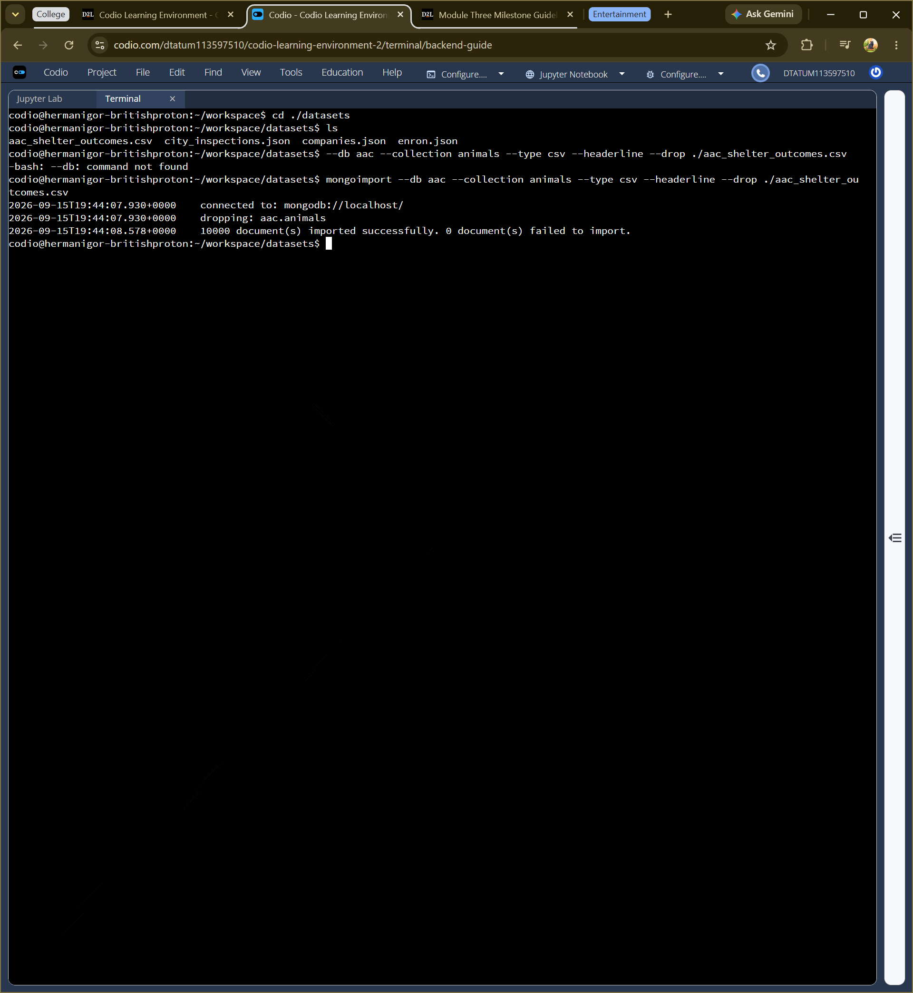
aacuser created in admin with readWrite on aac, then authenticated.
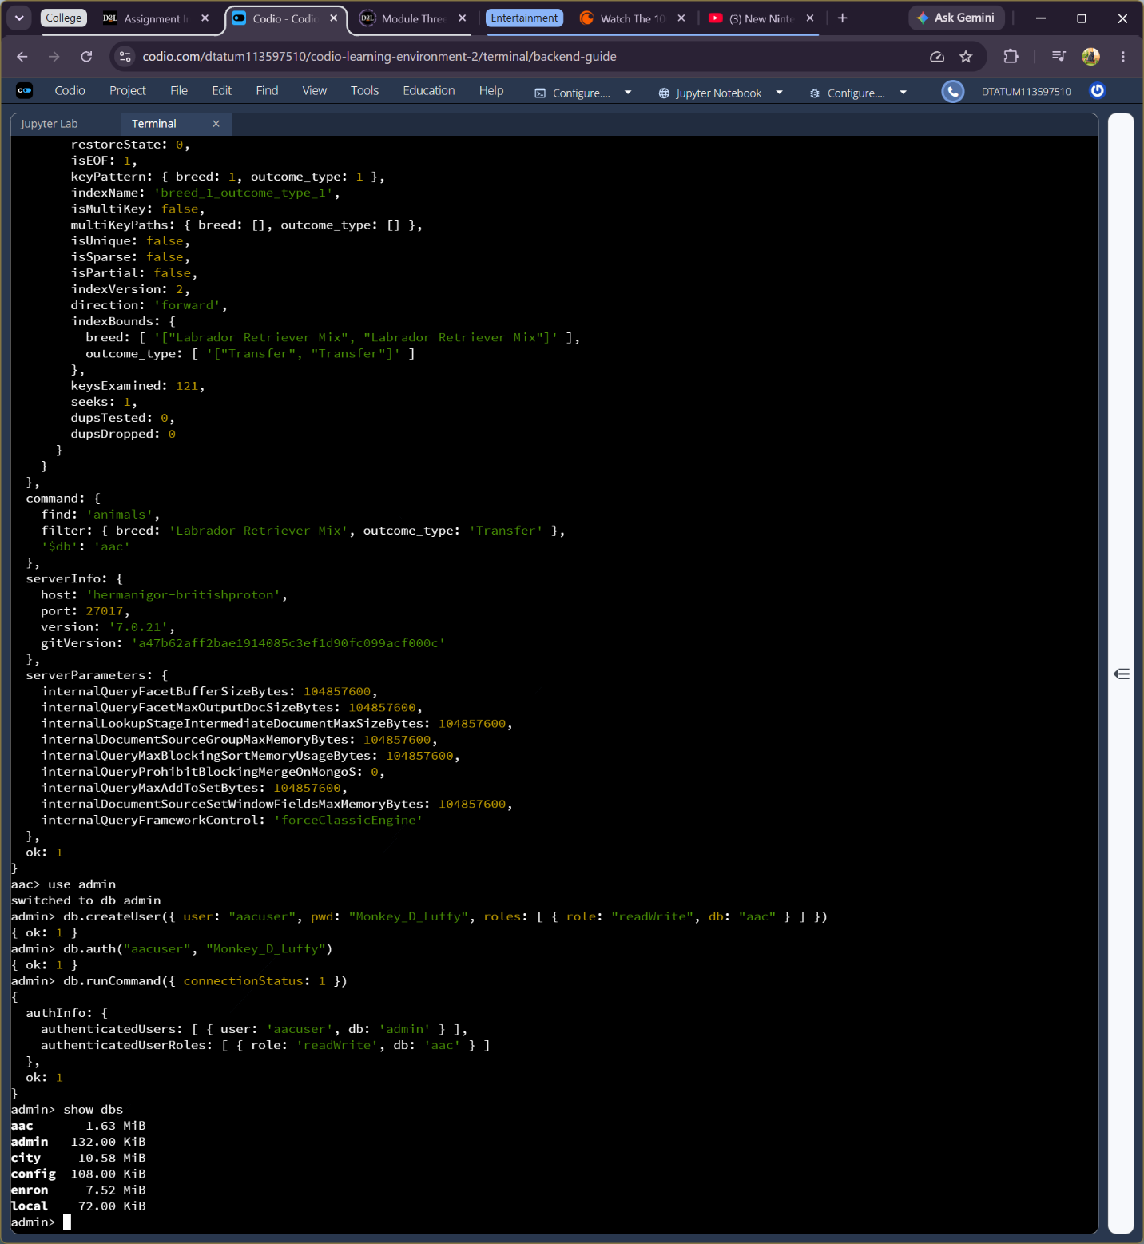
AnimalShelter class with create, read, update, and delete.
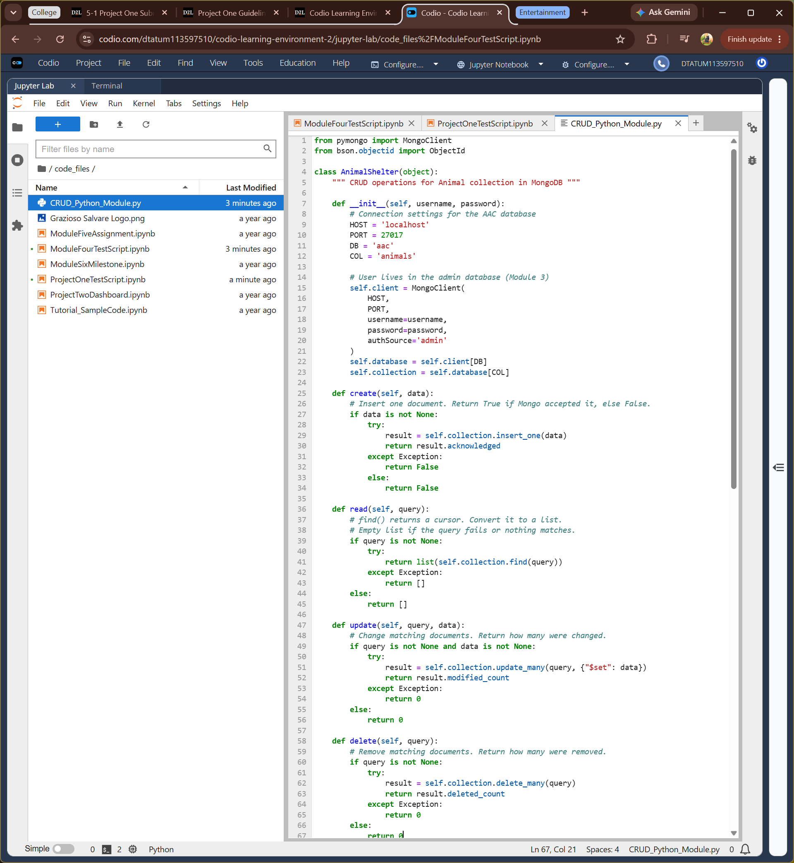
Notebook test. create returned True, update changed 1, delete removed 1.
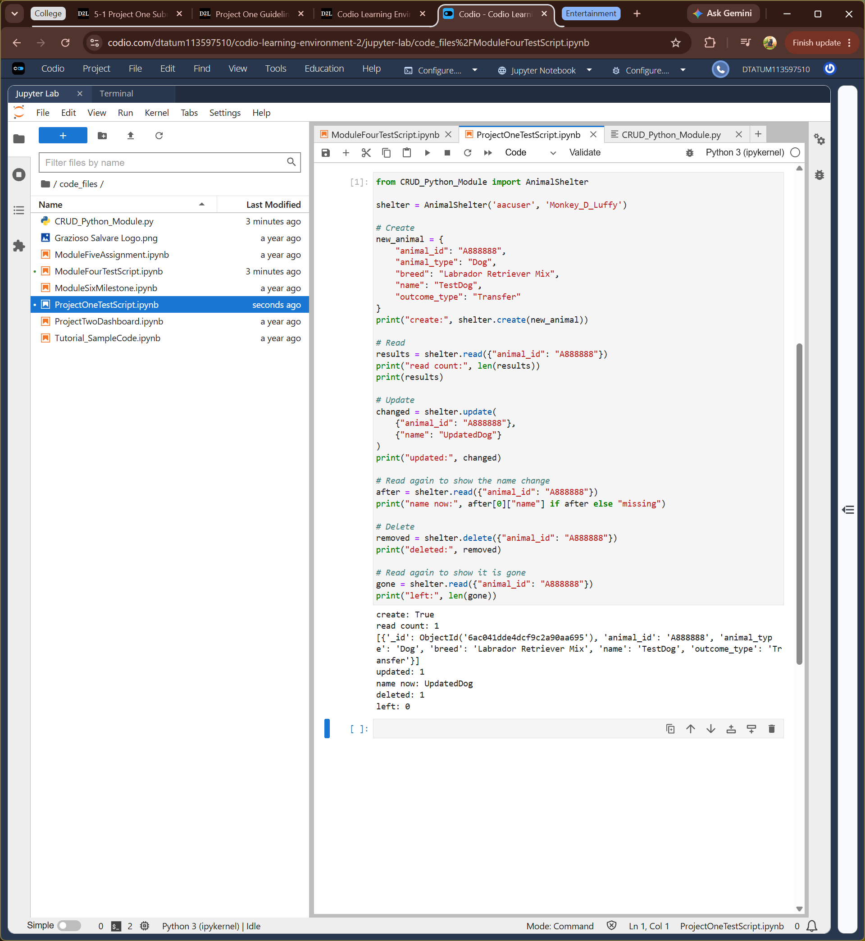
Contact
Darius Tatum, Southern New Hampshire University, CS-340 Client/Server Development

