Grazioso Salvare Dashboard
CS-340 Client/Server Development | Darius Tatum | October 11, 2026

About the Project
This dashboard is for Grazioso Salvare. They train dogs for search and rescue. The dogs come from a non-profit that runs five shelters around Austin, Texas. Grazioso needs a way to look at that shelter data and pull the dogs that fit a rescue type, instead of scrolling the whole file.
I am the developer on this for Global Rain. The earlier modules built the database and the CRUD class. This project is the page the client uses. It has four filter buttons, a table, a map, and a pie chart. The logo links to www.snhu.edu, which is the stand-in for the client home page.

What It Does
The page opens on every record in the Austin Animal Center Outcomes set. The user picks a rescue type. The class runs that query, and the table, the pie chart, and the map all update from the result. Reset puts the full set back.
The filters come from the Rescue Type table in the Dashboard Specifications document. Age uses age_upon_outcome_in_weeks.
- Water Rescue: Labrador Retriever Mix, Chesapeake Bay Retriever, or Newfoundland. Intact Female. 26 to 156 weeks.
- Mountain or Wilderness Rescue: German Shepherd, Alaskan Malamute, Old English Sheepdog, Siberian Husky, or Rottweiler. Intact Male. 26 to 156 weeks.
- Disaster or Individual Tracking: Doberman Pinscher, German Shepherd, Golden Retriever, Bloodhound, or Rottweiler. Intact Male. 20 to 300 weeks.
- Reset: no filter. The table goes back to the full set.

Tools
MongoDB is the database. The shelter records do not all look the same, and the queries for breed, sex, and age are easier to write as a document filter than as a join. Python talks to it through PyMongo inside the AnimalShelter class from Project One. PyMongo returns each record as a Python dictionary, so the query result goes straight into a pandas DataFrame for the table and the charts.
Dash is the page. The layout is the view. The callbacks are the controller. A radio button change calls the class, and the class calls MongoDB. Pandas sits in the middle so the query result can go into the DataTable and the pie chart.
The pie chart is Plotly. The map is dash-leaflet, using location_lat and location_long from the file. The logo file was already in the Codio code_files folder.
Dash DataTable: https://dash.plotly.com/datatable
Plotly pie charts: https://plotly.com/python/pie-charts/
Dash Leaflet: https://dash-leaflet-docs.onrender.com/

Getting Started
This runs in Codio, in the Jupyter Lab for this course. The database work was done in Module 3. These are the steps, in order.
- Open a terminal in the virtual lab and go to the datasets folder.
- Import the shelter file: mongoimport --db aac --collection animals --type csv --headerline --drop ./aac_shelter_outcomes.csv
- In mongosh, create the user in the admin database, not in aac. The user is aacuser with readWrite on aac. The password is the one set in Module 3.
- Put CRUD_Python_Module.py and ProjectTwoDashboard.ipynb in the same folder, code_files. The logo file Grazioso Salvare Logo.png has to be in that folder too.
- Open ProjectTwoDashboard.ipynb and run the cell. The app prints a proxy URL. Open that URL.

How to Use It
The page loads on Reset. That is the full set, page 1 of 1001. Pick Water Rescue, Mountain or Wilderness Rescue, or Disaster or Individual Tracking. The table shrinks to the matching dogs. Click a row and the map pin moves to that dog. Reset brings the full set back.
The class is called the same way as Project One.
from CRUD_Python_Module import AnimalShelter
shelter = AnimalShelter('aacuser', '<Module 3 password>')

Tests
I ran the notebook and checked each button. Reset showed the full set, with the first row as cat A746874. Water Rescue came back as intact females, Labrador Retriever and mixes, page 1 of 3. Mountain came back as intact males, German Shepherd and Alaskan Malamute, page 1 of 2. Disaster came back as intact males, Bloodhound and German Shepherd, page 1 of 3. Boomer on the disaster page is 209 weeks, which is past the mountain cutoff of 156, so that filter is not a copy of mountain. Reset after that went back to 1 of 1001.

Screenshots
Starting page. Reset is selected. The pager is 1 / 1001.
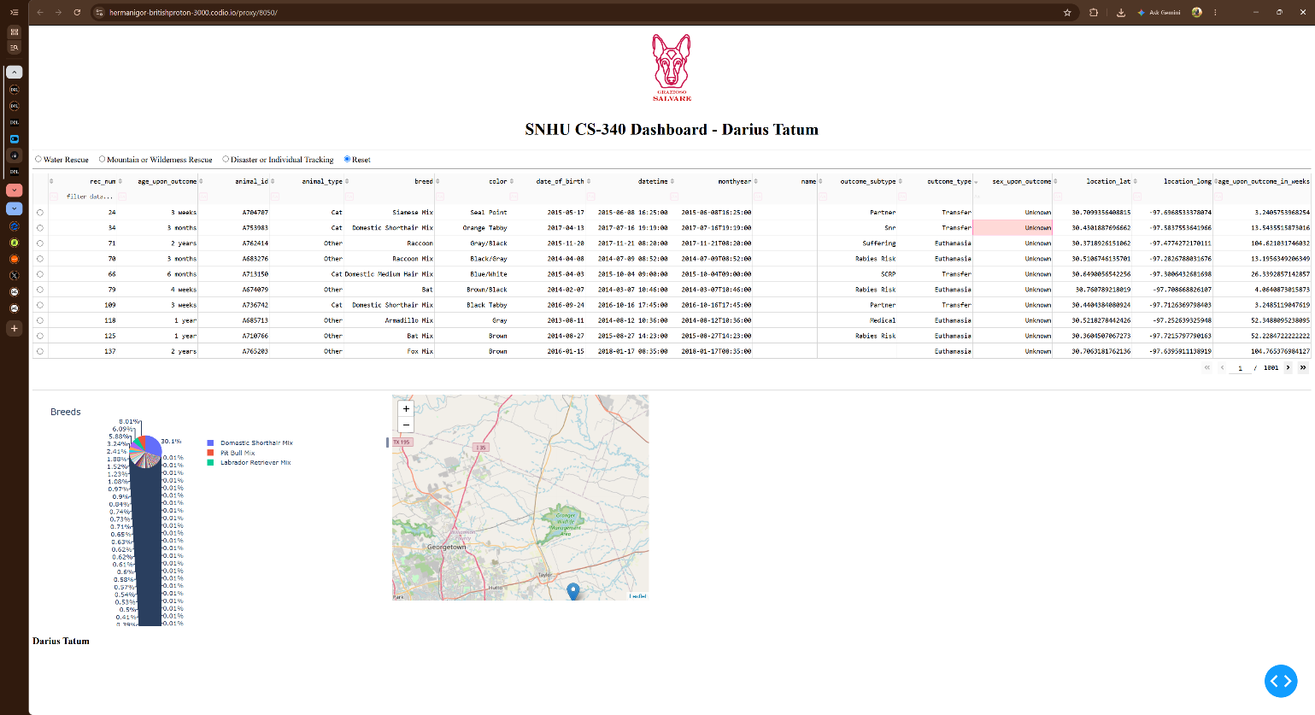
Figure 1. Starting page, unfiltered.
Water Rescue. Intact female, Labrador Retriever.
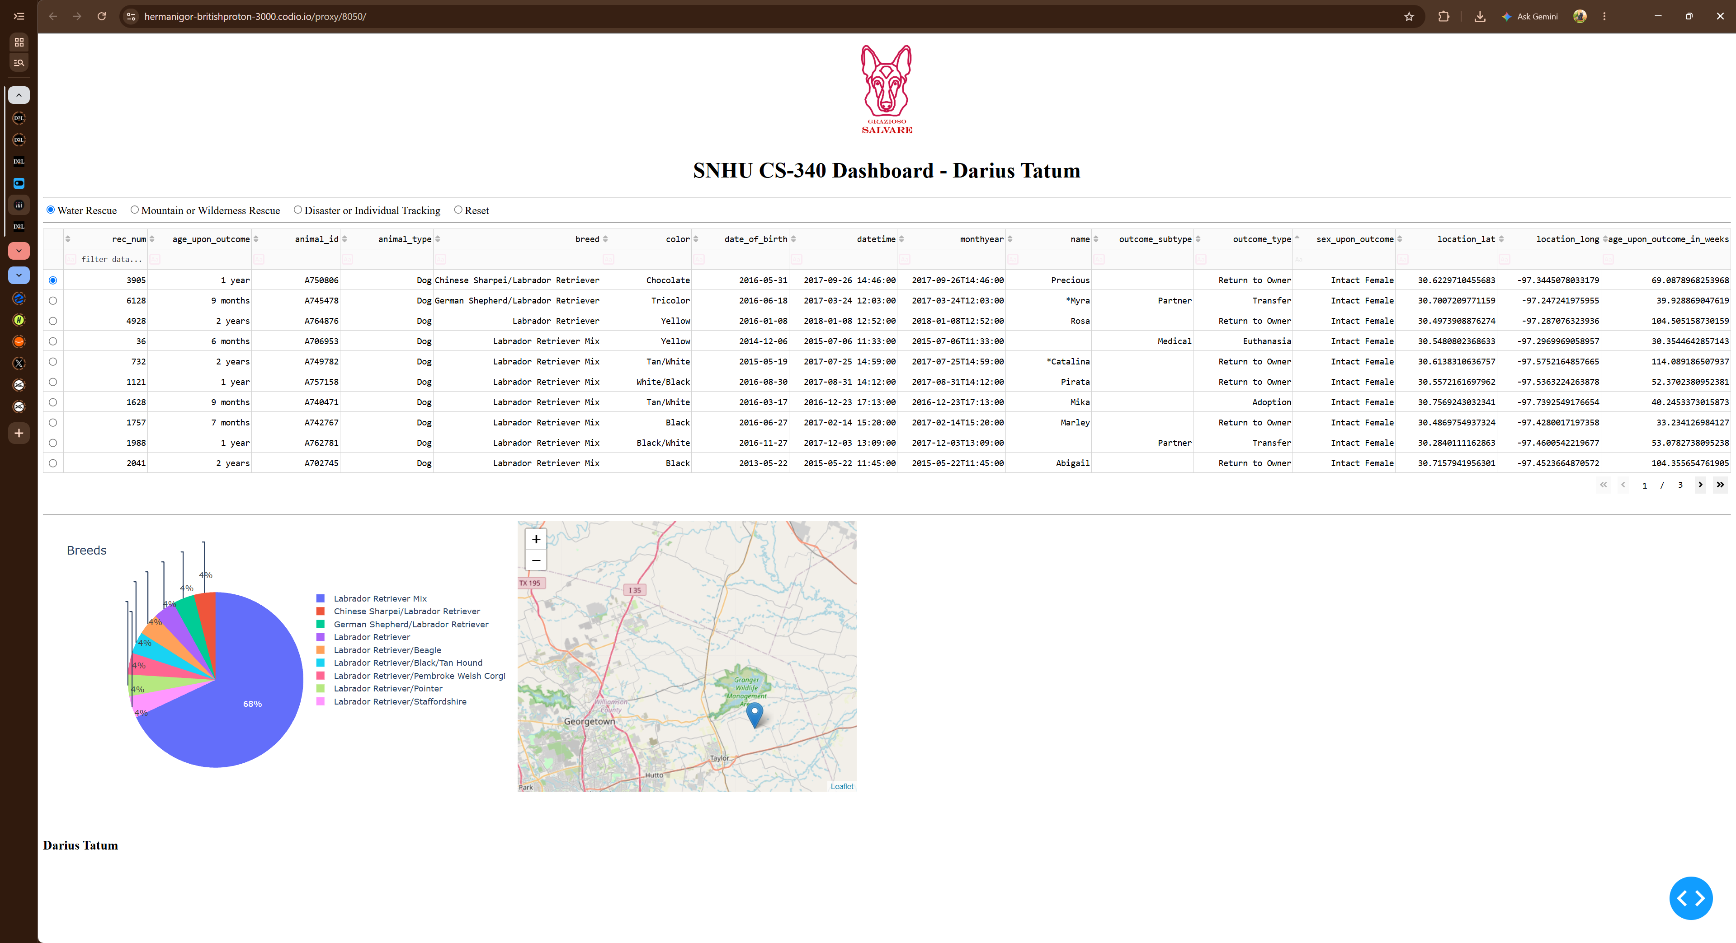
Figure 2. Water Rescue.
Mountain or Wilderness Rescue. Intact male, German Shepherd and Alaskan Malamute.
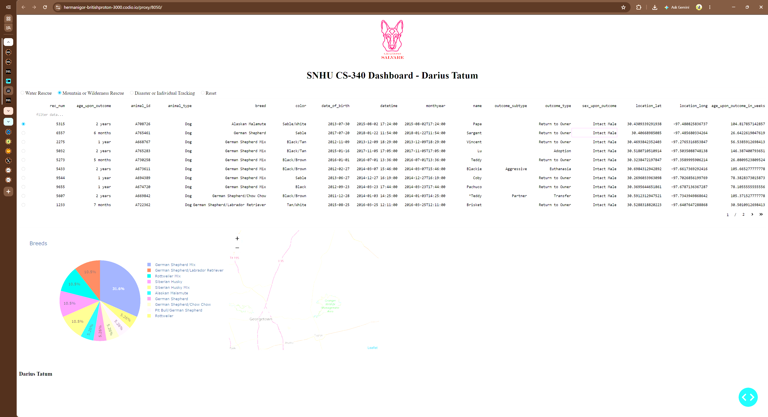
Figure 3. Mountain or Wilderness Rescue.
Disaster or Individual Tracking. Intact male, Bloodhound and German Shepherd.
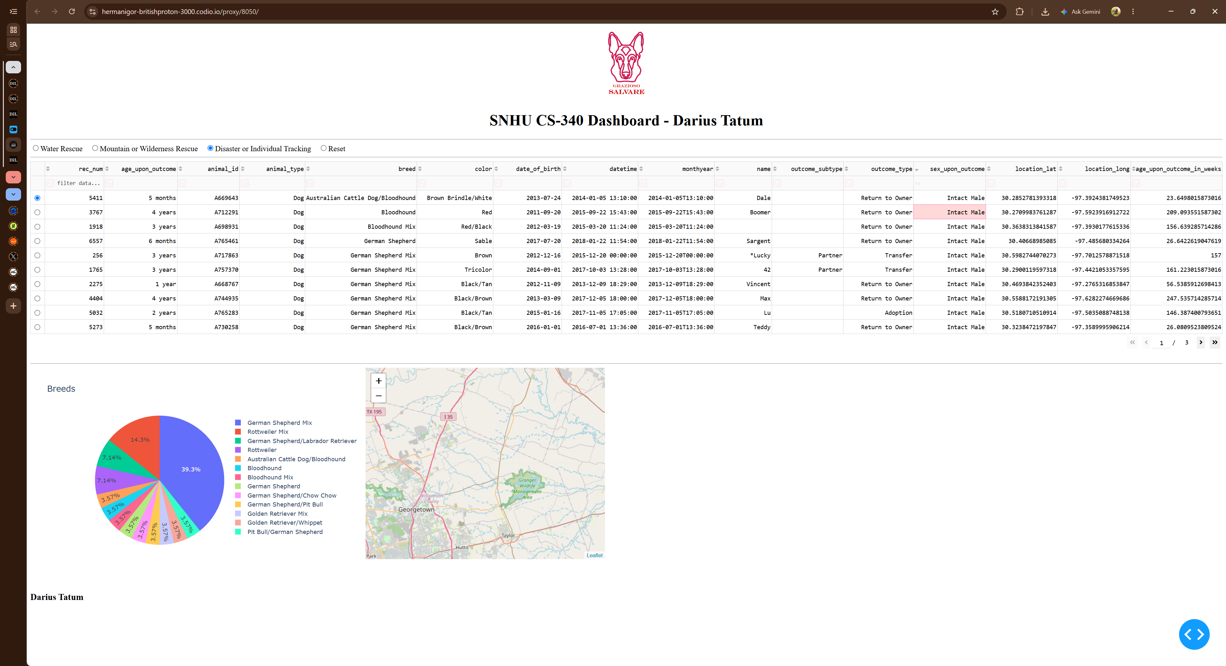
Figure 4. Disaster or Individual Tracking.
Reset after a filter. The pager is back to 1 / 1001.
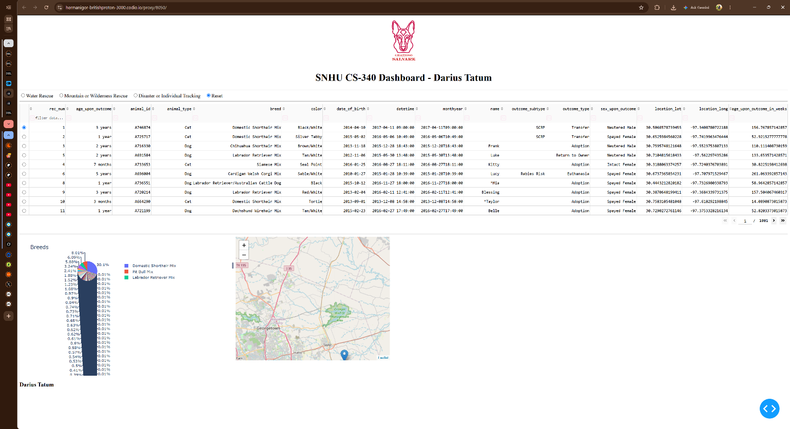
Figure 5. Reset, returned to the unfiltered state.

Steps
- Imported the CSV and created aacuser in Module 3.
- Built the AnimalShelter class in Project One. create, read, update, and delete.
- Built the unfiltered table and the map in Module 6.
- Copied that into ProjectTwoDashboard.ipynb and added the four radio buttons.
- Each button calls shelter.read() with the breed, sex, and age from the spec table.
- Added the pie chart so it redraws from whatever the table is showing.
- Ran each filter and took the screenshots above.

Challenges
The user aacuser was created in the admin database. Login failed until the class passed authSource='admin'. That was fixed in Module 3 and left alone after that.
The first run of this notebook had the pie chart id set to graph=id. The callback was looking for graph-id, so the page loaded the table and the map and threw "ID not found in layout." Changing the id fixed it.
The sample map used column numbers. The CSV has a blank first column, so those numbers pointed at the wrong fields. The map uses location_lat, location_long, breed, and name instead.
Water Rescue was easy to mix up with Mountain. Water is intact female and the Labrador group. Mountain and Disaster are intact male. Disaster also goes to 300 weeks, which is why a 209 week dog shows up there and not on the mountain page.

