

Practices for Secure Software Report

Table of Contents
Document Revision History 3
Client 3
Instructions 3
Developer 4
1. Algorithm Cipher 4
2. Certificate Generation 4
3. Deploy Cipher 4
4. Secure Communications 4
5. Secondary Testing 4
6. Functional Testing 4
7. Summary 4
8. Industry Standard Best Practices 4

Document Revision History

Version | Date | Author | Comments
1.0 | 04/16/2026 | Darius Tatum

Client



Developer
Darius Tatum

Algorithm Cipher

The application uses the SHA-256 hashing algorithm to generate a checksum for data verification. SHA-256 is part of the SHA-2 family of cryptographic hash functions and produces a fixed-length 256-bit output regardless of input size.

In this implementation, a string representing transaction-related data is converted into a byte array using UTF-8 encoding. The MessageDigest class is then used to apply the SHA-256 algorithm to the input. The resulting byte array is converted into a hexadecimal string format, allowing it to be displayed and compared in a readable form.

This approach ensures data integrity by producing a unique hash value for the original input. Any modification to the input data would result in a completely different hash, making it suitable for checksum verification in financial or transactional systems.

Certificate Generation

A self-signed SSL certificate was generated using the Java Keytool utility. The certificate was created with RSA encryption and a key size of 2048 bits, stored in a PKCS12 keystore file. During the generation process, identifying information such as name, organization, and location was provided to associate the certificate with the application.

The certificate enables the server to establish secure HTTPS connections by encrypting communication between the client and server. Although self-signed certificates are not trusted by default in browsers, they are sufficient for development and testing purposes.

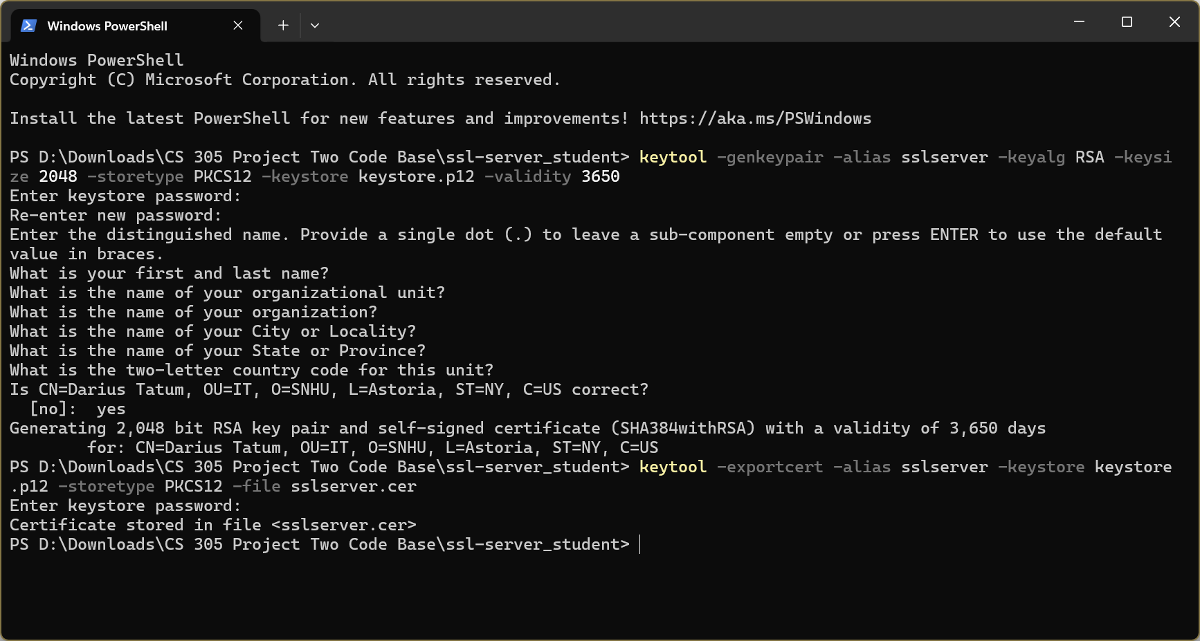
Figure 1: SSL certificate generated using Java Keytool

Deploy Cipher

The application was configured to use HTTPS by enabling SSL within the Spring Boot configuration. The keystore file containing the SSL certificate was referenced in the application properties file, along with the keystore password and alias.

The server was configured to run on port 8443, which is the standard port for HTTPS communication. Once deployed, the application used TLS to encrypt all incoming and outgoing data, ensuring secure transmission over the network.

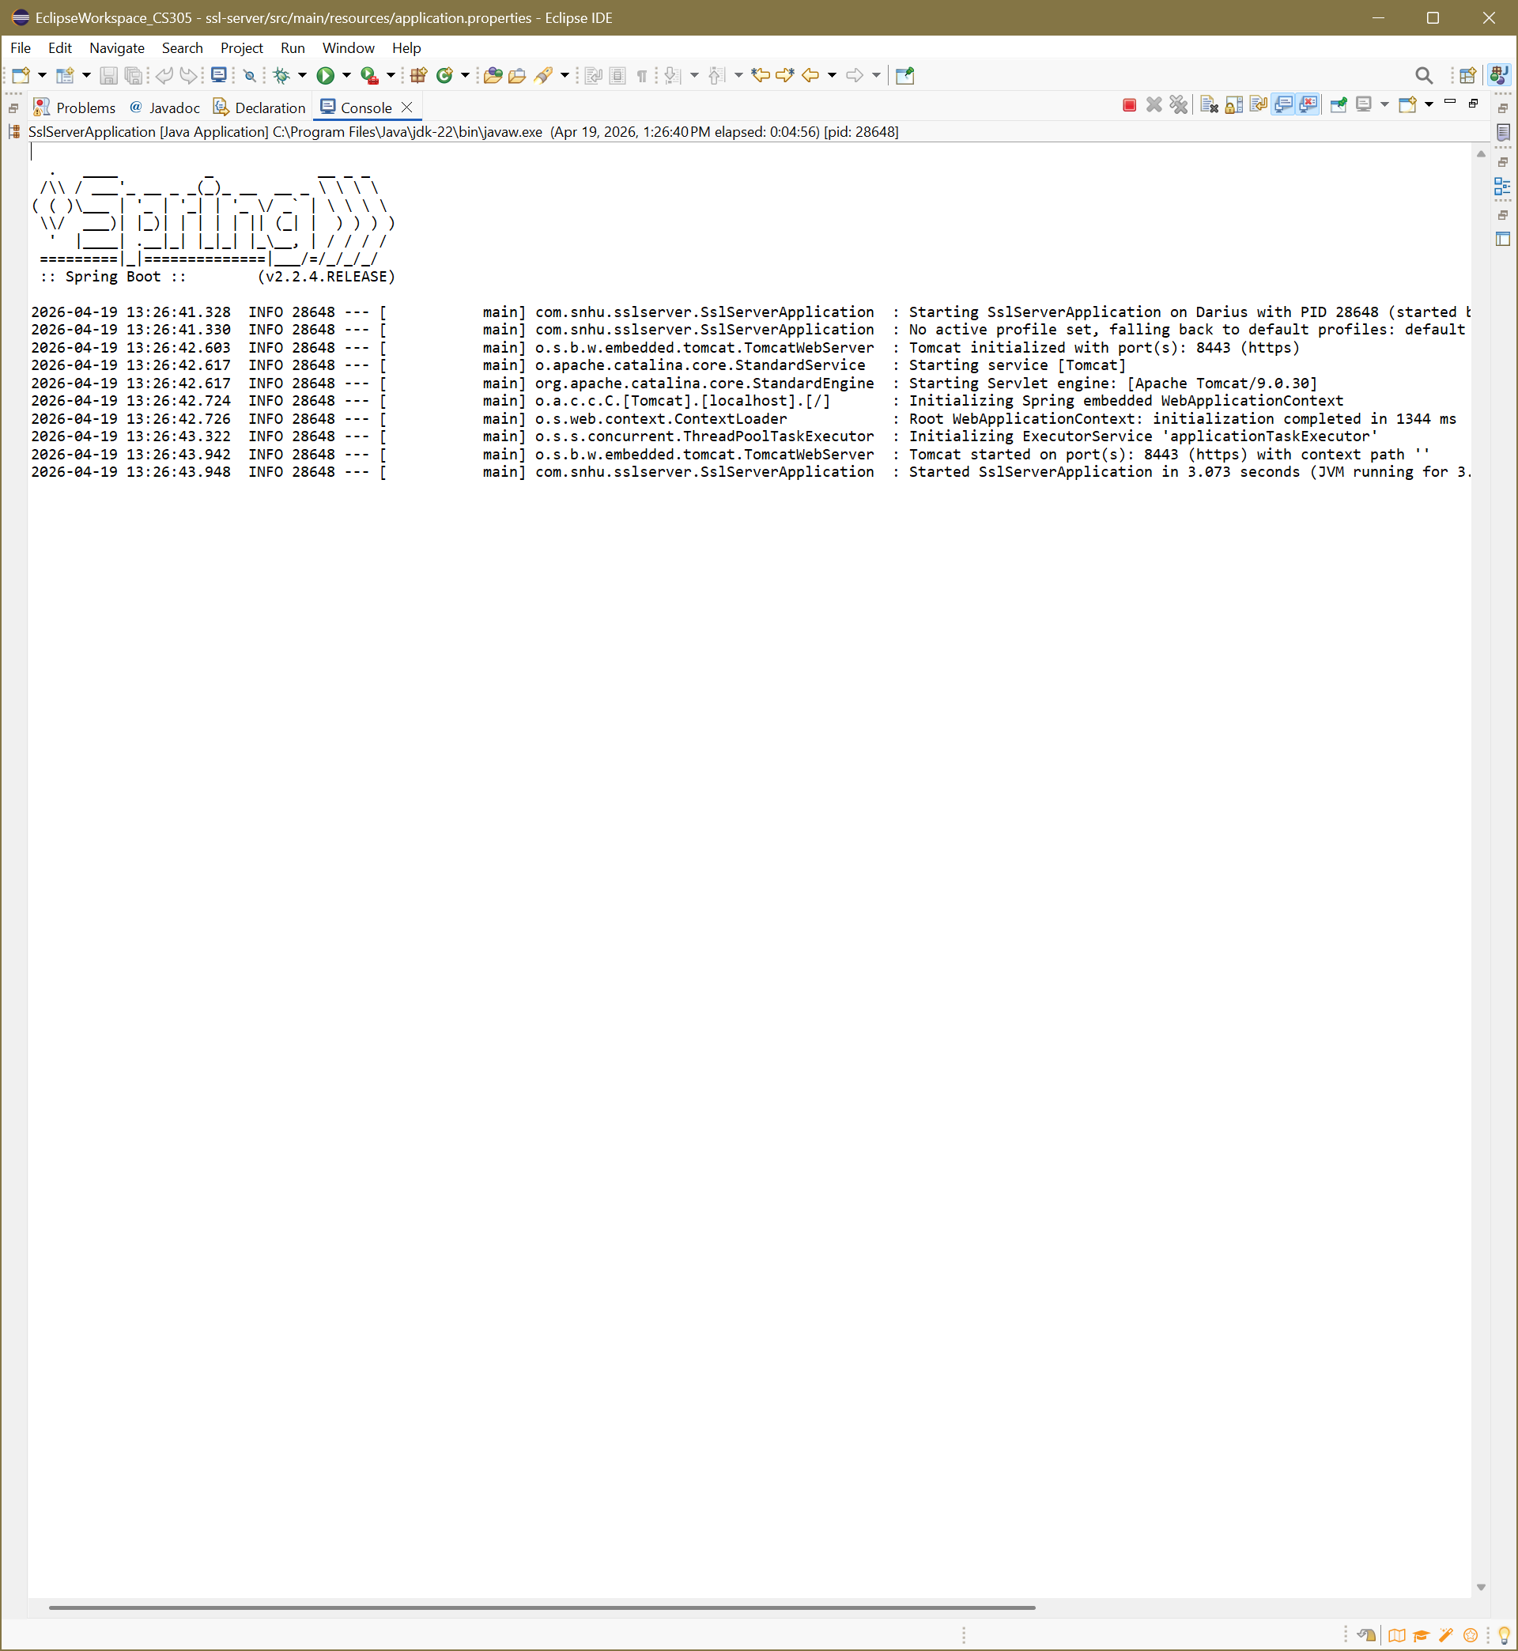
Figure 2: SSL configuration in application properties file

Secure Communications

Secure communication was verified by accessing the application through a web browser using the HTTPS protocol. When navigating to https://localhost:8443, the browser displayed a security warning due to the use of a self-signed certificate.

After proceeding past the warning, the application loaded successfully, confirming that HTTPS was properly configured and that communication between the client and server was encrypted. This demonstrates that the application enforces secure transport through TLS encryption despite the certificate not being issued by a trusted authority.


Figure 3: Browser security warning for self-signed certificate


Figure 4: Browser advanced/proceed option for self-signed certificate


Figure 5: Secure HTTPS connection displaying application output

Secondary Testing

Secondary testing was performed using OWASP Dependency-Check to identify known vulnerabilities within project dependencies. The initial scan revealed multiple vulnerabilities across several libraries, including high and critical severity issues.

After refactoring and applying mitigation steps, a follow-up scan was conducted. The results show a measurable reduction in identified vulnerabilities, demonstrating that security improvements were implemented while maintaining application stability.

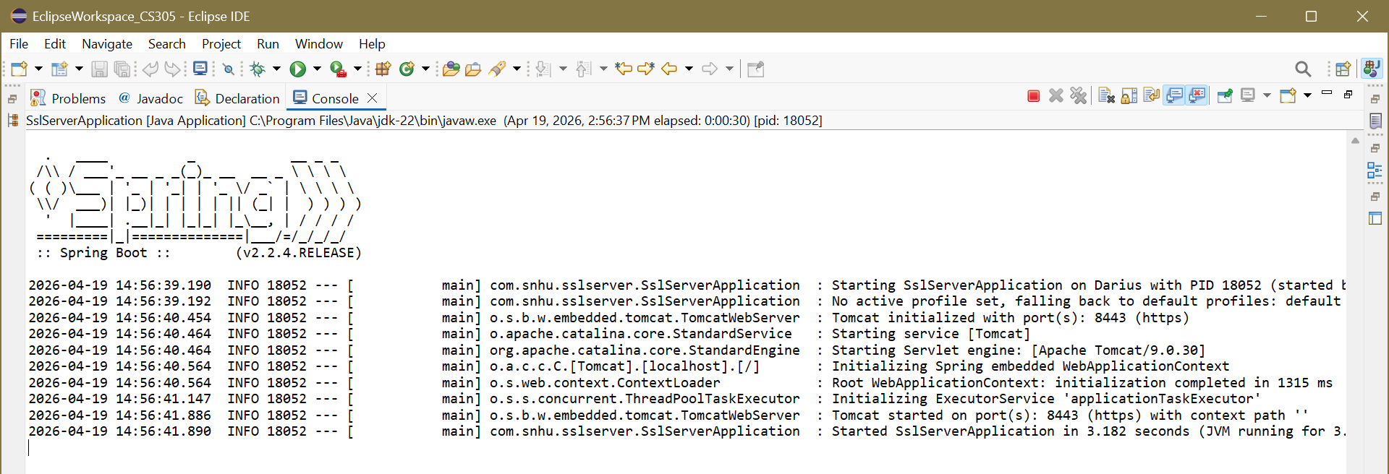
Figure 6: Refactored application running successfully without errors

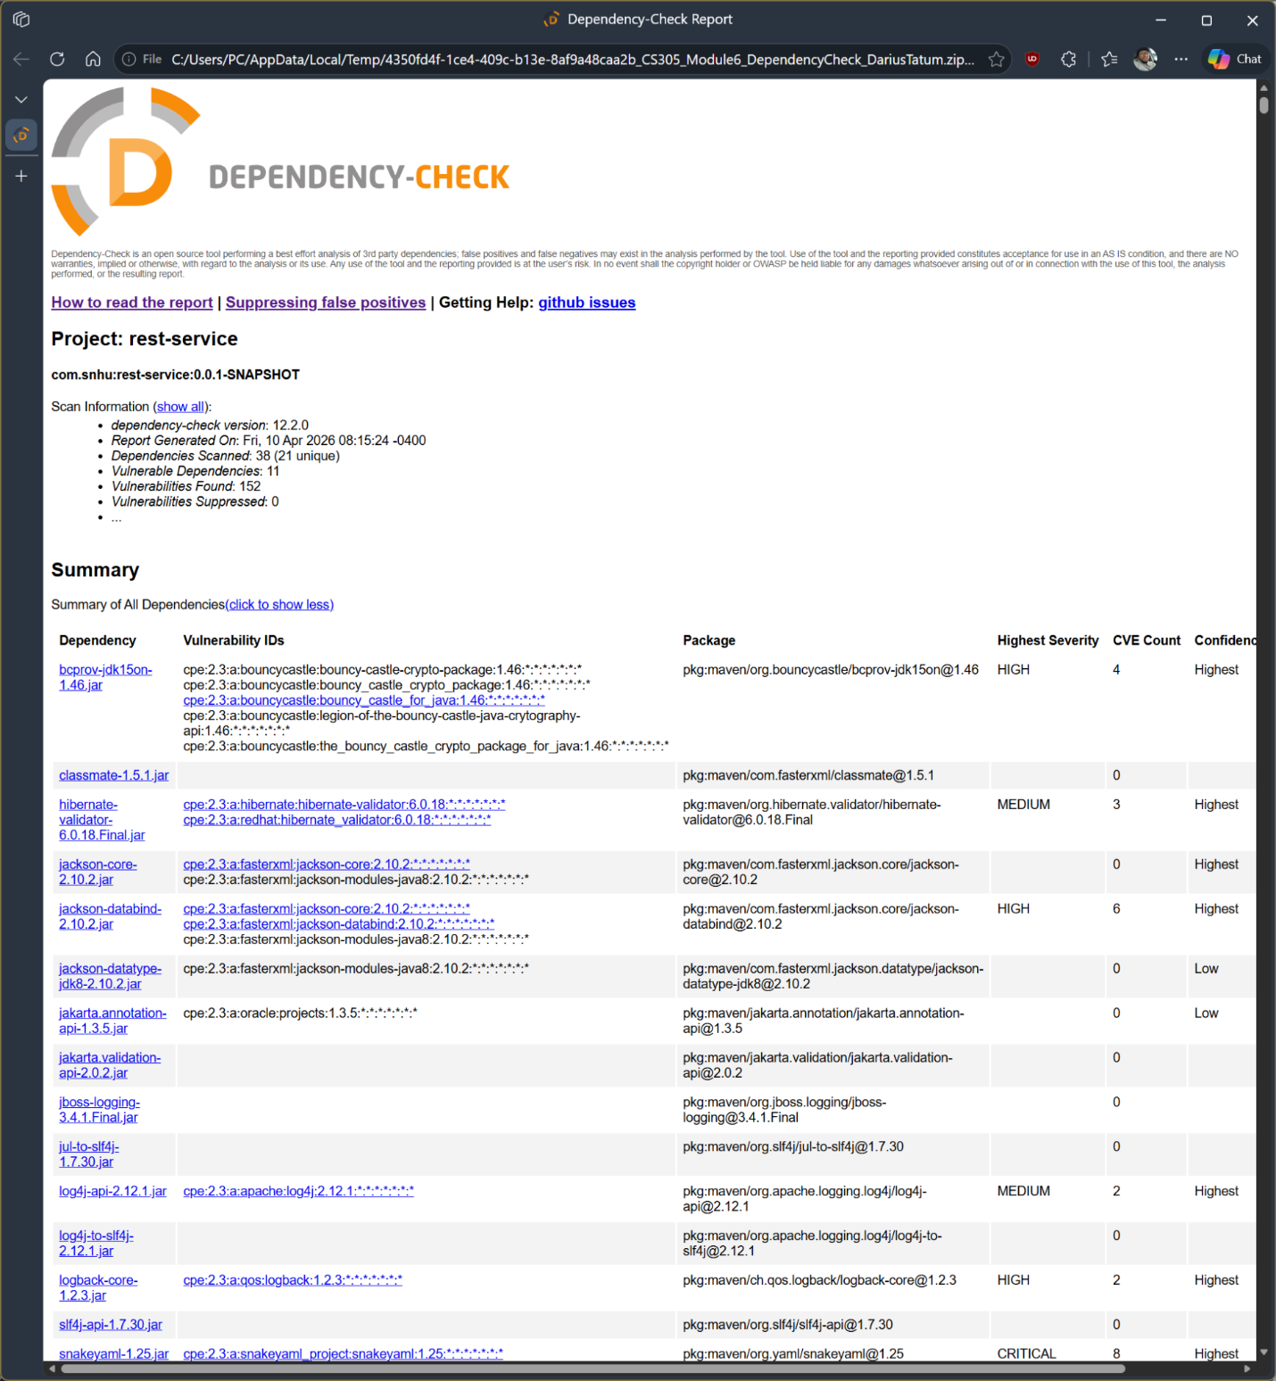
Figure 7: OWASP Dependency-Check report before refactoring

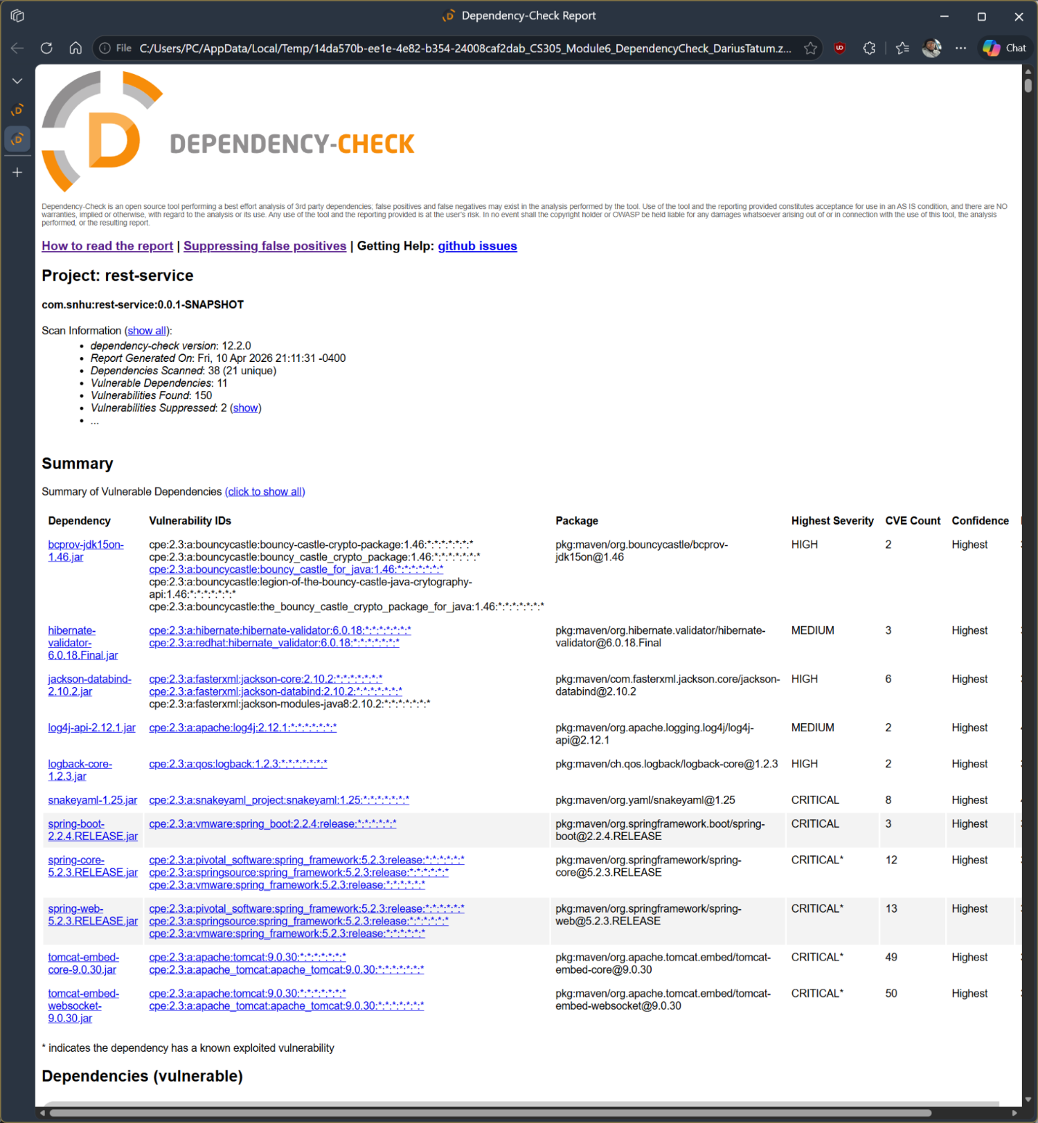
Figure 8: OWASP Dependency-Check report after refactoring

Functional Testing

Functional testing was conducted to verify that the application continued to operate correctly after security modifications were applied. The application was executed in the development environment, and the console output confirms that the Spring Boot application started successfully without runtime errors.

The system remained accessible over HTTPS, indicating that both functionality and secure communication were preserved following the refactoring process.

These results confirm that dependency vulnerabilities were reviewed and partially mitigated while maintaining application functionality.

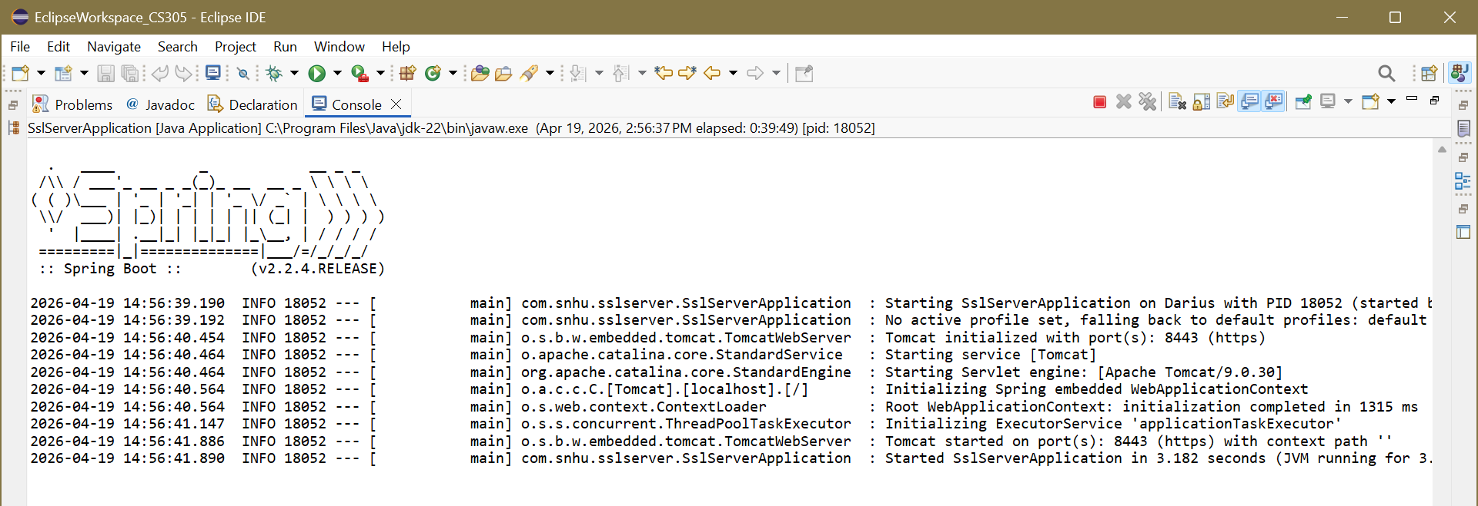
Figure 9: Refactored application executed successfully without errors

Summary

This project focused on implementing secure communication and data integrity verification within a Java Spring Boot application. HTTPS was successfully configured using an SSL certificate stored in a PKCS12 keystore, allowing encrypted communication between the client and server.

In addition to secure transport, a checksum verification mechanism was implemented using the SHA-256 hashing algorithm. This ensured that transmitted data could be validated for integrity, reducing the risk of tampering or corruption.

Testing confirmed that the application successfully served content over HTTPS and generated consistent hash outputs. The combination of encryption and hashing demonstrates a layered approach to security, addressing both data protection in transit and data validation at the application level.

Industry Standard Best Practices

Several industry-standard security practices were applied in this implementation. HTTPS was enabled using TLS, which ensures that all communication between the client and server is encrypted. This aligns with modern security requirements for protecting sensitive data during transmission.

The use of SHA-256 for checksum generation follows current cryptographic standards, as it is considered secure against collision and preimage attacks when properly implemented. Deprecated algorithms such as MD5 and SHA-1 were avoided due to their known vulnerabilities.

Additionally, sensitive configuration elements such as keystore files were managed within the application resources, and secure protocols were enforced through server configuration. These practices reflect recommendations from organizations such as the National Institute of Standards and Technology (NIST), which emphasize strong encryption, secure key management, and data integrity verification as core components of secure software design.

