CS 255 System Design Document

This system design document presents the technical architecture and UML models for the DriverPass application. It is based on the client’s business requirements and outlines the system’s structure, behaviors, and technical needs to support secure lesson scheduling, practice test functionality, user management, and DMV content updates. The diagrams and specifications included here will guide the development team during implementation.

UML Diagrams

UML Use Case Diagram

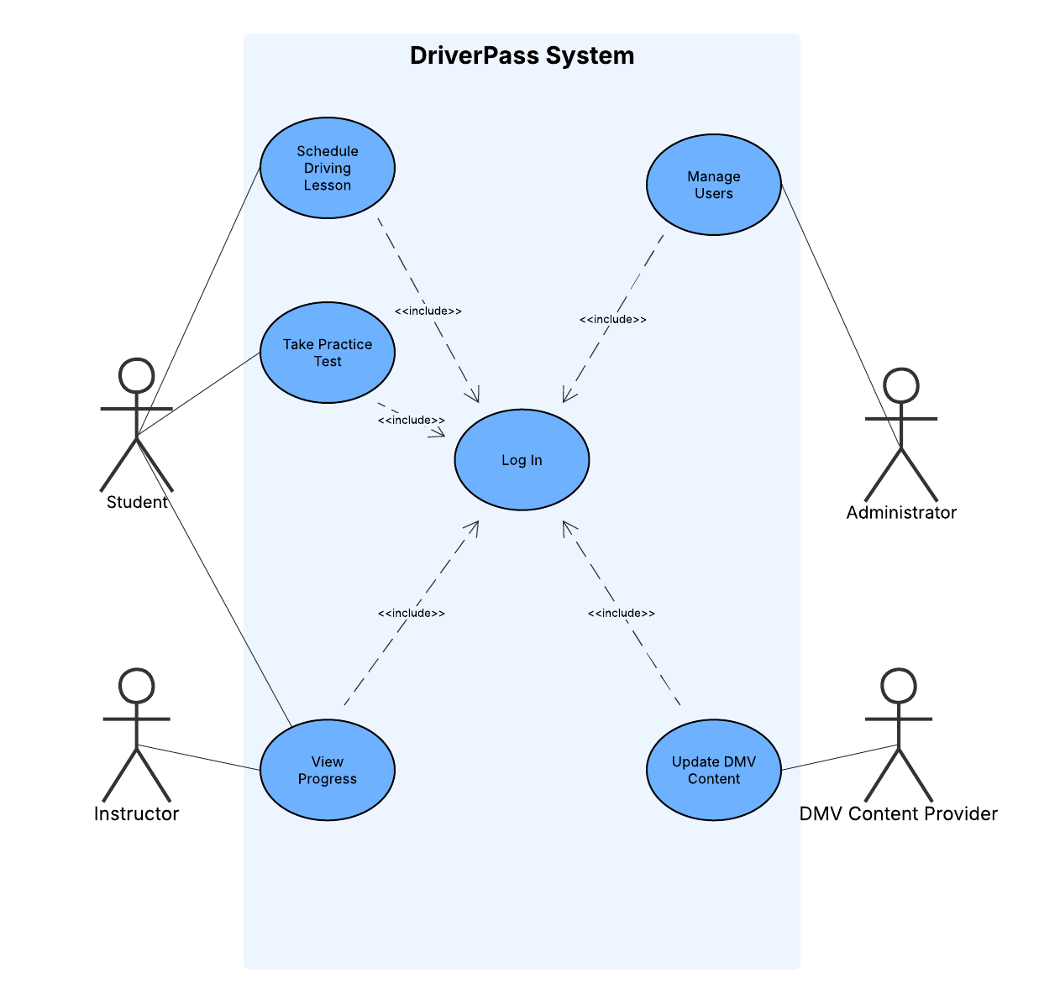

UML Activity Diagrams
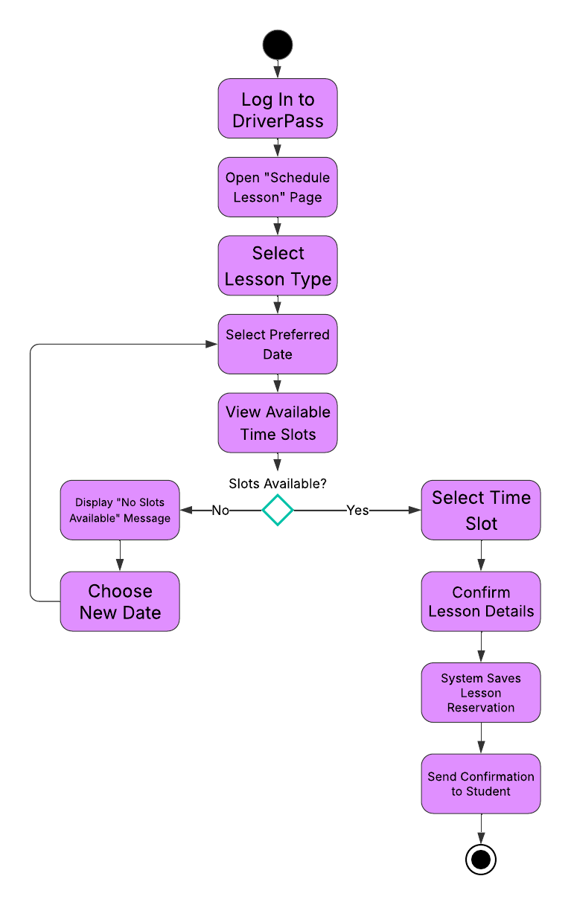

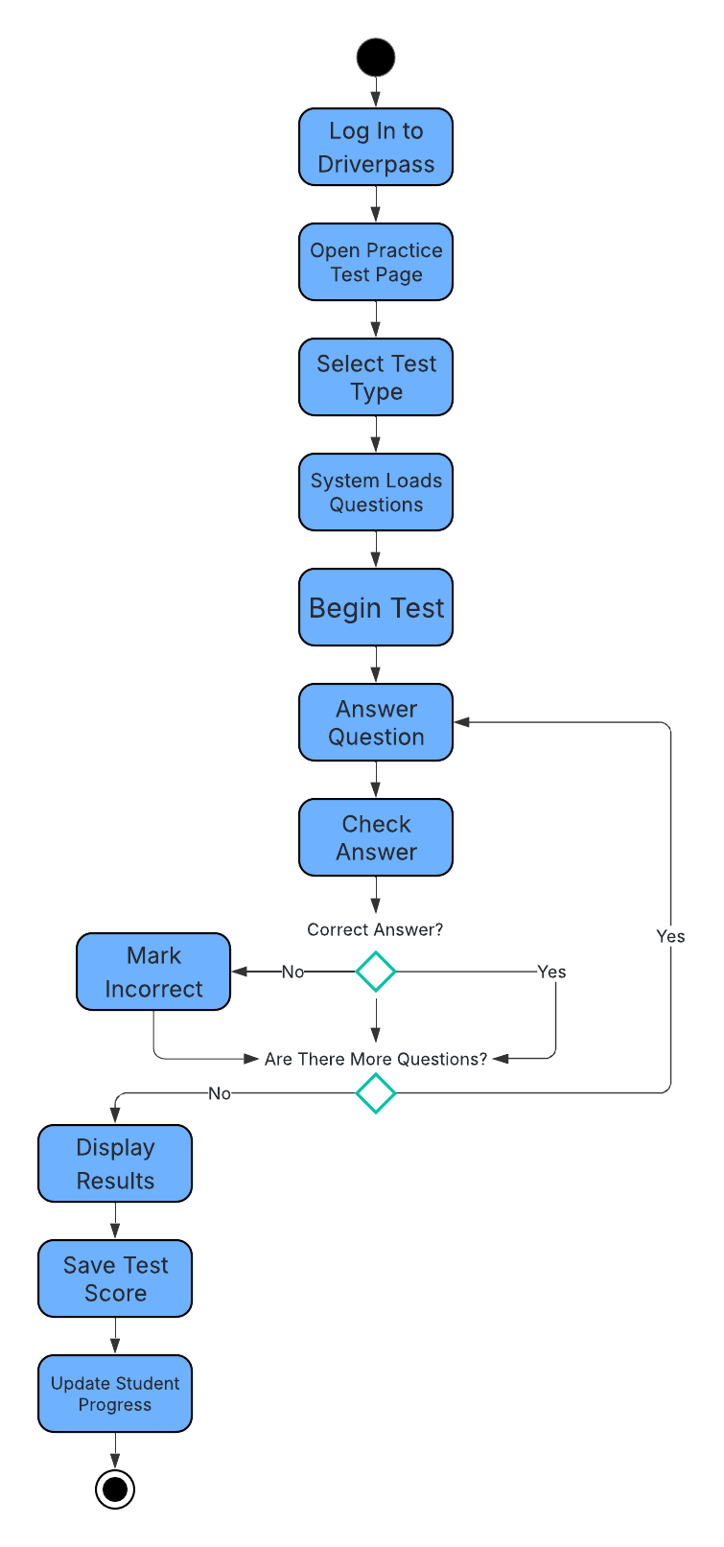

UML Sequence Diagram
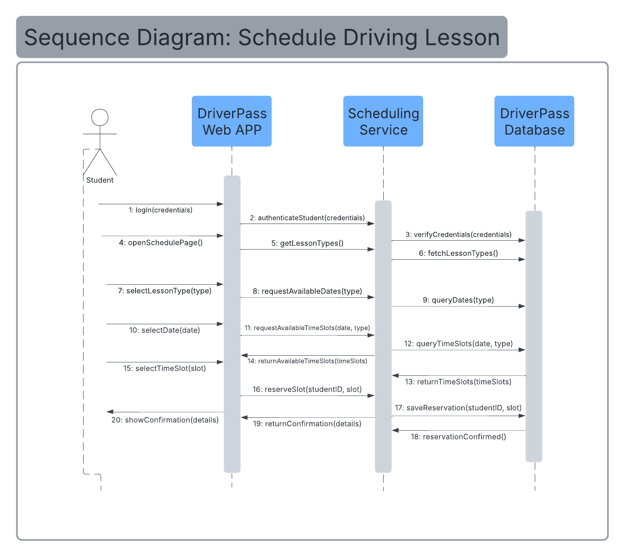

UML Class Diagram
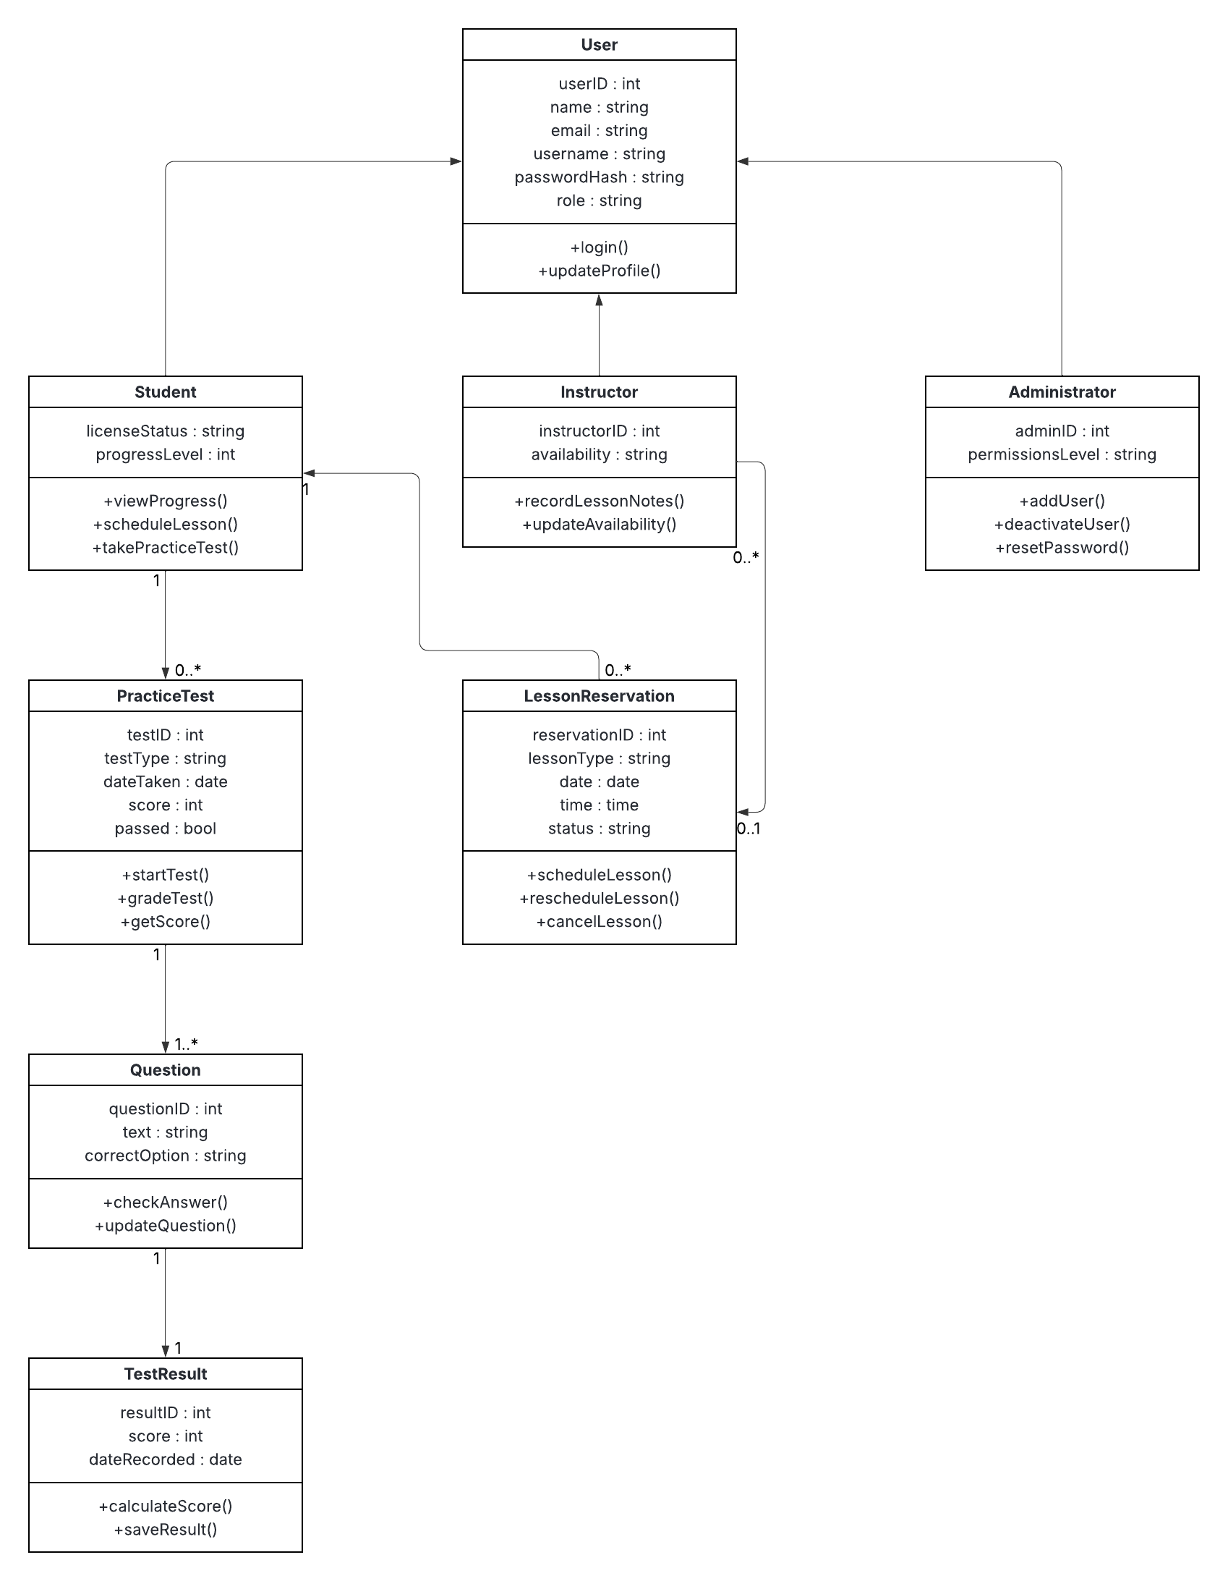

Technical Requirements
The DriverPass system will operate as a secure, web-based application supporting students, instructors, administrators, and a DMV content provider. The environment must enable lesson scheduling, practice test delivery, user management, and content updates while maintaining high performance, reliability, and data security.

Hardware Requirements
Client Devices:
Users will access DriverPass from standard internet-connected devices, including Windows and macOS computers, tablets, and smartphones. The system must support modern web browsers and responsive layouts so that users can perform key tasks—such as scheduling lessons or taking tests—from any location.
Server Environment:
DriverPass will be hosted in a cloud infrastructure that provides scalable web servers, application servers, and database servers. The environment must support load balancing and horizontal scaling to handle increases in student activity, particularly during high-demand periods.
Storage and Backups:
A persistent storage solution is required to maintain user accounts, test results, lessons, schedules, packages, and DMV question banks. Automated daily backups and point-in-time recovery capabilities must be implemented to protect data and support disaster recovery procedures.

Software Requirements
Server-Side Software:
The application will use a modern web framework (such as ASP.NET, Node.js, or Java/Spring) to manage business logic for authentication, scheduling, test scoring, and content updates. A relational database system (MySQL, PostgreSQL, or SQL Server) will store structured data and enforce relationships between students, instructors, lessons, and test results.
Client-Side Software:
DriverPass must support current versions of Chrome, Edge, Firefox, and Safari. The interface will use responsive web design to ensure compatibility across desktop and mobile devices.
Security Software & Practices:
All communication between users and the system must be encrypted over HTTPS/TLS. Passwords must be stored using secure hashing and salting techniques. Role-based access control will ensure that users can only access features appropriate for their roles. Account-lockout rules, session timeouts, and audit logging must be in place to strengthen system security.

Tools and Supporting Services
Development Tools:
The project team will use version control (such as Git), an integrated development environment, and issue-tracking tools to manage code changes and maintenance tasks efficiently.
Monitoring and Logging:
The infrastructure must support application performance monitoring and centralized logging. Logs must record significant user actions—such as lesson reservations, cancellations, or content changes—to support reporting and troubleshooting.
Third-Party Integrations:
A secure payment processor will manage credit-card transactions for package purchases. The system must also support integration with DMV content providers so updated rules, policies, and question banks can be imported when changes occur.

Infrastructure and Network Requirements
Cloud Hosting and Deployment:
DriverPass will run in a cloud environment that supports separate development, testing, and production environments. Automated deployment pipelines should be used to reduce manual errors during updates and releases.
Network Configuration:
Firewalls and access controls must restrict database access to authorized internal components. Administrative access to servers and databases will require secure authentication methods, such as VPN and MFA.
Scalability and Performance:
The system must handle simultaneous activity from students and instructors without lag. Core pages—login, scheduling, dashboards, and practice tests—should generally load within two to three seconds under normal operating conditions.
Reliability and Recovery:
The hosting environment should include redundancy across multiple availability zones, allowing the system to remain available even if one server fails. Disaster-recovery plans must detail the steps for restoring service quickly using backups and documented procedures.

