CS 255 Business Requirements Document

System Components and Design

Purpose
• The purpose of this project is to design a DriverPass system that helps students prepare for DMV driving tests through online learning tools and scheduling features.
• The client, DriverPass, wants a unified platform where students can access practice exams, book lessons, and track their progress.
• The system should also assist instructors and administrators with scheduling, performance tracking, and reporting.
• The overall goal is to improve student success rates by combining online preparation with structured in-person instruction.

System Background
• DriverPass identified that many students fail their DMV driving tests due to limited access to realistic practice materials and unreliable scheduling options.
• Currently, preparation often relies on inconsistent third-party websites and outdated resources.
• DriverPass wants to provide a centralized online platform that integrates both digital test preparation and lesson management with certified instructors.
• The system will include multiple user types — students, instructors, and administrators — each with specific functions and permissions to support efficiency and accountability.

Objectives and Goals
• Develop a secure, user-friendly platform that improves how students’ study for and schedule driving lessons.
• Allow students to:
- Take DMV-style practice tests anytime online.
- Book lessons with available instructors.
- Monitor test results and progress through personalized dashboards.
• Enable instructors to:
- View and update lesson schedules.
- Record lesson outcomes and feedback.
• Support administrators by:
- Managing users, instructors, and payment records.
- Generating reports on student performance and business metrics.
• The measurable outcome is to increase student pass rates and provide a more structured learning experience compared to traditional methods.

Requirements

Nonfunctional Requirements
In this section, you will detail the different nonfunctional requirements for the DriverPass system. You will need to think about the different things that the system needs to function properly.

Performance Requirements

• The system will be web-based and accessible through standard browsers, with a responsive layout for mobile devices.
• Primary pages (login, dashboard, practice tests, scheduling) are expected to load within 2–3 seconds under normal conditions.
• The system must support concurrent access for students, instructors, and administrators without slowing down during peak hours.
• Lesson availability and reservations need to update in real time to avoid double-booking.
• The DMV question bank and related content will receive monthly updates, with urgent rule changes applied as needed.

Platform Constraints
• The system will run on modern browsers (Chrome, Edge, Safari, Firefox) across Windows, macOS, iOS, and Android.
• The back end is required to use a relational database to store users, lessons, packages, payments, and test results.
• The system must integrate with both a third-party DMV content provider and a third-party payment processor.
• Hosting needs to support cloud scalability for increased traffic and remote use.

Accuracy and Precision
• Users will be uniquely identified by a system-generated ID linked to a verified email.
• Passwords must be case-sensitive, and all forms need to validate required fields.
• Test attempts, score calculations, and lesson outcomes are expected to be timestamped and logged for accuracy.
• Administrators will receive alerts when conflicts, failed payments, or content-sync errors occur.
• Practice exam scoring must follow the same rules as the DMV question bank for consistency.

Adaptability
• Administrators can add, remove, or update users, instructors, packages, and test content through the admin interface.
• DMV rule or question-set updates will occur without requiring system downtime.
• IT administrators are required to use role-based access to manage integrations and security.
• The system’s modular design supports adding new states, features, or lesson types with minimal disruption.

Security
• All user roles must authenticate with a unique username/email and password.
• Password-complexity rules will be enforced, and multi-factor authentication can be enabled if the business chooses.
• All communication between client and server will use HTTPS/TLS encryption.
• The system is required to lock an account after multiple failed login attempts and notify the user/admin.
• Password resets need to go through a secure, email-verified workflow.
• Role-based restrictions will prevent students, instructors, and administrators from accessing unrelated areas.
• Payments must be processed through the third-party provider, and full card numbers will not be stored in the system.

Functional Requirements
• Students can create an account and log in using verified credentials.
• Students will have access to DMV-style practice exams, and results will be stored.
• Practice exam feedback will display missed questions and correct answers after submission.
• Students can purchase lesson packages online, and purchase history will be stored.
• Students will be able to schedule, reschedule, or cancel lessons based on instructor availability.
• The system must prevent double-booking by locking time slots once selected.
• Instructors can view their schedules and accept or decline lessons.
• Instructors will record lesson completion, notes, and student performance through their interface.
• Administrators can create and manage lesson packages, pricing, and availability.
• Administrators will manage user accounts (activation, deactivation, role assignment).
• Reports on student progress, lesson completion, and revenue will be available to administrators.
• The system must integrate with a third-party processor to complete transactions securely.
• Automated email confirmations will be sent for purchases and lesson reservations.

User Interface
• Students will be able to browse and take practice tests, view scores, buy packages, and schedule lessons.
• Instructors can view schedules, update availability, and submit lesson feedback.
• Administrators will manage users, instructors, packages, test content, and reports from their dashboard.
• The user interface needs to remain intuitive, consistent, and accessible across desktop and mobile.
• Navigation will be clear and role-specific.

Assumptions
• Users are expected to have stable internet and a browser-enabled device.
• DriverPass will maintain contracts with DMV content and payment providers.
• Instructors will regularly update their availability.
• Students must enter accurate personal information when making appointments.
• Pricing and scheduling rules will be finalized before launch.

Limitations
• Accuracy of practice tests depends on third-party DMV content and update frequency.
• System performance may decline during large updates or unusually high traffic.
• Scheduling is limited to instructor-posted availability; last-minute changes may require manual intervention.
• Project scope is constrained by available development and QA resources.
• The initial version may not support every state until additional licensing is secured.

Gantt Chart
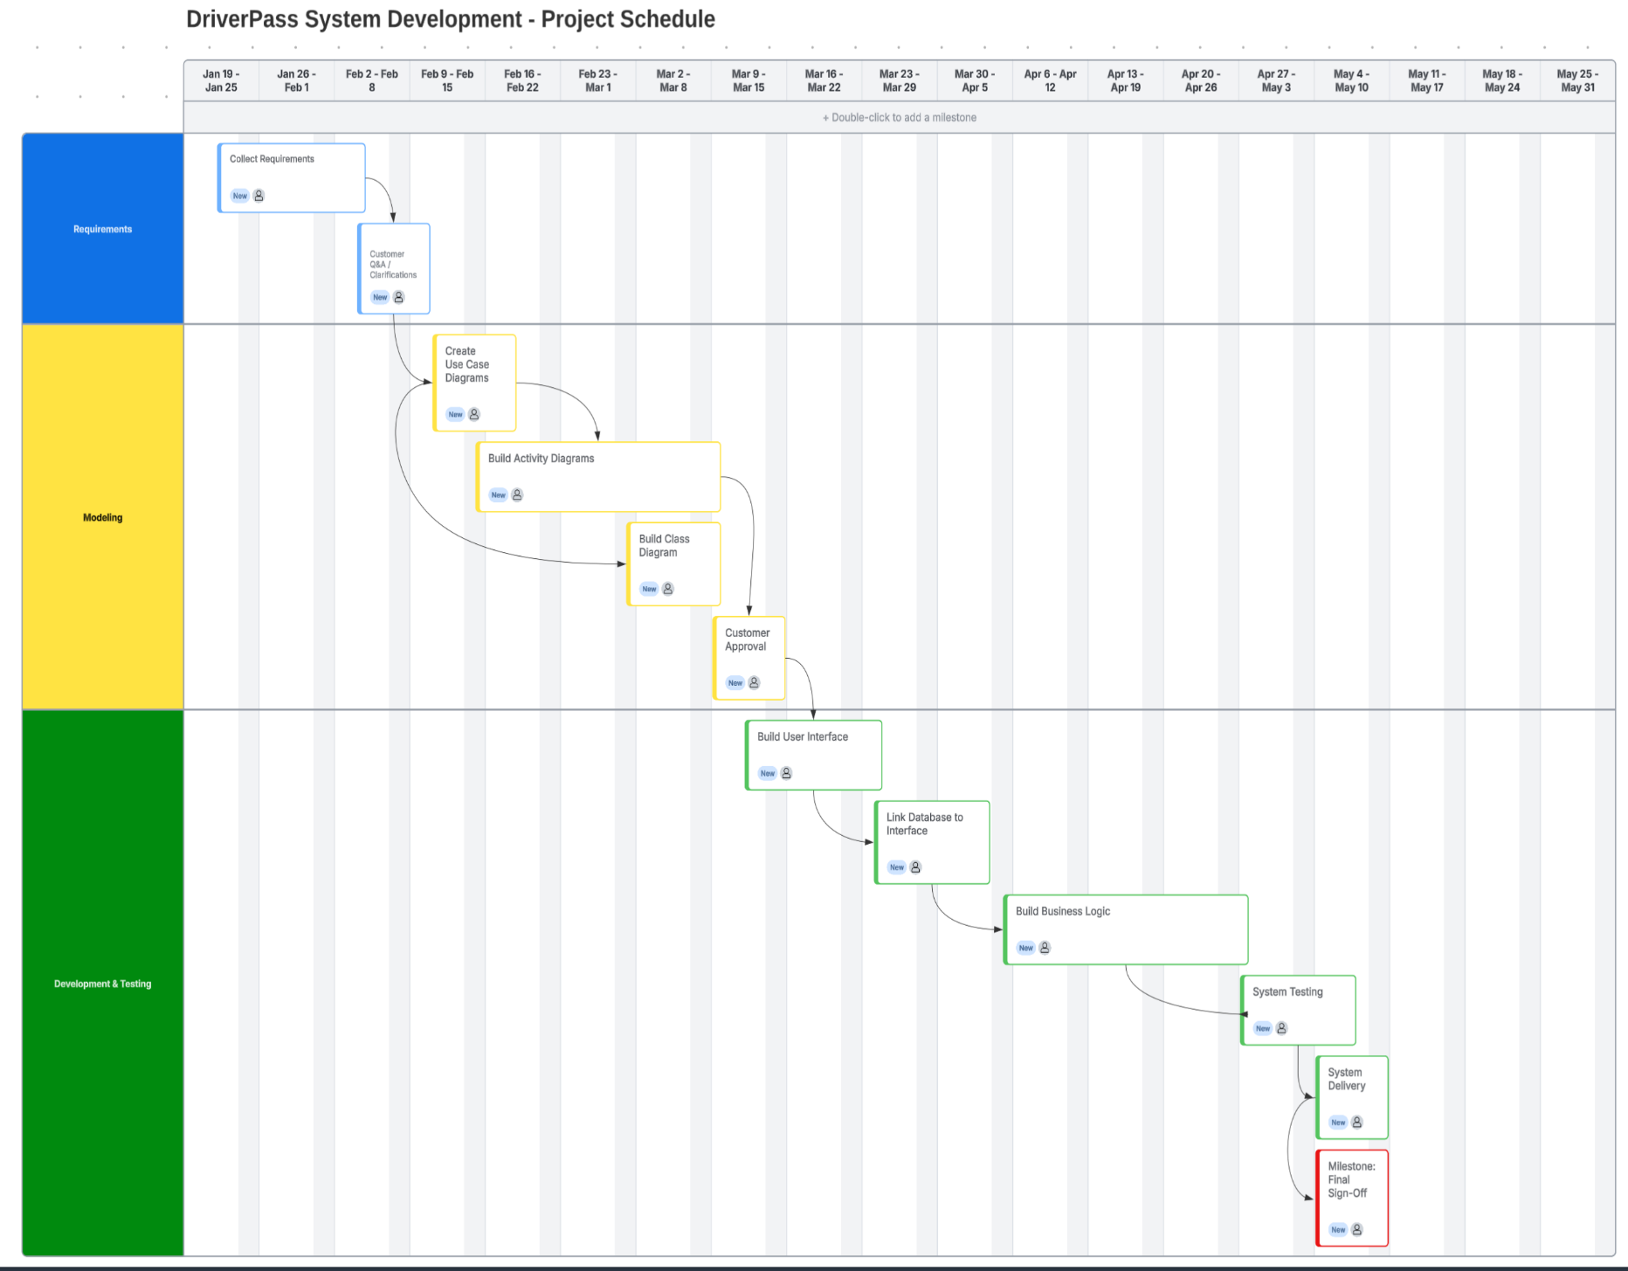
Figure 1. DriverPass Project Schedule Gantt Chart.

