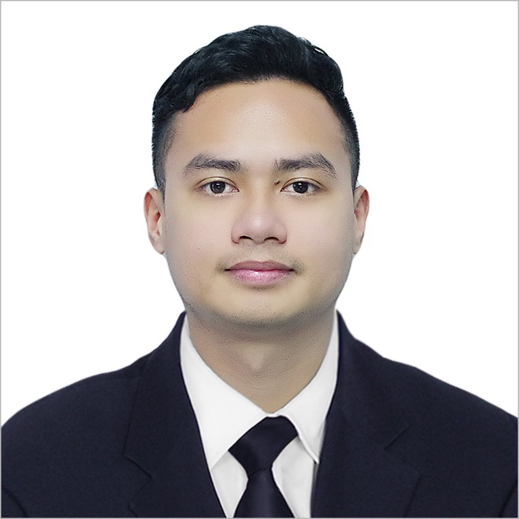 Darius La Madrid Paano

09152644507

December 18, 1993

1411 A Casañas St.

Sampaloc, Manila.

[paanodarius@yahoo.com](mailto:paanodarius@yahoo.com)

Portfolio: https://dariushow.github.io/my-portfolio/

Skills:

|  |  |  |
| --- | --- | --- |
| Soft Skill | Hard Skill | Programming Languages |
| Problem Solving | Git | HTML5(advanced) |
| Communication | Wireframes | CSS3(advanced) |
| Adaptability | Debugging | Bootstrap4(advanced) |
| Enthusiasm | Front End Frameworks | JavaScript(intermediate) |
| Work Ethic |  | Jquery(intermediate) |
| Communication |  | MySQl(intermediate) |
| Creativity |  | Php(intermediate)  Laravel FrameWorks(intermediate) |

**Education:**

**Primary Education**

Dr. Alejandro Albert Elementary School

(2000-2006)

**Secondary Education**

Esteban Abada High School

(2006-2010)

**Tertiary Education**

Bachelor of Science in Marine Transportation

Philippine Maritime Institute

(2010-2013)

**Work Experience**

Deck Cadet

Sea Queen Shipping Inc.

(2014-2015)

* Tank Soundings
* Ship Maintenance and Life Saving and Fire Fighting Maintenance
* Berthing and Unberthing operations
* Pilotage Operations
* Port Watch And Cargo Operations
* Navigation And Paper Works

Third officer

Sea Queen Shipping Inc.

(2016-2017)

* Tank Soundings
* Navigation and Paper Works
* Pilotage Operations
* Berthing and Unberthing Operation
* ISPS watch

Customer Service Representatives

ALORICA

(Aug 13,2017- December 11, 2017)

* Open and maintain customer accounts by recording account information
* Generate sales leads
* Identify and assess customers’ needs to achieve satisfaction
* Follow communication procedures, guidelines and policies

Third officer

Marlow Navigation

(2017-2018)

* Tank Soundings
* Navigation and Paper Works
* Pilotage Operations
* Berthing and Unberthing Operation
* ISPS watch

Achievements and Certificate:

* Coding Certificate(Oct 8, 2018 – January 28, 2019)
* Major Subject Proficiency Awards 2013