LabVIEW Pong

# Run Game

* Without AI: main.vi
* With AI: main_ai.vi

# Player Instructions

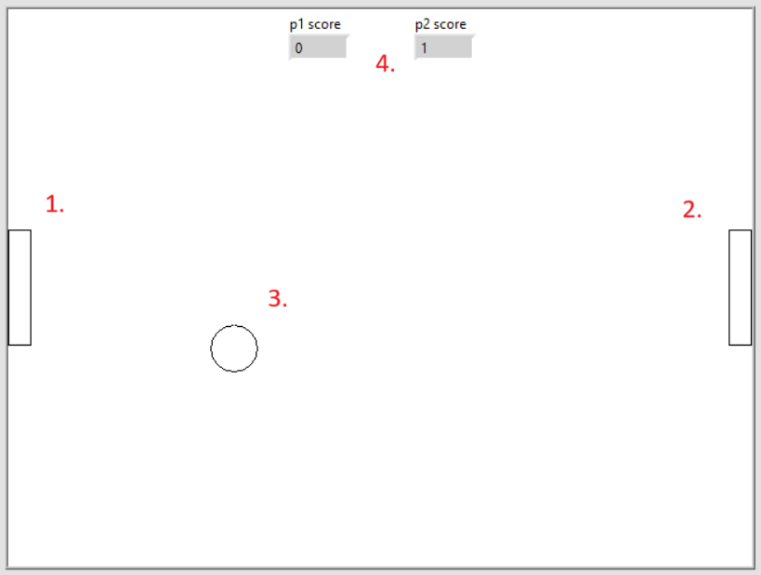

1. Left player: Control with W, S to move up and down respectively
2. Right player: Control with Up, Down arrows to move up and down respectively
3. Ball: Moves and bounces when in contact with upper or lower boundary, or with players.
4. Scoreboard: When the ball reaches the end of the opposite side of each player, the player scores one point.

Try to score as many points against your opponent to win the game, do not let the ball reach the end of your side!

Pause game button: Pause with spacebar  
(Pausing the game freezes the ball but players are still allowed to move up and down freely)

Modifiers: Play with them and find out!