Sprint 1: Made the UI

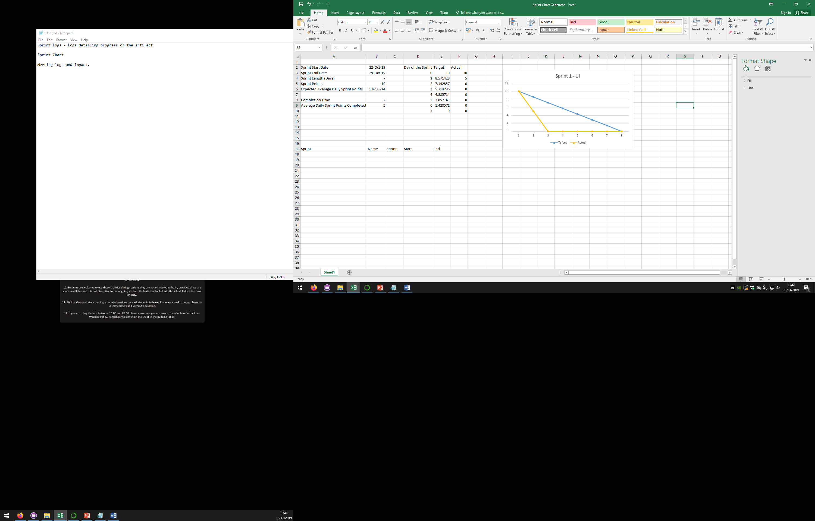

Sprint 2: News API

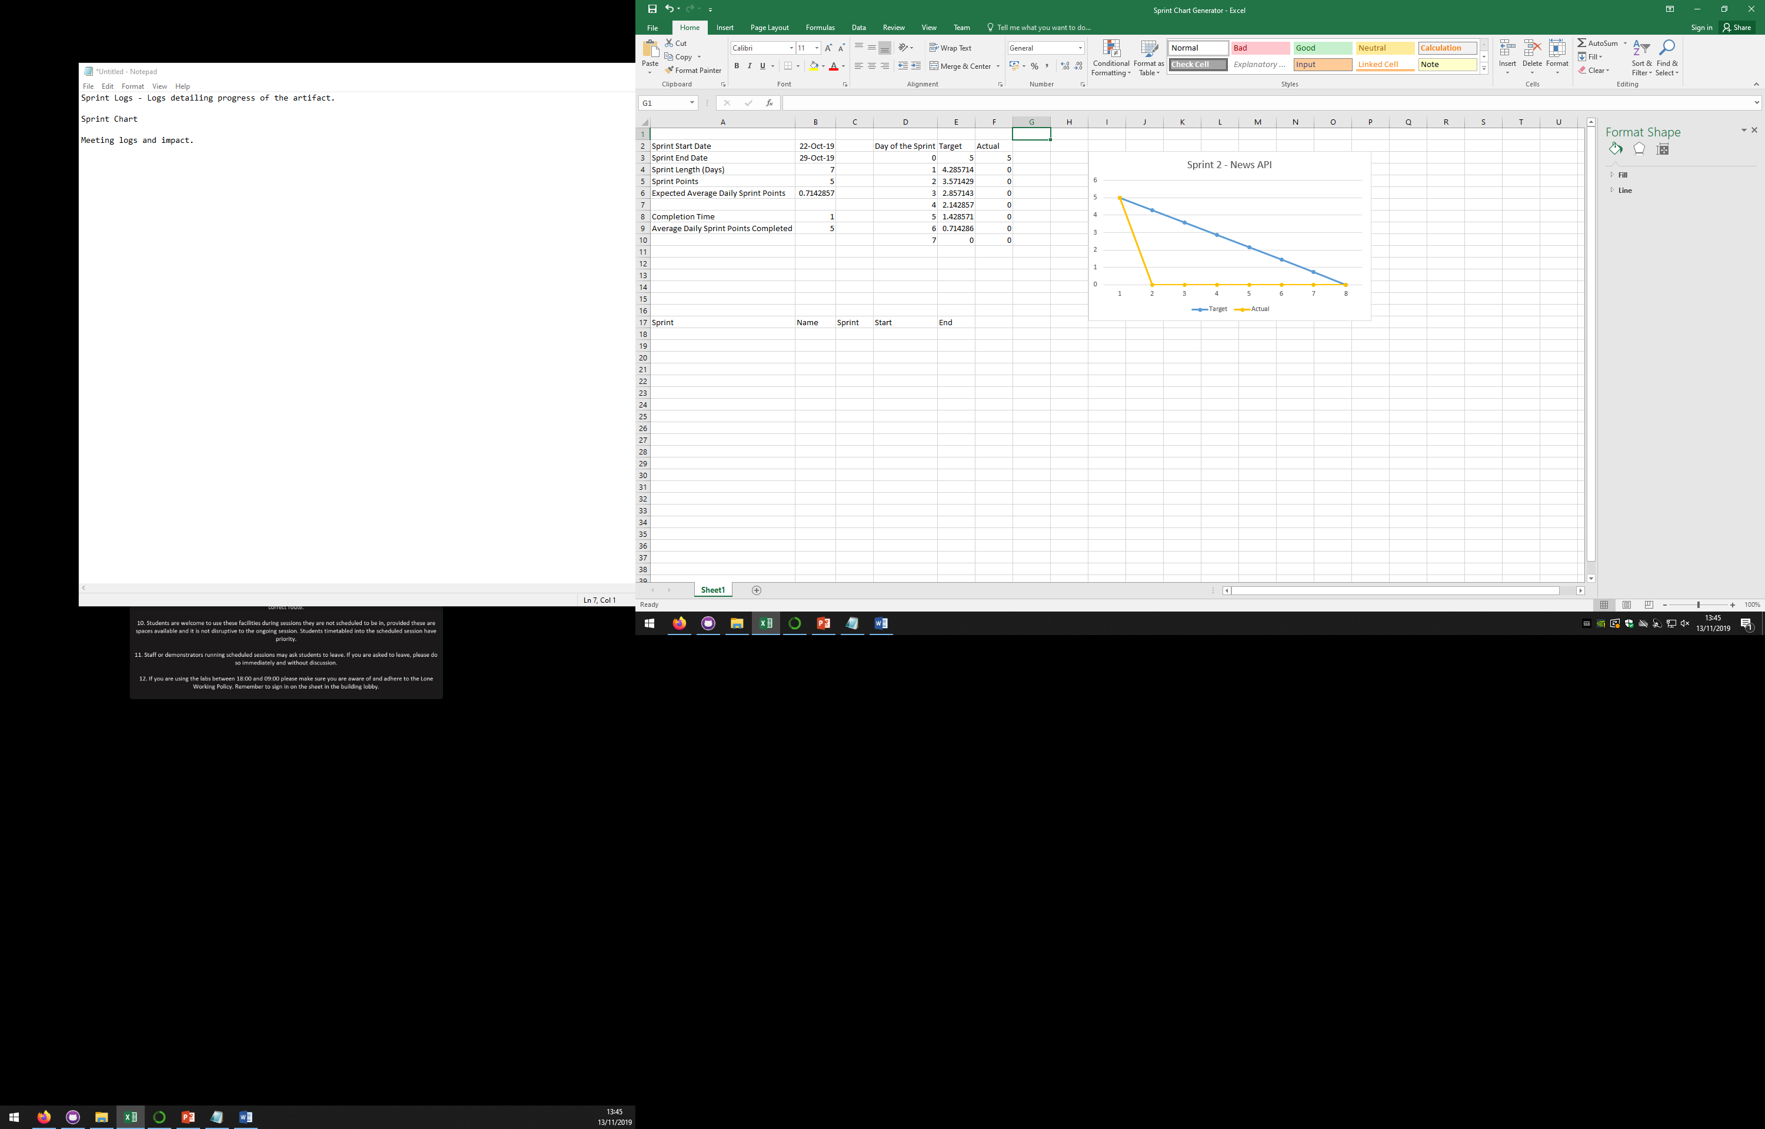

Sprint 3: Made our application be able to query Spotify results

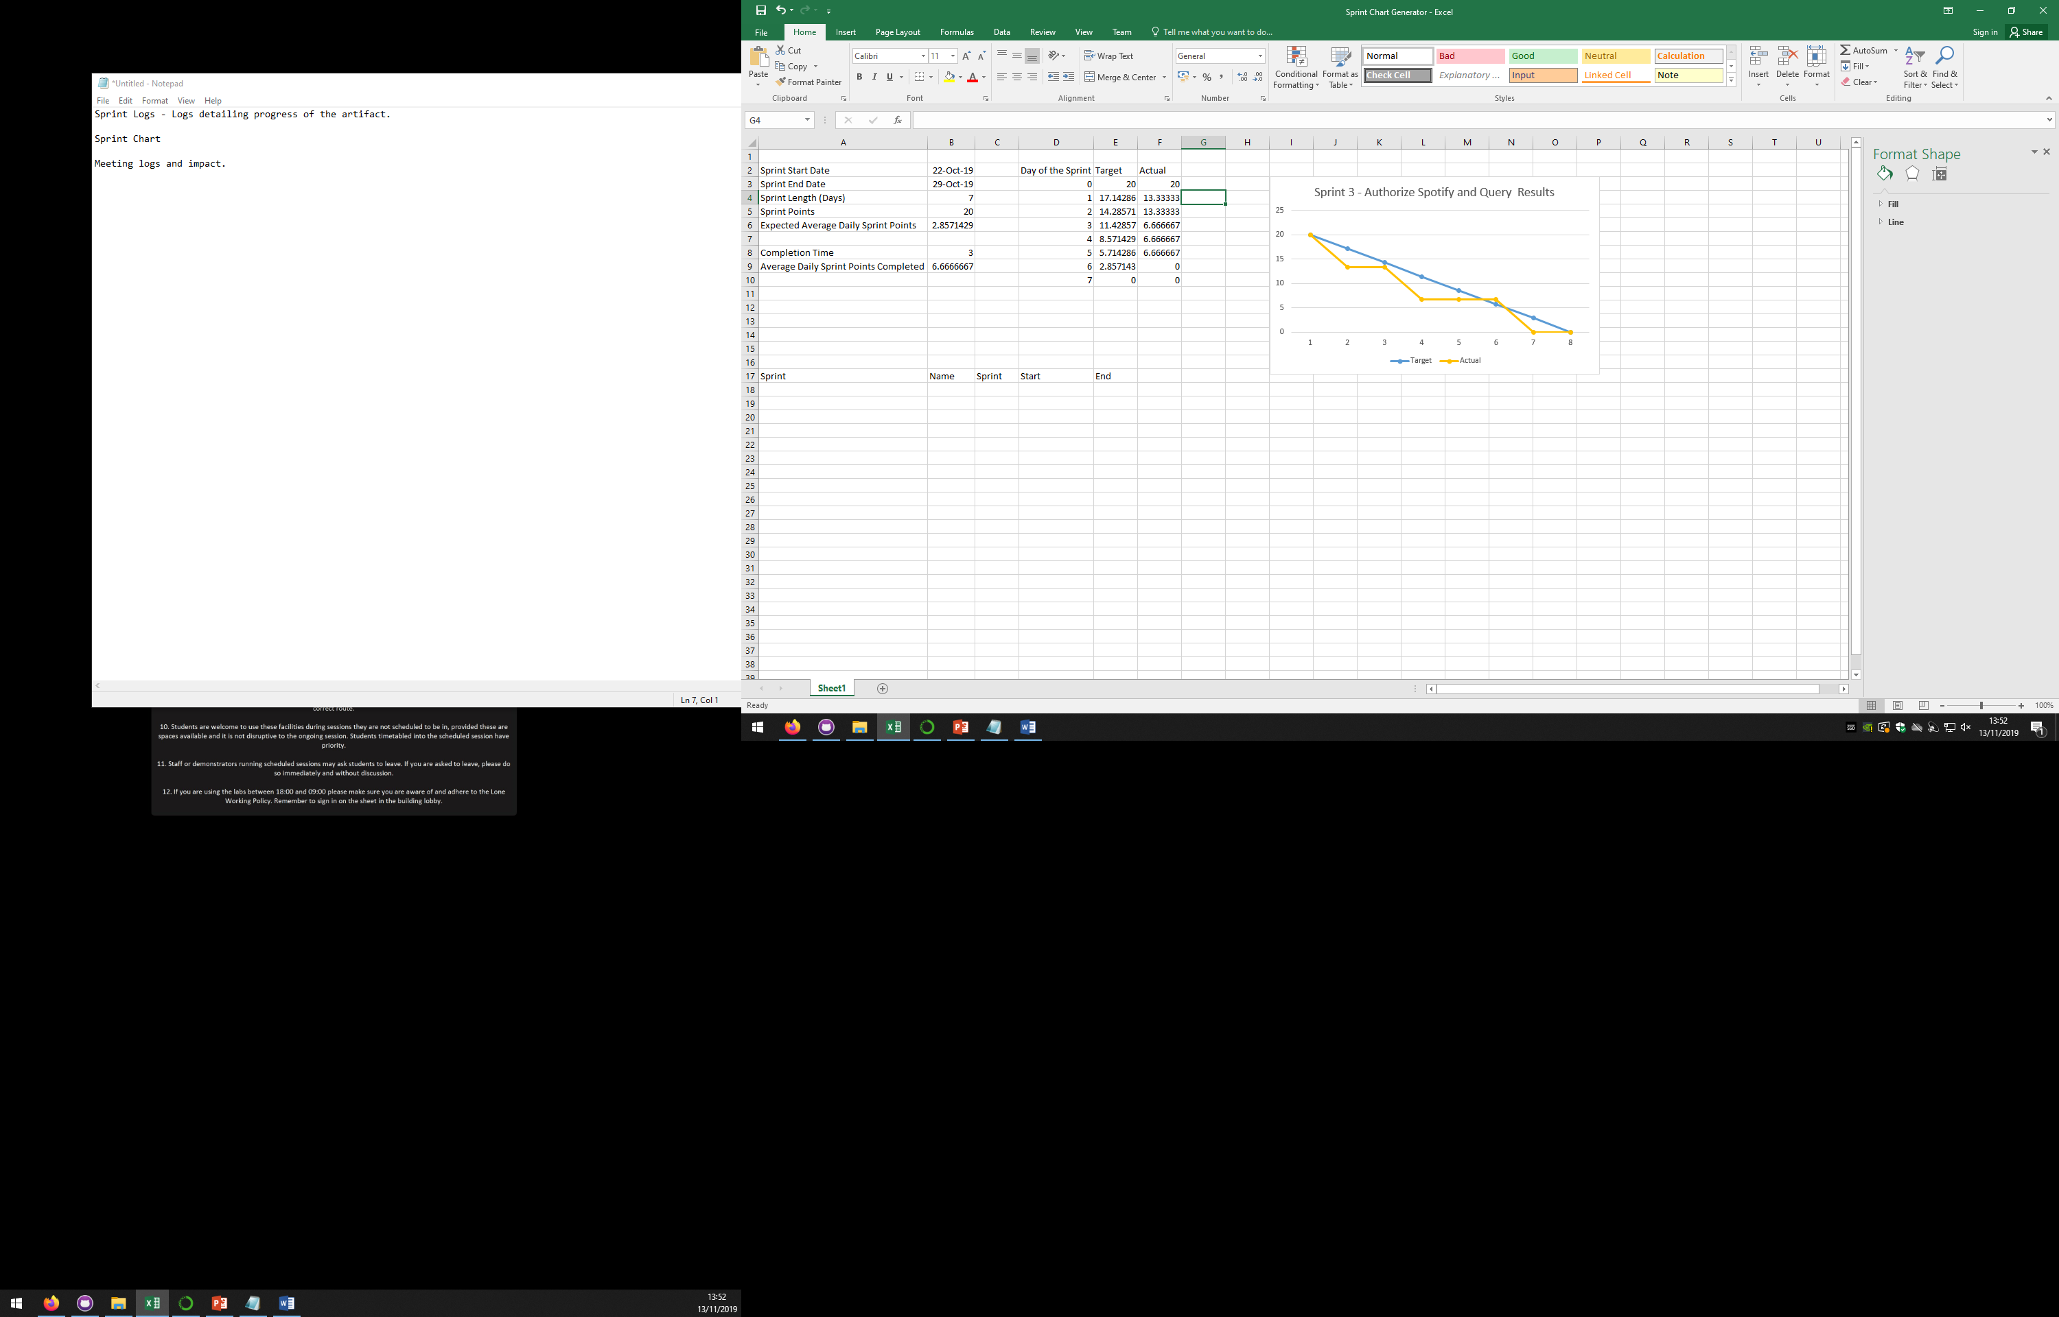

Sprint 4: Make a word extractor to extract words from headlines

Sprint 5: Make the playlist show up

Sprint 6: Make music play