A Selective Precedent? Youngstown and Presidential Immunity
Darius Sattari
Every data scientist or machine learning engineer’s worst nightmare is a disorganized, noisy dataset. The adage “garbage in… garbage out” captures the frustration of searching for a clean dataset. Supreme Court opinions largely avoid this problem. With records dating back to the nation’s founding, written with unusual care, these cases offer data that is abundant and clean.
Following his loss to Joe Biden in 2020, President Trump was indicted on charges that he attempted to overturn the election result. The prosecution led to Trump v. United States (2024), where the majority drew on Justice Jackson’s concurrence in Youngstown Sheet & Tube Co. v. Sawyer (1952), in creating protections against criminal prosecution for official presidential acts. Jackson described three zones. When the President acts with Congress’s authorization, his authority is at its maximum. When Congress has neither authorized nor forbidden the action, he operates in a “zone of twilight.” When he acts against the expressed or implied will of Congress, his power is at its “lowest ebb,” and he must rely on a constitutional power that Congress cannot limit. The Trump majority builds its zone of absolute immunity on Jackson’s phrase “conclusive and preclusive.” Jackson, however, wrote those words inside his third category, warning that a presidential claim to power “at once so conclusive and preclusive must be scrutinized with caution” (Youngstown, 1952). In Trump, the same phrase names the category of presidential power that receives the strongest protection. While the citation is accurate, what changed is the work the phrase is asked to do.
This raises my question: did the majority use Youngstown differently from other Supreme Court decisions? More specifically, was it more selective, taking one part of Jackson’s concurrence and leaving the rest? Legal scholars took up the question soon after the ruling (see Gillian E. Metzger, Disqualification, Immunity, and the Presidency (2025)). Their close reading is admirable, but the research is a lengthy process. The rapid growth of Large Language Models (LLMs) has taught us that words and arguments are data. A model cannot say what the Constitution means, but it can test whether a reading of Trump is unusual within the case law. My question, then, is this: why not use the data to answer that narrower question?
At its simplest form, an LLM takes text as input and predicts what comes next. To do that, it first converts words into numbers, as sketched in Figure 1. This project uses a related tool, an embedding model, which converts a whole paragraph into a list of numbers that captures what the paragraph is about. Two paragraphs that discuss the same thing in similar terms end up with similar numbers, so the model can say how alike any two passages are.
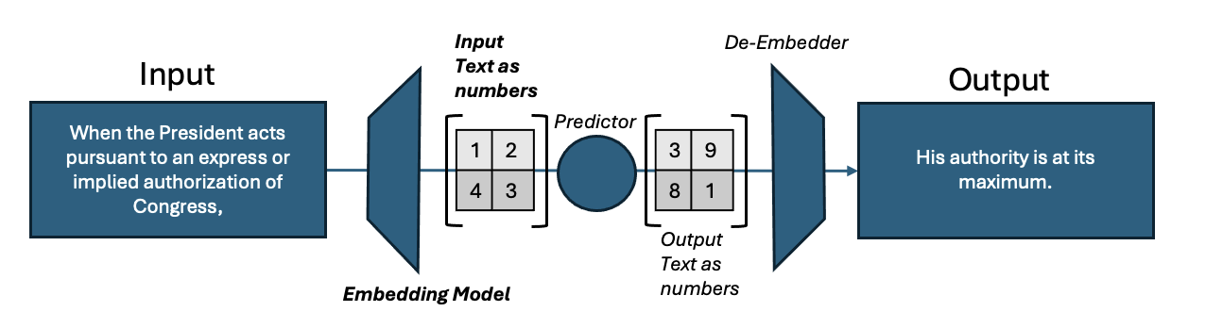
Figure 1: The embedding model, with the numerical representation of Justice Jackson’s words shown in bold.
I divided the thirty-eight paragraphs of Jackson’s concurrence into eight sections: Preamble, Zone 1, Zone 2, Zone 3, Applying the Zones, Rejecting Article II, Inherent and Emergency, and Structural Warning. The last of these is Jackson’s closing passage on the dangers of concentrated executive power, which stands apart from the three zones. The comparison set is twenty-six later presidential-power decisions, from United States v. Nixon (1974) to Trump v. United States (2024), taken from the Caselaw Access Project and the Court’s own slip opinions rendering ninety-seven separate opinions and about 5,500 substantive paragraphs. Every paragraph of every opinion was scored for how closely it resembles each paragraph of Jackson’s.
My first approach was simply to ask how far each opinion sat from Jackson’s language, and it taught me that such a distance mostly measures subject matter. Jackson’s zone paragraphs are about the President’s relationship with Congress, and his warning is about concentrated power and free government. A detention case such as Hamdi naturally sounds like a candidate for the warning, and a case about who holds a power, such as Medellín, naturally sounds like it fits the zones. So, the comparison has to be made inside a case. A majority and a dissent in the same case share the facts, the statute, the era, and the vocabulary. But what differs is what each side chose to do with Youngstown. For each of the twenty cases in which the Court divided, I asked one question: relative to its own dissent, how much more does the majority lean on Jackson’s three zones than on his warning? I call that difference Δ. A positive Δ means the majority kept the categories and left the warning to the dissent; a negative Δ means the reverse. Each opinion’s overall resemblance to Youngstown is subtracted out first, so citing it more often does not raise the score. The six cases in which the Court did not divide, including the unanimous United States v. Nixon, are set aside.
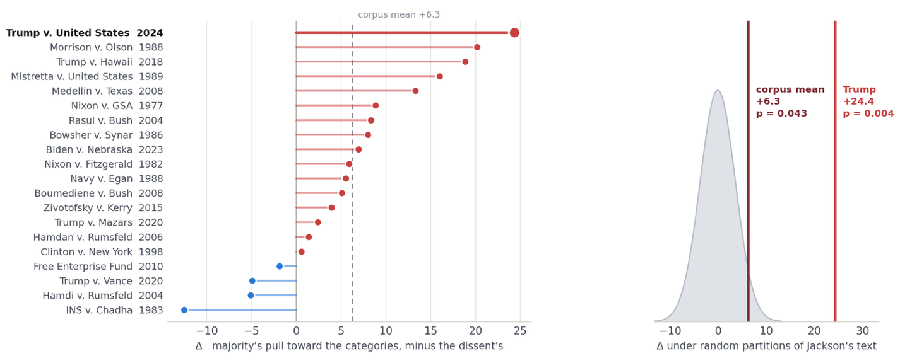
Figure 2 shows the result. The left panel ranks the twenty cases. Red bars are cases in which the majority took the zones and left the warning to the dissent; blue bars are the reverse. Sixteen of the twenty are red, and the dashed line marks the average of +6.3. A split that lopsided would arise by chance less than one time in a hundred. Trump v. United States sits at the top at +24.4, nearly four times the average and ahead of Morrison v. Olson and Trump v. Hawaii. The pattern appears in the security cases, the separation-of-powers cases, and the cases about the President personally alike. Referencing the right panel of Figure 2, I split Jackson’s paragraphs into two groups at random, 4,000 times, and recomputed the result each time. The grey curve is what those random splits produce: a cluster around zero. Only about four random splits in a hundred reached the real average, and only about four in a thousand reached Trump’s score.
Figure 2: Left, the twenty divided cases ranked by Δ. Right, the same statistic under 4,000 random splits of Jackson’s paragraphs, with the real results marked.
The first of two cautions with these results are that Trump is the most extreme case, but the gap between it and Morrison is not wide enough to call it a different kind of case. It just sits at the top of a continuum away from Jackson’s words, not in a class of its own. Second, the score measures emphasis, not endorsement. It shows which part of Jackson an opinion works with, not whether the opinion agrees with him. Before settling on this design, I tried to train the model to predict from an opinion’s text whether it favored a broader or narrower presidency. It did little better than a coin flip (which is bad), even though the same method told majorities from dissents with fair reliability. This is simply a limitation stating that deviation in heavy favor of the majority does not always mean a broader presidency is argued. It grounds the fact that figure 2 only analyzes differences in the mathematical representation of the text and ideas that follow.
Trump’s majority took “conclusive and preclusive” from a passage in which Jackson describes a claim courts should distrust. What the modeling adds is that the surrounding warning is exactly the material this majority engages least, relative to its dissenters, of any majority in fifty years of presidential-power cases. Professor Metzger makes the same point from the legal side, arguing that the Trump majority drew on Jackson’s category of exclusive presidential power while overlooking his warning to scrutinize such claims with caution, and she points to the opinion’s broad treatment of presidential control over investigations and prosecutions.
The answer to the question I began with is yes. The Trump majority used Youngstown more selectively than any other majority in the dataset. It kept Jackson’s classification scheme and left his warning about concentrated power to the dissent, to a degree no other case in the set approaches. That is not proof the decision was wrong; the model cannot judge the law. It is evidence that the majority’s reading of Jackson was unusual by the Court’s own standards, and that what it left out was the part of the concurrence written to caution courts about claims of exactly this kind.
This analysis took a week and it’s no substitute for close reading, but it can direct that reading to the right place. To me, this work shows a real use for the mathematics behind LLMs, apart from anything they generate, in the legal space.

