A Selective Precedent? Youngstown and Presidential Immunity
Darius Sattari
Every data scientist or machine learning engineer’s worst nightmare is an unprofessional, disorganized, noisy dataset. The adage “garbage in… garbage out” very much applies to the frustration that comes with trying to find clean datasets, and especially when trying to polish one yourself. Analyzing Supreme court cases, however, avoids this problem. With records dating back to the nation’s conception, and always authored by intellectuals of the highest level, these cases provide high levels of availability, abundance, and quality.
Following President Trump’s loss to Former President Biden, President Trump was indicted on the claim that he attempted to overthrow the election. This manifested into Trump v United States (2024) where the Supreme Court, and the majority ruling, used Justice Jackson’s framework from Youngstown (1952) when creating protections against criminal prosecution for presidential acts. CONTINUE LEGAL DISCUSSION. The Trump majority relies on Jackson’s phrase “conclusive and preclusive.” But Jackson first used that phrase while warning courts to examine claims of exclusive presidential power with great caution. In Trump, the phrase helps describe presidential power that receives the strongest protection.
This begs the question, did the way the majority used Youngstown in their ruling significantly deviate from that of other Supreme Court cases? More specifically, was it more selective? While this is the perfect question for a legal scholar to analyze, which I have found was a big research interest following the ruling (cite here), reading the methods these scholars employed to arrive at their conclusions is intellectually admirable, yet amazingly time inefficient. If we have learned anything from the rapid recent growth of Artificial Intelligence (AI), and more specifically Large Language Models (LLMs), we know that words, ideas, and thoughts are data. This recent shift in the state of art has completely shattered the notion that data is confined to numbers and sensor outputs. We also know, as mentioned, that Supreme Court case rulings is data of the highest quality. So, my question is, why don’t we use data to answer this legal question.
A quick overview of the methodology is outlined in Figure 1.

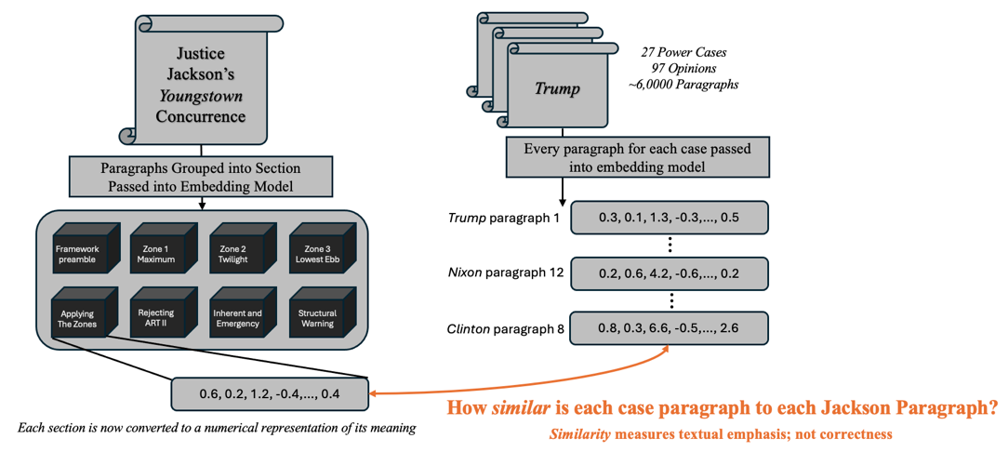
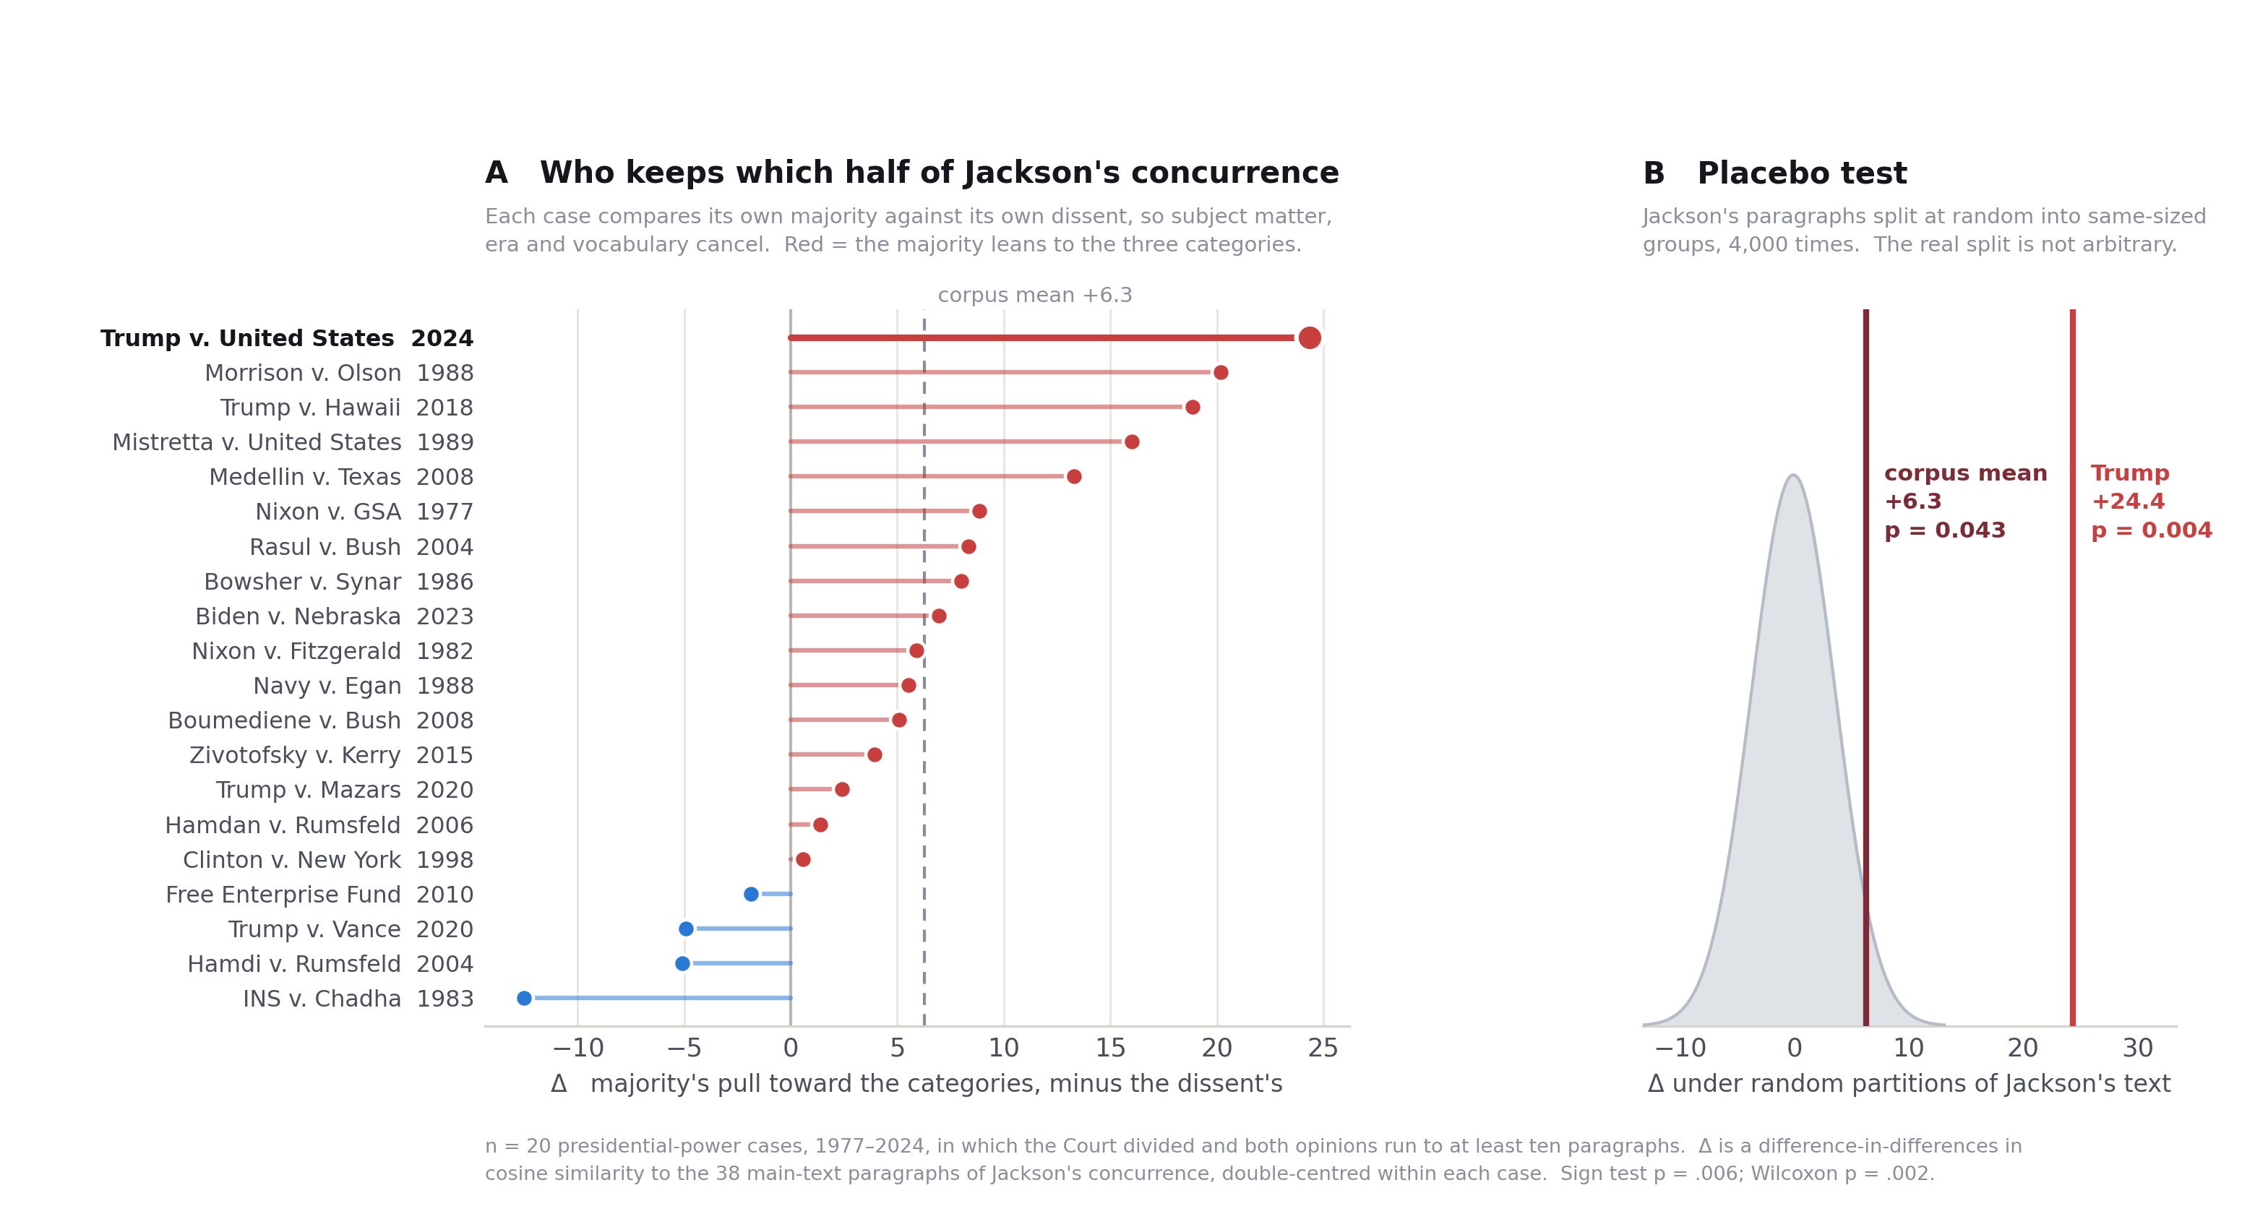
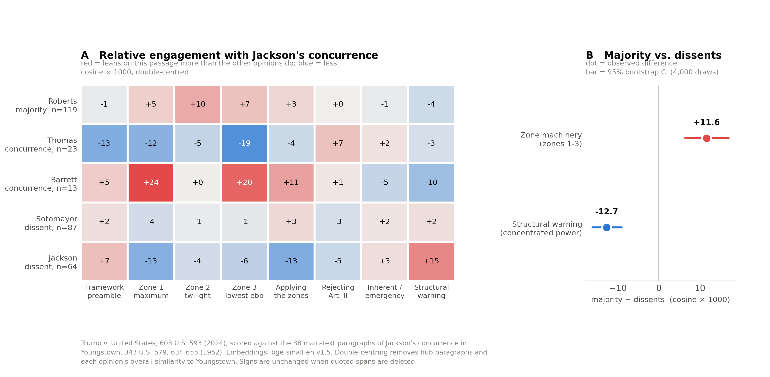

Justice | Position in this case | Nominating president
Roberts | Majority author | George W. Bush
Thomas | Joined majority; concurrence | George H. W. Bush
Alito | Joined majority | George W. Bush
Gorsuch | Joined majority | Donald Trump
Kavanaugh | Joined majority | Donald Trump
Barrett | Joined most; separate opinion | Donald Trump
Sotomayor | Dissent | Barack Obama
Kagan | Joined dissent | Barack Obama
Jackson | Dissent | Joe Biden

