CountR Face Recognition Api Proposal

Introduction:

The following is a work-in-progress proposal to implement a face recognition system on top of CountR’s current security systems. The goal of the system is to provide an asynchronous service that can be queried by a CountR application.
The system is split into a clientt-server architecture with the client being a compile-able JAR used by existing CountR applications connecting to a new Server module that must be set-up and maintained by CountR on-top of their existing applications.

Key Client Features:
1. 1-to-1 Face Verification
2. 1-to-Many Face Recogntion
3. Update face database. (ie. add new user to recognize)
Key Server Features:
1. Multiple Client Sessions

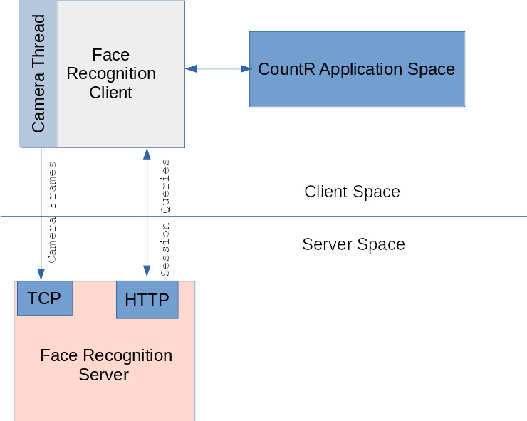

Simple Client User Guide
Scenario 1: Running a classification loop
FaceRecogntionClient client = new FaceRecognitionClient(config);
// Start camera thread
while(true){
ClientResponse is_user = client.GetRecognitionResult(some_user_id);
if( is_user.GetMostSimilar() == some_user_id){
return true;
}
// Do some logic here
}
FaceRecogntionClient client = new FaceRecognitionClient(config);
// Start camera thread
while(true){
ClientResponse is_user = client.GetRecognitionResult(some_user_id);
if( is_user.GetMostSimilar() == some_user_id){
return true;
}
// Do some logic here
}

Scenario 2: Running a session
FaceRecogntionClient client = new FaceRecognitionClient(config);
// Start camera thread
FaceRecognitionSession session = client.StartSession();
// Do some time consuming work
// Get some data about the session
SessionData data = session.GetSessionData();
String user = data.GetMostLikelyUserId()
// Do some more work…
// repeat...
SessionData data = session.GetSessionData();
// finally
Session.close()

Simple Server Configuration

