# 

# ****HomeGenie – Agentic AI-Powered Smart Home Automation System****

**Problem Statement:**

Existing smart home platforms like Google Home and Alexa are mostly reactive, needing direct user commands and offering limited adaptability. This project introduces a proactive, intelligent system that learns user habits, understands context, and autonomously performs tasks to enhance personalization and energy efficiency. It integrates Agentic AI with IoT through a multi-agent architecture consisting of Planner, Sensor, Memory, Scheduler, and Executor agents. Using simulated smart devices via Home Assistant and MQTT communication, the system can execute goals like “make it cozy” intelligently. The project aims to deliver a cost-effective, simulation-based prototype that demonstrates habit learning, real-time automation, and cross-platform control suitable for industrial collaboration.

**External Mentor/Guide:**  
 Dr. Brian Loh, Associate Professor, Swinburne University of Technology

**Internal Mentor/Guide:**  
 Dr. N. Ramkumar, Assistant Professor, Department of Artificial Intelligence and Data Science, Coimbatore Institute of Technology

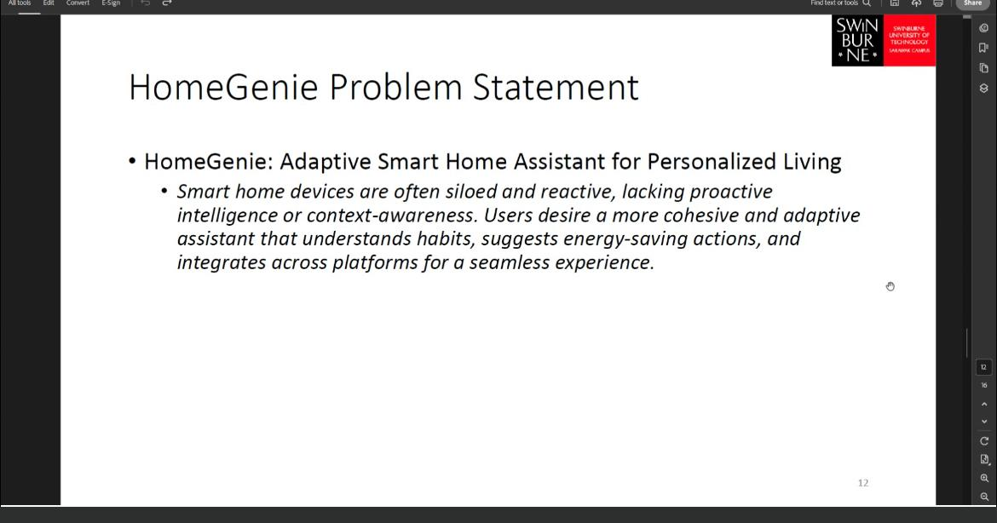**Meeting held:**

**Team Members:**

| Name | Register Number |
| --- | --- |
| Harish B | 7176 23 08 203 |
| Mukilan J | 7176 22 08 031 |
| Mithrajit Kathir S | 7176 22 08 030 |
| Sanjay S | 7176 22 08 047 |