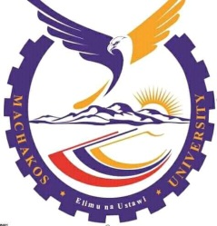
MACHAKOS UNIVERSITY
OFFICE OF THE DEAN, SCHOOL OF HUMANITIES AND SOCIAL SCIENCES

Phone: 044-21604, Fax: 044-20353 P O Box 136 - 90100
Mobile: No 0735 247939/0723 805829 Machakos, Kenya
Website: www.machakosuniversity.ac.ke Email: info@machakosuniversity.ac.ke

Our Ref: C01-8514-2021
Your Ref: ……………. Date: 28th APRIL, 2025
To Whom It May Concern,
RE: LETTER OF COMPLETION
This is to certify that CALEB MUMO NZOMO of Reg. No C01-8514-2021 is a bona fide student of Machakos University in the School of Humanities And Social Sciences who completed his final year examinations on April 2025.
Any assistance accorded to him will be highly appreciated.

Yours sincerely,

DR. LARRY NDIVO
AG. DEAN, SCHOOL OF HUMANITIES AND SOCIAL SCIENCES

