MOON
Programming Language Specification
Codename: Mars
Version 0.1.0 • Draft Specification
February 2026

CONFIDENTIAL
Dark Matter Tech • Orion Team

Table of Contents

1. Executive Summary
Moon is a statically-typed, compiled programming language designed to replace JavaScript and the DOM as the foundational technology of the web platform. Developed under codename Mars, Moon targets a new browser runtime that eliminates the legacy constraints of HTML, CSS, and JavaScript while providing native-quality experiences across all platforms.
Moon is not an incremental improvement. It is a ground-up replacement for the web’s execution model:
- Type safety: All types known at compile time. No any, no dynamic, no runtime coercion.
- Memory safety: ARC with cycle detection. No GC pauses. No manual memory management.
- Compiled: AOT compilation for production. Interpreted mode with hot reload for development.
- No DOM: Declarative, reactive UI scene graph replaces the Document Object Model entirely.
- No CSS: Type-safe styling properties. No cascade, no specificity, no selectors.
- Platform-aware: Runtime bridges to native capabilities (Apple Pay, Google Pay, APNs, FCM, biometrics, HSMs).
- Hardware security: First-class HSM, secure enclave, and hardware token support.
- Engine-agnostic: WebKit on Apple hardware, Blink everywhere else. Developer never cares.

Moon’s syntax is inspired by Kotlin. Its memory model borrows from Swift’s ARC. Its UI framework draws from SwiftUI, Jetpack Compose, and Flutter’s declarative paradigms.

2. Design Philosophy

2.1 Guiding Principles
Declare intent, not mechanics. Developers describe what they want. The runtime handles platform-specific implementation.
One codebase, native everywhere. Moon runs on macOS (WebKit), Android (Blink), Windows (Blink), Linux (Blink) — each delivering its best native experience.
Fail at compile time, not runtime. Type system, null safety, exhaustive matching, and capability declarations catch errors before deployment.
Security is not optional. Hardware-backed crypto, signed packages, capability permissions built in.
Performance is a feature. ARC + AOT + retained-mode renderer = consistent 60/120fps.

2.2 What Moon Replaces
Legacy Technology | Moon Replacement | Why
JavaScript / TypeScript | Moon language | Type-safe, compiled, memory-safe
HTML DOM | MoonUI scene graph | Declarative, reactive, retained-mode
CSS | Inline type-safe styling | No cascade, no specificity wars
npm / node_modules | Aurora package manager | Signed binaries, flat deps
WebAuthn (auth only) | Hardware Crypto Bridge | Full HSM operations
Web Crypto API | Hardware-backed crypto | Keys never leave hardware
Service Workers | Native push integration | APNs/FCM/WNS via bridge
Payment Request API | Native payment bridge | Apple Pay/Google Pay/native

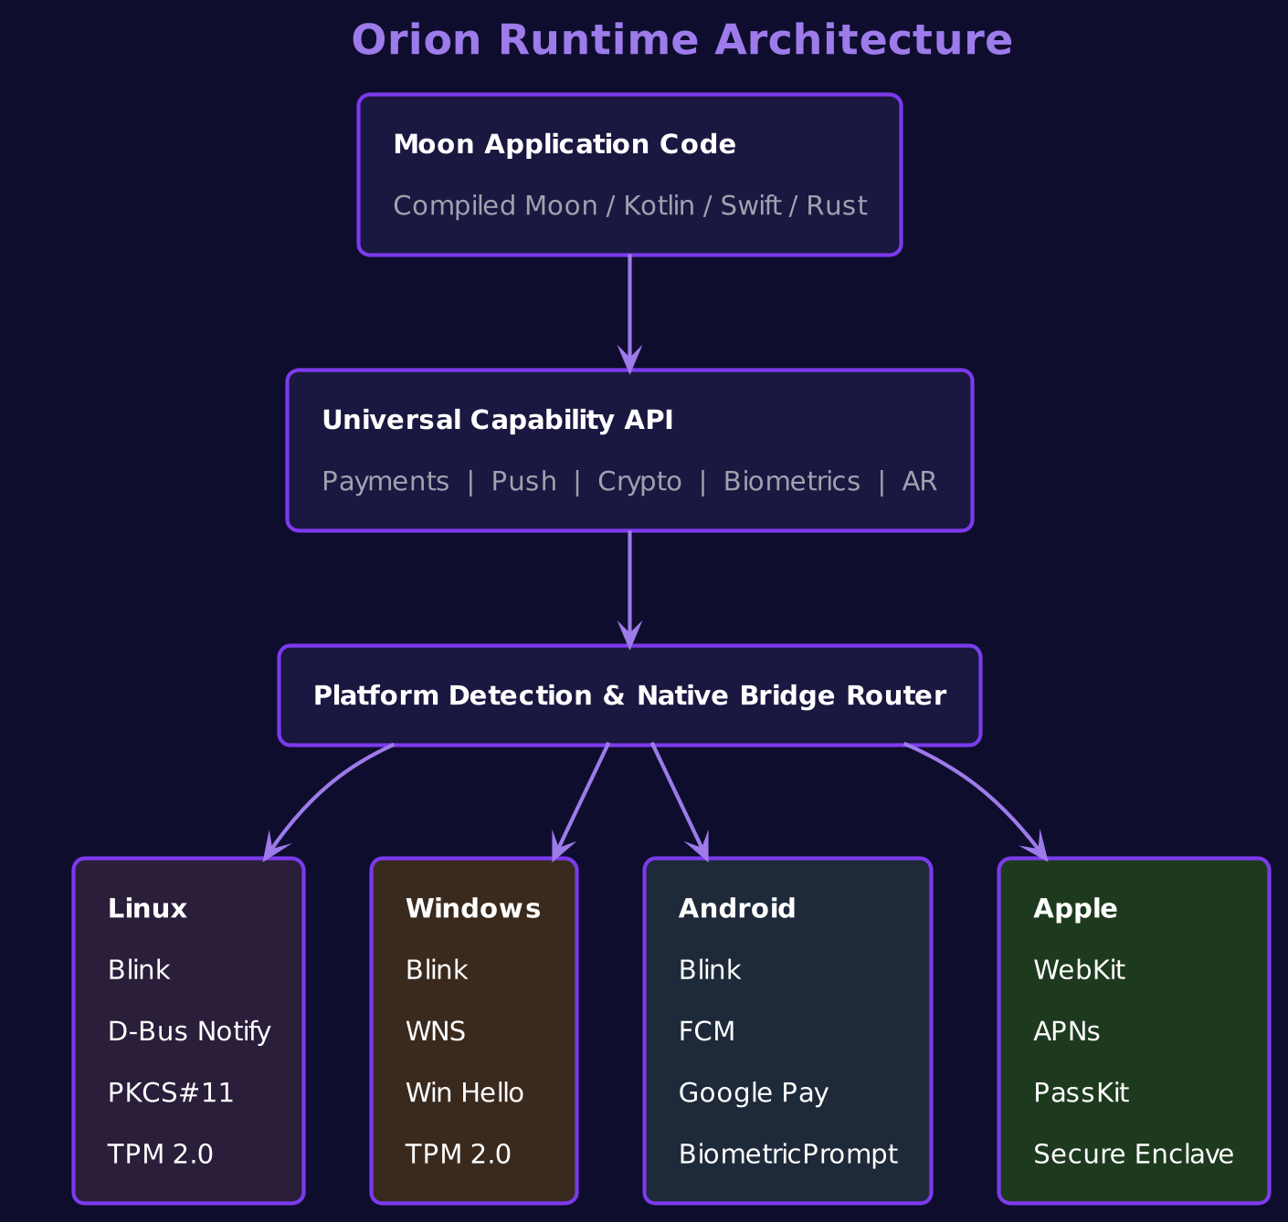
Figure 1: Orion Runtime Architecture

3. Language Overview
Moon uses Kotlin-inspired syntax with enhancements for web platform capabilities. Source files use .moon.

3.1 Hello World
// main.moon
fun main() {
print("Hello, Moon!")
}

3.2 Variables and Constants
val name: String = "Moon" // immutable
var counter: Int = 0 // mutable
val inferred = 42 // type inference

// Null safety
val required: String = "always set"
val optional: String? = null
val length = optional?.length ?: 0

3.3 Functions
fun add(a: Int, b: Int): Int {
return a + b
}

fun multiply(a: Int, b: Int): Int = a * b

fun greet(name: String, greeting: String = "Hello"): String {
return "${greeting}, ${name}!"
}

val doubled = listOf(1, 2, 3).map { it * 2 }
items.filter { it.price > 10.0 }.sortedBy { it.name }.take(5)

3.4 Control Flow
val result = when (status) {
Status.Active -> "Running"
Status.Paused -> "On hold"
Status.Stopped -> "Done"
}

val label = if (count > 0) "Items: $count" else "Empty"
for (i in 0 until 10) { /* 0..9 */ }

3.5 Data Classes
data class User(
val id: String, val name: String,
val email: String, val role: Role = Role.Viewer
)
val (id, name, email) = user
val admin = user.copy(role = Role.Admin)

3.6 Sealed Classes
sealed class Result<out T> {
data class Success<T>(val data: T) : Result<T>()
data class Error(val message: String) : Result<Nothing>()
object Loading : Result<Nothing>()
}

fun handle(r: Result<User>) = when (r) {
is Result.Success -> showUser(r.data)
is Result.Error -> showError(r.message)
Result.Loading -> showSpinner()
}

3.7 Interfaces
interface Serializable {
fun toBytes(): ByteArray
fun contentType(): String = "application/octet-stream"
}

class ApiResponse(
override val cacheKey: String, val body: ByteArray
) : Serializable, Cacheable {
override fun toBytes() = body
}

4. Type System
Every value has a known type at compile time. No any type, no implicit coercion, no escape hatches.

4.1 Primitive Types
Type | Size | Description
Int | 64-bit | Signed integer (default)
Int8, Int16, Int32 | 8/16/32 | Sized integers
Float32 / Float64 | 32/64 | IEEE 754 floats
Bool | 1-bit | true or false
Char | 32-bit | Unicode scalar
String | Variable | UTF-8, immutable
Unit / Nothing | 0-bit | Void / bottom type

4.2 Null Safety
val name: String = "Moon" // never null
val alias: String? = null // nullable
val len = alias?.length ?: 0 // safe call + elvis

if (alias != null) {
print(alias.length) // smart cast to String
}

4.3 Generics
class Repository<T : Entity> {
fun add(item: T) { items.add(item) }
fun find(id: String): T? = items.firstOrNull { it.id == id }
}

interface Producer<out T> { fun produce(): T }
interface Consumer<in T> { fun consume(item: T) }

4.4 Extensions
fun String.isValidEmail(): Bool =
this.matches(Regex("[a-zA-Z0-9+._-]+@[a-zA-Z0-9.-]+"))

val List<Int>.median: Float64
get() {
val s = this.sorted()
return if (size % 2 == 0) (s[size/2-1] + s[size/2]) / 2.0
else s[size/2].toFloat64()
}

5. Memory Model
Moon uses ARC supplemented by a lightweight cycle detector. Deterministic deallocation, no GC pauses, smooth 60/120fps rendering.
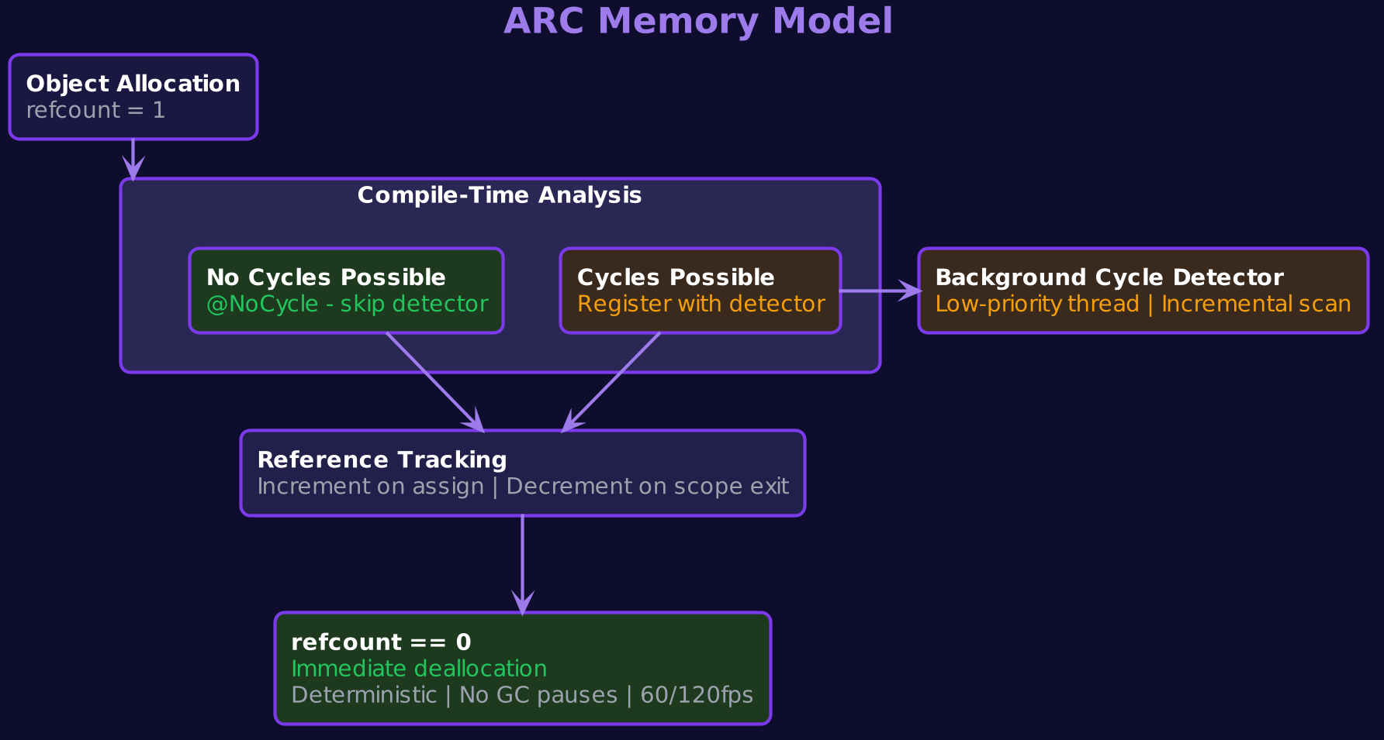
Figure 2: ARC Memory Model

5.1 ARC Semantics
fun processOrder(cart: Cart) {
val order = Order(cart) // refcount = 1
val receipt = order.receipt() // refcount = 2
sendEmail(receipt)
// scope exit: refcount 0 -> immediate dealloc
}

5.2 Weak and Unowned References
class Parent { var children: List<Child> = emptyList() }
class Child { weak var parent: Parent? = null }
class Engine { unowned val vehicle: Vehicle }

5.3 Cycle Detector
Compiler marks objects with no possible cycles as @NoCycle. Only potential-cycle objects register with a background incremental detector running on a low-priority thread.
// Compiler-inferred: no cycle possible
@NoCycle
class Logger(val tag: String)

// Potential cycle: parent <-> child
class TreeNode(val value: String) {
var children: List<TreeNode> = emptyList()
weak var parent: TreeNode? = null
}

// Detector runs incrementally, never pauses the UI thread
// Typical cycle collection: < 0.1ms per scan
The cycle detector uses a mark-and-sweep variant that runs in incremental slices during idle time. Objects annotated with @NoCycle bypass registration entirely, keeping the common case at zero overhead.

6. Concurrency
Structured concurrency inspired by Kotlin coroutines and Swift async/await, with compile-time data race safety.

6.1 Async/Await
suspend fun fetchUser(id: String): User {
val resp = http.get("https://api.example.com/users/$id")
return resp.decode<User>()
}

6.2 Structured Concurrency
suspend fun loadDashboard() {
val (user, orders, notifs) = concurrent {
val u = async { fetchUser(userId) }
val o = async { fetchOrders(userId) }
val n = async { fetchNotifications(userId) }
Triple(u.await(), o.await(), n.await())
}
render(Dashboard(user, orders, notifs))
}

6.3 Actors
actor ShoppingCart {
private var items = mutableListOf<CartItem>()
fun add(item: CartItem) { items.add(item) }
fun total(): Float64 = items.sumOf { it.price * it.quantity }
}

// All access automatically serialized
cart.add(item) // safe from any coroutine

6.4 Reactive Streams
val prices: Flow<Float64> = stockTicker("GOOG")
prices.filter { it > 150.0 }
.map { PriceAlert("GOOG", it) }
.collect { notify(it) }

val cartItems = MutableStateFlow<List<CartItem>>(emptyList())
cartItems.value = cartItems.value + newItem // triggers re-render

7. UI Framework (MoonUI)
MoonUI replaces HTML, CSS, and the DOM with a declarative, reactive scene graph. Retained-mode rendering with automatic diffing.
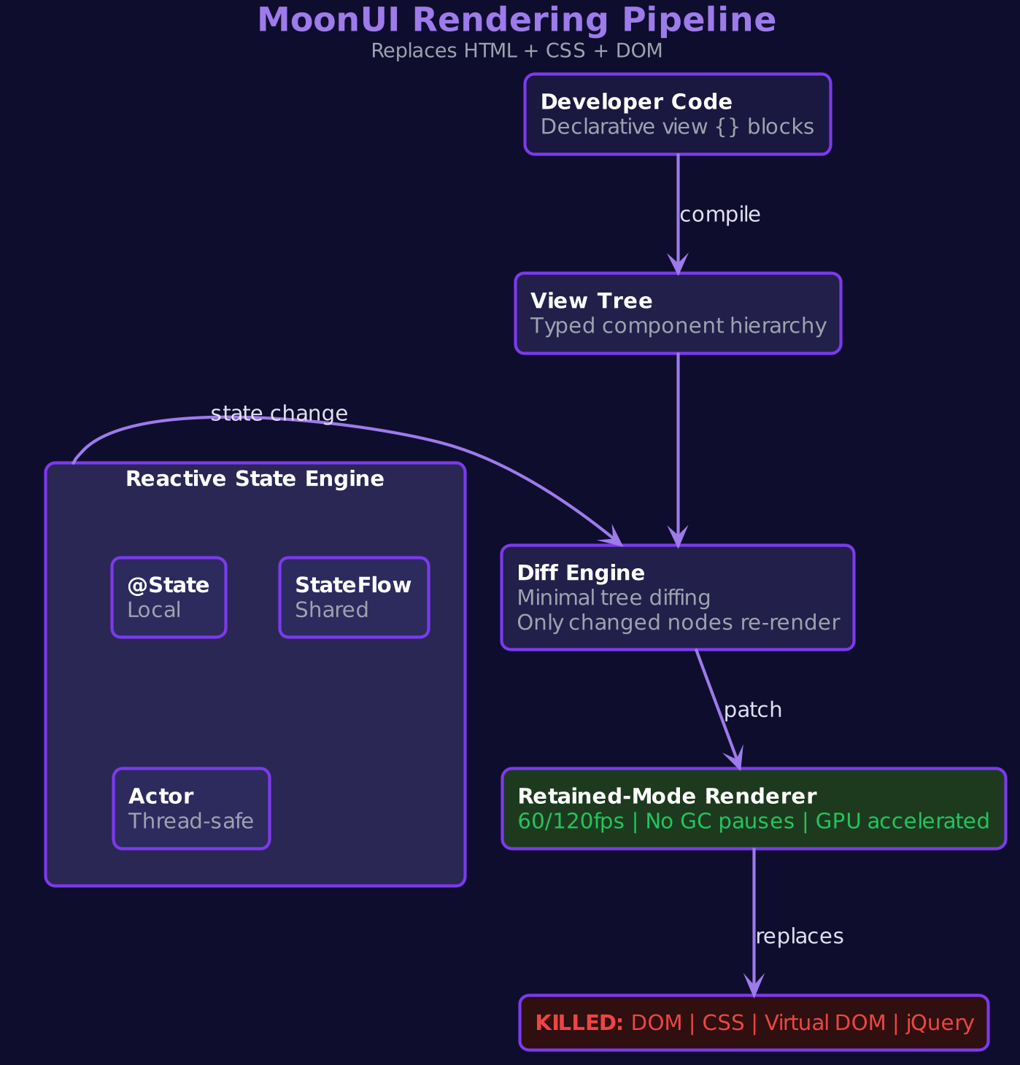
Figure 3: MoonUI Rendering Pipeline

7.1 Declarative Views
view ProductCard(product: Product) {
Column(spacing = 12.dp, padding = 16.dp) {
Image(product.thumbnailUrl)
.size(200.dp, 200.dp).cornerRadius(8.dp)
Text(product.name).font(.headline).color(.primary)
Text("$${product.price}").font(.body).color(.secondary)
Button("Add to Cart") { cart.add(product) }
.style(.primary).fullWidth()
}
}

7.2 State Management
view Counter() {
@State var count = 0
Column(alignment = .center, spacing = 16.dp) {
Text("Count: $count").font(.display)
Row(spacing = 8.dp) {
Button("-") { count-- }.style(.outlined)
Button("+") { count++ }.style(.primary)
}
}
}

7.3 Navigation
navigation App {
route("/") { HomePage() }
route("/products/{id}") { p -> ProductDetail(p["id"]) }
route("/cart") { CartPage() }
}
Navigator.push("/products/${product.id}")

7.4 Styling (No CSS)
val cardStyle = Style {
background(.surface)
cornerRadius(12.dp)
shadow(elevation = 4.dp, color = .black.opacity(0.1))
padding(16.dp)
}

theme AppTheme {
colors { primary = Color(0x5B21B6); surface = Color(0xFFFFFF) }
typography {
headline = Font("Inter", size = 24.sp, weight = .semibold)
body = Font("Inter", size = 16.sp, weight = .regular)
}
}

8. Platform Capability API
Orion detects the platform and bridges to native capabilities. Developers declare intent; the runtime resolves implementation.

8.1 Payments
@Capability(requires = Capability.Payments)
suspend fun checkout(cart: Cart): PaymentResult {
val payment = Payment(cart.total, Currency.USD)
// Apple -> Apple Pay | Android -> Google Pay | Fallback -> Stripe
return Platform.payments.request(payment)
}

8.2 Notifications
@Capability(requires = Capability.Notifications)
suspend fun registerPush() {
val token = Platform.notifications.register()
// Apple -> APNs | Android -> FCM | Windows -> WNS
api.registerDevice(token)
}

8.3 Biometrics
@Capability(requires = Capability.Biometrics)
suspend fun authenticate(): AuthResult {
return Platform.biometrics.authenticate(
reason = "Confirm your identity"
)
// Apple -> Face ID | Android -> BiometricPrompt | Win -> Hello
}

8.4 Platform Detection
when (Platform.current.os) {
OS.MacOS -> { /* WebKit */ }
OS.Android -> { /* Blink */ }
OS.Windows -> { /* Blink */ }
}
if (Platform.supports(Capability.Payments)) showPaymentButton()

9. Hardware Security Bridge
First-class HSM, secure enclave, and hardware token support. Private keys never leave the hardware.
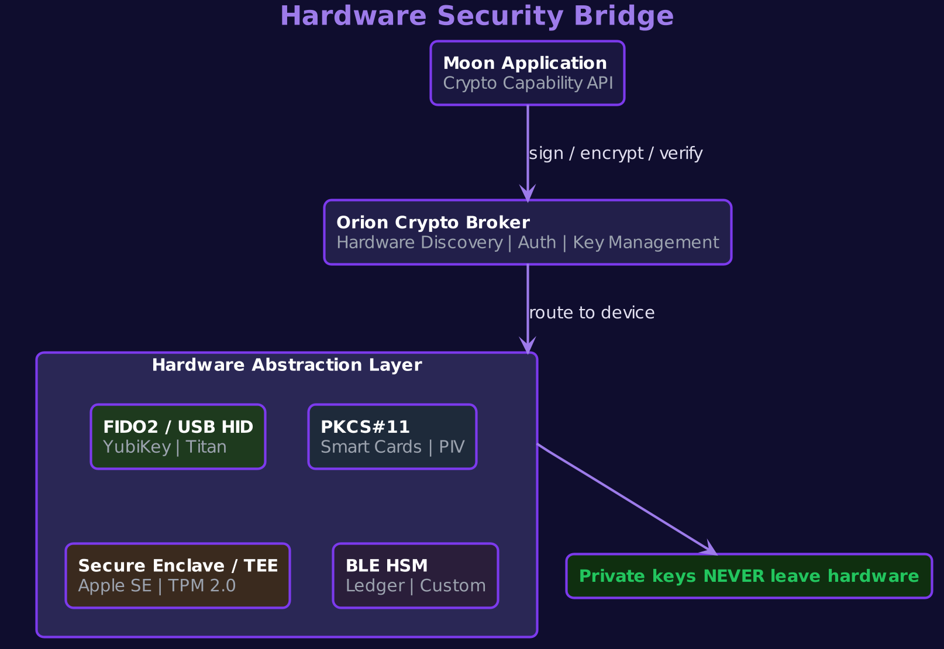
Figure 4: Hardware Security Bridge

9.1 Discovery & Operations
@Capability(requires = Capability.HardwareCrypto)
suspend fun signDocument(doc: ByteArray): Signature {
val key = Platform.crypto.getKey(
id = "signing-key", type = KeyType.Ed25519,
requireHardware = true
)
return key.sign(doc) // hardware signs, key never exposed
}

9.2 Encryption
suspend fun encryptMessage(
msg: ByteArray, recipient: PublicKey
): EncryptedPayload {
val key = Platform.crypto.getKey(
id = "msg-key", type = KeyType.X25519, requireHardware = true
)
return key.encrypt(msg, recipient,
EncryptionAlgorithm.XChaCha20Poly1305)
}

9.3 Capability Manifest
# aurora.manifest
crypto:
operations: [sign, verify, encrypt, decrypt, keyExchange]
key_types: [ed25519, x25519, ecdsa-p256]
requires_hardware: true
fallback: none
attestation: required
devices: [fido2, pkcs11, secure_enclave, bluetooth_hsm]

10. Package Manager (Aurora)
Aurora replaces npm, webpack, babel, eslint, and all config files with a single tool.
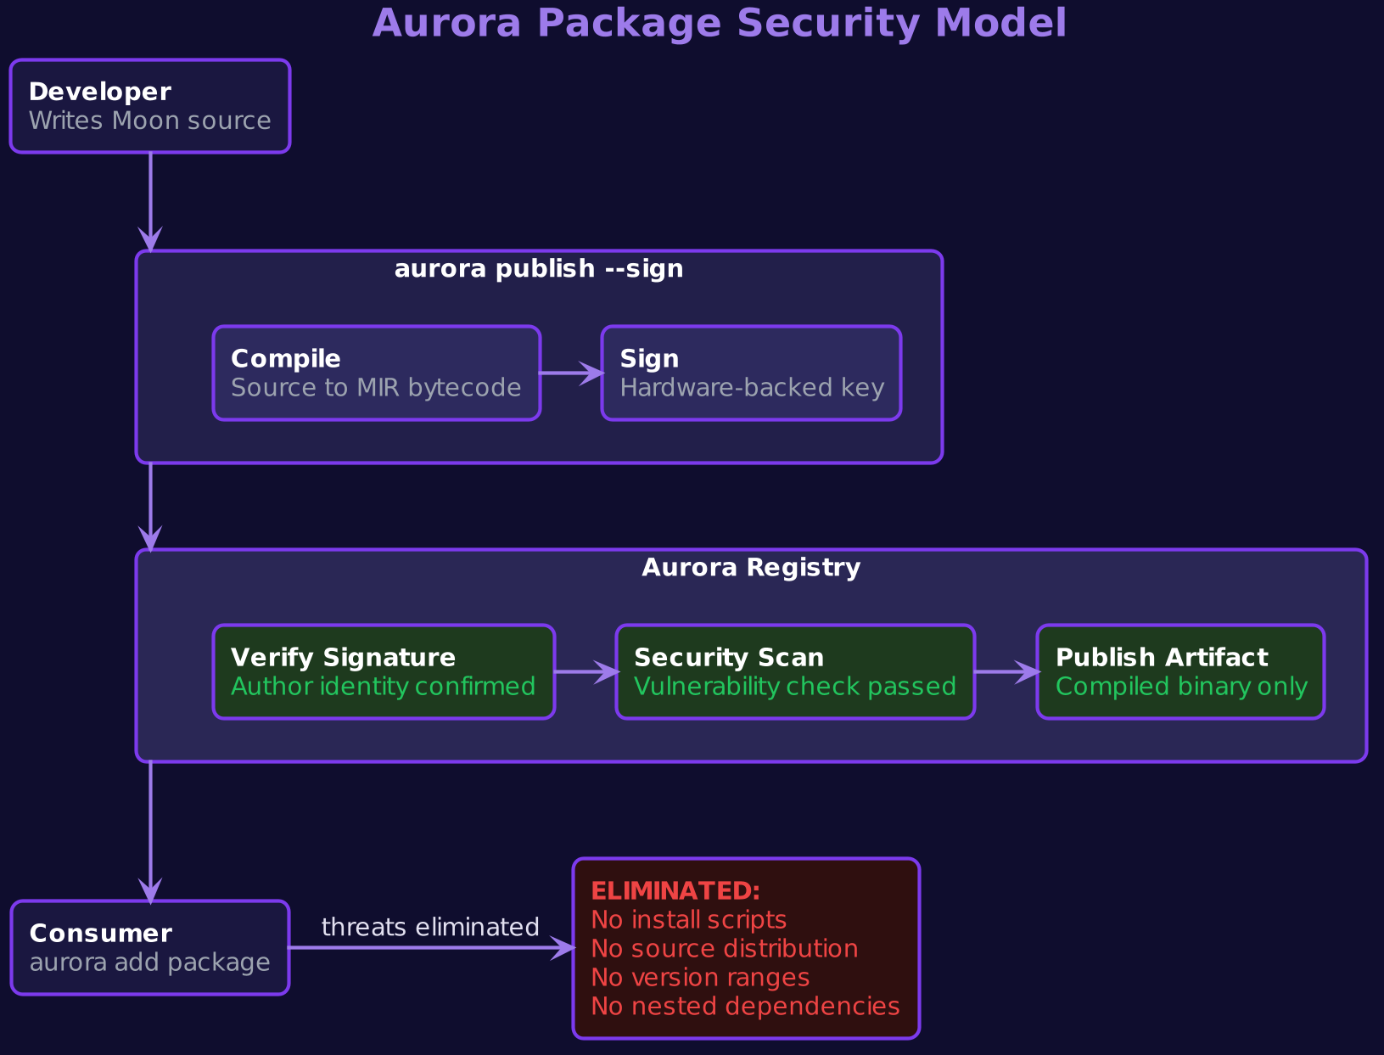
Figure 5: Aurora Security Model

10.1 CLI Commands
Command | Description
aurora init <name> | Create new project
aurora add <pkg> | Add dependency (exact pin)
aurora dev | Dev server + hot reload
aurora build --release | AOT compile
aurora test | Run tests
aurora publish --sign | Publish (requires signing key)
aurora audit --deep | Security audit

10.2 Manifest
# aurora.manifest
name: my-app
version: 1.0.0
target: web
moon: 1.0

platform_capabilities:
- payments
- notifications
- crypto: { requires_hardware: true }

dependencies:
moon-ui: 2.1.0
moon-http: 1.4.0
moon-json: 3.0.0

10.3 Security Model
- All packages cryptographically signed by author
- Distributed as compiled artifacts, not source
- No install scripts during dependency resolution
- Flat resolution — no nested node_modules
- Exact version pinning — nothing changes silently
- Registry-level scanning for vulnerabilities

11. Standard Library
Comprehensive standard library. No third-party packages needed for typical web development.
Module | Purpose | Key Types
moon.core | Primitives, collections | List, Map, Set, Sequence
moon.http | HTTP client/server | HttpClient, Request, Response
moon.json | Serialization | JsonEncoder, JsonDecoder
moon.crypto | Cryptography | Hash, Cipher, Signature, Key
moon.time | Date, time, duration | Instant, Duration, TimeZone
moon.test | Testing framework | TestSuite, Assert, Mock
moon.concurrent | Concurrency | Flow, Actor, Channel, Mutex
moon.view | MoonUI framework | View, State, Navigator, Style
moon.platform | Platform caps | Payment, Notification, Biometric
moon.storage | Persistence | Database, KeyValue, FileSystem
moon.net | Networking | Socket, WebSocket, URL
moon.media | Audio/video/image | Camera, Microphone, MediaPlayer

12. Interoperability
Moon is a polyglot compilation target. Write in Moon directly or use supported source languages.
Language | Tier | Compilation Path
Moon (native) | Primary | Moon → MIR → Bytecode
Kotlin | Tier 1 | Kotlin → KIR → MIR → Bytecode
Swift | Tier 1 | Swift → SIL → MIR → Bytecode
Rust | Tier 2 | Rust → LLVM IR → MIR → Bytecode
TypeScript | Migration | TS → AST → MIR (limited)

MIR (Moon Intermediate Representation) is the stable contract. Compiled packages are insulated from upstream language changes. Developers can write MIR directly as an escape hatch.

13. Compilation Pipeline
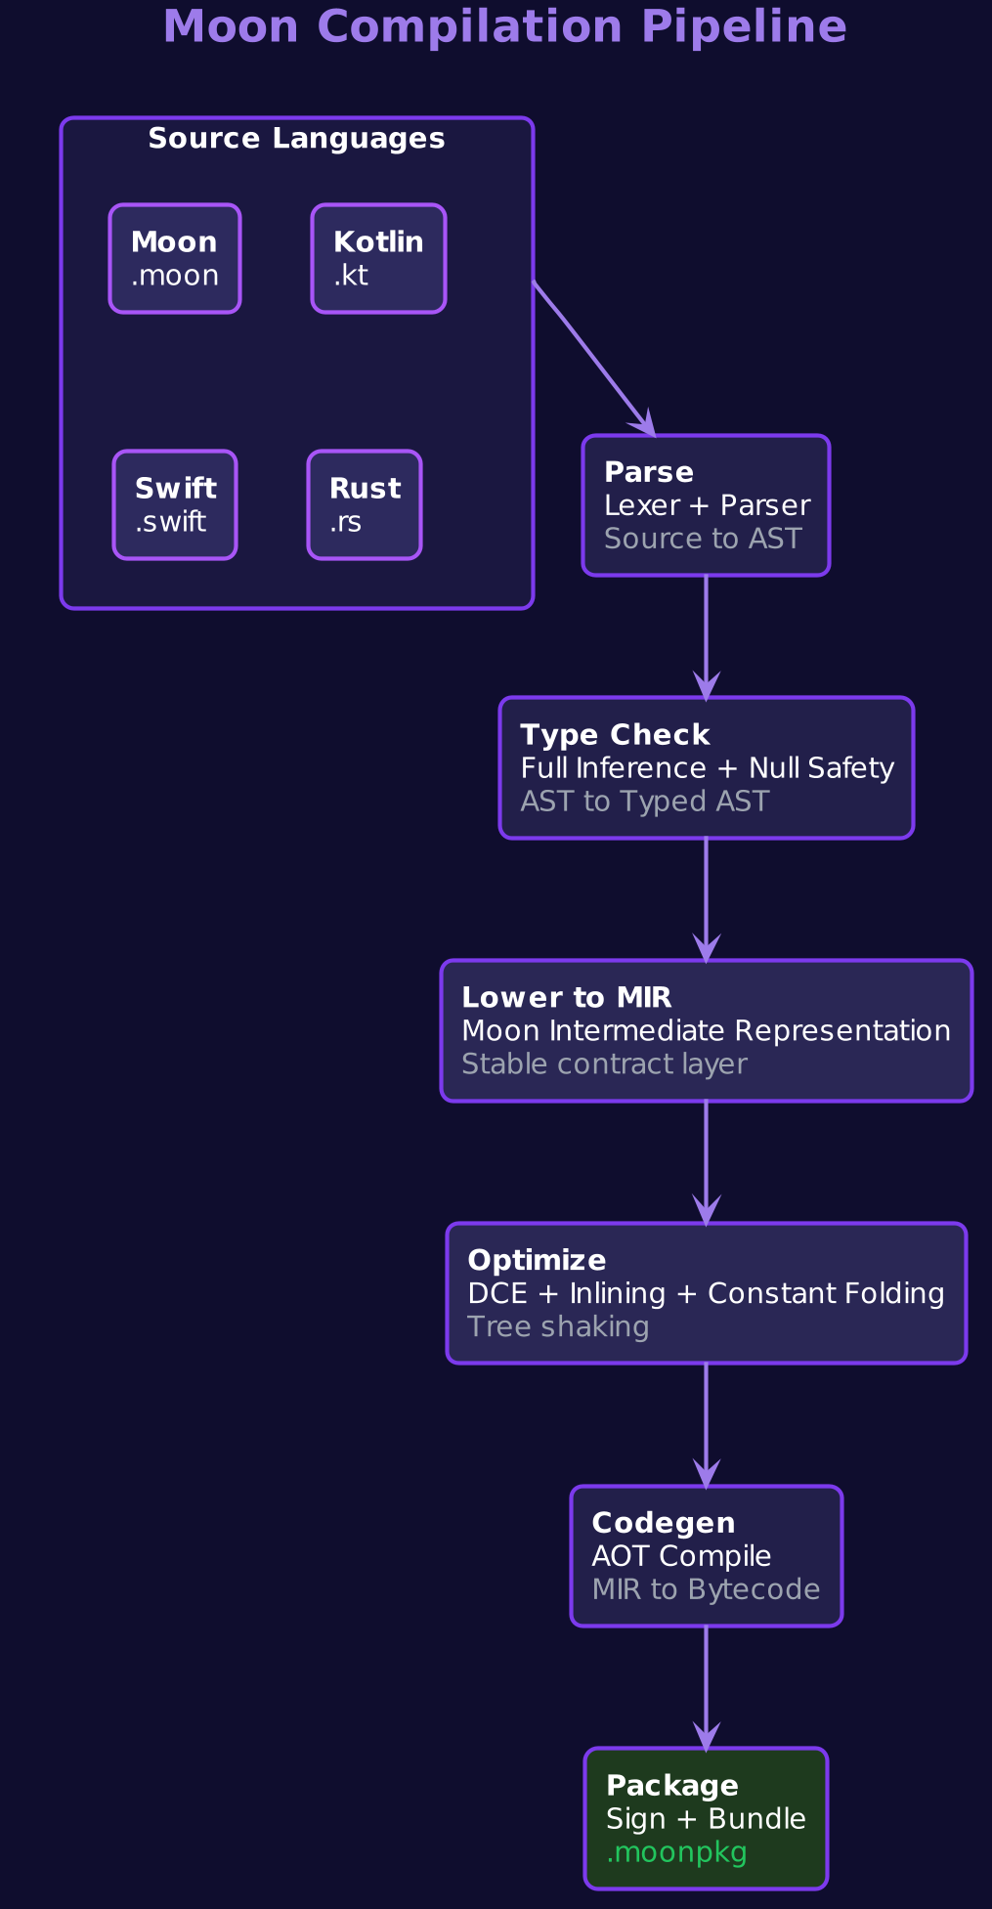
Figure 6: Moon Compilation Pipeline

13.1 Development Mode
aurora dev

# -> Moon Dev Server v1.0
# -> Watching src/ for changes
# -> http://localhost:3000
# -> Hot reload enabled
# -> [0.02s] Incremental recompile
# -> [0.01s] Hot reload applied (no page refresh)

13.2 Production Build
aurora build --release

# -> Compiling 47 source files...
# -> Type checking: passed
# -> Null safety: verified
# -> Capability validation: passed
# -> Tree shaking: removed 12 unused modules
# -> Output: dist/app.moonpkg (842 KB)
# -> Build complete in 2.3s

13.3 Stages
Stage | Input | Output | Description
Parse | .moon source | AST | Lexing and parsing
Type Check | AST | Typed AST | Inference + null safety
Lower | Typed AST | MIR | Moon IR generation
Optimize | MIR | Opt MIR | DCE, inlining, folding
Codegen | Opt MIR | Bytecode | Runtime bytecode
Package | Bytecode | moonpkg | Bundle + sign

14. Migration Strategy

14.1 Dual Runtime
Orion ships with both the legacy web engine (HTML/CSS/JS) and the Moon runtime. Legacy sites work unchanged. New apps target Moon. A bridge layer allows Moon apps to embed legacy content for gradual migration.

14.2 Timeline
Phase | Target | Milestone
Alpha | 2026 Q3 | Spec finalized, compiler prototype, dev tools
Beta | 2027 Q1 | Aurora registry, MoonUI beta, Orion Canary
Dev Preview | 2027 Q3 | Public SDK, documentation, example apps
Orion Integration | 2028 Q1 | Moon runtime in Orion stable (behind flag)
GA | 2028 Q3 | Flag removed, available to all Orion users
Legacy Deprecation | 2030+ | Begin JS engine deprecation signaling

14.3 TypeScript Migration
aurora migrate --from typescript --source ./src

# -> Analyzing 234 TypeScript files...
# -> Converting types: 98% automated
# -> Converting components to MoonUI: 85% automated
# -> Manual review needed: 12 files
# -> Output: ./src-moon/

15. Appendix: Grammar Reference
Abbreviated formal grammar for Moon in Extended Backus-Naur Form:
program = { declaration } ;
declaration = funDecl | viewDecl | classDecl | enumDecl
| interfaceDecl | actorDecl | typeAlias ;

funDecl = ["suspend"] "fun" id [typeParams]
"(" [params] ")" [":" type] block ;
viewDecl = "view" id "(" [params] ")" viewBlock ;
classDecl = ["data"|"sealed"] "class" id [typeParams]
["(" [params] ")"] [":" typeList] classBlock ;
actorDecl = "actor" id classBlock ;
enumDecl = "enum" "class" id enumBlock ;
navDecl = "navigation" id navBlock ;

type = id [typeArgs] ["?"] | funcType | tupleType ;
funcType = "(" [typeList] ")" "->" type ;

statement = valDecl | varDecl | assignment | expression
| ifExpr | whenExpr | forLoop | returnStmt ;
valDecl = "val" id [":" type] "=" expression ;
varDecl = ["weak"|"unowned"] "var" id [":" type] "=" expr ;
whenExpr = "when" "(" expr ")" "{" { whenEntry } "}" ;
lambda = "{" [params "->"] statements "}" ;

─── End of Specification ───
Moon Language • Codename Mars • Dark Matter Tech Confidential

