● Use tools like static analyzers or manual inspection methods.
import sqlite3
name = input("Enter username: ")
query = "SELECT * FROM users WHERE name = '" + name + "';" # vulnerable to SQL Injection
conn = sqlite3.connect("test.db")
cursor = conn.cursor()
cursor.execute(query)
print(cursor.fetchall())
conn.close()

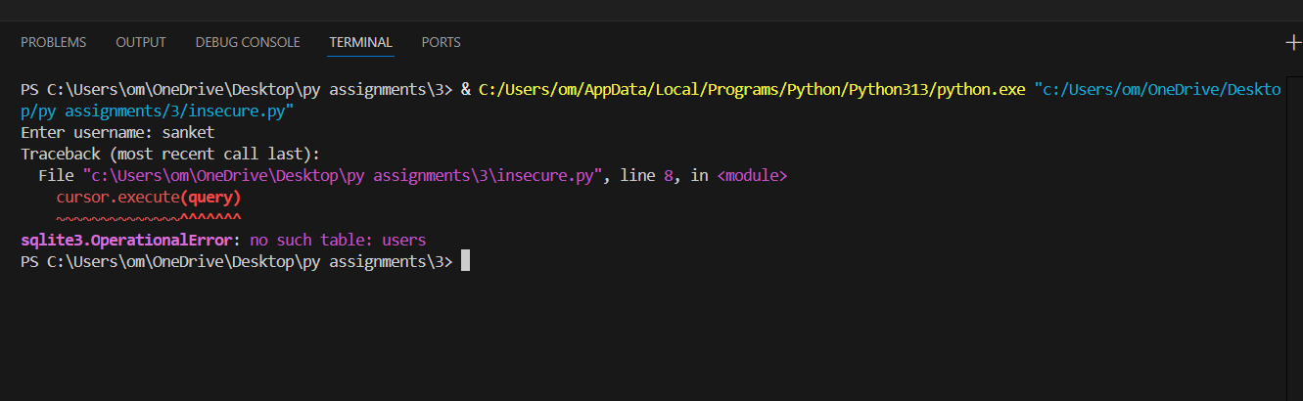

● Use tools like static analyzers or manual inspection methods.
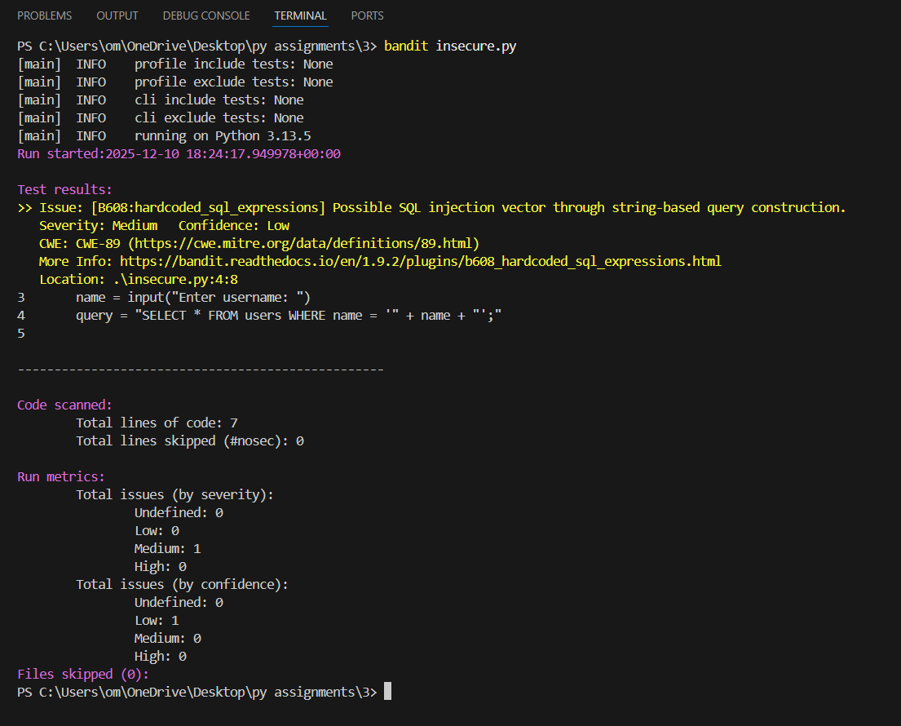

● Provide recommendations and best practices for secure coding.
- Use parameterized queries
- Validate user inputs
- Avoid string concatenation in SQL
- Use least privilege access
- Use static analysis tools regularly

● Document findings and suggest remediation steps for safer code.
import sqlite3

name = input("Enter username: ")
query = "SELECT * FROM users WHERE name = ?"

conn = sqlite3.connect("test.db")
cursor = conn.cursor()
cursor.execute(query, (name,))
print(cursor.fetchall())
conn.close()

